1 Recognise pairs of fractions that add up to 1
Let’s Learn
$\frac{1}{5}$ + = 1 | $\frac{5}{8}$ + = 1 | $\frac{4}{7}$ – = 1 | $\frac{2}{3}$ – = 1
Your Turn
$\frac{1}{3}$ + = 1 | $\frac{1}{8}$ + = 1 | $\frac{5}{6}$ + = 1 | $\frac{2}{5}$ + = 1

2 Count up in halves, thirds and quarters beyond 1
Let’s Learn
For each diagram, write the equivalent mixed number or improper fraction shown.
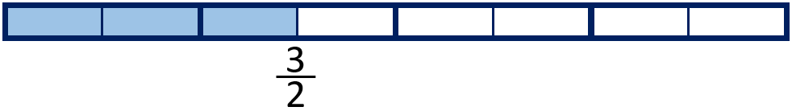 | 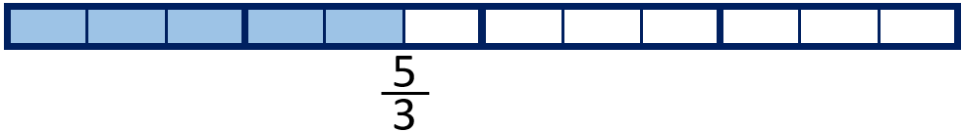
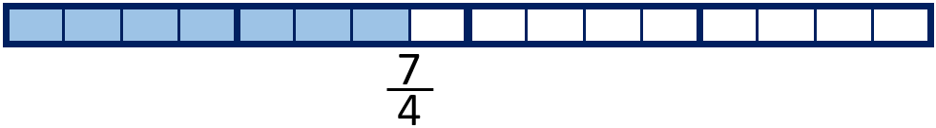 | 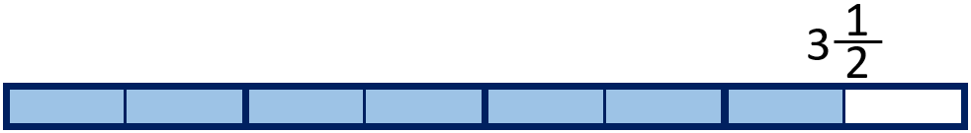
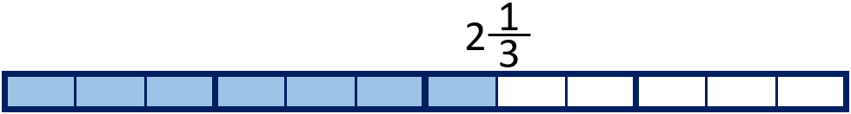 | 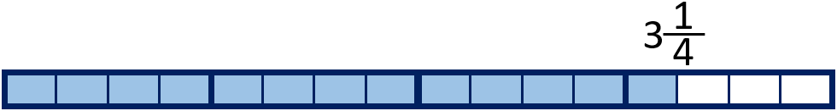
Your Turn
For each diagram, write the equivalent mixed number or improper fraction shown.
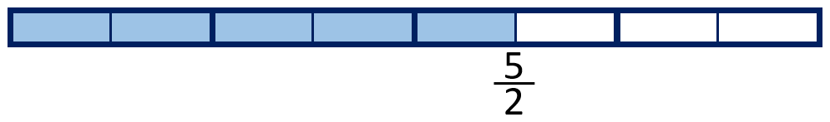 | 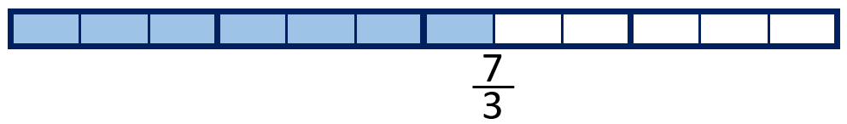
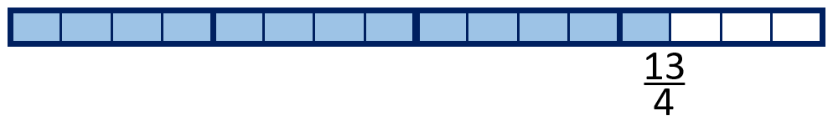 | 
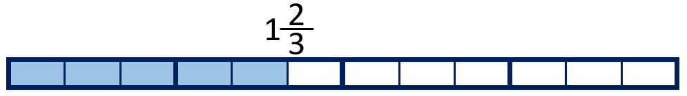 | 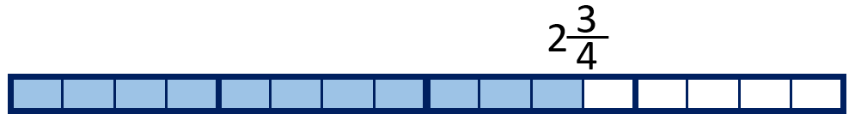

3 Identify equivalent fractions to a half
Let’s Learn
$\frac{1}{2}$ = $\frac{}{4}$ = $\frac{}{6}$ = $\frac{}{8}$ = $\frac{}{10}$ = $\frac{}{12}$

4 Use multiplication to find equivalent fractions
Let’s Learn
$\frac{1}{3}$ = $\frac{}{9}$ | $\frac{3}{5}$ = $\frac{}{10}$ | $\frac{2}{5}$ = $\frac{}{20}$ | $\frac{2}{3}$ = $\frac{8}{}$ | $\frac{3}{4}$ = $\frac{9}{}$
Your Turn
$\frac{1}{4}$ = $\frac{}{8}$ | $\frac{2}{5}$ = $\frac{}{15}$ | $\frac{2}{3}$ = $\frac{}{18}$ | $\frac{2}{7}$ = $\frac{6}{}$ | $\frac{2}{9}$ = $\frac{8}{}$

5 Use division to find equivalent fractions
Let’s Learn
$\frac{6}{9}$ = $\frac{}{3}$ | $\frac{4}{12}$ = $\frac{}{3}$ | $\frac{20}{24}$ = $\frac{}{6}$ | $\frac{6}{15}$ = $\frac{2}{}$ | $\frac{10}{20}$ = $\frac{1}{}$
Your Turn
$\frac{6}{8}$ = $\frac{}{4}$ | $\frac{4}{20}$ = $\frac{}{5}$ | $\frac{16}{28}$ = $\frac{}{7}$ | $\frac{10}{15}$ = $\frac{2}{}$ | $\frac{9}{27}$ = $\frac{1}{}$

6 Find a non-unit fraction of a number
Let’s Learn
$\frac{2}{5}$of 30 = | $\frac{5}{6}$ of 24 = | $\frac{3}{8}$of 24 =
Your Turn
$\frac{3}{5}$of 45 = | $\frac{4}{5}$ of 35 = | $\frac{5}{8}$of 32 =

7 Find a whole quantity give the quantity represented by a non-unit fraction
Let’s Learn
$\frac{2}{5}$ of = 10 | $\frac{5}{6}$ of = 15 | $\frac{3}{5}$ of = 15
Your Turn
$\frac{3}{5}$ of = 15 | $\frac{3}{4}$ of = 27 | $\frac{3}{7}$ of = 21

