1 Recognise representations for four-digit numbers
Let’s Learn
Write the numbers shown by the blocks below in digits.
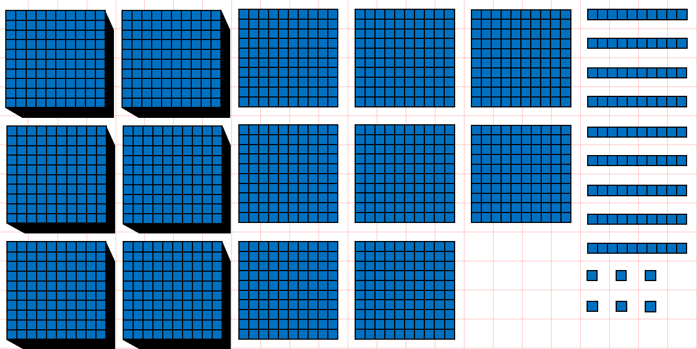  6869 |  | 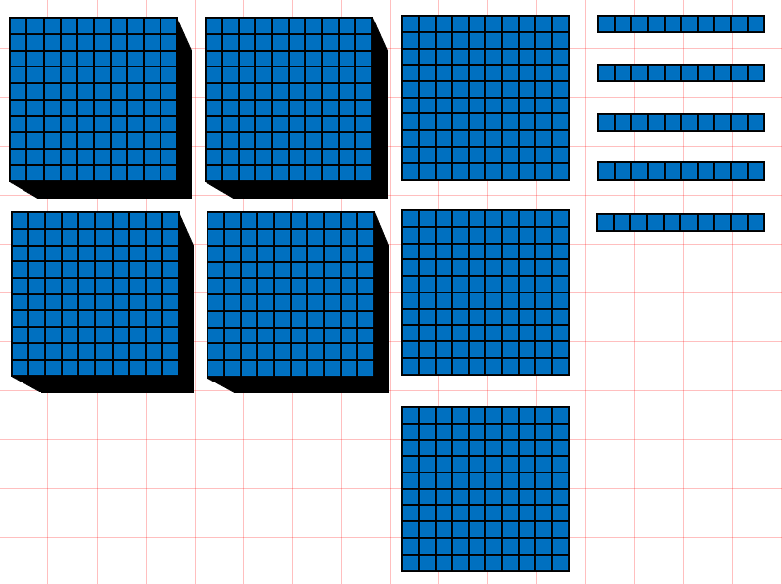  4350
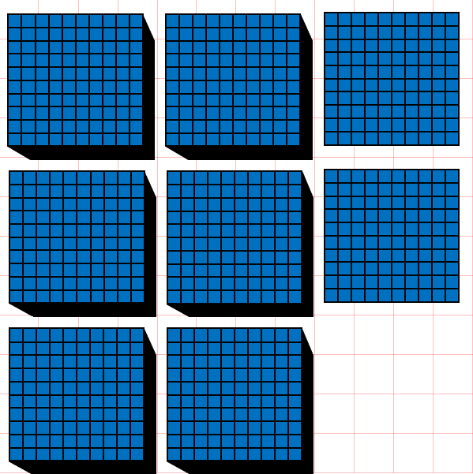  6200 | 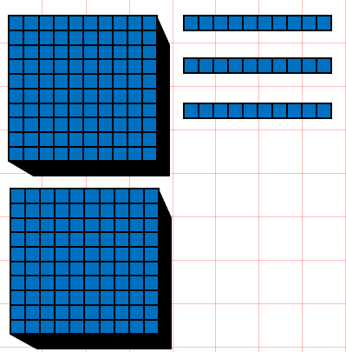  2030 |  | 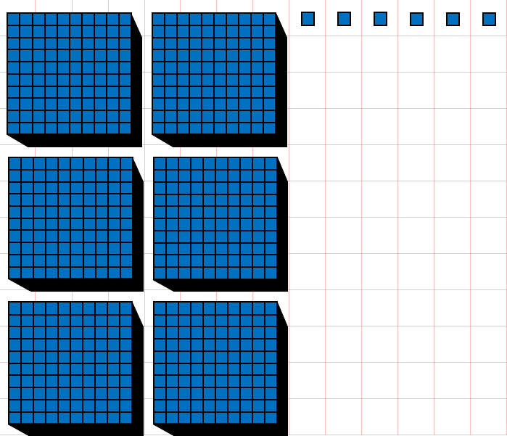  6006
Your Turn
Write the numbers shown by the blocks below in digits.
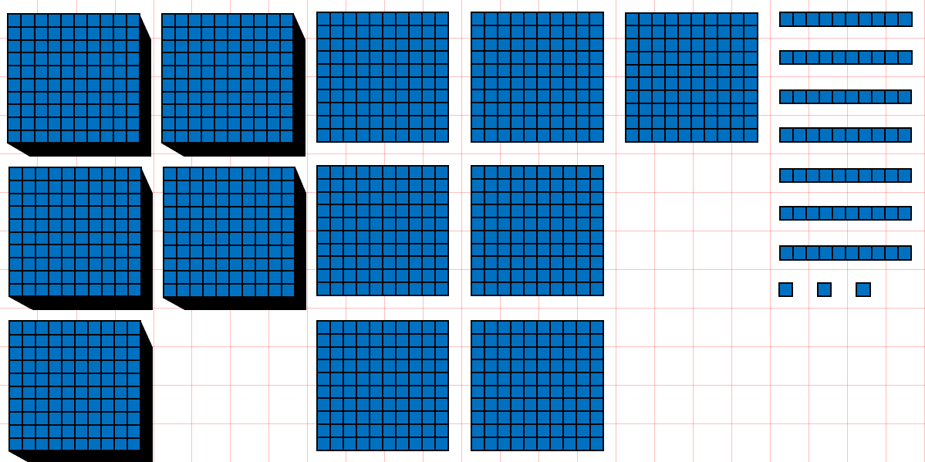  5773 |  | 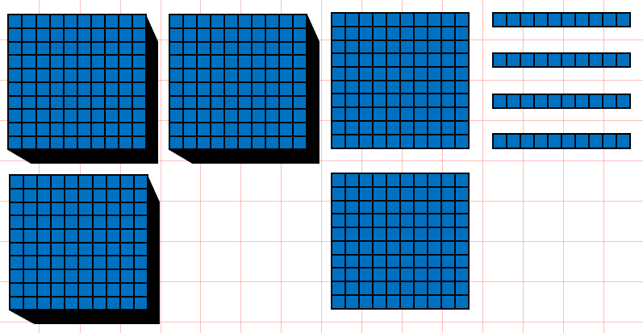  3240
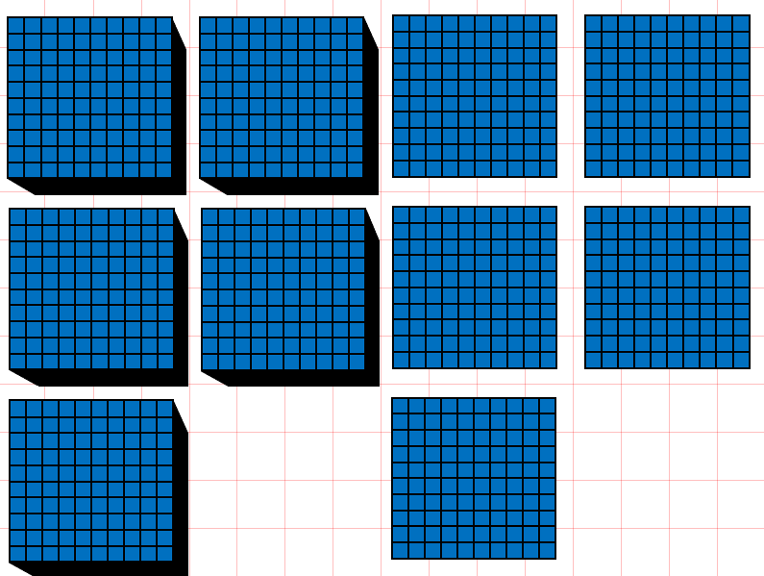  5500 | 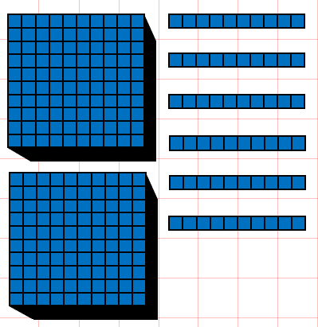  2060 |  | 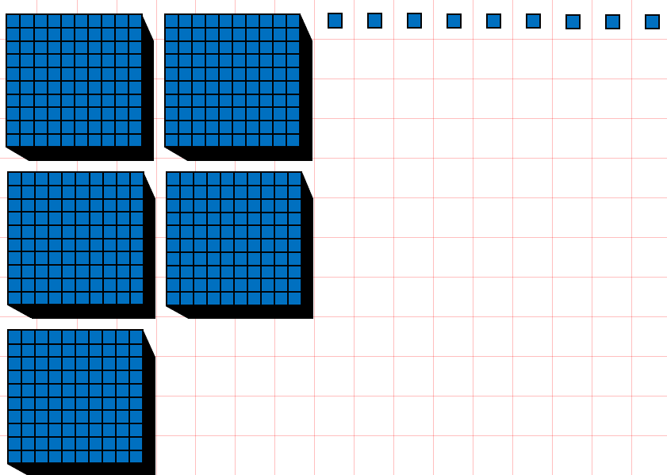  5009

2 Write four-digit numbers in digits
Let’s Learn
Write the numbers below in digits.
Four thousand, eight hundred and twenty-five  4825 | Nine thousand, two hundred  9200
Eight thousand and eighteen  8018 | Five thousand and five  5005
Your Turn
Write the numbers below in digits.
Two thousand, four hundred and eighty-seven  2487 | Eight thousand, nine hundred  8900
Seven thousand and twelve  7012 | Three thousand and one  3001

3 Write four-digit numbers in words
Let’s Learn
Write the numbers below in words.
1483 One thousand, four hundred and eighty-three

3072 Three thousand and seventy-two

3300 Three thousand, three hundred

4002 Four thousand and two

Your Turn
Write the numbers below in words.
4224 Four thousand, two hundred and twenty-four

8038 Eight thousand and thirty-eight

9100 Nine thousand, one hundred

5002 Five thousand and two

4 Identify the digit in each place value for four-digit numbers
Let’s Learn
For the questions below, write the digit in each place value.
4,593  4  Thousands:  5  Hundreds:  9  Tens:  3  Ones: | 4,809  8  Hundreds:  9  Ones:  4  Thousands:  0  Tens: | 3,190  0  Ones:  1  Hundreds:  9  Tens:  3  Thousands:
Your Turn
For the questions below, write the digit in each place value.
6,923  6  Thousands:  9  Hundreds:  2  Tens:  3  Ones: | 2,193  1  Hundreds:  3  Ones:  2  Thousands:  9  Tens: | 4,027  7  Ones:  0  Hundreds:  2  Tens:  4  Thousands:

5 Identify the value of each digit in four-digit numbers
Let’s Learn
For the questions below, write the value of each digit.
4,529  9  9 represents:  4000  4 represents:  500  5 represents:  20  2 represents: | 8,706  700  7 represents:  8000  8 represents:  6  6 represents: | 8,041  1  1 represents:  40  4 represents:  8000  8 represents:
Your Turn
For the questions below, write the value of each digit.
7,638  8  8 represents:  7000  7 represents:  600  6 represents:  30  3 represents: | 8,105  100  1 represents:  8000  8 represents:  5  5 represents: | 6,023  1  3 represents:  20  2 represents:  8000  6 represents:

6 Partition four-digit numbers
Let’s Learn
Partition the numbers below.
1
70
300
5000
5371 = + + +

5
30
700
1000
1735 = + + +

5
30
3000
3035 = + +

8
800
8000
8808 = + +

Your Turn
Partition the numbers below.
3
50
200
8000
8253 = + + +

1
20
100
2000
2121 = + + +

6
40
9000
9046 = + +

9
700
7000
7709 = + +

7 Compare four-digit numbers
Let’s Learn
For the questions below, write < or >
>  3528 ____ 2972 | >  4922 ____ 4099 | <  4722 ____ 4771 | >  5096 ____5093
Your Turn
For the questions below, write < or >
<  2848 ____ 8248 | >  6398 ____ 6099 | >  3824 ____ 3818 | <  8290 ____8292

8 Order four-digit numbers
Let’s Learn
Order each set of numbers from smallest to largest.
595, 9595, 9559, 5595, 5955
595
5595
5955
9559
9595

4411, 1441, 1414, 5111, 444
444
1414
1441
4411
5111

Your Turn
Order each set of numbers from smallest to largest.
2752, 277, 2572, 7225, 2725
277
2572
2725
2752
7225

533, 5333, 3535, 3553, 5353
533
3535
3553
5333
5353

9 Round to the nearest 1000
Let’s Learn
Round the numbers below to the nearest 1000.
2392 ≈ 2000 | 3971 ≈ 4000 | 7018 ≈ 7000 | 5544 ≈ 6000
Your Turn
Round the numbers below to the nearest 1000.
5293 ≈ 5000 | 3288 ≈ 3000 | 6919 ≈ 7000 | 6884 ≈ 7000

10 Round to the nearest 1000, 100 and 10
Let’s Learn
Round the numbers below.
4 5 4 9  4550  Nearest 10 ≈  4500  Nearest 100 ≈  5000  Nearest 1000 ≈ | 2 3 8 2  2380  Nearest 10 ≈  2400  Nearest 100 ≈  2000  Nearest 1000 ≈ | 5 8 9 6  5900  Nearest 10 ≈  5900  Nearest 100 ≈  6000  Nearest 1000 ≈
Your Turn
Round the numbers below.
3 6 3 7  3640  Nearest 10 ≈  3600  Nearest 100 ≈  4000  Nearest 1000 ≈ | 1 4 5 4  1450  Nearest 10 ≈  1500  Nearest 100 ≈  1000  Nearest 1000 ≈ | 4 7 9 6  4800  Nearest 10 ≈  4800  Nearest 100 ≈  5000  Nearest 1000 ≈

11 Write numbers to 100 in Roman numerals
Let’s Learn
Write the numbers below in Roman numerals.
35 = XXXV | 72 = LXXII | 27 = XXVII | 83 = LXXXIII | 38 = XXXVIII
99 = XCIX | 29 = XXIX | 92 = XCII | 74 = LXXIV | 47 = XLVII
Your Turn
Write the numbers below in Roman numerals.
26 = XXVI | 63 = LXIII | 36 = XXXVI | 94 = XCIV | 49 = XLIX
77 = LXXVII | 28 = XXVIII | 82 = LXXXII | 54 = LIV | 45 = XLV

12 Read Roman numerals to 100
Let’s Learn
Write the numbers represented by Roman numerals below.
IV = 4 | VII = 7 | XIX = 19 | XXVI = 26 | XXXIV = 34
XXXVII = 37 | XLI = 41 | XLIV = 44 | XLIX = 49 | LV = 55
LXIV = 64 | LXXIX = 79 | LXXXIII = 83 | XCIV = 94 | XCVIII = 98
Your Turn
Write the numbers represented by Roman numerals below.
VI = 6 | IX = 9 | XV = 15 | XXVIII = 28 | XXXVI = 36
XXXVIII = 38 | XLII = 42 | XLV = 45 | LI = 51 | LIV = 54
LXIX = 69 | LXXIV = 74 | LXXXI = 81 | XCVII = 97 | XCIX = 99

