1 Recognise representations for four-digit numbers
Let’s Learn
Write the numbers shown by the blocks below in digits.
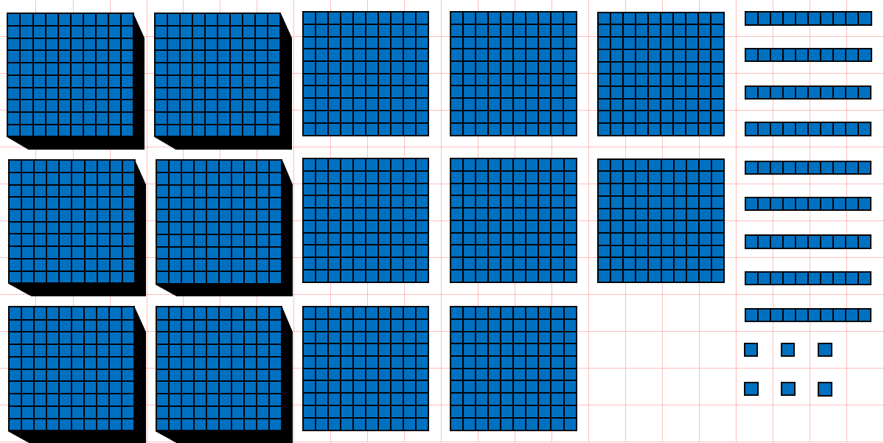 |  | 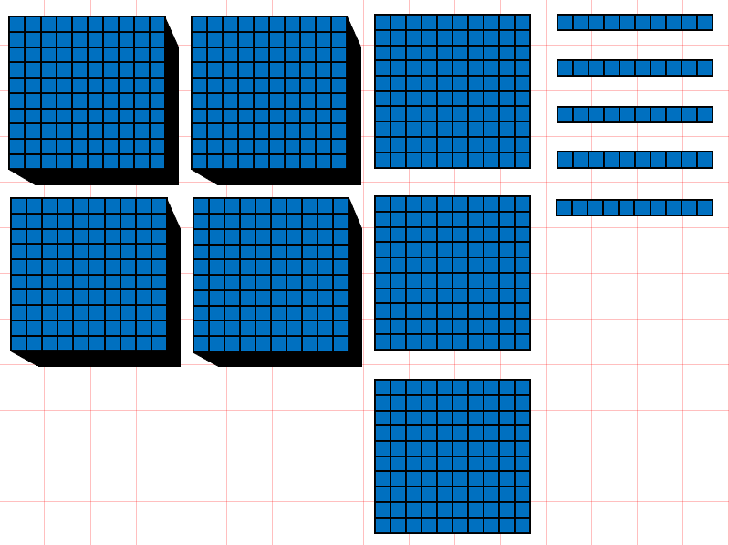
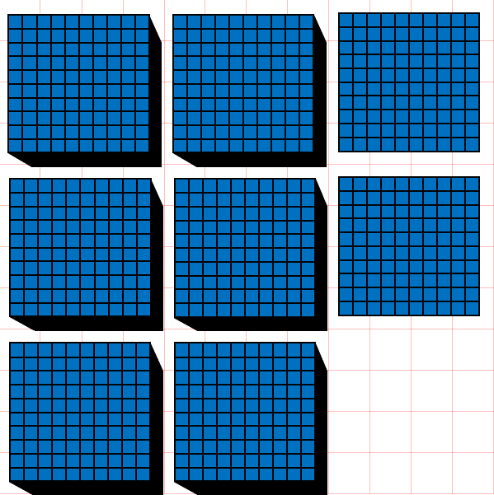 | 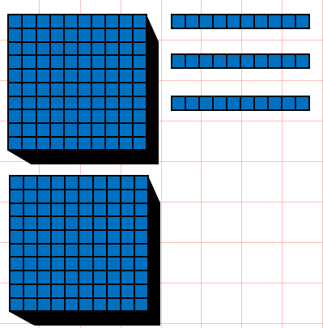 |  | 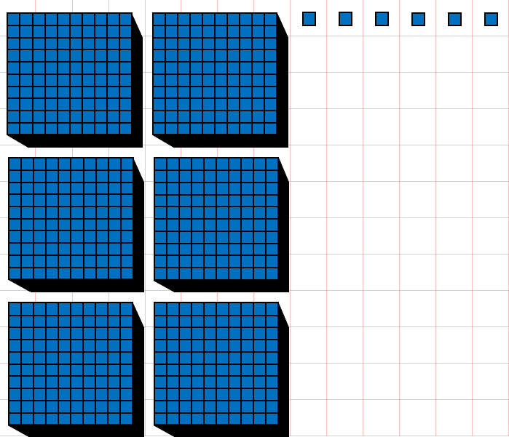
Your Turn
Write the numbers shown by the blocks below in digits.
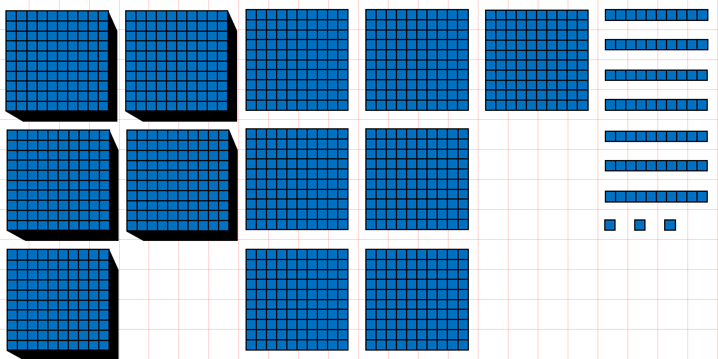 |  | 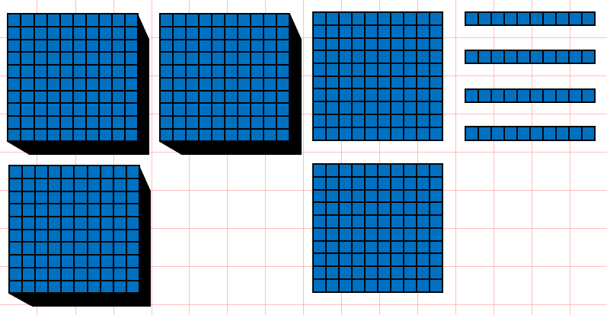
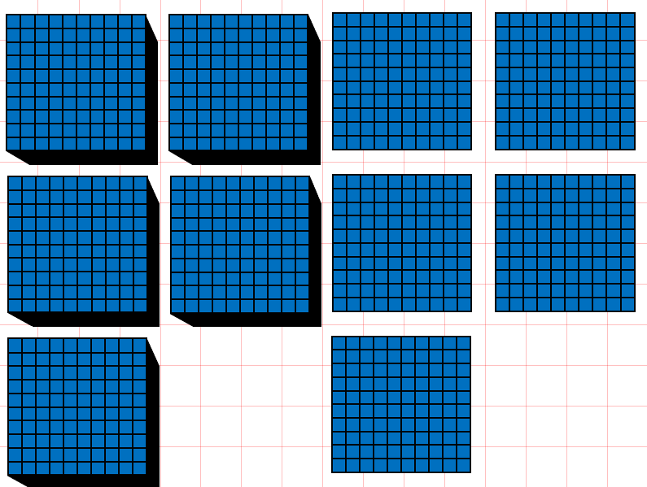 | 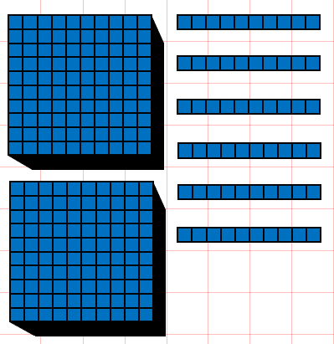 |  | 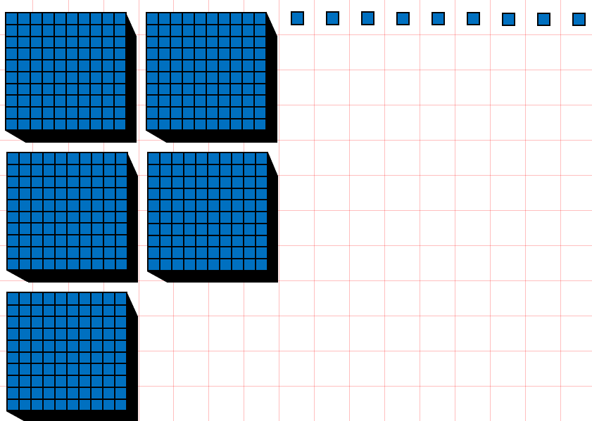

2 Write four-digit numbers in digits
Let’s Learn
Write the numbers below in digits.
Four thousand, eight hundred and twenty-five | Nine thousand, two hundred
Eight thousand and eighteen | Five thousand and five
Your Turn
Write the numbers below in digits.
Two thousand, four hundred and eighty-seven | Eight thousand, nine hundred
Seven thousand and twelve | Three thousand and one

3 Write four-digit numbers in words
Let’s Learn
Write the numbers below in words.
1483

3072

3300

4002

Your Turn
Write the numbers below in words.
4224

8038

9100

5002

4 Identify the digit in each place value for four-digit numbers
Let’s Learn
For the questions below, write the digit in each place value.
4,593  Thousands:  Hundreds:  Tens:  Ones: | 4,809  Hundreds:  Ones:  Thousands:  Tens: | 3,190  Ones:  Hundreds:  Tens:  Thousands:
Your Turn
For the questions below, write the digit in each place value.
6,923  Thousands:  Hundreds:  Tens:  Ones: | 2,193  Hundreds:  Ones:  Thousands:  Tens: | 4,027  Ones:  Hundreds:  Tens:  Thousands:

5 Identify the value of each digit in four-digit numbers
Let’s Learn
For the questions below, write the value of each digit.
4,529  9 represents:  4 represents:  5 represents:  2 represents: | 8,706  7 represents:  8 represents:  6 represents: | 8,041  1 represents:  4 represents:  8 represents:
Your Turn
For the questions below, write the value of each digit.
7,638  8 represents:  7 represents:  6 represents:  3 represents: | 8,105  1 represents:  8 represents:  5 represents: | 6,023  3 represents:  2 represents:  6 represents:

6 Partition four-digit numbers
Let’s Learn
Partition the numbers below.
5371 = + + +

1735 = + + +

3035 = + +

8808 = + +

Your Turn
Partition the numbers below.
8253 = + + +

2121 = + + +

9046 = + +

7709 = + +

7 Compare four-digit numbers
Let’s Learn
For the questions below, write < or >
3528 ____ 2972 | 4922 ____ 4099 | 4722 ____ 4771 | 5096 ____5093
Your Turn
For the questions below, write < or >
2848 ____ 8248 | 6398 ____ 6099 | 3824 ____ 3818 | 8290 ____8292

8 Order four-digit numbers
Let’s Learn
Order each set of numbers from smallest to largest.
595, 9595, 9559, 5595, 5955

4411, 1441, 1414, 5111, 444

Your Turn
Order each set of numbers from smallest to largest.
2752, 277, 2572, 7225, 2725

533, 5333, 3535, 3553, 5353

9 Round to the nearest 1000
Let’s Learn
Round the numbers below to the nearest 1000.
2392 ≈ | 3971 ≈ | 7018 ≈ | 5544 ≈
Your Turn
Round the numbers below to the nearest 1000.
5293 ≈ | 3288 ≈ | 6919 ≈ | 6884 ≈

10 Round to the nearest 1000, 100 and 10
Let’s Learn
Round the numbers below.
4 5 4 9  Nearest 10 ≈  Nearest 100 ≈  Nearest 1000 ≈ | 2 3 8 2  Nearest 10 ≈  Nearest 100 ≈  Nearest 1000 ≈ | 5 8 9 6  Nearest 10 ≈  Nearest 100 ≈  Nearest 1000 ≈
Your Turn
Round the numbers below.
3 6 3 7  Nearest 10 ≈  Nearest 100 ≈  Nearest 1000 ≈ | 1 4 5 4  Nearest 10 ≈  Nearest 100 ≈  Nearest 1000 ≈ | 4 7 9 6  Nearest 10 ≈  Nearest 100 ≈  Nearest 1000 ≈

11 Write numbers to 100 in Roman numerals
Let’s Learn
Write the numbers below in Roman numerals.
35 = | 72 = | 27 = | 83 = | 38 =
99 = | 29 = | 92 = | 74 = | 47 =
Your Turn
Write the numbers below in Roman numerals.
26 = | 63 = | 36 = | 94 = | 49 =
77 = | 28 = | 82 = | 54 = | 45 =

12 Read Roman numerals to 100
Let’s Learn
Write the numbers represented by Roman numerals below.
IV = | VII = | XIX = | XXVI = | XXXIV =
XXXVII = | XLI = | XLIV = | XLIX = | LV =
LXIV = | LXXIX = | LXXIII = | XCIV = | XCVIII =
Your Turn
Write the numbers represented by Roman numerals below.
VI = | IX = | XV = | XXVIII = | XXXVI =
XXXVIII = | XLII = | XLV = | LI = | LIV =
LXIX = | LXXIV = | LXXXI = | XCVII = | XCIX =

