1 Write unit fractions as decimals
Let’s Learn
Write each fraction as a decimal
$\frac{1}{2}$= 0.5 | $\frac{1}{4}$= 0.25 | $\frac{1}{5}$= 0.2 | $\frac{1}{50}$= 0.02

2 Write non-unit fractions as decimals
Let’s Learn
Write each fraction as a decimal
$\frac{3}{5}$= 0.6 | $\frac{3}{4}$= 0.75 | $\frac{4}{25}$= 0.16 | $\frac{12}{50}$= 0.24
Your Turn
Write each fraction as a decimal
$\frac{4}{5}$= 0.8 | $\frac{2}{4}$= 0.5 | $\frac{7}{25}$= 0.28 | $\frac{9}{50}$= 0.18

3 Locate decimals on fractional number lines
Let’s Learn
0.8
2.4
1.6
0.2

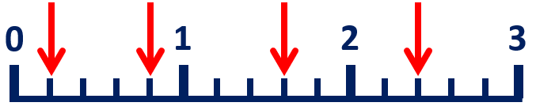
4.25
3.5
2.25
0.5

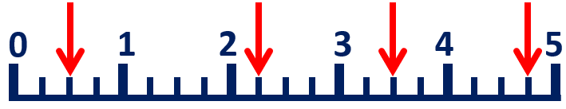
7.5
9.5
6
2

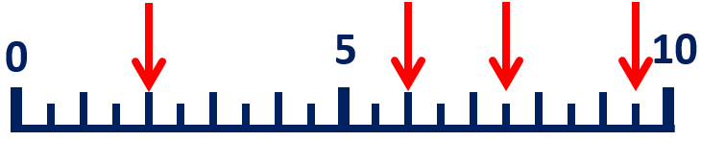
Your Turn
2.6
1.8
1.2
0.4

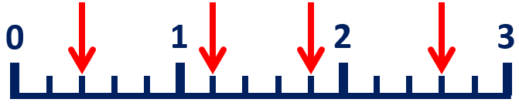
0.25
4.25
2.75
1.5

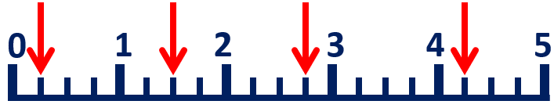
7.5
5.5
3
0.5

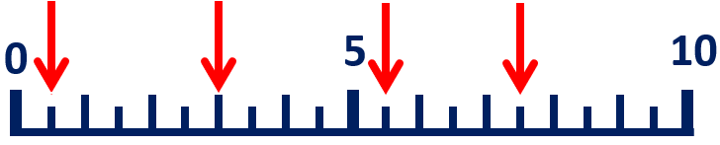

4 Recognise tenths, hundredths and thousandths
Let’s Learn
Look at this number: 294.35  Write the digit in the  9  tens place.  Write the digit in the  3  tenths place.  Write the  0.05  value of the digit 5. | Look at this number: 813.465  Write the digit in the  3  hundredths place.  Write the digit in the  8  hundreds place.  Write the  0.005  value of the digit 5.
Your Turn
Look at this number: 394.512  Write the digit in the  4  ones place.  Write the digit in the  2  thousandths place.  Write the  90  value of the digit 9. | Look at this number: 1432.587  Write the digit in the  5  tenths place.  Write the digit in the  1  thousands place.  Write the  0.08  value of the digit 8.

5 Convert decimal tenths, hundredths and thousandths to fractions
Let’s Learn
Write these decimals as fractions.
0.9 = $\frac{9}{10}$ | 0.09 = $\frac{9}{100}$ | 0.009 = $\frac{9}{1000}$ | 0.89 = $\frac{89}{100}$ | 0.089 = $\frac{89}{1000}$ | 0.389 = $\frac{389}{1000}$
Your Turn
Write these decimals as fractions.
0.7 = $\frac{7}{10}$ | 0.07 = $\frac{7}{100}$ | 0.007 = $\frac{7}{1000}$ | 0.45 = $\frac{45}{100}$ | 0.045 = $\frac{45}{1000}$ | 0.456 = $\frac{456}{1000}$

6 Convert fractional tenths, hundredths and thousandths to decimals
Let’s Learn
Write these fractions as decimals.
$\frac{3}{10}$ = 0.3 | $\frac{3}{100}$ = 0.03 | $\frac{3}{1000}$ = 0.003 | $\frac{54}{100}$ = 0.54 | $\frac{54}{1000}$ = 0.054 | $\frac{543}{1000}$ = 0.543
Your Turn
Write these fractions as decimals.
$\frac{4}{10}$ = 0.4 | $\frac{4}{100}$ = 0.04 | $\frac{4}{1000}$ = 0.004 | $\frac{76}{100}$ = 0.76 | $\frac{76}{1000}$ = 0.076 | $\frac{176}{1000}$ = 0.176

7 Recognise equivalent fractions with tenths, hundredths and thousandths
Let’s Learn
Write the equivalent number of tenths and hundredths and in decimal form.
0.7  7  70  $\frac{700}{1000}$ = $\frac{}{100}$ = $\frac{}{10}$ = | 0.07  7  $\frac{70}{1000}$ = $\frac{}{100}$ =
Your Turn
Write the equivalent number of tenths and hundredths and in decimal form.
0.3  3  30  $\frac{300}{1000}$ = $\frac{}{100}$ = $\frac{}{10}$ = | 0.03  3  $\frac{30}{1000}$ = $\frac{}{100}$ =

8 Partition numbers with up to three decimal places
Let’s Learn
Partition each decimal into tenths, hundredths and thousandths.
0.158 = 0.1 + 0.05 + 0.008 or $\frac{1}{10}$ + $\frac{5}{100}$ + $\frac{8}{1000}$ | 0.629 = 0.6 + 0.02 + 0.009 or $\frac{6}{10}$ + $\frac{2}{100}$ + $\frac{9}{1000}$
Your Turn
Partition each decimal into tenths, hundredths and thousandths.
0.629 = 0.6 + 0.02 + 0.009 or $\frac{6}{10}$ + $\frac{2}{100}$ + $\frac{9}{1000}$ | 0.801 = 0.8 + 0.001 or $\frac{8}{10}$ + $\frac{1}{1000}$

9 Convert decimals to mixed numbers
Let’s Learn
Write these decimals as mixed numbers.
5.4 = 5$\frac{4}{10}$ | 5.04 = 5$\frac{4}{100}$ | 5.004 = 5$\frac{9}{1000}$
6.24 = 6$\frac{24}{100}$ | 7.024 = 7$\frac{24}{1000}$ | 7.124 = 7$\frac{124}{1000}$
Your Turn
Write these decimals as mixed numbers.
2.2 = 2$\frac{2}{10}$ | 2.02 = 2$\frac{2}{100}$ | 2.002 = 2$\frac{2}{1000}$
5.55 = 5$\frac{55}{100}$ | 5.055 = 5$\frac{55}{1000}$ | 5.555 = 5$\frac{555}{1000}$

10 Convert mixed numbers to decimals
Let’s Learn
Write these mixed numbers as decimals.
1$\frac{2}{10}$ = 1.2 | 1$\frac{2}{100}$ = 1.02 | 1$\frac{2}{1000}$ = 1.002
4$\frac{32}{100}$ = 4.32 | 5$\frac{32}{1000}$ = 5.032 | 6$\frac{321}{1000}$ = 6.321
Your Turn
Write these mixed numbers as decimals.
1$\frac{5}{10}$ = 1.5 | 1$\frac{5}{100}$ = 1.05 | 1$\frac{5}{1000}$ = 1.005
4$\frac{30}{100}$ = 4.3 | 4$\frac{30}{1000}$ = 4.03 | 4$\frac{300}{1000}$ = 4.3

11 Understand zeros as placeholders in decimals
Let’s Learn
Write each number.
3 tens and 3 hundredths = 30.03 | 3 thousands, 3 tens,  3 tenths and 3 thousandths = 3030.303
Your Turn
Write each number.
4 tens and 4 hundredths = 40.04 | 4 thousands, 4 tens,  4 tenths and 4 thousandths = 4040.404

12 Count on in thousandths
Let’s Learn
For the questions below, write the next seven numbers, counting in thousandths.
0.623, 0.624, 0.625,
0.626
0.627
0.628
0.632
0.631
0.63
0.629

0.795, 0.796, 0.797,
0.798
0.799
0.8
0.804
0.803
0.802
0.801

2.593, 2.594, 2.595,
2.596
2.597
2.598
2.602
2.601
2.6
2.599

1.995, 1.996, 1.997,
1.998
1.999
2
2.004
2.003
2.002
2.001

Your Turn
For the questions below, write the next seven numbers, counting in thousandths.
0.504, 0.505, 0.506,
0.507
0.508
0.509
0.513
0.512
0.511
0.51

0.893, 0.894, 0.895,
0.896
0.897
0.898
0.902
0.901
0.9
0.899

1.293, 1.294, 1.295,
1.296
1.297
1.298
1.302
1.301
1.3
1.299

0.995, 0.996, 0.997,
0.998
0.999
1
1.004
1.003
1.002
1.001

13 Count back in thousandths
Let’s Learn
For the questions below, write the next seven numbers, counting in thousandths.
0.537, 0.536, 0.535,
0.534
0.533
0.532
0.528
0.529
0.53
0.531

0.905, 0.904, 0.903,
0.902
0.901
0.9
0.896
0.897
0.898
0.899

3.507, 3.506, 3.505,
3.504
0.503
0.502
0.498
0.499
0.5
0.501

1.005, 1.004, 1.003,
1.002
1.001
1
0.996
0.997
0.998
0.999

Your Turn
For the questions below, write the next seven numbers, counting in thousandths.
0.616, 0.615, 0.614,
0.613
0.612
0.611
0.607
0.608
0.609
0.61

0.107, 0.106, 0.105,
0.104
0.103
0.102
0.008
0.009
0.1
0.101

1.627, 1.626, 1.625,
1.624
1.623
1.622
1.618
1.619
1.62
1.621

3.004, 3.003, 3.002,
3.001
3
2.999
2.995
2.996
2.997
2.998

14 Locate thousandths on a number line
Let’s Learn
0.438
0.435
0.431
0.423

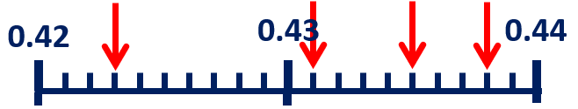
1.009
1.004
1.001
0.994

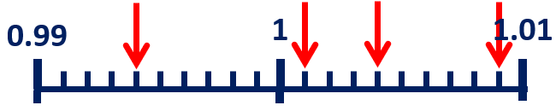
2.119
2.113
2.109
2.103

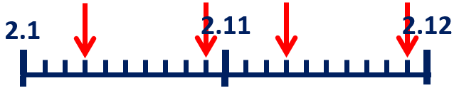
Your Turn
0.529
0.523
0.519
0.512

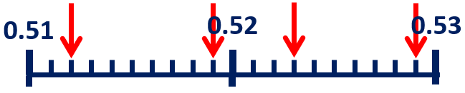
1.017
1.014
1.009
1.004

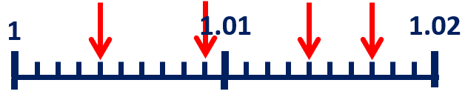
1.108
1.102
1.098
1.092

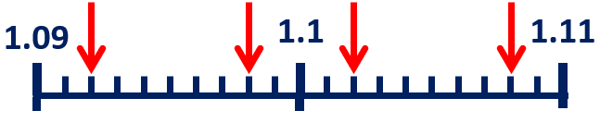

15 Compare numbers with up to three decimal places
Let’s Learn
Write > or < in each box.
>  5.298 5.289 | >  34.2 30.993 | <  1.405 1.44 | >  2.9 2.099
Your Turn
Write > or < in each box.
>  0.362 0.236 | <  1.292 30.9 | <  0.605 0.65 | <  3.099 3.8

16 Order decimals
Let’s Learn
Order each set of numbers from smallest to largest.
0.34 0.3 0.403 0.344 0.43
0.3
0.344
0.43
0.403
0.34

4 3.94 4.03 4.004 3.499
3.499
4.004
4.03
4
3.94

Your Turn
Order each set of numbers from smallest to largest.
0.5 0.505 0.055 0.05 0.55
0.05
0.5
0.55
0.505
0.055

4.4 4.34 4.034 4.04 4.434
4.034
4.4
4.434
4.34
4.04

17 Add numbers with up to three decimal places
Let’s Learn
5.87 + 3.123 = 8.993 | 19.36 + 35.816 = 55.176 | 5.871 + 3.2 = 9.071
Your Turn
3.8 + 2.155 = 5.995 | 17.765 + 13.44 = 31.205 | 7.709 + 0.7 = 8.409

18 Subtract numbers with up to three decimal places
Let’s Learn
37.8 – 14.671 = 23.129 | 36.909 – 20.67 = 16.239 | 6 – 5.738 = 0.262
Your Turn
45.9 – 13.363 = 32.537 | 25.159 – 10.9 = 14.259 | 7 – 6.519 = 0.481

19 Make decimal number bonds to 1
Let’s Learn
0.706  0.294 + = 1 | 0.462  0.538 + = 1
Your Turn
0.109  0.891 + = 1 | 0.723  0.277 + = 1

20 Solve missing number decimal addition and subtraction problems
Let’s Learn
38.953  = 29.5 + 9.453 | 12.426  + 2.704 = 14.5
4.902  – 1.082 = 3.82 | 0.062  4.04 – = 3.978
Your Turn
22.466  = 13.76 + 8.706 | 26.099  + 2.601 = 28.7
6.155  – 1.055 = 5.1 | 2.095  6.045 – = 3.95

21 Round decimals to the nearest whole number
Let’s Learn
Round the numbers below to the nearest whole number.
2.3 ≈ 2 | 3.9 ≈ 4 | 7.08 ≈ 7 | 5.544 ≈ 6
Your Turn
Round the numbers below to the nearest whole number.
4.1 ≈ 4 | 0.6 ≈ 1 | 4.72 ≈ 5 | 6.155 ≈ 6

22 Round decimals to the nearest tenth
Let’s Learn
Round the numbers below to the nearest tenth.
2.36 ≈ 2.4 | 2.63 ≈ 2.6 | 4.808 ≈ 4.8 | 6.464 ≈ 6.5
Your Turn
Round the numbers below to the nearest tenth.
4.45 ≈ 4.5 | 4.54 ≈ 4.5 | 2.362 ≈ 2.4 | 5.088 ≈ 5.1

23 Round decimals to the nearest hundredth
Let’s Learn
Round the numbers below to the nearest hundredth.
0.381 ≈ 0.38 | 1.405 ≈ 1.41 | 5.598 ≈ 5.6 | 6.107 ≈ 6.11
Your Turn
Round the numbers below to the nearest hundredth.
0.737 ≈ 0.74 | 2.508 ≈ 2.51 | 5.704 ≈ 5.7 | 6.183 ≈ 6.18

24 Divide decimals by 10, 100 and 1000
Let’s Learn
0.68 ÷ 10 = 0.068 | 80.08 ÷ 10 = 8.008 | 0.7 ÷ 100 = 0.007
2.06 ÷ 100 = 0.0206 | 34.1 ÷ 1000 = 0.0341 | 146.1 ÷ 1000 = 0.1461
Your Turn
0.6 ÷ 10 = 0.06 | 50.5 ÷ 10 = 5.05 | 9.7 ÷ 100 = 0.097
65 ÷ 100 = 0.65 | 43 ÷ 1000 = 0.043 | 22.1 ÷ 1000 = 0.0221

25 Multiply decimals by 10, 100 and 1000
Let’s Learn
40.01 x 10 = 400.1 | 6.1 x 10 = 61 | 36.21 x 100 = 3621
0.6 x 100 = 60 | 5.8 x 1000 = 5800 | 7.05 x 1000 = 7050
Your Turn
22.02 x 10 = 220.2 | 0.61 x 10 = 6.1 | 28.28 x 100 = 2828
0.4 x 100 = 40 | 3.5 x 1000 = 3500 | 6.052 x 1000 = 6052

