1 Write unit fractions as decimals
Let’s Learn
Write each fraction as a decimal
$\frac{1}{2}$= | $\frac{1}{4}$= | $\frac{1}{5}$= | $\frac{1}{50}$=

2 Write non-unit fractions as decimals
Let’s Learn
Write each fraction as a decimal
$\frac{3}{5}$= | $\frac{3}{4}$= | $\frac{4}{25}$= | $\frac{12}{50}$=
Your Turn
Write each fraction as a decimal
$\frac{4}{5}$= | $\frac{2}{4}$= | $\frac{7}{25}$= | $\frac{9}{50}$=

3 Locate decimals on fractional number lines
Let’s Learn
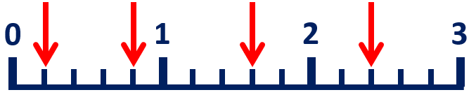
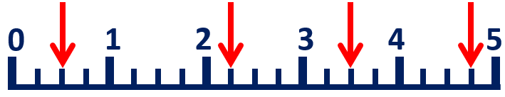
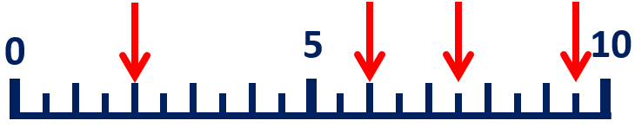
Your Turn
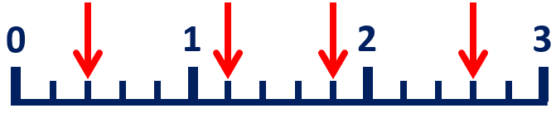
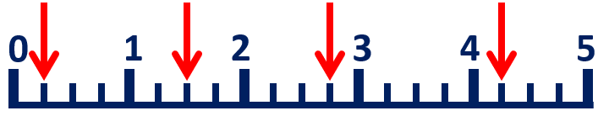
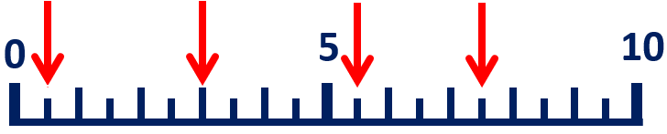

4 Recognise tenths, hundredths and thousandths
Let’s Learn
Look at this number: 294.35  Write the digit in the  tens place.  Write the digit in the  tenths place.  Write the  value of the digit 5. | Look at this number: 813.465  Write the digit in the  hundredths place.  Write the digit in the  hundreds place.  Write the  value of the digit 5.
Your Turn
Look at this number: 394.512  Write the digit in the  ones place.  Write the digit in the  thousandths place.  Write the  value of the digit 9. | Look at this number: 1432.587  Write the digit in the  tenths place.  Write the digit in the  thousands place.  Write the  value of the digit 8.

5 Convert decimal tenths, hundredths and thousandths to fractions
Let’s Learn
Write these decimals as fractions.
0.9 = | 0.09 = | 0.009 = | 0.89 = | 0.089 = | 0.389 =
Your Turn
Write these decimals as fractions.
0.7 = | 0.07 = | 0.007 = | 0.45 = | 0.045 = | 0.456 =

6 Convert fractional tenths, hundredths and thousandths to decimals
Let’s Learn
Write these fractions as decimals.
$\frac{3}{10}$ = | $\frac{3}{100}$ = | $\frac{3}{1000}$ = | $\frac{54}{100}$ = | $\frac{54}{1000}$ = | $\frac{543}{1000}$ =
Your Turn
Write these fractions as decimals.
$\frac{4}{10}$ = | $\frac{4}{100}$ = | $\frac{4}{1000}$ = | $\frac{76}{100}$ = | $\frac{76}{1000}$ = | $\frac{176}{1000}$ =

7 Recognise equivalent fractions with tenths, hundredths and thousandths
Let’s Learn
Write the equivalent number of tenths and hundredths and in decimal form.
$\frac{700}{1000}$ = $\frac{}{100}$ = $\frac{}{10}$ = | $\frac{70}{1000}$ = $\frac{}{100}$ =
Your Turn
Write the equivalent number of tenths and hundredths and in decimal form.
$\frac{300}{1000}$ = $\frac{}{100}$ = $\frac{}{10}$ = | $\frac{30}{1000}$ = $\frac{}{100}$ =

8 Partition numbers with up to three decimal places
Let’s Learn
Partition each decimal into tenths, hundredths and thousandths.
0.158 = | 0.629 =
Your Turn
Partition each decimal into tenths, hundredths and thousandths.
0.629 = | 0.801 =

9 Convert decimals to mixed numbers
Let’s Learn
Write these decimals as mixed numbers.
5.4 = | 5.04 = | 5.004 =
6.24 = | 7.024 = | 7.124 =
Your Turn
Write these decimals as mixed numbers.
2.2 = | 2.02 = | 2.002 =
5.55 = | 5.055 = | 5.555 =

10 Convert mixed numbers to decimals
Let’s Learn
Write these mixed numbers as decimals.
1$\frac{2}{10}$ = | 1$\frac{2}{100}$ = | 1$\frac{2}{1000}$ =
4$\frac{32}{100}$ = | 5$\frac{32}{1000}$ = | 6$\frac{321}{1000}$ =
Your Turn
Write these mixed numbers as decimals.
1$\frac{5}{10}$ = | 1$\frac{5}{100}$ = | 1$\frac{5}{1000}$ =
4$\frac{30}{100}$ = | 4$\frac{30}{1000}$ = | 4$\frac{300}{1000}$ =

11 Understand zeros as placeholders in decimals
Let’s Learn
Write each number.
3 tens and 3 hundredths = | 3 thousands, 3 tens,  3 tenths and 3 thousandths =
Your Turn
Write each number.
4 tens and 4 hundredths = | 4 thousands, 4 tens,  4 tenths and 4 thousandths =

12 Count on in thousandths
Let’s Learn
For the questions below, write the next seven numbers, counting in thousandths.
0.623, 0.624, 0.625,

0.795, 0.796, 0.797,

2.593, 2.594, 2.595,

1.995, 1.996, 1.997,

Your Turn
For the questions below, write the next seven numbers, counting in thousandths.
0.504, 0.505, 0.506,

0.893, 0.894, 0.895,

1.293, 1.294, 1.295,

0.995, 0.996, 0.997,

13 Count back in thousandths
Let’s Learn
For the questions below, write the next seven numbers, counting in thousandths.
0.537, 0.536, 0.535,

0.905, 0.904, 0.903,

3.507, 3.506, 3.505,

1.005, 1.004, 1.003,

Your Turn
For the questions below, write the next seven numbers, counting in thousandths.
0.616, 0.615, 0.614,

0.107, 0.106, 0.105,

1.627, 1.626, 1.625,

3.004, 3.003, 3.002,

14 Locate thousandths on a number line
Let’s Learn
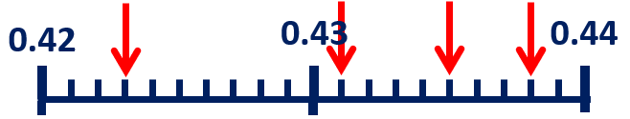
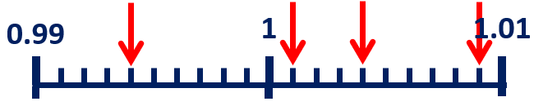
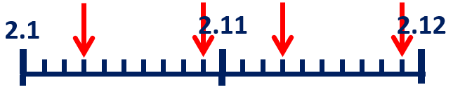
Your Turn
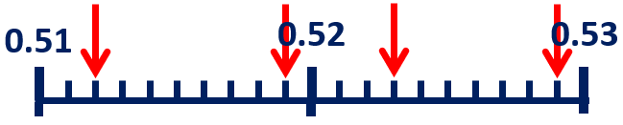
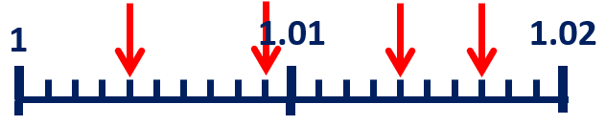
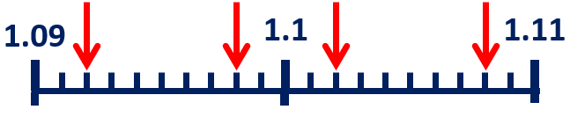

15 Compare numbers with up to three decimal places
Let’s Learn
Write > or < in each box.
5.298 5.289 | 34.2 30.993 | 1.405 1.44 | 2.9 2.099
Your Turn
Write > or < in each box.
0.362 0.236 | 1.292 30.9 | 0.605 0.65 | 3.099 3.8

16 Order decimals
Let’s Learn
Order each set of numbers from smallest to largest.
0.34 0.3 0.403 0.344 0.43

4 3.94 4.03 4.004 3.499

Your Turn
Order each set of numbers from smallest to largest.
0.5 0.505 0.055 0.05 0.55

4.4 4.34 4.034 4.04 4.434

17 Add numbers with up to three decimal places
Let’s Learn
5.87 + 3.123 = | 19.36 + 35.816 = | 5.871 + 3.2 =
Your Turn
3.8 + 2.155 = | 17.765 + 13.44 = | 7.709 + 0.7 =

18 Subtract numbers with up to three decimal places
Let’s Learn
37.8 – 14.671 = | 36.909 – 20.67 = | 6 – 5.738 =
Your Turn
45.9 – 13.363 = | 25.159 – 10.9 = | 7 – 6.519 =

19 Make decimal number bonds to 1
Let’s Learn
0.294 + = 1 | 0.538 + = 1
Your Turn
0.891 + = 1 | 0.277 + = 1

20 Solve missing number decimal addition and subtraction problems
Let’s Learn
= 29.5 + 9.453 | + 2.704 = 14.5
– 1.082 = 3.82 | 4.04 – = 3.978
Your Turn
= 13.76 + 8.706 | + 2.601 = 28.7
– 1.055 = 5.1 | 6.045 – = 3.95

21 Round decimals to the nearest whole number
Let’s Learn
Round the numbers below to the nearest whole number.
2.3 ≈ | 3.9 ≈ | 7.08 ≈ | 5.544 ≈
Your Turn
Round the numbers below to the nearest whole number.
4.1 ≈ | 0.6 ≈ | 4.72 ≈ | 6.155 ≈

22 Round decimals to the nearest tenth
Let’s Learn
Round the numbers below to the nearest tenth.
2.36 ≈ | 2.63 ≈ | 4.808 ≈ | 6.464 ≈
Your Turn
Round the numbers below to the nearest tenth.
4.45 ≈ | 4.54 ≈ | 2.362 ≈ | 5.088 ≈

23 Round decimals to the nearest hundredth
Let’s Learn
Round the numbers below to the nearest hundredth.
0.381 ≈ | 1.405 ≈ | 5.598 ≈ | 6.107 ≈
Your Turn
Round the numbers below to the nearest hundredth.
0.737 ≈ | 2.508 ≈ | 5.704 ≈ | 6.183 ≈

24 Divide decimals by 10, 100 and 1000
Let’s Learn
0.68 ÷ 10 = | 80.08 ÷ 10 = | 0.7 ÷ 100 =
2.06 ÷ 100 = | 34.1 ÷ 1000 = | 146.1 ÷ 1000 =
Your Turn
0.6 ÷ 10 = | 50.5 ÷ 10 = | 9.7 ÷ 100 =
65 ÷ 100 = | 43 ÷ 1000 = | 22.1 ÷ 1000 =

25 Multiply decimals by 10, 100 and 1000
Let’s Learn
40.01 x 10 = | 6.1 x 10 = | 36.21 x 100 =
0.6 x 100 = | 5.8 x 1000 = | 7.05 x 1000 =
Your Turn
22.02 x 10 = | 0.61 x 10 = | 28.28 x 100 =
0.4 x 100 = | 3.5 x 1000 = | 6.052 x 1000 =

