1 Multiply 2, 3, 4 or 5-digit numbers by 10
Let’s Learn
28 x 10 = | 509 x 10 = | 86054 x 10 =
Your Turn
33 x 10 = | 580 x 10 = | 83854 x 10 =

2 Multiply 2, 3 or 4 digit numbers by 100
Let’s Learn
63 x 100 = | 700 x 100 = | 5008 x 100 =
Your Turn
54 x 100 = | 606 x 100 = | 4030 x 100 =

3 Multiply 2 or 3 digit numbers by 1000
Let’s Learn
6 x 1000 = | 79 x 1000 = | 201 x 1000 =
Your Turn
9 x 1000 = | 80 x 1000 = | 421 x 1000 =

4 Solve missing number problems for multiplying by 10, 100 or 1000
Let’s Learn
30 x = 30000 | 78 x = 7800 | 2050 x = 20500
Your Turn
50 x = 5000 | 446 x = 446000 | 250 x = 2500

5 Multiply a single-digit number by a multiple of 1000
Let’s Learn
3 x 2000 = | 6000 x 5 = | 7 x 7000 =
Your Turn
2 x 3000 = | 5000 x 9 = | 8 x 8000 =

6 Multiply by a four-digit number using the grid method
Let’s Learn
Answer the questions below using the grid method.
5 x 5289 = | 3 x 7441 =
Your Turn
Answer the questions below using the grid method.
4 x 4769 = | 8 x 4761 =

7 Multiply by a four-digit number using a written method
Let’s Learn
Answer the questions below using the column method.
3084 x 3 = | 3516 x 5 = | 9 x 1515 =
Your Turn
Answer the questions below using the column method.
2086 x 4 = | 5314 x 6 = | 7 x 1716 =

8 Multiply two multiples of 10
Let’s Learn
70 x 60 = | 50 x 80 = | 90 x 90 =
Your Turn
60 x 60 = | 40 x 90 = | 80 x 50 =

9 Multiply two two-digit numbers using the grid method
Let’s Learn
Answer the questions below using the grid method.
66 x 53 = | 73 x 45 =
Your Turn
Answer the questions below using the grid method.
58 x 47 = | 85 x 33 =

10 Multiply two two-digit numbers using long multiplication
Let’s Learn
Answer the questions below using the column method.
71 x 46 = | 81 x 37 = | 54 x 23 = | 53 x 56 =
Your Turn
Answer the questions below using the column method.
61 x 51 = | 73 x 27 = | 73 x 25 = | 44 x 58 =

11 Multiply a multiple of 100 by a multiple of 10
Let’s Learn
700 x 60 = | 500 x 80 = | 900 x 90 =
Your Turn
800 x 60 = | 500 x 20 = | 800 x 80 =

12 Multiply a three-digit number by a two-digit number using the grid method
Let’s Learn
Answer the questions below using the grid method.
56 x 234 = | 94 x 517 =
Your Turn
Answer the questions below using the grid method.
65 x 229 = | 93 x 428 =

13 Multiply a three-digit number by a two-digit number using long multiplication
Let’s Learn
Answer the questions below using the column method.
694 x 34 = | 785 x 23 = | 678 x 54 =
Your Turn
Answer the questions below using the column method.
418 x 46 = | 836 x 27 = | 569 x 63 =

14 Multiply a four-digit number by a two-digit number using long multiplication
Let’s Learn
3862 x 34 = | 4781 x 23 = | 5967 x 61 =
Your Turn
3468 x 62 = | 5413 x 86 = | 7312 x 97 =

15 Solve multiplication problems with missing digits
Let’s Learn
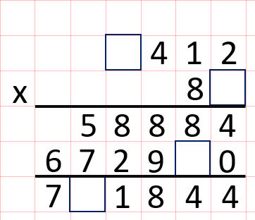 | 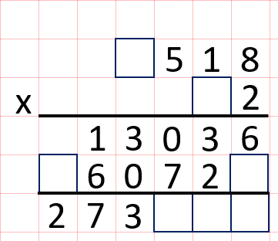 | 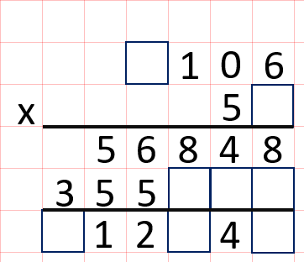
Your Turn
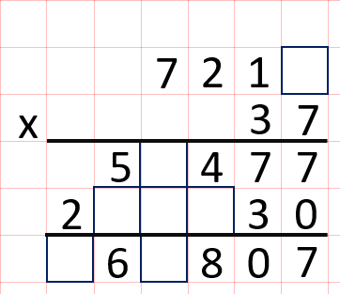 | 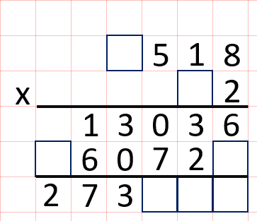 | 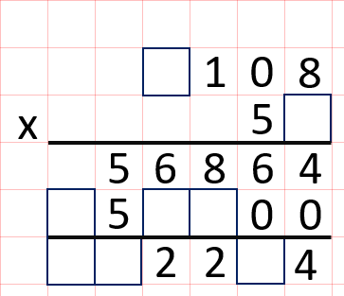

16 Multiply two multiples of 100
Let’s Learn
800 x 600 = | 500 x 900 = | 700 x 700 =
Your Turn
900 x 300 = | 500 x 400 = | 900 x 900 =

