1 Connect fractions, decimals and percentages
Let’s Learn
Write each representation as a fraction, a decimal and a percentage.
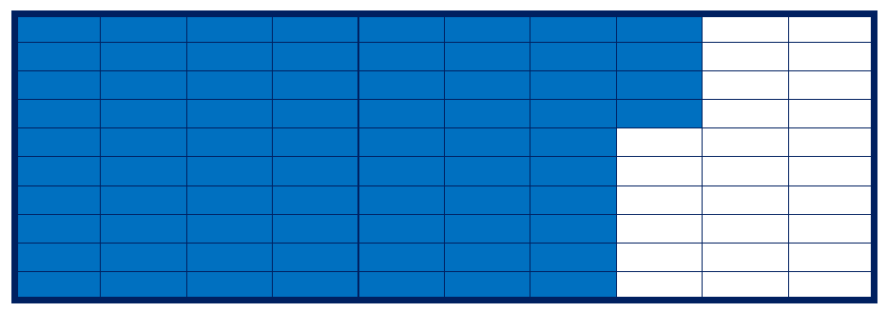$\frac{74}{100}$, 0.74, 74%
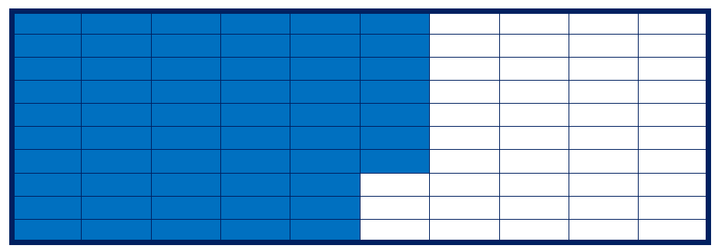$\frac{57}{100}$, 0.57, 57%
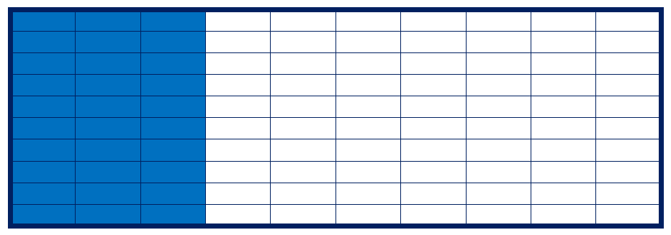$\frac{30}{100}$ or $\frac{3}{10}$, 0.3, 30%

2 Convert unit fractions to percentages
Let’s Learn
Write each fraction as a percentage.
$\frac{1}{2}$ = 50% | $\frac{1}{4}$ = 25% | $\frac{1}{5}$ = 20%

3 Convert fractions to percentages
Let’s Learn
Write each fraction as a percentage.
$\frac{9}{10}$ = 90% | $\frac{3}{5}$ = 60% | $\frac{17}{20}$ = 85%
Your Turn
Write each fraction as a percentage.
$\frac{7}{10}$ = 70% | $\frac{3}{4}$ = 75% | $\frac{17}{25}$ = 68%

4 Write percentages as simplified fractions
Let’s Learn
Write each percentage as a simplified fraction.
30% = $\frac{3}{10}$ | 2% = $\frac{1}{50}$ | 40% = $\frac{2}{5}$
Your Turn
Write each percentage as a simplified fraction.
10% = $\frac{1}{10}$ | 4% = $\frac{1}{25}$ | 75% = $\frac{3}{4}$

5 Convert decimals to percentages
Let’s Learn
Write each decimal as a percentage.
0.03 = 3% | 0.4 = 40% | 0.23 = 23%
Your Turn
Write each decimal as a percentage.
0.05 = 5% | 0.3 = 30% | 0.65 = 65%

