1 Connect fractions, decimals and percentages
Let’s Learn
Write each representation as a fraction, a decimal and a percentage.
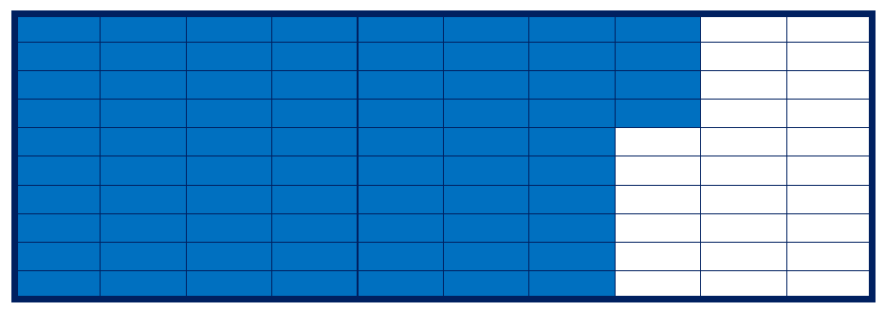



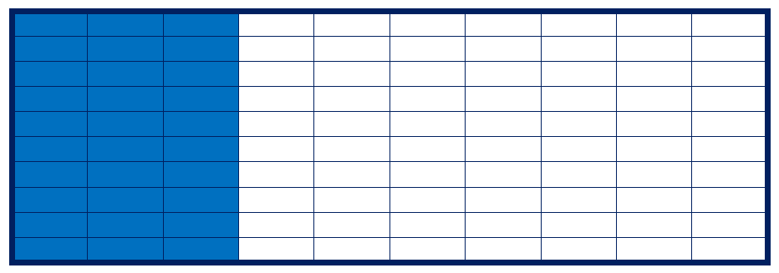

2 Convert unit fractions to percentages
Let’s Learn
Write each fraction as a percentage.
$\frac{1}{2}$ = | $\frac{1}{4}$ = | $\frac{1}{5}$ =

3 Convert fractions to percentages
Let’s Learn
Write each fraction as a percentage.
$\frac{9}{10}$ = | $\frac{3}{5}$ = | $\frac{17}{20}$ =
Your Turn
Write each fraction as a percentage.
$\frac{7}{10}$ = | $\frac{3}{4}$ = | $\frac{17}{25}$ =

4 Write percentages as simplified fractions
Let’s Learn
Write each percentage as a simplified fraction.
30% = | 2% = | 40% =
Your Turn
Write each percentage as a simplified fraction.
10% = | 4% = | 75% =

5 Convert decimals to percentages
Let’s Learn
Write each decimal as a percentage.
0.03 = | 0.4 = | 0.23 =
Your Turn
Write each decimal as a percentage.
0.05 = | 0.3 = | 0.65 =

