1 Write numbers up to 10 million in digits
Let’s Learn
Write the numbers below in digits.
Seven million, two hundred and three thousand and twenty-seven  7 203 027 | Eight million, two hundred thousand, three hundred  8 200 300
Five million, two thousand, five hundred  5 002 500 | Two million, two hundred and two thousand and two  2 202 002
Your Turn
Write the numbers below in digits.
Four million, seven hundred and twenty thousand and twenty  4 720 020 | Four million, fifty thousand and eighty  4 050 080
Five million, three thousand and five  5 003 005 | Three million, two hundred thousand and twelve  2 200 012

2 Write numbers up to 10 million in words
Let’s Learn
Write the numbers below in words.
9,291,536 Nine million, two hundred and ninety-one thousand, five hundred and thirty-six

4,590,000 Four million, five hundred and ninety thousand

6,070,040 Six million, seventy thousand and forty

4,000,800 Four million, eight hundred

Your Turn
Write the numbers below in words.
3,203,567 Three million, two hundred and three thousand, five hundred and sixty-seven

6,210,000 Six million, two hundred and ten thousand

5,050,050 Five million, fifty thousand and fifty

3,000,080 Three million and eighty

3 Identify the digit in each place value for seven-digit numbers
Let’s Learn
For the questions below, write the digit of each place value.
7,451,194  5  1  1  7  Millions:  4  Hundred thousands:  Ten thousands:  Thousands:  Hundreds:  9  Tens:  4  Ones: | 5,709,846  5  9  6  7  Hundred thousands:  4  Tens:  Millions:  Thousands:  Ones:  0  Ten thousands:  8  Hundreds: | 2,043,198  0  3  4  8  Ones:  1  Hundreds:  Hundred thousands:  Thousands:  Ten thousands:  2  Millions:  9  Tens:
Your Turn
For the questions below, write the digit of each place value.
2,447,891  4  7  8  2  Millions:  4  Hundred thousands:  Ten thousands:  Thousands:  Hundreds:  9  Tens:  1  Ones: | 2,896,051  2  6  1  8  Hundred thousands:  5  Tens:  Millions:  Thousands:  Ones:  9  Ten thousands:  0  Hundreds: | 1,471,380  4  1  7  0  Ones:  3  Hundreds:  Hundred thousands:  Thousands:  Ten thousands:  1  Millions:  8  Tens:

4 Identify the value of each digit in seven-digit numbers
Let’s Learn
For the questions below, write the value of each digit.
4,052,160  4 000 000  4 represents:  50 000  5 represents:  2 000  2 represents:  100  1 represents:  60  6 represents: | 8,504,297  200  2 represents:  4 000  4 represents:  7  7 represents:  8 000 000  8 represents:  90  9 represents:  500 000  5 represents: | 2,638,041  600 000  6 represents:  8 000  8 represents:  2 000 000  2 represents:  1  1 represents:  40  4 represents:  30 000  3 represents:
Your Turn
For the questions below, write the value of each digit.
7,035,690  7 000 000  7 represents:  30 000  3 represents:  5 000  5 represents:  600  6 represents:  90  9 represents: | 4,802,695  600  6 represents:  2 000  2 represents:  5  5 represents:  4 000 000  4 represents:  90  9 represents:  800 000  8 represents: | 1,279,068  200 000  2 represents:  9 000  9 represents:  1 000 000  1 represents:  8  8 represents:  60  6 represents:  70 000  7 represents:

5 Partition seven-digit numbers
Let’s Learn
Partition the numbers below.
4 000 000
300 000
7 000
40
2
4,307,042 = + + + +

10
3
400
3 000
90 000
6 000 000
100 000
6,193,413 = + + + + + +

7 000 000
400 000
60 000
200
50
3
7,460,253 = + + + + +

Your Turn
Partition the numbers below.
6 000 000
600 000
9 000
10
2
6,609,012 = + + + +

60
3
200
5 000
60 000
5 000 000
200 000
5,265,263 = + + + + + +

7 000 000
200 000
80 000
900
80
9
7,280,989 = + + + + +

6 Order numbers with up to seven digits
Let’s Learn
Order each set of numbers from smallest to largest.
9 600 000, 696 000, 90 000, 6 990 000, 9 660 000
9 660 000
9 600 000
6 990 000
696 000
90 000

77 666, 6 677 666, 7 777, 7 676 666, 7 767 777
7 767 777
7 676 666
6 677 666
77 666
7 777

Your Turn
Order each set of numbers from smallest to largest.
500 000, 54 000, 4 055 000, 4 500 000, 4 504 000
4 504 000
4 500 000
4 055 000
500 000
54 000

9 090, 8 090 000, 9 800 000, 900 000, 8 800 000
9 800 000
8 800 000
8 090 000
900 000
9 090

7 Round to the nearest 10, 100, 1000, 10 000, 100 000 and 1 000 000
Let’s Learn
For the questions below, round each number to the specified degree of accuracy.
7,451,194  Round to the nearest…  7000000  Million:  7500000  Hundred thousand:  7450000  Ten thousand:  7451000  Thousand:  7451200  Hundred:  7451190  Ten: | 3,409,846  Round to the nearest…  3000000  Million:  3400000  Hundred thousand:  3410000  Ten thousand:  3410000  Thousand:  3409800  Hundred:  3409850  Ten: | 2,042,242  Round to the nearest…  2000000  Million:  2000000  Hundred thousand:  2040000  Ten thousand:  2042000  Thousand:  2042200  Hundred:  2042240  Ten:
Your Turn
For the questions below, round each number to the specified degree of accuracy.
6,901,098  Round to the nearest…  7000000  Million:  6900000  Hundred thousand:  6900000  Ten thousand:  6901000  Thousand:  6901100  Hundred:  6901100  Ten: | 1,208,917  Round to the nearest…  1000000  Million:  1200000  Hundred thousand:  1210000  Ten thousand:  1209000  Thousand:  1208900  Hundred:  1298920  Ten: | 3,106,307  Round to the nearest…  3000000  Million:  3100000  Hundred thousand:  3110000  Ten thousand:  3106000  Thousand:  3106300  Hundred:  3106310  Ten:

8 Recognise place value – millionths to thousandths
Let’s Learn
We have a base 10 number system. Explain what this means.
We use 10 digits to make numbers. 10 of one place value is the same as 1 of the place value to the left.

9 Count in powers of 10
Let’s Learn
Complete the missing values by counting in powers of 10.
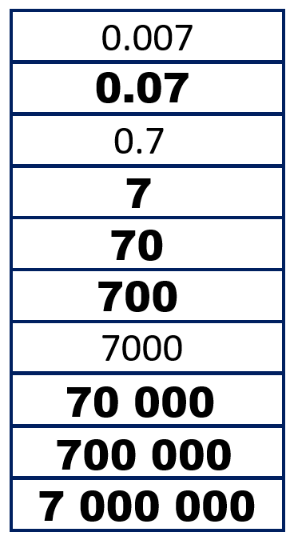 | 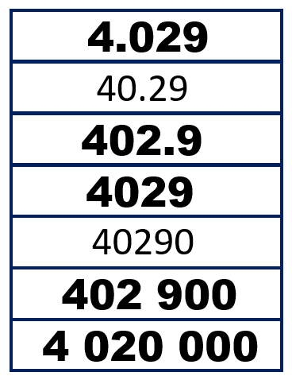 | 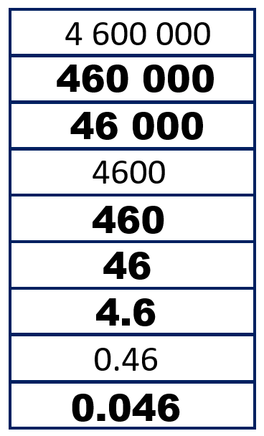
Your Turn
Complete the missing values by counting in powers of 10.
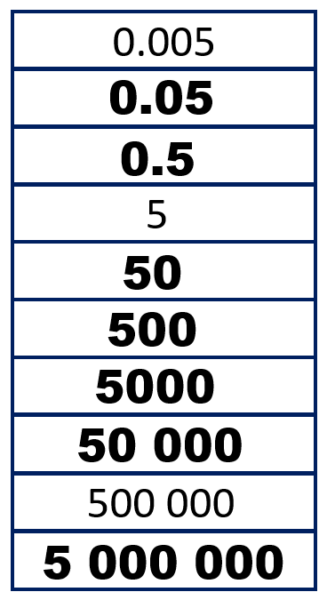 | 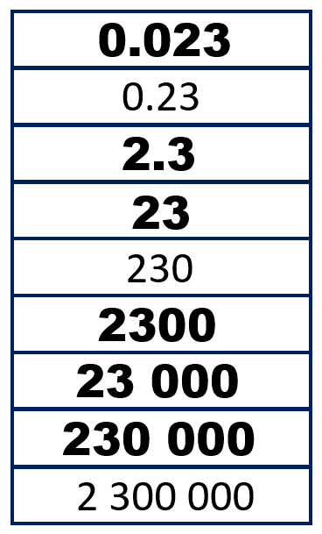 | 