1 Write numbers up to 10 million in digits
Let’s Learn
Write the numbers below in digits.
Seven million, two hundred and three thousand and twenty-seven | Eight million, two hundred thousand, three hundred
Five million, two thousand, five hundred | Two million, two hundred and two thousand and two
Your Turn
Write the numbers below in digits.
Four million, seven hundred and twenty thousand and twenty | Four million, fifty thousand and eighty
Five million, three thousand and five | Three million, two hundred thousand and twelve

2 Write numbers up to 10 million in words
Let’s Learn
Write the numbers below in words.
9,291,536

4,590,000

6,070,040

4,000,800

Your Turn
Write the numbers below in words.
3,203,567

6,210,000

5,050,050

3,000,080

3 Identify the digit in each place value for seven-digit numbers
Let’s Learn
For the questions below, write the digit of each place value.
7,451,194  Millions:  Hundred thousands:  Ten thousands:  Thousands:  Hundreds:  Tens:  Ones: | 5,709,846  Hundred thousands:  Tens:  Millions:  Thousands:  Ones:  Ten thousands:  Hundreds: | 2,043,198  Ones:  Hundreds:  Hundred thousands:  Thousands:  Ten thousands:  Millions:  Tens:
Your Turn
For the questions below, write the digit of each place value.
2,447,891  Millions:  Hundred thousands:  Ten thousands:  Thousands:  Hundreds:  Tens:  Ones: | 2,896,051  Hundred thousands:  Tens:  Millions:  Thousands:  Ones:  Ten thousands:  Hundreds: | 1,471,380  Ones:  Hundreds:  Hundred thousands:  Thousands:  Ten thousands:  Millions:  Tens:

4 Identify the value of each digit in seven-digit numbers
Let’s Learn
For the questions below, write the value of each digit.
4,052,160  4 represents:  5 represents:  2 represents:  1 represents:  6 represents: | 8,504,297  2 represents:  4 represents:  7 represents:  8 represents:  9 represents:  5 represents: | 2,638,041  6 represents:  8 represents:  2 represents:  1 represents:  4 represents:  3 represents:
Your Turn
For the questions below, write the value of each digit.
7,035,690  7 represents:  3 represents:  5 represents:  6 represents:  9 represents: | 4,802,695  6 represents:  2 represents:  5 represents:  4 represents:  9 represents:  8 represents: | 1,279,068  2 represents:  9 represents:  1 represents:  8 represents:  6 represents:  7 represents:

5 Partition seven-digit numbers
Let’s Learn
Partition the numbers below.
4,307,042 = + + + +

6,193,413 = + + + + + +

7,460,253 = + + + + +

Your Turn
Partition the numbers below.
6,609,012 = + + + +

5,265,263 = + + + + + +

7,280,989 = + + + + +

6 Order numbers with up to seven digits
Let’s Learn
Order each set of numbers from smallest to largest.
9 600 000, 696 000, 90 000, 6 990 000, 9 660 000

77 666, 6 677 666, 7 777, 7 676 666, 7 767 777

Your Turn
Order each set of numbers from smallest to largest.
500 000, 54 000, 4 055 000, 4 500 000, 4 504 000

9 090, 8 090 000, 9 800 000, 900 000, 8 800 000

7 Round to the nearest 10, 100, 1000, 10 000, 100 000 and 1 000 000
Let’s Learn
For the questions below, round each number to the specified degree of accuracy.
7,451,194  Round to the nearest…  Million:  Hundred thousand:  Ten thousand:  Thousand:  Hundred:  Ten: | 3,409,846  Round to the nearest…  Million:  Hundred thousand:  Ten thousand:  Thousand:  Hundred:  Ten: | 2,042,242  Round to the nearest…  Million:  Hundred thousand:  Ten thousand:  Thousand:  Hundred:  Ten:
Your Turn
For the questions below, round each number to the specified degree of accuracy.
6,901,098  Round to the nearest…  Million:  Hundred thousand:  Ten thousand:  Thousand:  Hundred:  Ten: | 1,208,917  Round to the nearest…  Million:  Hundred thousand:  Ten thousand:  Thousand:  Hundred:  Ten: | 3,106,307  Round to the nearest…  Million:  Hundred thousand:  Ten thousand:  Thousand:  Hundred:  Ten:

8 Recognise place value – millionths to thousandths
Let’s Learn
We have a base 10 number system. Explain what this means.

9 Count in powers of 10
Let’s Learn
Complete the missing values by counting in powers of 10.
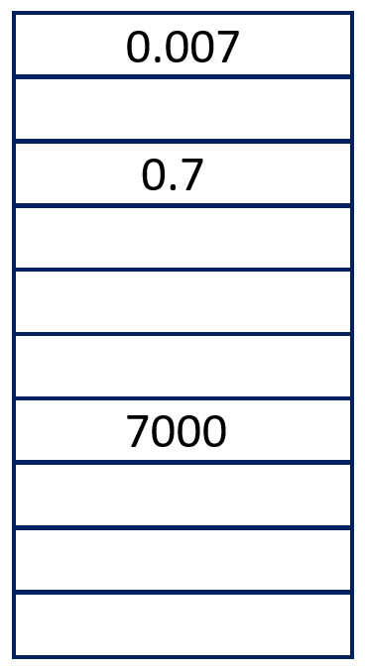 | 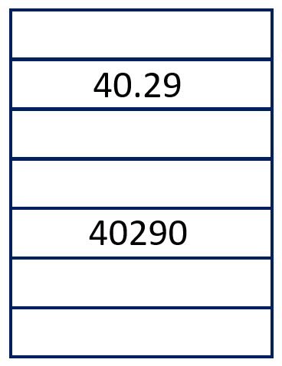 | 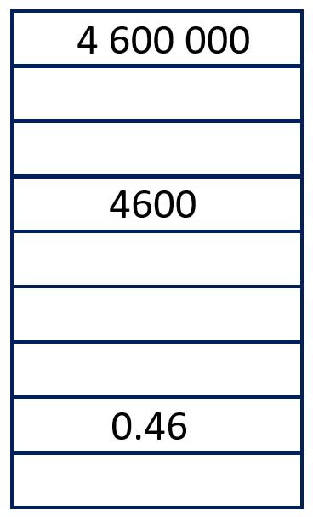
Your Turn
Complete the missing values by counting in powers of 10.
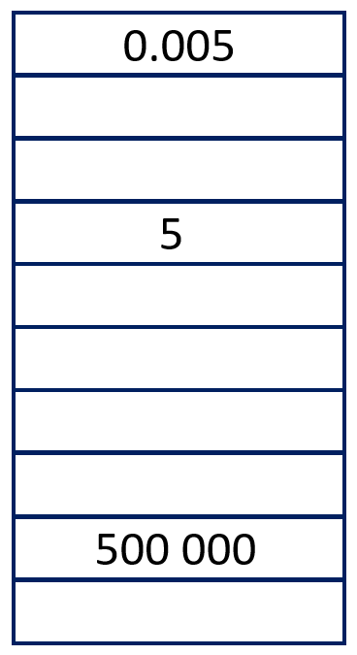 | 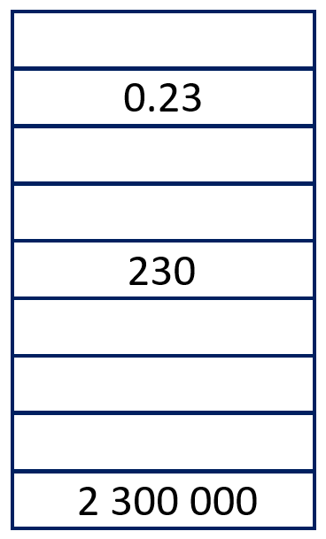 | 