Place Value
Go to https://keystage2maths.com/y3/placevalue/ for help.

1 Recognise representations for numbers to 1000
Let’s Learn
Write the numbers represented by the blocks below.
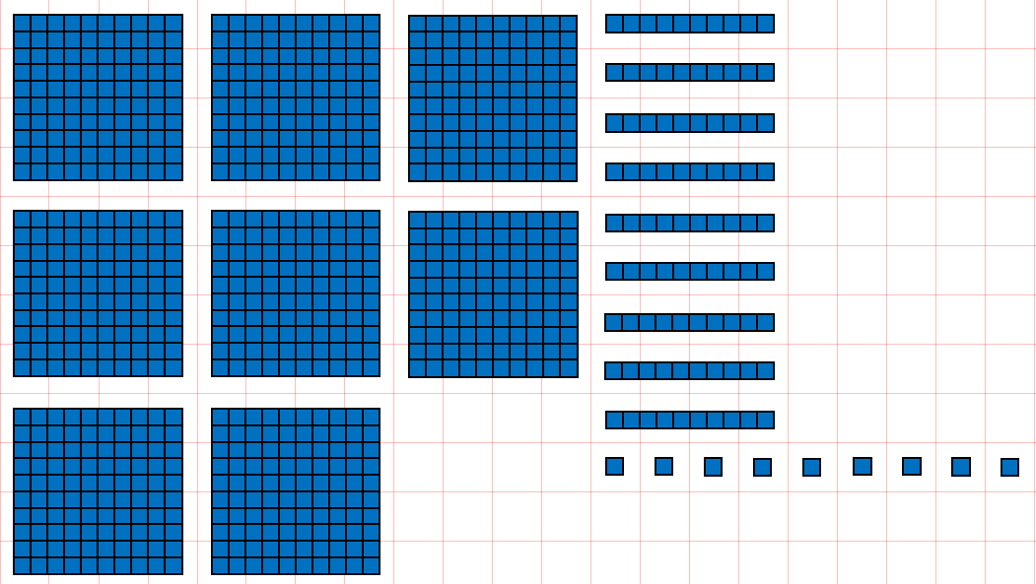  899 | 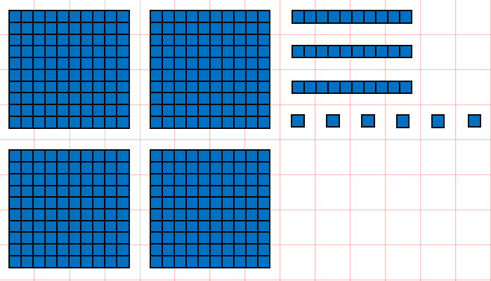  436
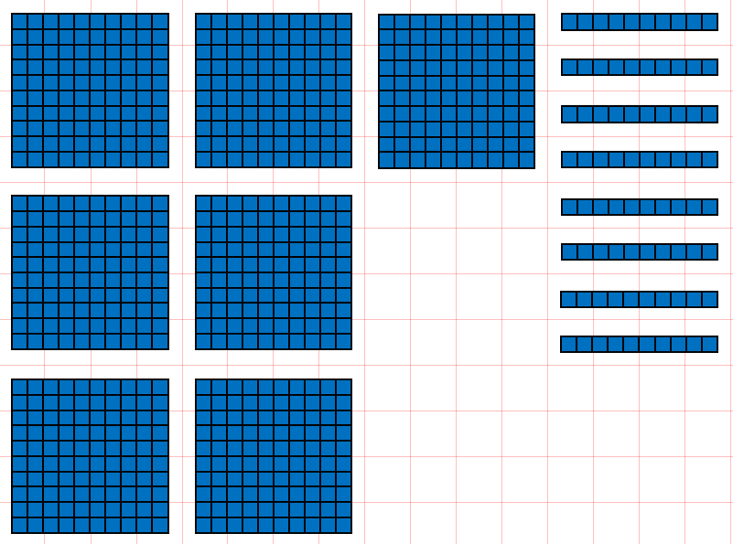  780 | 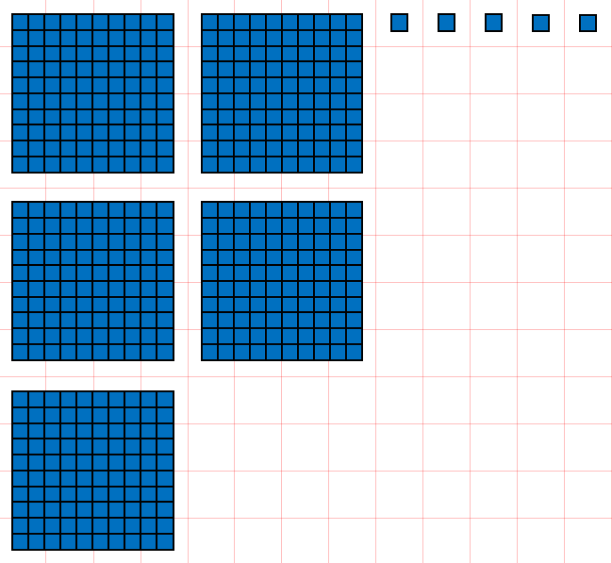  505
Your Turn
Write the numbers represented by the blocks below.
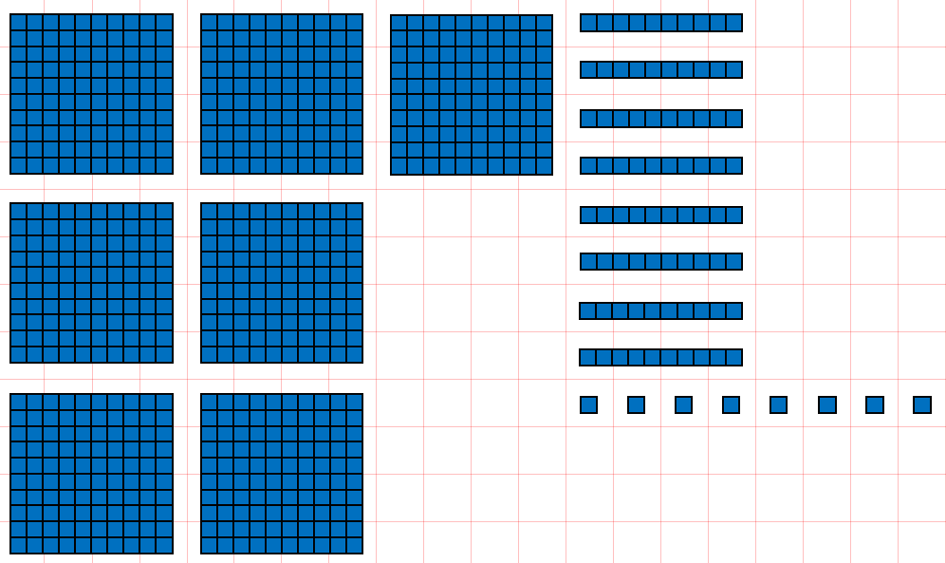  788 | 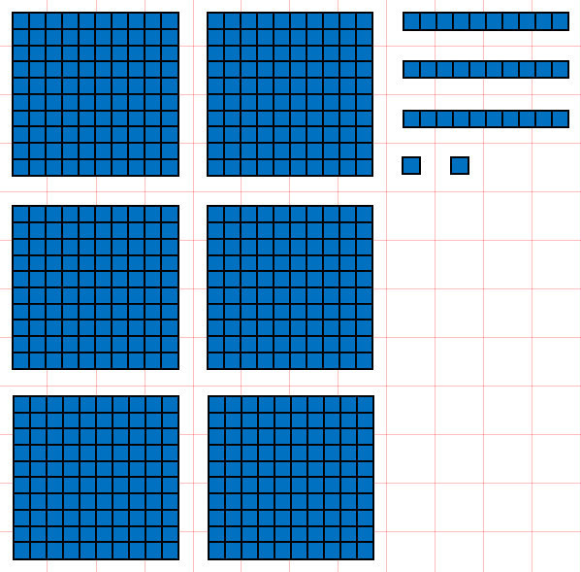  632
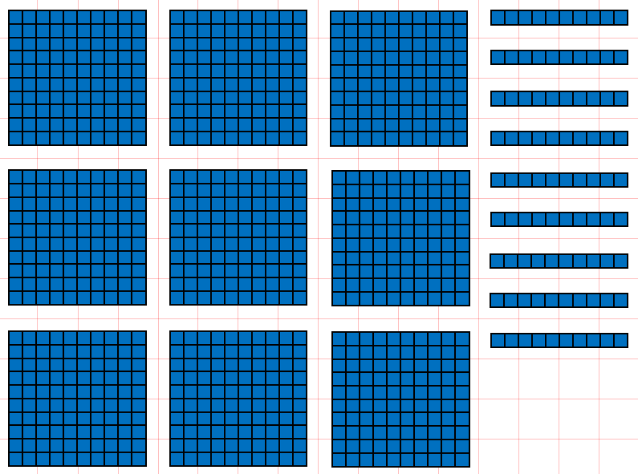  990 | 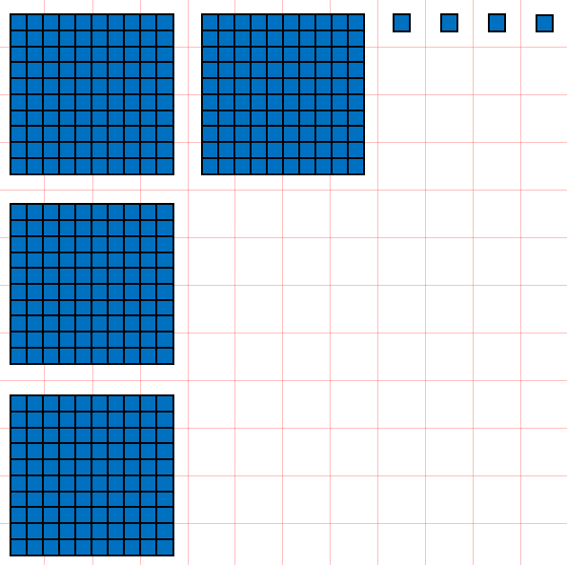  404

2 Write numbers to 1000 in digits
Let’s Learn
Write the numbers below in digits.
Eight hundred and twenty-five  825 | Nine hundred  900
Three hundred and twenty  320 | Four hundred and two  402
Your Turn
Write the numbers below in digits.
Seven hundred and seventeen  717 | Four hundred  400
Six hundred and fifty  650 | Two hundred and four  204

3 Write numbers to 1000 in words
Let’s Learn
Write the numbers below in words.
582 Five hundred and eighty-two

700 Seven hundred

840 Eight hundred and forty

201 Two hundred and one

Your Turn
Write the numbers below in words.
787 Seven hundred and eighty-seven

900 Nine hundred

260 Two hundred and sixty

903 Nine hundred and three

4 Partition three-digit numbers
Let’s Learn
Partition the numbers below into hundreds, tens and ones.
3  80  400  483 = + + | 5  50  500  555 = + +
9  600  609 = + | 70  800  870 = +
Your Turn
Partition the numbers below into hundreds, tens and ones.
1  90  700  791 = + + | 3  30  300  333 = + +
7  200  207 = + | 80  700  780 = +

5 Compare three-digit numbers
Let’s Learn
For the questions below, write < or >
<  35 ____ 350 | <  492 _____ 509 | >  472 _____ 427 | >  479 _____ 474
Your Turn
For the questions below, write < or >
>  885 ____ 88 | >  828 _____ 288 | <  345 _____ 354 | >  678 _____ 670

6 Order three-digit numbers
Let’s Learn
Order each set of numbers from smallest to largest.
671, 67, 706, 660, 716
716
706
671
660
67

405, 504, 44, 404, 454
504
454
405
404
44

Your Turn
Order each set of numbers from smallest to largest.
232, 223, 332, 32, 323
332
323
232
223
32

777, 77, 757, 575, 775
777
775
757
575
77

7 Round two-digit numbers to the nearest 10
Let’s Learn
Round the numbers below to the nearest 10.
42 ≈ 40 | 58 ≈ 60 | 28 ≈ 30
81 ≈ 80 | 35 ≈ 40 | 85 ≈ 90
Your Turn
Round the numbers below to the nearest 10.
77 ≈ 80 | 51 ≈ 50 | 34 ≈ 30
86 ≈ 90 | 25 ≈ 30 | 95 ≈ 100

8 Round three-digit numbers to the nearest 10
Let’s Learn
Round the numbers below to the nearest 10.
215 ≈ 220 | 492 ≈ 490 | 333 ≈ 330 | 897 ≈ 900 | 303 ≈ 300
Your Turn
Round the numbers below to the nearest 10.
344 ≈ 340 | 627 ≈ 630 | 666 ≈ 670 | 904 ≈ 900 | 399 ≈ 400

9 Round to the nearest 100
Let’s Learn
Round the numbers below to the nearest 100.
215 ≈ 200 | 492 ≈ 500 | 333 ≈ 300 | 897 ≈ 900 | 303 ≈ 300
Your Turn
Round the numbers below to the nearest 100.
344 ≈ 300 | 627 ≈ 600 | 666 ≈ 700 | 904 ≈ 900 | 399 ≈ 400

Addition
Go to https://keystage2maths.com/y3/addition/ for help.

1 Count on from a three-digit number in ones
Let’s Learn
For the questions below, write the next seven numbers.
95, 96, 97,
103
104
642
305
304
813
102
101
100
99
98

634, 635, 636,
643
641
640
639
638
637

805, 806, 807,
814
812
811
810
809
808
300
301
302

296, 297, 298,
303
299

Your Turn
For the questions below, write the next seven numbers.
93, 94, 95,
101
102
275
404
403
613
100
99
98
97
96

267, 268, 269,
276
274
273
272
271
270

604, 605, 606,
614
612
610
609
608
607
399
400
401

395, 396, 397,
402
398

2 Add a single-digit number to a three-digit number
Let’s Learn
Complete the questions below using mental methods.
479 + 4 = 483 | 328 + 6 = 334 | 695 + 9 = 704 | 294 + 8 = 302
Your Turn
Complete the questions below using mental methods.
269 + 3 = 272 | 448 + 6 = 454 | 295 + 7 = 302 | 398 + 8 = 406

3 Add two multiples of 10 beyond 100
Let’s Learn
Complete the questions below using mental methods.
140 + 40 = 180 | 270 + 50 = 320 | 380 + 60 = 440
Your Turn
Complete the questions below using mental methods.
250 + 30 = 280 | 390 + 40 = 430 | 570 + 70 = 640

4 Count on in tens from a three-digit number
Let’s Learn
For the questions below, write the next seven numbers, counting on in tens.
157, 167, 177,
237
247
227
217
207
197
187
619

539, 549, 559,
629
609
599
589
579
569

Your Turn
For the questions below, write the next seven numbers, counting on in tens.
243, 253, 263,
323
333
313
303
293
283
273
621

541, 551, 561,
631
611
601
591
581
571

5 Add a multiple of 10 to a three-digit number
Let’s Learn
Complete the questions below using mental methods.
242 + 60 = 302 | 458 + 70 = 528 | 865 + 80 = 945 | 194 + 90 = 284
Your Turn
Complete the questions below using mental methods.
332 + 70 = 402 | 263 + 60 = 323 | 744 + 80 = 824 | 298 + 50 = 348

6 Count on or back in multiples of 100
Let’s Learn
Count from 0 to 1000 in steps of 100.
0, , 1000
800
900
700
600
500
400
100
300
200

Count back from 1000 to 0 in steps of 100.
1000, , 0
100
200
300
400
500
600
900
800
700

7 Count on in hundreds
Let’s Learn
For the questions below, write the next seven numbers, counting on in steps of 100.
41, 141, 241,
441
541
741
841
941
641
341

66, 166, 266,
666
566
866
966
766
466
366

Your Turn
For the questions below, write the next seven numbers, counting on in steps of 100.
64, 164, 264,
464
564
764
864
964
664
364

10, 110, 210,
610
510
810
910
710
410
310

8 Add a multiple of 100 to a three-digit number
Let’s Learn
Complete the questions below using mental methods.
526 + 400 = 926 | 406 + 400 = 806 | 500 + 319 = 819 | 700 + 122 = 822
Your Turn
Complete the questions below using mental methods.
365 + 400 = 765 | 504 + 400 = 904 | 400 + 326 = 726 | 500 + 187 = 687

9 Add numbers with up to three digits using the column method
Let’s Learn
Complete the questions below using column addition.
552 + 38 = 590 | 679 + 43 = 722 | 464 + 152 = 616 | 388 + 219 = 607
Your Turn
Complete the questions below using column addition.
418 + 53 = 471 | 557 + 57 = 614 | 672 + 190 = 862 | 265 + 237 = 502

Subtraction
Go to https://keystage2maths.com/y3/subtraction/ for help.

1 Count back from a three-digit number in ones
Let’s Learn
For the questions below, write the next seven numbers.
103, 102, 101,
100
99
98
97
96
94
95
587
497
498
808

595, 594, 593,
586
588
589
590
591
592

816, 815, 814,
807
809
810
811
812
813
502
501
500
499

506, 505, 504,
503

Your Turn
For the questions below, write the next seven numbers.
104, 103, 102,
101
100
99
98
97
95
96
464
398
399
208

472, 471, 470,
463
465
466
467
468
469

216, 215, 214,
207
209
210
211
212
213
403
402
401
400

407, 406, 405,
404

2 Subtract a single-digit number from a three-digit number
Let’s Learn
Complete the questions below using mental methods.
284 – 5 = 279 | 392 – 6 = 386 | 204 – 8 = 196 | 403 – 7 = 396
Your Turn
Complete the questions below using mental methods.
373 – 5 = 368 | 493 – 6 = 487 | 603 – 8 = 595 | 501 – 7 = 494

3 Solve missing number problems for addition and subtraction of ones with three-digit numbers
Let’s Learn
Complete the questions below by finding the missing numbers.
405  = 396 + 9 | 608  = 616 – 8 | 7  473 + = 480
828  + 3 = 831 | 465  – 6 = 459 | 5  703 – = 698
Your Turn

Complete the questions below by finding the missing numbers.
304  = 295 + 9 | 506  = 512 – 6 | 6  294 + = 300
279  + 6 = 285 | 392  – 4 = 388 | 6  404 – = 398

4 Solve missing number problems for addition with multiples of 10 with three-digit answers
Let’s Learn
Complete the questions below by finding the missing numbers.
40  220 + = 260 | 60  170 + = 230 | 70  590 + = 660
Your Turn
Complete the questions below by finding the missing numbers.
60  310 + = 370 | 40  280 + = 320 | 60  670 + = 730
5 Subtract two multiples of 10 beyond 100
Let’s Learn
Complete the questions below using mental methods.
260 – 40 = 220 | 320 – 50 = 270 | 430 – 60 = 370
Your Turn
Complete the questions below using mental methods.
490 – 40 = 450 | 910 – 50 = 860 | 520 – 70 = 450

6 Solve missing number problems for subtraction with multiples of 10 with three-digit answers
Let’s Learn
Complete the questions below by finding the missing numbers.
40  550 – = 510 | 40  220 – = 180 | 90  550 – = 460
Your Turn
Complete the questions below by finding the missing numbers.
50  660 – = 610 | 50  330 – = 280 | 80  670 – = 590

7 Count back in tens from a three-digit number
Let’s Learn
For the questions below, write the next seven numbers, counting back in tens.
725, 715, 705,
645
655
675
635
665
685
695

546, 536, 526,
456
466
476
486
496
506
516

Your Turn
For the questions below, write the next seven numbers, counting back in tens.
332, 322, 312,
252
262
282
242
272
292
302

869, 859, 849,
779
789
799
809
819
829
839

8 Subtract a multiple of 10 from a three-digit number mentally
Let’s Learn
Complete the questions below using mental methods.
404 – 30 = 374 | 351 – 70 = 281 | 736 – 80 = 656 | 755 – 90 = 665
Your Turn
Complete the questions below using mental methods.
306 – 60 = 246 | 411 – 70 = 341 | 825 – 80 = 745 | 888 – 90 = 798

9 Solve missing number problems for addition and subtraction of tens with three-digit numbers
Let’s Learn
Complete the questions below by finding the missing numbers.
414  = 394 + 20 | 362  = 412 – 50 | 40  637 + = 677
295  + 40 = 335 | 469  – 30 = 439 | 30  916 – = 886
Your Turn
Complete the questions below by finding the missing numbers.
504  = 484 + 20 | 586  = 636 – 50 | 50  222 + = 272
182  + 50 = 232 | 333  – 30 = 303 | 50  512 – = 462

10 Add and subtract two multiples of 100 within 1000
Let’s Learn
Complete the questions below using mental methods.
400 + 200 = 600 | 500 – 100 = 400 | 500 + 400 = 900 | 700 – 400 = 300
Your Turn
Complete the questions below using mental methods.
300 + 300 = 600 | 800 – 100 = 700 | 400 + 300 = 700 | 900 – 500 = 400

11 Solve missing numbers for addition and subtraction with multiples of 100 within 1000
Let’s Learn
Complete the questions below by finding the missing numbers.
300  200 + = 500 | 200  700 + = 900 | 400  400 + = 800
400  900 – = 500 | 100  200 – = 100 | 400  600 – = 200
Your Turn
Complete the questions below by finding the missing numbers.
200  300 + = 500 | 300  500 + = 800 | 100  500 + = 600
500  900 – = 400 | 100  600 – = 500 | 500  700 – = 200

12 Count back in hundreds
Let’s Learn
For the questions below, write the next seven numbers, counting back in steps of 100.
955, 855, 755,
355
155
55
255
455
555
655

903, 803, 703,
103
203
603
3
303
403
503

Your Turn
For the questions below, write the next seven numbers, counting back in steps of 100.
922, 822, 722,
322
122
22
222
422
522
622

901, 801, 701,
101
201
601
1
301
401
501

13 Subtract a multiple of 100 from a three-digit number
Let’s Learn
Complete the questions below using mental methods.
999 – 200 = 799 | 562 – 400 = 162 | 375 – 300 = 75 | 857 – 500 = 357
Your Turn
Complete the questions below using mental methods.
888 – 200 = 688 | 743 – 400 = 343 | 513 – 500 = 13 | 962 – 300 = 662

14 Solve missing number problems for addition and subtraction of hundreds with three-digit numbers
Let’s Learn
Complete the questions below by finding the missing numbers.
496  = 296 + 200 | 63  = 663 – 600 | 300  362 + = 662
605  + 300 = 905 | 775  – 500 = 275 | 600  723 – = 123

Your Turn
Complete the questions below by finding the missing numbers.
652  = 452 + 200 | 73  = 973 – 900 | 300  265 + = 565
508  + 200 = 708 | 582  – 400 = 182 | 700  831 – = 131

15 Subtract numbers with up to three digits using the column method
Let’s Learn
Complete the questions below using column subtraction.
733 – 25 = 708 | 318 – 44 = 274 | 350 – 136 = 214 | 675 – 387 = 288
Your Turn
Complete the questions below using column subtraction.
551 – 38 = 513 | 739 – 89 = 650 | 670 – 225 = 445 | 854 – 479 = 375

16 Check by using the inverse operation with three-digit numbers
Let’s Learn
Check the answers to these calculations by using the inverse operation.
238 + 184 = 422  422 – 184 = 238 or 422 – 238 = 184 | 718 – 284 = 434  434 + 284 = 718 or 284 + 434 = 718
Your Turn
Check the answers to these calculations by using the inverse operation.
352 + 282 = 643  643 – 282 = 352 or 643 – 352 = 282 | 704 – 275 = 429  429 + 275 = 704 or 275 + 429 = 704

17 Solve missing number problems for addition and subtraction with three-digit numbers
Let’s Learn
Complete the questions below by finding the missing numbers.
293  246 + = 539 | 269  + 293 = 562 | 581  – 305 = 276 | 168  741 – = 573
Your Turn
Complete the questions below by finding the missing numbers.
533  185 + = 718 | 189  + 458 = 647 | 661  – 309 = 352 | 458  914 – = 456

Multiplication
Go to https://keystage2maths.com/y3/multiplication/ for help.

1 Multiply by 3
Let’s Learn
3 x 3 = 9 | 4 x 3 = 12 | 7 x 3 = 21 | 11 x 3 = 33

2 Multiply by 4
Let’s Learn
2 x 4 = 8 | 6 x 4 = 24 | 9 x 4 = 36 | 10 x 4 = 40

3 Connect the 2 and 4 times tables
Let’s Learn
3  x 4 = 6 x 2 | 1  x 4 = 2 x 2 | 4  x 2 = 2 x 4

4 Multiply by 8
Let’s Learn
2 x 8 = 16 | 6 x 8 = 48 | 8 x 8 = 64 | 11 x 8 = 88

5 Connect the 4 and 8 times tables
Let’s Learn
2  x 8 = 4 x 4 | 5  x 8 = 10 x 4 | 6  x 4 = 3 x 8

6 Represent multiplication using an array
Let’s Learn
5  5 x 2 = 2 x | 4  4 x 3 = 3 x

7 Multiply by a multiple of 10 with knowledge of the 2, 3, 4, 5 and 8 times tables
Let’s Learn
3 x 80 = 240 | 40 x 8 = 320 | 9 x 20 = 180
Your Turn
7 x 50 = 350 | 80 x 8 = 640 | 5 x 20 = 100

8 Multiply by a two-digit number using the grid method using knowledge of the 2, 3, 4, 5 and 8 times tables
Let’s Learn
Answer the questions below using the grid method.
4 x 55 = 220 | 23 x 7 = 161
Your Turn
Answer the questions below using the grid method.
2 x 88 = 176 | 32 x 9 = 288

9 Multiply by a two-digit number using the expanded column method using knowledge of the 2, 3, 4, 5 and 8 times tables
Let’s Learn
Answer the questions below using the expanded column method.
33 x 2 = 66 | 76 x 5 = 380 | 85 x 3 = 255
Your Turn
Answer the questions below using the expanded column method.
44 x 2 = 88 | 39 x 5 = 195 | 58 x 4 = 232

10 Multiply by a two-digit number using the column method using knowledge of the 2, 3, 4, 5 and 8 times tables within 100
Let’s Learn
Answer the questions below using the column method.
16 x 4 = 64 | 24 x 3 = 72 | 2 x 35 = 70
Your Turn
Answer the questions below using the column method.
16 x 5 = 80 | 23 x 4 = 92 | 2 x 46 = 92

11 Multiply by a two-digit number using the column method using knowledge of the 2, 3, 4, 5 and 8 times tables within 1000
Let’s Learn
24 x 6 = 144 | 74 x 2 = 148 | 3 x 45 = 135
Your Turn
23 x 7 = 161 | 93 x 2 = 186 | 4 x 53 = 212
Division
Go to https://keystage2maths.com/y3/division/ for help.

1 Divide by 3
Let’s Learn
3 ÷ 3 = 1 | 12 ÷ 3 = 4 | 27 ÷ 3 = 9 | 36 ÷ 3 = 12

2 Divide by 4
Let’s Learn
8 ÷ 4 = 2 | 20 ÷ 4 = 5 | 36 ÷ 4 = 9 | 40 ÷ 4 = 10

3 Divide by 8
Let’s Learn
24 ÷ 8 = 3 | 32 ÷ 8 = 4 | 64 ÷ 8 = 8 | 96 ÷ 8 = 12

4 Divide by grouping
Let’s Learn
Answer the questions below by grouping.
12 ÷ 4 = 3 | 20 ÷ 5 = 4 | 18 ÷ 2 = 9

5 Divide by sharing
Let’s Learn
Now answer the questions above by sharing.

6 Solve missing number problems for multiplication and division with knowledge of the 2, 3, 4, 5, 8 and 10 times tables
Let’s Learn
35  = 7 x 5 | 7  = 14 ÷ 2 | 8  4 x = 32
9  x 3 = 27 | 48  ÷ 8 = 6 | 6  24 ÷ = 4

7 Divide a multiple of 10 by a single-digit number
Let’s Learn
80 ÷ 2 = 40 | 150 ÷ 3 = 50 | 160 ÷ 4 = 40 | 210 ÷ 3 = 70
Your Turn
60 ÷ 2 = 30 | 240 ÷ 3 = 80 | 240 ÷ 4 = 60 | 250 ÷ 5 = 50

8 Divide by chunking
Let’s Learn
Answer the questions below using the chunking method.
78 ÷ 3 = 26 | 260 ÷ 5 = 52 | 144 ÷ 4 = 36
Your Turn
Answer the questions below using the chunking method.
100 ÷ 4 = 25 | 141 ÷ 3 = 47 | 180 ÷ 5 = 36

9 Divide by a single-digit number using long division
Let’s Learn
Answer the questions below using long division.
68 ÷ 2 = 34 | 72 ÷ 3 = 24 | 96 ÷ 4 = 24 | 123 ÷ 3 = 41
Your Turn
Answer the questions below using long division.
69 ÷ 3 = 23 | 72 ÷ 4 = 18 | 95 ÷ 5 = 19 | 128 ÷ 2 = 64
10 Divide using short division
Let’s Learn
Now answer the questions above using short division.
Your Turn
Now answer the questions above using short division.

Fractions
Go to https://keystage2maths.com/y3/fractions/ for help.

1 Identify a fraction as part of a whole
Let’s Learn
Name the shaded fraction represented in each fraction bar.
  $\frac{1}{2}$ | $\frac{1}{5}$ | $\frac{1}{6}$ | $\frac{2}{3}$ | $\frac{3}{4}$ | $\frac{5}{8}$
Your Turn
Name the shaded fraction represented in each fraction bar.
$\frac{1}{3}$ | $\frac{1}{4}$ | $\frac{2}{7}$ | $\frac{2}{3}$ | $\frac{4}{5}$ | $\frac{7}{8}$

2 Add fractions with the same denominator within 1
Let’s Learn
$\frac{2}{5}$ + $\frac{1}{5}$ = $\frac{3}{5}$ | $\frac{1}{9}$ + $\frac{4}{9}$ = $\frac{5}{9}$ | $\frac{3}{8}$ + $\frac{3}{8}$ = $\frac{6}{8}$ | $\frac{2}{7}$ + $\frac{3}{7}$ = $\frac{5}{7}$
Your Turn
$\frac{3}{7}$ + $\frac{1}{7}$ = $\frac{4}{7}$ | $\frac{1}{5}$ + $\frac{2}{5}$ = $\frac{3}{5}$ | $\frac{3}{10}$ + $\frac{2}{10}$ = $\frac{5}{10}$ | $\frac{2}{9}$ + $\frac{5}{9}$ = $\frac{7}{9}$

3 Subtract fractions with the same denominator within 1
Let’s Learn
$\frac{6}{7}$ – $\frac{1}{7}$ = $\frac{5}{7}$ | $\frac{5}{8}$ – $\frac{4}{8}$ = $\frac{1}{8}$ | $\frac{4}{5}$ – $\frac{2}{5}$ = $\frac{2}{5}$ | $\frac{3}{4}$ – $\frac{1}{4}$ = $\frac{2}{4}$
Your Turn
$\frac{6}{8}$ – $\frac{1}{8}$ = $\frac{5}{8}$ | $\frac{5}{6}$ – $\frac{4}{6}$ = $\frac{1}{6}$ | $\frac{6}{7}$ – $\frac{2}{7}$ = $\frac{4}{7}$ | $\frac{4}{9}$ – $\frac{1}{9}$ = $\frac{3}{9}$

4 Solve missing number problems for addition and subtraction of fractions with the same denominator within 1
Let’s Learn
$\frac{1}{5}$  $\frac{3}{5}$ + = $\frac{4}{5}$ | $\frac{4}{8}$  $\frac{1}{8}$ + = $\frac{5}{8}$ | $\frac{3}{7}$  $\frac{5}{7}$ – = $\frac{2}{7}$ | $\frac{4}{6}$  $\frac{5}{6}$ – = $\frac{1}{6}$
Your Turn
$\frac{4}{6}$  $\frac{1}{6}$ + = $\frac{5}{6}$ | $\frac{1}{3}$  $\frac{1}{3}$ + = $\frac{2}{3}$ | $\frac{4}{8}$  $\frac{5}{8}$ – = $\frac{1}{8}$ | $\frac{3}{9}$  $\frac{5}{9}$ – = $\frac{2}{9}$

5 Find a unit fraction of a number
Let’s Learn
$\frac{1}{3}$of 24 = 8 | $\frac{1}{5}$ of 30 = 6 | $\frac{1}{8}$of 24 = 3
Your Turn
$\frac{1}{3}$of 18 = 6 | $\frac{1}{4}$ of 28 = 7 | $\frac{1}{7}$of 35 = 5

6 Find a whole quantity given the quantity represented by a unit fraction
Let’s Learn
$\frac{1}{3}$ of = 7  21 | $\frac{1}{5}$ of = 4  20 | $\frac{1}{6}$ of = 4  24
$\frac{1}{4}$ of = 100  400 | $\frac{1}{3}$ of = 70  210 | $\frac{1}{5}$ of = 43  215
Your Turn
$\frac{1}{6}$ of = 7  42 | $\frac{1}{8}$of = 5  40 | $\frac{1}{9}$ of = 2  18
$\frac{1}{3}$ of = 200  600 | $\frac{1}{6}$ of = 60  360 | $\frac{1}{2}$ of = 78  156

7 Find a quarter by halving twice, or an eighth by halving three times
Let’s Learn
$\frac{1}{2}$of 48 = 24 | $\frac{1}{4}$ of 48 = 12 | $\frac{1}{8}$of 48 = 6
$\frac{1}{2}$of 32 = 16 | $\frac{1}{4}$ of 32 = 8 | $\frac{1}{8}$of 32 = 4
Your Turn
$\frac{1}{2}$of 40 = 20 | $\frac{1}{4}$ of 40 = 10 | $\frac{1}{8}$of 40 = 5
$\frac{1}{2}$of 24 = 12 | $\frac{1}{4}$ of 24 = 6 | $\frac{1}{8}$of 24 = 3

Decimals
Go to https://keystage2maths.com/y3/decimals/ for help.

1 Convert between fractional and decimal tenths
Let’s Learn
2  0.2 =  $\frac{}{10}$ | 3  0.3 =  $\frac{}{10}$ |  | 6  0.6 =  $\frac{}{10}$
Write the quantity shown by each fraction bar as both a decimal and a fraction.
  1  0.1  =  $\frac{}{10}$ |  |   9  0.9  =  $\frac{}{10}$
Write the values of A, B and C on the number line as decimals.
0.9
0.5
0.2

Your Turn
1  0.1 =  $\frac{}{10}$ | 7  0.7 =  $\frac{}{10}$ |  | 9  0.9 =  $\frac{}{10}$
Write the quantity shown by each fraction bar as both a fraction and a decimal.
  4  0.4  =  $\frac{}{10}$ |  |   8  0.8  =  $\frac{}{10}$
Write the values of A, B and C on the number line as decimals.
0.8
0.4
0.3

2 Convert between fractional and decimal tenths beyond 1
Let’s Learn
11  1.1 =  $\frac{}{10}$ | 14  1.4 =  $\frac{}{10}$ | 27  2.7 =  $\frac{}{10}$ | $\frac{13}{10}$ =  1.3 | $\frac{29}{10}$ =  2.9
Write the values of A, B and C on the number line as decimals.
0.4
1.1
1.8

Your Turn
13  1.3 =  $\frac{}{10}$ | 17  1.7 =  $\frac{}{10}$ | 28  2.8 =  $\frac{}{10}$ | $\frac{19}{10}$ =  1.9 | $\frac{21}{10}$ =  2.1
Write the values of A, B and C on the number line as decimals.
1.4
0.7
0.3

3 Add numbers with tenths
Let’s Learn
3.1 + 2.6 = 5.7 | 3.9 + 3.3 = 7.2 | 3.4 + 0.6 = 4 | 3.7 + 3.5 = 7.2
Your Turn
8.6 + 5.6 = 14.2 | 36.9 + 5.8 = 42.7 | 82.2 + 5.6 = 87.8

4 Subtract numbers with tenths
Let’s Learn
7.6 – 5.2 = 2.4 | 6.5 – 1.9 = 4.6 | 9.4 – 5.8 = 3.6 | 6.1 – 0.2 = 5.9
Your Turn
17.4 – 5.1 = 12.3 | 21.7 – 2.7 = 19 | 12.4 – 4.5 = 7.9 | 29.3 – 12.6 = 16.7

5 Add numbers with tenths to whole numbers
Let’s Learn
3 + 2.6 = 5.6 | 3.9 + 3 = 6.9
Your Turn
5 + 3.5 = 8.5 | 9.7 + 3 = 12.7

6 Subtract numbers with tenths from whole numbers
Let’s Learn
9 – 5.4 = 3.6 | 5 – 0.1 = 4.9
Your Turn
7 – 0.7 = 6.3 | 5 – 3.2 = 1.8

7 Divide one- or two-digit numbers by 10 to make tenths
Let’s Learn
1 ÷ 10 = 0.1 | 4 ÷ 10 = 0.4 | 6 ÷ 10 = 0.6
40 ÷ 10 = 4 | 13 ÷ 10 = 1.3 | 28 ÷ 10 = 2.8
Your Turn
3 ÷ 10 = 0.3 | 5 ÷ 10 = 0.5 | 9 ÷ 10 = 0.9
10 ÷ 10 = 1 | 11 ÷ 10 = 1.1 | 35 ÷ 10 = 3.5

8 Multiply numbers with tenths by 10
Let’s Learn
2 x 10 = 20 | 0.2 x 10 = 2 | 0.8 x 10 = 8
1.6 x 10 = 16 | 60.1 x 10 = 601 | 24.6 x 10 = 246
Your Turn
7 x 10 = 70 | 0.7 x 10 = 7 | 0.9 x 10 = 9
3.5 x 10 = 35 | 30.5 x 10 = 305 | 35.3 x 10 = 353

