Place Value
Go to https://keystage2maths.com/y3/placevalue/ for help.

1 Recognise representations for numbers to 1000
Let’s Learn
Write the numbers represented by the blocks below.
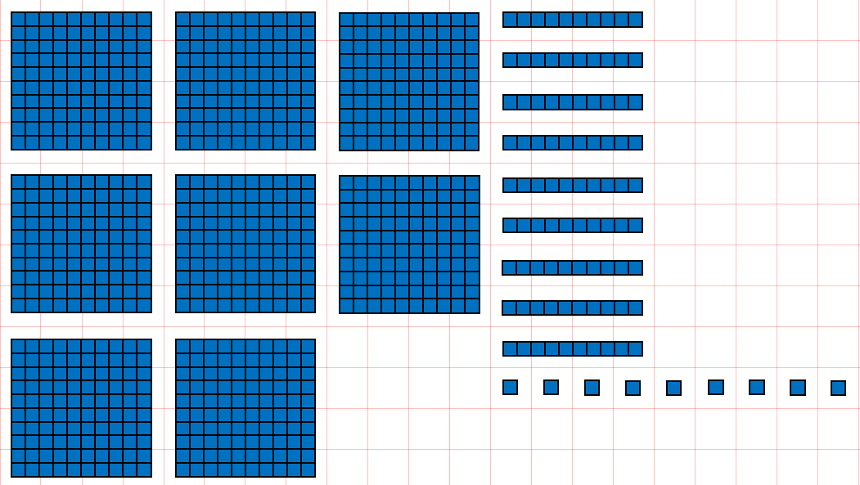 | 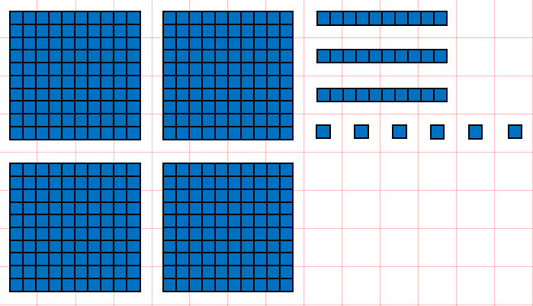
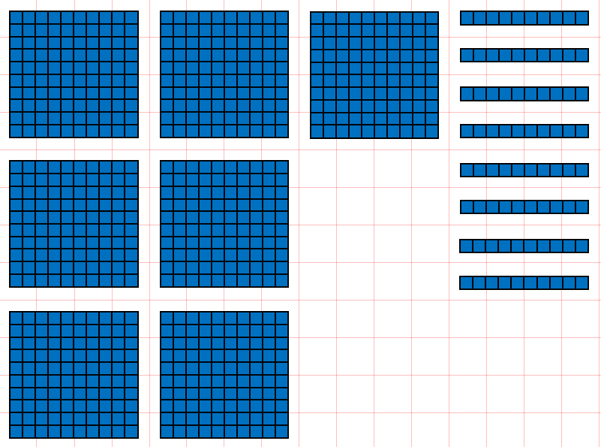 | 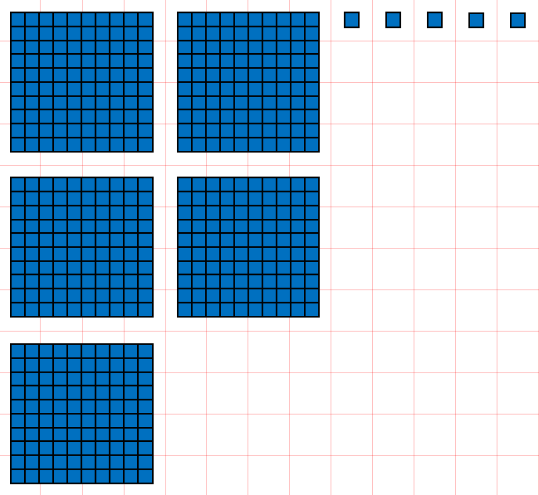
Your Turn
Write the numbers represented by the blocks below.
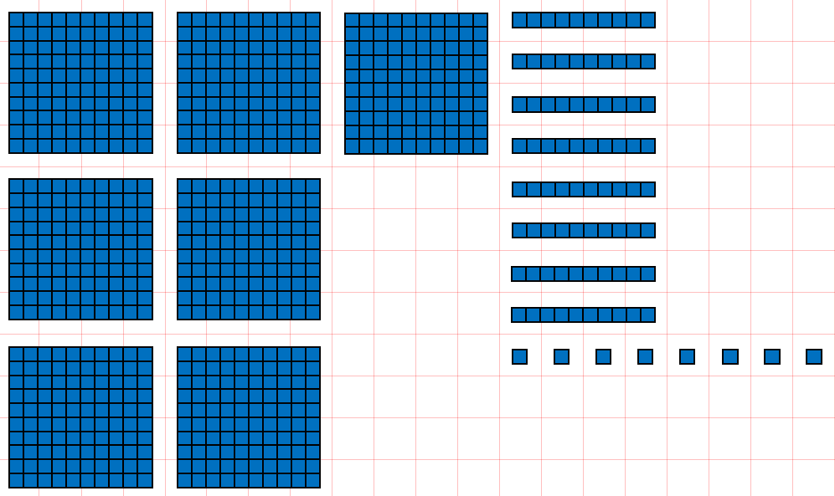 | 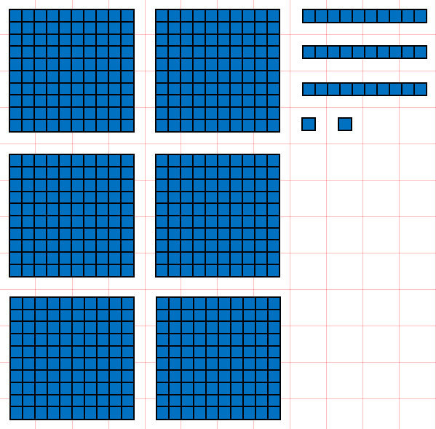
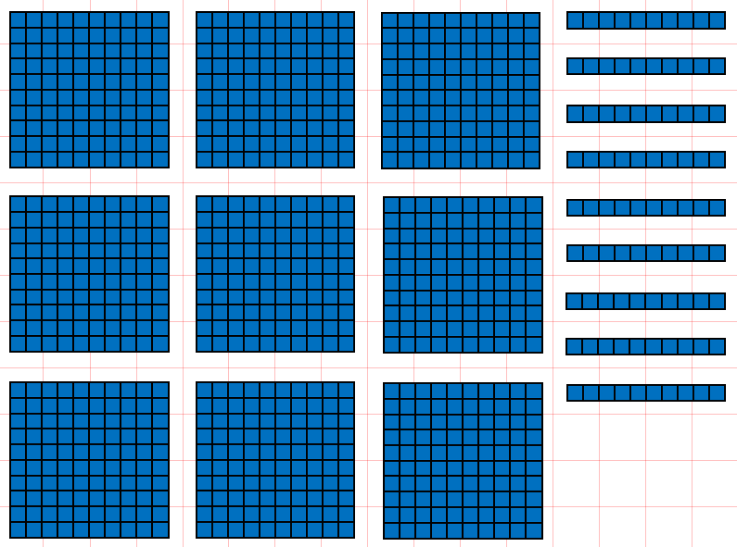 | 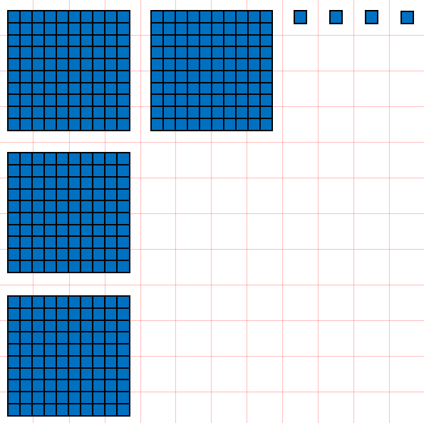

2 Write numbers to 1000 in digits
Let’s Learn
Write the numbers below in digits.
Eight hundred and twenty-five | Nine hundred
Three hundred and twenty | Four hundred and two
Your Turn
Write the numbers below in digits.
Seven hundred and seventeen | Four hundred
Six hundred and fifty | Two hundred and four

3 Write numbers to 1000 in words
Let’s Learn
Write the numbers below in words.
582

700

840

201

Your Turn
Write the numbers below in words.
787

900

260

903

4 Partition three-digit numbers
Let’s Learn
Partition the numbers below into hundreds, tens and ones.
483 = + + | 555 = + +
609 = + | 870 = +
Your Turn
Partition the numbers below into hundreds, tens and ones.
791 = + + | 333 = + +
207 = + | 780 = +

5 Compare three-digit numbers
Let’s Learn
For the questions below, write < or >
35 ____ 350 | 492 _____ 509 | 472 _____ 427 | 479 _____ 474
Your Turn
For the questions below, write < or >
885 ____ 88 | 828 _____ 288 | 345 _____ 354 | 678 _____ 670

6 Order three-digit numbers
Let’s Learn
Order each set of numbers from smallest to largest.
671, 67, 706, 660, 716

405, 504, 44, 404, 454

Your Turn
Order each set of numbers from smallest to largest.
232, 223, 332, 32, 323

777, 77, 757, 575, 775

7 Round two-digit numbers to the nearest 10
Let’s Learn
Round the numbers below to the nearest 10.
42 ≈ | 58 ≈ | 28 ≈
81 ≈ | 35 ≈ | 85 ≈
Your Turn
Round the numbers below to the nearest 10.
77 ≈ | 51 ≈ | 34 ≈
86 ≈ | 25 ≈ | 95 ≈

8 Round three-digit numbers to the nearest 10
Let’s Learn
Round the numbers below to the nearest 10.
215 ≈ | 492 ≈ | 333 ≈ | 897 ≈ | 303 ≈
Your Turn
Round the numbers below to the nearest 10.
344 ≈ | 627 ≈ | 666 ≈ | 904 ≈ | 399 ≈

9 Round to the nearest 100
Let’s Learn
Round the numbers below to the nearest 100.
215 ≈ | 492 ≈ | 333 ≈ | 897 ≈ | 303 ≈
Your Turn
Round the numbers below to the nearest 100.
344 ≈ | 627 ≈ | 666 ≈ | 904 ≈ | 399 ≈

Addition
Go to https://keystage2maths.com/y3/addition/ for help.

1 Count on from a three-digit number in ones
Let’s Learn
For the questions below, write the next seven numbers.
95, 96, 97,

634, 635, 636,

805, 806, 807,

296, 297, 298,

Your Turn
For the questions below, write the next seven numbers.
93, 94, 95,

267, 268, 269,

604, 605, 606,

395, 396, 397,

2 Add a single-digit number to a three-digit number
Let’s Learn
Complete the questions below using mental methods.
479 + 4 = | 328 + 6 = | 695 + 9 = | 294 + 8 =
Your Turn
Complete the questions below using mental methods.
269 + 3 = | 448 + 6 = | 295 + 7 = | 398 + 8 =

3 Add two multiples of 10 beyond 100
Let’s Learn
Complete the questions below using mental methods.
140 + 40 = | 270 + 50 = | 380 + 60 =
Your Turn
Complete the questions below using mental methods.
250 + 30 = | 390 + 40 = | 570 + 70 =

4 Count on in tens from a three-digit number
Let’s Learn
For the questions below, write the next seven numbers, counting on in tens.
157, 167, 177,

539, 549, 559,

Your Turn
For the questions below, write the next seven numbers, counting on in tens.
243, 253, 263,

541, 551, 561,

5 Add a multiple of 10 to a three-digit number
Let’s Learn
Complete the questions below using mental methods.
242 + 60 = | 458 + 70 = | 865 + 80 = | 194 + 90 =
Your Turn
Complete the questions below using mental methods.
332 + 70 = | 263 + 60 = | 744 + 80 = | 298 + 50 =

6 Count on or back in multiples of 100
Let’s Learn
Count from 0 to 1000 in steps of 100.
0, , 1000

Count back from 1000 to 0 in steps of 100.
1000, , 0

7 Count on in hundreds
Let’s Learn
For the questions below, write the next seven numbers, counting on in steps of 100.
41, 141, 241,

66, 166, 266,

Your Turn
For the questions below, write the next seven numbers, counting on in steps of 100.
64, 164, 264,

10, 110, 210,

8 Add a multiple of 100 to a three-digit number
Let’s Learn
Complete the questions below using mental methods.
526 + 400 = | 406 + 400 = | 500 + 319 = | 700 + 122 =
Your Turn
Complete the questions below using mental methods.
365 + 400 = | 504 + 400 = | 400 + 326 = | 500 + 187 =

9 Add numbers with up to three digits using the column method
Let’s Learn
Complete the questions below using column addition.
552 + 38 = | 679 + 43 = | 464 + 152 = | 388 + 219 =
Your Turn
Complete the questions below using column addition.
418 + 53 = | 557 + 57 = | 672 + 190 = | 265 + 237 =

Subtraction
Go to https://keystage2maths.com/y3/subtraction/ for help.

1 Count back from a three-digit number in ones
Let’s Learn
For the questions below, write the next seven numbers.
103, 102, 101,

595, 594, 593,

816, 815, 814,

506, 505, 504,

Your Turn
For the questions below, write the next seven numbers.
104, 103, 102,

472, 471, 470,

216, 215, 214,

407, 406, 405,

2 Subtract a single-digit number from a three-digit number
Let’s Learn
Complete the questions below using mental methods.
284 – 5 = | 392 – 6 = | 204 – 8 = | 403 – 7 =
Your Turn
Complete the questions below using mental methods.
373 – 5 = | 493 – 6 = | 603 – 8 = | 501 – 7 =

3 Solve missing number problems for addition and subtraction of ones with three-digit numbers
Let’s Learn
Complete the questions below by finding the missing numbers.
= 396 + 9 | = 616 – 8 | 473 + = 480
+ 3 = 831 | – 6 = 459 | 703 – = 698
Your Turn

Complete the questions below by finding the missing numbers.
= 295 + 9 | = 512 – 6 | 294 + = 300
+ 6 = 285 | – 4 = 388 | 404 – = 398

4 Solve missing number problems for addition with multiples of 10 with three-digit answers
Let’s Learn
Complete the questions below by finding the missing numbers.
220 + = 260 | 170 + = 230 | 590 + = 660
Your Turn
Complete the questions below by finding the missing numbers.
310 + = 370 | 280 + = 320 | 670 + = 730
5 Subtract two multiples of 10 beyond 100
Let’s Learn
Complete the questions below using mental methods.
260 – 40 = | 320 – 50 = | 430 – 60 =
Your Turn
Complete the questions below using mental methods.
490 – 40 = | 910 – 50 = | 520 – 70 =

6 Solve missing number problems for subtraction with multiples of 10 with three-digit answers
Let’s Learn
Complete the questions below by finding the missing numbers.
550 – = 510 | 220 – = 180 | 550 – = 460
Your Turn
Complete the questions below by finding the missing numbers.
660 – = 610 | 330 – = 280 | 670 – = 590

7 Count back in tens from a three-digit number
Let’s Learn
For the questions below, write the next seven numbers, counting back in tens.
725, 715, 705,

546, 536, 526,

Your Turn
For the questions below, write the next seven numbers, counting back in tens.
332, 322, 312,

869, 859, 849,

8 Subtract a multiple of 10 from a three-digit number mentally
Let’s Learn
Complete the questions below using mental methods.
404 – 30 = | 351 – 70 = | 736 – 80 = | 755 – 90 =
Your Turn
Complete the questions below using mental methods.
306 – 60 = | 411 – 70 = | 825 – 80 = | 888 – 90 =

9 Solve missing number problems for addition and subtraction of tens with three-digit numbers
Let’s Learn
Complete the questions below by finding the missing numbers.
= 394 + 20 | = 412 – 50 | 637 + = 677
+ 40 = 335 | – 30 = 439 | 916 – = 886
Your Turn
Complete the questions below by finding the missing numbers.
= 484 + 20 | = 636 – 50 | 222 + = 272
+ 50 = 232 | – 30 = 303 | 512 – = 462

10 Add and subtract two multiples of 100 within 1000
Let’s Learn
Complete the questions below using mental methods.
400 + 200 = | 500 – 100 = | 500 + 400 = | 700 – 400 =
Your Turn
Complete the questions below using mental methods.
300 + 300 = | 800 – 100 = | 400 + 300 = | 900 – 500 =

11 Solve missing numbers for addition and subtraction with multiples of 100 within 1000
Let’s Learn
Complete the questions below by finding the missing numbers.
200 + = 500 | 700 + = 900 | 400 + = 800
900 – = 500 | 200 – = 100 | 600 – = 200
Your Turn
Complete the questions below by finding the missing numbers.
300 + = 500 | 500 + = 800 | 500 + = 600
900 – = 400 | 600 – = 500 | 700 – = 200

12 Count back in hundreds
Let’s Learn
For the questions below, write the next seven numbers, counting back in steps of 100.
955, 855, 755,

903, 803, 703,

Your Turn
For the questions below, write the next seven numbers, counting back in steps of 100.
922, 822, 722,

901, 801, 701,

13 Subtract a multiple of 100 from a three-digit number
Let’s Learn
Complete the questions below using mental methods.
999 – 200 = | 562 – 400 = | 375 – 300 = | 857 – 500 =
Your Turn
Complete the questions below using mental methods.
888 – 200 = | 743 – 400 = | 513 – 500 = | 962 – 300 =

14 Solve missing number problems for addition and subtraction of hundreds with three-digit numbers
Let’s Learn
Complete the questions below by finding the missing numbers.
= 296 + 200 | = 663 – 600 | 362 + = 662
+ 300 = 905 | – 500 = 275 | 723 – = 123

Your Turn
Complete the questions below by finding the missing numbers.
= 452 + 200 | = 973 – 900 | 265 + = 565
+ 200 = 708 | – 400 = 182 | 831 – = 131

15 Subtract numbers with up to three digits using the column method
Let’s Learn
Complete the questions below using column subtraction.
733 – 25 = | 318 – 44 = | 350 – 136 = | 675 – 387 =
Your Turn
Complete the questions below using column subtraction.
551 – 38 = | 739 – 89 = | 670 – 225 = | 854 – 479 =

16 Check by using the inverse operation with three-digit numbers
Let’s Learn
Check the answers to these calculations by using the inverse operation.
238 + 184 = 422 | 718 – 284 = 434
Your Turn
Check the answers to these calculations by using the inverse operation.
352 + 282 = 643 | 704 – 275 = 429

17 Solve missing number problems for addition and subtraction with three-digit numbers
Let’s Learn
Complete the questions below by finding the missing numbers.
246 + = 539 | + 293 = 562 | – 305 = 276 | 741 – = 573
Your Turn
Complete the questions below by finding the missing numbers.
185 + = 718 | + 458 = 647 | – 309 = 352 | 914 – = 456

Multiplication
Go to https://keystage2maths.com/y3/multiplication/ for help.

1 Multiply by 3
Let’s Learn
3 x 3 = | 4 x 3 = | 7 x 3 = | 11 x 3 =

2 Multiply by 4
Let’s Learn
2 x 4 = | 6 x 4 = | 9 x 4 = | 10 x 4 =

3 Connect the 2 and 4 times tables
Let’s Learn
x 4 = 6 x 2 | x 4 = 2 x 2 | x 2 = 2 x 4

4 Multiply by 8
Let’s Learn
2 x 8 = | 6 x 8 = | 8 x 8 = | 11 x 8 =

5 Connect the 4 and 8 times tables
Let’s Learn
x 8 = 4 x 4 | x 8 = 10 x 4 | x 4 = 3 x 8

6 Represent multiplication using an array
Let’s Learn
5 x 2 = 2 x | 4 x 3 = 3 x

7 Multiply by a multiple of 10 with knowledge of the 2, 3, 4, 5 and 8 times tables
Let’s Learn
3 x 80 = | 40 x 8 = | 9 x 20 =
Your Turn
7 x 50 = | 80 x 8 = | 5 x 20 =

8 Multiply by a two-digit number using the grid method using knowledge of the 2, 3, 4, 5 and 8 times tables
Let’s Learn
Answer the questions below using the grid method.
4 x 55 = | 23 x 7 =
Your Turn
Answer the questions below using the grid method.
2 x 88 = | 32 x 9 =

9 Multiply by a two-digit number using the expanded column method using knowledge of the 2, 3, 4, 5 and 8 times tables
Let’s Learn
Answer the questions below using the expanded column method.
33 x 2 = | 76 x 5 = | 85 x 3 =
Your Turn
Answer the questions below using the expanded column method.
44 x 2 = | 39 x 5 = | 58 x 4 =

10 Multiply by a two-digit number using the column method using knowledge of the 2, 3, 4, 5 and 8 times tables within 100
Let’s Learn
Answer the questions below using the column method.
16 x 4 = | 24 x 3 = | 2 x 35 =
Your Turn
Answer the questions below using the column method.
16 x 5 = | 23 x 4 = | 2 x 46 =

11 Multiply by a two-digit number using the column method using knowledge of the 2, 3, 4, 5 and 8 times tables within 1000
Let’s Learn
24 x 6 = | 74 x 2 = | 3 x 45 =
Your Turn
23 x 7 = | 93 x 2 = | 4 x 53 =
Division
Go to https://keystage2maths.com/y3/division/ for help.

1 Divide by 3
Let’s Learn
3 ÷ 3 = | 12 ÷ 3 = | 27 ÷ 3 = | 36 ÷ 3 =

2 Divide by 4
Let’s Learn
8 ÷ 4 = | 20 ÷ 4 = | 36 ÷ 4 = | 40 ÷ 4 =

3 Divide by 8
Let’s Learn
24 ÷ 8 = | 32 ÷ 8 = | 64 ÷ 8 = | 96 ÷ 8 =

4 Divide by grouping
Let’s Learn
Answer the questions below by grouping.
12 ÷ 4 = | 20 ÷ 5 = | 18 ÷ 2 =

5 Divide by sharing
Let’s Learn
Now answer the questions above by sharing.

6 Solve missing number problems for multiplication and division with knowledge of the 2, 3, 4, 5, 8 and 10 times tables
Let’s Learn
= 7 x 5 | = 14 ÷ 2 | 4 x = 32
x 3 = 27 | ÷ 8 = 6 | 24 ÷ = 4

7 Divide a multiple of 10 by a single-digit number
Let’s Learn
80 ÷ 2 = | 150 ÷ 3 = | 160 ÷ 4 = | 210 ÷ 3 =
Your Turn
60 ÷ 2 = | 240 ÷ 3 = | 240 ÷ 4 = | 250 ÷ 5 =

8 Divide by chunking
Let’s Learn
Answer the questions below using the chunking method.
78 ÷ 3 = | 260 ÷ 5 = | 144 ÷ 4 =
Your Turn
Answer the questions below using the chunking method.
100 ÷ 4 = | 141 ÷ 3 = | 180 ÷ 5 =

9 Divide by a single-digit number using long division
Let’s Learn
Answer the questions below using long division.
68 ÷ 2 = | 72 ÷ 3 = | 96 ÷ 4 = | 123 ÷ 3 =
Your Turn
Answer the questions below using long division.
69 ÷ 3 = | 72 ÷ 4 = | 95 ÷ 5 = | 128 ÷ 2 =
10 Divide using short division
Let’s Learn
Now answer the questions above using short division.
Your Turn
Now answer the questions above using short division.

Fractions
Go to https://keystage2maths.com/y3/fractions/ for help.

1 Identify a fraction as part of a whole
Let’s Learn
Name the shaded fraction represented in each fraction bar.


Your Turn
Name the shaded fraction represented in each fraction bar.

2 Add fractions with the same denominator within 1
Let’s Learn
$\frac{2}{5}$ + $\frac{1}{5}$ = | $\frac{1}{9}$ + $\frac{4}{9}$ = | $\frac{3}{8}$ + $\frac{3}{8}$ = | $\frac{2}{7}$ + $\frac{3}{7}$ =
Your Turn
$\frac{3}{7}$ + $\frac{1}{7}$ = | $\frac{1}{5}$ + $\frac{2}{5}$ = | $\frac{3}{10}$ + $\frac{2}{10}$ = | $\frac{2}{9}$ + $\frac{5}{9}$ =

3 Subtract fractions with the same denominator within 1
Let’s Learn
$\frac{6}{7}$ – $\frac{1}{7}$ = | $\frac{5}{8}$ – $\frac{4}{8}$ = | $\frac{4}{5}$ – $\frac{2}{5}$ = | $\frac{3}{4}$ – $\frac{1}{4}$ =
Your Turn
$\frac{6}{8}$ – $\frac{1}{8}$ = | $\frac{5}{6}$ – $\frac{4}{6}$ = | $\frac{6}{7}$ – $\frac{2}{7}$ = | $\frac{4}{9}$ – $\frac{1}{9}$ =

4 Solve missing number problems for addition and subtraction of fractions with the same denominator within 1
Let’s Learn
$\frac{3}{5}$ + = $\frac{4}{5}$ | $\frac{1}{8}$ + = $\frac{5}{8}$ | $\frac{5}{7}$ – = $\frac{2}{7}$ | $\frac{5}{6}$ – = $\frac{1}{6}$
Your Turn
$\frac{1}{6}$ + = $\frac{5}{6}$ | $\frac{1}{3}$ + = $\frac{2}{3}$ | $\frac{5}{8}$ – = $\frac{1}{8}$ | $\frac{5}{9}$ – = $\frac{2}{9}$

5 Find a unit fraction of a number
Let’s Learn
$\frac{1}{3}$of 24 = | $\frac{1}{5}$ of 30 = | $\frac{1}{8}$of 24 =
Your Turn
$\frac{1}{3}$of 18 = | $\frac{1}{4}$ of 28 = | $\frac{1}{7}$of 35 =

6 Find a whole quantity given the quantity represented by a unit fraction
Let’s Learn
$\frac{1}{3}$ of = 7 | $\frac{1}{5}$ of = 4 | $\frac{1}{6}$ of = 4
$\frac{1}{4}$ of = 100 | $\frac{1}{3}$ of = 70 | $\frac{1}{5}$ of = 43
Your Turn
$\frac{1}{6}$ of = 7 | $\frac{1}{8}$of = 5 | $\frac{1}{9}$ of = 2
$\frac{1}{3}$ of = 200 | $\frac{1}{6}$ of = 60 | $\frac{1}{2}$ of = 78

7 Find a quarter by halving twice, or an eighth by halving three times
Let’s Learn
$\frac{1}{2}$of 48 = | $\frac{1}{4}$ of 48 = | $\frac{1}{8}$of 48 =
$\frac{1}{2}$of 32 = | $\frac{1}{4}$ of 32 = | $\frac{1}{8}$of 32 =
Your Turn
$\frac{1}{2}$of 40 = | $\frac{1}{4}$ of 40 = | $\frac{1}{8}$of 40 =
$\frac{1}{2}$of 24 = | $\frac{1}{4}$ of 24 = | $\frac{1}{8}$of 24 =

Decimals
Go to https://keystage2maths.com/y3/decimals/ for help.

1 Convert between fractional and decimal tenths
Let’s Learn
0.2 =  $\frac{}{10}$ | 0.3 =  $\frac{}{10}$ |  | 0.6 =  $\frac{}{10}$
Write the quantity shown by each fraction bar as both a fraction and a decimal.
  =  $\frac{}{10}$ |  |   =  $\frac{}{10}$
Write the values of A, B and C on the number line as decimals.

Your Turn
0.1 =  $\frac{}{10}$ | 0.7 =  $\frac{}{10}$ |  | 0.9 =  $\frac{}{10}$
Write the quantity shown by each fraction bar as both a fraction and a decimal.
  =  $\frac{}{10}$ |  |   =  $\frac{}{10}$
Write the values of A, B and C on the number line as decimals.

2 Convert between fractional and decimal tenths beyond 1
Let’s Learn
1.1 =  $\frac{}{10}$ | 1.4 =  $\frac{}{10}$ | 2.7 =  $\frac{}{10}$ | $\frac{13}{10}$ = | $\frac{29}{10}$ =
Write the values of A, B and C on the number line as decimals.
Your Turn
1.3 =  $\frac{}{10}$ | 1.7 =  $\frac{}{10}$ | 2.8 =  $\frac{}{10}$ | $\frac{19}{10}$ = | $\frac{21}{10}$ =
Write the values of A, B and C on the number line as decimals.

3 Add numbers with tenths
Let’s Learn
3.1 + 2.6 = | 3.9 + 3.3 = | 3.4 + 0.6 = | 3.7 + 3.5 =
Your Turn
8.6 + 5.6 = | 36.9 + 5.8 = | 82.2 + 5.6 =

4 Subtract numbers with tenths
Let’s Learn
7.6 – 5.2 = | 6.5 – 1.9 = | 9.4 – 5.8 = | 6.1 – 0.2 =
Your Turn
17.4 – 5.1 = | 21.7 – 2.7 = | 12.4 – 4.5 = | 29.3 – 12.6 =

5 Add numbers with tenths to whole numbers
Let’s Learn
3 + 2.6 = | 3.9 + 3 =
Your Turn
5 + 3.5 = | 9.7 + 3 =

6 Subtract numbers with tenths from whole numbers
Let’s Learn
9 – 5.4 = | 5 – 0.1 =
Your Turn
7 – 0.7 = | 5 – 3.2 =

7 Divide one- or two-digit numbers by 10 to make tenths
Let’s Learn
1 ÷ 10 = | 4 ÷ 10 = | 6 ÷ 10 =
40 ÷ 10 = | 13 ÷ 10 = | 28 ÷ 10 =
Your Turn
3 ÷ 10 = | 5 ÷ 10 = | 9 ÷ 10 =
10 ÷ 10 = | 11 ÷ 10 = | 35 ÷ 10 =

8 Multiply numbers with tenths by 10
Let’s Learn
2 x 10 = | 0.2 x 10 = | 0.8 x 10 =
1.6 x 10 = | 60.1 x 10 = | 24.6 x 10 =
Your Turn
7 x 10 = | 0.7 x 10 = | 0.9 x 10 =
3.5 x 10 = | 30.5 x 10 = | 35.3 x 10 =

