Place Value
Go to https://keystage2maths.com/y4/placevalue/ for help.

1 Recognise representations for four-digit numbers
Let’s Learn
Write the numbers shown by the blocks below in digits.
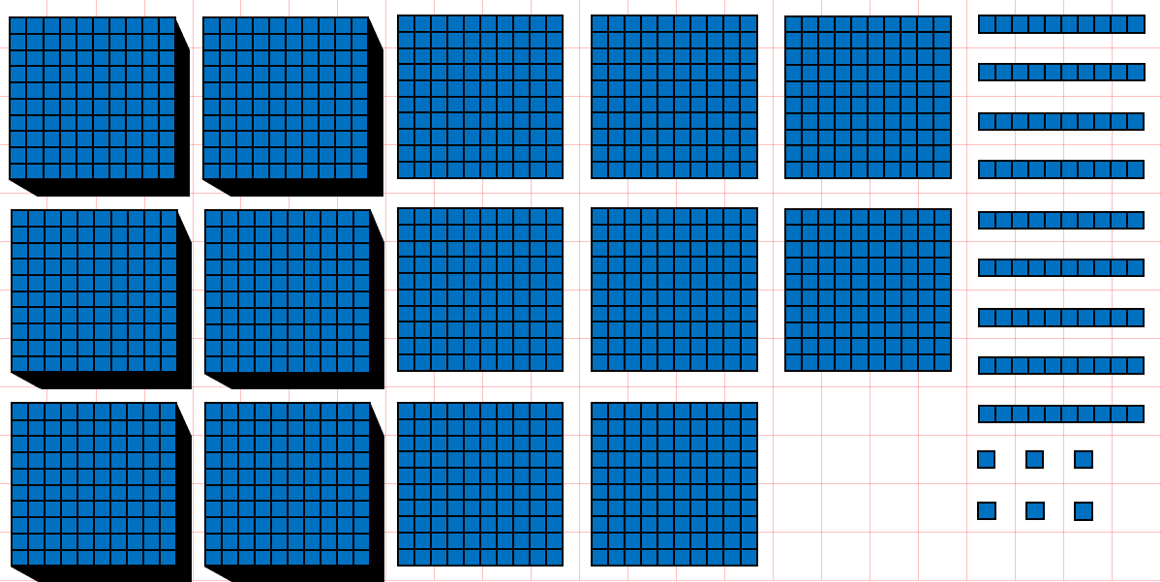  6869 |  | 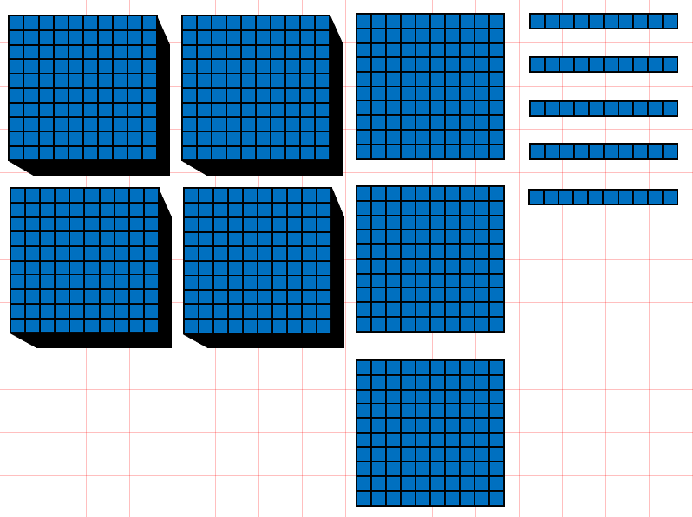  4350
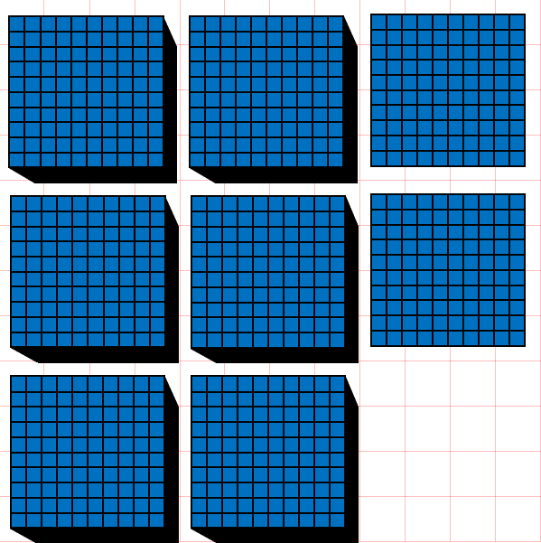  6200 | 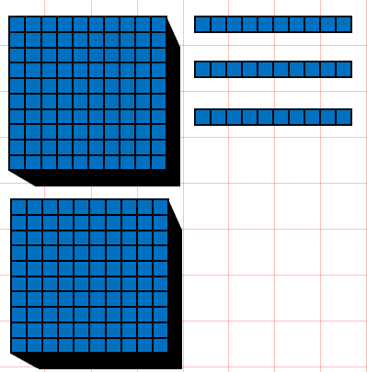  2030 |  | 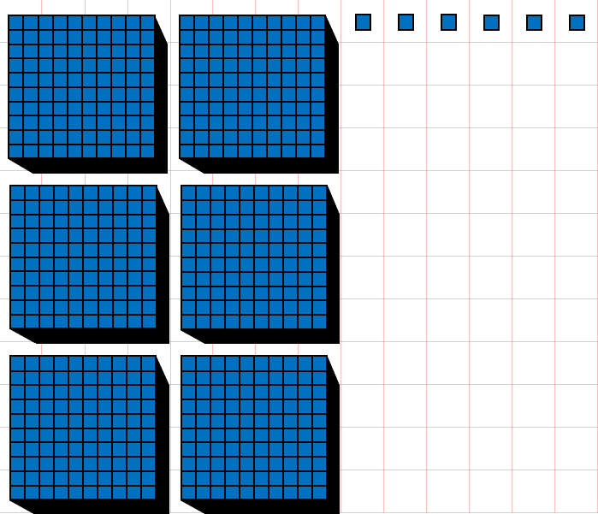  6006
Your Turn
Write the numbers shown by the blocks below in digits.
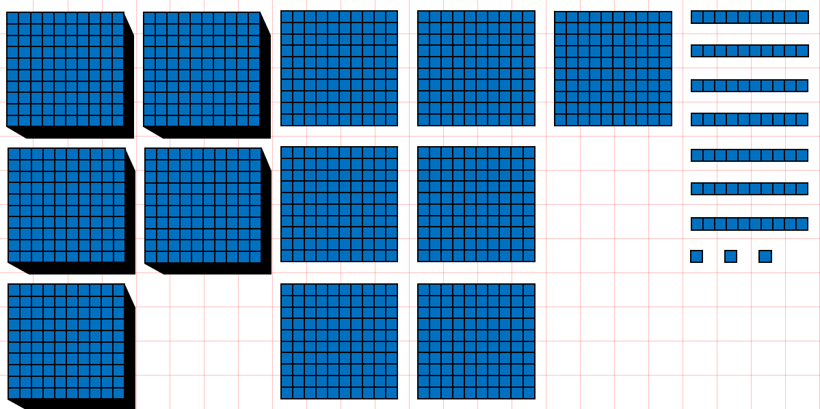  5773 |  | 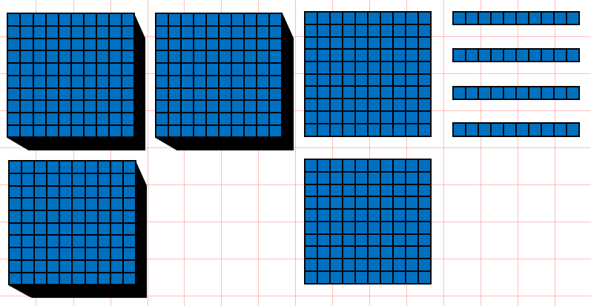  3240
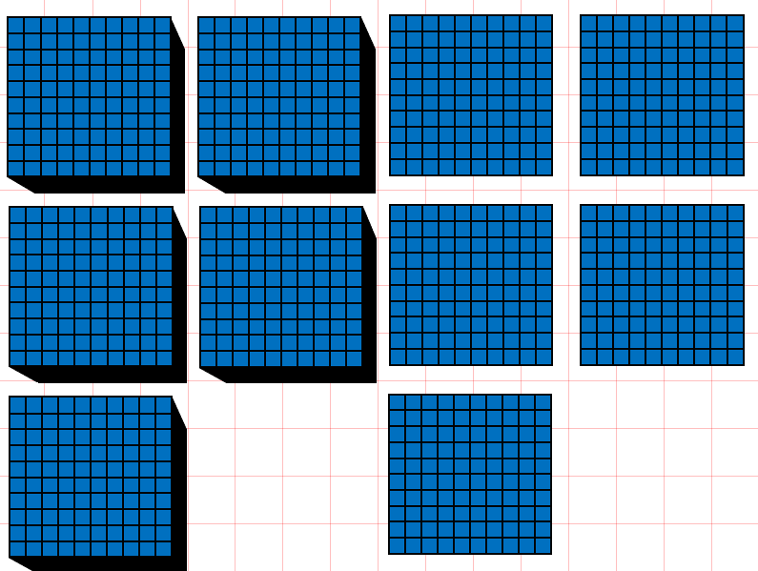  5500 | 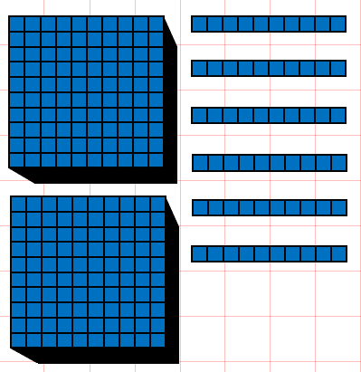  2060 |  | 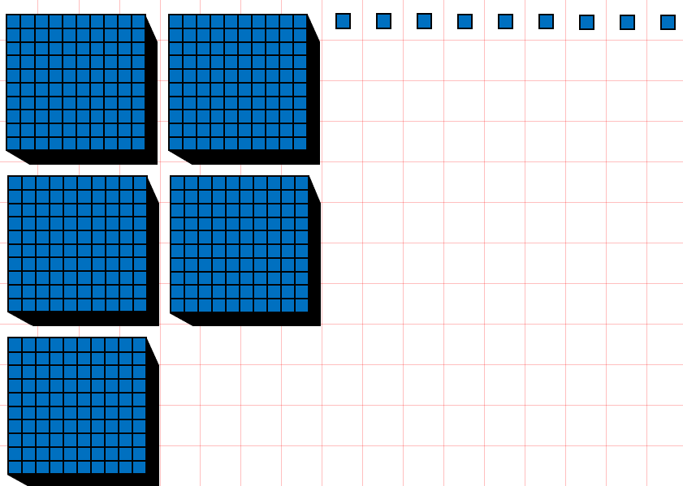  5009

2 Write four-digit numbers in digits
Let’s Learn
Write the numbers below in digits.
Four thousand, eight hundred and twenty-five  4825 | Nine thousand, two hundred  9200
Eight thousand and eighteen  8018 | Five thousand and five  5005

Your Turn
Write the numbers below in digits.
Two thousand, four hundred and eighty-seven  2487 | Eight thousand, nine hundred  8900
Seven thousand and twelve  7012 | Three thousand and one  3001

3 Write four-digit numbers in words
Let’s Learn
Write the numbers below in words.
1483 One thousand, four hundred and eighty-three

3072 Three thousand and seventy-two

3300 Three thousand, three hundred

4002 Four thousand and two

Your Turn
Write the numbers below in words.
4224 Four thousand, two hundred and twenty-four

8038 Eight thousand and thirty-eight

9100 Nine thousand, one hundred

5002 Five thousand and two

4 Identify the digit in each place value for four-digit numbers
Let’s Learn
For the questions below, write the digit in each place value.
4,593  4  Thousands:  5  Hundreds:  9  Tens:  3  Ones: | 4,809  8  Hundreds:  9  Ones:  4  Thousands:  0  Tens: | 3,190  0  Ones:  1  Hundreds:  9  Tens:  3  Thousands:
Your Turn
For the questions below, write the digit in each place value.
6,923  6  Thousands:  9  Hundreds:  2  Tens:  3  Ones: | 2,193  1  Hundreds:  3  Ones:  2  Thousands:  9  Tens: | 4,027  7  Ones:  0  Hundreds:  2  Tens:  4  Thousands:

5 Identify the value of each digit in four-digit numbers
Let’s Learn
For the questions below, write the value of each digit.
4,529  9  9 represents:  4000  4 represents:  500  5 represents:  20  2 represents: | 8,706  700  7 represents:  8000  8 represents:  6  6 represents: | 8,041  1  1 represents:  40  4 represents:  8000  8 represents:
Your Turn
For the questions below, write the value of each digit.
7,638  8  8 represents:  7000  7 represents:  600  6 represents:  30  3 represents: | 8,105  100  1 represents:  8000  8 represents:  5  5 represents: | 6,023  1  3 represents:  20  2 represents:  8000  6 represents:

6 Partition four-digit numbers
Let’s Learn
Partition the numbers below.
1
70
300
5000
5371 = + + +

5
30
700
1000
1735 = + + +

5
30
3000
3035 = + +

8
800
8000
8808 = + +

Your Turn
Partition the numbers below.
3
50
200
8000
8253 = + + +

1
20
100
2000
2121 = + + +

6
40
9000
9046 = + +

9
700
7000
7709 = + +

7 Compare four-digit numbers
Let’s Learn
For the questions below, write < or >
>  3528 ____ 2972 | >  4922 ____ 4099 | <  4722 ____ 4771 | >  5096 ____5093
Your Turn
For the questions below, write < or >
<  2848 ____ 8248 | >  6398 ____ 6099 | >  3824 ____ 3818 | <  8290 ____8292
8 Order four-digit numbers
Let’s Learn
Order each set of numbers from smallest to largest.
595, 9595, 9559, 5595, 5955
595
5595
5955
9559
9595

4411, 1441, 1414, 5111, 444
444
1414
1441
4411
5111

Your Turn
Order each set of numbers from smallest to largest.
2752, 277, 2572, 7225, 2725
277
2572
2725
2752
7225

533, 5333, 3535, 3553, 5353
533
3535
3553
5333
5353

9 Round to the nearest 1000
Let’s Learn
Round the numbers below to the nearest 1000.
2392 ≈ 2000 | 3971 ≈ 4000 | 7018 ≈ 7000 | 5544 ≈ 6000
Your Turn
Round the numbers below to the nearest 1000.
5293 ≈ 5000 | 3288 ≈ 3000 | 6919 ≈ 7000 | 6884 ≈ 7000

10 Round to the nearest 1000, 100 and 10
Let’s Learn
Round the numbers below.
4 5 4 9  4550  Nearest 10 ≈  4500  Nearest 100 ≈  5000  Nearest 1000 ≈ | 2 3 8 2  2380  Nearest 10 ≈  2400  Nearest 100 ≈  2000  Nearest 1000 ≈ | 5 8 9 6  5900  Nearest 10 ≈  5900  Nearest 100 ≈  6000  Nearest 1000 ≈
Your Turn
Round the numbers below.
3 6 3 7  3640  Nearest 10 ≈  3600  Nearest 100 ≈  4000  Nearest 1000 ≈ | 1 4 5 4  1450  Nearest 10 ≈  1500  Nearest 100 ≈  1000  Nearest 1000 ≈ | 4 7 9 6  4800  Nearest 10 ≈  4800  Nearest 100 ≈  5000  Nearest 1000 ≈

11 Write numbers to 100 in Roman numerals
Let’s Learn
Write the numbers below in Roman numerals.
35 = XXXV | 72 = LXXII | 27 = XXVII | 83 = LXXXIII | 38 = XXXVIII
99 = XCIX | 29 = XXIX | 92 = XCII | 74 = LXXIV | 47 = XLVII

Your Turn
Write the numbers below in Roman numerals.
26 = XXVI | 63 = LXIII | 36 = XXXVI | 94 = XCIV | 49 = XLIX
77 = LXXVII | 28 = XXVIII | 82 = LXXXII | 54 = LIV | 45 = XLV

12 Read Roman numerals to 100
Let’s Learn
Write the numbers represented by Roman numerals below.
IV = 4 | VII = 7 | XIX = 19 | XXVI = 26 | XXXIV = 34
XXXVII = 37 | XLI = 41 | XLIV = 44 | XLIX = 49 | LV = 55
LXIV = 64 | LXXIX = 79 | LXXXIII = 83 | XCIV = 94 | XCVIII = 98
Your Turn
Write the numbers represented by Roman numerals below.
VI = 6 | IX = 9 | XV = 15 | XXVIII = 28 | XXXVI = 36
XXXVIII = 38 | XLII = 42 | XLV = 45 | LI = 51 | LIV = 54
LXIX = 69 | LXXIV = 74 | LXXXI = 81 | XCVII = 97 | XCIX = 99

Addition
Go to https://keystage2maths.com/y4/addition/ for help.

1 Count on in ones from a four-digit number
Let’s Learn
For the questions below, write the next seven numbers, counting in ones.
4095, 4096, 4097,
4098
4099
4100
4104
4103
4102
4101

2997, 2998, 2999,
3000
3001
3002
3006
3005
3004
3003

Your Turn
For the questions below, write the next seven numbers, counting in ones.
6093, 6094, 6095,
6096
6097
6098
6102
6101
6100
6099

4996, 4997, 4998,
4999
5000
5001
5005
5004
5003
5002

2 Add a single-digit number to a four-digit number
Let’s Learn
Complete the questions below using mental methods.
6098 + 5 = 6103 | 5636 + 8 = 5644 | 2994 + 9 = 3003 | 3993 + 7 = 4000
Your Turn
Complete the questions below using mental methods.
4096 + 5 = 4101 | 7647 + 8 = 7655 | 1995 + 9 = 2004 | 8992 + 8 = 9000

3 Count on in tens from a four-digit number
Let’s Learn
For the questions below, write the next seven numbers, counting on in tens.
5476, 5486, 5496,
5506
5516
5526
5566
5556
5546
5536

6964, 6974, 6984,
6994
7004
7014
7054
7044
7034
7024

Your Turn
For the questions below, write the next seven numbers, counting on in tens.
4745, 4755, 4765,
4775
4785
4795
4835
4825
4815
4805

7342, 7352, 7362,
7372
7382
7392
7432
7422
7412
7402

4 Add a multiple of 10 to a four-digit number
Let’s Learn
Complete the questions below using mental methods.
8054 + 50 = 8104 | 7383 + 40 = 7423 | 3979 + 50 = 4029 | 2996 + 70 = 3066
Your Turn
Complete the questions below using mental methods.
7050 + 60 = 7110 | 6288 + 40 = 6328 | 2985 + 50 = 3035 | 1998 + 70 = 2068

5 Add two multiples of 100 beyond 1000
Let’s Learn
Complete the questions below using mental methods.
900 + 300 = 1200 | 800 + 600 = 1400 | 1700 + 300 = 2000 | 5500 + 800 = 6300
Your Turn
Complete the questions below using mental methods.
700 + 500 = 1200 | 900 + 800 = 1700 | 2500 + 500 = 3000 | 4700 + 800 = 5500

6 Count on in hundreds from a four-digit number
Let’s Learn
For the questions below, write the next seven numbers, counting on in hundreds.
6132, 6232, 6332,
6432
6532
6632
7032
6932
6832
6732

4555, 4655, 4755,
4855
4955
5055
5455
5355
5255
5155

Your Turn
For the questions below, write the next seven numbers, counting on in hundreds.
5355, 5455, 5555,
5655
5755
5855
6255
6155
6055
5955

3520, 3620, 3720,
3820
3920
4020
4420
4320
4220
4120

7 Add a multiple of 100 to a four-digit number
Let’s Learn
Complete the questions below using mental methods.
1244 + 500 = 1744 | 3539 + 500 = 4039 | 5381 + 800 = 6181 | 3855 + 800 = 4655
Your Turn
Complete the questions below using mental methods.
3333 + 500 = 3833 | 4830 + 500 = 5330 | 6655 + 800 = 7455 | 2999 + 700 = 3699

8 Add four-digit numbers using column addition
Let’s Learn
Complete the questions below using column addition.
2839 + 86 = 2925 | 2424 + 909 = 3333 | 856 + 567 = 1423 | 3867 + 2536 = 6403
Your Turn
Complete the questions below using column addition.
5976 + 68 = 6044 | 5555 + 918 = 6473 | 769 + 652 = 1421 | 4844 + 4188 = 9032

Subtraction
Go to https://keystage2maths.com/y4/subtraction/ for help.

1 Count back in ones from a four-digit number
Let’s Learn
For the questions below, write the next seven numbers, counting back in ones.
2106, 2105, 2104,
2103
2102
2101
2097
2098
2099
2100

4003, 4002, 4001,
4000
3999
3998
3994
3995
39966
3997

Your Turn
For the questions below, write the next seven numbers, counting back in ones.
3105, 3104, 3103,
3102
3101
3100
3096
3097
3098
3099

2006, 2005, 2004,
2003
2002
2001
1997
1998
1999
2000

2 Subtract a single-digit number from a four-digit number
Let’s Learn
Complete the questions below using mental methods.
7342 – 8 = 7334 | 4103 – 4 = 4099 | 2000 – 6 = 1994 | 3003 – 8 = 2995
Your Turn
Complete the questions below using mental methods.
5554 – 8 = 5546 | 6101 – 5 = 6096 | 3000 – 7 = 2993 | 4004 – 9 = 3995

3 Count back in tens from a four-digit number
Let’s Learn
For the questions below, write the next seven numbers, counting back in tens.
6143, 6133, 6123,
6113
6103
6093
6053
6063
6073
6083

7055, 7045, 7035,
7025
7015
7005
6965
6975
6985
6995

Your Turn
For the questions below, write the next seven numbers, counting back in tens.
5465, 5455, 5445,
5435
5425
5415
5375
5385
5395
5405

6044, 6034, 6024,
6014
6004
5994
5954
5964
5974
5984

4 Subtract a multiple of 10 from a four-digit number
Let’s Learn
Complete the questions below using mental methods.
2465 – 50 = 2415 | 3723 – 40 = 3682 | 4006 – 60 = 3946 | 7043 – 80 = 6963
Your Turn
Complete the questions below using mental methods.
3595 – 50 = 3545 | 2312 – 40 = 2272 | 7005 – 70 = 6935 | 1044 – 80 = 964

5 Subtract a multiple of 100 from a four-digit multiple of 100
Let’s Learn
8700 – 600 = 8100 | 1400 – 600 = 800 | 5500 – 800 = 4700 | 6200 – 900 = 5300
Your Turn
5500 – 400 = 5100 | 1700 – 900 = 800 | 2300 – 700 = 1600 | 7300 – 800 = 6500

6 Count back in hundreds from a four-digit number
Let’s Learn
For the questions below, write the next seven numbers, counting back in hundreds.
1862, 1762, 1662,
1562
1492
1362
962
1062
1162
1262

5565, 5465, 5365,
5265
5165
5065
4665
4765
4865
4965

Your Turn
For the questions below, write the next seven numbers, counting back in hundreds.
1766, 1666, 1566,
1466
1366
1266
866
966
1066
1166

6466, 6366, 6266,
6166
6066
5966
5566
5666
5766
5866

7 Subtract a multiple of 100 from a four-digit number
Let’s Learn
1202 – 300 = 902 | 4488 – 400 = 4088 | 5380 – 800 = 4580 | 7525 – 900 = 6625
Your Turn
1303 – 500 = 803 | 2660 – 600 = 2060 | 6222 – 700 = 5522 | 7330 – 900 = 6430

8 Add and subtract a multiple of 1000 from a four-digit number
Let’s Learn
3924 + 3000 = 6924 | 4905 + 2000 = 6905 | 2593 – 2000 = 593 | 5999 – 3000 = 2999
Your Turn
2749 + 6000 = 8749 | 4959 + 3000 = 7959 | 6440 – 6000 = 440 | 9437 – 4000 = 5437

9 Subtract mentally by finding the difference, targeting the ten, hundred or thousand
Let’s Learn
Complete the questions below by finding the difference, targeting the ten, hundred or thousand.
2006 – 1893 = 113 | 4000 – 3775 = 225 | 4007 – 3950 = 57 | 3100 – 2968 = 132
Your Turn
Complete the questions below by finding the difference, targeting the ten, hundred or thousand.
3006 – 2797 = 209 | 5000 – 4546 = 454 | 3004 – 2970 = 34 | 5200 – 4958 = 242

10 Subtract four-digit numbers using column subtraction
Let’s Learn
Complete the questions below using column subtraction.
5421 – 55 = 5366 | 5815 – 746 = 5069 | 4342 – 2352 = 1990 | 4342 – 3444 = 898
Your Turn
Complete the questions below using column subtraction.
6558 – 69 = 6489 | 3312 – 158 = 3154 | 8266 – 1491 = 6775 | 6520 – 5558 = 962

11 Exchange across zero to subtract four-digit numbers using column subtraction
Let’s Learn
5006 – 55 = 4951 | 4002 – 533 = 3469 | 7008 – 3933 = 3075 | 4000 – 2436 = 1564
Your Turn
8008 – 66 = 7942 | 5004 – 885 = 4119 | 6006 – 4374 = 1632 | 7000 – 4727 = 2273

12 Check answers using the inverse operation with four-digit numbers
Let’s Learn
Check the answers to these calculations by using the inverse operation.
3952 + 1064 = 5016  5016 – 1064 = 3952 or 5016 – 3952 = 1064 | 7433 – 2488 = 4945  4945 + 2488 = 7433 or 2488 + 4945 = 7433
Your Turn
Check the answers to these calculations by using the inverse operation.
2794 + 1254 = 4048  4048 – 1254 = 2794 or 4048 – 2794 = 1254 | 8102 – 3456 = 4646  4646 + 3456 = 8102 or 3456 + 4646 = 8102

13 Solve missing number problems for addition and subtraction with four-digit numbers
Let’s Learn
Complete the questions below by finding the missing numbers.
8010  = 4503 + 3507 | 4505  + 3803 = 8313
3654  7309 – = 3655 | 7190  – 2646 = 4544
Your Turn
Complete the questions below by finding the missing numbers.
8880  = 4965 + 3915 | 4837  + 4535 = 9372
4834  7528 – = 2694 | 5466  – 2638 = 2828

Multiplication
Go to https://keystage2maths.com/y4/multiplication/ for help.

1 Multiply by 6
Let’s Learn
1 x 6 = 6 | 5 x 6 = 30 | 8 x 6 = 48 | 12 x 6 = 72

2 Connect the 3 and 6 times tables
Let’s Learn
4  x 6 = 8 x 3 | 3  x 6 = 6 x 3 | 2  x 3 = 1 x 6

3 Multiply by 7
Let’s Learn
3 x 7 = 21 | 6 x 7 = 42 | 8 x 7 = 56 | 10 x 7 = 70

4 Multiply by 9
Let’s Learn
1 x 9 = 9 | 5 x 9 = 45 | 9 x 9 = 81 | 11 x 9 = 99

5 Multiply by 11
Let’s Learn
1 x 11 = 11 | 4 x 11 = 44 | 8 x 11 = 88 | 12 x 11 = 132

6 Multiply by 12
1 x 12 = 12 | 4 x 12 = 48 | 8 x 12 = 96 | 12 x 12 = 144

7 Multiply by a multiple of 10 with knowledge of the 6, 7, 9, 11 and 12 times tables
Let’s Learn
3 x 60 = 180 | 90 x 7 = 630 | 9 x 70 = 630
Your Turn
7 x 60 = 420 | 80 x 9 = 720 | 9 x 80 = 720

8 Multiply by a two-digit number using the grid method using knowledge of the 6, 7 and 9 times tables
Let’s Learn
Answer the questions below using the grid method.
4 x 66 = 264 | 79 x 6 = 474
Your Turn
Answer the questions below using the grid method.
9 x 28 = 252 | 67 x 7 = 469

9 Multiply by a two-digit number using the expanded column method using knowledge of the 6, 7 and 9 times tables
Let’s Learn
Answer the questions below using the expanded column method.
63 x 7 = 441 | 76 x 9 = 684 | 89 x 6 = 534
Your Turn
Answer the questions below using the expanded column method.
57 x 7 = 399 | 75 x 8 = 600 | 68 x 9 = 612

10 Multiply by a two-digit number using the column method using knowledge of the 6, 7 and 9 times tables
Let’s Learn
Answer the questions below using the column method.
52 x 6 = 432 | 28 x 9 = 252 | 7 x 76 = 532
Your Turn
Answer the questions below using the column method.
56 x 6 = 336 | 82 x 9 = 738 | 7 x 39 = 273

11 Multiply three-numbers together
Let’s Learn
3 x 8 x 9 = 216 | 8 x 6 x 5 = 240 | 6 x 7 x 5 = 210
Your Turn
4 x 7 x 9 = 252 | 4 x 9 x 5 = 180 | 8 x 7 x 5 = 280

12 Multiply a single-digit number by 100
Let’s Learn
3 x 100 = 300 | 100 x 5 = 500 | 8 x 100 = 800
Your Turn
2 x 100 = 200 | 100 x 6 = 600 | 7 x 100 = 700

13 Multiply a single-digit number by a multiple of 100
Let’s Learn
3 x 300 = 900 | 500 x 5 = 2500 | 8 x 800 = 6400
Your Turn
2 x 400 = 800 | 700 x 7 = 4900 | 9 x 800 = 7200

14 Multiply by a three-digit number using the grid method
Let’s Learn
Answer the questions below using the grid method.
5 x 123 = 615 | 234 x 4 = 936
Your Turn
Answer the questions below using the grid method.
5 x 147 = 735 | 389 x 3 = 1167
7 x 229 = 1603 | 476 x 9 = 4284

15 Multiply by a three-digit number using the expanded column method
Let’s Learn
Answer the questions below using the expanded column method.
353 x 2 = 706 | 457 x 5 = 2285 | 293 x 7 = 2051
Your Turn
Answer the questions below using the expanded column method.
564 x 2 = 1128 | 929 x 5 = 4645 | 297 x 6 = 1782

16 Multiply by a three-digit number using the column method
Let’s Learn
Answer the questions below using the column method.
167 x 4 = 668 | 879 x 3 = 2637 | 4 x 867 = 3468
Your Turn
Answer the questions below using the column method.
157 x 5 = 785 | 976 x 4 = 3904 | 8 x 817 = 6536

Division
Go to https://keystage2maths.com/y4/division/ for help.

1 Divide by 2, 3, 4, 5, 8 and 10 with remainders
Let’s Learn
11 ÷ 4 = | 18 ÷ 5 = | 15 ÷ 2 =

2 Divide by 6
Let’s Learn
12 ÷ 6 = | 30 ÷ 6 = | 42 ÷ 6 = | 66 ÷ 6 =

3 Divide by 7
Let’s Learn
7 ÷ 7 = | 28 ÷ 7 = | 49 ÷ 7 = | 84 ÷ 7 =

4 Divide by 9
Let’s Learn
18 ÷ 9 = | 45 ÷ 9 = | 81 ÷ 9 = | 90 ÷ 9 =

5 Divide by 11
Let’s Learn
11 ÷ 11 = | 44 ÷ 11 = | 99 ÷ 11 = | 121 ÷ 11 =

6 Divide by 12
Let’s Learn
12 ÷ 12 = | 72 ÷ 12 = | 84 ÷ 12 = | 120 ÷ 12 =

7 Solve missing number problems for multiplication and division with knowledge of the 6, 7, 9, 11 and 12 times tables
Let’s Learn
= 6 x 6 | = 63 ÷ 9 | 7 x = 42
x 12 = 108 | ÷ 11 = 9 | 56 ÷ = 7

8 Divide with remainders
Let’s Learn
20 ÷ 6 = | 24 ÷ 7 = | 64 ÷ 9 =

9 Divide a multiple of 10 by a single-digit number mentally using knowledge of the 6, 7 and 9 times tables
Let’s Learn
420 ÷ 7 = | 360 ÷ 6 = | 720 ÷ 9 =
Your Turn
280 ÷ 7 = | 560 ÷ 8 = | 630 ÷ 9 =

10 Divide a multiple of 100 by a single-digit number mentally
Let’s Learn
600 ÷ 2 = | 3500 ÷ 5 = | 2700 ÷ 3 =
Your Turn
800 ÷ 2 = | 3600 ÷ 6 = | 4500 ÷ 9 =

11 Divide a three-digit number by a single-digit number using long division
Let’s Learn
Answer the questions below using long division.
486 ÷ 3 = | 581 ÷ 7 = | 592 ÷ 8 =
Your Turn
Answer the questions below using long division.
588 ÷ 2 = | 498 ÷ 6 = | 651 ÷ 7 =

12 Divide a three-digit number by a single-digit number using short division
Let’s Learn
Now answer the questions above using short division.
Your Turn
Now answer the questions above using short division.

13 Solve missing number multiplication problems
Let’s Learn
= 164 x 6 | 3 x = 522 | x 9 = 504
Your Turn
= 109 x 7 | 6 x = 732 | x 7 = 525

14 Solve missing number division problems
Let’s Learn
= 596 ÷ 2 | 632 ÷ = 8 | ÷ 9 = 304
Your Turn
= 591 ÷ 3 | 276 ÷ = 6 | ÷ 7 = 607

15 Divide by chunking with remainders
Let’s Learn
Answer the questions below by chunking.
69 ÷ 2 = | 124 ÷ 3 = | 135 ÷ 4 =
Your Turn
Answer the questions below by chunking.
97 ÷ 3 = | 250 ÷ 6 = | 195 ÷ 8 =

16 Divide using long division with remainders
Let’s Learn
Now answer the questions above using long division.
Your Turn
Now answer the questions above using long division.

17 Divide using short division with remainders
Let’s Learn
Now answer the questions above using short division.
Your Turn
Now answer the questions above using long division.

Fractions
Go to https://keystage2maths.com/y4/fractions/ for help.

1 Recognise pairs of fractions that add up to 1
Let’s Learn
$\frac{4}{5}$  $\frac{1}{5}$ + = 1 | $\frac{3}{8}$  $\frac{5}{8}$ + = 1 | $\frac{3}{7}$  $\frac{4}{7}$ + = 1 | $\frac{1}{3}$  $\frac{2}{3}$ + = 1
Your Turn
$\frac{2}{3}$  $\frac{1}{3}$ + = 1 | $\frac{7}{8}$  $\frac{1}{8}$ + = 1 | $\frac{1}{6}$  $\frac{5}{6}$ + = 1 | $\frac{3}{5}$  $\frac{2}{5}$ + = 1

2 Count up in halves, thirds and quarters beyond 1
Let’s Learn
For each diagram, write the equivalent mixed number or improper fraction shown.
1$\frac{1}{2}$   | 1$\frac{2}{3}$  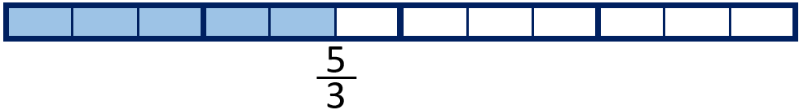
1$\frac{3}{4}$  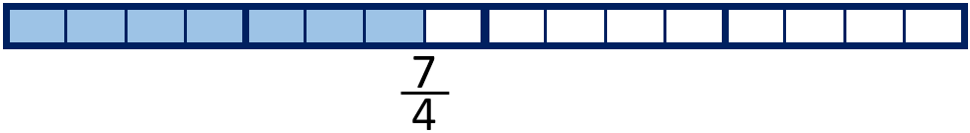 | 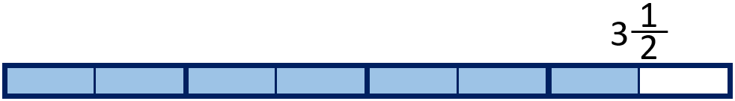  $\frac{7}{2}$
  $\frac{7}{3}$ |   $\frac{13}{4}$
Your Turn
For each diagram, write the equivalent mixed number or improper fraction shown.
2$\frac{1}{2}$  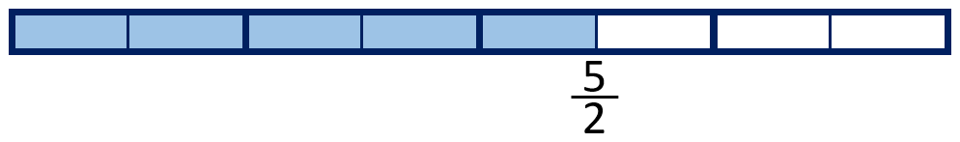 | 2$\frac{1}{3}$  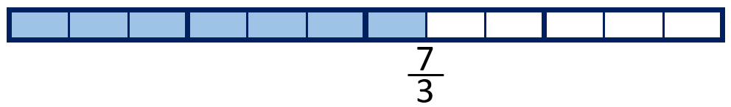
3$\frac{1}{4}$  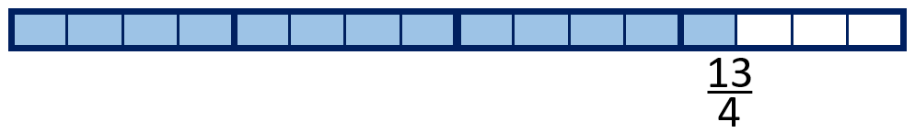 |   $\frac{3}{2}$
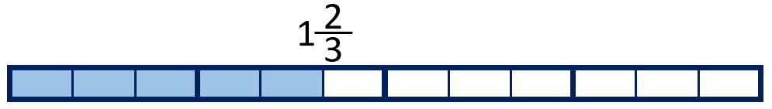  $\frac{5}{3}$ | 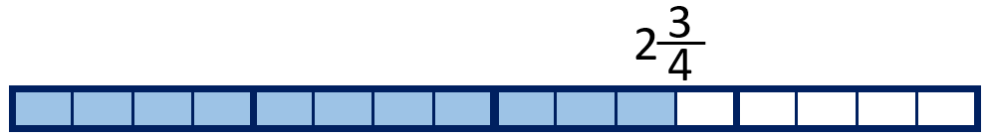  $\frac{11}{4}$

3 Identify equivalent fractions to a half
Let’s Learn
6
5
2
4
3
$\frac{1}{2}$ = $\frac{}{4}$ = $\frac{}{6}$ = $\frac{}{8}$ = $\frac{}{10}$ = $\frac{}{12}$

4 Use multiplication to find equivalent fractions
Let’s Learn
3  $\frac{1}{3}$ = $\frac{}{9}$ | 6  $\frac{3}{5}$ = $\frac{}{10}$ | 8  $\frac{2}{5}$ = $\frac{}{20}$ | $\frac{2}{3}$ = $\frac{8}{}$  12 | $\frac{3}{4}$ = $\frac{9}{}$  12
Your Turn
2  $\frac{1}{4}$ = $\frac{}{8}$ | 6  $\frac{2}{5}$ = $\frac{}{15}$ | 12  $\frac{2}{3}$ = $\frac{}{18}$ | $\frac{2}{7}$ = $\frac{6}{}$  21 | $\frac{2}{9}$ = $\frac{8}{}$  36

5 Use division to find equivalent fractions
Let’s Learn
2  $\frac{6}{9}$ = $\frac{}{3}$ | 1  $\frac{4}{12}$ = $\frac{}{3}$ | 5  $\frac{20}{24}$ = $\frac{}{6}$ | $\frac{6}{15}$ = $\frac{2}{}$  5 | $\frac{10}{20}$ = $\frac{1}{}$  2
Your Turn
3  $\frac{6}{8}$ = $\frac{}{4}$ | 1  $\frac{4}{20}$ = $\frac{}{5}$ | 4  $\frac{16}{28}$ = $\frac{}{7}$ | $\frac{10}{15}$ = $\frac{2}{}$  3 | $\frac{9}{27}$ = $\frac{1}{}$  3

6 Find a non-unit fraction of a number
Let’s Learn
$\frac{2}{5}$of 30 = 12 | $\frac{5}{6}$ of 24 = 20 | $\frac{3}{8}$of 24 = 9
Your Turn
$\frac{3}{5}$of 45 = 27 | $\frac{4}{5}$ of 35 = 28 | $\frac{5}{8}$of 32 = 20

7 Find a whole quantity give the quantity represented by a non-unit fraction
Let’s Learn
$\frac{2}{5}$ of = 10  25 | $\frac{5}{6}$ of = 15  18 | $\frac{3}{5}$ of = 15  25
Your Turn
$\frac{3}{5}$ of = 15  25 | $\frac{3}{4}$ of = 27  36 | $\frac{3}{7}$ of = 21  49

Decimals
Go to https://keystage2maths.com/y4/decimals/ for help.

1 Recognise tenths and hundredths
Let’s Learn
Answer as a decimal.
1 ÷ 10 = 0.1 | 1 ÷ 100 = 0.01 | 0.1 ÷ 10 = 0.01

2 Convert between fractional and decimal tenths and hundredths
Let’s Learn
90  0.9 =  $\frac{}{100}$ | 40  0.4 =  $\frac{}{100}$ | 2  0.02 =  $\frac{}{100}$ | 9  0.09 =  $\frac{}{100}$ | 12  0.12 =  $\frac{}{100}$ | 99  0.99 =  $\frac{}{100}$
Your Turn
80  0.8 =  $\frac{}{100}$ | 10  0.1 =  $\frac{}{100}$ | 3  0.03 =  $\frac{}{100}$ | 8  0.08 =  $\frac{}{100}$ | 38  0.38 =  $\frac{}{100}$ | 44  0.44 =  $\frac{}{100}$

3 Recognise equivalent fractions with tenths and hundredths
Let’s Learn
Write the equivalent number of tenths and in decimal form.
0.2  2  $\frac{20}{100}$ = $\frac{}{10}$ = | 0.6  6  $\frac{60}{100}$ = $\frac{}{10}$ =
Your Turn
Write the equivalent number of tenths and in decimal form.
0.3  3  $\frac{30}{100}$ = $\frac{}{10}$ = | 0.9  9  $\frac{90}{100}$ = $\frac{}{10}$ =

4 Partition decimals into tenths and hundredths
Let’s Learn
Partition each decimal into tenths and hundredths.
0.47 = 0.4 + 0.07 | 0.61 = 0.6 + 0.01
Your Turn
Partition each decimal into tenths and hundredths.
0.15 = 0.1 + 0.05 | 0.51 = 0.5 + 0.01

5 Add tenths and hundredths in decimal form
Let’s Learn
0.2 + 0.02 = 0.22 | 0.5 + 0.06 = 0.56
Your Turn
0.7 + 0.05 = 0.75 | 0.3 + 0.08 = 0.38

6 Subtract tenths and hundredths in decimal form
Let’s Learn
0.2 – 0.02 = 0.18 | 0.5 – 0.06 = 0.44 | 0.45 – 0.3 = 0.15 | 0.58 – 0.5 = 0.08
Your Turn
0.6 – 0.04 = 0.56 | 0.9 – 0.01 = 0.89 | 0.77 – 0.4 = 0.37 | 0.44 – 0.4 = 0.04

7 Count on in tenths or hundredths
Let’s Learn
For the questions below, write the next seven numbers, counting in tenths or hundredths.
0.62, 0.63, 0.64,
0.65
0.66
0.67
0.71
0.7
0.69
0.68

0.05, 0.15, 0.25,
0.35
0.45
0.55
0.95
0.85
0.75
0.65

0.94, 0.95, 0.96,
0.97
0.98
0.99
1.03
1.02
1.01
1

0.49, 0.59, 0.69,
0.79
0.89
0.99
1.39
1.29
1.19
1.09

3.47, 3.48, 3.49,
3.5
3.51
3.52
3.56
3.55
3.54
3.53

2.61, 2.71, 2.81,
2.91
3.01
3.11
3.51
3.41
3.31
3.21

Your Turn
For the questions below, write the next seven numbers, counting in tenths or hundredths.
0.73, 0.74, 0.75,
0.76
0.77
0.78
0.82
0.81
0.8
0.79

0.02, 0.12, 0.22,
0.32
0.42
0.52
0.92
0.82
0.72
0.62

0.97, 0.98, 0.99,
1
1.01
1.02
1.06
1.05
1.04
1.03

0.37, 0.47, 0.57,
0.67
0.77
0.87
1.27
1.17
1.07
0.97

3.95, 3.96, 3.97,
3.98
3.99
4
4.04
4.03
4.02
4.01

2.45, 2.55, 2.65,
2.75
2.85
2.95
3.35
3.25
3.15
3.05

8 Count back in tenths or hundredths
Let’s Learn
For the questions below, write the next seven numbers, counting back in tenths or hundredths.
0.16, 0.15, 0.14,
0.13
0.12
0.11
0.07
0.08
0.09
0.1

1.05, 1.04, 1.03,
1.02
1.01
1
0.96
0.97
0.98
0.99

3.25, 3.24, 3.23,
3.22
3.21
3.2
3.16
3.17
3.18
3.19

3.25, 3.15, 3.05,
2.95
2.85
2.75
2.35
2.45
2.55
2.65

Your Turn
For the questions below, write the next seven numbers, counting back in tenths or hundredths.
0.24, 0.23, 0.22,
0.21
0.2
0.19
0.15
0.16
0.17
0.18

2.07, 2.06, 2.05,
2.04
2.03
2.02
1.98
1.99
2
2.01

5.55, 5.54, 5.53,
5.52
5.51
5.5
5.46
5.47
5.48
5.49

3.66, 3.56, 3.46,
3.36
3.26
3.16
2.76
2.86
2.96
3.06

9 Locate tenths and hundredths on a number line
Let’s Learn
0.48
0.42
0.39
0.32

1.77
1.74
1.68
1.63

0.15
0.45
0.65
0.95

1.35
0.95
0.45
0.05

0.96
0.58
0.43
0.18

Your Turn
0.89
0.81
0.78
0.73

2.97
2.94
2.89
2.84

0.85
0.55
0.25
0.05

0.35
1.05
1.55
1.95

0.87
0.51
0.34
0.09

10 Compare numbers with tenths or hundredths
Let’s Learn
Write > or < in each box.
<  0.2 0.33 | <  0.9 0.99 | >  0.5 0.45 | <  0.55 0.7
<  7.65 7.69 | >  4.71 4.69 | >  6.01 5.99 | <  5.45 5.5
Your Turn
Write > or < in each box.
<  0.5 0.54 | >  0.7 0.56 | <  0.8 0.91 | >  0.75 0.6
<  7.05 7.44 | >  5.72 4.73 | >  6.1 6.09 | <  5.79 5.9

11 Add numbers with one or two decimal places
Let’s Learn
6.1 + 2.35 = 8.45 | 5.3 + 1.95 = 7.25 | 56.38 + 24.7 = 81.01
Your Turn
6.9 + 6.15 = 13.05 | 16.3 + 1.87 = 18.17 | 48.26 + 12.8 = 61.06

12 Subtract numbers with one or two decimal places
Let’s Learn
31.8 – 6.45 = 25.35 | 26.8 – 6.12 = 20.68 | 125.48 – 72.3 = 53.18
Your Turn
52.4 – 6.67 = 45.73 | 39.1 – 6.09 = 33.01 | 118.72 – 91.3 = 27.42

13 Subtract numbers with one or two decimal places from whole numbers
Let’s Learn
5 – 1.35 = 3.65 | 8 – 4.65 = 3.35 | 11 – 4.01 = 6.99
Your Turn
4 – 1.15 = 2.85 | 7 – 2.25 = 4.75 | 12 – 6.01 = 5.99

14 Multiply numbers with hundredths by 10
Let’s Learn
5 x 10 = 50 | 0.5 x 10 = 5 | 0.05 x 10 = 0.5
0.09 x 10 = 0.9 | 0.43 x 10 = 4.3 | 4.03 x 10 = 40.3
Your Turn
6 x 10 = 60 | 0.6 x 10 = 6 | 0.06 x 10 = 0.6
0.07 x 10 = 0.7 | 0.67 x 10 = 6.7 | 6.07 x 10 = 60.7

15 Divide one-, two- or three-digit numbers by 100
Let’s Learn
4 ÷ 100 = 0.04 | 40 ÷ 100 = 0.4 | 67 ÷ 100 = 0.67
400 ÷ 100 = 4 | 399 ÷ 100 = 3.99 | 401 ÷ 100 = 4.01

Your Turn
2 ÷ 100 = 0.02 | 30 ÷ 100 = 0.3 | 32 ÷ 100 = 0.32
300 ÷ 100 = 3 | 302 ÷ 100 = 3.02 | 332 ÷ 100 = 3.32

16 Multiply decimals by 100
Let’s Learn
0.5 x 100 = 50 | 0.04 x 100 = 4 | 0.54 x 100 = 54
5.4 x 100 = 540 | 5.04 x 100 = 504 | 50.4 x 100 = 5040
Your Turn
0.8 x 100 = 80 | 0.06 x 100 = 6 | 0.86 x 100 = 86
6.8 x 100 = 680 | 8.06 x 100 = 806 | 80.6 x 100 = 8060

17 Solve missing number problems for multiplication and division of decimals by 10 or 100
Let’s Learn
100  8.3 x = 830 | 10  0.08 x = 0.8 | 100  0.83 x = 83
10  8.3 ÷ = 0.83 | 10  83 ÷ = 8.3 | 100  83 ÷ = 0.83
Your Turn
10  6.5 x = 65 | 10  0.65 x = 6.5 | 100  0.6 x = 60
100  6 ÷ = 0.06 | 100  65 ÷ = 0.65 | 10  60.5 ÷ = 6.05

