Place Value
Go to https://keystage2maths.com/y4/placevalue/ for help.

1 Recognise representations for four-digit numbers
Let’s Learn
Write the numbers shown by the blocks below in digits.
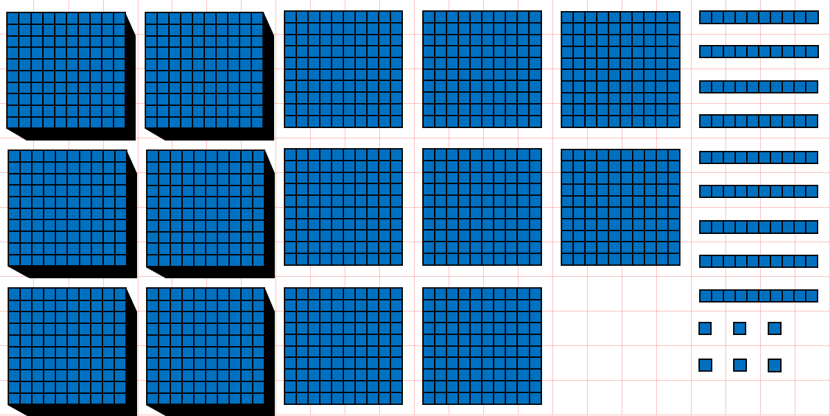 |  | 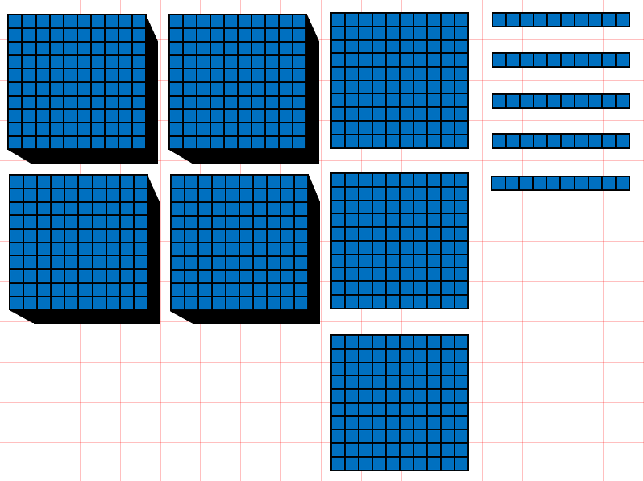
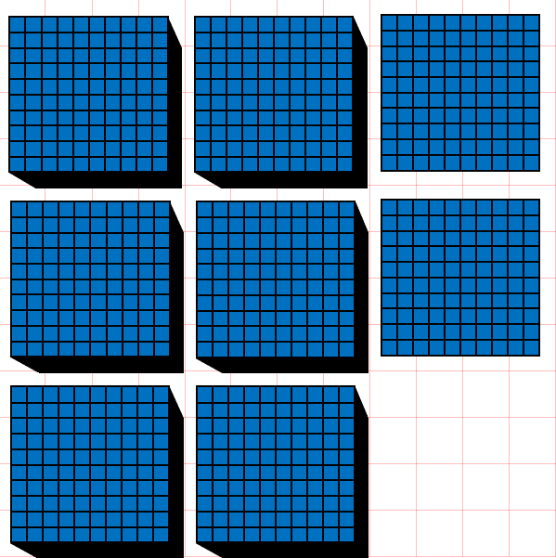 | 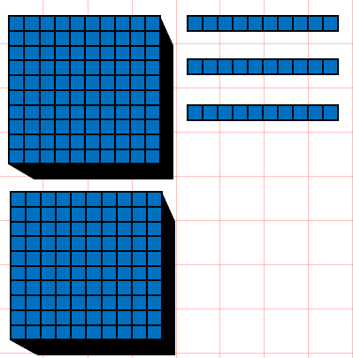 |  | 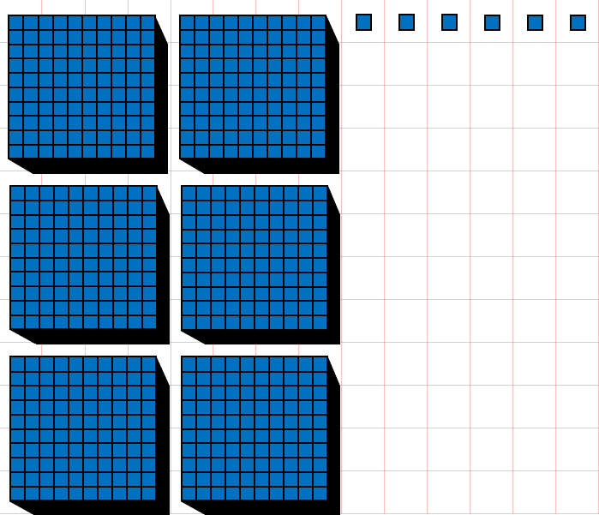
Your Turn
Write the numbers shown by the blocks below in digits.
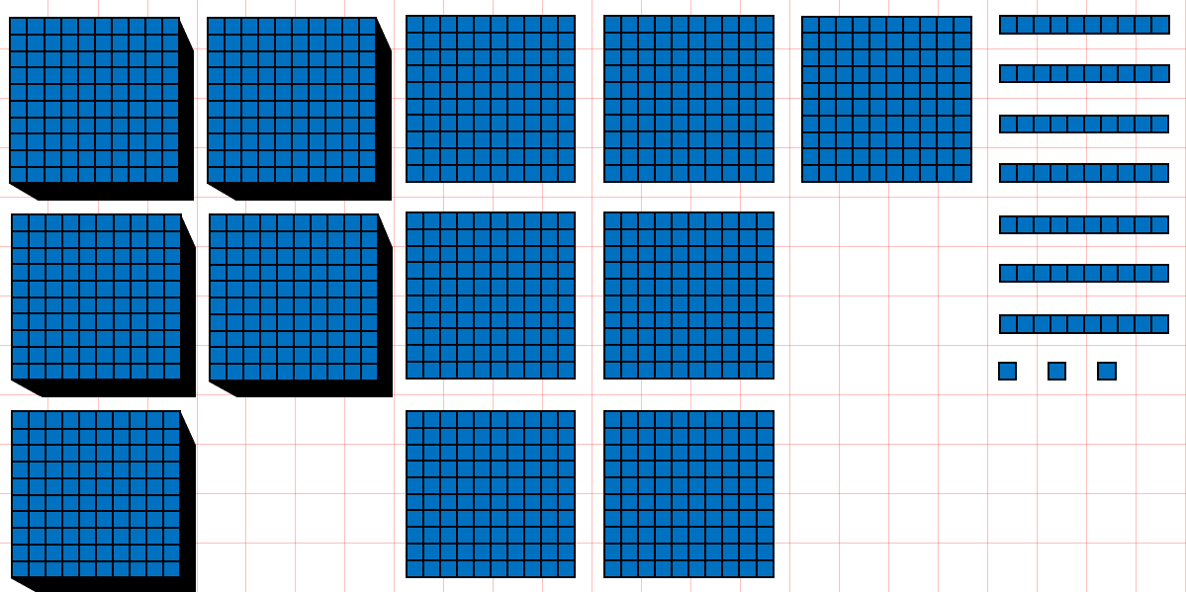 |  | 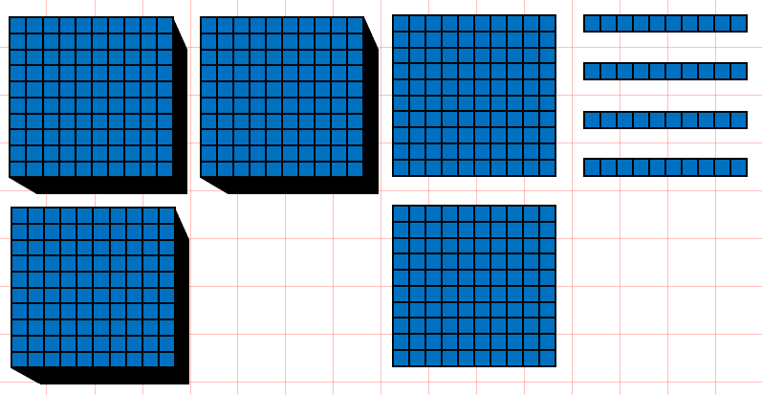
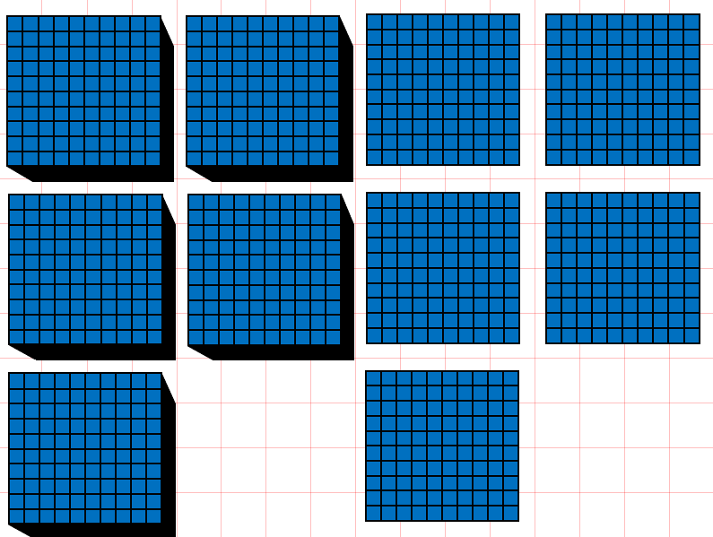 | 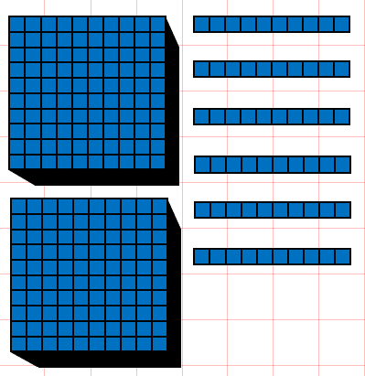 |  | 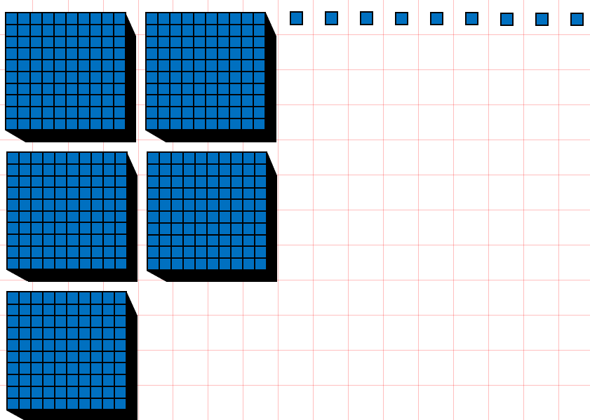

2 Write four-digit numbers in digits
Let’s Learn
Write the numbers below in digits.
Four thousand, eight hundred and twenty-five | Nine thousand, two hundred
Eight thousand and eighteen | Five thousand and five

Your Turn
Write the numbers below in digits.
Two thousand, four hundred and eighty-seven | Eight thousand, nine hundred
Seven thousand and twelve | Three thousand and one

3 Write four-digit numbers in words
Let’s Learn
Write the numbers below in words.
1483

3072

3300

4002

Your Turn
Write the numbers below in words.
4224

8038

9100

5002

4 Identify the digit in each place value for four-digit numbers
Let’s Learn
For the questions below, write the digit in each place value.
4,593  Thousands:  Hundreds:  Tens:  Ones: | 4,809  Hundreds:  Ones:  Thousands:  Tens: | 3,190  Ones:  Hundreds:  Tens:  Thousands:
Your Turn
For the questions below, write the digit in each place value.
6,923  Thousands:  Hundreds:  Tens:  Ones: | 2,193  Hundreds:  Ones:  Thousands:  Tens: | 4,027  Ones:  Hundreds:  Tens:  Thousands:

5 Identify the value of each digit in four-digit numbers
Let’s Learn
For the questions below, write the value of each digit.
4,529  9 represents:  4 represents:  5 represents:  2 represents: | 8,706  7 represents:  8 represents:  6 represents: | 8,041  1 represents:  4 represents:  8 represents:
Your Turn
For the questions below, write the value of each digit.
7,638  8 represents:  7 represents:  6 represents:  3 represents: | 8,105  1 represents:  8 represents:  5 represents: | 6,023  3 represents:  2 represents:  6 represents:

6 Partition four-digit numbers
Let’s Learn
Partition the numbers below.
5371 = + + +

1735 = + + +

3035 = + +

8808 = + +

Your Turn
Partition the numbers below.
8253 = + + +

2121 = + + +

9046 = + +

7709 = + +

7 Compare four-digit numbers
Let’s Learn
For the questions below, write < or >
3528 ____ 2972 | 4922 ____ 4099 | 4722 ____ 4771 | 5096 ____5093
Your Turn
For the questions below, write < or >
2848 ____ 8248 | 6398 ____ 6099 | 3824 ____ 3818 | 8290 ____8292
8 Order four-digit numbers
Let’s Learn
Order each set of numbers from smallest to largest.
595, 9595, 9559, 5595, 5955

4411, 1441, 1414, 5111, 444

Your Turn
Order each set of numbers from smallest to largest.
2752, 277, 2572, 7225, 2725

533, 5333, 3535, 3553, 5353

9 Round to the nearest 1000
Let’s Learn
Round the numbers below to the nearest 1000.
2392 ≈ | 3971 ≈ | 7018 ≈ | 5544 ≈
Your Turn
Round the numbers below to the nearest 1000.
5293 ≈ | 3288 ≈ | 6919 ≈ | 6884 ≈

10 Round to the nearest 1000, 100 and 10
Let’s Learn
Round the numbers below.
4 5 4 9  Nearest 10 ≈  Nearest 100 ≈  Nearest 1000 ≈ | 2 3 8 2  Nearest 10 ≈  Nearest 100 ≈  Nearest 1000 ≈ | 5 8 9 6  Nearest 10 ≈  Nearest 100 ≈  Nearest 1000 ≈
Your Turn
Round the numbers below.
3 6 3 7  Nearest 10 ≈  Nearest 100 ≈  Nearest 1000 ≈ | 1 4 5 4  Nearest 10 ≈  Nearest 100 ≈  Nearest 1000 ≈ | 4 7 9 6  Nearest 10 ≈  Nearest 100 ≈  Nearest 1000 ≈

11 Write numbers to 100 in Roman numerals
Let’s Learn
Write the numbers below in Roman numerals.
35 = | 72 = | 27 = | 83 = | 38 =
99 = | 29 = | 92 = | 74 = | 47 =

Your Turn
Write the numbers below in Roman numerals.
26 = | 63 = | 36 = | 94 = | 49 =
77 = | 28 = | 82 = | 54 = | 45 =

12 Read Roman numerals to 100
Let’s Learn
Write the numbers represented by Roman numerals below.
IV = | VII = | XIX = | XXVI = | XXXIV =
XXXVII = | XLI = | XLIV = | XLIX = | LV =
LXIV = | LXXIX = | LXXIII = | XCIV = | XCVIII =
Your Turn
Write the numbers represented by Roman numerals below.
VI = | IX = | XV = | XXVIII = | XXXVI =
XXXVIII = | XLII = | XLV = | LI = | LIV =
LXIX = | LXXIV = | LXXXI = | XCVII = | XCIX =

Addition
Go to https://keystage2maths.com/y4/addition/ for help.

1 Count on in ones from a four-digit number
Let’s Learn
For the questions below, write the next seven numbers, counting in ones.
4095, 4096, 4097,

2997, 2998, 2999,

Your Turn
For the questions below, write the next seven numbers, counting in ones.
6093, 6094, 6095,

4996, 4997, 4998,

2 Add a single-digit number to a four-digit number
Let’s Learn
Complete the questions below using mental methods.
6098 + 5 = | 5636 + 8 = | 2994 + 9 = | 3993 + 7 =
Your Turn
Complete the questions below using mental methods.
4096 + 5 = | 7647 + 8 = | 1995 + 9 = | 8992 + 8 =

3 Count on in tens from a four-digit number
Let’s Learn
For the questions below, write the next seven numbers, counting on in tens.
5476, 5486, 5496,

6964, 6974, 6984,

Your Turn
For the questions below, write the next seven numbers, counting on in tens.
4745, 4755, 4765,

7342, 7352, 7362,

4 Add a multiple of 10 to a four-digit number
Let’s Learn
Complete the questions below using mental methods.
8054 + 50 = | 7383 + 40 = | 3979 + 50 = | 2996 + 70 =
Your Turn
Complete the questions below using mental methods.
7050 + 60 = | 6288 + 40 = | 2985 + 50 = | 1998 + 70 =

5 Add two multiples of 100 beyond 1000
Let’s Learn
Complete the questions below using mental methods.
900 + 300 = | 800 + 600 = | 1700 + 300 = | 5500 + 800 =
Your Turn
Complete the questions below using mental methods.
700 + 500 = | 900 + 800 = | 2500 + 500 = | 4700 + 800 =

6 Count on in hundreds from a four-digit number
Let’s Learn
For the questions below, write the next seven numbers, counting on in hundreds.
6132, 6232, 6332,

4555, 4655, 4755,

Your Turn
For the questions below, write the next seven numbers, counting on in hundreds.
5355, 5455, 5555,

3520, 3620, 3720,

7 Add a multiple of 100 to a four-digit number
Let’s Learn
Complete the questions below using mental methods.
1244 + 500 = | 3539 + 500 = | 5381 + 800 = | 3855 + 800 =
Your Turn
Complete the questions below using mental methods.
3333 + 500 = | 4830 + 500 = | 6655 + 800 = | 2999 + 700 =

8 Add four-digit numbers using column addition
Let’s Learn
Complete the questions below using column addition.
2839 + 86 = | 2424 + 909 = | 856 + 567 = | 3867 + 2536 =
Your Turn
Complete the questions below using column addition.
5976 + 68 = | 5555 + 918 = | 769 + 652 = | 4844 + 4188 =

Subtraction
Go to https://keystage2maths.com/y4/subtraction/ for help.

1 Count back in ones from a four-digit number
Let’s Learn
For the questions below, write the next seven numbers, counting back in ones.
2106, 2105, 2104,

4003, 4002, 4001,

Your Turn
For the questions below, write the next seven numbers, counting back in ones.
3105, 3104, 3103,

2006, 2005, 2004,

2 Subtract a single-digit number from a four-digit number
Let’s Learn
Complete the questions below using mental methods.
7342 – 8 = | 4103 – 4 = | 2000 – 6 = | 3003 – 8 =
Your Turn
Complete the questions below using mental methods.
5554 – 8 = | 6101 – 5 = | 3000 – 7 = | 4004 – 9 =

3 Count back in tens from a four-digit number
Let’s Learn
For the questions below, write the next seven numbers, counting back in tens.
6143, 6133, 6123,

7055, 7045, 7035,

Your Turn
For the questions below, write the next seven numbers, counting back in tens.
5465, 5455, 5445,

6044, 6034, 6024,

4 Subtract a multiple of 10 from a four-digit number
Let’s Learn
Complete the questions below using mental methods.
2465 – 50 = | 3723 – 40 = | 4006 – 60 = | 7043 – 80 =
Your Turn
Complete the questions below using mental methods.
3595 – 50 = | 2312 – 40 = | 7005 – 70 = | 1044 – 80 =

5 Subtract a multiple of 100 from a four-digit multiple of 100
Let’s Learn
8700 – 600 = | 1400 – 600 = | 5500 – 800 = | 6200 – 900 =
Your Turn
5500 – 400 = | 1700 – 900 = | 2300 – 700 = | 7300 – 800 =

6 Count back in hundreds from a four-digit number
Let’s Learn
For the questions below, write the next seven numbers, counting back in hundreds.
1862, 1762, 1662,

5565, 5465, 5365,

Your Turn
For the questions below, write the next seven numbers, counting back in hundreds.
1766, 1666, 1566,

6466, 6366, 6266,

7 Subtract a multiple of 100 from a four-digit number
Let’s Learn
1202 – 300 = | 4488 – 400 = | 5380 – 800 = | 8525 – 900 =
Your Turn
1303 – 500 = | 2660 – 600 = | 6222 – 700 = | 7330 – 900 =

8 Add and subtract a multiple of 1000 from a four-digit number
Let’s Learn
3924 + 3000 = | 4905 + 2000 = | 2593 – 2000 = | 5999 – 3000 =
Your Turn
2749 + 6000 = | 4959 + 3000 = | 6440 – 6000 = | 9437 – 4000 =

9 Subtract mentally by finding the difference, targeting the ten, hundred or thousand
Let’s Learn
Complete the questions below by finding the difference, targeting the ten, hundred or thousand.
2006 – 1893 = | 4000 – 3775 = | 4007 – 3950 = | 3100 – 2968 =
Your Turn
Complete the questions below by finding the difference, targeting the ten, hundred or thousand.
3006 – 2797 = | 5000 – 4546 = | 3004 – 2970 = | 5200 – 4958 =

10 Subtract four-digit numbers using column subtraction
Let’s Learn
Complete the questions below using column subtraction.
5421 – 55 = | 5815 – 746 = | 4342 – 2352 = | 4342 – 3444 =
Your Turn
Complete the questions below using column subtraction.
6558 – 69 = | 3312 – 158 = | 8266 – 1491 = | 6520 – 5558 =

11 Exchange across zero to subtract four-digit numbers using column subtraction
Let’s Learn
5006 – 55 = | 4002 – 533 = | 7008 – 3933 = | 4000 – 2436 =
Your Turn
8008 – 66 = | 5004 – 885 = | 6006 – 4374 = | 7000 – 4727 =

12 Check answers using the inverse operation with four-digit numbers
Let’s Learn
Check the answers to these calculations by using the inverse operation.
3952 + 1064 = 5016 | 7433 – 2488 = 4945
Your Turn
Check the answers to these calculations by using the inverse operation.
2794 + 1254 = 4048 | 8102 – 3456 = 4646

13 Solve missing number problems for addition and subtraction with four-digit numbers
Let’s Learn
Complete the questions below by finding the missing numbers.
= 4503 + 3507 | + 3803 = 8313
7309 – = 3655 | – 2646 = 4544
Your Turn
Complete the questions below by finding the missing numbers.
= 4965 + 3915 | + 4535 = 9372
7528 – = 2694 | – 2638 = 2828

Multiplication
Go to https://keystage2maths.com/y4/multiplication/ for help.

1 Multiply by 6
Let’s Learn
1 x 6 = | 5 x 6 = | 8 x 6 = | 12 x 6 =

2 Connect the 3 and 6 times tables
Let’s Learn
x 6 = 8 x 3 | x 6 = 6 x 3 | x 3 = 1 x 6

3 Multiply by 7
Let’s Learn
3 x 7 = | 6 x 7 = | 8 x 7 = | 10 x 7 =

4 Multiply by 9
Let’s Learn
1 x 9 = | 5 x 9 = | 9 x 9 = | 11 x 9 =

5 Multiply by 11
Let’s Learn
1 x 11 = | 4 x 11 = | 8 x 11 = | 12 x 11 =

6 Multiply by 12
Let’s Learn
1 x 12 = | 4 x 12 = | 8 x 12 = | 12 x 12 =
7 Multiply by a multiple of 10 with knowledge of the 6, 7, 9, 11 and 12 times tables
Let’s Learn
3 x 60 = | 90 x 7 = | 9 x 70 =
Your Turn
7 x 60 = | 80 x 9 = | 9 x 80 =

8 Multiply by a two-digit number using the grid method using knowledge of the 6, 7 and 9 times tables
Let’s Learn
Answer the questions below using the grid method.
4 x 66 = | 79 x 6 =
Your Turn
Answer the questions below using the grid method.
9 x 28 = | 67 x 7 =

9 Multiply by a two-digit number using the expanded column method using knowledge of the 6, 7 and 9 times tables
Let’s Learn
Answer the questions below using the expanded column method.
63 x 7 = | 76 x 9 = | 89 x 6 =
Your Turn
Answer the questions below using the expanded column method.
57 x 7 = | 75 x 8 = | 68 x 9 =

10 Multiply by a two-digit number using the column method using knowledge of the 6, 7 and 9 times tables
Let’s Learn
Answer the questions below using the column method.
52 x 6 = | 28 x 9 = | 7 x 76 =
Your Turn
Answer the questions below using the column method.
56 x 6 = | 82 x 9 = | 7 x 39 =

11 Multiply three-numbers together
Let’s Learn
3 x 8 x 9 = | 8 x 6 x 5 = | 6 x 7 x 5 =
Your Turn
4 x 7 x 9 = | 4 x 9 x 5 = | 8 x 7 x 5 =

12 Multiply a single-digit number by 100
Let’s Learn
3 x 100 = | 100 x 5 = | 8 x 100 =
Your Turn
2 x 100 = | 100 x 6 = | 7 x 100 =

13 Multiply a single-digit number by a multiple of 100
Let’s Learn
3 x 300 = | 500 x 5 = | 8 x 800 =
Your Turn
2 x 400 = | 700 x 7 = | 9 x 800 =

14 Multiply by a three-digit number using the grid method
Let’s Learn
Answer the questions below using the grid method.
5 x 123 = | 234 x 4 =
Your Turn
Answer the questions below using the grid method.
5 x 147 = | 389 x 3 =
7 x 229 = | 476 x 9 =

15 Multiply by a three-digit number using the expanded column method
Let’s Learn
Answer the questions below using the expanded column method.
353 x 2 = | 457 x 5 = | 293 x 7 =
Your Turn
Answer the questions below using the expanded column method.
564 x 2 = | 929 x 5 = | 297 x 6 =

16 Multiply by a three-digit number using the column method
Let’s Learn
Answer the questions below using the column method.
167 x 4 = | 879 x 3 = | 4 x 867 =
Your Turn
Answer the questions below using the column method.
157 x 5 = | 976 x 4 = | 8 x 817 =

Division
Go to https://keystage2maths.com/y4/division/ for help.

1 Divide by 2, 3, 4, 5, 8 and 10 with remainders
Let’s Learn
11 ÷ 4 = | 18 ÷ 5 = | 15 ÷ 2 =

2 Divide by 6
Let’s Learn
12 ÷ 6 = | 30 ÷ 6 = | 42 ÷ 6 = | 66 ÷ 6 =

3 Divide by 7
Let’s Learn
7 ÷ 7 = | 28 ÷ 7 = | 49 ÷ 7 = | 84 ÷ 7 =

4 Divide by 9
Let’s Learn
18 ÷ 9 = | 45 ÷ 9 = | 81 ÷ 9 = | 90 ÷ 9 =

5 Divide by 11
Let’s Learn
11 ÷ 11 = | 44 ÷ 11 = | 99 ÷ 11 = | 121 ÷ 11 =

6 Divide by 12
Let’s Learn
12 ÷ 12 = | 72 ÷ 12 = | 84 ÷ 12 = | 120 ÷ 12 =

7 Solve missing number problems for multiplication and division with knowledge of the 6, 7, 9, 11 and 12 times tables
Let’s Learn
= 6 x 6 | = 63 ÷ 9 | 7 x = 42
x 12 = 108 | ÷ 11 = 9 | 56 ÷ = 7

8 Divide with remainders
Let’s Learn
20 ÷ 6 = | 24 ÷ 7 = | 64 ÷ 9 =

9 Divide a multiple of 10 by a single-digit number mentally using knowledge of the 6, 7 and 9 times tables
Let’s Learn
420 ÷ 7 = | 360 ÷ 6 = | 720 ÷ 9 =
Your Turn
280 ÷ 7 = | 560 ÷ 8 = | 630 ÷ 9 =

10 Divide a multiple of 100 by a single-digit number mentally
Let’s Learn
600 ÷ 2 = | 3500 ÷ 5 = | 2700 ÷ 3 =
Your Turn
800 ÷ 2 = | 3600 ÷ 6 = | 4500 ÷ 9 =

11 Divide a three-digit number by a single-digit number using long division
Let’s Learn
Answer the questions below using long division.
486 ÷ 3 = | 581 ÷ 7 = | 592 ÷ 8 =
Your Turn
Answer the questions below using long division.
588 ÷ 2 = | 498 ÷ 6 = | 651 ÷ 7 =

12 Divide a three-digit number by a single-digit number using short division
Let’s Learn
Now answer the questions above using short division.
Your Turn
Now answer the questions above using short division.

13 Solve missing number multiplication problems
Let’s Learn
= 164 x 6 | 3 x = 522 | x 9 = 504
Your Turn
= 109 x 7 | 6 x = 732 | x 7 = 525

14 Solve missing number division problems
Let’s Learn
= 596 ÷ 2 | 632 ÷ = 8 | ÷ 9 = 304
Your Turn
= 591 ÷ 3 | 276 ÷ = 6 | ÷ 7 = 607

15 Divide by chunking with remainders
Let’s Learn
Answer the questions below by chunking.
69 ÷ 2 = | 124 ÷ 3 = | 135 ÷ 4 =
Your Turn
Answer the questions below by chunking.
97 ÷ 3 = | 250 ÷ 6 = | 195 ÷ 8 =

16 Divide using long division with remainders
Let’s Learn
Now answer the questions above using long division.
Your Turn
Now answer the questions above using long division.

17 Divide using short division with remainders
Let’s Learn
Now answer the questions above using short division.
Your Turn
Now answer the questions above using long division.

Fractions
Go to https://keystage2maths.com/y4/fractions/ for help.

1 Recognise pairs of fractions that add up to 1
Let’s Learn
$\frac{1}{5}$ + = 1 | $\frac{5}{8}$ + = 1 | $\frac{4}{7}$ – = 1 | $\frac{2}{3}$ – = 1
Your Turn
$\frac{1}{3}$ + = 1 | $\frac{1}{8}$ + = 1 | $\frac{5}{6}$ + = 1 | $\frac{2}{5}$ + = 1

2 Count up in halves, thirds and quarters beyond 1
Let’s Learn
For each diagram, write the equivalent mixed number or improper fraction shown.
 | 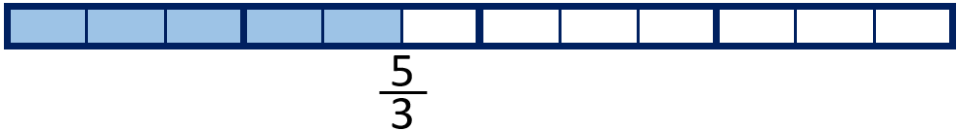
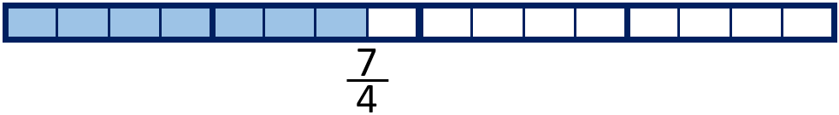 | 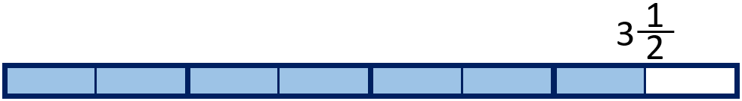
 | 
Your Turn
For each diagram, write the equivalent mixed number or improper fraction shown.
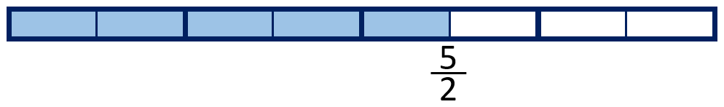 | 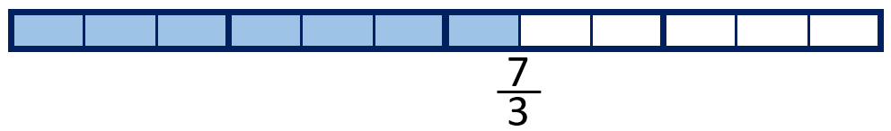
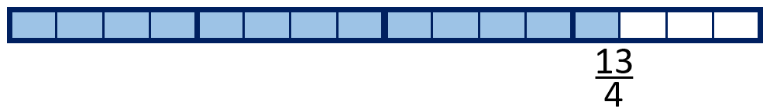 | 
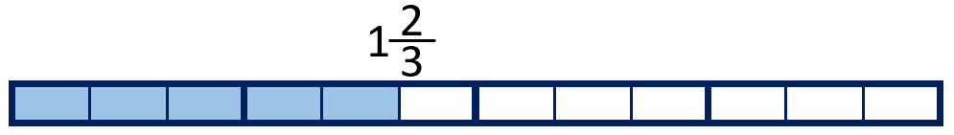 | 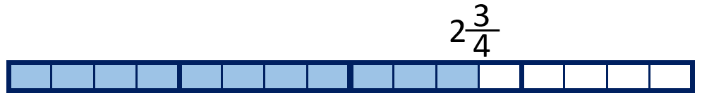

3 Identify equivalent fractions to a half
Let’s Learn
$\frac{1}{2}$ = $\frac{}{4}$ = $\frac{}{6}$ = $\frac{}{8}$ = $\frac{}{10}$ = $\frac{}{12}$

4 Use multiplication to find equivalent fractions
Let’s Learn
$\frac{1}{3}$ = $\frac{}{9}$ | $\frac{3}{5}$ = $\frac{}{10}$ | $\frac{2}{5}$ = $\frac{}{20}$ | $\frac{2}{3}$ = $\frac{8}{}$ | $\frac{3}{4}$ = $\frac{9}{}$
Your Turn
$\frac{1}{4}$ = $\frac{}{8}$ | $\frac{2}{5}$ = $\frac{}{15}$ | $\frac{2}{3}$ = $\frac{}{18}$ | $\frac{2}{7}$ = $\frac{6}{}$ | $\frac{2}{9}$ = $\frac{8}{}$

5 Use division to find equivalent fractions
Let’s Learn
$\frac{6}{9}$ = $\frac{}{3}$ | $\frac{4}{12}$ = $\frac{}{3}$ | $\frac{20}{24}$ = $\frac{}{6}$ | $\frac{6}{15}$ = $\frac{2}{}$ | $\frac{10}{20}$ = $\frac{1}{}$
Your Turn
$\frac{6}{8}$ = $\frac{}{4}$ | $\frac{4}{20}$ = $\frac{}{5}$ | $\frac{16}{28}$ = $\frac{}{7}$ | $\frac{10}{15}$ = $\frac{2}{}$ | $\frac{9}{27}$ = $\frac{1}{}$

6 Find a non-unit fraction of a number
Let’s Learn
$\frac{2}{5}$of 30 = | $\frac{5}{6}$ of 24 = | $\frac{3}{8}$of 24 =
Your Turn
$\frac{3}{5}$of 45 = | $\frac{4}{5}$ of 35 = | $\frac{5}{8}$of 32 =

7 Find a whole quantity give the quantity represented by a non-unit fraction
Let’s Learn
$\frac{2}{5}$ of = 10 | $\frac{5}{6}$ of = 15 | $\frac{3}{5}$ of = 15
Your Turn
$\frac{3}{5}$ of = 15 | $\frac{3}{4}$ of = 27 | $\frac{3}{7}$ of = 21

Decimals
Go to https://keystage2maths.com/y4/decimals/ for help.

1 Recognise tenths and hundredths
Let’s Learn
Answer as a decimal.
1 ÷ 10 = | 1 ÷ 100 = | 0.1 ÷ 10 =

2 Convert between fractional and decimal tenths and hundredths
Let’s Learn
0.9 =  $\frac{}{100}$ | 0.4 =  $\frac{}{100}$ | 0.02 =  $\frac{}{100}$ | 0.09 =  $\frac{}{100}$ | 0.12 =  $\frac{}{100}$ | 0.99 =  $\frac{}{100}$
Your Turn
0.8 =  $\frac{}{100}$ | 0.1 =  $\frac{}{100}$ | 0.03 =  $\frac{}{100}$ | 0.08 =  $\frac{}{100}$ | 0.38 =  $\frac{}{100}$ | 0.44 =  $\frac{}{100}$

3 Recognise equivalent fractions with tenths and hundredths
Let’s Learn
Write the equivalent number of tenths and in decimal form.
$\frac{20}{100}$ = $\frac{}{10}$ = | $\frac{60}{100}$ = $\frac{}{10}$ =
Your Turn
Write the equivalent number of tenths and in decimal form.
$\frac{30}{100}$ = $\frac{}{10}$ = | $\frac{90}{100}$ = $\frac{}{10}$ =

4 Partition decimals into tenths and hundredths
Let’s Learn
Partition each decimal into tenths and hundredths.
0.47 = | 0.61 =
Your Turn
Partition each decimal into tenths and hundredths.
0.15 = | 0.51 =

5 Add tenths and hundredths in decimal form
Let’s Learn
0.2 + 0.02 = | 0.5 + 0.06 =
Your Turn
0.7 + 0.05 = | 0.3 + 0.08 =

6 Subtract tenths and hundredths in decimal form
Let’s Learn
0.2 – 0.02 = | 0.5 – 0.06 = | 0.45 – 0.3 = | 0.58 – 0.5 =
Your Turn
0.6 – 0.04 = | 0.9 – 0.01 = | 0.77 – 0.4 = | 0.44 – 0.4 =

7 Count on in tenths or hundredths
Let’s Learn
For the questions below, write the next seven numbers, counting in tenths or hundredths.
0.62, 0.63, 0.64,

0.05, 0.15, 0.25,

0.94, 0.95, 0.96,

0.49, 0.59, 0.69,

3.47, 3.48, 3.49,

2.61, 2.71, 2.81,

Your Turn
For the questions below, write the next seven numbers, counting in tenths or hundredths.
0.73, 0.74, 0.75,

0.02, 0.12, 0.22,

0.97, 0.98, 0.99,

0.37, 0.47, 0.57,

3.95, 3.96, 3.97,

2.45, 2.55, 2.65,

8 Count back in tenths or hundredths
Let’s Learn
For the questions below, write the next seven numbers, counting back in tenths or hundredths.
0.16, 0.15, 0.14,

1.05, 1.04, 1.03,

3.25, 3.24, 3.23,

3.25, 3.15, 3.05,

Your Turn
For the questions below, write the next seven numbers, counting back in tenths or hundredths.
0.24, 0.23, 0.22,

2.07, 2.06, 2.05,

5.55, 5.54, 5.53,

3.66, 3.56, 3.46,

9 Locate tenths and hundredths on a number line
Let’s Learn
Your Turn
10 Compare numbers with tenths or hundredths
Let’s Learn
Write > or < in each box.
0.2 0.33 | 0.9 0.99 | 0.5 0.45 | 0.55 0.7
7.65 7.69 | 4.71 4.69 | 6.01 5.99 | 5.45 5.5
Your Turn
Write > or < in each box.
0.5 0.54 | 0.7 0.56 | 0.8 0.91 | 0.75 0.6
7.05 7.44 | 5.72 4.73 | 6.1 6.09 | 5.79 5.9

11 Add numbers with one or two decimal places
Let’s Learn
6.1 + 2.35 = | 5.3 + 1.95 = | 56.38 + 24.7 =
Your Turn
6.9 + 6.15 = | 16.3 + 1.87 = | 48.26 + 12.8 =

12 Subtract numbers with one or two decimal places
Let’s Learn
31.8 – 6.45 = | 26.8 – 6.12 = | 125.48 – 72.3 =
Your Turn
52.4 – 6.67 = | 39.1 – 6.09 = | 118.72 – 91.3 =

13 Subtract numbers with one or two decimal places from whole numbers
Let’s Learn
5 – 1.35 = | 8 – 4.65 = | 11 – 4.01 =
Your Turn
4 – 1.15 = | 7 – 2.25 = | 12 – 6.01 =

14 Multiply numbers with hundredths by 10
Let’s Learn
5 x 10 = | 0.5 x 10 = | 0.05 x 10 =
0.09 x 10 = | 0.43 x 10 = | 4.03 x 10 =
Your Turn
6 x 10 = | 0.6 x 10 = | 0.06 x 10 =
0.07 x 10 = | 0.67 x 10 = | 6.07 x 10 =

15 Divide one-, two- or three-digit numbers by 100
Let’s Learn
4 ÷ 100 = | 40 ÷ 100 = | 67 ÷ 100 =
400 ÷ 100 = | 399 ÷ 100 = | 401 ÷ 100 =

Your Turn
2 ÷ 100 = | 30 ÷ 100 = | 32 ÷ 100 =
300 ÷ 100 = | 302 ÷ 100 = | 332 ÷ 100 =

16 Multiply decimals by 100
Let’s Learn
0.5 x 100 = | 0.04 x 100 = | 0.54 x 100 =
5.4 x 100 = | 5.04 x 100 = | 50.4 x 100 =
Your Turn
0.8 x 100 = | 0.06 x 100 = | 0.86 x 100 =
6.8 x 100 = | 8.06 x 100 = | 80.6 x 100 =

17 Solve missing number problems for multiplication and division of decimals by 10 or 100
Let’s Learn
8.3 x = 830 | 0.08 x = 0.8 | 0.83 x = 83
8.3 ÷ = 0.83 | 83 ÷ = 8.3 | 83 ÷ = 0.83
Your Turn
6.5 x = 65 | 0.65 x = 6.5 | 0.6 x = 60
6 ÷ = 0.06 | 65 ÷ = 0.65 | 60.5 ÷ = 6.05

