Place Value
Go to https://keystage2maths.com/y6/placevalue/ for help.

1 Write numbers up to 10 million in digits
Let’s Learn
Write the numbers below in digits.
Seven million, two hundred and three thousand and twenty-seven | Eight million, two hundred thousand, three hundred
Five million, two thousand, five hundred | Two million, two hundred and two thousand and two
Your Turn
Write the numbers below in digits.
Four million, seven hundred and twenty thousand and twenty | Four million, fifty thousand and eighty
Five million, three thousand and five | Three million, two hundred thousand and twelve

2 Write numbers up to 10 million in words
Let’s Learn
Write the numbers below in words.
9,291,536

4,590,000

6,070,040

4,000,800

Your Turn
Write the numbers below in words.
3,203,567

6,210,000

5,050,050

3,000,080

3 Identify the digit in each place value for seven-digit numbers
Let’s Learn
For the questions below, write the digit of each place value.
7,451,194  Millions:  Hundred thousands:  Ten thousands:  Thousands:  Hundreds:  Tens:  Ones: | 5,709,846  Hundred thousands:  Tens:  Millions:  Thousands:  Ones:  Ten thousands:  Hundreds: | 2,043,198  Ones:  Hundreds:  Hundred thousands:  Thousands:  Ten thousands:  Millions:  Tens:
Your Turn
For the questions below, write the digit of each place value.
2,447,891  Millions:  Hundred thousands:  Ten thousands:  Thousands:  Hundreds:  Tens:  Ones: | 2,896,051  Hundred thousands:  Tens:  Millions:  Thousands:  Ones:  Ten thousands:  Hundreds: | 1,471,380  Ones:  Hundreds:  Hundred thousands:  Thousands:  Ten thousands:  Millions:  Tens:

4 Identify the value of each digit in seven-digit numbers
Let’s Learn
For the questions below, write the value of each digit.
4,052,160  4 represents:  5 represents:  2 represents:  1 represents:  6 represents: | 8,504,297  2 represents:  4 represents:  7 represents:  8 represents:  9 represents:  5 represents: | 2,638,041  6 represents:  8 represents:  2 represents:  1 represents:  4 represents:  3 represents:

Your Turn
For the questions below, write the value of each digit.
7,035,690  7 represents:  3 represents:  5 represents:  6 represents:  9 represents: | 4,802,695  6 represents:  2 represents:  5 represents:  4 represents:  9 represents:  8 represents: | 1,279,068  2 represents:  9 represents:  1 represents:  8 represents:  6 represents:  7 represents:

5 Partition seven-digit numbers
Let’s Learn
Partition the numbers below.
4,307,042 = + + + +

6,193,413 = + + + + + +

7,460,253 = + + + + +

Your Turn
Partition the numbers below.
6,609,012 = + + + +

5,265,263 = + + + + + +

7,280,989 = + + + + +

6 Order numbers with up to seven digits
Let’s Learn
Order each set of numbers from smallest to largest.
9 600 000, 696 000, 90 000, 6 990 000, 9 660 000

77 666, 6 677 666, 7 777, 7 676 666, 7 767 777

Your Turn
Order each set of numbers from smallest to largest.
500 000, 54 000, 4 055 000, 4 500 000, 4 504 000

9 090, 8 090 000, 9 800 000, 900 000, 8 800 000

7 Round to the nearest 10, 100, 1000, 10 000, 100 000 and 1 000 000
Let’s Learn
For the questions below, round each number to the specified degree of accuracy.
7,451,194  Round to the nearest…  Million:  Hundred thousand:  Ten thousand:  Thousand:  Hundred:  Ten: | 3,409,846  Round to the nearest…  Million:  Hundred thousand:  Ten thousand:  Thousand:  Hundred:  Ten: | 2,042,242  Round to the nearest…  Million:  Hundred thousand:  Ten thousand:  Thousand:  Hundred:  Ten:
Your Turn
For the questions below, round each number to the specified degree of accuracy.
6,901,098  Round to the nearest…  Million:  Hundred thousand:  Ten thousand:  Thousand:  Hundred:  Ten: | 1,208,917  Round to the nearest…  Million:  Hundred thousand:  Ten thousand:  Thousand:  Hundred:  Ten: | 3,106,307  Round to the nearest…  Million:  Hundred thousand:  Ten thousand:  Thousand:  Hundred:  Ten:

8 Recognise place value – millionths to thousandths
Let’s Learn
We have a base 10 number system. Explain what this means.

9 Count in powers of 10
Let’s Learn
Complete the missing values by counting in powers of 10.
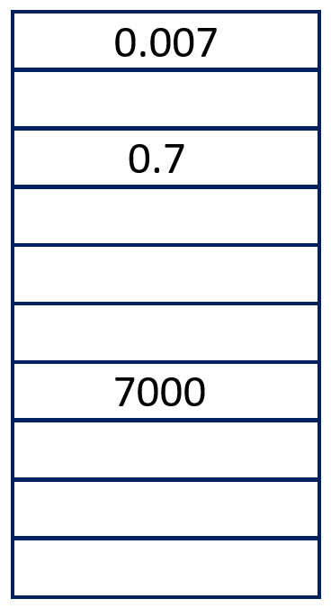 | 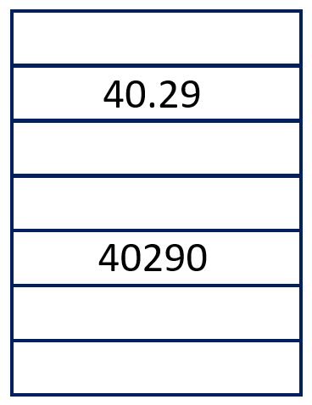 | 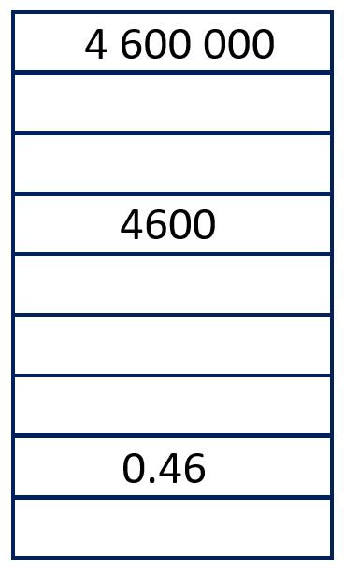
Your Turn
Complete the missing values by counting in powers of 10.
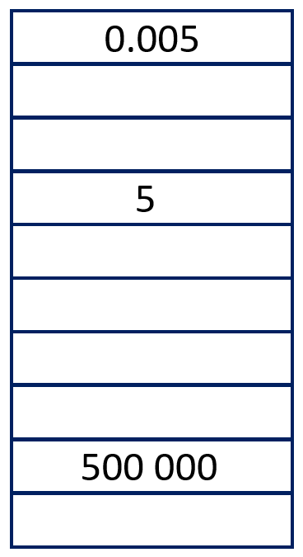 | 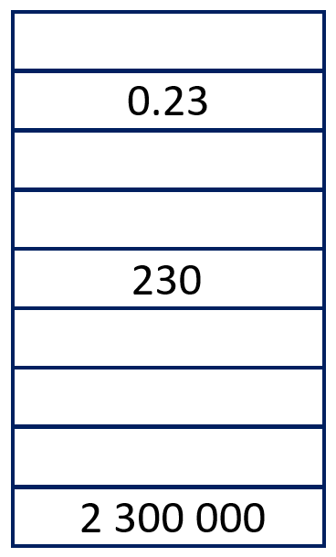 | 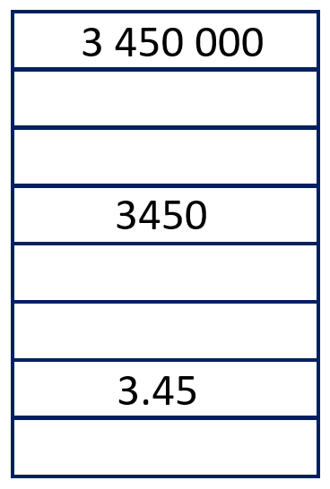

Four Operations
Go to https://keystage2maths.com/y6/fouroperations/ for help.

1 Perform mental calculations involving brackets
Let’s Learn
(2 x 35) + (60 ÷ 3) = | 70 ÷ (14 – 4) =
40 + (40 ÷ 5) = | (194 + 6) x (34 – 4) =
Your Turn
(2 x 25) + (90 ÷ 3) = | 90 ÷ (15 – 5) =
30 + (30 ÷ 6) = | (198 + 2) x (42 – 2) =

2 Apply knowledge of the order of operations
Let’s Learn
20 – 4 x 2 = | 30 + 5 x 2 = | 60 – 42 ÷ 6 =
80 + 20 ÷ 10 = | 9² – 36 ÷ 9 = | 8² + 24 ÷ 4 =
Your Turn
20 + 4 x 2 = | 3 x 5 + 2 = | 60 + 42 ÷ 6 =
80 – 20 + 10 = | 9² + 36 ÷ 9 = | 8 – 2² ÷ 4 =

3 Use factor pairs in mental calculations for division
Let’s Learn
Use factor pairs to solve the division questions below.
414 ÷ 18 = | 819 ÷ 21 = | 1888 ÷ 32 =
Your Turn
Use factor pairs to solve the division questions below.
546 ÷ 21 = | 900 ÷ 36 = | 3384 ÷ 72 =

4 Divide by a two-digit number with a single-digit quotient
Let’s Learn
120 ÷ 15 = | 39 ÷ 13 = | 188 ÷ 47 = | 258 ÷ 43 = | 153 ÷ 17 =
Your Turn
90 ÷ 15 = | 92 ÷ 23 = | 158 ÷ 46 = | 222 ÷ 37 = | 136 ÷ 17 =

5 Begin to divide by a 2-digit number using long division by calculating to 5 times
Let’s Learn
645 ÷ 43 = | 850 ÷ 34 =
585 ÷ 39 = | 4563 ÷ 13 =
Your Turn
888 ÷ 37 = | 714 ÷ 17 =
3016 ÷ 13 = | 725 ÷ 29 =

6 Divide by a 2-digit number using long division
Let’s Learn
2016 ÷ 36 = | 3384 ÷ 47 =
Your Turn
2331 ÷ 37 = | 1118 ÷ 43 =

7 Divide by a 2-digit number using the most efficient method
Let’s Learn
2242 ÷ 59 = | 8015 ÷ 83 =
Your Turn
8827 ÷ 97 = | 1911 ÷ 49 =

Fractions
Go to https://keystage2maths.com/y6/fractions/ for help.

1 Simplify fractions
Let’s Learn
Simplify the fractions below to their lowest terms.
$\frac{6}{12}$ = | $\frac{10}{15}$ = | $\frac{20}{24}$ = | $\frac{6}{10}$ =
Your Turn
Simplify the fractions below to their lowest terms.
$\frac{8}{16}$ = | $\frac{12}{16}$ = | $\frac{20}{25}$ = | $\frac{6}{15}$ =

2 Compare fractions with denominators which are not common multiples
Let’s Learn
Write < or >.
$\frac{1}{2}$ $\frac{3}{5}$ | $\frac{5}{6}$ $\frac{3}{4}$ | $\frac{5}{8}$ $\frac{7}{12}$
Your Turn
Write < or >.
$\frac{1}{3}$ $\frac{2}{7}$ | $\frac{5}{6}$ $\frac{7}{8}$ | $\frac{3}{5}$ $\frac{7}{12}$

3 Compare improper fractions with denominators which are not common multiples
Let’s Learn
Write < or >.
$\frac{3}{2}$ $\frac{8}{5}$ | $\frac{7}{6}$ $\frac{5}{4}$
Your Turn
Write < or >.
$\frac{4}{3}$ $\frac{7}{5}$ | $\frac{7}{5}$ $\frac{3}{2}$

4 Order fractions with denominators which are not common multiples
Let’s Learn
Order these fractions from smallest to largest.
$\frac{7}{10}$, $\frac{4}{5}$, $\frac{11}{15}$, $\frac{2}{3}$

Your Turn
Order these fractions from smallest to largest.
$\frac{1}{2}$, $\frac{5}{8}$, $\frac{7}{12}$, $\frac{2}{3}$

5 Order improper fractions with denominators which are not common multiples
Let’s Learn
Order these fractions from smallest to largest.
$\frac{11}{10}$, $\frac{7}{5}$, $\frac{13}{15}$, $\frac{4}{3}$

Your Turn
Order these fractions from smallest to largest.
$\frac{19}{12}$, $\frac{9}{5}$, $\frac{16}{10}$, $\frac{9}{6}$

6 Add fractions with denominators which are not common multiples within 1
Let’s Learn
$\frac{1}{2}$ + $\frac{1}{5}$ = | $\frac{1}{5}$ + $\frac{3}{4}$ =
Your Turn
$\frac{1}{2}$ + $\frac{1}{9}$ = | $\frac{1}{5}$ + $\frac{4}{7}$ =

7 Subtract fractions with denominators which are not common multiples within 1
Let’s Learn
$\frac{5}{6}$ – $\frac{1}{8}$ = | $\frac{3}{4}$ – $\frac{2}{3}$ =
Your Turn
$\frac{5}{6}$ – $\frac{1}{4}$ = | $\frac{3}{5}$ – $\frac{2}{7}$ =

8 Solve missing number problems for addition and subtraction of fractions with denominators which are not common multiples within 1
Let’s Learn
$\frac{3}{5}$ + = $\frac{3}{4}$ | $\frac{1}{2}$ – = $\frac{1}{5}$ | – $\frac{2}{5}$= $\frac{1}{3}$
Your Turn
$\frac{2}{5}$ + = $\frac{5}{6}$ | $\frac{1}{3}$ – = $\frac{1}{8}$ | – $\frac{2}{7}$= $\frac{1}{8}$

9 Add fractions with denominators which are not common multiples beyond 1 whole, writing answers as mixed numbers
Let’s Learn
$\frac{4}{5}$ + $\frac{3}{4}$ = | $\frac{6}{7}$ + $\frac{1}{2}$ =
Your Turn
$\frac{4}{5}$ + $\frac{2}{3}$ = | $\frac{7}{8}$ + $\frac{1}{6}$ =

10 Subtract a fraction from an improper fraction or mixed number with a denominator which is not a multiple of the denominator in the fraction and with 1 whole
Let’s Learn
1$\frac{1}{2}$ – $\frac{2}{3}$ = | 1$\frac{1}{6}$ – $\frac{3}{4}$ =
Your Turn
1$\frac{1}{3}$ – $\frac{1}{2}$ = | 1$\frac{1}{4}$ – $\frac{3}{5}$ =

11 Solve missing number problems for addition and subtraction of fractions with denominators which are not common multiples beyond 1
Let’s Learn
1$\frac{1}{7}$ – = $\frac{2}{3}$ | – $\frac{3}{8}$= $\frac{5}{7}$ | $\frac{1}{3}$ + = 1$\frac{1}{5}$
Your Turn
1$\frac{1}{8}$ – = $\frac{4}{5}$ | – $\frac{5}{8}$= $\frac{5}{6}$ | $\frac{1}{2}$ + = 1$\frac{1}{5}$

12 Add a fraction to a mixed number with a denominator which is not a multiple of the denominator in the fraction, without regrouping
Let’s Learn
2$\frac{2}{5}$ + $\frac{1}{4}$ = | 1$\frac{1}{2}$ + $\frac{1}{5}$ =

Your Turn
1$\frac{3}{5}$ + $\frac{1}{6}$ = | 2$\frac{1}{3}$ + $\frac{3}{5}$ =

13 Add a fraction to a mixed number with a denominator which is not a multiple of the denominator in the fraction, regrouping to make 1 more whole
Let’s Learn
Answer the questions below by regrouping to make 1 more whole.
1$\frac{2}{5}$ + $\frac{3}{4}$ = | 2$\frac{1}{2}$ + $\frac{4}{5}$ =
Your Turn
Answer the questions below by regrouping to make 1 more whole.
1$\frac{3}{4}$ + $\frac{4}{5}$ = | 2$\frac{1}{2}$ + $\frac{6}{7}$ =

14 Add a fraction to a mixed number with a denominator which is not a multiple of the denominator in the fraction by converting to an improper fraction
Let’s Learn
Now answer the questions above by converting mixed numbers to improper fractions.
Your Turn
Now answer the questions above by converting mixed numbers to improper fractions.

15 Add mixed numbers with denominators which are not common multiples, without regrouping
Let’s Learn
2$\frac{1}{6}$ + 2$\frac{2}{5}$ = | 2$\frac{3}{7}$ + 1$\frac{1}{2}$ =
Your Turn
2$\frac{5}{6}$ + 1$\frac{1}{7}$ = | 2$\frac{2}{9}$ + 2$\frac{1}{2}$ =

16 Add mixed numbers with denominators which are not common multiples, regrouping to make 1 more whole
Let’s Learn
Answer the questions below by regrouping to make 1 more whole.
2$\frac{1}{2}$ + 2$\frac{5}{7}$ = | 2$\frac{3}{4}$ + 1$\frac{2}{3}$ =
Your Turn
Answer the questions below by regrouping to make 1 more whole.
2$\frac{1}{2}$ + 2$\frac{3}{5}$ = | 2$\frac{4}{5}$ + 1$\frac{3}{4}$ =

17 Add mixed numbers with denominators which are not common multiples by converting to improper fractions
Let’s Learn
Now answer the questions above by converting mixed numbers to improper fractions.
Your Turn
Now answer the questions above by converting mixed numbers to improper fractions.

18 Subtract a fraction from a mixed number with a denominator which is not a multiple of the denominator in the fraction, without regrouping
Let’s Learn
1$\frac{4}{5}$ – $\frac{3}{4}$ = | 2$\frac{1}{2}$ – $\frac{1}{7}$ =
Your Turn
1$\frac{6}{7}$ – $\frac{3}{4}$ = | 2$\frac{5}{9}$ – $\frac{1}{2}$ =

19 Subtract a fraction from a mixed number with a denominator which is not a multiple of the denominator in the fraction, regrouping to make 1 fewer whole
Let’s Learn
Answer the questions below by regrouping to make 1 fewer whole.
2$\frac{1}{5}$ – $\frac{3}{4}$ = | 2$\frac{1}{3}$ – $\frac{1}{2}$ =

Your Turn
Answer the questions below by regrouping to make 1 fewer whole.
2$\frac{1}{6}$ – $\frac{1}{4}$ = | 2$\frac{1}{2}$ – $\frac{2}{3}$ =

20 Subtract a fraction from a mixed number with a denominator which is not a multiple of the denominator in the fraction by converting to an improper fraction
Let’s Learn
Now answer the questions above by converting mixed numbers to improper fractions.
Your Turn
Now answer the questions above by converting mixed numbers to improper fractions.

21 Subtract mixed numbers with denominators which are not common multiples, without regrouping
Let’s Learn
2$\frac{3}{4}$ – 1$\frac{2}{3}$ = | 2$\frac{3}{5}$ – 1$\frac{1}{2}$ =
Your Turn
2$\frac{3}{5}$ – 1$\frac{1}{3}$ = | 2$\frac{7}{9}$ – 1$\frac{3}{8}$ =

22 Subtract mixed numbers with denominators which are not common multiples, regrouping to make 1 fewer whole
Let’s Learn
Answer the questions below by regrouping to make 1 fewer whole.
3$\frac{1}{5}$ – 1$\frac{1}{3}$ = | 3$\frac{3}{4}$ – 1$\frac{5}{6}$ =
Your Turn
Answer the questions below by regrouping to make 1 fewer whole.
3$\frac{1}{4}$ – 1$\frac{1}{3}$ = | 4$\frac{2}{5}$ – 1$\frac{1}{2}$ =

23 Subtract mixed numbers with denominators which are not common multiples by converting to improper fractions
Let’s Learn
Now answer the questions above by converting mixed numbers to improper fractions.
Your Turn
Now answer the questions above by converting mixed numbers to improper fractions.

24 Multiply unit fractions
Let’s Learn
$\frac{1}{3}$x $\frac{1}{3}$ = | $\frac{3}{5}$x $\frac{1}{4}$ = | $\frac{7}{10}$x $\frac{1}{2}$ =
Your Turn
$\frac{1}{4}$x $\frac{1}{4}$ = | $\frac{3}{4}$x $\frac{1}{5}$ = | $\frac{5}{12}$x $\frac{1}{2}$ =

25 Multiply non-unit fractions
Let’s Learn
$\frac{2}{3}$x $\frac{2}{3}$ = | $\frac{3}{5}$x $\frac{3}{4}$ =
Your Turn
$\frac{4}{5}$x $\frac{4}{5}$ = | $\frac{2}{5}$x $\frac{3}{4}$ =

26 Multiply non-unit fractions, simplifying at the end
Let’s Learn
For the questions below, simplify your answer after multiplying.
$\frac{3}{4}$x $\frac{8}{9}$ = | $\frac{7}{10}$x $\frac{5}{10}$ =
Your Turn
For the questions below, simplify your answer after multiplying.
$\frac{4}{5}$x $\frac{5}{6}$ = | $\frac{8}{10}$x $\frac{4}{10}$ =
27 Divide fractions by whole numbers
Let’s Learn
$\frac{1}{3}$÷ 3 = | $\frac{3}{5}$÷ 4 = | $\frac{7}{10}$÷ 2 =
Your Turn
$\frac{1}{4}$÷ 2 = | $\frac{3}{4}$÷ 5 = | $\frac{3}{10}$÷ 5 =

28 Find the fraction that lies halfway between two fractions
Let’s Learn
Find the midpoint of $\frac{1}{5}$and $\frac{2}{5}$. | Find the midpoint of $\frac{2}{3}$and $\frac{3}{4}$.
Your Turn
Find the midpoint of $\frac{4}{7}$and $\frac{2}{3}$. | Find the midpoint of $\frac{2}{7}$and $\frac{1}{3}$.

Decimals
Go to https://keystage2maths.com/y6/decimals/ for help.

1 Write remainders as decimals
Let’s Learn
For each question, write the remainder as a decimal.
12 ÷ 5 = | 19 ÷ 4 = | 11 ÷ 2 =
Your Turn
For each question, write the remainder as a decimal.
18 ÷ 5 = | 13 ÷ 4 = | 15 ÷ 2 =

2 Write remainders as decimals with larger numbers
Let’s Learn
For each question, write the remainder as a decimal.
5481 ÷ 5 = | 3181 ÷ 4 = | 9651 ÷ 2 =
Your Turn
For each question, write the remainder as a decimal.
9184 ÷ 5 = | 3362 ÷ 4 = | 3079 ÷ 2 =

3 Multiply a number with tenths by a whole number
Let’s Learn
0.2 x 3 = | 0.4 x 3 = | 0.3 x 5 =
3.2 x 4 = | 1.4 x 5 = | 2.7 x 4 =
Your Turn
0.3 x 3 = | 0.5 x 4 = | 0.6 x 6 =
3.1 x 5 = | 2.5 x 3 = | 2.3 x 5 =

4 Multiply a number with tenths and hundredths by a whole number
Let’s Learn
0.02 x 3 = | 0.04 x 3 = | 0.03 x 5 =
4.32 x 3 = | 2.84 x 4 = | 3.07 x 5 =

Your Turn
0.03 x 3 = | 0.04 x 5 = | 0.06 x 7 =
5.17 x 9 = | 5.43 x 7 = | 31.8 x 4 =

5 Multiply a number with tenths, hundredths and thousandths by a whole number
Let’s Learn
2.814 x 5 = | 21.26 x 7 =
Your Turn
261.8 x 4 = | 4.206 x 8 =

6 Divide a number with tenths, hundredths or thousandths
Let’s Learn
7.2 ÷ 3 = | 4.86 ÷ 3 = | 5.862 ÷ 3 =
Your Turn
9.6 ÷ 4 = | 5.81 ÷ 7 = | 98.63 ÷ 7 =

7 Divide a decimal, writing remainders as decimals
Let’s Learn
6.2 ÷ 5 = | 9.7 ÷ 4 = | 7.1 ÷ 2 =
Your Turn
8.8 ÷ 5 = | 9.9 ÷ 4 = | 8.7 ÷ 2 =

8 Use short multiplication to multiply a decimal
Let’s Learn
0.5 x 36 = | 0.6 x 300 = | 312 x 0.3 =
Your Turn
19 x 0.5 = | 0.7 x 200 = | 0.4 x 235 =

9 Use long multiplication to multiply a decimal
Let’s Learn
14 x 5.1 = | 2.8 x 40 = | 312 x 4.3 =
Your Turn
3.5 x 27 = | 4.7 x 50 = | 3.12 x 43 =

10 Use long division to divide a decimal
Let’s Learn
14.08 ÷ 32 = | 456.3 ÷ 13 =
Your Turn
82.08 ÷ 24 = | 3.384 ÷ 47 =

Percentages
Go to https://keystage2maths.com/y6/percentages/ for help.

1 Find a percentage of a number which is a multiple of 100
Let’s Learn
7% of 500 = | 15% x 1000 = | 19% of 800 =
Your Turn
6% of 800 = | 40% x 2000 = | 37% of 500 =

2 Find a percentage by first dividing by 100
Let’s Learn
28% of 650 = | 85% of 360 = | 24% of 350 = | 35% x 320 =
Your Turn
36% of 450 = | 35% of 320 = | 45% of 460 = | 65% x 340 =

3 Find a percentage of a number by changing the percentage to a simplified unit fraction
Let’s Learn
50% of 596 = | 25% of 96 = | 20% of 1800 =
Your Turn
50% of 588 = | 25% of 72 = | 20% of 1600 =

4 Find a percentage of a number by first finding 1, 5, 10 or 50 percent
Let’s Learn
35% of 320 = | 99% of 300 = | 51% of 600 = | 90% of 240 =
Your Turn
15% of 800 = | 99% of 900 = | 55% of 400 = | 70% of 380 =

