1 Count back in hundreds from a six-digit number
Let’s Learn
For the questions below, write the next seven numbers, counting back in hundreds.
100640, 100540, 100440,
100340
100240
100140
99740
99840
99940
100040
244040
243940
243544
243644
243744
243844

244444, 244344, 244244,
244144

Your Turn
For the questions below, write the next seven numbers, counting back in hundreds.
100533, 100433, 100333,
100233
100133
100033
99633
99733
99833
99933
233922
233822
233422
233522
233622
233722

234322, 234222, 234122,
234022

2 Subtract a multiple of 100 from a six-digit number
Let’s Learn
Complete the questions below using mental methods.
49882 – 500 =  49 382 | 10191 – 500 =  9 691 | 284529 – 800 =  283 729 | 100394 – 600 =  99 794
Your Turn
Complete the questions below using mental methods.
22922 – 700 =  22 222 | 10395 – 500 =  9 895 | 313131 – 600 =  312 531 | 100522 – 600 =  99 922

3 Count back in thousands from a six-digit number
Let’s Learn
For the questions below, write the next seven numbers, counting back in thousands.
103555, 102555, 101555,
100555
99555
98555
94555
95555
96555
97555
351222
350222
346222
347222
348222
349222

355222, 354222, 353222,
352222

Your Turn
For the questions below, write the next seven numbers, counting back in thousands.
104450, 103450, 102450,
101450
100450
99450
95450
96450
97450
98450
461333
460333
456333
457333
458333
459333

465333, 464333, 463333,
462333

4 Subtract a multiple of 1000 from a six-digit number
Let’s Learn
Complete the questions below using mental methods.
28284 – 2000 =  26 284 | 231932 – 5000 =  226 932 | 286745 – 8000 =  278 745 | 400400 – 4000 =  396 400
Your Turn
Complete the questions below using mental methods.
39393 – 3000 =  36 393 | 451900 – 5000 =  446 900 | 275755 – 6000 =  269 755 | 300300 – 7000 =  293 300

5 Count back in steps of 10 000 from a six-digit number
Let’s Learn
For the questions below, write the next seven numbers, counting back in ten-thousands.
135400, 125400, 115400,
105400
95400
85400
45400
55400
65400
75400
904005
894005
854005
864005
874005
884005

944005, 934005, 924005,
914005

Your Turn
For the questions below, write the next seven numbers, counting back in ten-thousands.
146600, 136600, 126600,
116600
106600
96600
56600
66600
76600
86600
795900
785900
745900
755900
765900
775900

835900, 825900, 815900,
805900

6 Subtract a multiple of 10 000 from a six-digit number
Let’s Learn
Complete the questions below using mental methods.
186000 – 30000 = 156 000 | 224284 – 70000 = 154 284 | 369009 – 70000 = 299 009
Your Turn
Complete the questions below using mental methods.
199000 – 90000 = 109 000 | 343434 – 70000 = 273 434 | 646004 – 80000 = 566 004

7 Subtract a multiple of 100 000 from a six-digit number
Let’s Learn
555000 – 500000 = 55 000 | 490000 – 300000 = 190 000 | 750000 – 500000 = 250 000
Your Turn
777000 – 700000 = 77 000 | 550000 – 300000 = 250 000 | 750000 – 200000 = 550 000

8 Solve missing number addition problems with six-digit numbers mentally
Let’s Learn
Complete the questions below by finding the missing numbers.
5 000  56500 + = 61500 | 10 000  93300 + = 103300
300 000  290005 + = 590005 | 500  299850 + = 300350
Your Turn
Complete the questions below by finding the missing numbers.
3 000  59500 + = 62500 | 20 000  195500 + = 215500
300 000  330003 + = 630003 | 700  399770 + = 400470

9 Solve missing number subtraction problems with six-digit numbers mentally
Let’s Learn
800  30450 – = 29650 | 100 000  310300 – = 210300
50 000  246700 – = 196700 | 8 000  677050 – = 669050
Your Turn
500  31450 – = 30950 | 500 000  550500 – = 50500
60 000  333300 – = 273300 | 3 000  602020 – = 599020

10 Subtract large numbers using column subtraction
Let’s Learn
Complete the questions below using column subtraction.
13442 – 5144 =  8 298 | 124485 – 29669 =  94 816 | 214489 – 47969 =  166 520 | 352063 – 147445 =  204 618
Your Turn
Complete the questions below using column subtraction.
11711 – 2188 =  9 523 | 124242 – 44638 =  79 604 | 112269 – 86362 =  25 907 | 576191 – 267548 =  308 643

11 Exchange across zero to subtract large numbers using column subtraction
Let’s Learn
10005 – 5245 =  4 760 | 166005 – 85936 =  80 069 | 404004 – 35488 =  368 516 | 392003 – 139549 =  252 454
Your Turn
10009 – 6525 =  3 484 | 123004 – 50018 =  72 986 | 706002 – 19538 =  686 464 | 645000 – 337457 =  307 543

12 Solve missing number problems for addition and subtraction with large numbers
Let’s Learn
Complete the questions below by finding the missing numbers.
860 514  = 656571 + 203943 | 233 628  + 58392 = 292020
118 138  654674 – = 536536 | 230 355  – 147445 = 82910
Your Turn
Complete the questions below by finding the missing numbers.
691 526  = 474733 + 216793 | 138 485  + 25546 = 164031
714 513  861790 – = 147277 | 426 079  – 57923 = 368156

13 Solve missing digit subtraction problems
Let’s Learn
Complete the subtraction questions below by finding the missing digits.
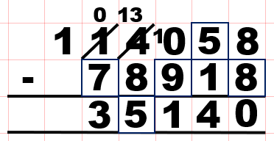 | 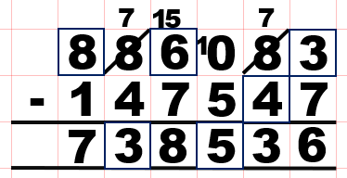
Your Turn
Complete the subtraction questions below by finding the missing digits.
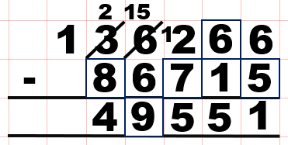 | 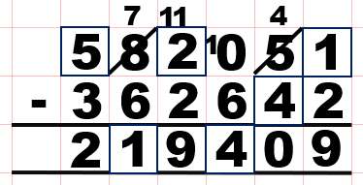

14 Subtract to make a negative answer
Let’s Learn
3 – 7 = -4 | 4 – 9 = -5 | 1 – 8 = -7
Your Turn
5 – 9 = -4 | 4 – 5 = -1 | 1 – 6 = -5

15 Subtract to make a negative answer with larger numbers
Let’s Learn
26 – 72 = -46 | 5 – 85 = -80 | 89 – 91 = -2
Your Turn
39 – 85 = -46 | 8 – 89 = -81 | 58 – 64 = -6

