Six children swim a 50 metre race.  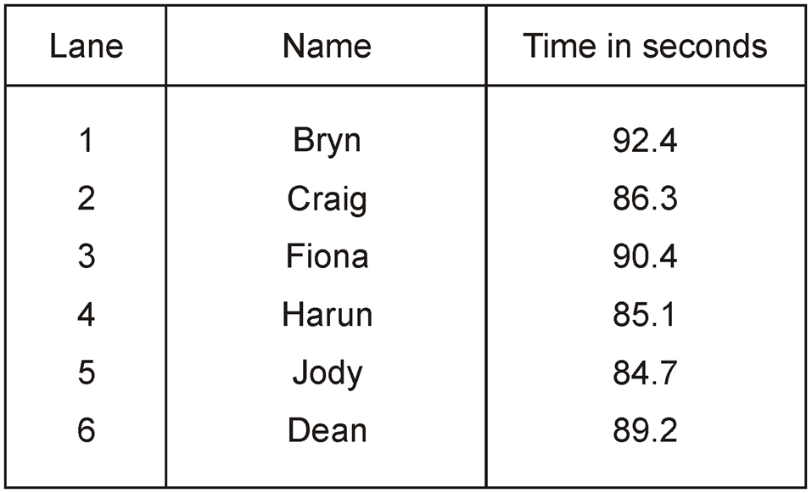  Who finished first?  How many seconds faster was Dean than Fiona? | Here is part of a number square.  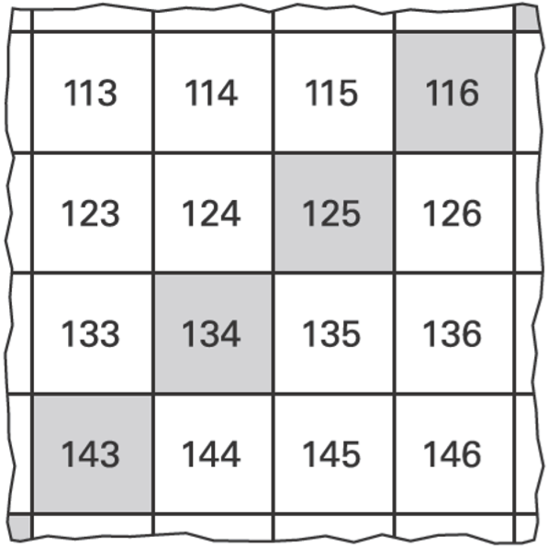  The shaded numbers are part of a sequence.  Explain the rule for the sequence.
Shade $\frac{1}{5}$of this shape.  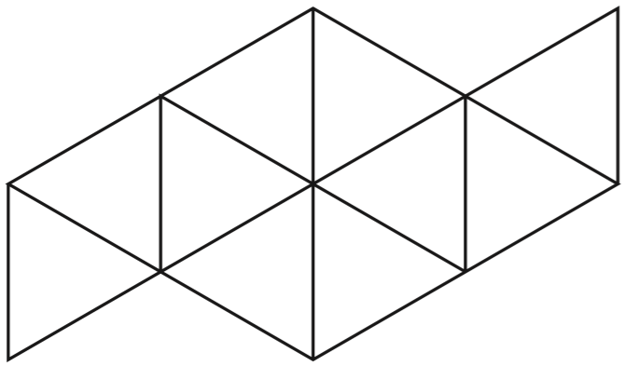 | Liam has five coins.  Three of the coins add up to 30p.  Three of the coins add up to 40p.  All five coins add up to £1  What are the coins that Liam has?  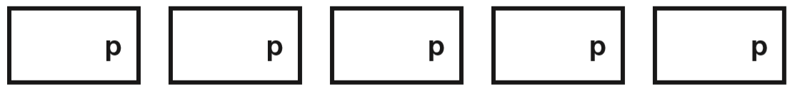
Some children collect cans for recycling.  Here is a chart of how many cans they collect in the first week.  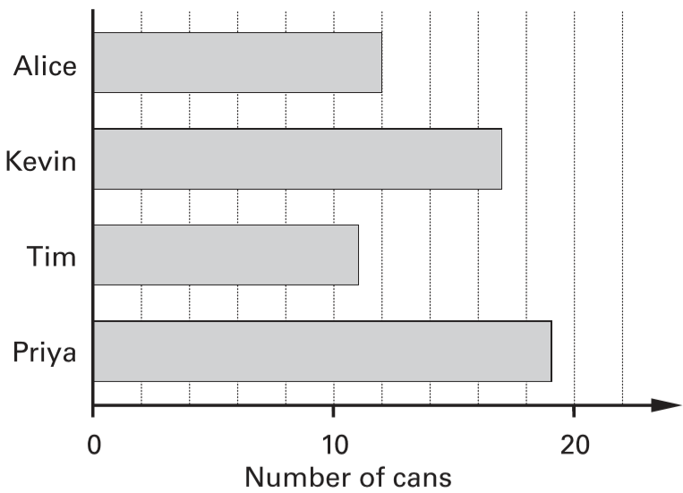  How many cans has Kevin collected?  Alice’s target is to collect 30 cans. How many more cans does Alice need to reach her target? | How much water is in this container?  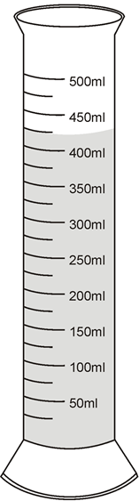
Look at these digits.  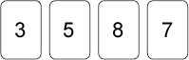  Use the digits to make the largest possible even number. Use each digit once.  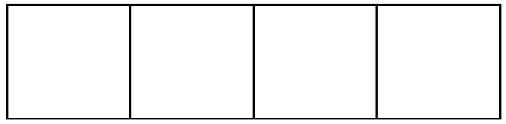 | Complete the table.  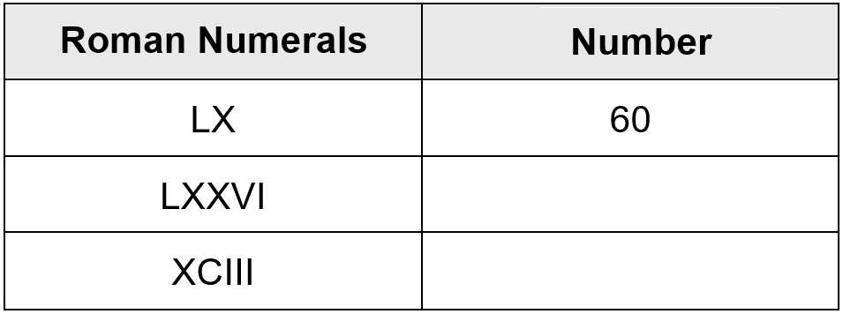
Here is a row of numbers.  1 2 3 4 5 6 7 8 9 10 11 12 13 14 15 16 17 18  Find three numbers next to each other which add up to 39. Draw a ring round them. | Write numbers in the boxes to make this calculation correct.  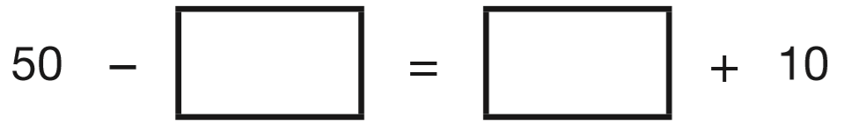

Here are four shapes on a square grid.  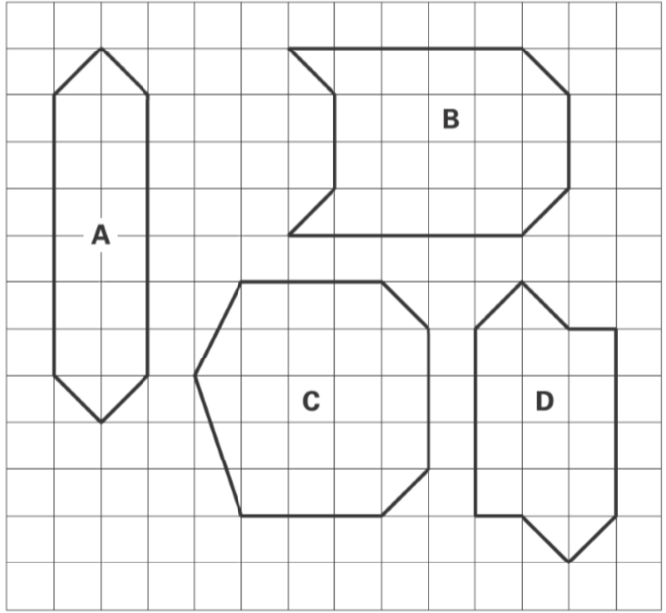  Complete the table.  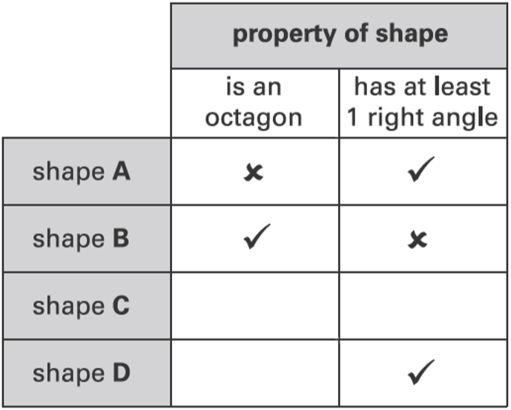 | 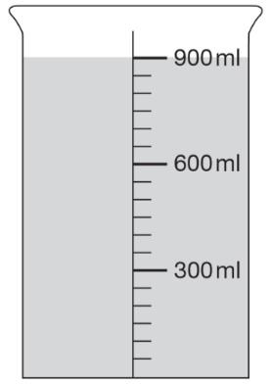  This container has 900 millilitres of water in it.  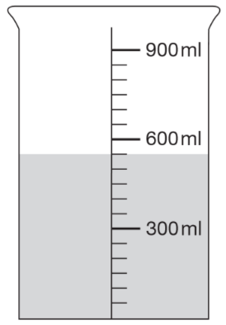  Lara pours out some water so that it looks like this.  How much water has Lara poured out?  Then she pours out another 150ml of water. Draw an arrow to show the new level of the water.  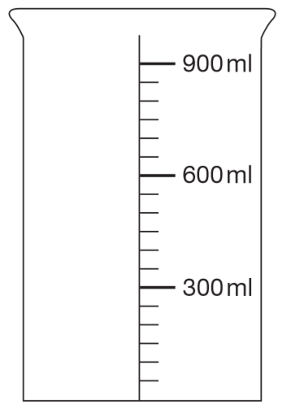
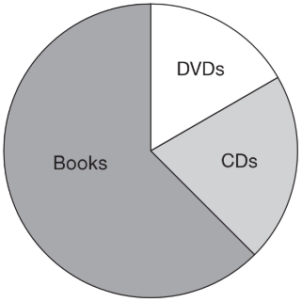  A shop sells books, CDs and DVDs.  This pie chart shows the sales of each in one week.  Estimate the fraction of the total sales that were DVDs.  In this week, 200 CDs were sold.  Estimate how many books were sold. | These are some prices in a fish and chip shop.  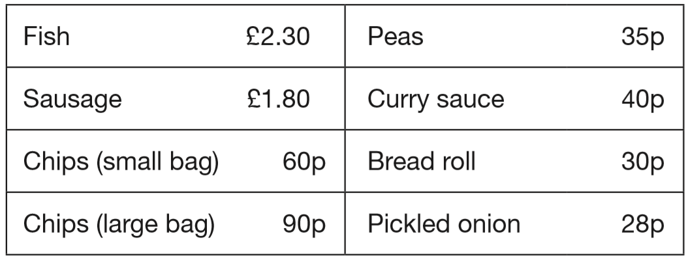  Alfie buys one fish, a large bag of chips and a pickled onion. How much does he pay?  Megan buys a sausage and a bread roll.  Chen buys a small bag of chips and a curry sauce.  How much more does Megan pay than Chen?
Stefan has a bag that contains 3 blue marbles and 5 red marbles only. What fraction of the marbles in the bag are blue?  Stefan adds one blue marble and one red marble to the bag.  What fraction of the marbles in the bag are blue now? | Here are some pairs of numbers.  For each pair, circle the number that is nearer to 5  3.5 9.5  2.5 5.5  4.5 6.5

Circle one number in each box to make a total of 1000  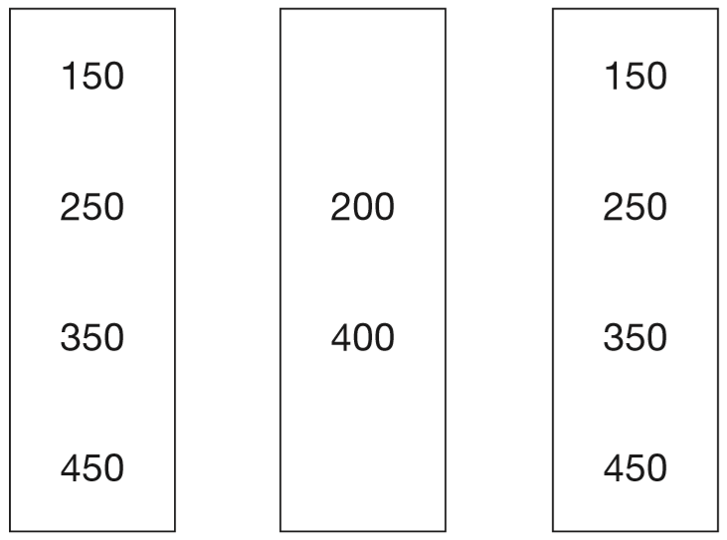 | Leila knows that  65 x 3 = 195  Explain how she can use this information to find the answer to this multiplication: 165 x 3
Here are some numbers.  6 2 32 5  Write each number in a box to make this number story correct.  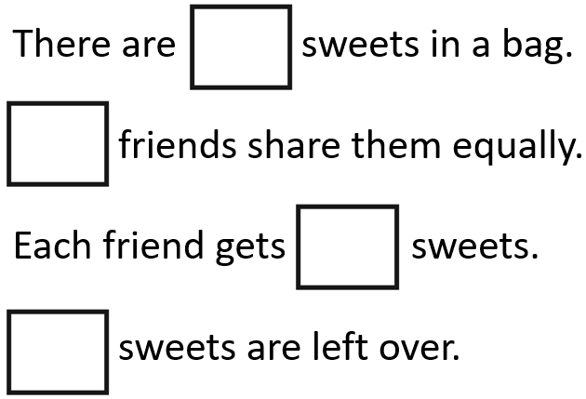 | There are 64 picture cards in this pile.  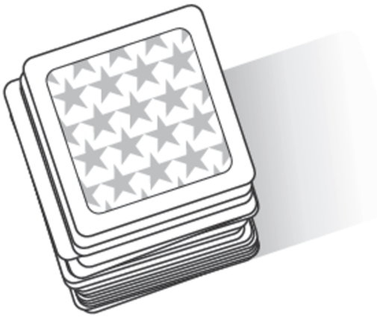  Five children each take the same number of cards.  24 cards are left over.  How many cards does each child take?
Circle three numbers which add to make 190  10 30 50 70 90 | Write what the missing numbers could be.  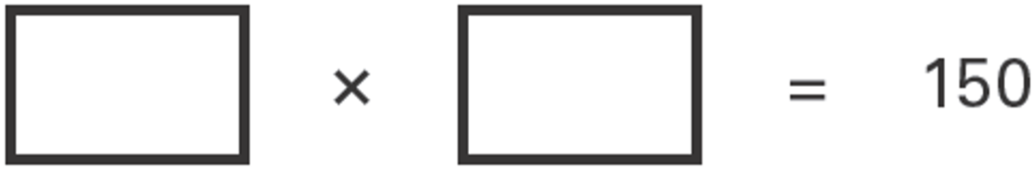
Circle the approximate measurement.  The length of a banana is about …  2 cm 20 cm 2 mm 2 m 20 m  The mass of an apple is about …  2 g 20 kg 200 kg 200 g 2 kg  A glass of fruit juice is about …  2 ml 2 l 20 ml 200 ml 20 l | Meg has 20 pet stickers to go on this page.  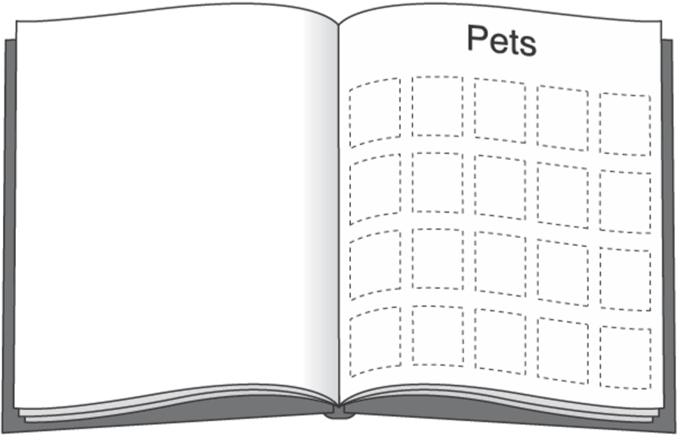  ¼ of them are dog stickers.  ½ of them are cat stickers.  The rest are rabbit stickers.  How many rabbit stickers does she have?
Here are five shapes on a regular grid.  Which shape has only one line of symmetry?  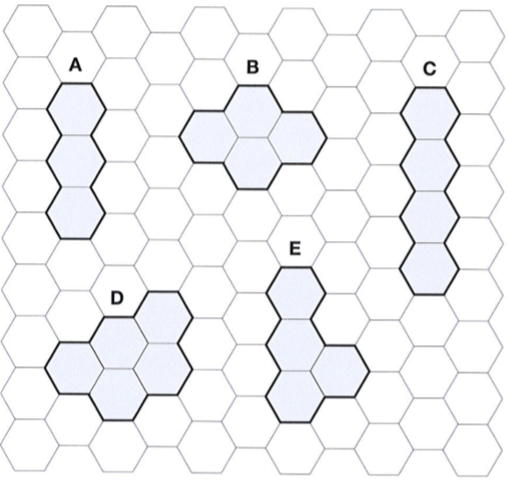 | On a sheet of stickers there are 5 circles, 2 stars and one rectangle.  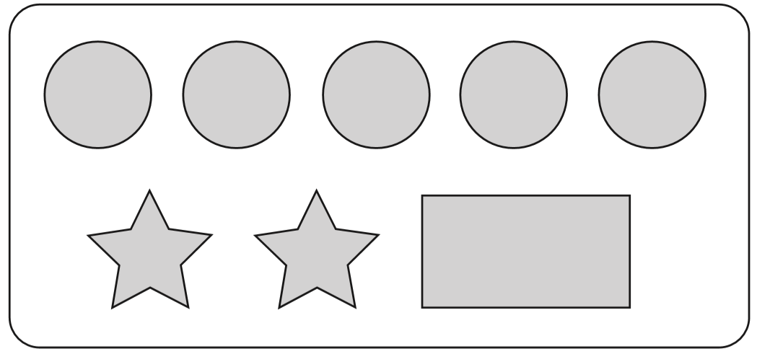  How many stickers are there altogether on 4 sheets?  Nisha needs 55 circles. How many sheets of stickers does she need?  Ben has 10 sheets of stickers.  How many more circles than rectangles does he have?

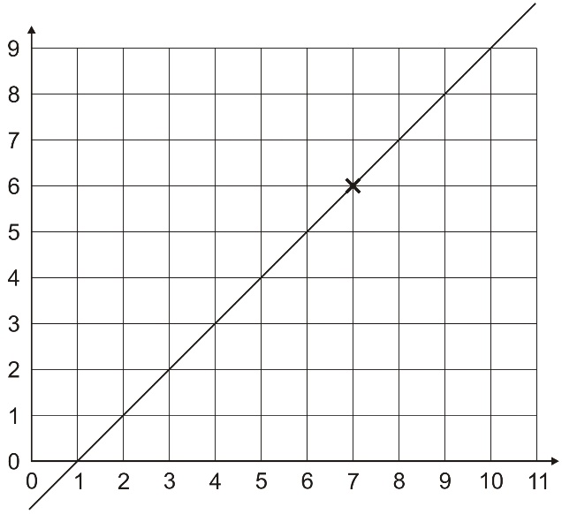  (7, 6) are coordinates of a point on the line.  Tick which of these are coordinates of other points on the line.  (3, 2) (9, 10) (5, 4)  (4, 2) (10, 9) (7, 9) | Park School collects money for three charities.  This pictogram shows how much they have collected.  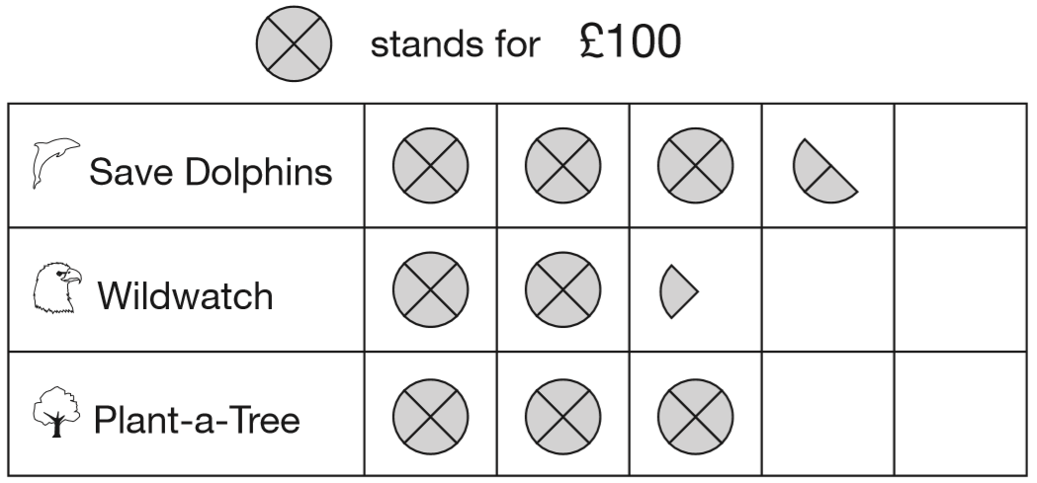  How much more have they collected for Save Dolphins than Plant-a-Tree?  The target for Wildwatch is £500. How much more money do they need to collect for Wildwatch?  How much money have they collected altogether, rounded to the nearest hundred pounds?
Draw one line to join two fractions which have the same value.  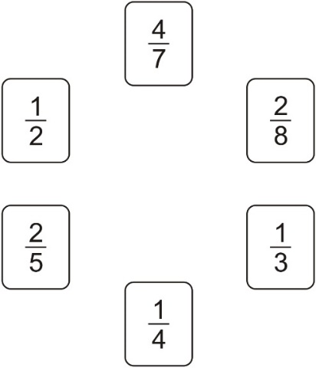 | John and Paula go to a fair.  Galaxy £1.50 per ride  Lazer 90p per ride  Big Wheel £1.20 per ride  Spaceship 75p per ride  John has £2  He goes on one ride and has exactly 80p left.  Which ride does he go on?  Paula has a 50p coin and three 20p coins.  She pays for a ride on the Laser.  How much money is left?
David puts this amount of water in a container.  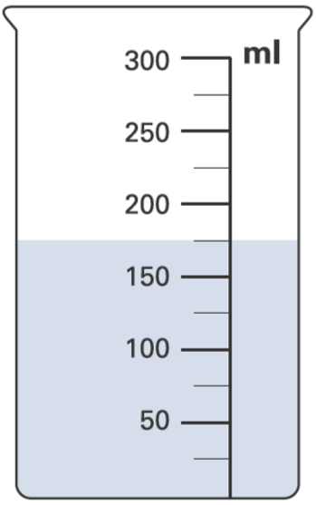  Then he pours 50 millilitres of the water out.  How much water is left in the container? | Round the lengths to the nearest whole metre.  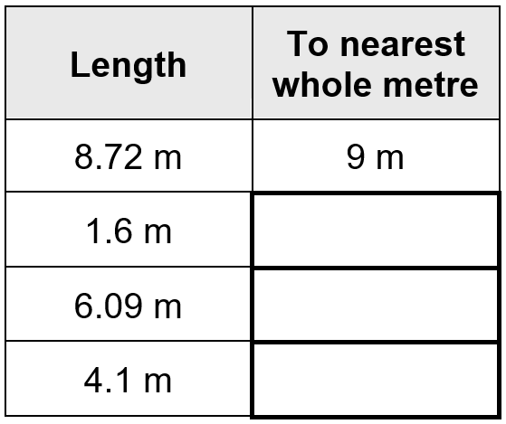
A car costs more than £8600 but less than £9100  Circle the prices that the car could cost.  £8569 £9090 £9130 £8999 | Write in the four missing digits.  Put one digit in each box.  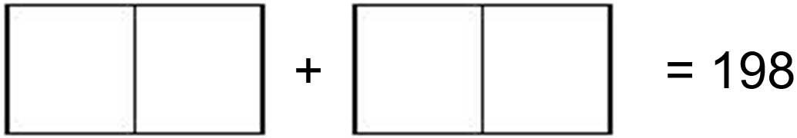

Here are three bags in a shop.  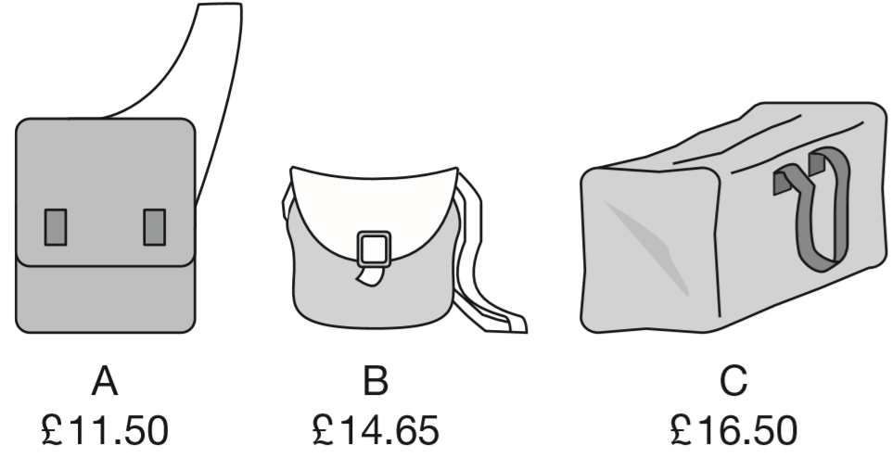  How much does bag B cost to the nearest pound?  Jamie buys bag A and bag C.  How much change does he get from £40? | Draw two different rectangles. Use the dots.  
Write what the missing numbers could be.  ____ is an odd number, and is greater than 15  ____ is a number greater than 100 and can be divided by 4, with no remainder. | 2.1 is marked on the number line.  Mark 0.65 on the number line.  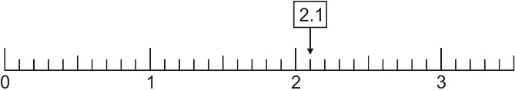
Plants are sold in trays of 20  Ivana buys 7 trays of plants.  How many plants is this?  David wants 240 plants.  How many trays does he need to buy? | Write these lengths in order, starting with the shortest.  ½m 25mm 3.5cm 20cm  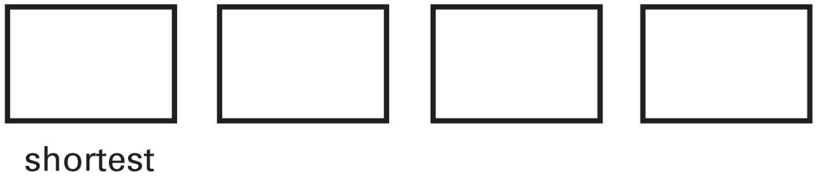
Amy did a survey of what time people get up on a Sunday morning. This table shows her results for 150 people.  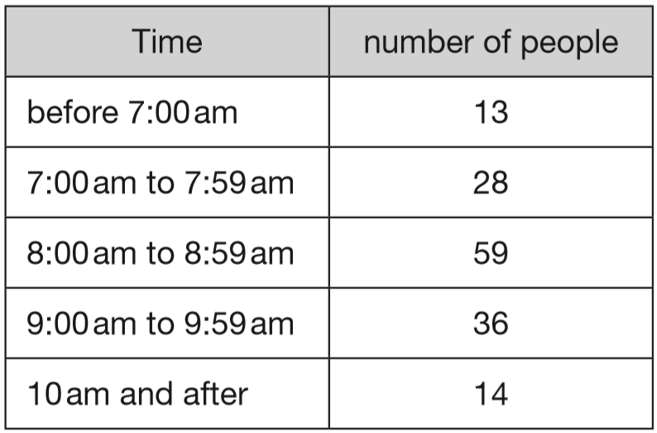  How many people get up at 8am or later? | Here are five quadrilaterals on a square grid. A dotted line has been drawn on each quadrilateral. For each shape, put a tick if the dotted line is a line of symmetry.  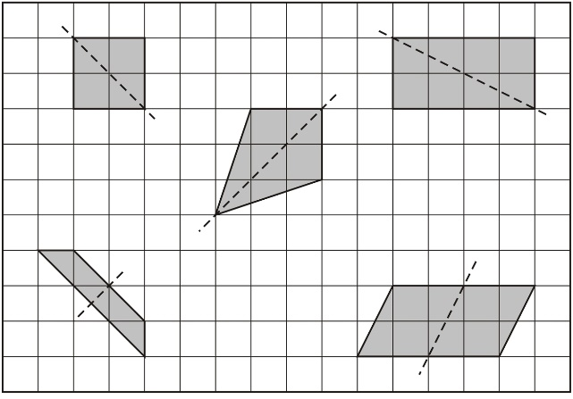
Dan has these coins.  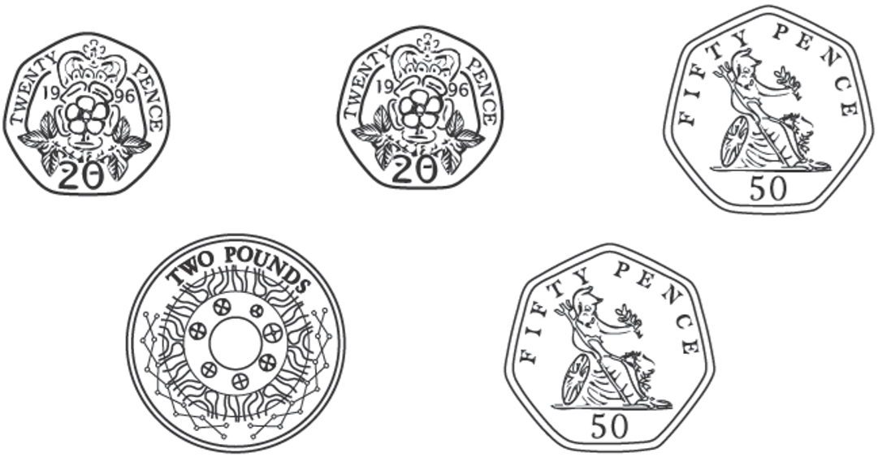  Vijay has £1.50  How much more money does Dan have than Vijay? | Book Sale: Any 3 books for £14.50  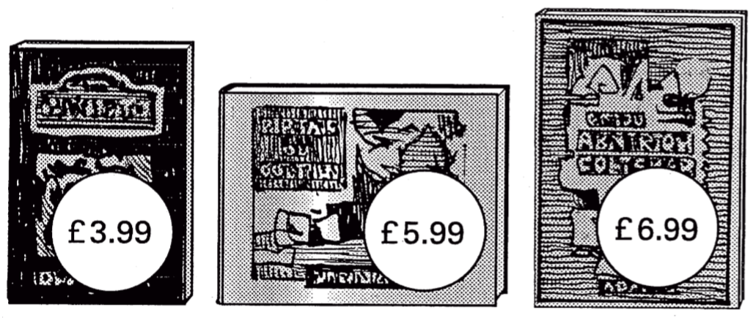  Lee bought these three books in the sale for £14.50  How much money did he save altogether compared to the full price of the books?

Emma buys 5 bunches of flowers.  Each bunch of flowers costs £1.20  How much does Emma pay altogether? | Which number below is four thousand and seven? Put a ring round it.  47 407 4,007 40,007 400,007
This table shows when flights take off at an airport.  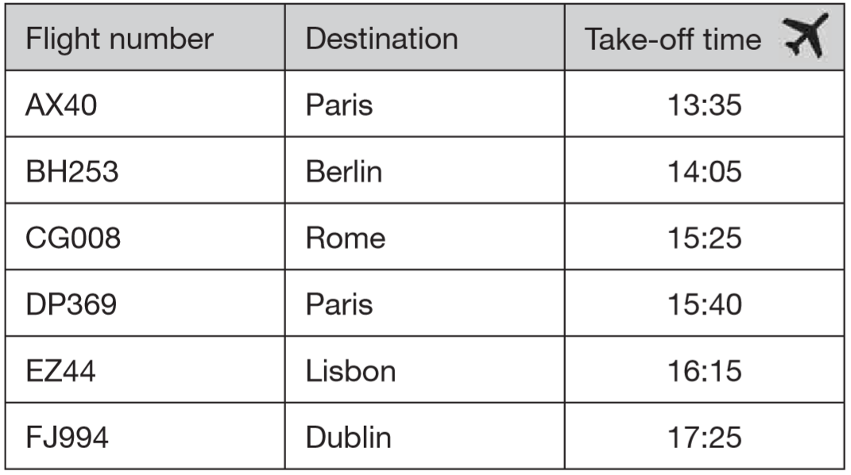  How many flights take off between 3pm and 5pm?  How much later does the second flight to Paris take off than the first?  The flight to Dublin takes 50 minutes. What time does it arrive in Dublin? | This table shows the cost of sending a letter.  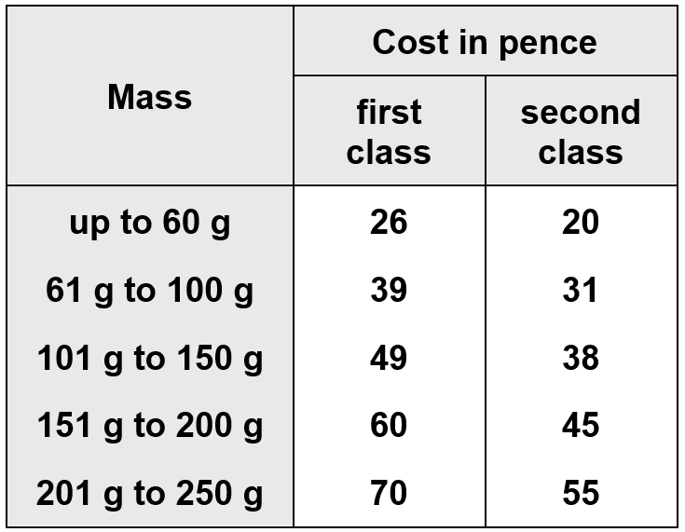  Paul is sending a letter.  It costs 38p second class.  How much would it cost him to send it first class?  Jenny has a letter with a mass of 170 g.  What does it cost to send it first class?
Write a decimal that is between 3.7 and 3.8 | Write the missing numbers in the sequence.  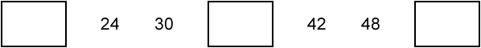
Here are the times of some television programmes.  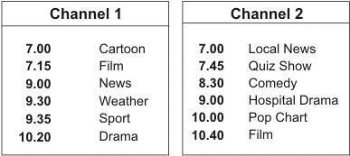  What is showing on Channel 2 at ten minutes to eight?  Tom watches Hospital Drama and then changes to Channel 1 at the end. What is showing on Channel 1 when he changes channel?  The film on Channel 2 starts at 10.40  It lasts for one and a half hours.  At what time does the film end? | Six classes at Winward Primary School collected some money. The chart shows how much money the boys and girls collected.  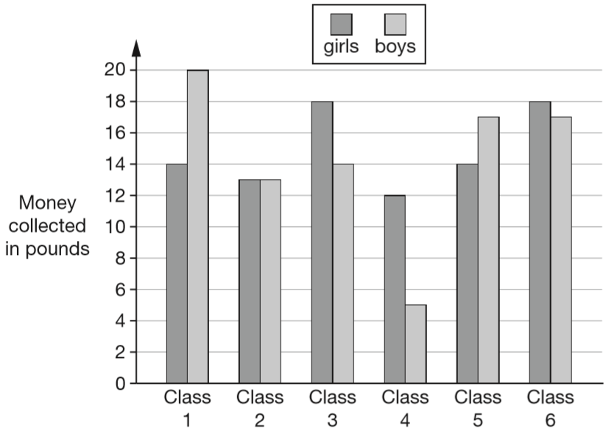  In Class 4, how much more money did the girls collect than the boys?  How many classes collected more than £30?
A shop sells candles.  plain candles - 35p each  star candles - 60p each  stripe candles - 85p each  Sapna buys 4 star candles and 2 stripe candles.  How much does she pay altogether?  Special offer: Buy 10 candles and get 50p off.  Josh buys 10 plain candles in the special offer.  How much does he pay for the 10 candles? | kilograms litres centimetres  Choose one of the words to complete each sentence below.  You can measure how tall you are in  You can measure how heavy you are in  You can measure how much you drink in

Here are three shapes made from regular hexagons.  Write the fraction of each shape that is shaded.  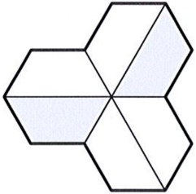  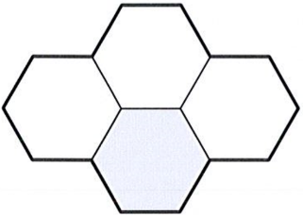  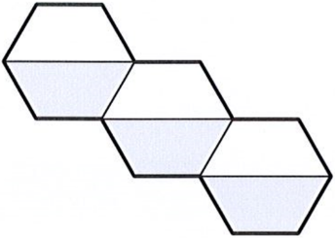 | This graph shows the temperature at midday each day for a week.  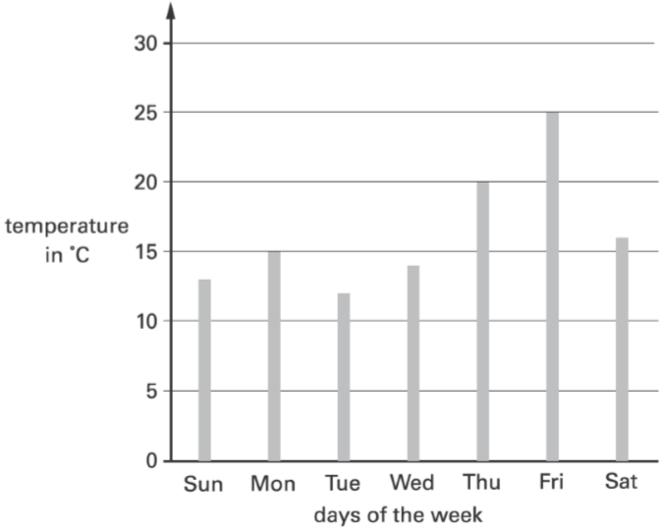  Estimate how much higher the temperature was on Friday than on Saturday.
In athletics, Holly did the ‘Hop, step, jump’.  The length of her ‘hop’ was 0.86 m  The length of her ‘step’ was 1.21 m  The length of her ‘jump’ was 3.78 m  What was the total length of Holly’s ‘Hop, step, jump’ to one decimal place?  Circle the correct answer.  5.8 m 5.9 m 6.0 m 6.1 m | Here is a shape divided into centimetre squares. What is the perimeter of the shape?  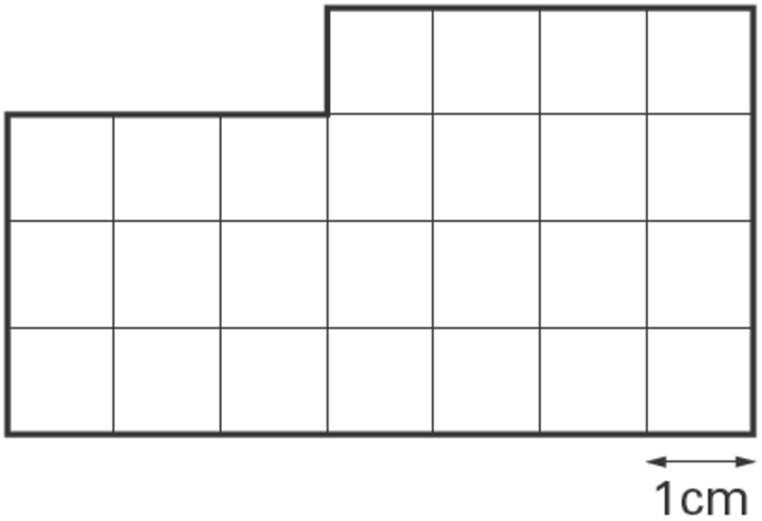
Each of these shapes has one or more lines of symmetry. Draw all the lines of symmetry on each shape.  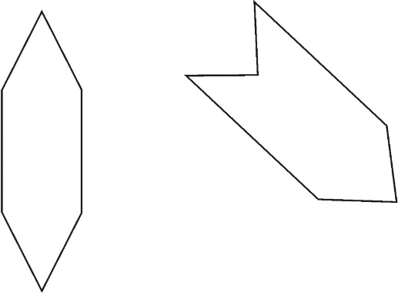 | In this shape, one of the angles is obtuse.  Tick the obtuse angle.  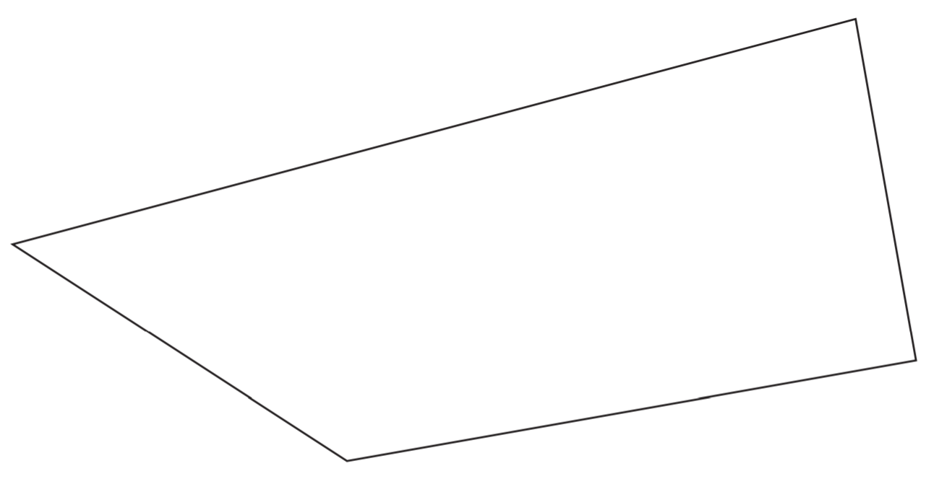
Tick each shape that is exactly $\frac{1}{4}$shaded.  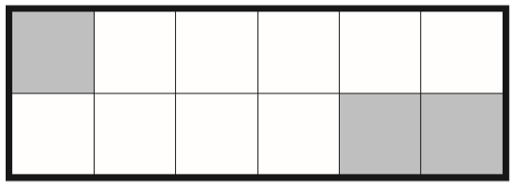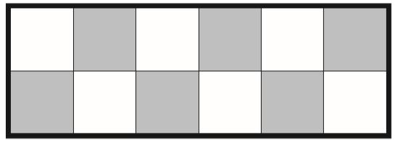  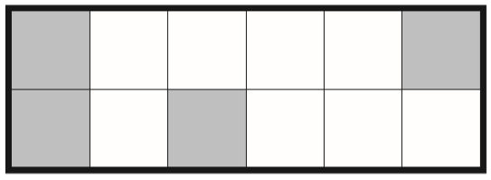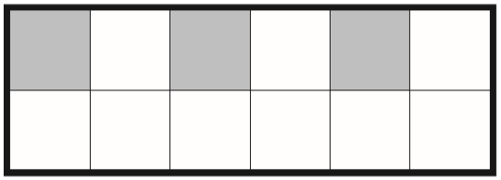 | Leon and Sara each started with different numbers.  Leon says, ‘I added 5 to my number.’  Sara says, ‘I subtracted 8 from my number.’  Leon and Sara both get the same answer.  What numbers could they have started with?
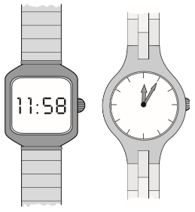  One of these watches is 3 minutes fast.  The other watch is 4 minutes slow.  What is the correct time? | Write in the missing numbers.  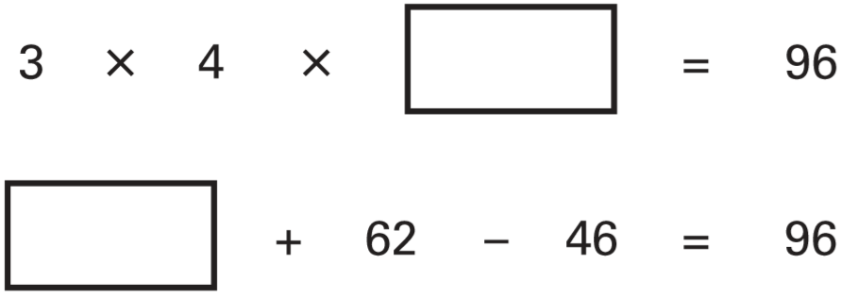

Here is a 1 cm square grid. Some of the grid is shaded. What is the area of the shaded shape?  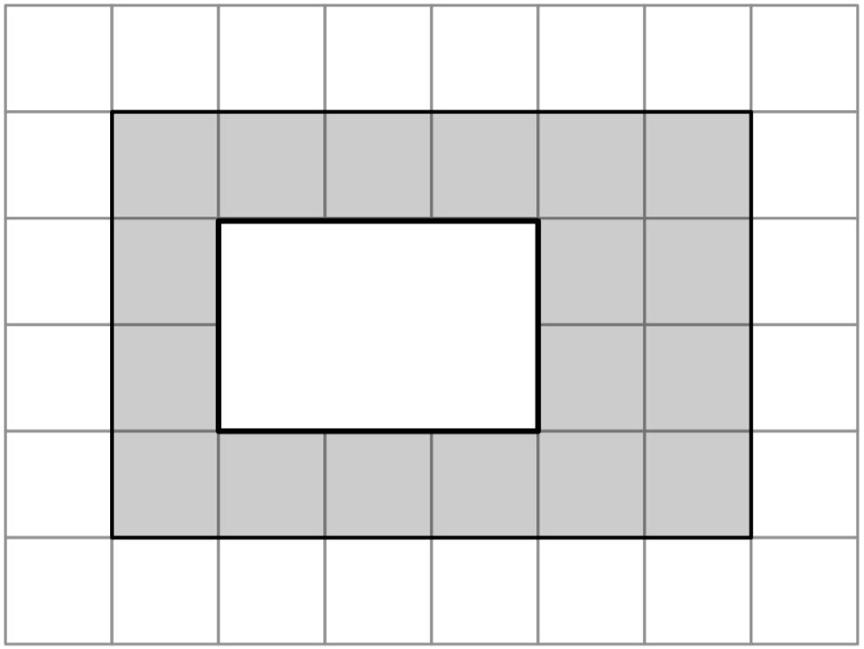 | Kiz asked each child in his class, ‘What kind of television programme do you prefer to watch?’ Here are his results.  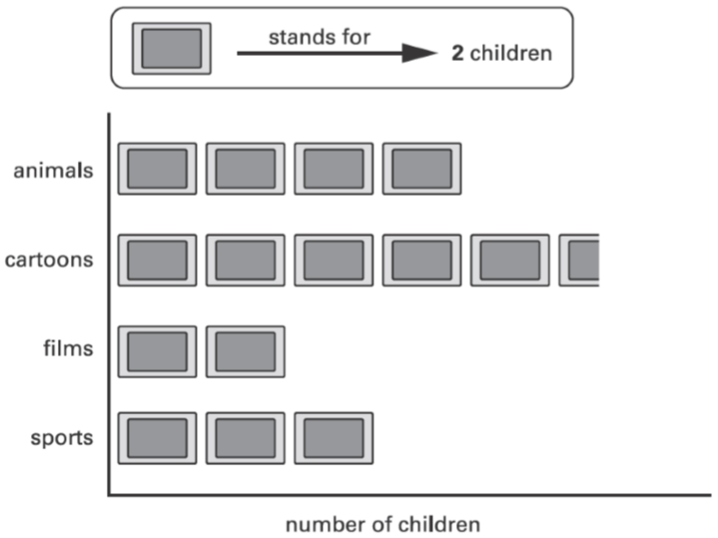  How many more children prefer to watch cartoons than films?
Write in the missing number.   | 4 pineapples cost £3.40  Calculate the cost of 1 pineapple.
Draw an arrow on the number line to show 1$\frac{3}{4}$ | An aeroplane takes off on Tuesday at 22:47  It lands on Wednesday at 07:05  How long in hours and minutes is the flight?
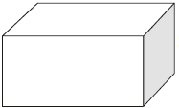  How many faces, vertices and edges does a cuboid have?  Faces:  Vertices:  Edges: | Each missing digit in these calculations is 2, 5 or 7  Write in the missing digits.  You may use each digit more than once.  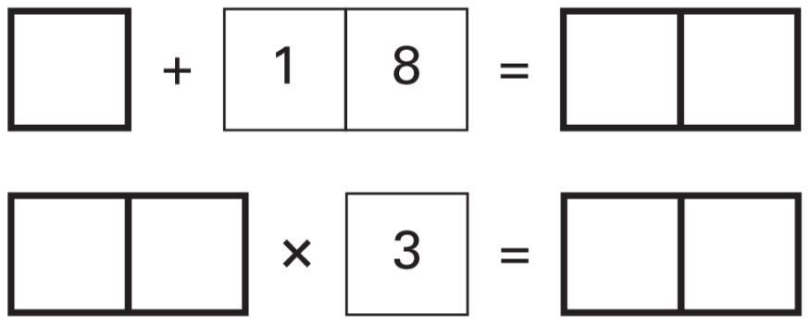
A school has a quiz each year. There are two teams. Here are their results.  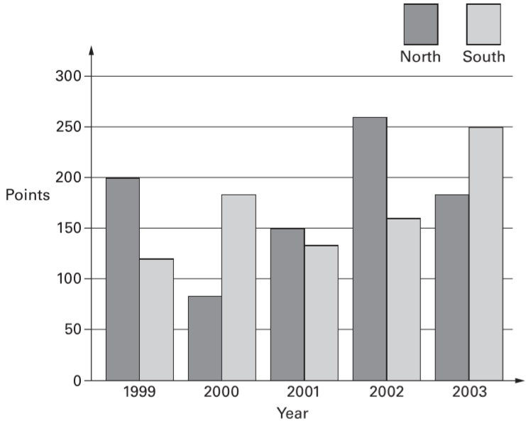  In which year did North beat South by 100 points?  In which year did South beat North by the greatest amount? | These are the times letters are collected from a post box.  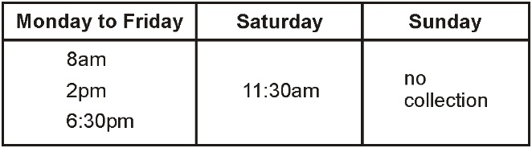  What is the latest time letters are collected on Wednesday?  Carla posts a letter at 9am on Monday.  How long will it be before it is collected?  Gareth posts a letter on Saturday at 3pm.  When is it collected from the post box?  Day:  Time:

Kate has a piece of ribbon one metre long.  She cuts off 30 centimetres.  How many centimetres of ribbon are left? | Kirsty ran a race in one and a half minutes.  Mina took 10 seconds longer.  How many seconds did Mina take to run the race?
There are 12 pencils in a box.  A school buys 24 boxes.  How many pencils does the school buy? | Write the missing number.  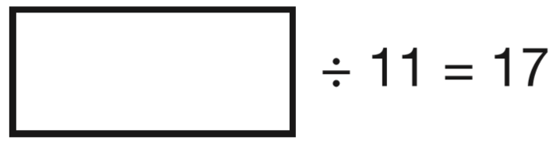
Amy has some circular tiles and some rectangular tiles.  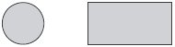  She makes these patterns with them. For each pattern, put a tick if it has a line of symmetry. Put a cross if it does not.  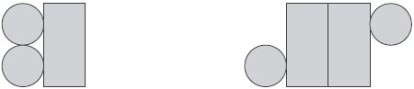  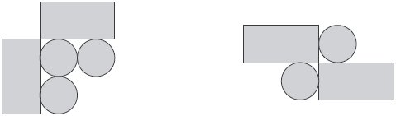 | Jade asked each child in her class, ‘Do you stay at school or go home for lunch?’ Here are her results.  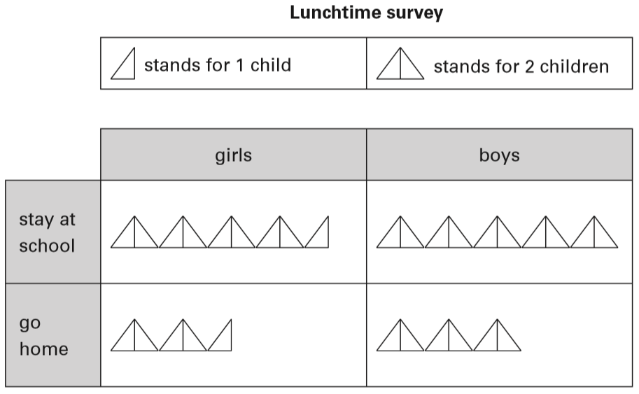  How many more girls stay at school than go home for lunch?
Here is part of a number grid.  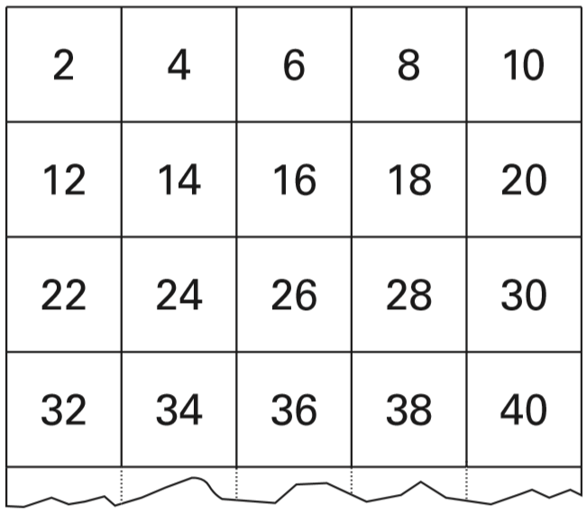  Here is another part of the same grid.  Write in the missing numbers.  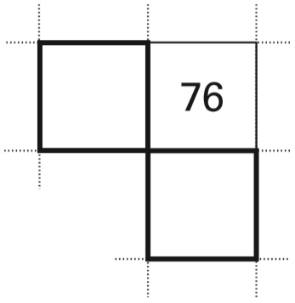 | Liam, Sarah and Amy buy lunch at a salad bar.  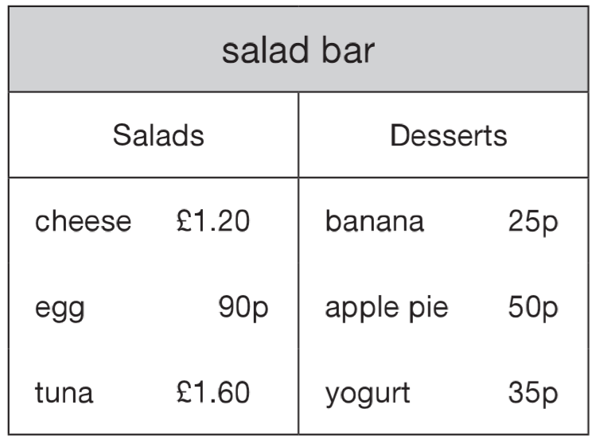  Liam has £2.50 to spend  He buys a tuna salad and an apple pie.  How much money has he got left?  Sarah buys a cheese salad and a yogurt.  Amy buys an egg salad.  How much more does Sarah pay than Amy?
One battery weighs the same as 60 paperclips.  One pencil sharpener weighs the same as 20 paperclips.  How many pencil sharpeners weigh the same as one battery?  How many paperclips weigh the same as 2 batteries and 4 pencil sharpeners together? | One jug contains water and the other jug contains oil.  How much more oil is there than water?  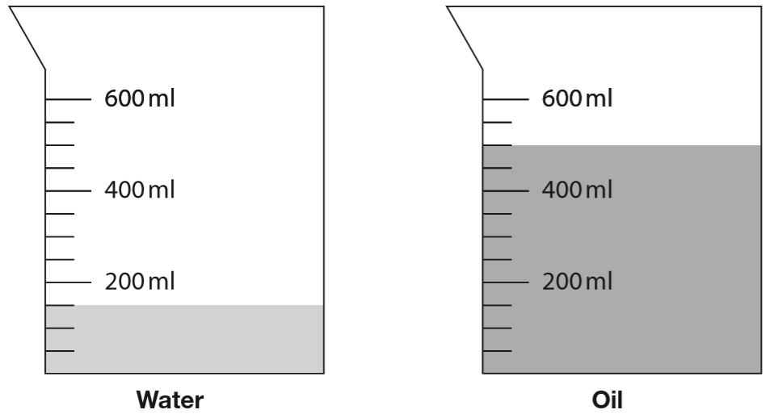
Here are five coins.  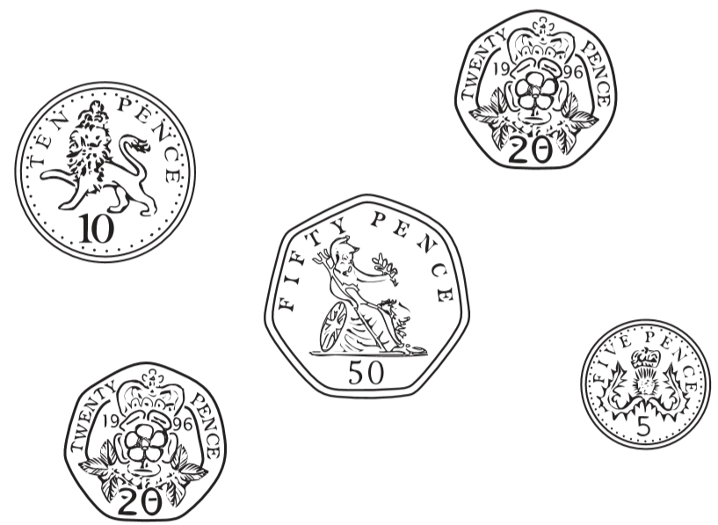  Stefan takes two coins and Lara takes the other three coins.  Stefan takes 15p more than Lara.  Tick the two coins Stefan takes. | This graph shows the age of players at a football club.  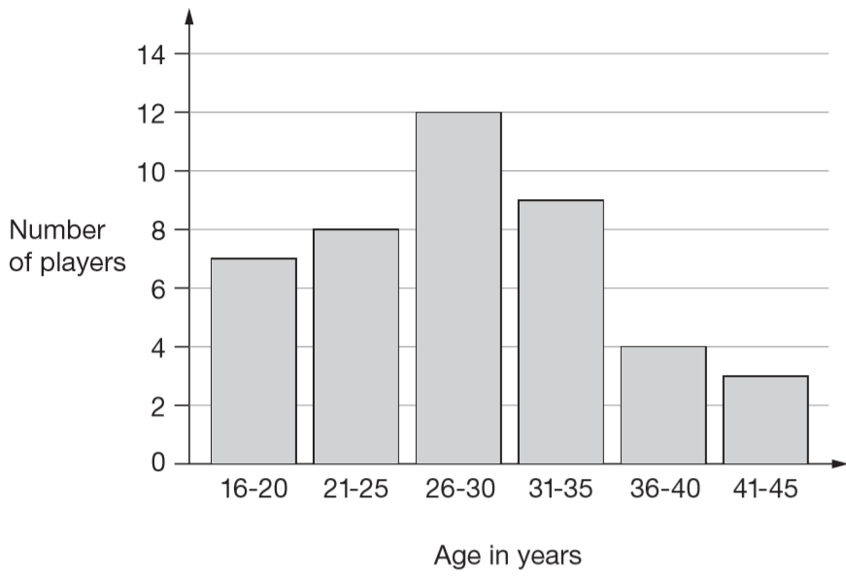  How many players are aged 30 or younger?  A player aged 36 and a player aged 39 join the club. Add this information to the graph.
The numbers in this sequence increase by 101 each time.  Write the next two numbers in the sequence.  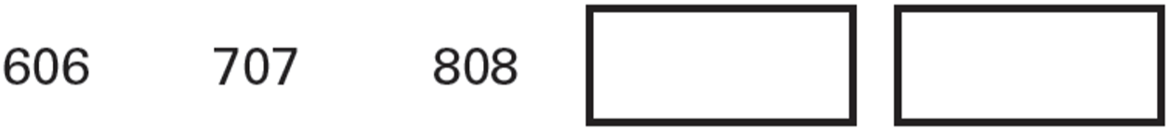 | Eggs are put in trays of 12  The trays are packed in boxes.  Each box contains 180 eggs.  How many trays are in each box?
This diagram has four angles marked A, B, C and D.  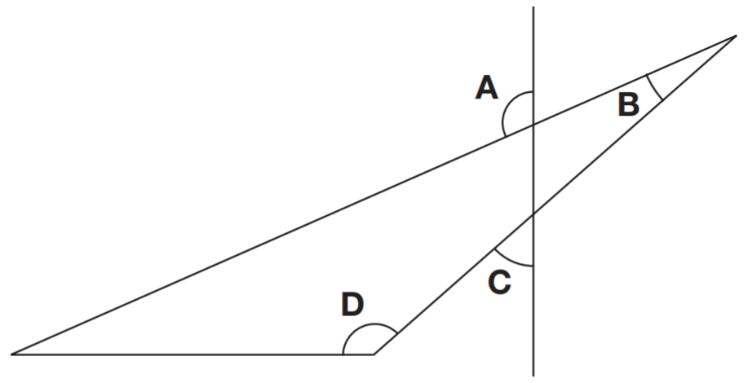Write the letters of the angles that are obtuse angles. | Karen makes a fraction using two number cards.  She says, ‘My fraction is equivalent to ½  One of the number cards is 6’  What could Karen’s fraction be?  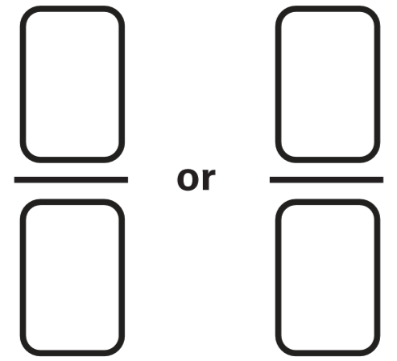
Write in what the missing numbers could be.  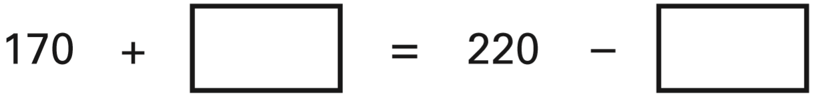 | What is the remainder when you divide 53 by 8?
The children in Farm School Orchestra each play one instrument.  The table show how many children play each instrument.  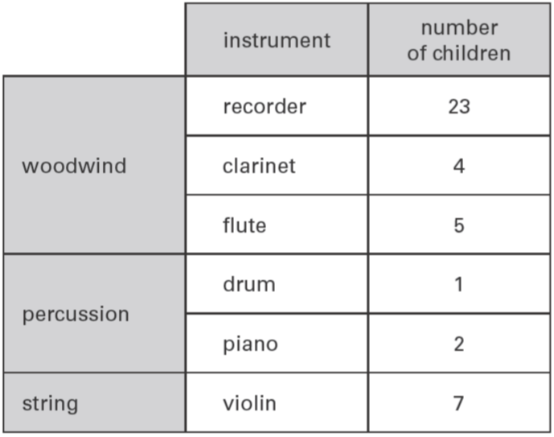  How many more children play a recorder than play a violin?  How many children do not play a percussion instrument? | pack of 4 cans of lemonade £1.20  pack of 6 cans of lemonade £1.70  Asim and Mike both buy 12 cans of lemonade.  Asim buys 3 packs of 4 cans.  Mike buys 2 packs of 6 cans.  Mike says to Asim, ‘You paid 50p more than me.’ Is Mike correct? Explain how you know.

Here is a baby’s drinking cup.  How many millilitres of water are in the cup?  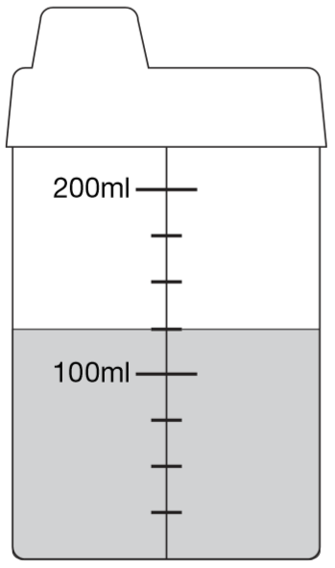 | Write these numbers in order from highest to lowest.  1003 3010 3001 1030  310 130 1300 103  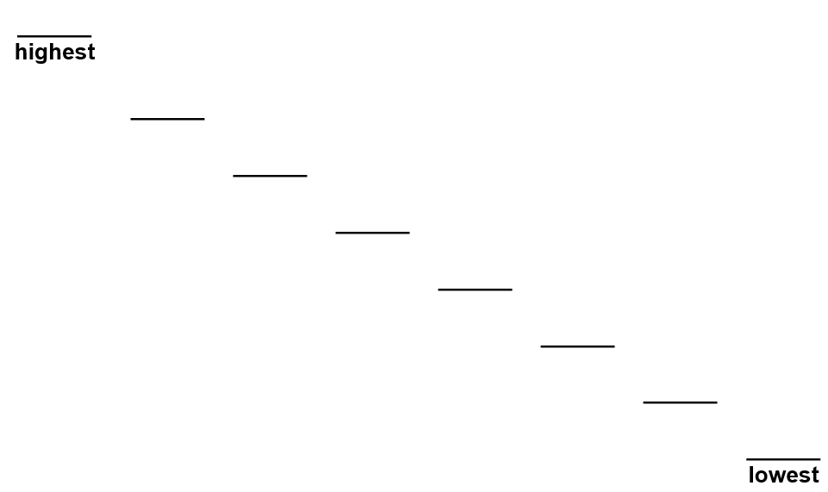
Here are some number cards.  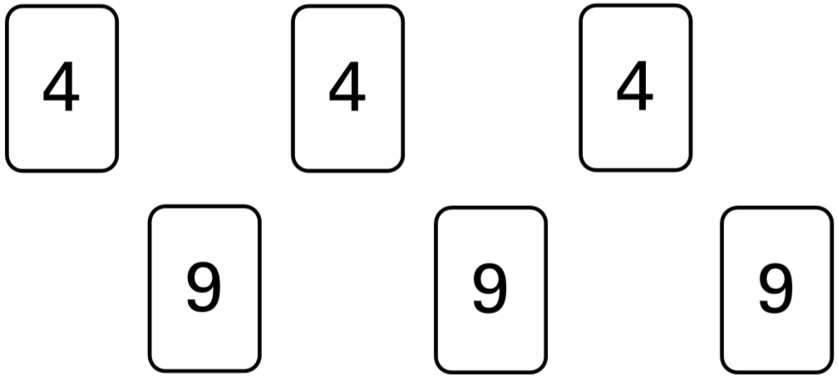  Use five of the number cards to make this correct.  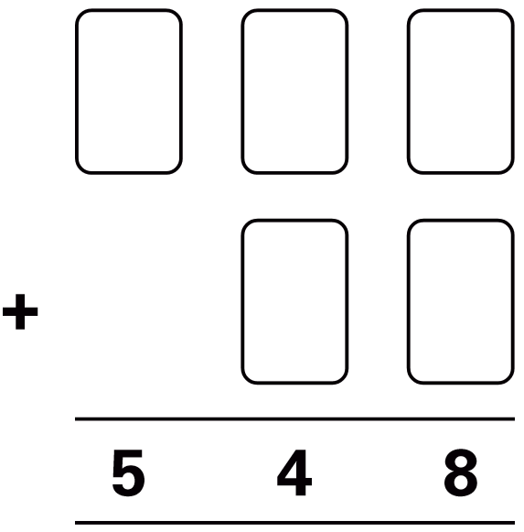 | Children run a 100 metres race on Sports Day.  Here are their times.  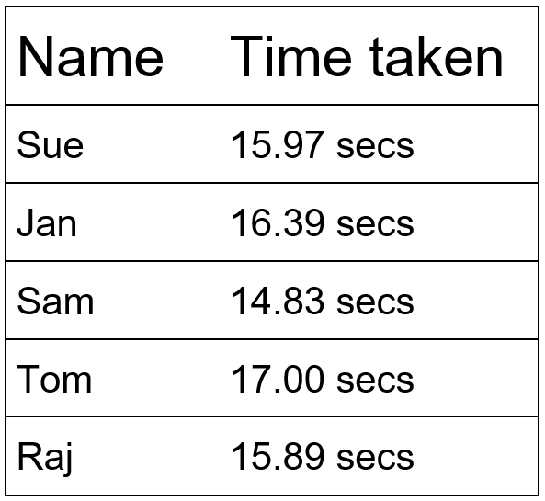  What is the winner's time?  Who has the time nearest to 16 seconds?
Here are some numbers.  1 2 3 4 5  Write one of the numbers in each box to make these correct.  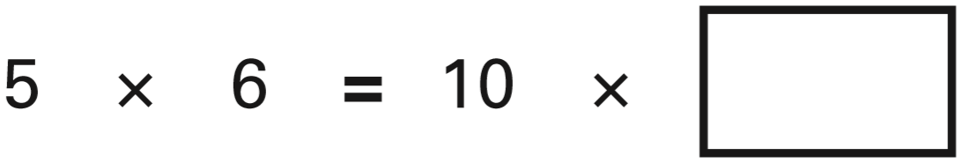  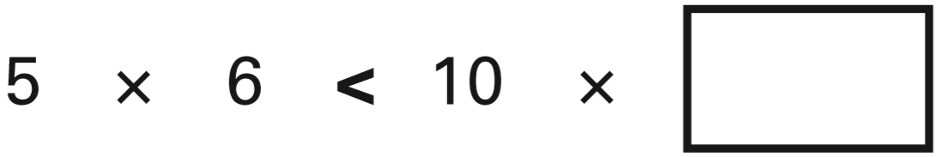 | The diagram is made of squares.  What fraction of the diagram is shaded?  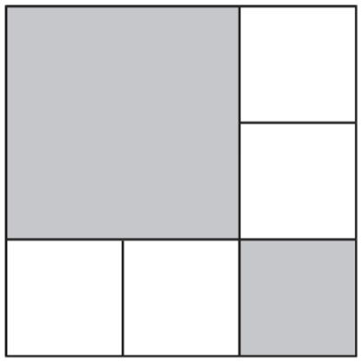
Here are five digit cards.  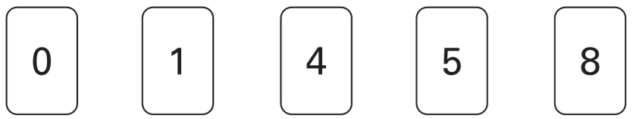  Use all five digit cards to make this correct.  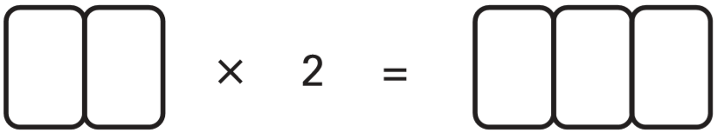 | A box of four balls costs £2.96  How much does each ball cost?  Dean and Alex buy 3 boxes of balls between them.  Dean pays £4.50  How much must Alex pay?
In the number 4,378, the ﬁgure 7 represents 7 tens.  What does the ﬁgure 3 represent?  What does the ﬁgure 4 represent? | A number multiplied by itself gives the answer 49  Circle the number.  2 3 4 5 6 7 8 9

Use the dots to draw a square with sides 6 cm long.  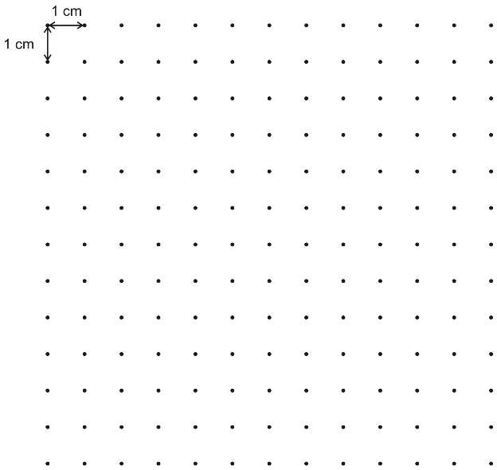 | This was the time on Selin’s watch when she set off for a walk.  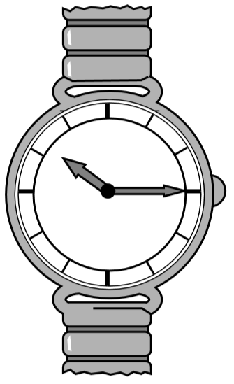  What time did the watch show 20 minutes before this?  What time did it show an hour and a half after she set off for the walk?
Write these numbers in order.  One has been done for you.  3.03 3 3.3 3.23 3.2  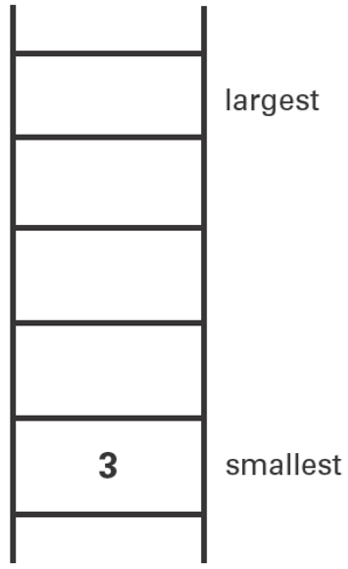 | Rose made shapes using four squares on a centimetre grid.  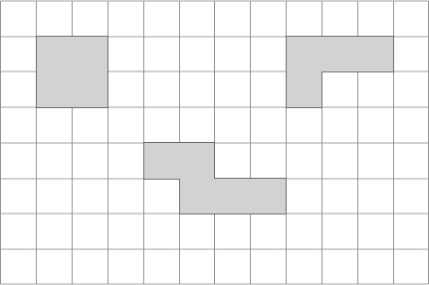  What is the length of the shortest perimeter?  What is the length of the longest perimeter?
Alan has 45 beans.  He plants 3 beans in each of his pots.  How many pots does he need?  Leila puts 4 seeds in each of her pots.  She uses 6 pots and has 1 seed left over.  How many seeds did she start with? | Annie had 36 sweets. She ate $\frac{2}{3}$of them.  Ben had 40 sweets. He ate $\frac{1}{5}$of them.  How many more sweets did Annie eat than Ben?
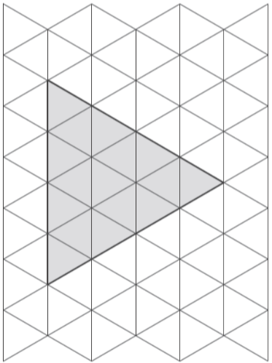  Here is a grid of equilateral triangles.  Draw all the lines of symmetry on the shaded triangle. | 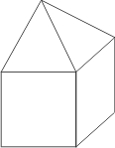  Ben fits a square-based pyramid exactly on top of a cube.  How many faces, vertices and edges does Ben’s new shape have?  Faces:  Vertices:  Edges:
Write the missing number.  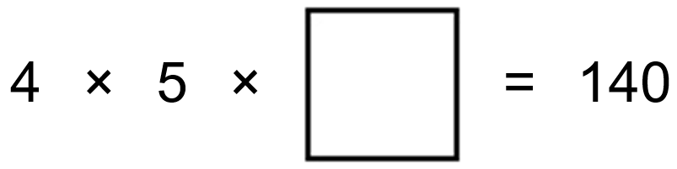 | Circle the number closest in value to 0.1  0.01 0.05 0.11 0.2 0.9

Here is a set of 20 squares around a shaded space. What is the area of the shaded space?  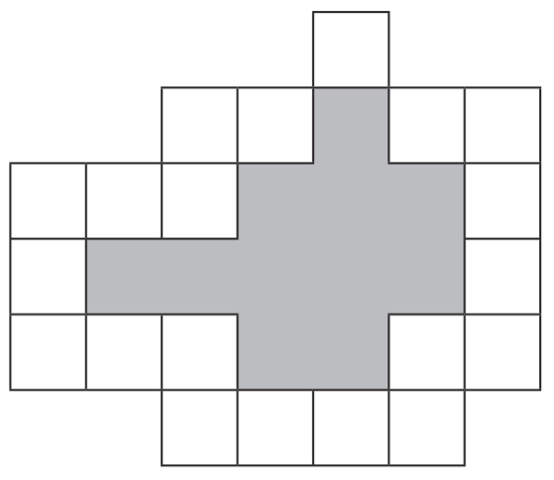 | Tick the two shapes that have three-quarters shaded.  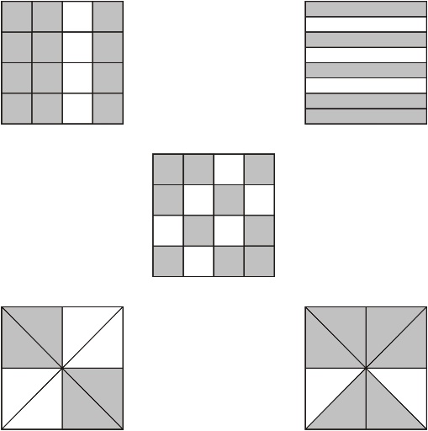
These are the radio programmes one morning.  7:00 Music show  7:55 Weather report  8:00 News  8:15 Travel news  8:25 Sport  8:45 Holiday programme  Josh turns the radio on at 7:25am.  How many minutes does he have to wait for the Weather report?  The Holiday programme lasts for 40 minutes.  At what time does the Holiday programme finish? | Here are some shaded shapes on a grid.  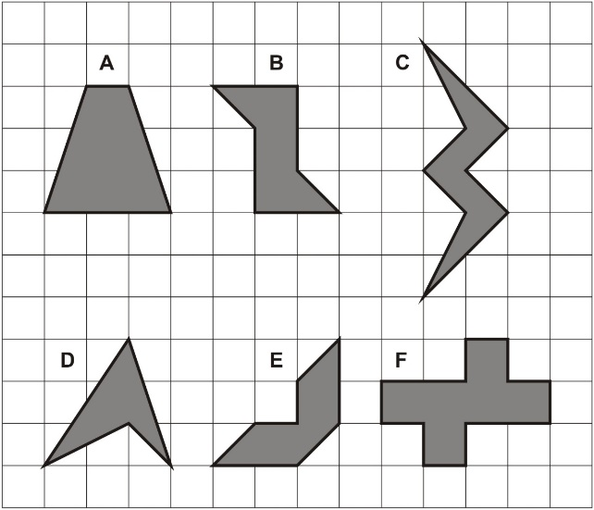  Which three shapes have reflective symmetry?
Cinema tickets cost £3.65 each.  Hannah buys 4 tickets.  How much does Hannah pay? | A letter costs 65p to send.  Carla has 20p stamps and 5p stamps.  How many of each stamp does she need?
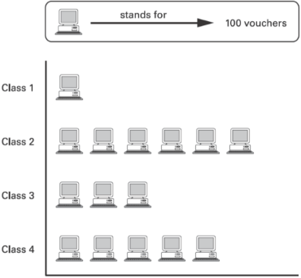  The children at Brook School collect computer vouchers.  Altogether, they need 10 000 vouchers to get a computer.  How many more vouchers do they need? | Shade $\frac{1}{5}$of this shape.  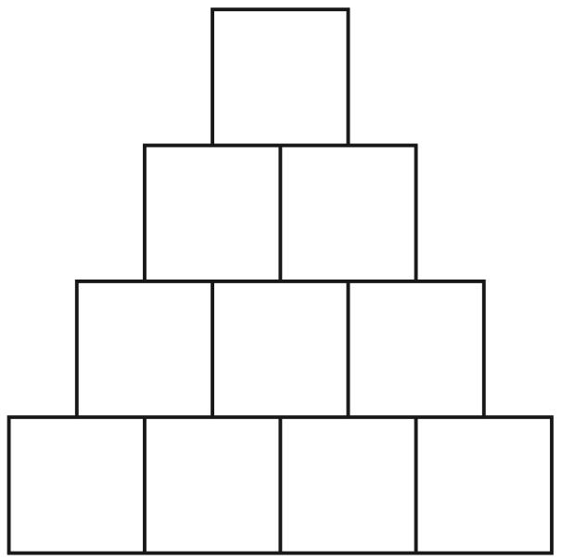
The table shows the cost of a new football kit.  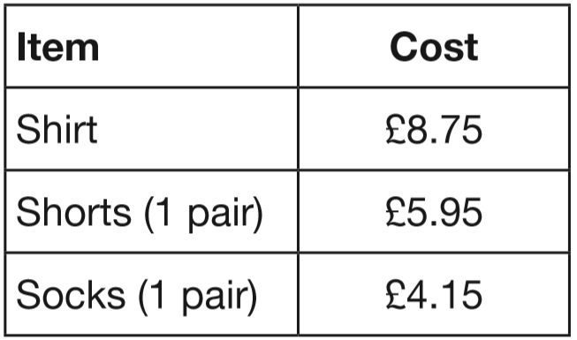  Altogether, how much does the complete football kit cost? | Tick the two numbers which have a total of 10  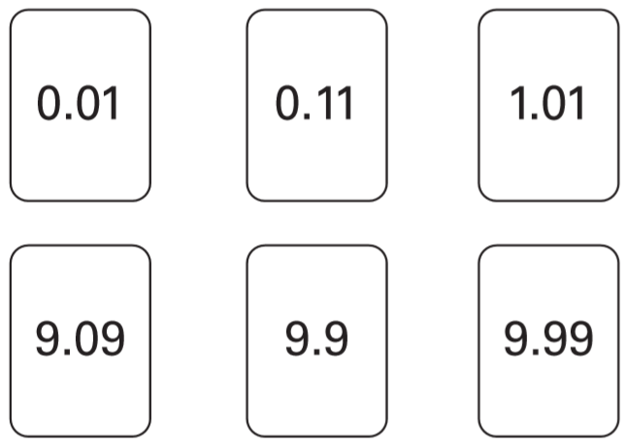

Two of these sentences could be true.  Tick the two sentences that could be true.  Adam’s pencil is 12 centimetres long.  Leah is 12 metres tall.  Jake’s glass holds 12 litres of milk.  Kate’s younger sister weighs 12 kilograms. | Here are four digit cards.  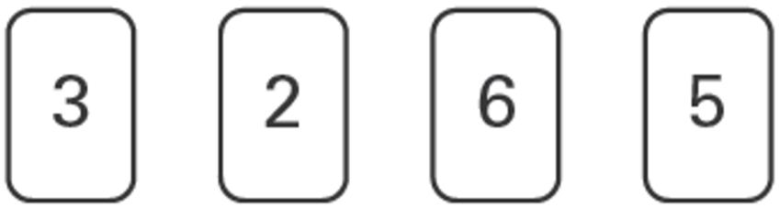  Write in three of the digits to make the total nearest to 1000  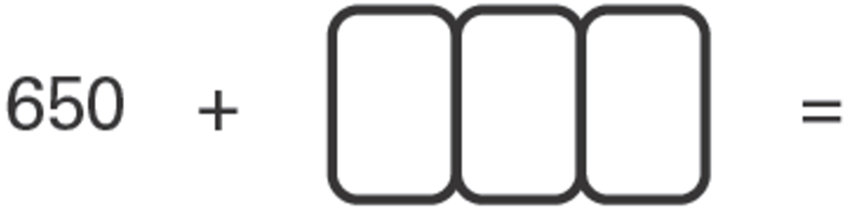
Round these numbers to one decimal place.  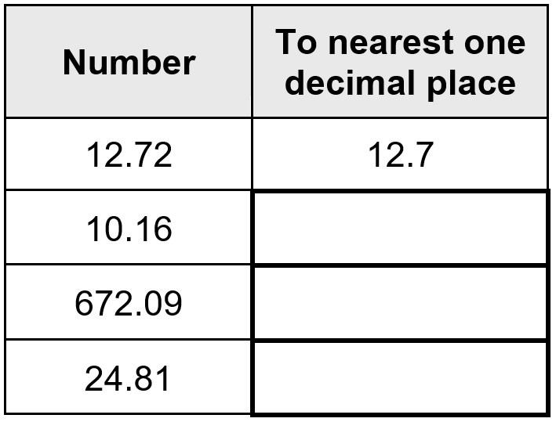 | Tom, Amy and Helen want to go on a boat trip. There are three boats.  Lark: 50 minute trip  Heron: 70 minute trip  Kestrel: 90 minute trip  Tom and Amy go on the Heron. They leave at 2:15pm. At what time do they return?  Helen goes on the Kestrel and gets back at 4:15pm. At what time did the boat leave?
Chen has £9.10  He wants to buy a game which costs £11.50  How much more does he need to save? | Circle three numbers that add to make 750  450 350 250 150 50
In the chart any three numbers in a line, across or down, have a total of 18.45  Write the missing number.  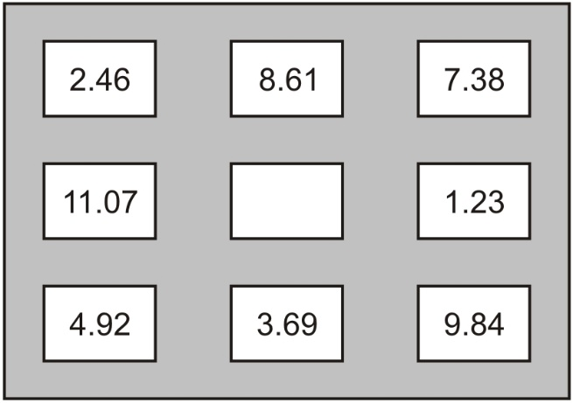 | Here are two model boats on a centimetre scale.  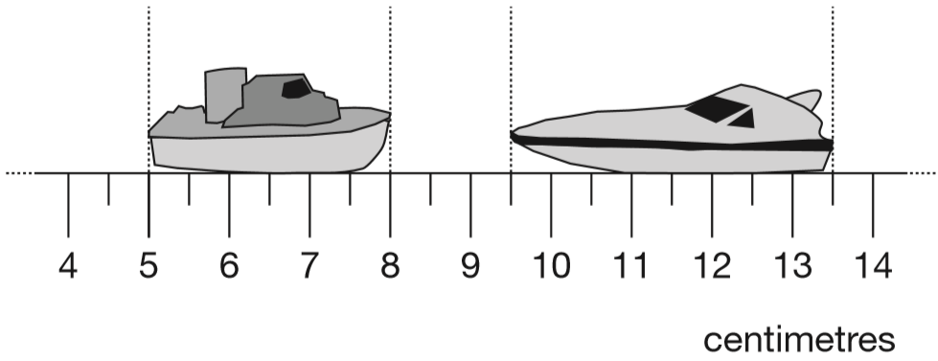  How far apart are the boats?  What is the difference in the lengths of the two boats?
Kirsty, Seb, Mina, Jack and Donna belong to a sports club. This table shows the sports they do in one week.  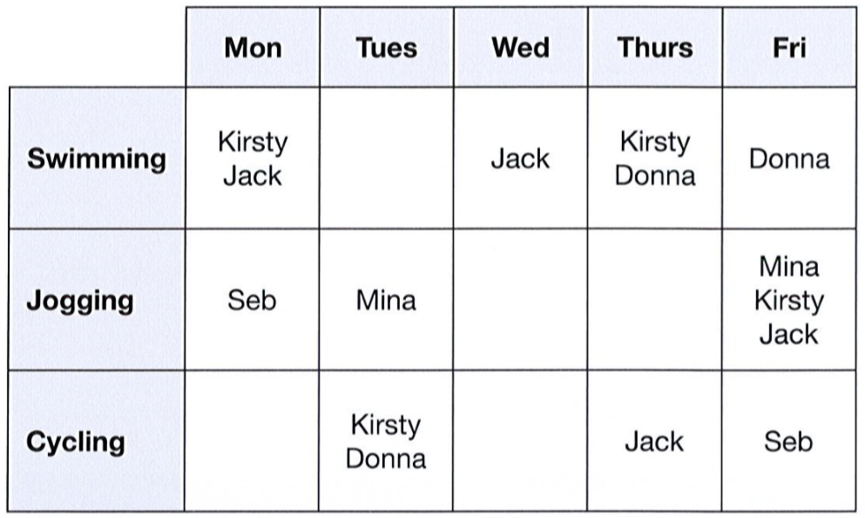  How many of the children do not go swimming?  Write the names of all the children who go both jogging and cycling. | Three children measure the height of their sunﬂowers. Here are their results.  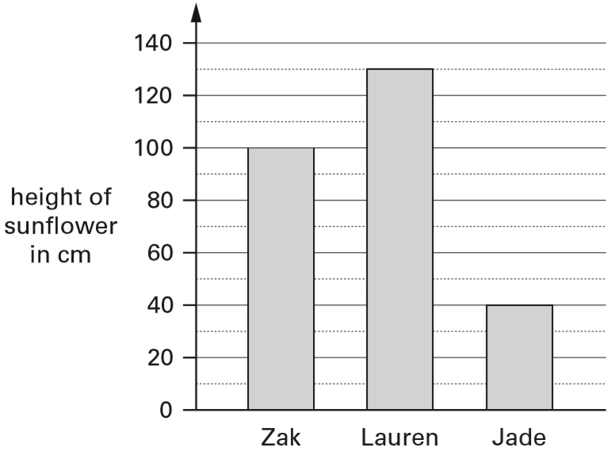  How tall is Lauren’s sunﬂower?  How much taller is Zak’s sunﬂower than Jade’s?

Joe places some apples on a weighing scale.  The pointer shows the mass of the apples.  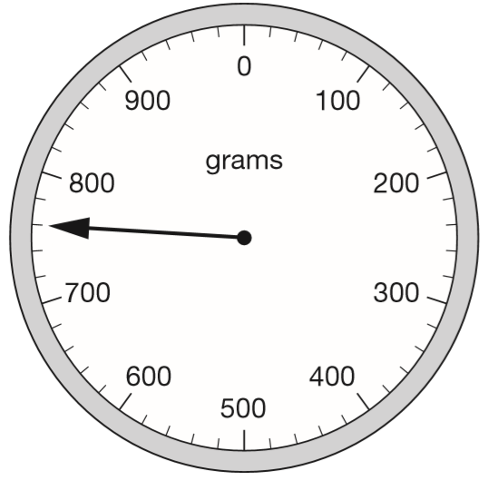  He takes away one apple.  The mass goes down by 120 grams.  Draw the pointer in its new position on the scale below.  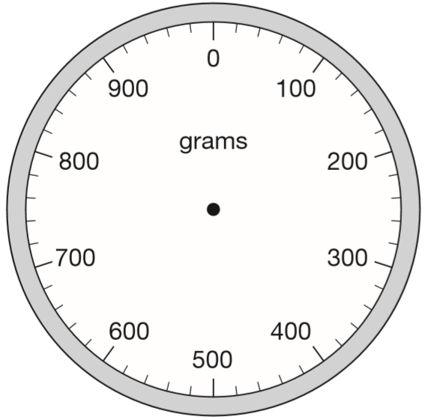 | Leon’s grid has two shaded shapes.  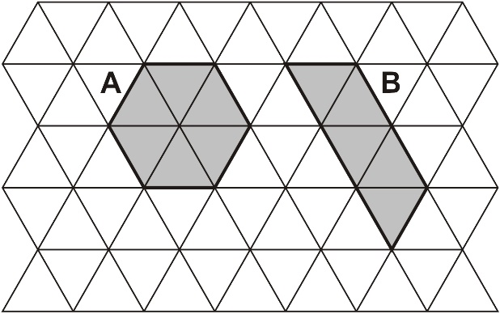  Leon says, ‘Shape A has a larger area than shape B.’ Explain how he could have worked this out.  On this grid draw a different shape.  It must have the same area as shape A.  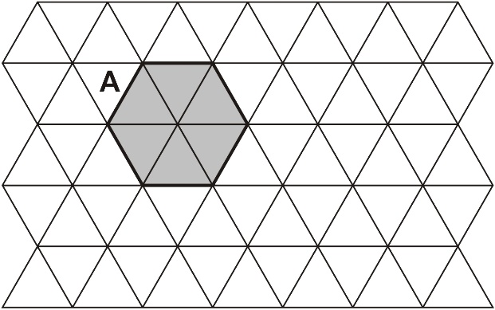
Jamie, Kate and Hassan run a 50m race.  Kate’s time is 13 seconds.  Jamie finishes 5 seconds before Kate.  Hassan finishes 3 seconds after Jamie.  What is Hassan’s time in seconds? | 50 children need two pencils each.  There are 20 pencils in a box.  How many boxes of pencils are needed?  50 children need one pen each.  Pens are sold in packs of 4  How many packs of pens need to be bought?
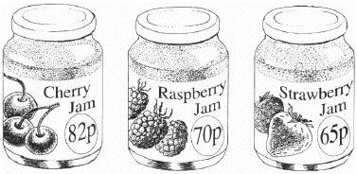  Emma buys these three jars of jam.  What is the total cost of the three jars?  Jack buys one jar of cherry jam for 82p.  He pays with a £5 note.  How much change does he get? | Circle one amount each time to make these sentences correct.  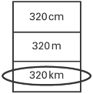  One has been done for you.  The distance from London to Manchester is about  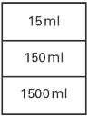  A tea cup is likely to hold about  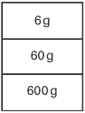  A hen’s egg is likely to weigh about
Write the missing number.  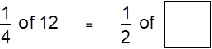 | Seb made a jump of two and a half metres.  Kirsty’s jump was 10 centimetres longer.  How long was Kirsty’s jump?

Write the answers to these calculations in Roman numerals. One has been done for you.  V + VI = XI  IX + XLV =  XC − XXIV = | Look at this number.  24.65  Circle the number below that shows the value of the 6.  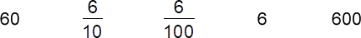
Write the number that is nearest to 5000 which uses all the digits 4, 5, 6 and 7   | Complete the number sentences.  340 ÷ 7 = _____ remainder _____  ______ ÷ 3 = 295 remainder 2
Write the correct number in the IN box.  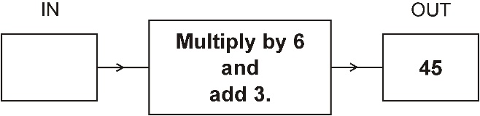 | Parveen has the same number of 20p and 50p coins. She has £7.00  How many of each coin does she have?
Write the two missing numbers in this sequence.  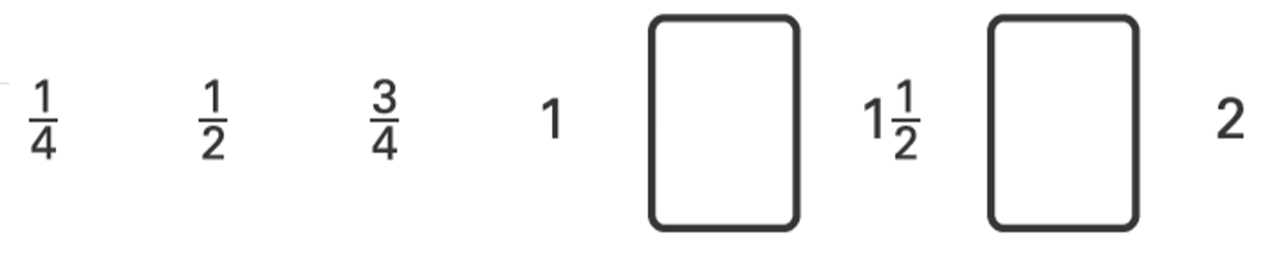 | bottle of milk - 39p cake - 29p  Ben buys three bottles of milk and six cakes.  How much does he spend altogether?
Put ticks and crosses on the chart to complete it correctly.  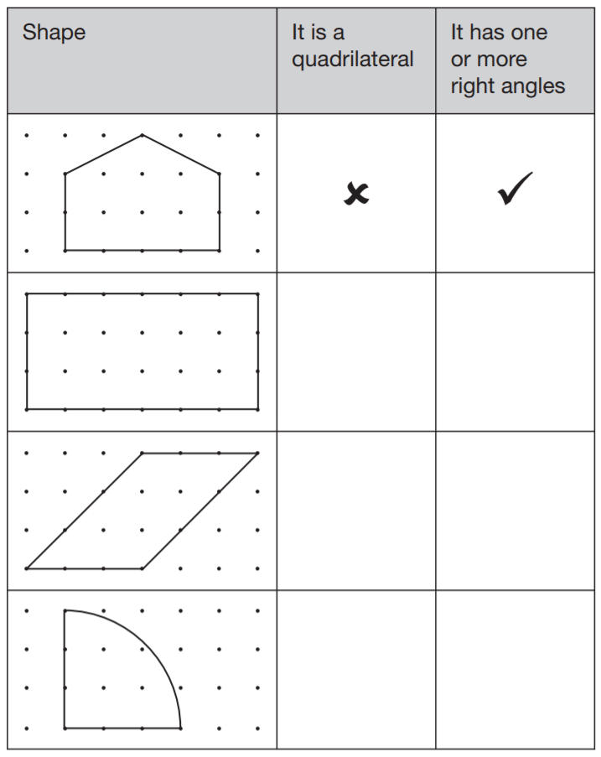 | Each of these diagrams is divided into equal parts. Some of the parts are shaded.  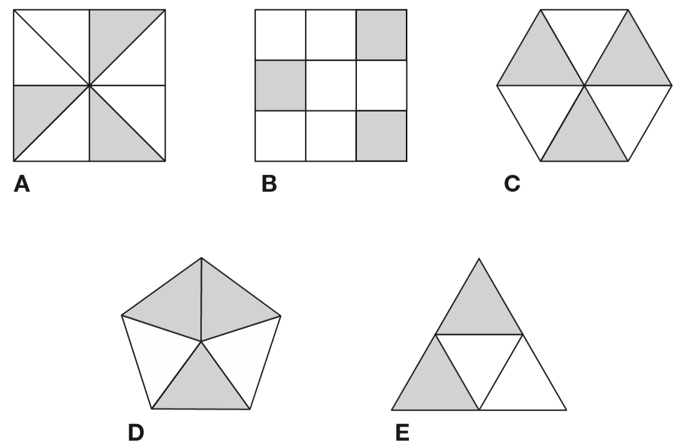  Write the letters of all the diagrams that have exactly $\frac{1}{2}$shaded.  Write the letters of all the diagrams that have exactly $\frac{1}{3}$shaded.
Which shape has the longest perimeter?  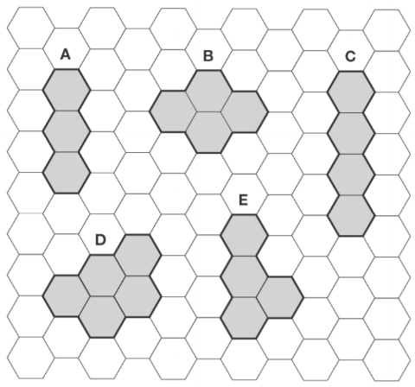 | Circle the number which is closer to 1000  996 1006  Explain how you know.

This table shows the opening times of a pet clinic.  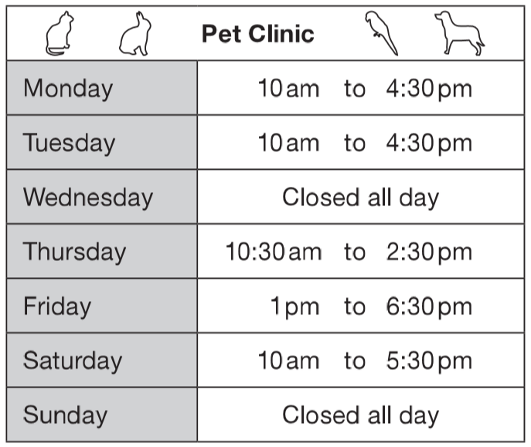  How many hours is the clinic open on Thursday?  On which day is the clinic open for the longest time?  Liam takes his dog to the clinic on Saturday. He arrives at 9:25am. How many minutes is it before the clinic opens? | 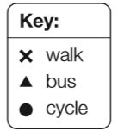  This diagram shows how nine people travel to work and how far away they live.  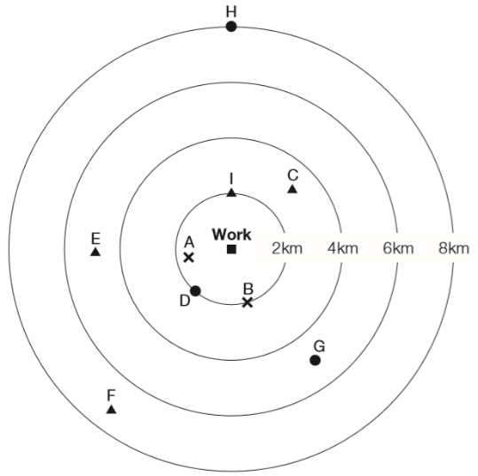  How many people live more than 4km from work?  How far from work does person G live?  Write the letter of the person who lives 2km from work and cycles.
Martin has some bricks.  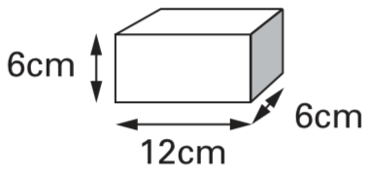  They are 12cm long, 6cm high and 6cm deep.  He builds this tower with five bricks.  How tall is the tower?  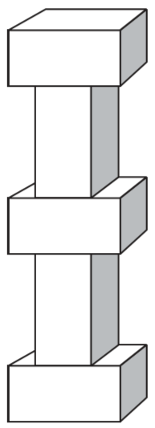 | Each of these bags contains £1.60  Each bag contains only one type of coin.  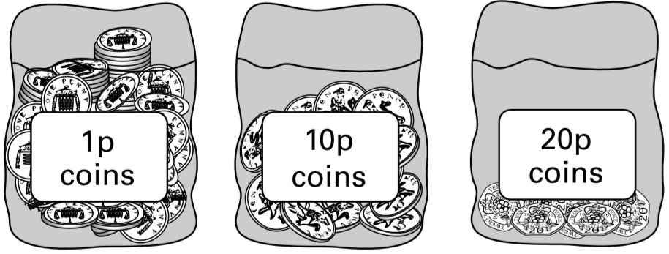  Complete this table to show how many coins are in each bag.  One has been done for you.  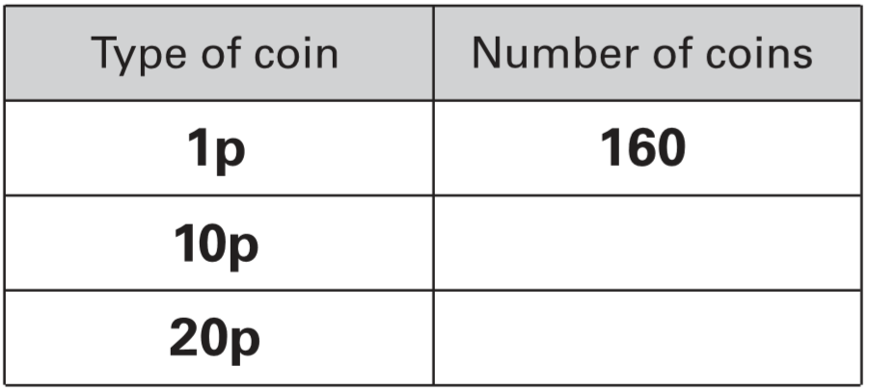
Write the largest whole number to make this statement true.  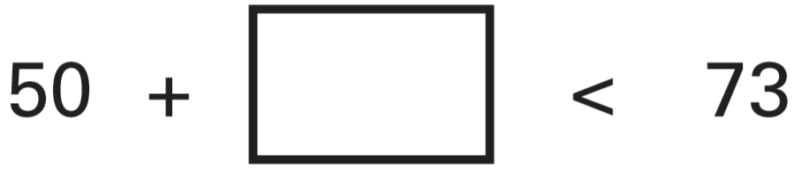 | There are 3 chocolates in a tube.  There are 4 tubes in row.  There are 5 rows in a box.  How many chocolates are there in a box?
Write these numbers in order.  One has been done for you.  2.04 24 0.4 0.24 4  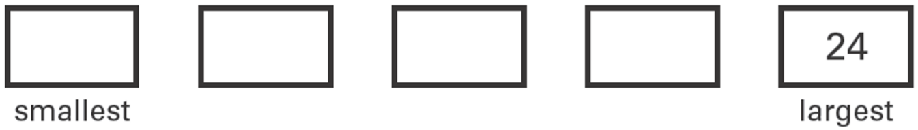 | Here are some signs.  ÷ x =  Write two of the signs to make this correct.  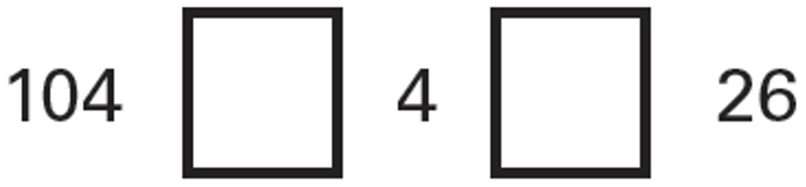
Mrs Patel buys 4 milkshakes costing 65p each and 3 sandwiches costing £1.70 each.  Work out the total cost. | A box holds 6 eggs.  How many boxes are needed to hold 52 eggs?

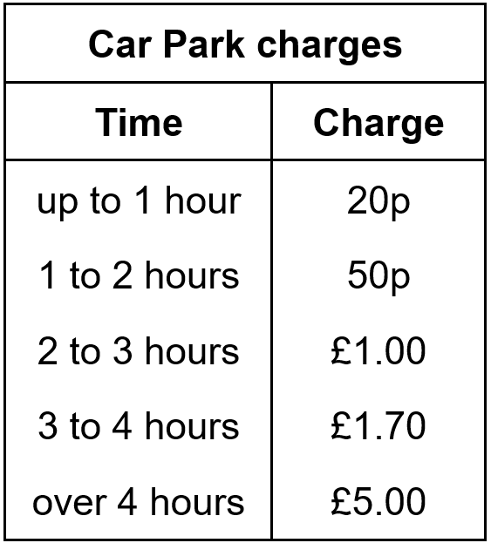  Emma parks her car at 9.30 am.  She collects the car at 1.20 pm.  How much does she pay?  Dan and Mark both use the car park.  Dan says, ‘I paid exactly twice as much as Mark but I only stayed 10 minutes longer.’  Explain how Dan could be correct. | Here is a graph of guitar sales.  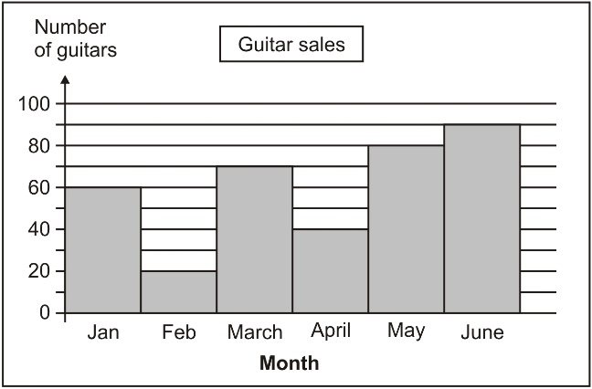  The table below shows the change in sales from month to month. Use the graph to complete the table.  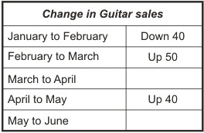  Which month had the greatest change in sales compared with the month before?
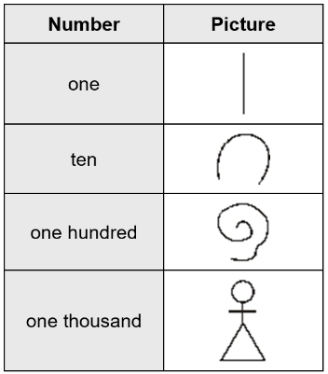  The ancient Egyptians used pictures to show numbers.  The table gives some of these pictures.  Write in figures the number that each picture below is showing.  The first one is done for you.  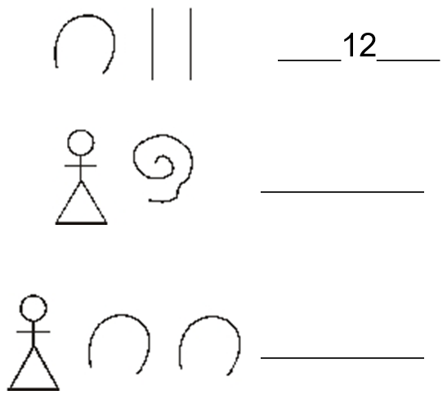 | Write in the missing number.  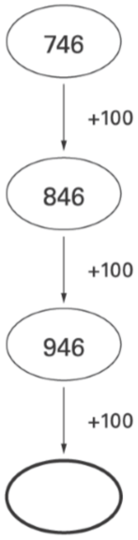
Jenny can walk 103 metres in 1 minute.  How far can she walk in 2 minutes? | Write what the four missing digits could be.
Write in the missing number.  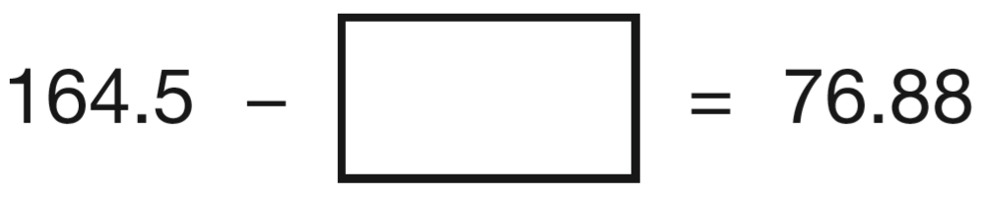 | It costs Ben £4.16 to post two parcels.  One parcel costs £3.32 to post.  How much does the other parcel cost to post?

Write one number from each circle to make this calculation correct.  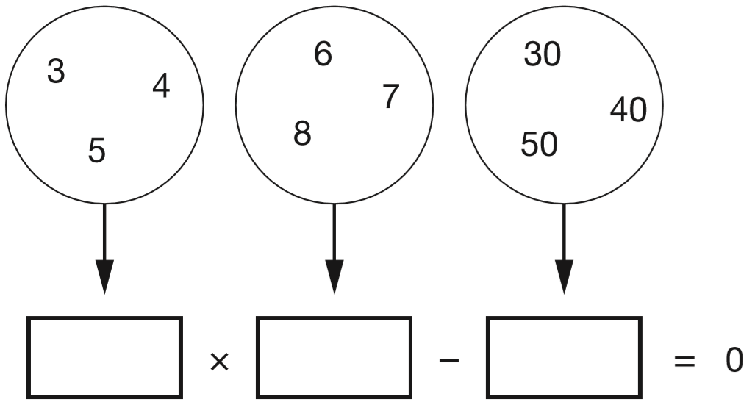 | Andy has these cards:  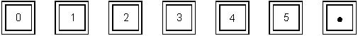  He made the number 42.5 with four of his cards.  Use some of Andy’s cards to show the number 10 times as big as 42.5  Use some of Andy’s cards to show the number 100 times as big as 42.5
Here are some patterns made with identical triangles. Tick the two patterns that have a line of symmetry.  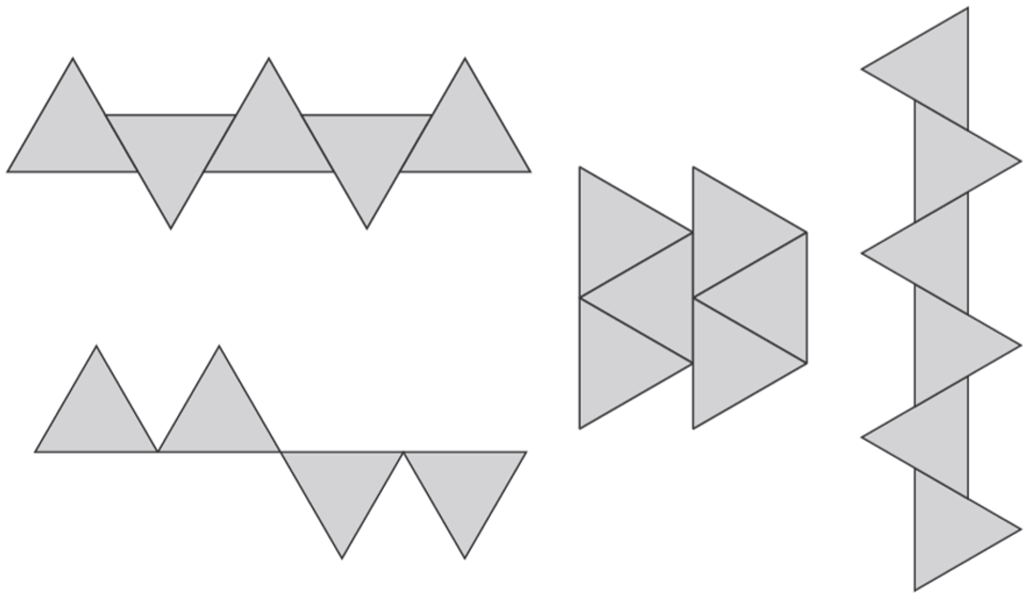 | These are the prices in a shoe shop.  boots - £45.50  sandals - £12.75  trainers - £34.99  How much more do the boots cost than the trainers?  Rosie buys a pair of trainers and a pair of sandals.  How much change does she get from £50?
Mina and Seb share these coins so that they each have the same amount of money.  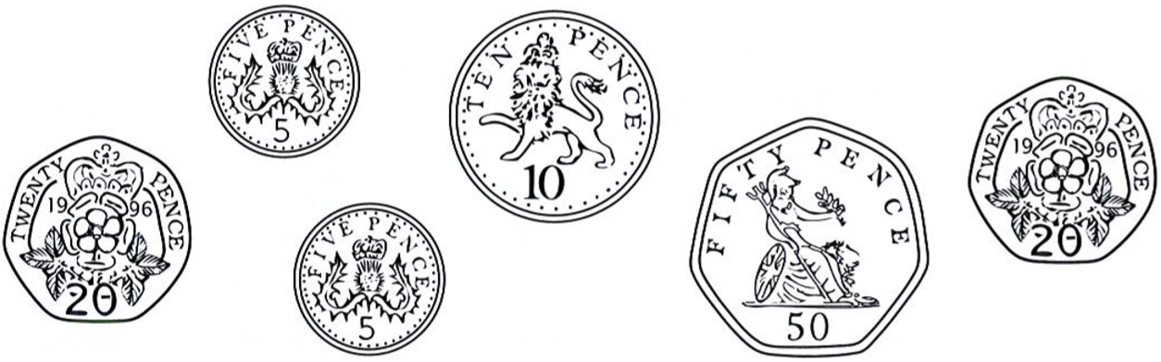  Mina chooses her coins first.  Seb takes the rest of the coins.  What coins could Mina choose? | The diagram shows part of a ruler.  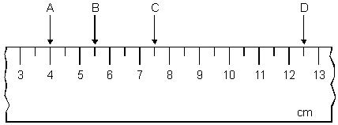  Complete these sentences.  The distance between A and B is _____ cm.  The distance between C and D is _____ cm.
These are the prices in a fish and chip shop.  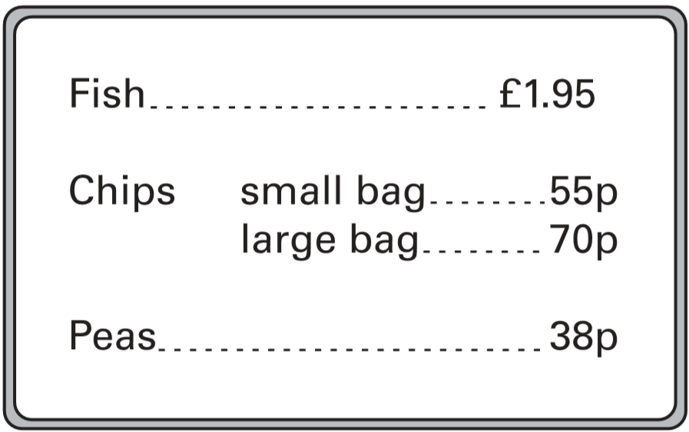  Luke has £3  He wants to buy one fish, peas and two large bags of chips.  How much more money does he need? | 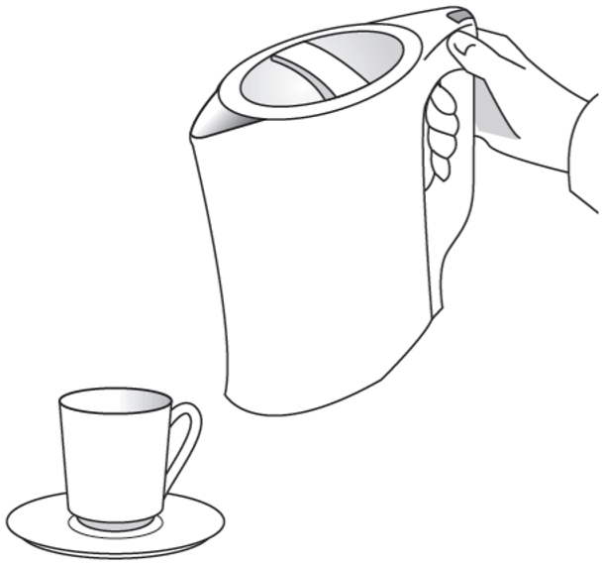  About how much water could the kettle hold?  Circle the correct amount.  2 litres 5 litres 10 litres  20 litres 50 litres
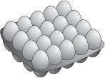  A farmer has 157 eggs.  He stores them in trays.  Each tray holds 20 eggs.  How many trays does he need to store all the eggs? | Look at this number.  46.3  Draw a ring around the value of the 3  $\frac{3}{100}$ 3 $\frac{3}{10}$ 30

A shop sells batteries in packs of four and packs of two.  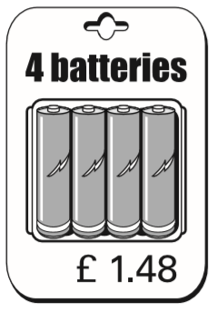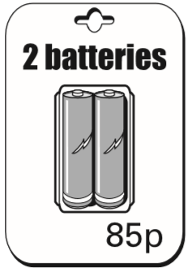  Mary buys 2 packs of two batteries.  Hamid buys 1 pack of four.  How much more does Mary pay than Hamid?  Simon and Nick want two batteries each.  They buy a pack of four and share the cost equally. How much does each pay? | Jamie is cooking pasta.  He weighs 350 grams of pasta.  Draw an arrow on the scale to show 350 grams.  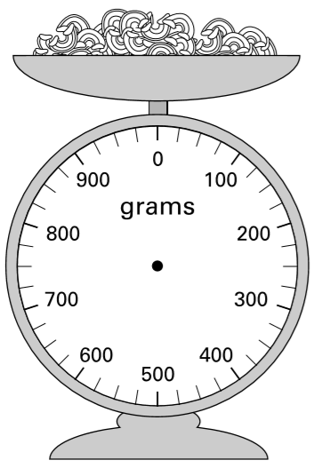
These are the prices of sandwiches, drinks and fruit.  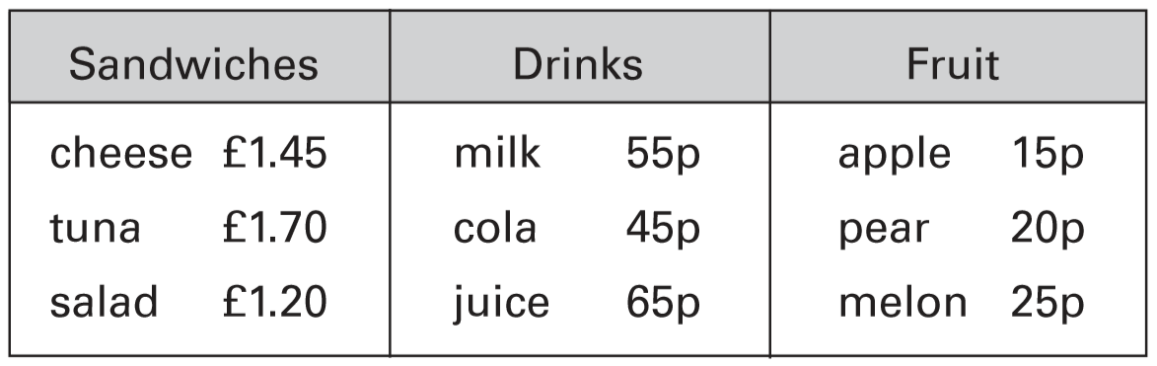  Shereen buys a tuna sandwich, milk and a pear. How much does she pay?  Mike has 80p to spend on a fruit and a drink.  What two things can he buy for exactly 80p? | Shade more triangles on this shape so that $\frac{1}{3}$ is shaded.  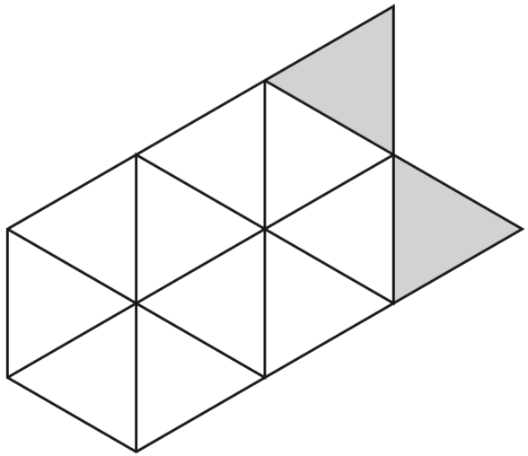
Write these times in order, starting with the shortest.  24 days 1 month 10 weeks 48 hours  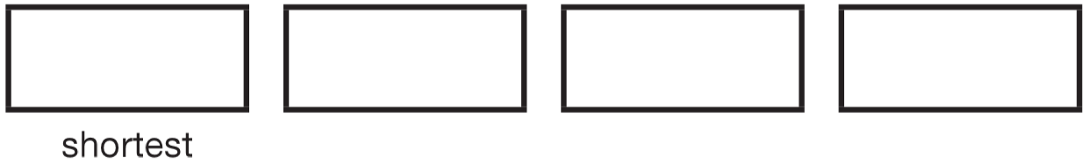 | Dan says,  ‘I choose a number.  I multiply it by 5  Then I subtract 7  My answer is 38’  What number did Dan choose?
These three square tiles have symmetrical patterns on them.  Draw the line of symmetry on each tile.  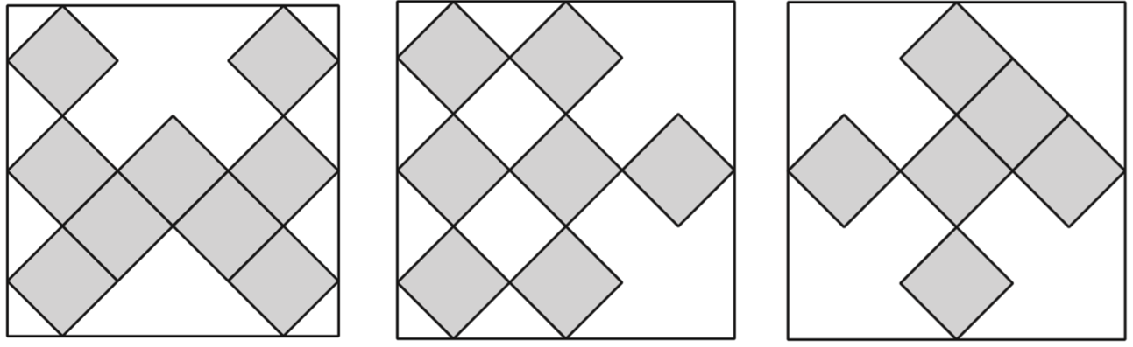 | Plastic cups are sold in packs of 8  Amir needs 27 cups.  How many packs must he buy?  There are 30 paper plates in a pack.  Amir buys 2 packs.  He uses 37 plates.  How many plates are left?
Freddie is half as tall as his mother.  Freddie is one metre shorter than his father.  Freddie’s father is 180 centimetres tall.  How many centimetres tall is Freddie’s mother? | Write a different digit in each box to make these correct.  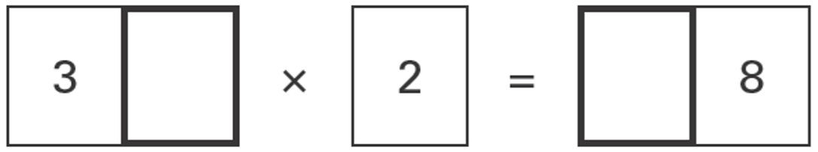  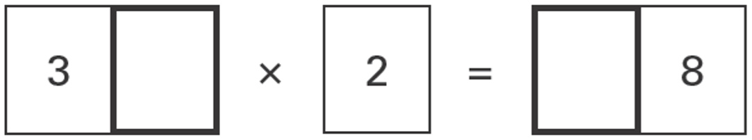

Five children took part in a chess competition.  They each played six games.  This table shows how many games each child won, drew or lost.  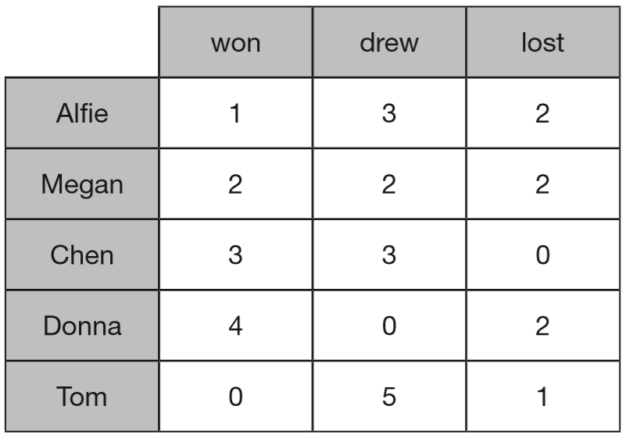  How many children drew more games than they lost?  Each child scores two points for a win, one point for a draw, no points for a loss.  Who scored the most points? | Sarah has a packet of balloons. The contents of the packet are:  5 red balloons  5 blue balloons  10 yellow balloons  Sarah says, ‘One-quarter of the balloons are red.’ Is Sarah correct? Explain how you know.
What is the total weight of these apples?  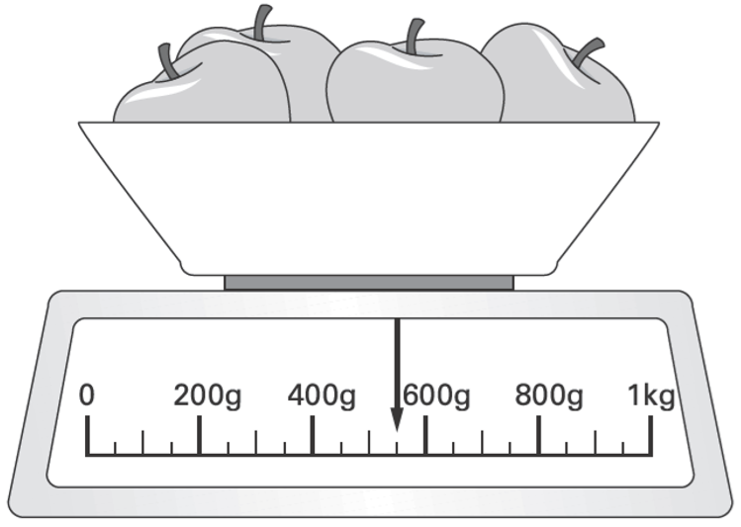 | Here are four digit cards.  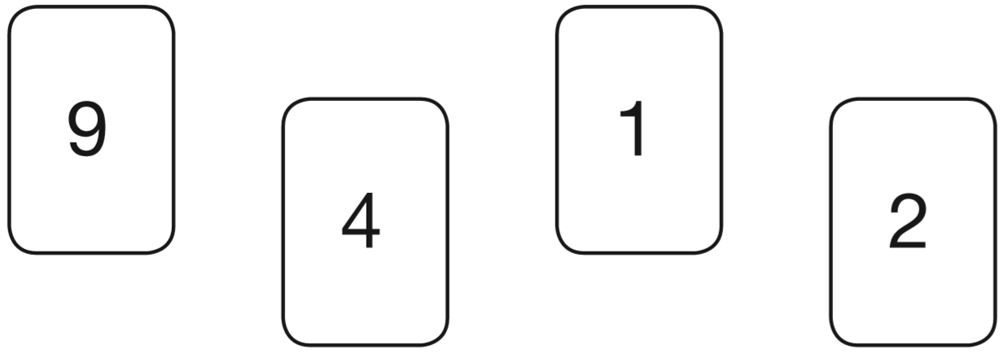  Use each digit card once to make the decimal number nearest to 20  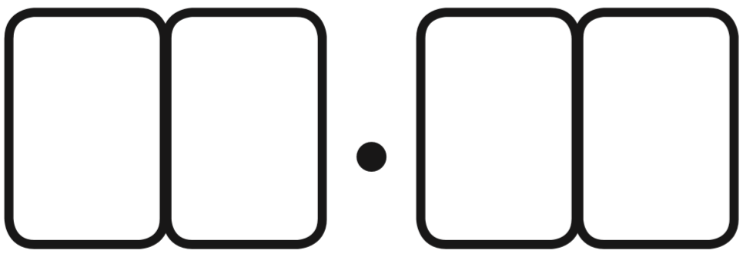
Jamie makes a time line of part of his day.  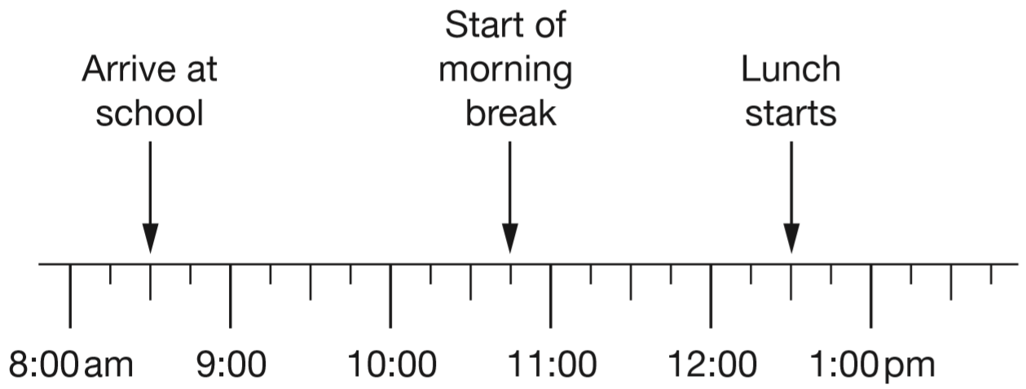  What time does Jamie’s morning break start?  Lunch lasts for three-quarters of an hour. What time does lunch finish? | Here is a repeating pattern of shapes.  Each shape is numbered.    The pattern continues in the same way.  Write the numbers of the next two stars in the pattern.  Complete this sentence.  Shape number 35 will be a circle because ...
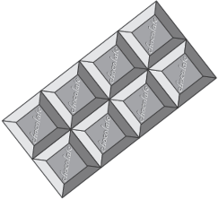  Here is a chocolate bar.  William eats 3 pieces and Amber eats 2 pieces.  What fraction of the chocolate bar remains? | Circle the two divisions which have an answer of 5 remainder 2  17 ÷ 5 17 ÷ 3 22 ÷ 4 22 ÷ 5
Sam has 90 bricks.  He uses $\frac{3}{5}$of them to build a tower.  Grace has 120 bricks.  She uses $\frac{5}{6}$of them to build a tower.  How many bricks are left over altogether? | Seb has to see the doctor at 10:05am.  He gets to the doctor’s surgery at 9:52am.  How many minutes early is he?  He leaves the doctor’s surgery at 10:25am.  He gets to school 45 minutes later.  What time does he arrive at school?

Here are some number cards:  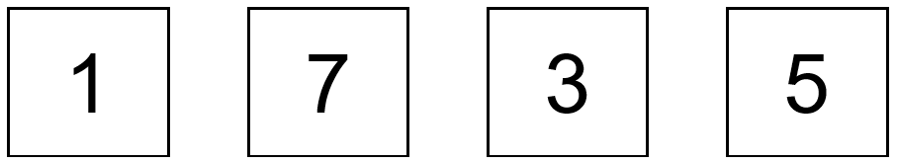  Use some of the four number cards to make numbers that are as close as possible to the numbers written below.  Examples:  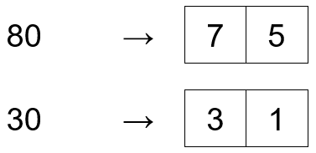  You must not use the same card more than once in each answer.  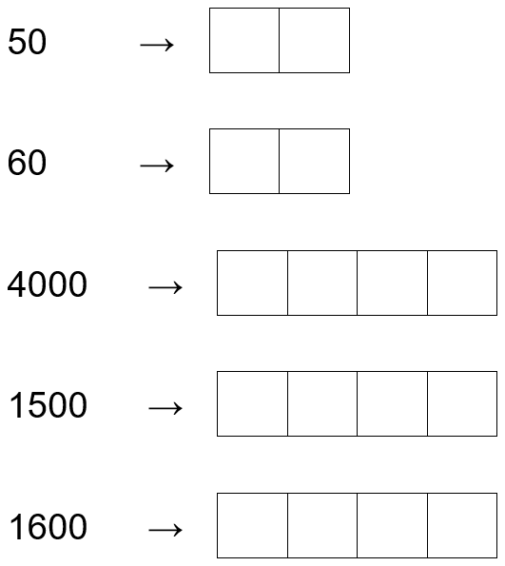 | Emily is making a cake.  She puts flour on the scales.  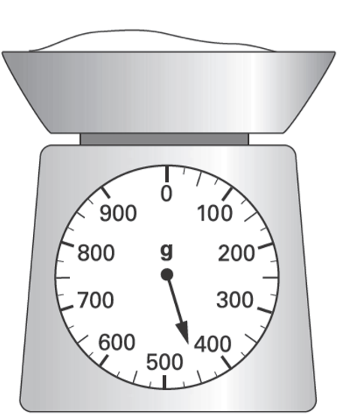  She then adds sugar to the flour.  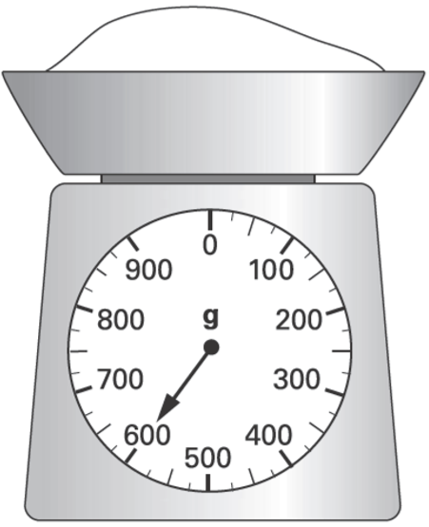  How much sugar does she add?
Look at angles a, b, c, d and e.  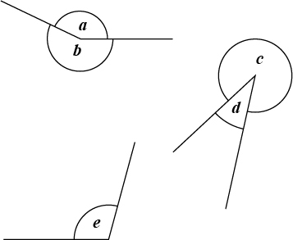  Write the angles in order of size, starting with the smallest.  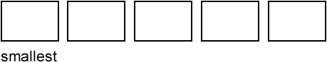 | Amy went on a cycling holiday.  This chart shows how far she cycled each day.  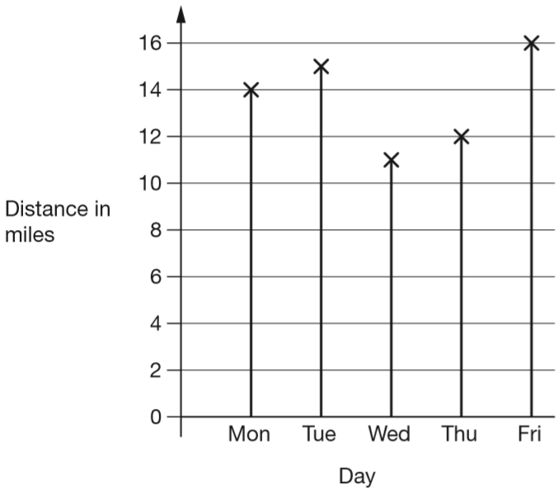  How much further did Amy cycle on Friday than on Wednesday?  How far did Amy cycle altogether on the three days she cycled the most?
The numbers in this sequence increase by 75 each time. Write in the two missing numbers.  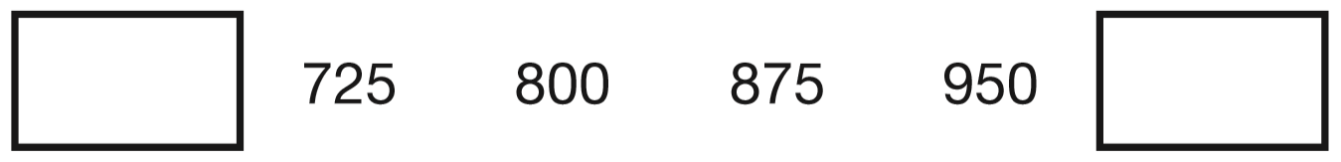 | Write what the missing numbers could be.  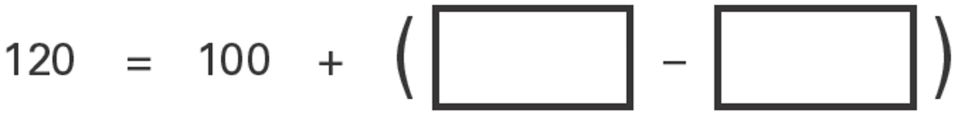
Ben counts in multiples of 25  Circle the numbers he says.  52 75 125 255 300 | Write in the missing digits.  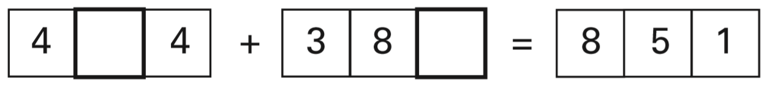

This number machine multiplies all numbers by 2, and then adds 1.  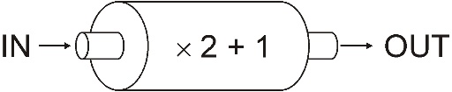  Write the missing numbers in the table.  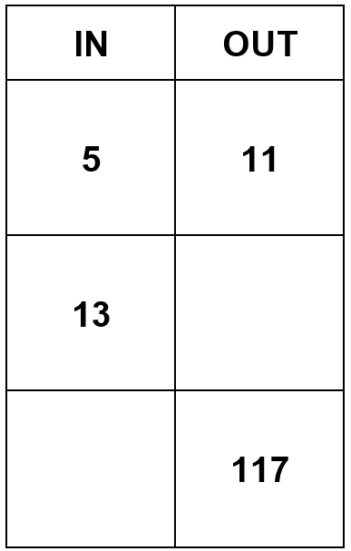 | Hassan has a jug with some water in it.  He adds another 140 millilitres of water.  Draw a line to show the new level of water.  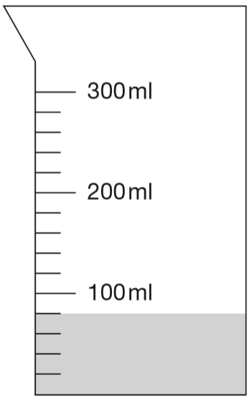
Draw two more lines to match 3500 to numbers with the same value.  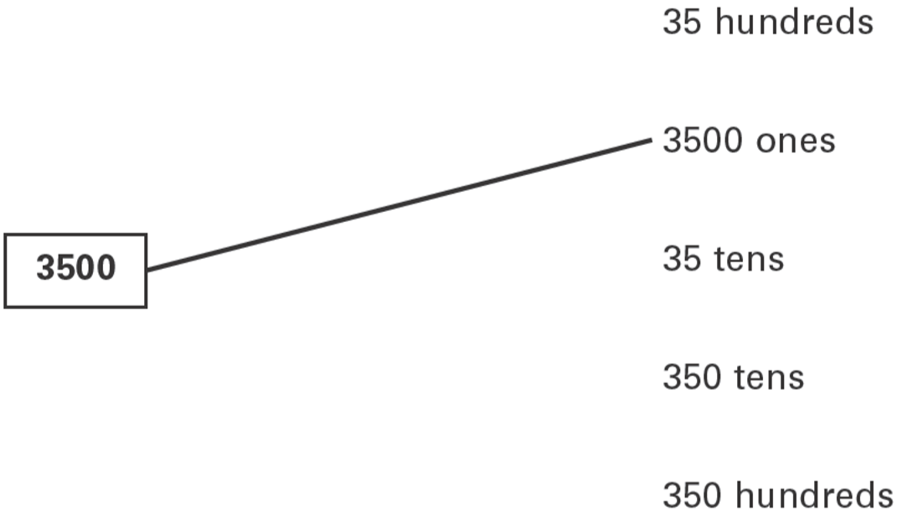 | Here are three fractions.  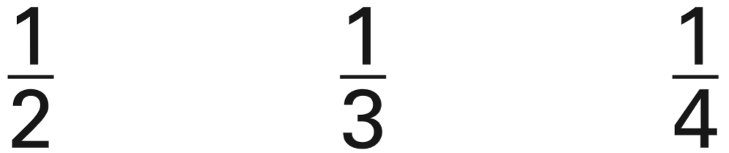  Write the fractions in the correct boxes on the number line.  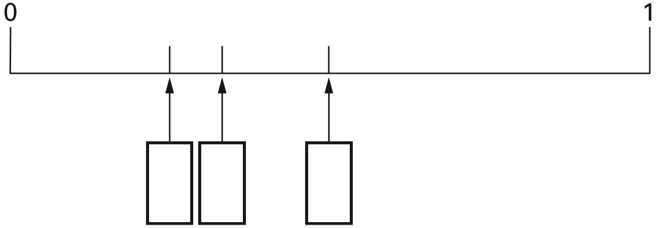
Four children run in a race.  Gemma takes 5 minutes 20 seconds.  Complete the graph for Gemma.  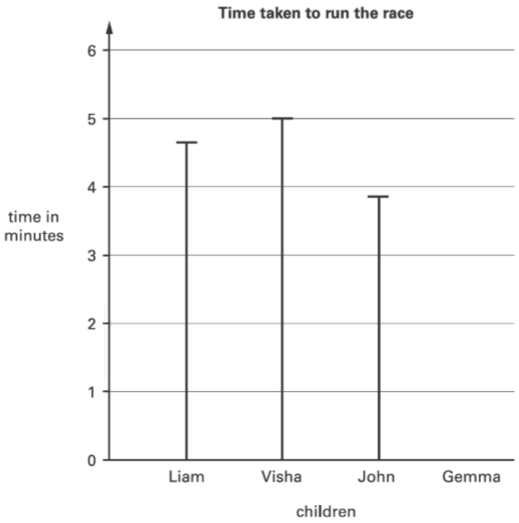 | A camping shop sells tents, sleeping bags and backpacks. This chart shows how many of each they sold in June.  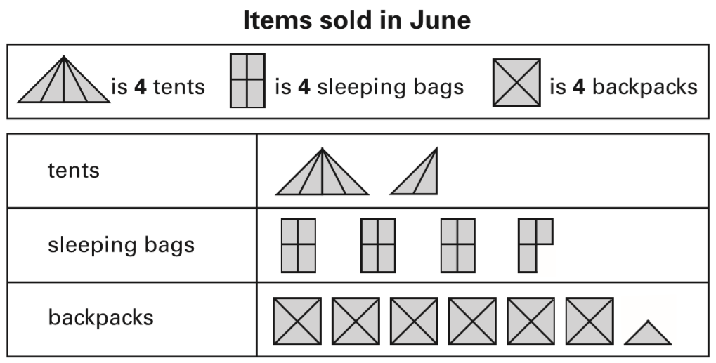  The shop had 20 sleeping bags at the beginning of June.  How many of these sleeping bags did the shop have left at the end of June?  In July, the shop sold three times as many tents as in June.  How many tents did the shop sell in July?
A shop sells food for birds.  Bird seed - £3.79 for a bag  Peanuts - £1.35 for a bag  Bird feeder - £8.95 each  Amir has £20.  He wants to buy a bird-feeder and 4 bags of bird seed.  How much more money does he need? | A film lasts for 1 hour and 30 minutes and is shown twice.  Complete the timetable for showing the film.  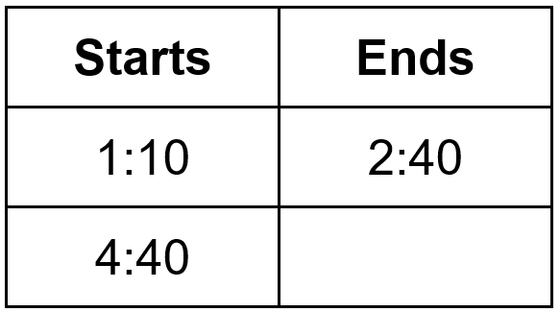

Here is a rectangle with 13 identical shaded squares inside it.  What fraction of the rectangle is shaded?  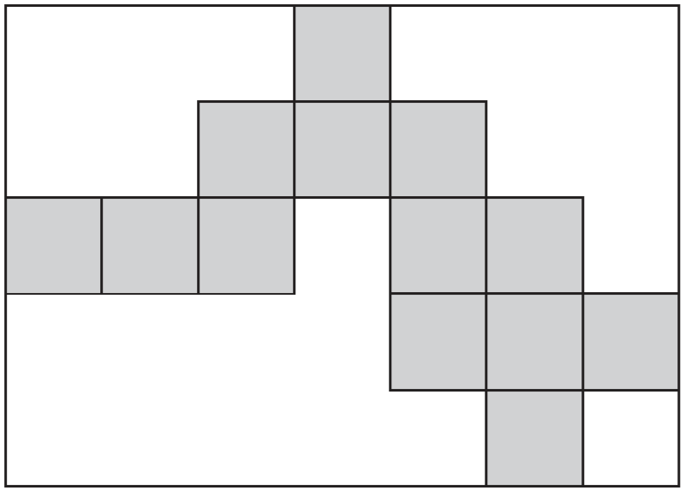 | Some children go camping.  It costs £2.20 for each child to camp each night.  They go for 6 nights.  How much will each child have to pay for the 6 nights?  There are 70 children.  Each tent takes up to 6 children.  What is the least number of tents they will need?
Dan is making a cuboid by fitting shapes together.  Here are four of the faces of the cuboid he is making.  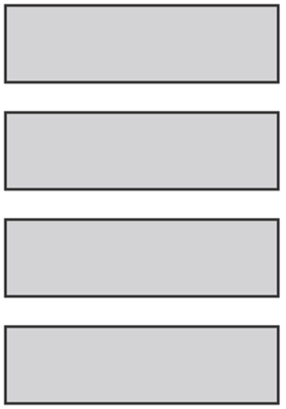  Which other shapes does Dan need to complete his cuboid? Tick them.  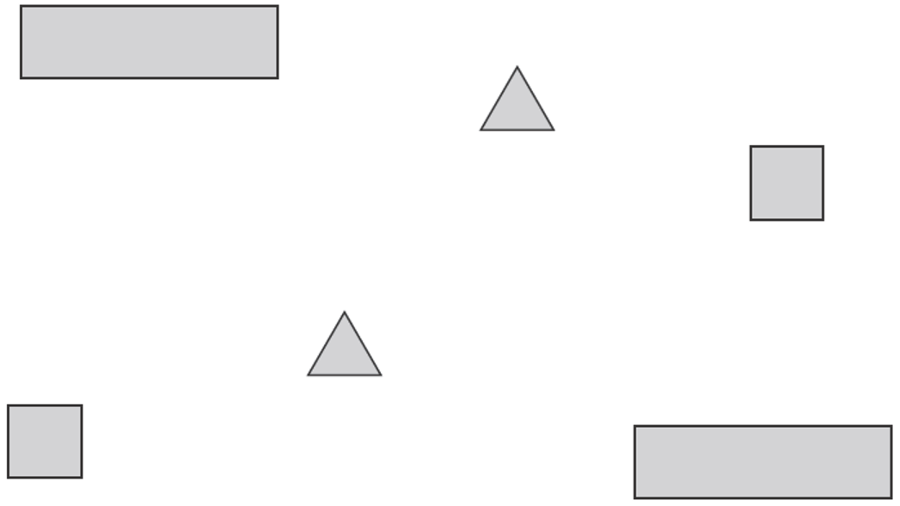 | Here is half of a symmetrical picture.  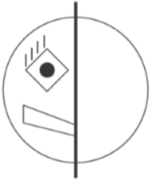  Which of these is the reflection of the picture? Write its letter.  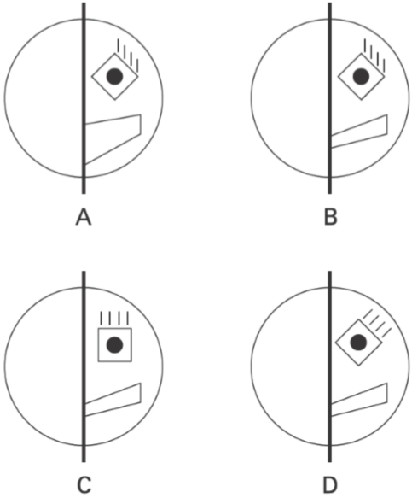
Lisa places a counter on square D4  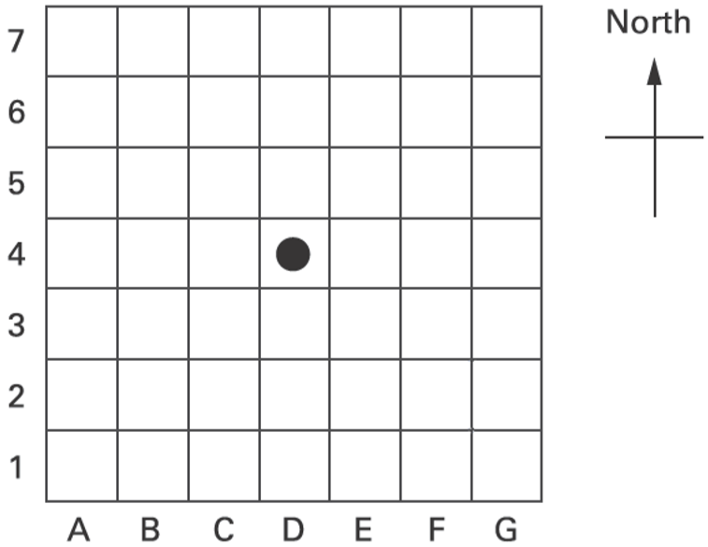  She moves in 2 squares east and 3 squares south. Write the position of the square she moves it to. | Mr Khan makes a blackcurrant drink for a party. He pours blackcurrant squash into a jug.  How much water must he add to make 500 millilitres of drink?  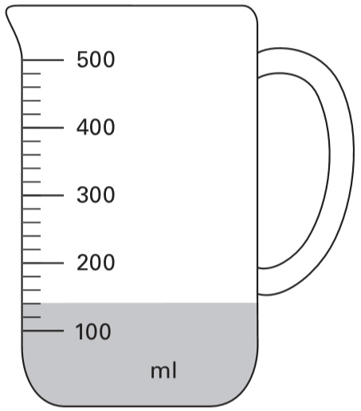
There are 275 children in Fernley School.  They get into groups of eight.  What is the largest number of groups of eight that they can make? | The difference between two numbers is 2  When each number is rounded to the nearest hundred, the difference between them is 100  Write what the two numbers could be.

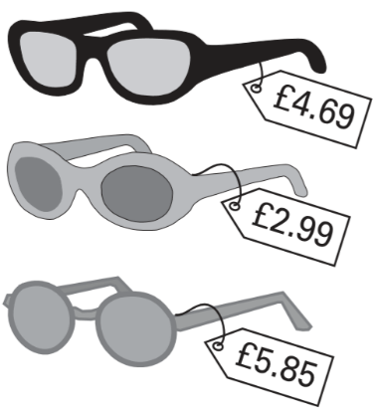  A shop sells three types of sunglasses.  What is the difference in price between the most expensive and least expensive sunglasses?  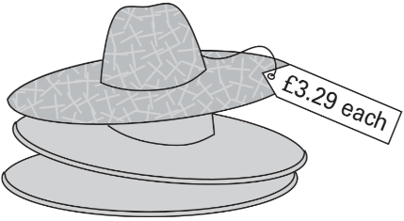  The shop also sells sun hats.  Ryan buys the £4.69 sunglasses and a sun hat.  How much change does he get from £10? | Complete the table.  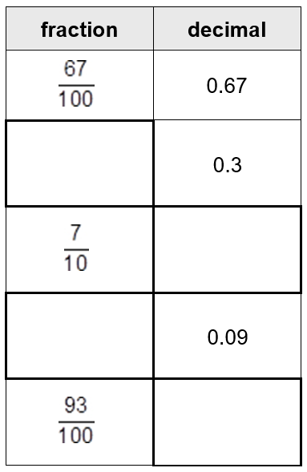
Here are five rectangles, each with a shaded pattern.  For each rectangle, put a tick if the pattern has a line of symmetry.  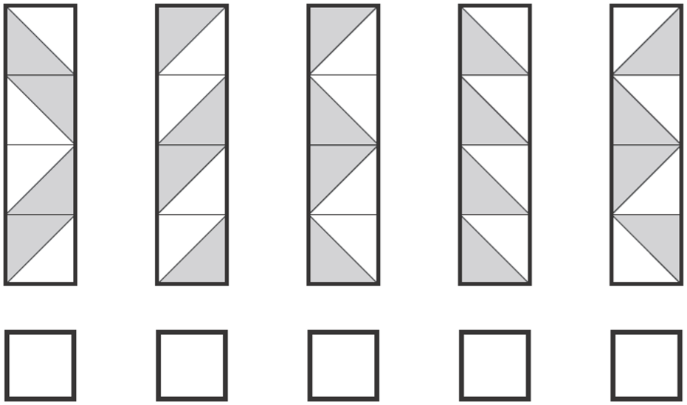 | Here is part of the timetable for Class 6 on a Monday.  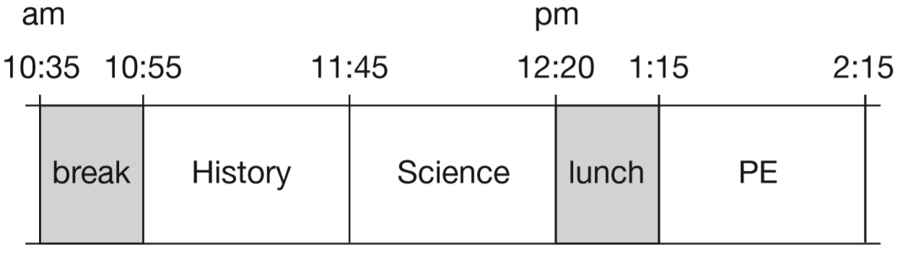  How long is it from the end of break to the start of lunch?  Nisha leaves the Science lesson after 25 minutes to go to the dentist.  What time does she leave the Science lesson?
This scale shows the mass of Amy’s kitten when it was one month old.  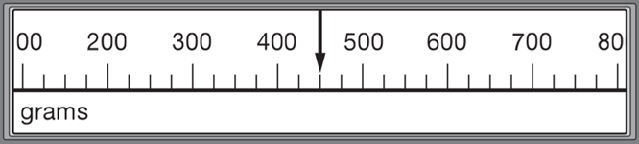  This scale shows the mass of the kitten when it was two months old.  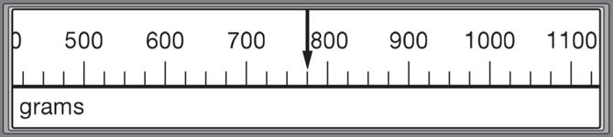  What is the increase in mass? | 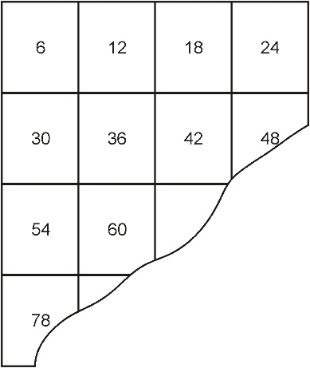  This number square is torn.  What was the largest number on the square before it was torn?
The three missing numbers are each greater than zero.  Write in what the missing numbers could be. | Circle each number which has a remainder of 2 when divided by 5  15 32 26 24 27 45
Lauren has some cherries.  She eats 2 of them.  Then she eats half of what is left.  She now has 6 cherries.  How many cherries did she start with? | Shade more squares so that exactly half of the shape is shaded.  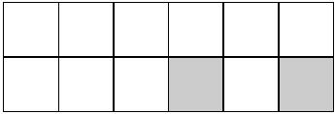

Here are some number cards:  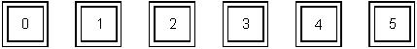  Joan picked these three cards:  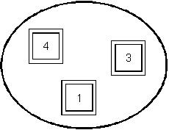  She made the number 314 with her cards.  Make a smaller number with Joan’s three cards.  Make the biggest number you can with Joan’s three cards.  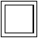  Which extra card should Joan pick to make her number 10 times as big? | Put a ring around the lightest box.  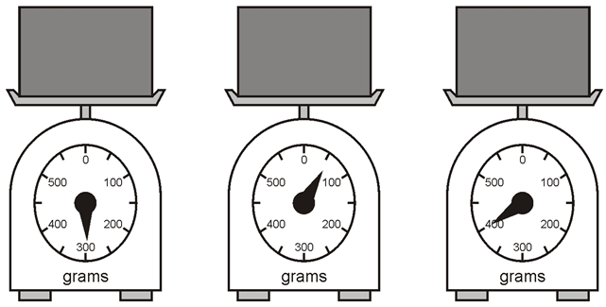  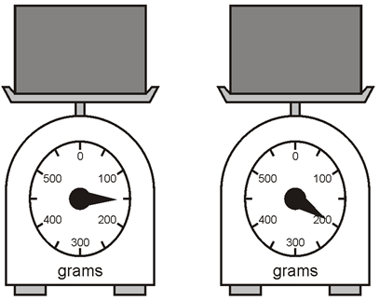
The table shows the different faces of some 3-D shapes. Write numbers on the faces to show how many of each there are. 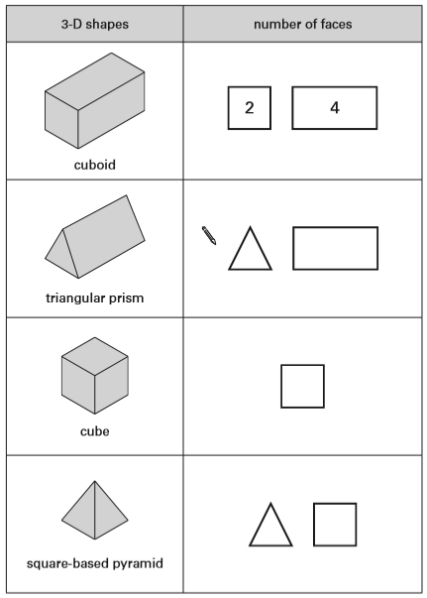 | The Fun Day started at this time in the morning.  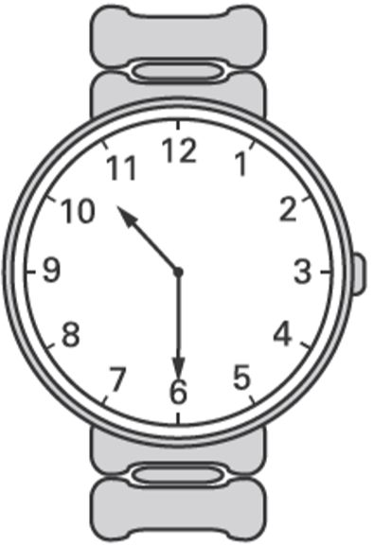  It finished at this time in the afternoon.  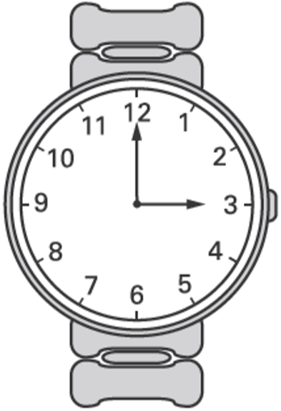  How long did the Fun Day last?  ___ hours ___ minutes
Here is a number sentence.  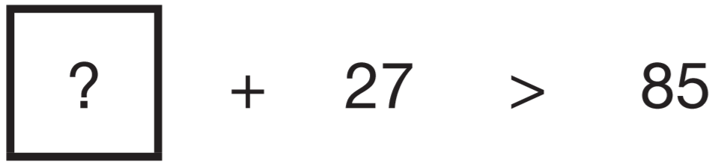  Circle all the numbers below that make the number sentence correct.  30 40 50 60 70 | flowerpots £12.75 each  spades £9.65  Nicola has £50  She buys 3 flowerpots and a spade.  How much money does she have left?
Use the digits 2, 3 and 4 once to make the multiplication which has the greatest product.  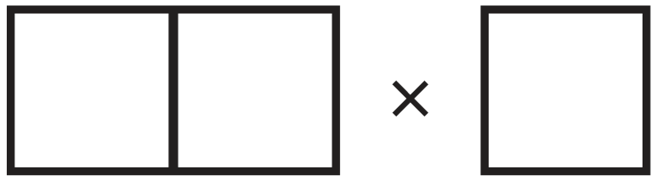 | Two of these numbers divide by 5 with no remainder. Circle the two numbers.  67 33 25 57 13 60

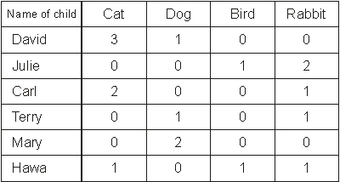  Here is a table of the pets owned by six children.  Here is a graph of the pets of five of the children.  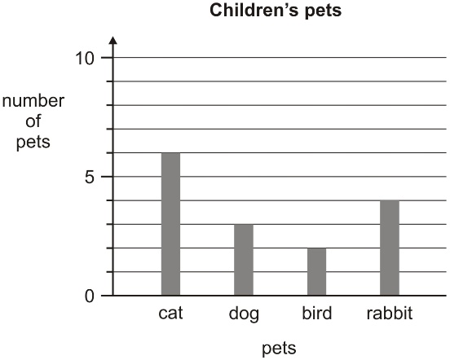  The pets of one of the children are not on the graph. Whose pets are not on the graph? | 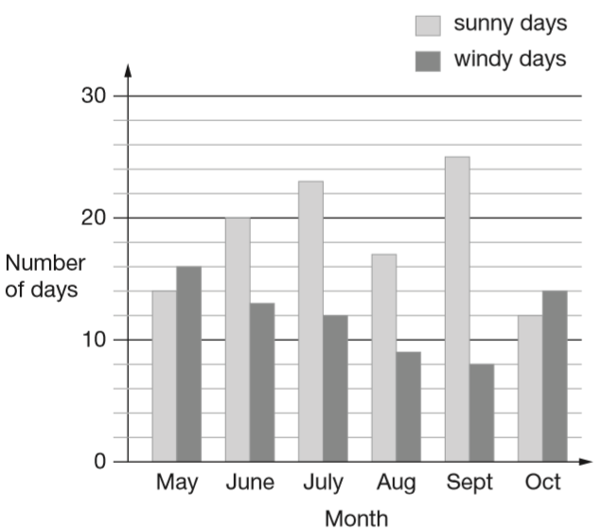  The chart shows the number of sunny days and the number of windy days in six months.  Which months had more windy days than sunny days?  How many months had more than 15 sunny days?  How many more sunny days than windy days were there in June?
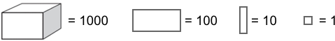  Write the value of each diagram.  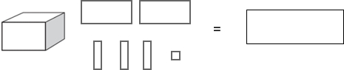  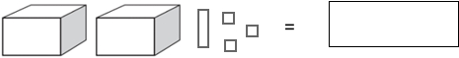 | 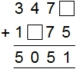
Look at the diagrams. Complete the fractions.  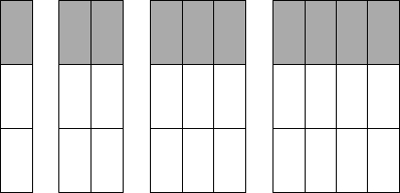  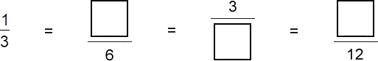 | The rule for this number sequence is "double and subtract 1"  Write in the missing number.  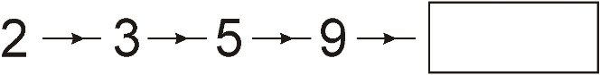  Here is part of another sequence with the same rule. Write in the missing number.  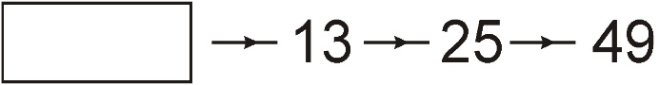
Lauren buys 4 ice creams.  Each ice cream costs 85p.  How much do they cost altogether? | Circle the two numbers which add up to 1  0.1 0.65 0.99 0.45 0.35
Here is a doubling sequence.  Write the three missing numbers.  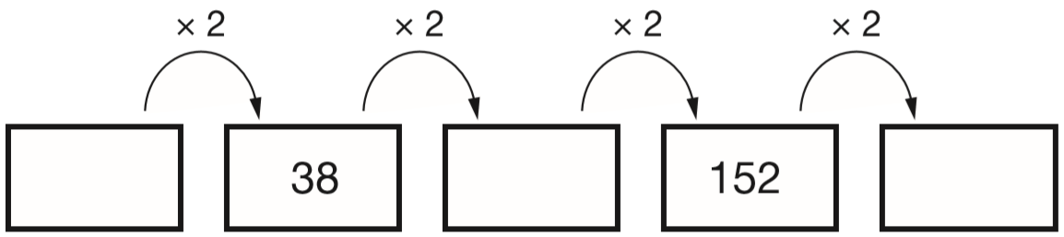 | Each brick is 12cm long.  Martin makes a line of bricks 132cm long.  How many bricks does he use?  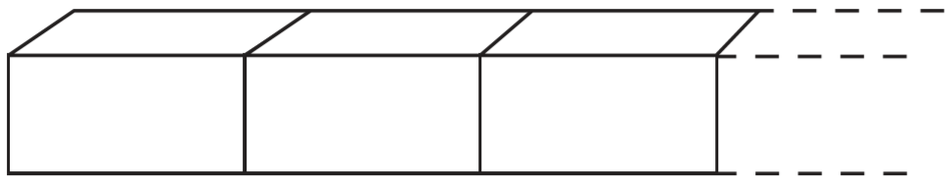

Here are five shapes on a square grid. Write the letters of the two shapes which have a line of symmetry.  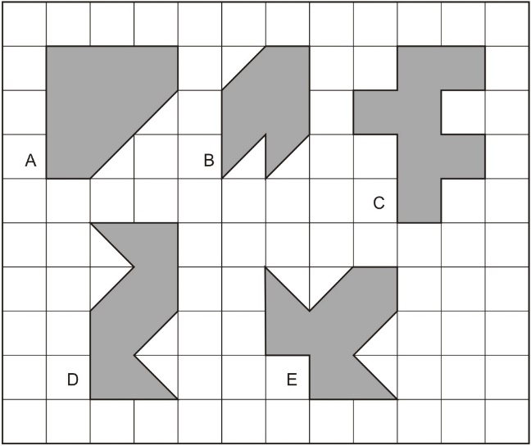 | The shaded rectangle covers squares  (D, 4) and (E, 4).  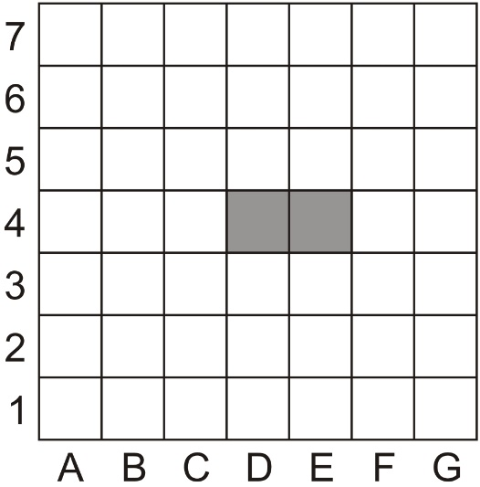  Draw and shade the rectangle that covers  (B, 5) and (B, 6).
Kirsty, Seb and Mina made toffee apples to sell at the school fair.  They made 80 toffee apples altogether.  Kirsty sold 12 toffee apples.  Seb sold 25 toffee apples.  Mina sold 17 toffee apples.  How many toffee apples were left?  Kirsty sold her 12 toffee apples for 50p each.  How much money did she collect? | Here is part of a number sequence.  The numbers increase by the same amount each time.  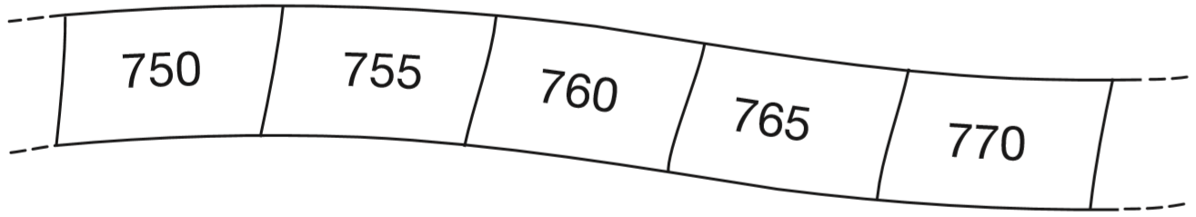  The sequence continues.  Circle all of the numbers below that would appear in the sequence.  840 905 989 1000 2051
Write these numbers in order of size, starting with the smallest.  3.01 13.0 0.31 1.30 3.1  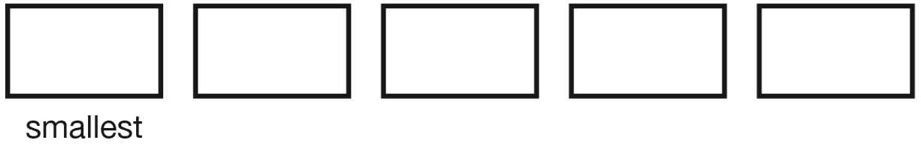 | In the high jump, Vijay jumped 96cm on his first try.  He jumped 1m 15cm on his second try.  How much higher did he jump on his second try?
Join each of these calculations to the number that is nearest to the correct answer.  One has been done for you.  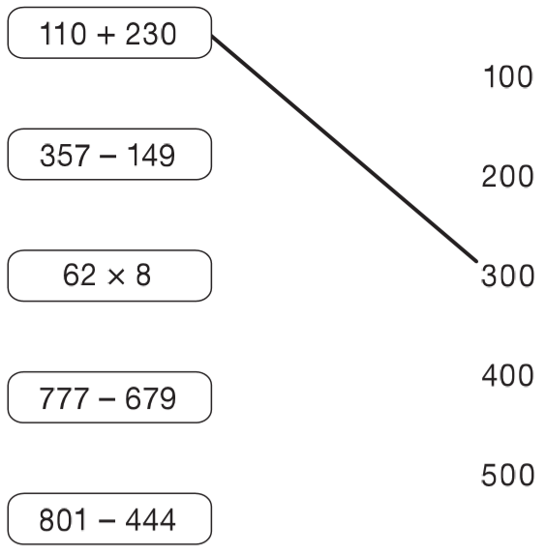 | Sarah is cooking.  Tick the most likely capacity of the pan.  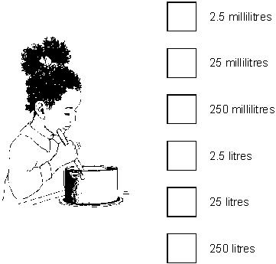
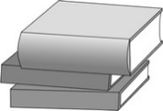  Ellie has a pile of three books.  Two of the books are 16 mm thick. The other book is 35 mm thick.  What is the height of the pile of books? | A rectangular swimming pool is 25 metres long and 10 metres wide.  David swims 5 lengths. Rosie swims 12 widths.  How much further does David swim than Rosie?

Here is the cost of pizzas.  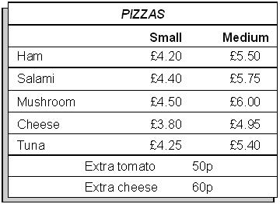  Jill orders one small cheese pizza with extra tomato.  What is the total cost?  Ben buys one small pizza and one medium pizza. They cost him £10  Which two could they be?  one small ________ pizza  and one medium _________ pizza | A shop sells T-shirts. This chart shows how many T-shirts were sold in a month.  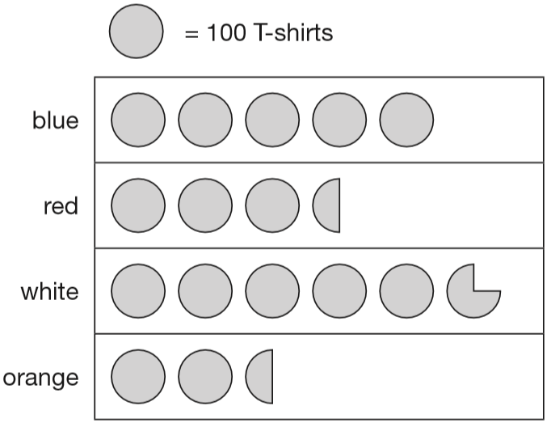  Write the colours of the T-shirts that sold more than 400 in the month.  How many red T-shirts and orange T-shirts were sold altogether?  How many more white than blue T-shirts were sold?
This diagram shows a shaded rectangle surrounded by squares.  What fraction of the diagram is shaded?  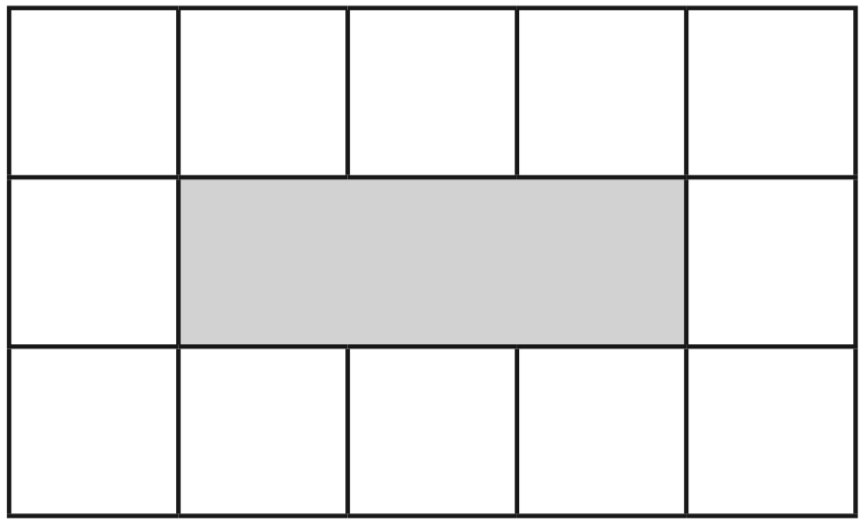 | Circle the two fractions that have the same value.  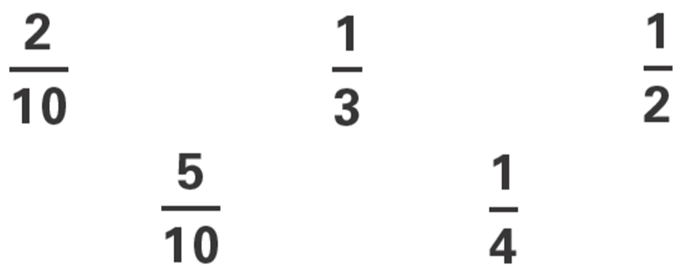
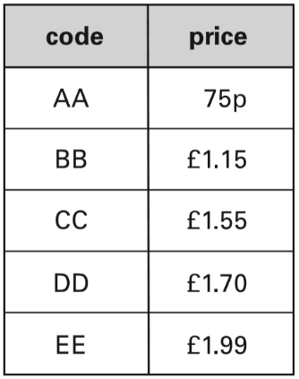  A shop sells greetings cards. Each card has a price code on it.  These are the codes.  Tina buys two cards. One card has code AA on it. The other card has code DD on it.  How much does Tina pay?  Omar buys a card. He pays with a £2 coin. He gets 45p change. What is the code on his card? | Here are some shapes on a grid.  Which shape has the longest perimeter?  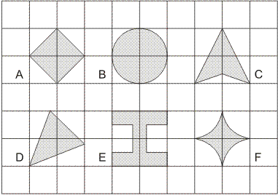
Look at the parcels on the scales.  Write them in order, starting from the lightest.  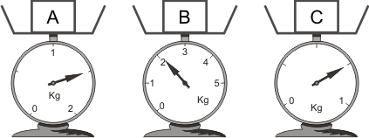  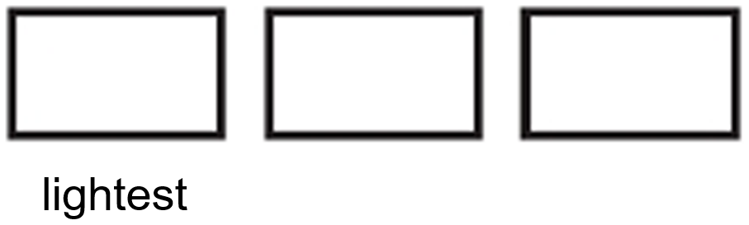 | Complete the number sentences using these cards.  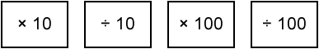  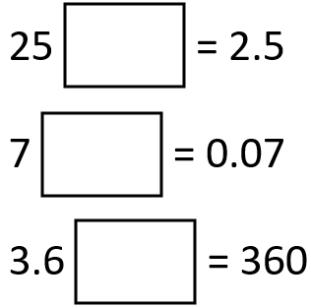
This rectangle has 4 small squares inside.  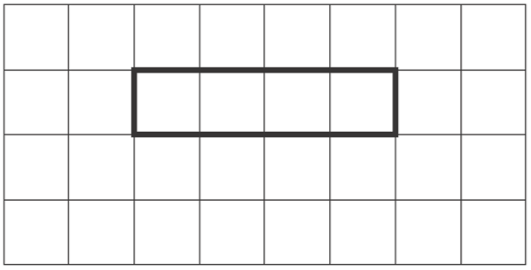  Draw a rectangle that has 12 small squares inside.  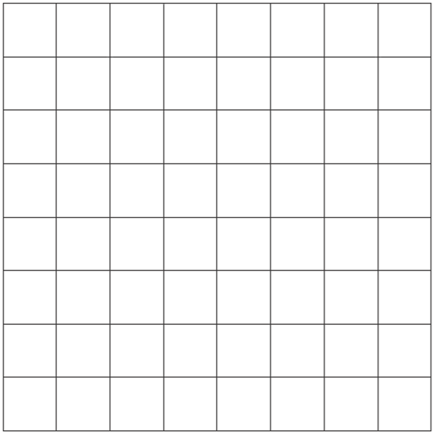 | Write in the missing number.  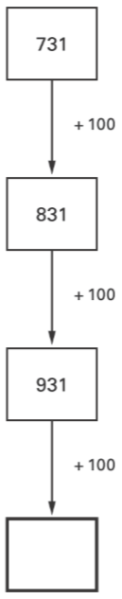
This calculation has the same number missing from each box.  Write the missing number in the boxes.  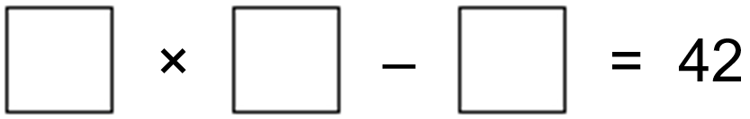 | Popcorn - £1.95  Milkshake - £1.25  Nico buys a box of popcorn and two milkshakes.  How much does Nico spend altogether?
Draw one line of symmetry on each of these designs.  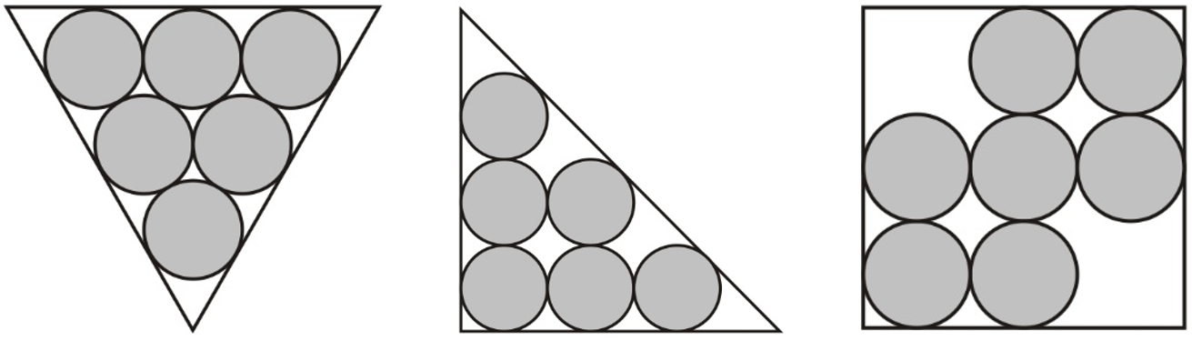 | Ben has 2 types of coin in his pocket.  He has 4 coins of one type and 2 coins of another type.    Altogether he has £1  What two types of coins does he have?  Ben has 4 ___p coins and 2 ___p coins.
Shade $\frac{1}{4}$of this shape.  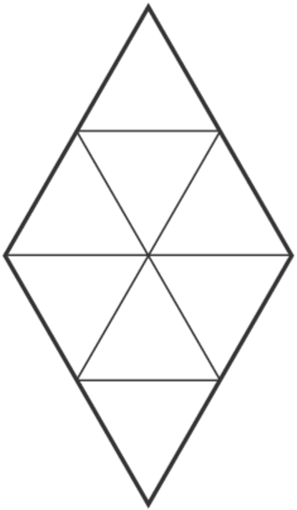 | These are the prices of coconuts and bananas.  coconuts - 78p each  bananas - £1.20 for 1kg  Josh buys one coconut and half a kilogram of bananas.  How much does he spend altogether?  Oranges cost 25p each.  How many oranges can Josh buy for £1.50?
Sam and Ben share a pizza with their Dad.  Sam ate $\frac{1}{3}$of the pizza. Ben ate $\frac{1}{6}$of the pizza.  Dad ate the rest.  What fraction of the pizza did Dad eat? | Pam has £1.37  She wants to buy a box of crayons which cost £2.75  How much more money does she need?

Nadia is working with whole numbers.  She says, ‘If you add a two-digit number to a two-digit number you cannot get a four-digit number.’ Is she correct? Explain why. | Here is part of a centimetre scale, with two points marked.  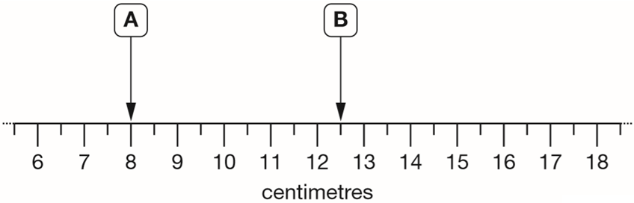  What is the distance between point A and point B?  Point C is twice as far from point A as it is from point B. On the scale above, mark one place where point C could be.
Write the missing numbers in this sequence.  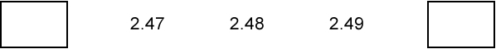 | Ben saved twenty-four 10p coins and ten 20p coins. How much money has Ben saved?
Here are some regular 2-D shapes. A hand hides part of each one. Match each regular shape to its name. One has been done for you.  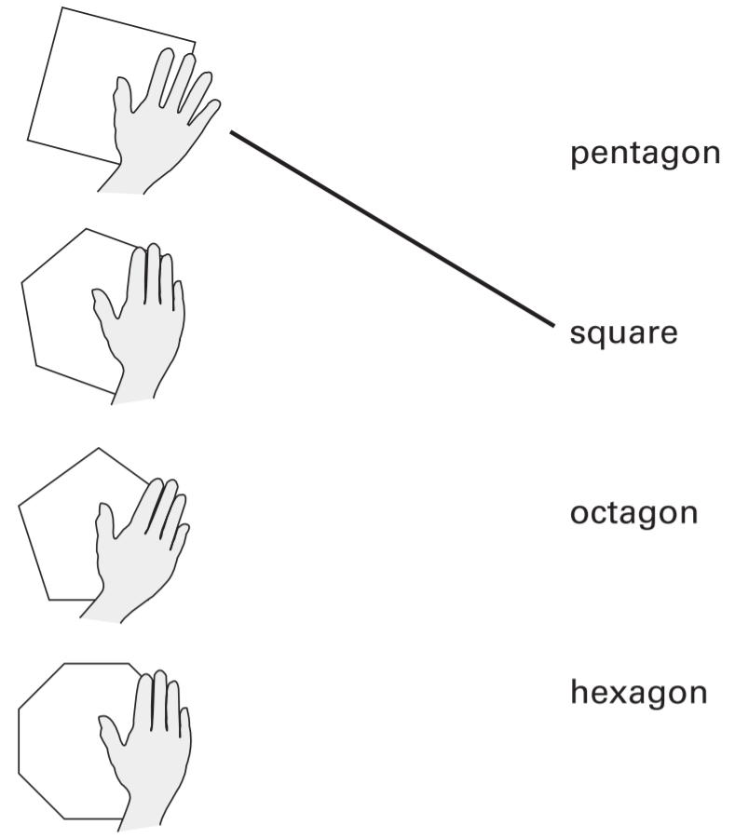 | Megan and Chen each have a bag of counters.  Megan’s bag has 5 blue counters and 5 green counters.  Chen’s bag has 10 blue counters, 5 green counters and 5 red counters.  They each take a counter from their bag without looking.  Chen says, ‘I am more likely than Megan to take a blue counter.’  Is Chen correct? Explain how you know.
Seb saved up for a new skateboard that cost £40  The table shows how much money he saved each week.  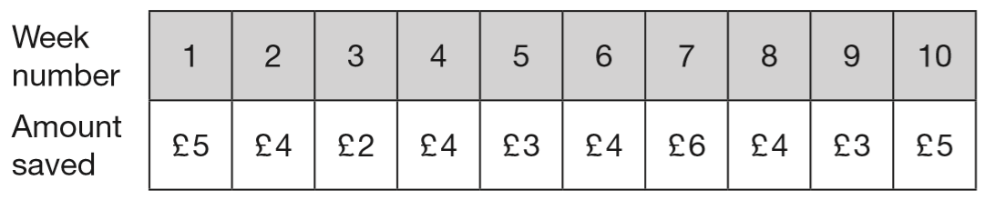  If Seb had saved an extra £1 each week, in which week would he have reached his target of £40? | Holly takes half an hour to walk from home to school.  She arrives at school at 8:25am.  At what time did she leave home?  Dev leaves school at half past three.  He arrives home at ten past four.  How many minutes did it take him to get home?
These are all times on the same morning.  A 7:56 am  B quarter to eight  C six minutes to eight  D half past seven  Write the letters for the times in order, starting with the earliest. | Here is a list of numbers.  1140 1400 1440 1040 1410  Complete these sentences.  The smallest number in the list is _______  The largest number in the list is _______

Some children ran in two races on sports day. Here are their times.  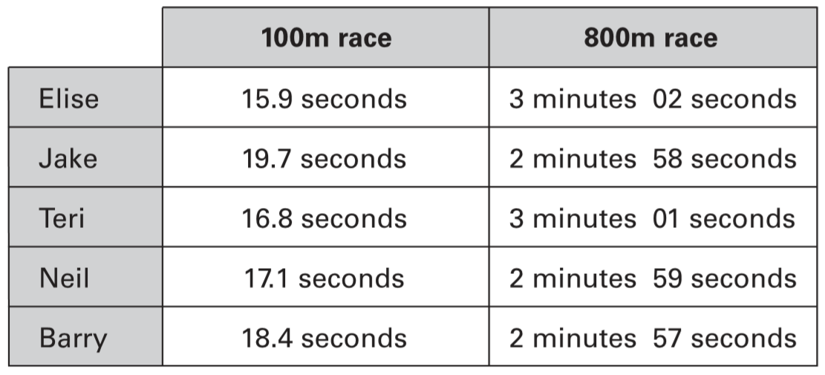  Who finished the 100m race in second place?  In the 800m race, how many seconds did Barry finish ahead of Elise? | The three numbers on each line add up to 763  Write in the missing numbers.  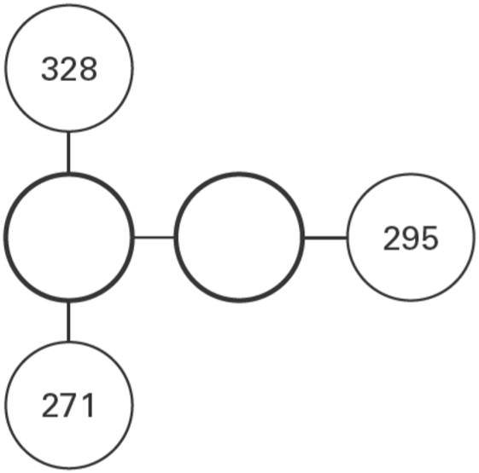
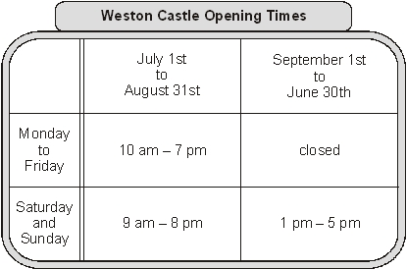  At what time does the castle close on Wednesday July 15th?  For which months is the castle open seven days a week?  On Sunday March 8th John goes into the castle at 3pm. He stays until closing time. For how many hours does he stay in the castle? | Class 6 launched some balloons at a school fete. This diagram shows how far some of the balloons travelled.  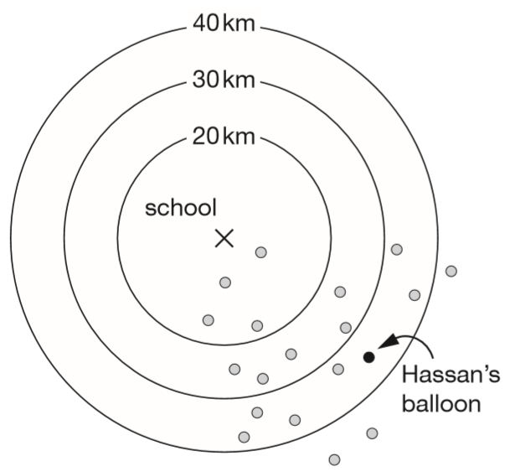  How many balloons on the diagram travelled between 20km and 30km?  Estimate how far Hassan’s balloon travelled.
Amy chooses two of these cards.  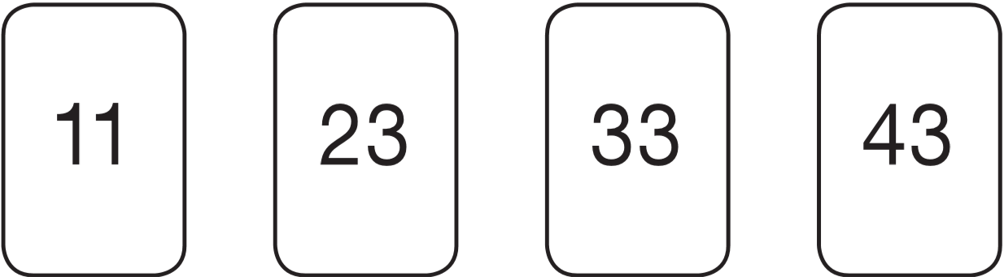  She adds the numbers on her two cards together.  She rounds the result to the nearest 10  Her answer is 60  Which two cards did Amy choose? | Shade $\frac{1}{4}$of this shape.  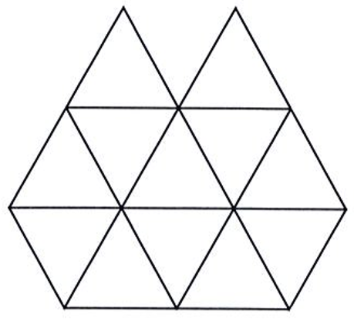
Two of the fractions below are equivalent. Circle them.  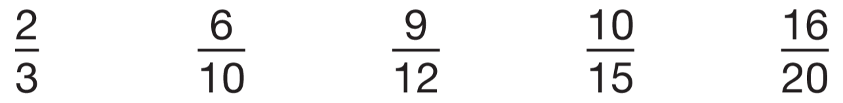 | Write what the numbers in the boxes could be.  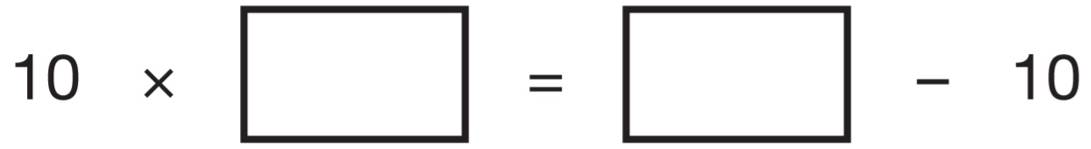
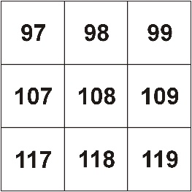  Circle one number on the grid which can be divided by 9 with a remainder of 1 | Zak has more than 10 counters and fewer than 20 counters.  When he groups them in threes no counters are left over.  How many counters could Zak have?

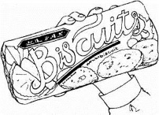  Robin has bought this packet of biscuits.  Tick the amount the biscuits are most likely to weigh.  10kg 250kg 5g 250g 100g 5kg | Cinema prices:  adults £3.25  children £2.00  How much will it cost for 2 adults and 3 children to go to the cinema?
Class 6 collect litter from a park. This chart shows some of the litter they have collected so far.  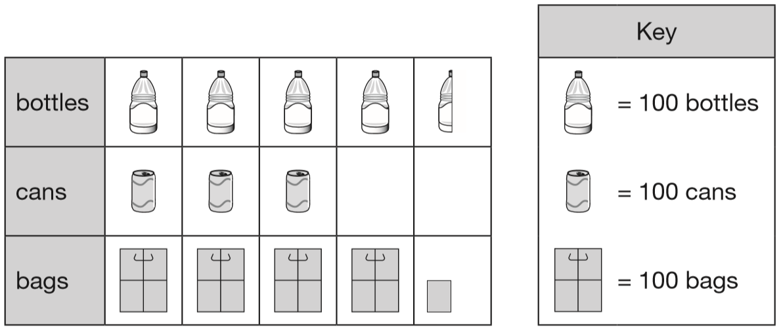  How many bottles have Class 6 collected?  How many more bags than cans have they collected? | This table shows the number of visitors to a library during a week.  How many days had a total of more than 150 visitors?  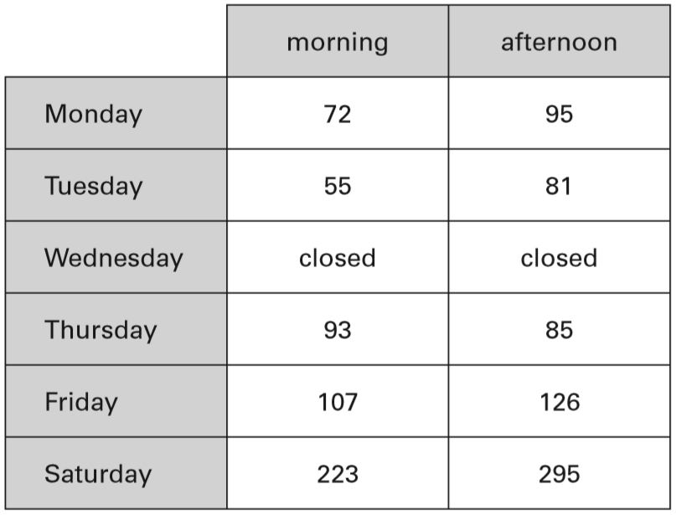
These two shapes are made from equilateral triangles.  Draw one line of symmetry on each shape.  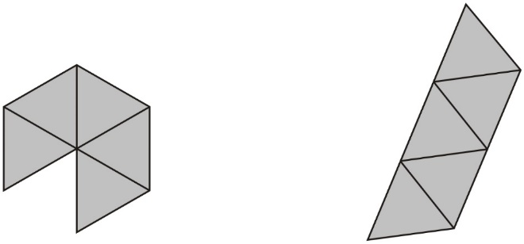 | Use these signs.  = < >  Write the correct signs in the boxes.  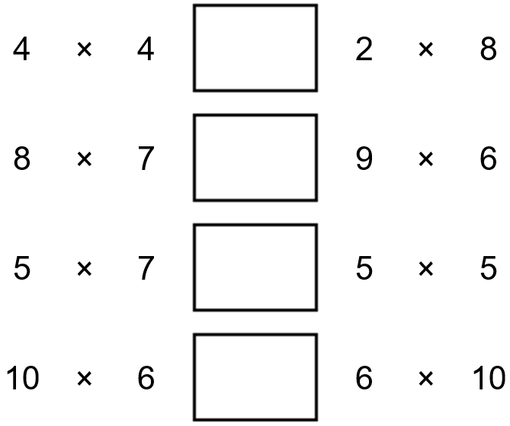
How much heavier is parcel A than parcel B?  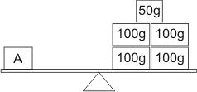  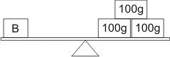 | Write in the missing digit.  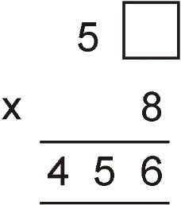
Complete the table.  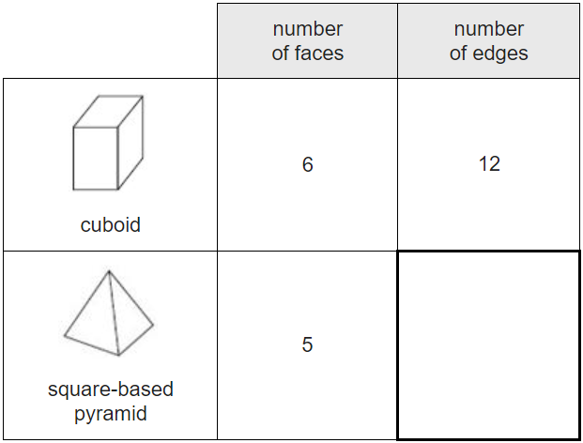 | Jemma thinks of a number. She says,  ‘Add 3 to my number and then multiply the result by 5  The answer is 35’  What is Jemma’s number?  Riaz thinks of a number. He says,  ‘Halve my number and then add 17  The answer is 23’  What is Riaz’s number?

These are some prices in a flower shop.  Tulips – £1.20 for a bunch  Roses – 40p each  Daffodils – 55p for a bunch  How many roses can you buy for exactly £2?  Amy buys one bunch of tulips and three bunches of daffodils.  How much does she pay altogether? | Luke needs 200 grams of flour.  Draw an arrow on the scale to show 200 g.  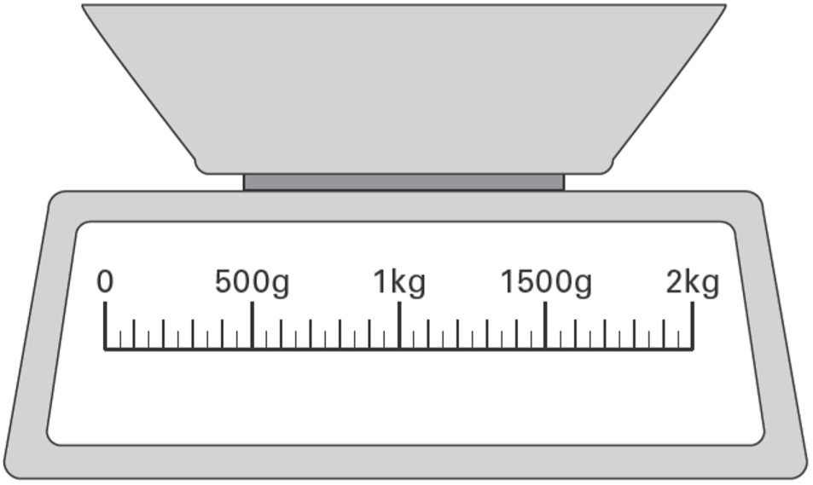
At a tournament there are 7 players in each team. There are 112 players altogether.  How many teams is this? | A film starts at 6:45pm.  It lasts 2 hours and 35 minutes.  What time will the film finish?
Circle two numbers which add to make 0.12  0.1 0.5 0.05 0.7 0.07 0.2 | Write 3 numbers less than 10 which total 20.  Don’t write the same number more than once.
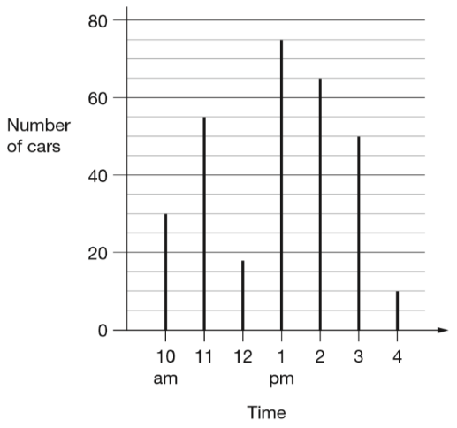  This chart shows the number of cars in a car park at different times on one day.  There are 80 cars in the car park when it is full.  How many empty spaces were there in the car park at 3pm?  There are 80 cars in the car park when it is full.  Circle all the times when the car park was less than half full.  10 am 11 am 12 noon 1 pm  2 pm 3 pm 4 pm | Complete the sequence. 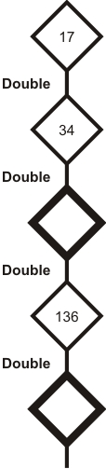
Here are shapes made with centimetre squares.  Which shape has a perimeter of 10 cm?  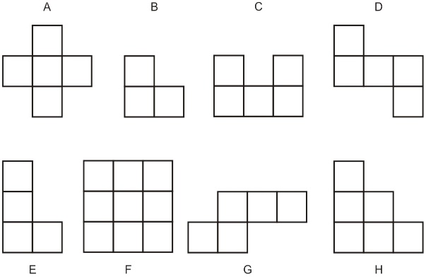 | Annie has a £2 coin. Sam has these coins.  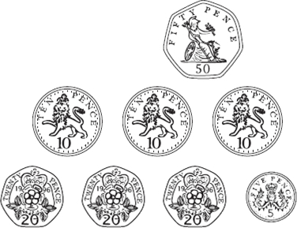  How much more money does Annie have?

The letter D has a line of symmetry.  Tick all the other letters that have a line of symmetry.  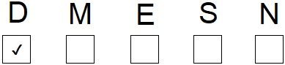 | Lewis makes a call from a telephone box.  He has £2 in coins.  He uses these five coins to make the call.  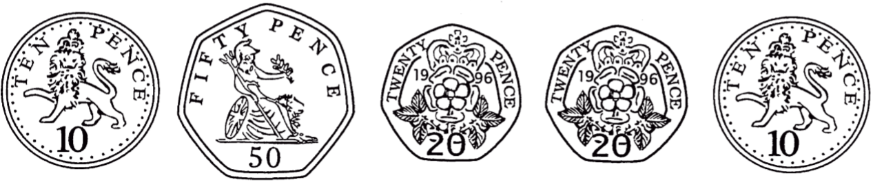  How much money has he got left from the £2?
Max jumped 2.25 metres on his second try at the long jump.  This was 75 centimetres longer than on his first try.  How far in metres did he jump on his first try? | Miss Wood’s class had 120 pencils at the start of the year.  12 children use 5 pencils each.  11 children use 4 pencils each.  How many pencils are left at the end of the year?
Write the missing numbers.  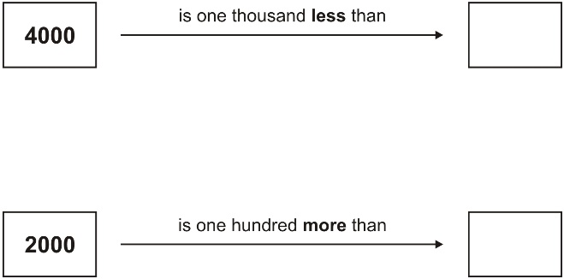 | There are 24 coloured cubes in a box.  Three-quarters of the cubes are red, four of the cubes are blue and the rest are green. How many green cubes are in the box?  One more blue cube is put into the box.  What fraction of the cubes in the box are blue now?
Write in the missing numbers.  One has been done for you.  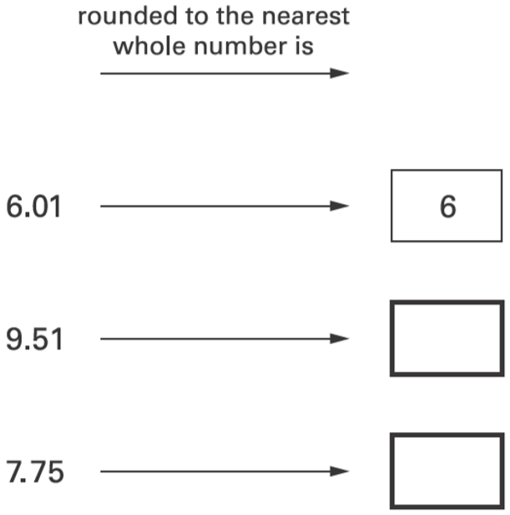 | Vijay has a jug with some water in.  How many more millilitres must he add to make 1 litre?  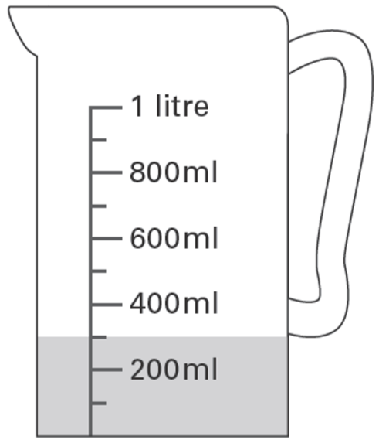
Here is part of a number sequence.  The numbers in the sequence increase by 25 each time.  50 75 100 125 …  Circle all of the numbers below that will appear in the sequence.  255 650 735 900 995 | 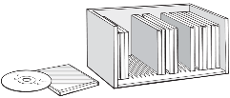  Here is a CD rack.  One rack holds 25 CDs.  David has 83 CDs.  How many racks does he need to hold all his CDs?  Lin has 6 racks full of CDs.  How many CDs does Lin have altogether?
cat food 35p  Sarah’s cat eats one tin of cat food each day.  How much does it cost to feed Sarah’s cat for 7 days? | Numbers are missing on four of these calculator buttons.  Write in numbers to make the answer 47  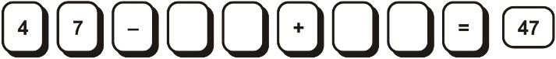

Here are the start and finish times of some children doing a sponsored walk.  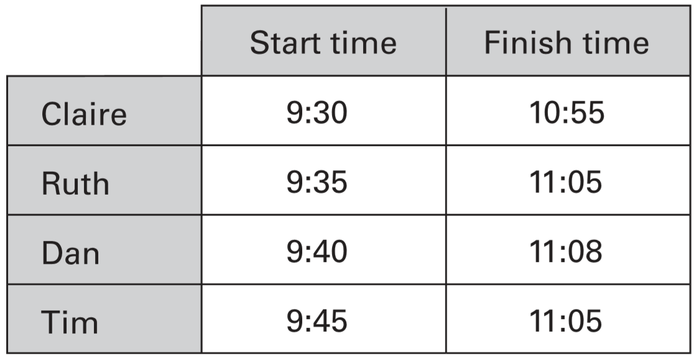  How much longer did Claire take than Tim? | Sarah wants to shade $\frac{3}{4}$ of this shape.  She has shaded 2 triangles.  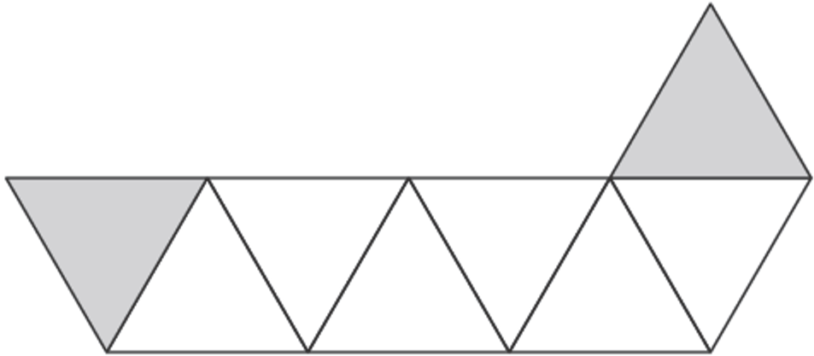  How many more triangles must she shade so that $\frac{3}{4}$is shaded?
Circle all the numbers that are greater than 0.6  0.5 0.8 0.23 0.09 0.67 | Circle the number nearest to 1000  1060 1049 1100 960 899
Here are four designs made from two sizes of circles.  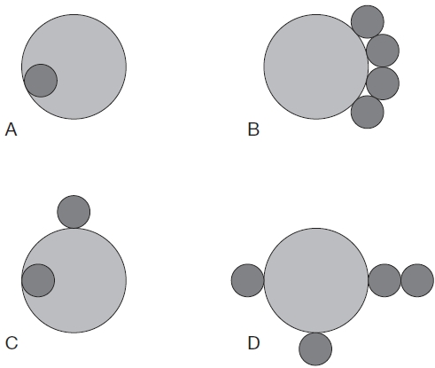  Write the letters of all the designs that have line symmetry. | A shop sells scarves and hats.  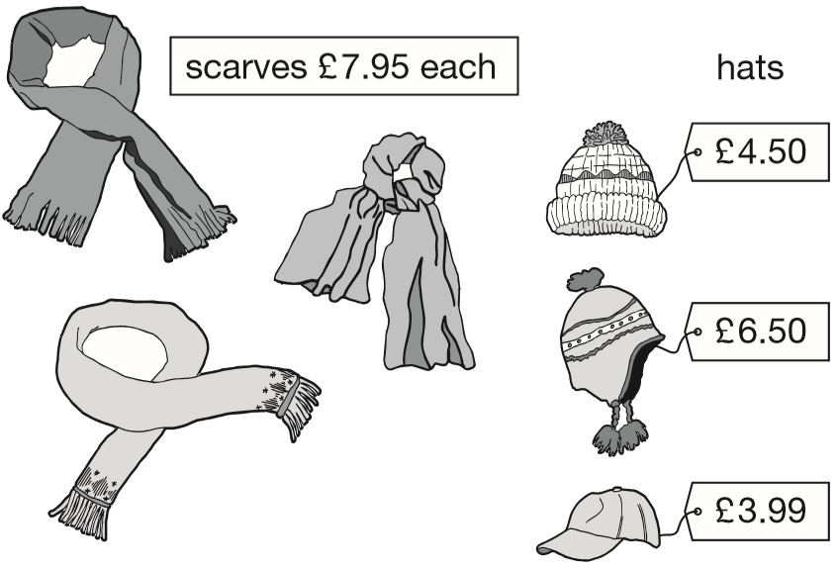  Ben buys one of the scarves and the £4.50 hat. How much change does he get from £20?  Emily buys two scarves and a hat.  What is the most she could pay?
Here is a number line.  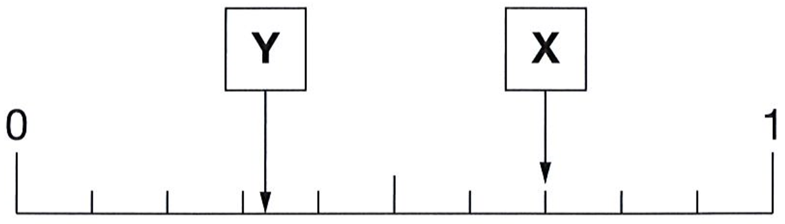  What is the value of X?  Estimate the value of Y. | The first two numbers in this sequence are 2.1 and 2.2  The sequence then follows the rule: ‘to get the next number, add the two previous numbers’  Write in the next two numbers in the sequence.  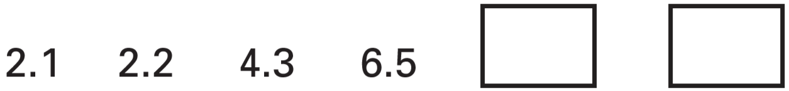
Draw crosses on the two shapes that are in the wrong places in the sorting diagram.  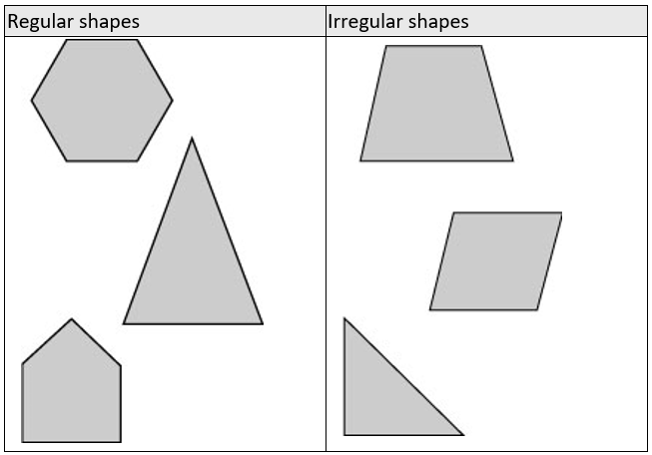 | A fraction of each shape is shaded. Match each fraction to the correct place on the number line. One has been done for you.  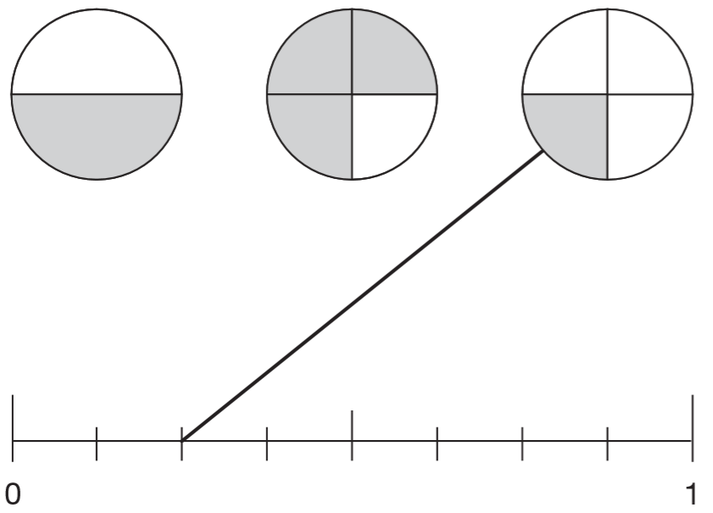

Children take part in a long jump on Sports Day. Sue jumped 212 cm.  Draw Sue’s long jump result on the graph.  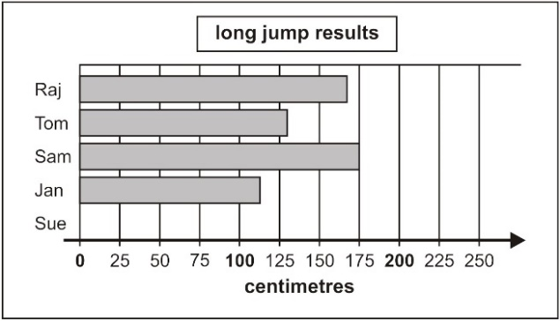  Use the graph to estimate how much further Sam jumped than Jan. | Here is a set of stamps.  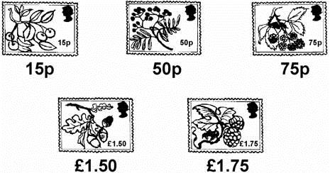  David posts a parcel.  It costs £1.90  He uses two of these stamps.  Which two stamps does he use?
Here is a number machine.  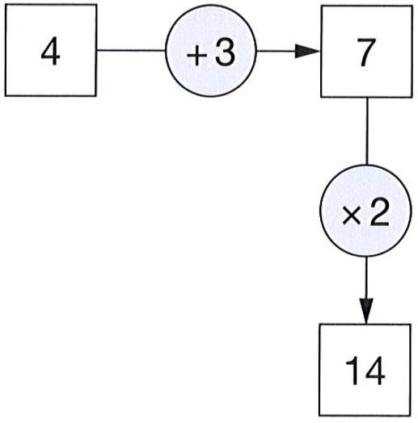  Here is another number machine.  Write the four missing numbers.  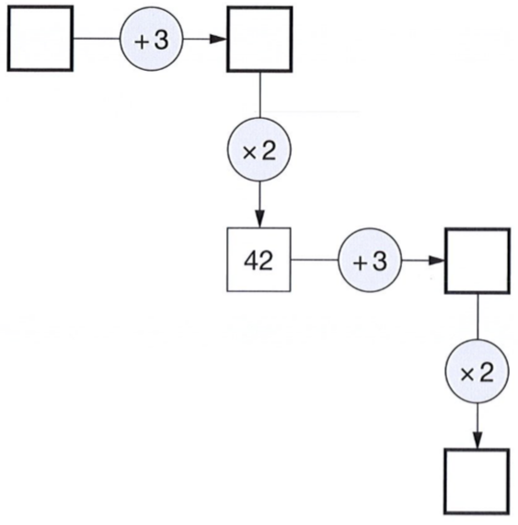 | A line starts at A and goes along the dotted lines to B.  It divides the area of the grid into halves.  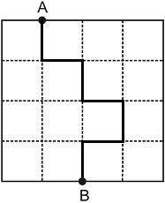  Divide the area of the grid below into halves. Start at A and go along the dotted lines to B.  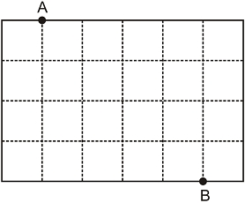
Zak puts a cake in the oven at 6:50  He takes it out of the oven 50 minutes later.  What time does he take the cake out? | Dev has five coins.  He has £1.60 altogether.  Write what the five coins could be.  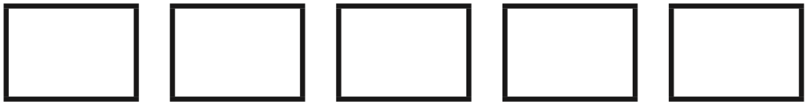
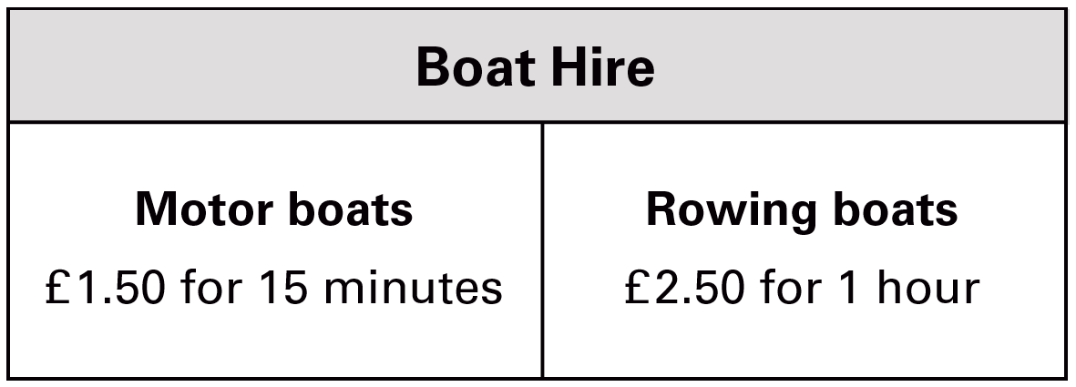  How much does it cost to hire a rowing boat for three hours?  Sasha pays £3.00 to hire a motor boat.  She goes out at 3:20pm.  By what time must she return? | Look at the ruler below.  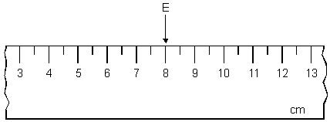  I want the distance between E and F to be 3½ cm.  There are two places F could be.  Show the two places by drawing arrows on the ruler.

These are the opening times at a swimming pool.  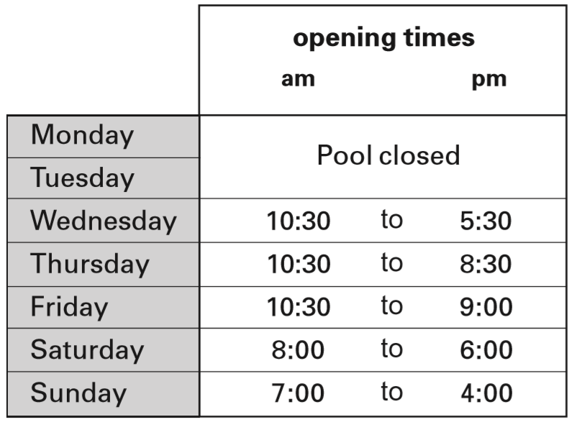  How many hours is the pool open on a Sunday?  Which day has the latest closing time?  Habib arrives at the pool at 5:20pm on Saturday.  How many minutes is it before the pool closes? | 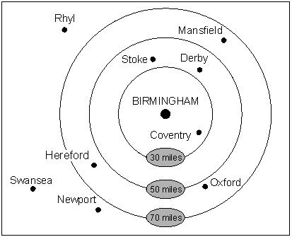  This diagram shows the distances of different towns from Birmingham.  Write the name of a town which is between 30 and 50 miles from Birmingham.  Use the diagram to estimate the distance in miles from Birmingham to Mansfield.
Jack leaves for school at 8:10  It takes him 40 minutes to get to school.  Tick the time Jack gets to school.  8:30 8:40 8:50 9:00 9:50 | Circle two numbers which divide by 5 with no remainder.  7 60 19 45 37 58
This table shows the four most popular names for baby girls born each year from 2004 to 2008.  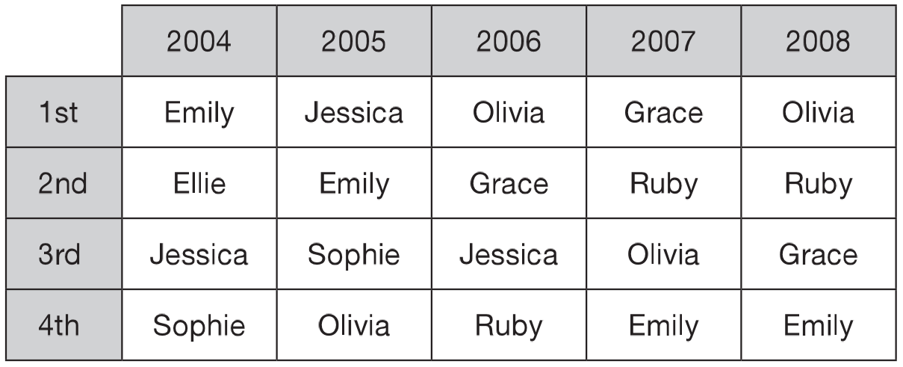  In how many years was Olivia in the top three most popular names?  Write all the years when Emily was a more popular name than Jessica. | Here is a centimetre grid.  Draw a rectangle whose longer sides are 6 cm  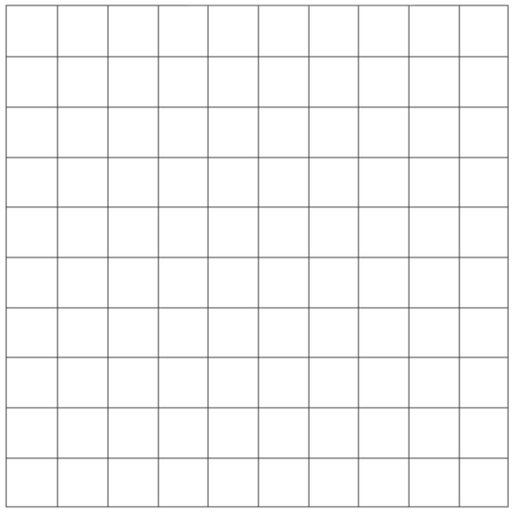
Here are some shapes on a grid.  Which shape has the largest area? | Here are the sunrise and sunset times for some days in July.  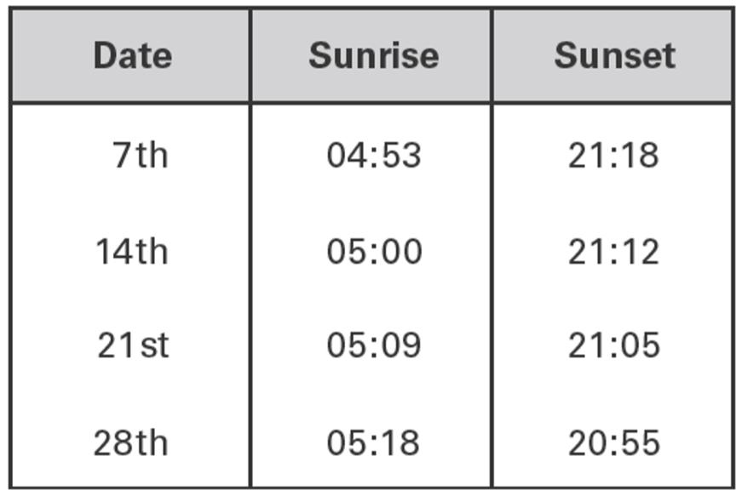  How many minutes earlier is the sunset on 28th July than on 7th July?

The diagram shows the volume of water in two measuring jugs.  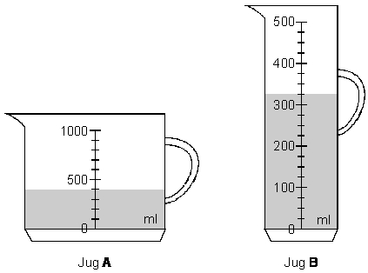  Which jug contains more water?  How much more does it contain? | Shade one third of this shape.  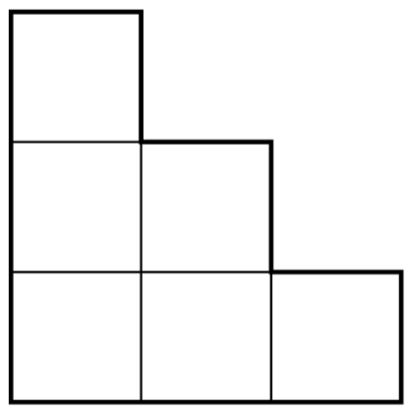  Shade one quarter of this shape.  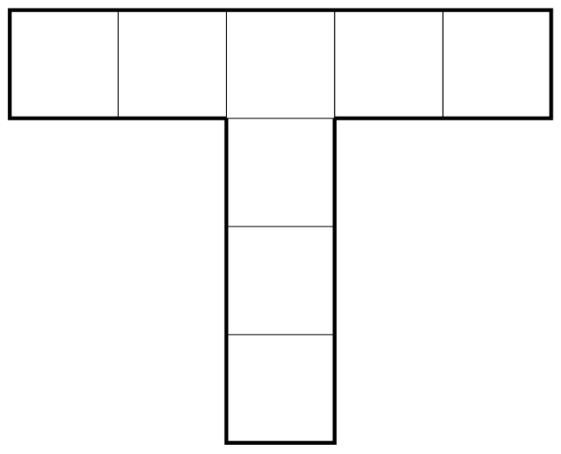
The Cave has co-ordinates (7 , 4).  What are the co-ordinates of the Treasure?  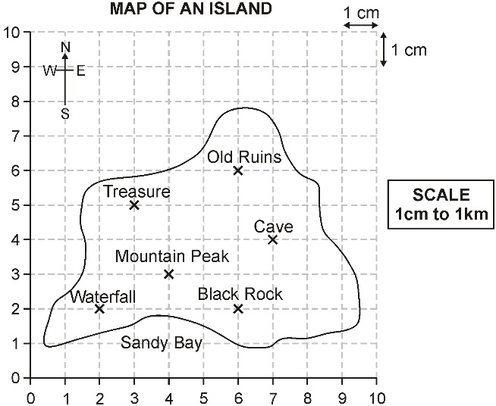 | The diagram shows distances on a train journey from Exeter to York.  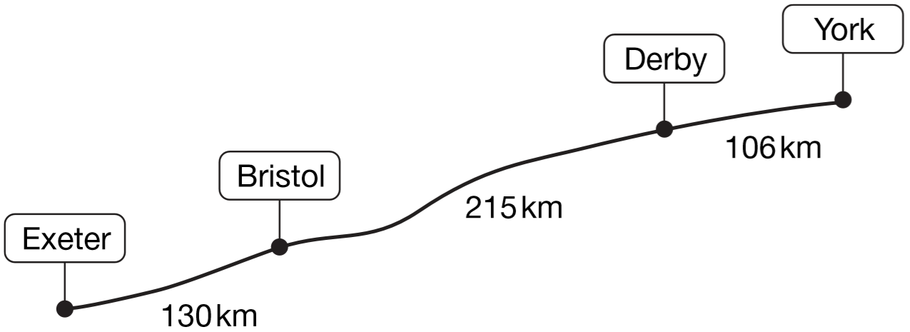  How many kilometres is it altogether from Exeter to York?  What is the distance from Derby to York rounded to the nearest 10km?
Amy did a survey of what time people get up on a Sunday morning. This table shows her results for 150 people.  Amy says, ‘Two-thirds of the 150 people in the survey get up before 9am.’ Amy is correct. Explain how you know. | Here are some number cards:  You can use each card once to make the number 1,735, like this:  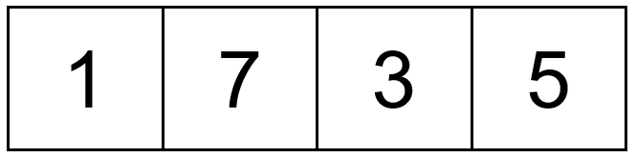  What is the biggest number you can make with the four cards?  Explain why you cannot make an even number with the four cards.

Here is a design and a mirror line.  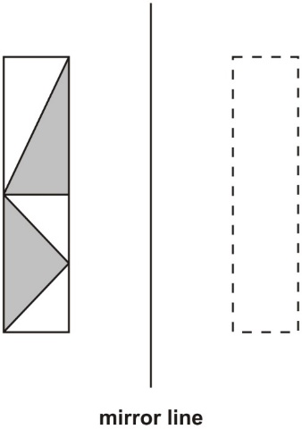  Which one of the designs below is the reflection of the design in the mirror line?  Tick the correct design.  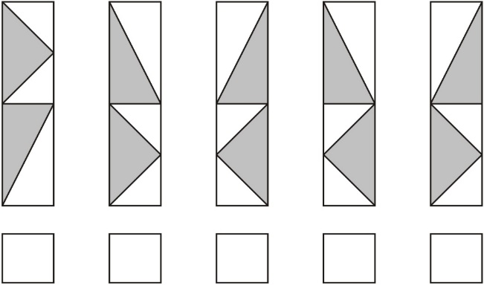 | 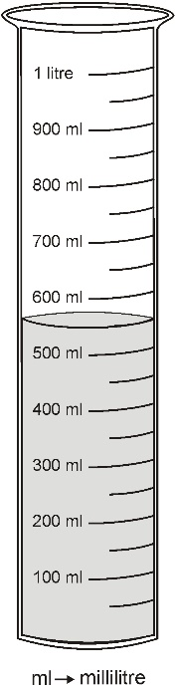  How much water is in this container?  How much more water is needed to make 1 litre?
The table shows the time taken for school teams to complete the relay race.  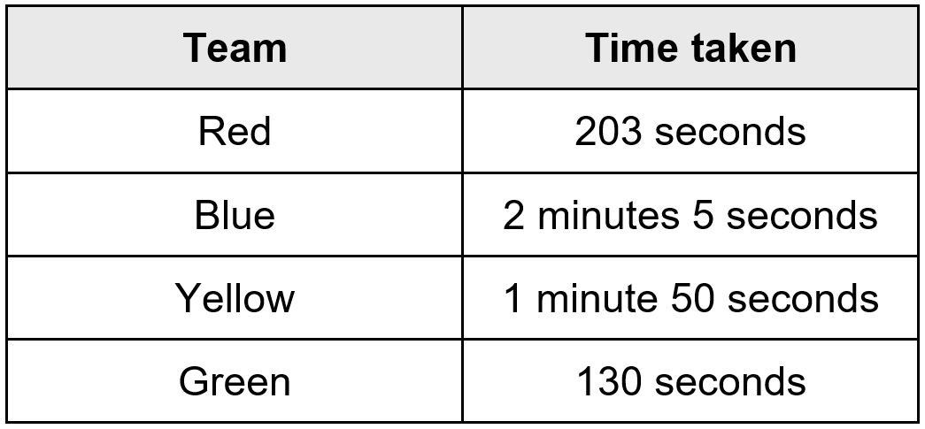  Which team finished first?  Which team finished last? | Here is a shaded rectangle drawn on a grid of centimetre squares.  What is the area of the shaded rectangle?  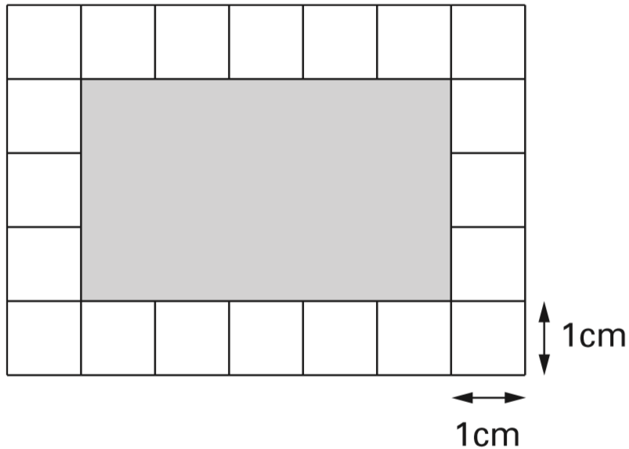
Asif, Vicky and Nita go to town by bus. This is what they pay.  Asif: 75p Vicky: £1.35 Nita: £1.55  How much more does Nita pay than Asif?  Vicky then takes another bus from town to visit her auntie. She pays 90p on this bus.  How much has Vicky paid altogether for her two bus tickets? | 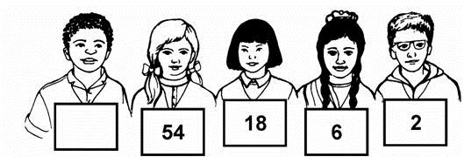  Children in Year 6 make number patterns.  This group uses the rule ‘divide by 3’.  Write in the missing number.
Here is a centimetre square grid.  On the grid draw a shape which has an area of 10 square centimetres.  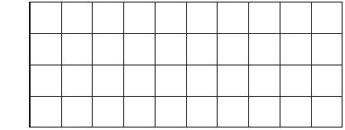 | Josh thinks of a number.  He adds 4  He multiplies his result by 3  Then he takes away 9  His final answer is 90  What number did Josh start with?

Write two more numbers in this diagram so that the total of all the numbers is 1000.  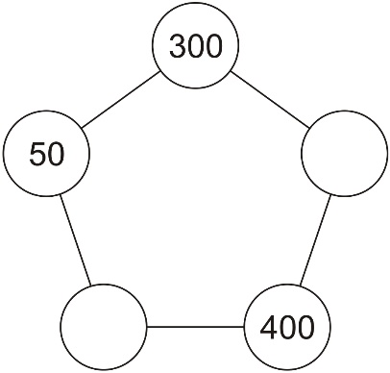 | 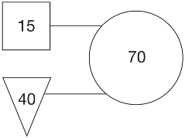  In this diagram the rule is:  ‘double the number in the square and add the number in the triangle to make the number in the circle.’  Use the same rule to write in the missing numbers below.  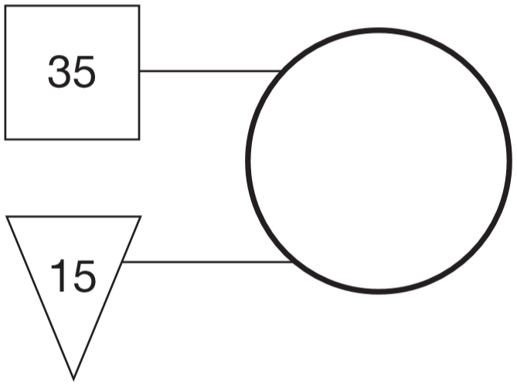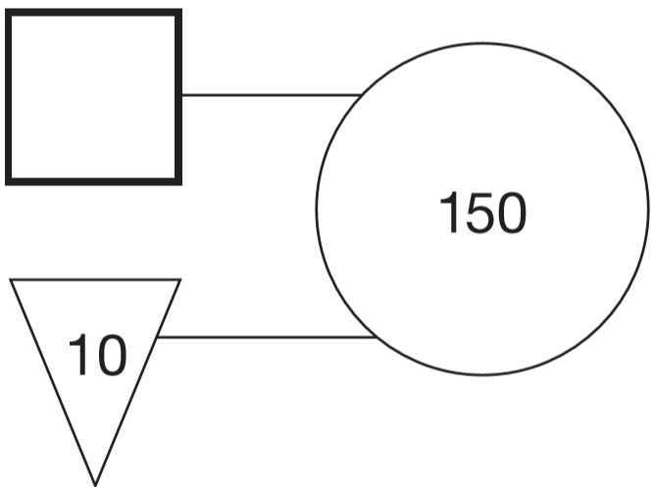
Complete these fractions to make each equivalent to $\frac{3}{5}$  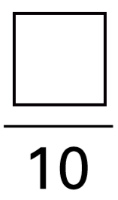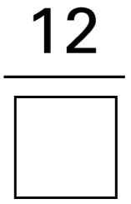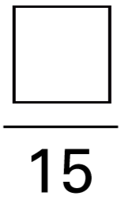 | These diagrams are made from regular octagons.  Draw the line of symmetry on each diagram.  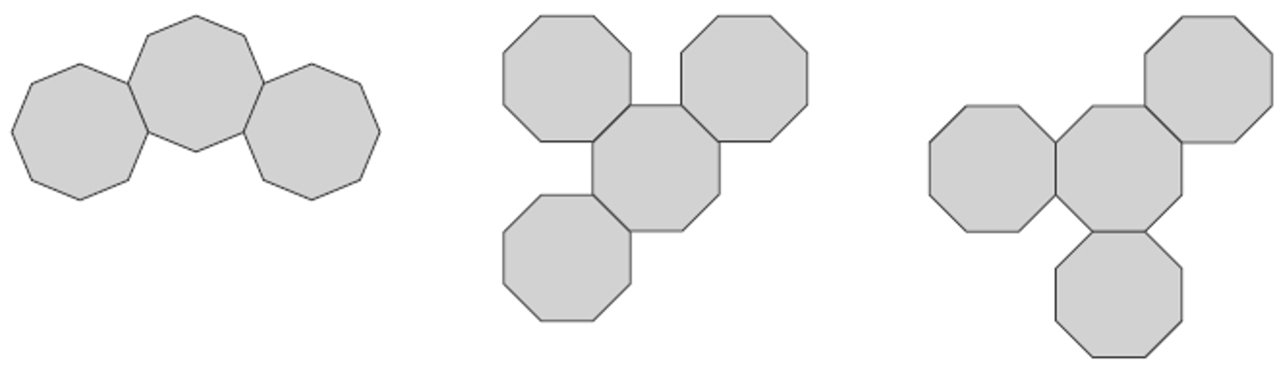
Three children do a sponsored silence.  This is a chart of the money they collected.  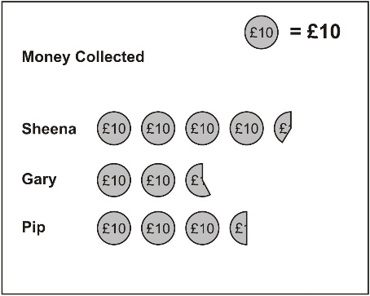  Estimate how much Sheena collected.  Together Gary and Pip collected more than £60  Explain how the chart shows this. | Class 6 did a survey of birthday dates. This chart shows the number of people with birthdays in each three months of the year.  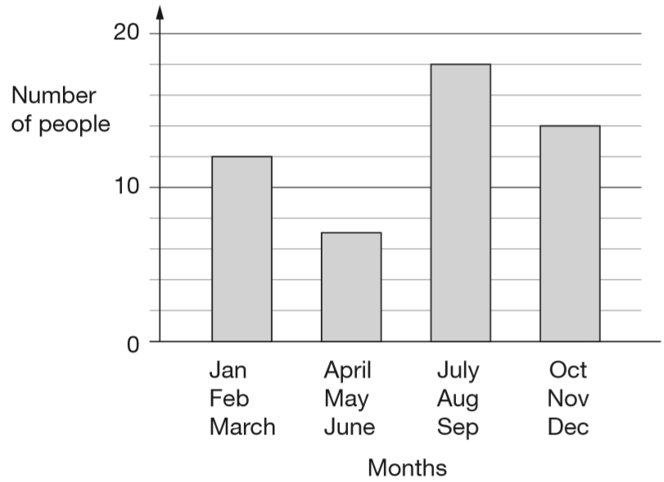  From the chart, how many people have a birthday before July?  Nobody has a birthday in October.  Six people have a birthday in November. How many people have a birthday in December?
Here are five number cards.  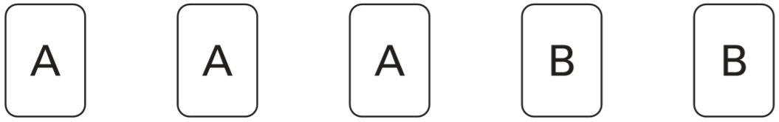  A and B stand for two different whole numbers.  The sum of all the numbers on all five cards is 30  What could be the values of A and B? | Here are five patterns.  For each pattern put a tick if it has a line of symmetry. Put a cross if it does not.  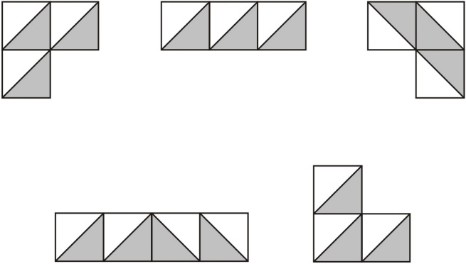

This table shows the numbers of children who went walking, sailing or climbing at an outdoor centre.  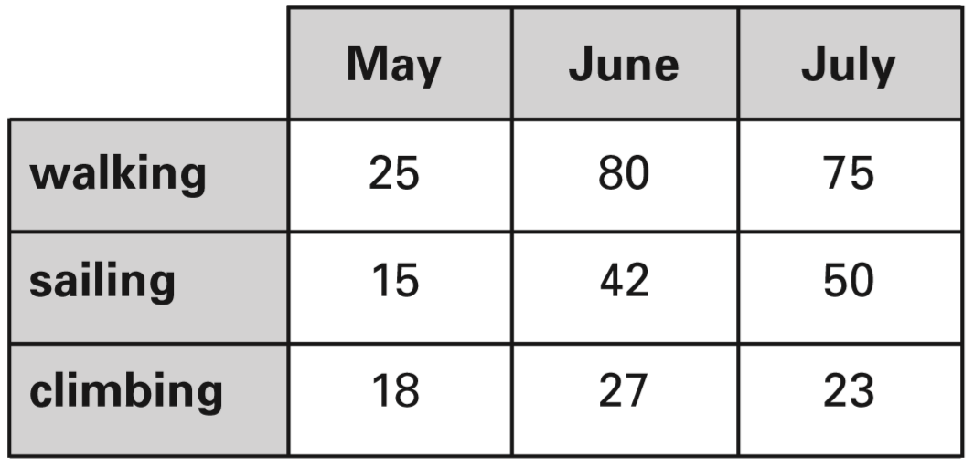  How many children went sailing in May, June and July altogether?  How many more children went walking in June than climbing in June? | The table below shows five journeys a taxi driver made one day.  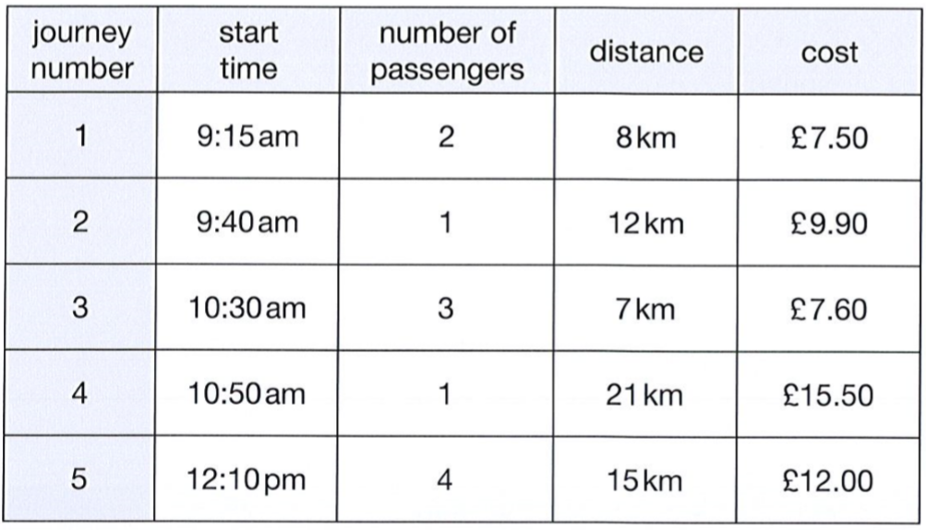  The 12 km journey took 40 minutes. What time did the taxi finish its journey?
The pie charts show the results of a school’s netball and football matches.  The netball team played 30 games.  The football team played 24 games.  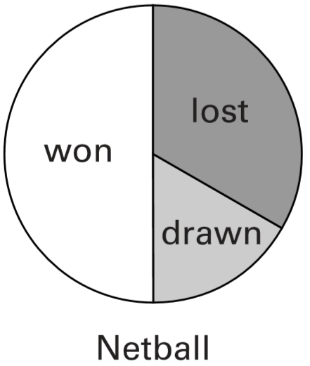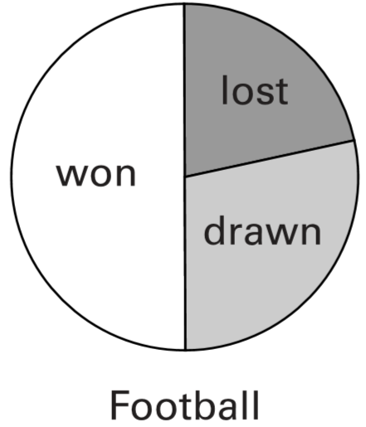  David says, ‘The two teams won the same number of games.’  Is he correct? Explain how you know. | Emma counts how many letters there are in each of 40 words.  The bar chart shows her results.  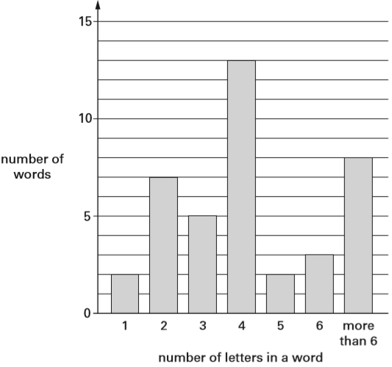  How many words have fewer than 4 letters in them?  What fraction of the 40 words have more than 6 letters in them?
Write in the missing numbers.  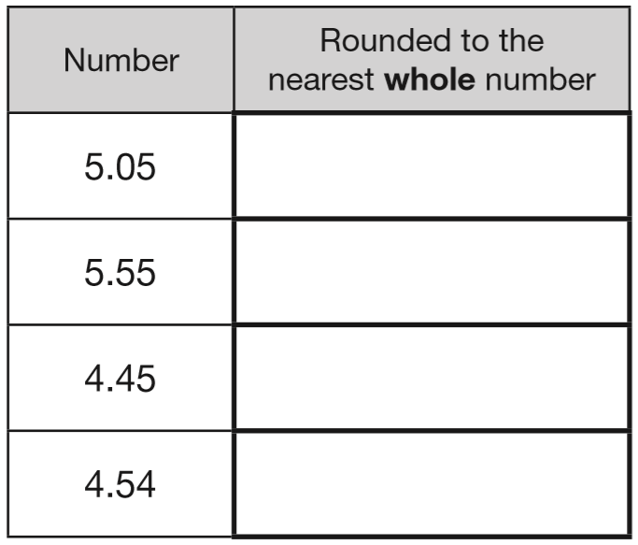 | Alfie places three cubes on a coordinate grid.  The base of his shape is a rectangle.  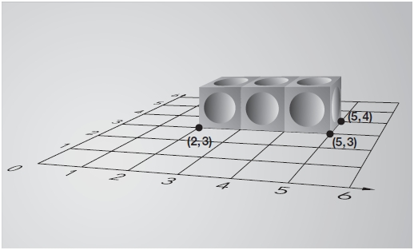  Complete this sentence:  The four vertices of the rectangle are  (2, 3), (5, 3), (5, 4) and:
Here is a number written in Roman numerals.  XXIV  Write the number in figures. | Circle the numbers that add up to 100  64 32 16 8 4 2 1

The jug shows how much juice Tom has.  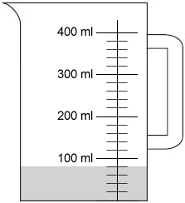  How much juice is in the jug?  He fills the jug up to 400 ml with water. How much water does he put in the jug? | The table below shows five journeys a taxi driver made one day. On journey number 5, the passengers shared the cost equally.  How much did each passenger pay?  How many passengers made journeys of more than 10 km?
Megan and Chen are washing cars.  Megan gets £39 and Chen gets £55  They share what they get equally between them.  How much does each of them get? | Fares to France:  Adults £23.00  Children £11.50  There are 2 adults and 3 children in a family.  How much does it cost the family to go to France?
Write in the missing digits to make this correct.  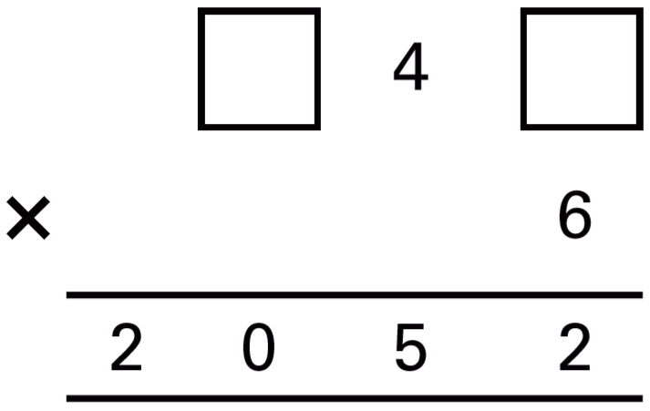 | Here is a number sequence.  Write in the missing numbers.  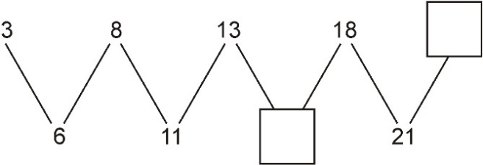
Here is a jug with some water in it.  How many more millilitres of water must be added so that there are 500 ml in the jug?  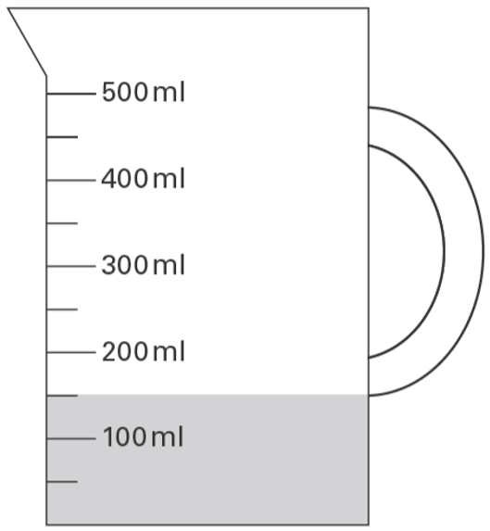 | Here are some shapes on a 1cm square grid.  What is the perimeter of shape A?  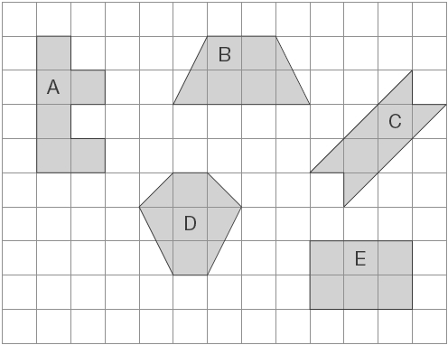
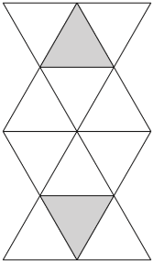  Here is a shape made from matching triangles.  Circle the fraction of the shape that is shaded.  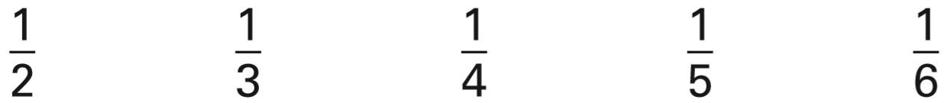 | Circle the three numbers which divide by 5 with no remainder.  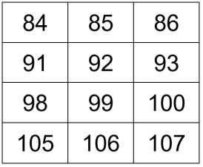

This graph shows the number of people visiting a shop.  275 people visited on Tuesday.  Draw the missing bar on the graph.  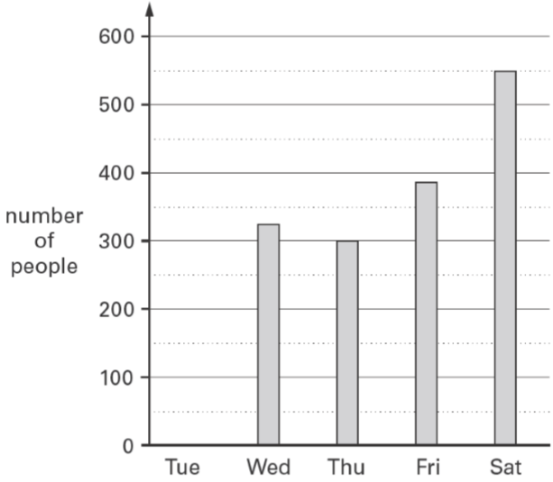  Estimate how many more people visited the shop on Saturday than Friday. | The numbers in this sequence increase by 10 each time.  3 13 23 …  The sequence continues in the same way.  Write two numbers from the sequence that add to make a total of 96  Explain why it is not possible to find three numbers from the sequence that add to make a total of 96
How many vertices does this 3-D shape have?  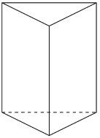 | Here is part of a number line.  Write in the missing fraction.  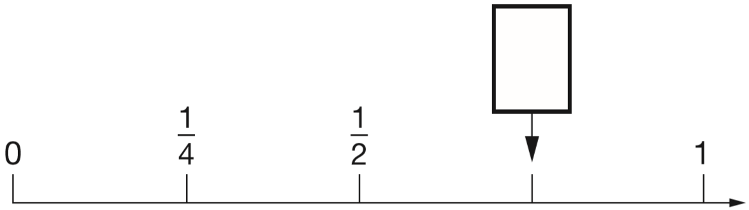
Five children share a bag of cherries.  Each child gets 6 cherries.  There are 3 cherries left over.  How many cherries were in the bag altogether? | Write these numbers in order of size, starting with the smallest.  901 1091 910 109 190  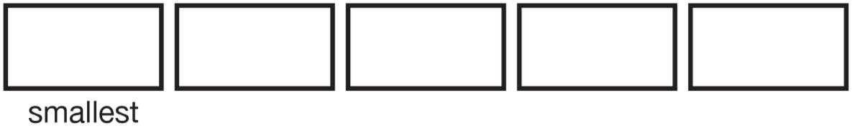
Mr Tyler is 1.97 m tall.  His young daughter is 83 cm tall.  What is the difference in their heights, to the nearest 10 cm? | Tick the two divisions that have the same answer.  100 ÷ 10 100 ÷ 5 100 ÷ 2 20 ÷ 2
Emily has these coins.  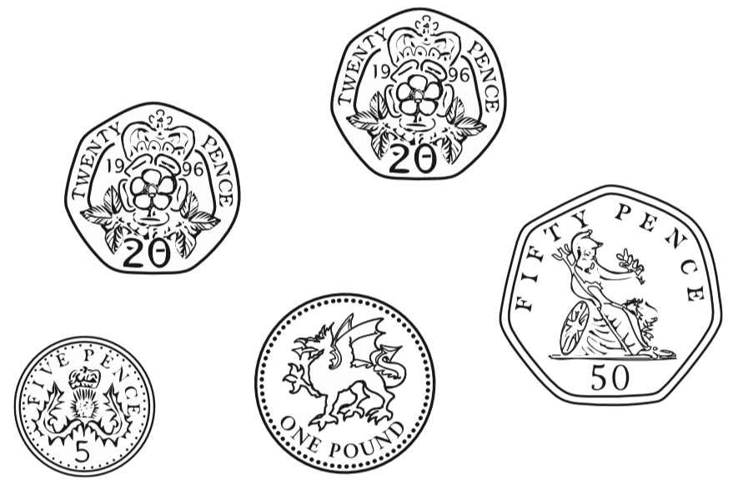  How much more money does Emily need to make exactly £5? | A clock shows this time.  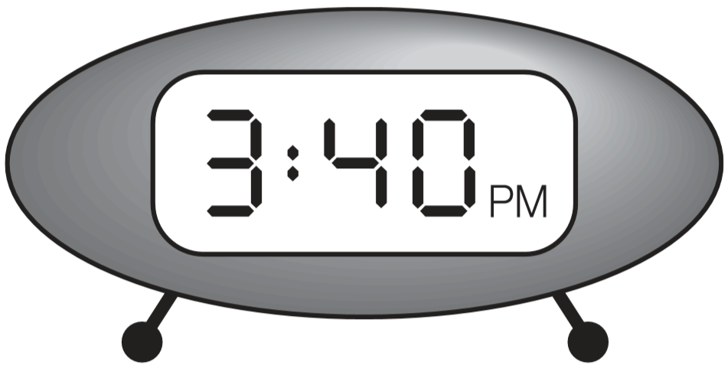  How long is it from this time until 5pm?  What time was it quarter of an hour before the time on the clock?
Write what the three missing numbers could be.  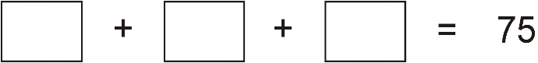  Write what the two missing numbers could be.  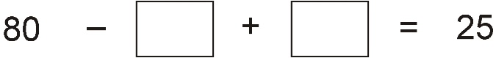 | Write the missing number in each calculation.  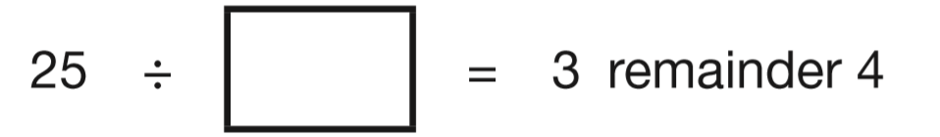  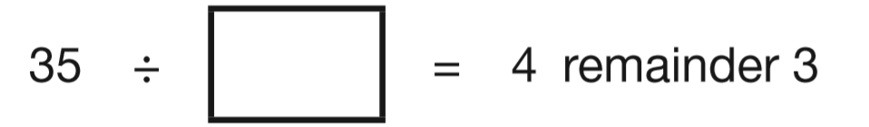

Each missing digit in this sum is a 9 or a 1  Write in the missing digits.  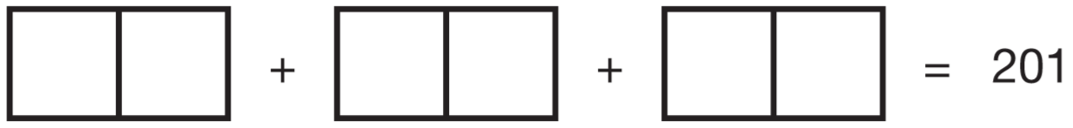 | One length of a swimming pool is 25 metres.  How many lengths are there in a 150 metre race?
A spoonful is 5ml.  How many spoonfuls can you get from a 375ml bottle? | Vijay buys 9 party bags.  Each bag costs 99p.  How much do they cost altogether?
Tony and Gemma looked for snails, worms, slugs and beetles in their gardens. They each made a pie chart of what they found.  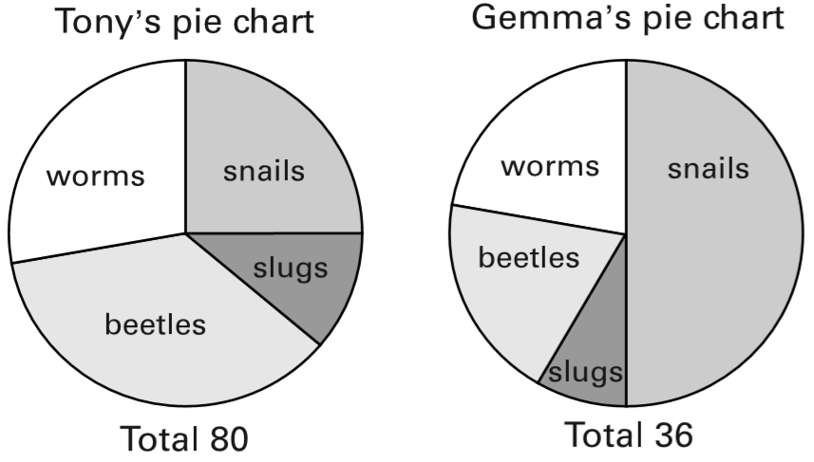  Estimate the number of worms that Tony found.  Who found more snails?  Explain how you know. | A survey was done to find out children’s favourite season. This chart shows the results.  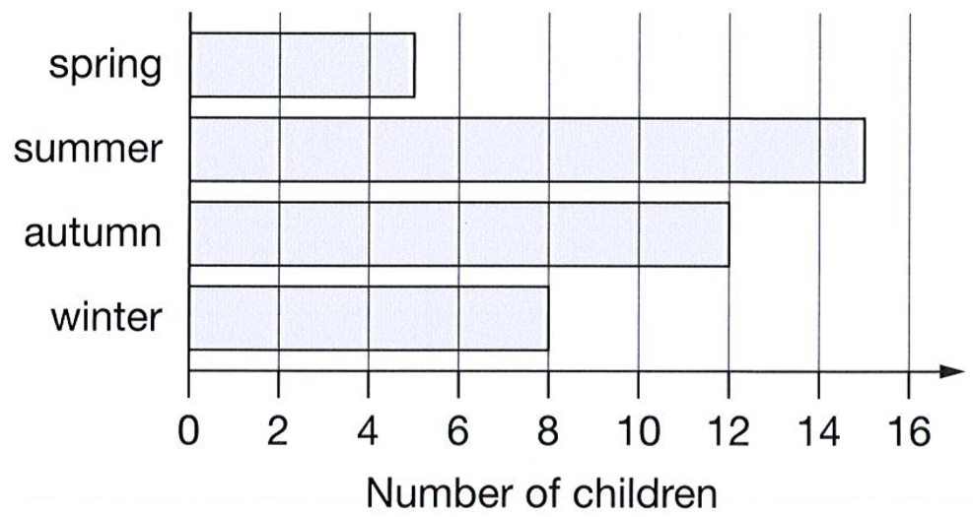  How many more children chose autumn than chose spring?  Kirsty says, ‘Exactly twice as many children chose summer as chose winter.’  Is Kirsty correct? Explain how you know.
Here is part of a number line.  Draw an arrow to show the position of 0.32  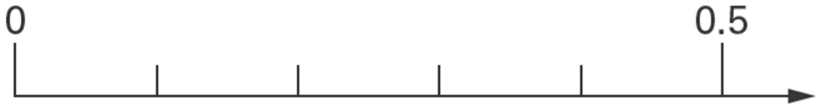 | Reshma buys 4 packets of balloons.  She pays with a £5 note and gets 40p change.  How much does one packet of balloons cost?
Circle all the numbers that are less than 0.4  0.3 0.8 0.23 0.09 0.63 | Liam buys two apples.  He pays with a £1 coin and gets 64p change.  How much does one apple cost?
These are the opening times at Black Tower Castle.  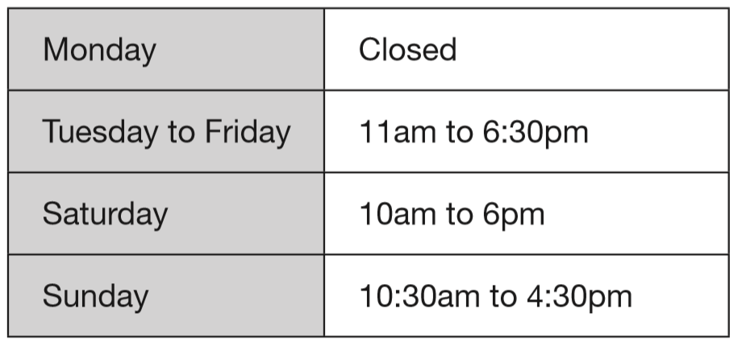  How many hours is the castle open on Saturdays?  Alfie arrived at the castle at 5pm on a Thursday.  How long could he stay before closing time? | 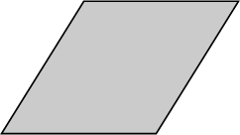  Jack says, “My rhombus is a regular quadrilateral.”  Explain why Jack is not correct.

Circle two decimals that have a difference of 0.5  0.2 0.25 0.4 0.45 0.6 0.75 | The coach leaves the school at 9:30  It gets back to school three hours later.  At what time does it get back?
Nisha has thirty 5p coins and twenty 10p coins.  How much money does she have altogether? | These are the start and finish times on a video cassette recorder.  START 14:45 FINISH 17:25  For how long was the video recording?
grapefruit 45p each melons 59p each  Zak has one 50p coin and three 20p coins.  He buys a grapefruit and a melon.  How much money does he have left? | Megan has 7 coins that make one pound.  The coins are of only two different kinds.  What are the 7 coins?  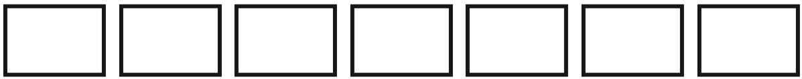
Dev and Joe each buy a book.  Dev pays with a £5 note and gets £1.05 change.  Joe’s book costs £7  How much more does Joe’s book cost than Dev’s book? | Look at these digits.  5 0 8 2  Make the largest number possible with the digits. Write your number in words.
David needs to solve this problem.  ‘How much do two oranges and one apple cost?’  Tick all the information that David needs to solve his problem.  An orange costs 5p more than an apple.  An apple costs 20p  David has £1 | Tick the correct answer.  About how much does a new-born baby weigh?  0.3 kg 3 kg 30 kg 300 kg  About how much milk does a baby’s bottle hold?  3 millilitres 300 millilitres 3 litres 300 litres
Here are a pencil sharpener, a key and a rubber.  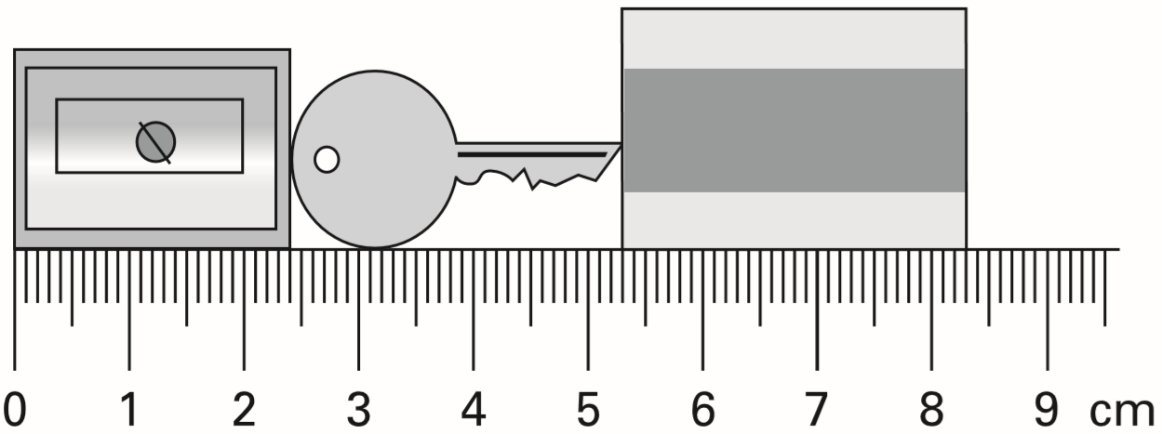  What is the length of all three things together?  What is the length of the key? | A boat can safely carry 145 kilograms.  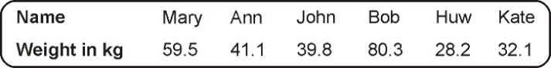  Work out if the boat can safely carry Mary and Bob.

