
Recognise place value in two-digit numbers
66  85 | >  <  >
46 < 62  56 > 50  76 < 77 | 68 > 53  10 < 24  9 > 7
46 | 16, 40, 46, 64, 106



Recognise place value in three-digit numbers
300  301 | 2  6
300  301 | 124  206
Two hundred and sixty-nine  504 | Park
89, 91, 98, 108, 121 | 106, 140, 146, 160, 164
565, 450, 405, 209, 124 | 299, 456, 472, 575, 901

many possible answers  e.g.  25  301  308 | 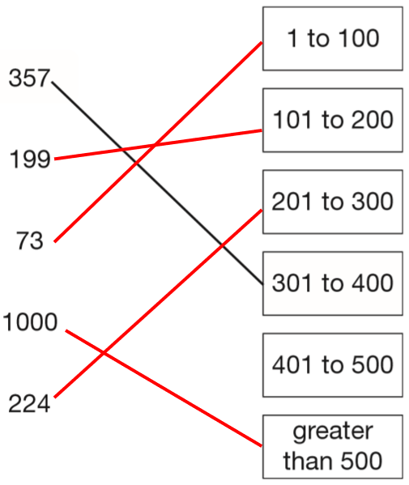
2019 Paper 3 Question 7b  2  3  2 | 147
2019 Paper 3 Question 7b  2  3  2 | 973  379
375 | 664, 662, 646, 642, 624 (any order)
57, 75, 27, 52, 72, 25 (any order) | 664, 662, 646, 642, 624 (any order)
Round to the nearest 10 or 100
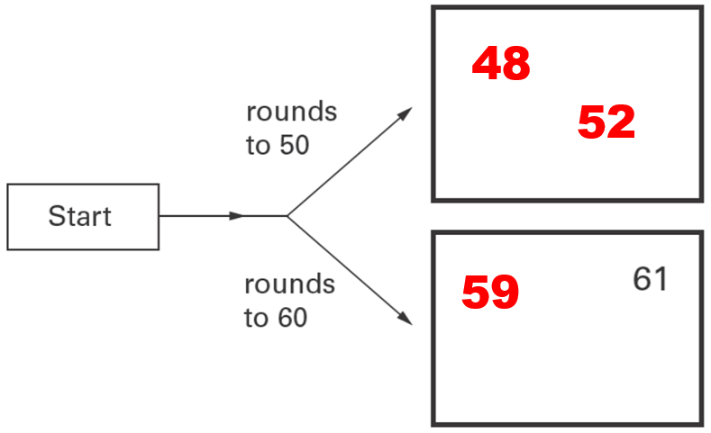 | 82, 77
 | 84, 76
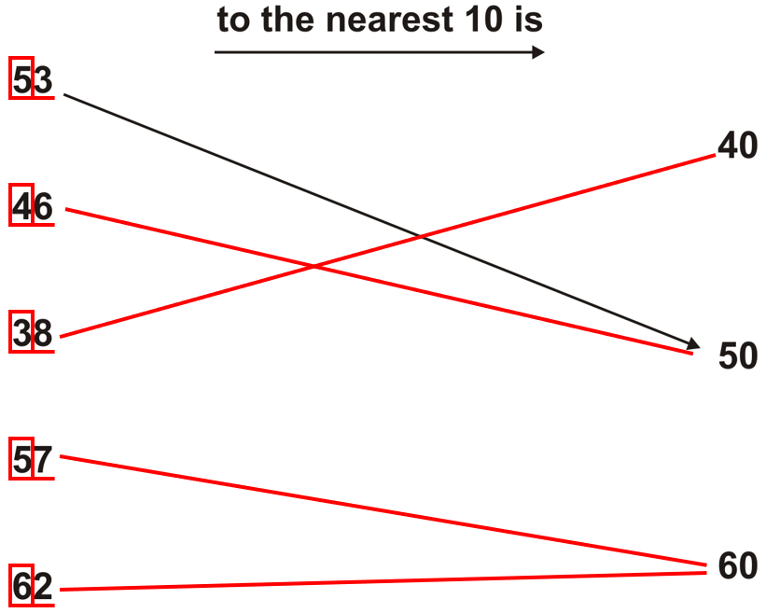 | 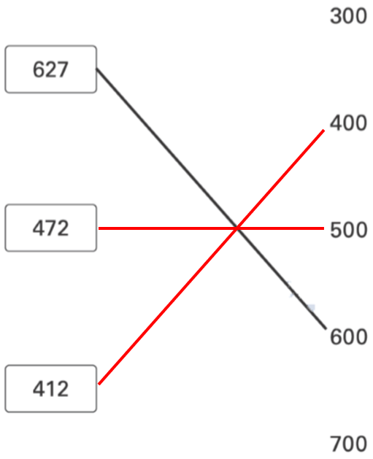
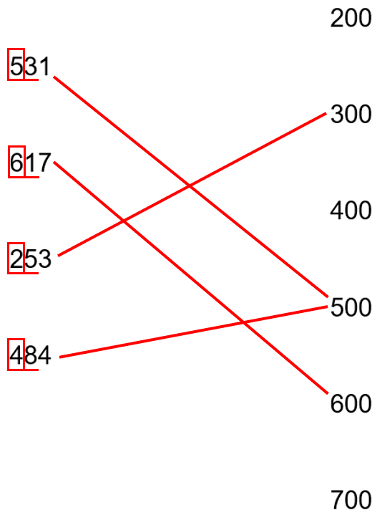

Use the inverse to find missing numbers in addition and subtraction problems
57 | 73
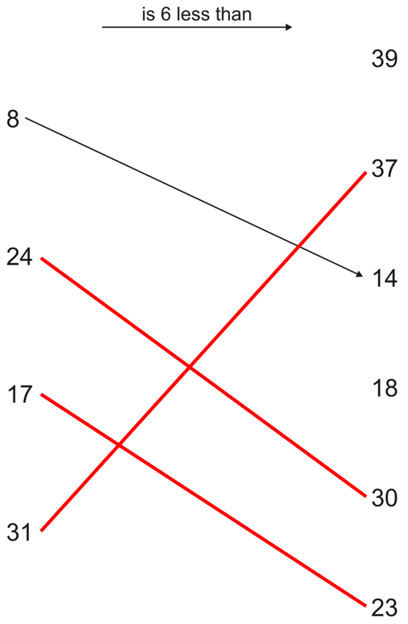 | 80  33  0
43  0 | 2015 Paper 2 Question 1  257
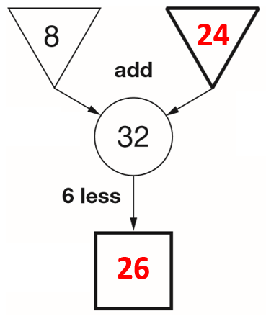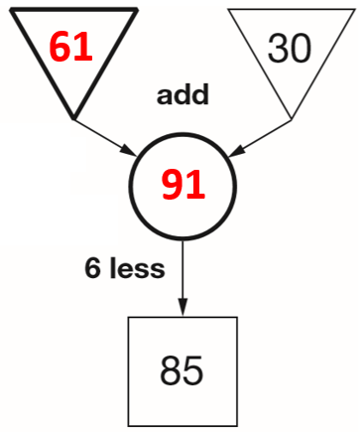 | 95  130
2018 Paper 2 Question 2
28 + 67 = 95 or 67 + 28 = 95

Find missing numbers in the addition or subtraction of multiple numbers
Write in the missing numbers.
89 | 310
120 | 120
40 | 181
20

Complete simple addition and subtraction sequences with missing numbers
37, 27 | 100, 65
20, 38 | 16, 40, 64
20, 38 | 2018 Paper 3 Question 1  35, 56, 70
15  31 | 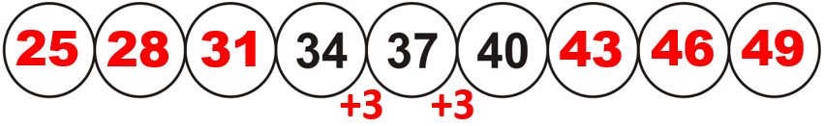
15  31 | 880  980, 990
794, 844 | 250, 450
2016 Paper 3 Question 1  68, 110, 152 | 2019 Paper 2 Question 5  110, 290, 335
570, 730
Use number cards to write correct addition and subtraction calculations
many possible answers | 18 = 12 + 6  or 12 = 9 + 3  or 9 = 6 + 3
7, 3 (any order)  8, 1 (any order)  4, 2 (any order) | 30 + 20 = 50  30 + 10 = 40  (any order)
7, 3 (any order)  8, 1 (any order)  4, 2 (any order) | 26 + 14 (any order)  or 24 + 16 (any order)
76 + 24 (any order)  or 74 + 26 (any order) | 53 – 6
136  31 – 6 | one of the pairs below  63 and 87  64 and 86  65 and 85  66 and 84  67 and 83  73 and 77  74 and 76
458 + 42
Find missing digits in addition and subtraction calculations
97 – 54 | 61 – 27
37 + 63 | 35 + 65
44 + 56 | 137 + 63
2019 Paper 3 Question 5  128 + 72 | many possible answers  e.g. 408 – 200
2016 Paper 2 Question 3  151 + 464 | 258 + 297
3 and 3  or 4 and 2 (any order)  or 5 and 1 (any order) | 593 – 202 = 391

Complete puzzles involving addition and subtraction
150 matched to 85 + 65 and 450 – 300 | 225 and 475
7 and 14  or 15 and 8 | 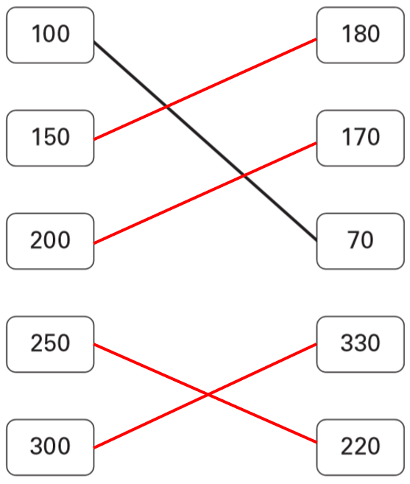
67 and 45 (any order) | 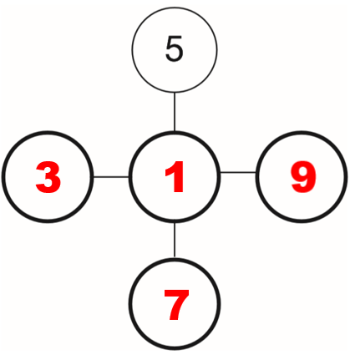 or 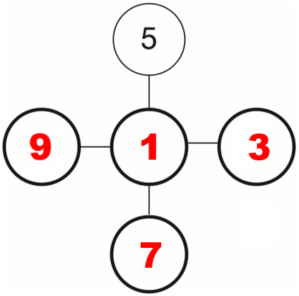

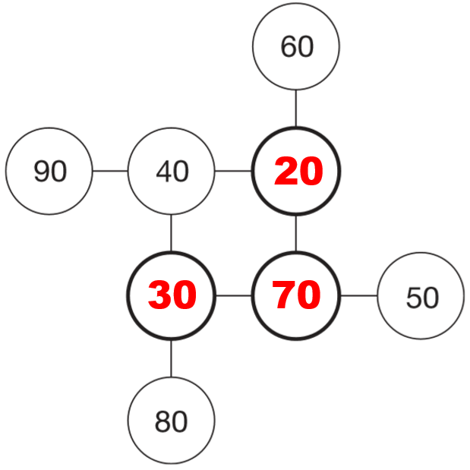 | 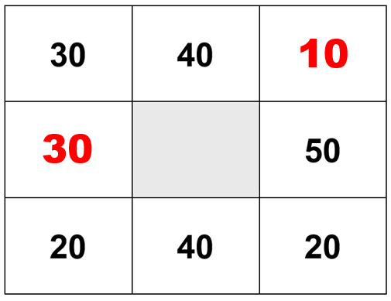
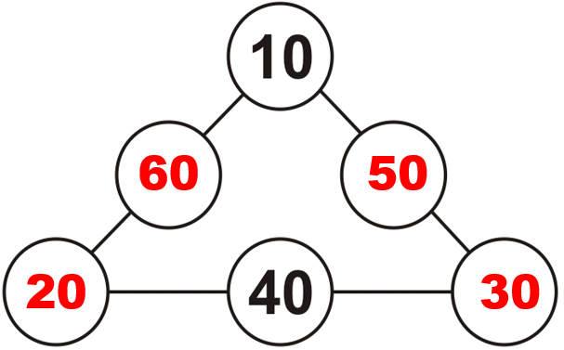  or  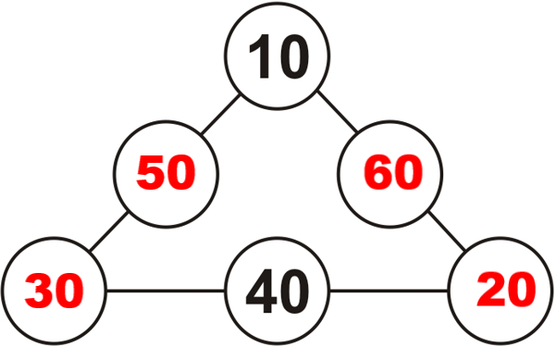 | many possible answers  e.g. 50 + 3 + 1  – and =  or = and +
+ and =

– and =
or = and +
– and =  or = and +  – and =  or + and =  or = and –  or = and + | – + –  + – –
Find the number closest to or furthest from a three-digit number
111 | 288
491 | 651
2016 Paper 2 Question 1  499  555 | 246
2016 Paper 2 Question 1  499  555 | 699
Interpret tables to solve addition and subtraction problems
3  4  monkey | Sarah is wrong.  25 + 19 = 44 walked  27 + 23 = 50 did not walk  44 is not more than 50
25 | £112  £16
15  USA | Jack

34  32 | 160 g  360 g
34  32 | 60 ml

Solve one-step addition and subtraction problems
31 – 9 | 31
31 – 9 | 28
28 | 90p
50 | 43
23 | 38 kg
100 | 356
120 g | 60 ml
56 | 2019 Paper 3 Question 7a  155 g
14 cm | 2019 Paper 3 Question 7a  155 g
406 | 2019 Paper 3 Question 7a  155 g

Solve two-step addition and subtraction problems
55 cm | 15
55 cm | 25p
55 cm | 8 m
11 kg | 7
11 kg | 202
43  24 | 2018 Paper 2 Question 16  Cross  Tick  Tick  Cross

Make different combinations
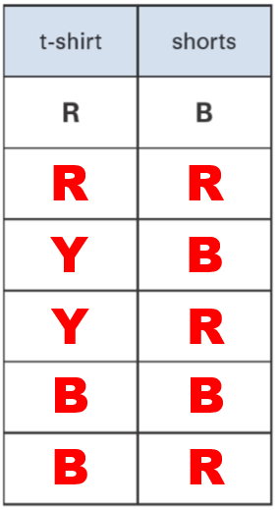 | 2018 Paper 3 Question 2  blue and red  white and red
Solve problems involving unequal distribution
11 boys and 10 girls | 8 in the longer piece, 7 in the shorter piece
Robbie has 6, Sapna has 8 | 15 cm

Solve problems involving times tables knowledge
2019 Paper 2 Question 1  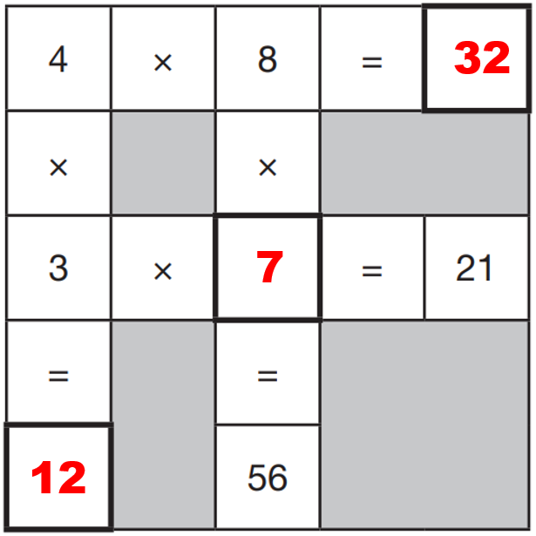 | 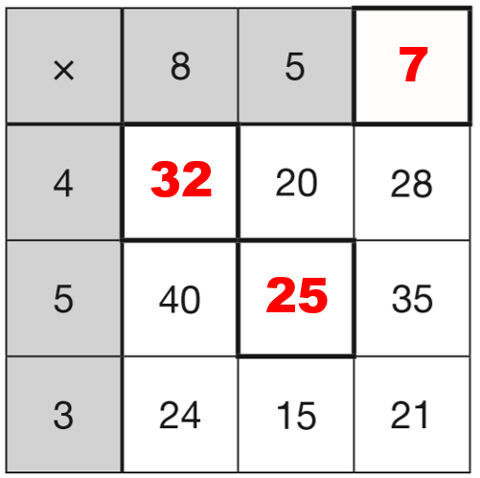
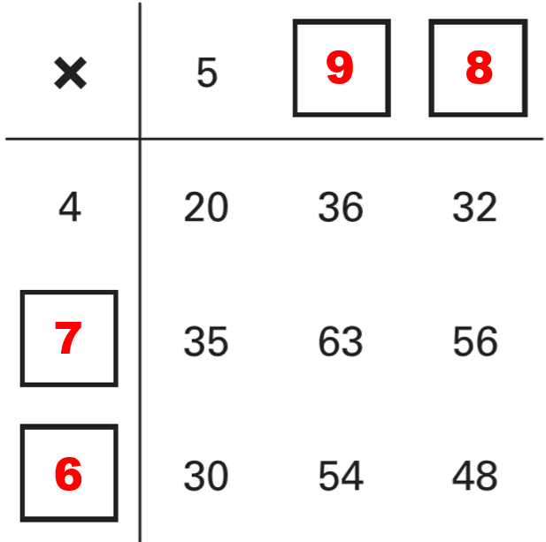 | 20 x 1 (any order)  or 10 x 2 (any order)  or 5 x 4 (any order)
 | 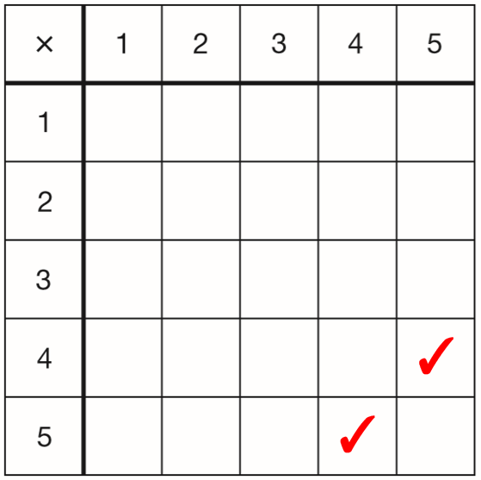

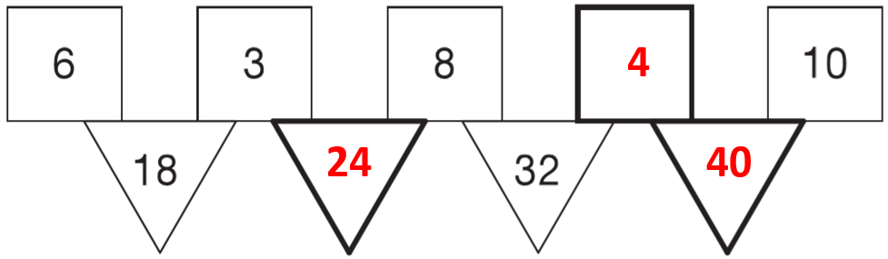 | Tick  Cross  Tick
60 ÷ 10 = 6  or 60 ÷ 6 = 10 | ÷
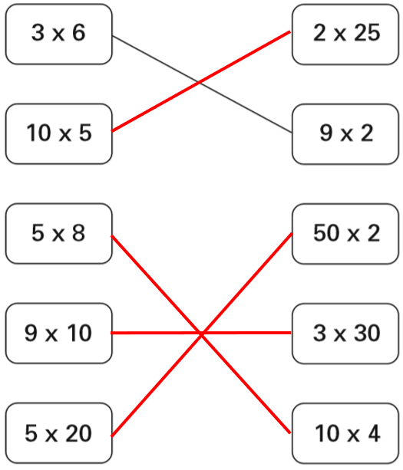 | =  >  <
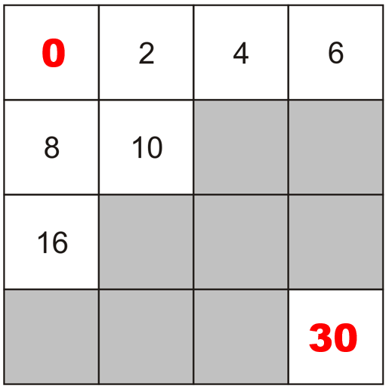 | 7

Solve word problems involving multiplication and division
Tick  Cross  Tick | 4
7 | 40
2 metres | 40
35 | 40
7  24 | 8
7  24 | 32  5
15 | 90  13
288 | 90  13

Solve number problems using the four operations
<  >  =  > | 6
<  >  =  > | + and x  ÷ and –
33

Solve word problems using the four operations
Tom has 4  Nadia has 28  4 | 54  63
10 | 19  14
2015 Paper 2 Question 2  122 | 19  14

Recognise vocabulary of odd and even
12 crossed out | Luke is correct.  If a number ends in 1, 3, 5, 7 or 9, it is odd.  If a number ends in 0, 2, 4, 6 or 8, it is even.
Nisha is wrong.  many possible explanations  e.g. 8 is an even number. Half of 8 is 4, which is even. | 50 is an even number.  odd + odd + odd = odd  Three odd numbers can’t add up to an even number.
Seb is wrong.  many possible explanations  e.g. 48 + 1 + 1 = 50 and 1 is an odd number.  If two of the three numbers are odd numbers, then the answer will be an even number. | It’s not fair.  There are 4 odd numbers but only 3 even numbers so Sapna scores on more than half of the cards.

Use knowledge of odd and even numbers to solve problems
9, 11, 13, 15, 17 or 19 | 4  3  5
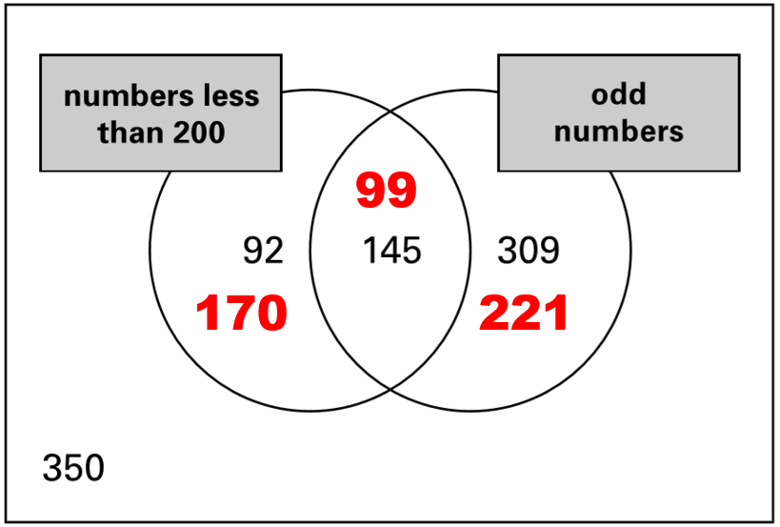 | 4  3  5
845 | 645
918 or 938 | 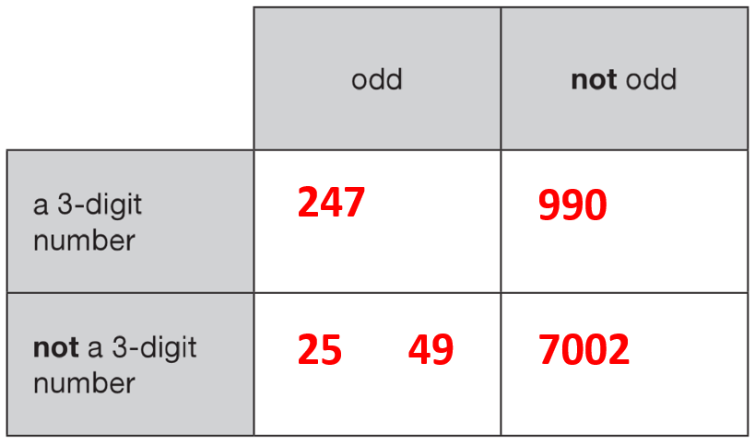
511, 151, 115, 331, 313 or 133

