
Identify fractions
$\frac{2}{8}$ or $\frac{1}{4}$ | 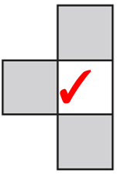
$\frac{5}{20}$ or $\frac{1}{4}$ | $\frac{2}{5}$
$\frac{5}{20}$ or $\frac{1}{4}$ | $\frac{9}{10}$

Compare and order fractions
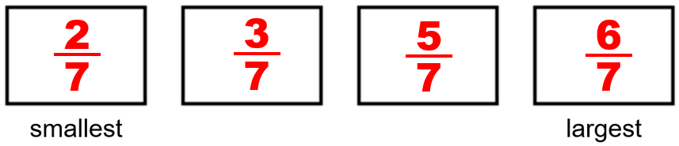 | 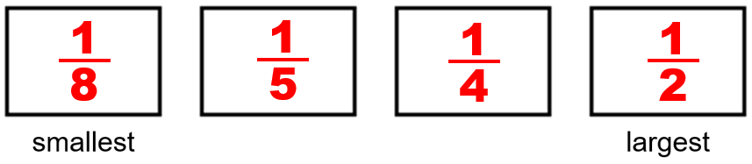
$\frac{1}{3}$ | $\frac{1}{4}$ and $\frac{2}{5}$


Recognise fractions that add to 1 whole
$\frac{1}{4}$ | $\frac{5}{8}$
$\frac{2}{7}$ | $\frac{1}{10}$  $\frac{9}{10}$
$\frac{5}{8}$ | $\frac{2}{8}$
Tom | $\frac{4}{9}$
$\frac{5}{11}$

$\frac{9}{11}$

Find a unit fraction of a number
7 apples circled | 8
7 apples circled | 20

Dev is wrong.  e.g.  18 ends in an 8 but half of 18 is 9.  38 ends in an 8 but half of 38 is 19. | 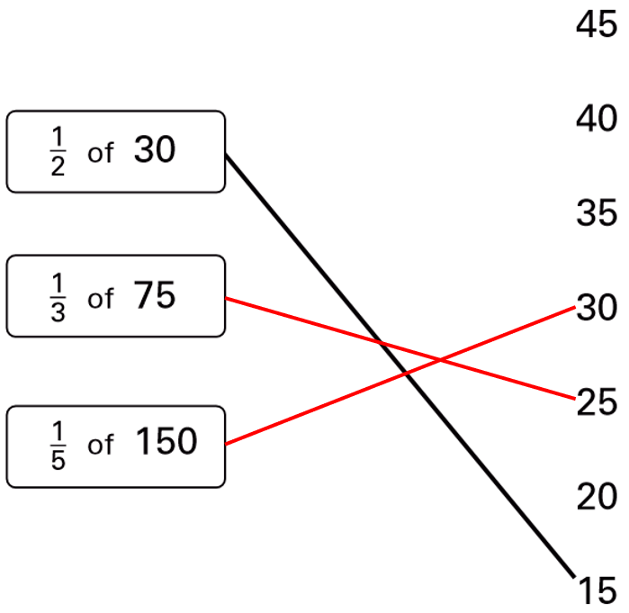
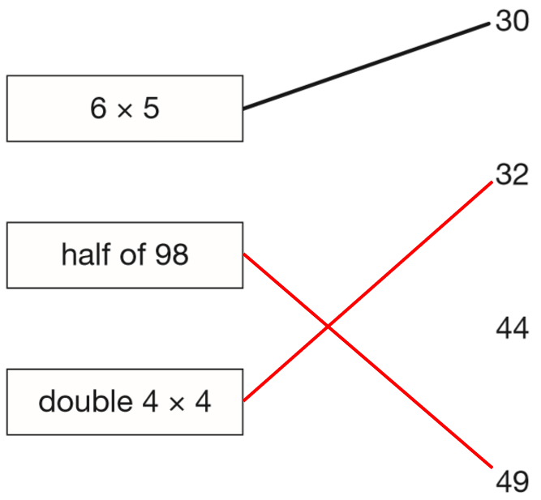 | 150
 | 20
8  Cross  Tick  Cross | Week 6
8  Cross  Tick  Cross | The half price offer is cheaper.  Half of 80p is 40p.  2 packets of 30p pencils cost 60p.  40p is cheaper than 60p.
Identify tenths on number lines and recognise their value
0.6 or $\frac{6}{10}$ | 5.7 or 5$\frac{7}{10}$
8.2, 10.1 | 1.9, 2.8
3.5, 5.4 | 7.2
9.8 | 0.5, 2.4, 4.2, 4.7, 14.9
0.2, $\frac{3}{10}$, 0.6, $\frac{9}{10}$ | 7 m

