
Identify fractions
Here is a square.  What fraction of the square is shaded?  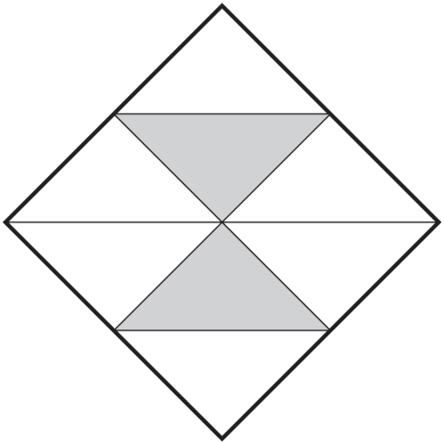 | Here are some shapes.  Tick the shape that has $\frac{3}{4}$ shaded.  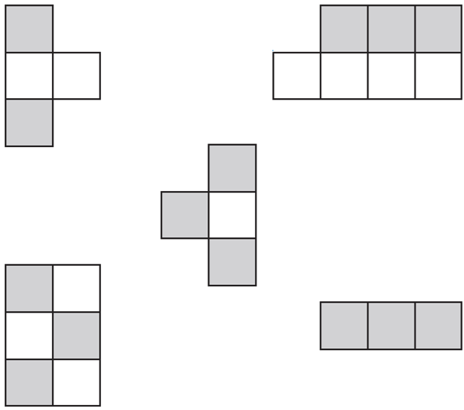
Rosie collects data about birds visiting a bird table. Here are her results.  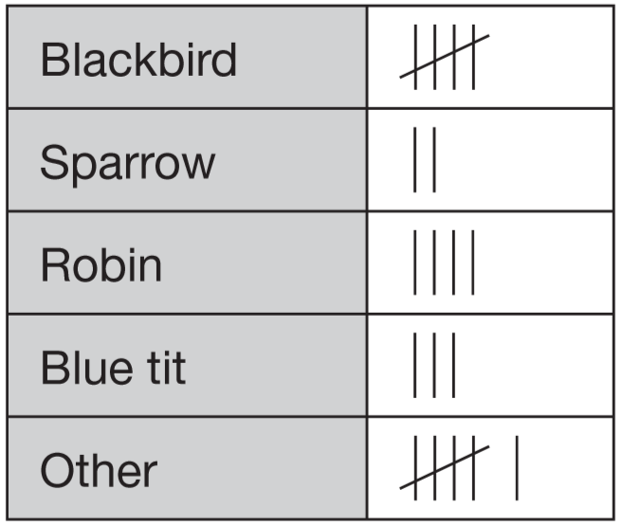  Rosie saw 20 birds altogether.  What fraction of the birds were blackbirds? | What fraction of these tiles are circled?  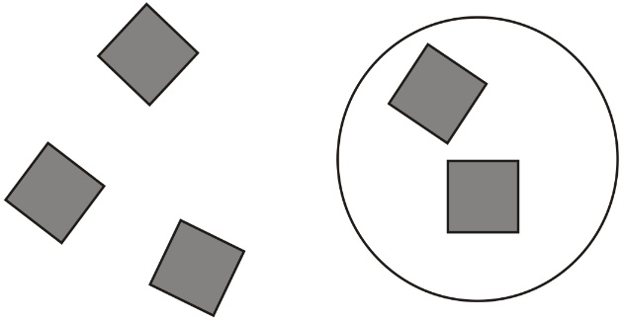
Here is part of a number line.
Write the fraction shown by the arrow.
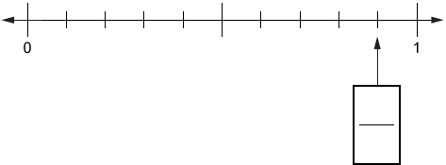

Compare and order fractions
Write these numbers in order, starting with the smallest.  $\frac{5}{7}$ $\frac{2}{7}$ $\frac{6}{7}$ $\frac{3}{7}$  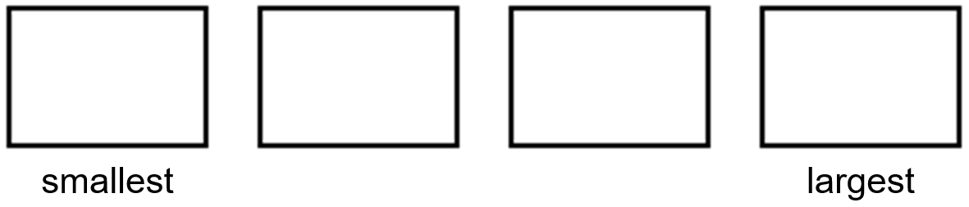 | Write these numbers in order starting with the smallest.  $\frac{1}{2}$ $\frac{1}{4}$ $\frac{1}{8}$ $\frac{1}{5}$
Circle the biggest fraction.  $\frac{1}{6}$ $\frac{1}{4}$ $\frac{1}{3}$ $\frac{1}{5}$ | Circle all the fractions that are bigger than $\frac{1}{5}$.  $\frac{1}{6}$ $\frac{1}{4}$ $\frac{1}{7}$ $\frac{2}{5}$



Recognise fractions that add to 1 whole
Four children share an apple equally.  What fraction of the apple does each child get? | $\frac{3}{8}$of a class are boys. What fraction of the class are girls?
$\frac{5}{7}$of the week had sunny days.  What fraction of the week did not have sunny days? | Sam cuts a pizza into ten equal pieces.  He eats one piece.  What fraction of the pizza does he eat?  What fraction of the pizza is left?
Sam put away $\frac{1}{8}$of the washing.  Ben put away $\frac{2}{8}$of the washing.  Dad put away the rest.  What fraction of the washing did Dad put away? | Ben cuts a pizza into 8 equal pizzas.  Ben eats $\frac{5}{8}$and Sue eats $\frac{1}{8}$of the pizza.  What fraction of the pizza is left?
Annie ate $\frac{1}{8}$of the pizza.  Grace ate $\frac{2}{8}$of the pizza.  Tom ate the rest.  Who ate the most pizza? | Tom ate $\frac{3}{9}$of the chocolates.  Maria ate $\frac{2}{9}$of the chocolates.  What fraction of the chocolates is left?
In a pack of 11 sweets,
- 2 are red
- 5 are blue
- 3 are yellow and
- 1 is green.
What fraction of the pack is blue?

What fraction of the pack is not red?

Find a unit fraction of a number
Here are 21 apples.  Put a ring around one third of them.  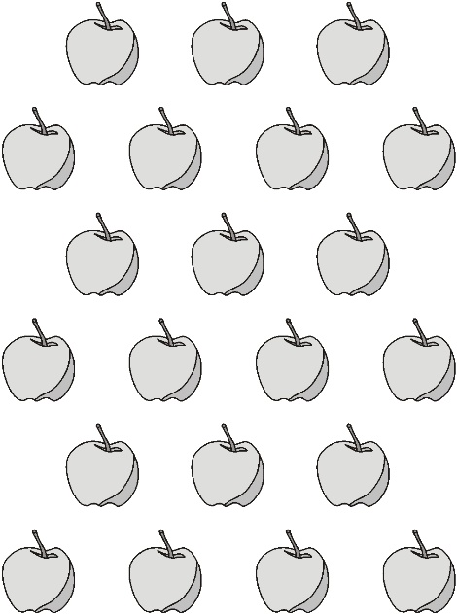 | Sarah has a bag of 24 marbles.  $\frac{1}{3}$of the marbles are red.  How many marbles are red?
Dan’s book has 42 pages.
Dan has read about half the number of pages.
About how many pages could this be?
Circle the number.

10 20 30 40 50

Dev says, ‘When you halve any number that ends in 8 the answer always ends in 4’.  Is he correct? Explain how you know. | Match each box to the correct number.  One has been done for you.  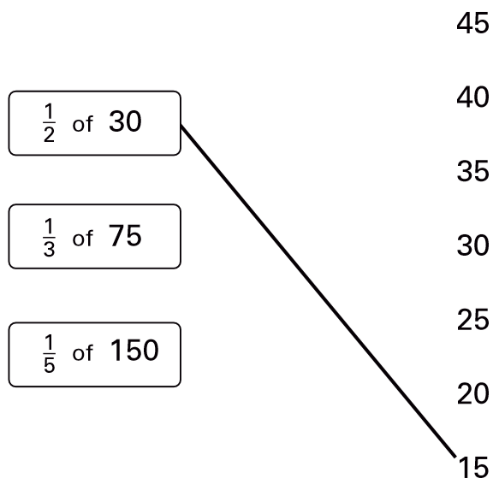
Join each box to the correct number.  One has been done for you.  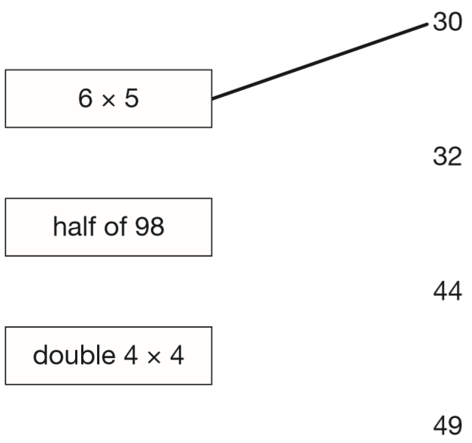 | Mina has 76 marbles in a jar.  The jar is about half full.  Estimate how many marbles Mina will have when the jar is full.  Circle the best estimate.  75 100 125 150 175
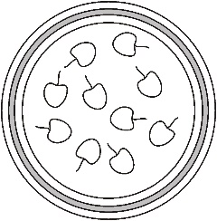
Jack ate half the cherries on the plate.
These are the cherries that were left.

How many cherries were on Jack’s plate before he ate half of them?
60 children visit the zoo.  They each vote for their favourite big cat.  Complete the table.  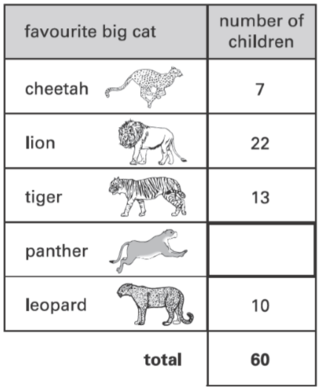  Now look at each sentence below.  Put a tick if it is true.  Nine more children voted for the lion than for the leopard.  The lion was more popular than the tiger.  ¼ of the children voted for the tiger. | Seb saved up for a new skateboard that cost £40  The table shows how much money he saved each week.  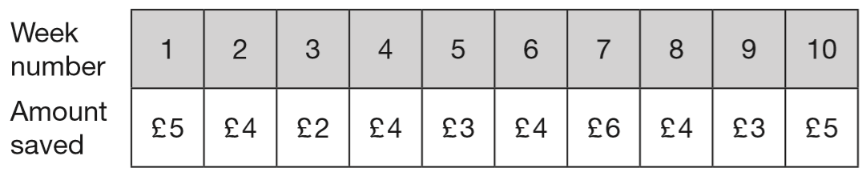  In which week did Seb reach half the amount he needed for the skateboard?
A shop has these special offers.
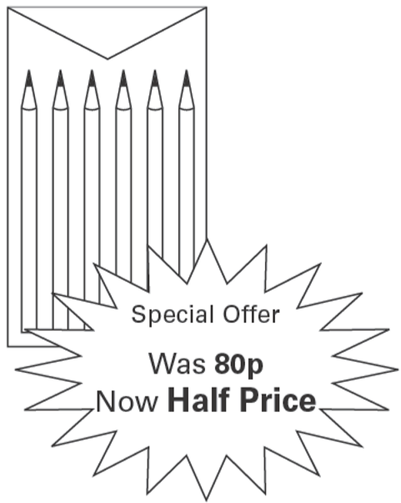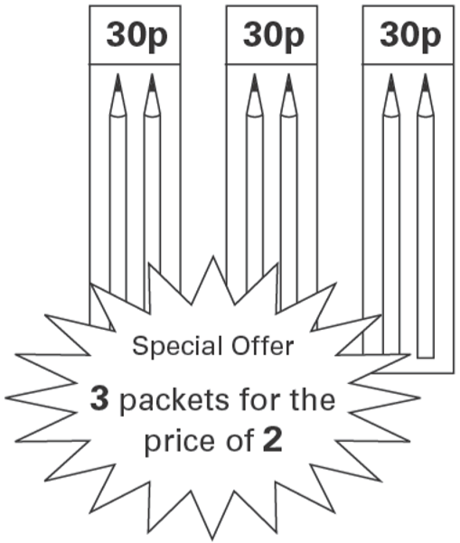
Joe wants to buy 6 pencils.
Which is the cheaper offer?
Explain how you know.

Identify tenths on number lines and recognise their value
Here is part of a number line.  Write in the missing number.  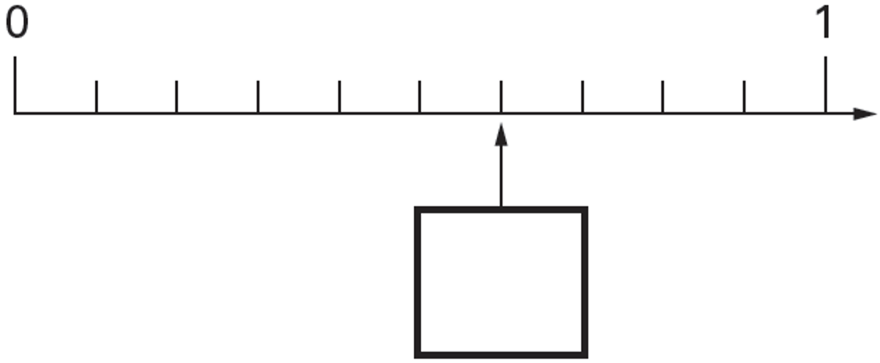 | Here is part of a number line.  Write the missing number in the box.  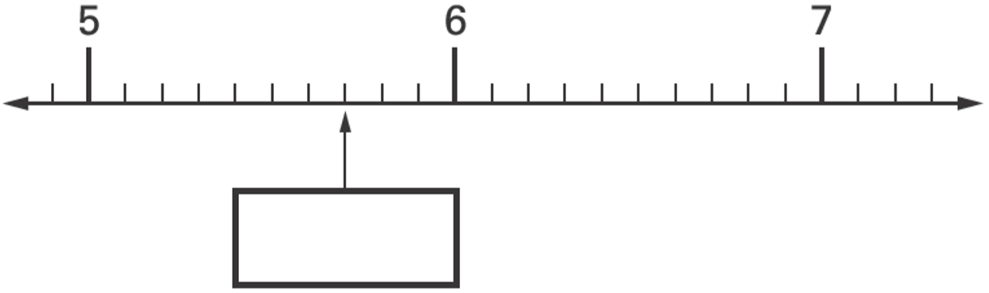
Here is part of a number line.  Write in the numbers missing from the two empty boxes.  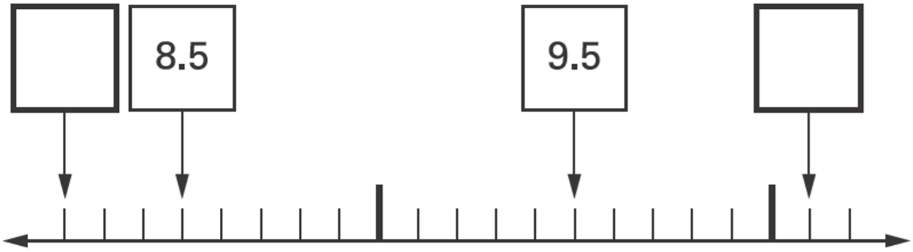 | Write the missing numbers in the boxes.  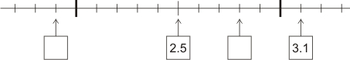
Here is part of a number line.  Write the missing numbers in the two empty boxes.  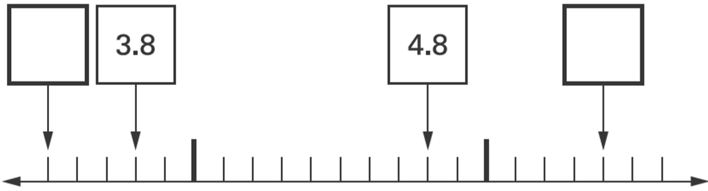 | What number is marked at A?  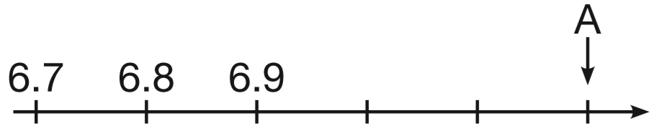
Write in the missing number on this number line.  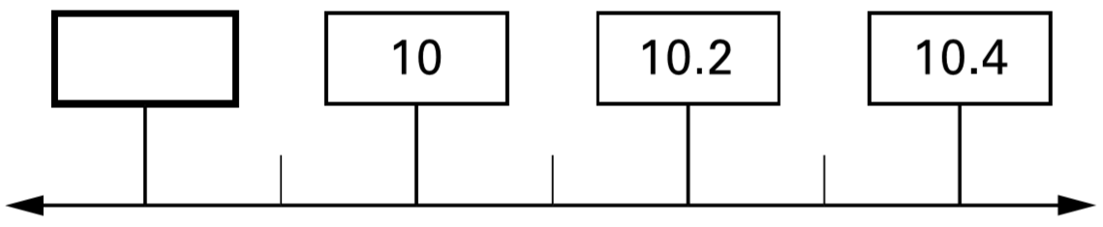 | Arrange these decimals in order of size, with the smallest first.  4.7 14.9 2.4 4.2 0.5  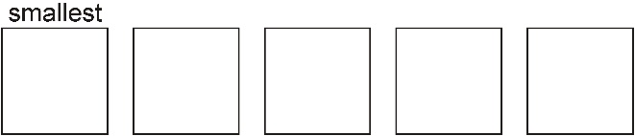
Write these numbers in order, starting with the smallest.  0.6 $\frac{3}{10}$ 0.2 $\frac{9}{10}$ | Mr Patel bought wood to make two shelves.  The first shelf was 2.8 m long.  And other shelf was 3.9 m long.  What is the shortest length of wood Mr Patel has to buy to make the two shelves? Circle the correct answer to the nearest metre.  3 m 4 m 5 m 6 m 7 m 8 m

