
Order amounts of money
Write these prices in order, starting with the smallest.  72p £2.70 £0.27 £7.20 £2.07  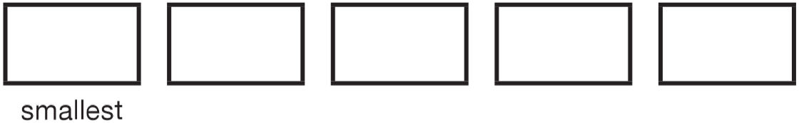 | Write these amounts of money in order of size, starting with the smallest amount.  £5.40 £0.65 72p £10 £2.88  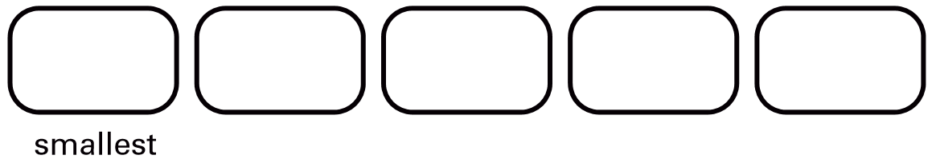
Write these prices in order from smallest to largest.  99p £10.50 £0.75 £9 £2.05  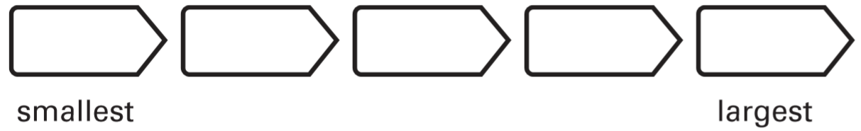 | Write these prices in order, starting with the smallest.  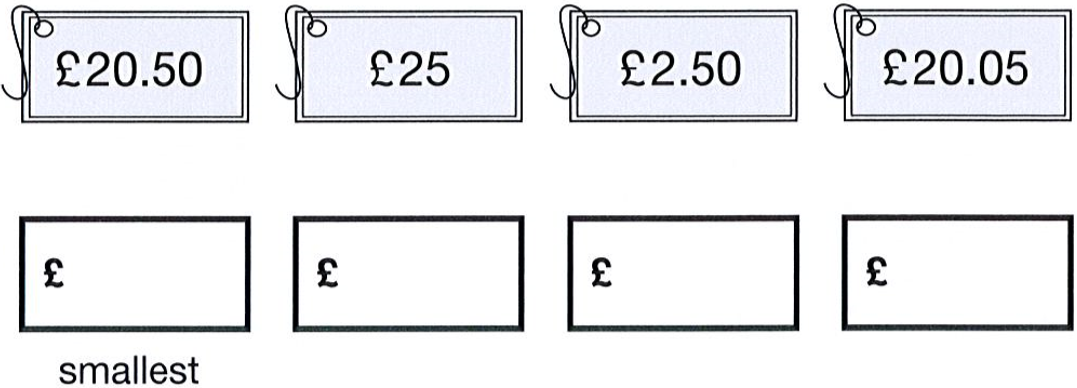
Here are some amounts of money.  Circle all the amounts that can be made with three coins.  71p 72p 73p 74p 75p | Here are some sentences about an amount of money.  Mark each sentence with a tick if it is correct.  Put a cross if it is not correct.  £1.03 can be made with exactly 1 coin.  £1.03 can be made with exactly 2 coins.  £1.03 can be made with exactly 3 coins.  £1.03 can be made with exactly 4 coins.
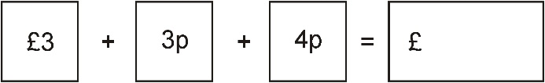
Tim buys a 19p postcard.
He pays exactly 19p with five coins.
What could the five coins be?
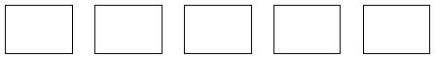

Total the value of given coins
Robin has these coins.  How much money does he have?  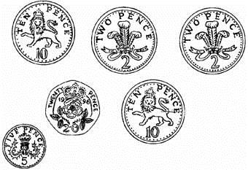 | Make £1.75  Circle each coin you choose.  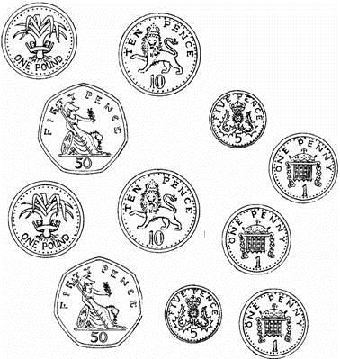
How many 5p coins equal 50p?

Tick the coins you need to make £3.17  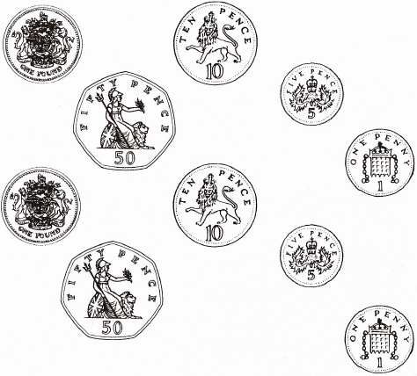 | 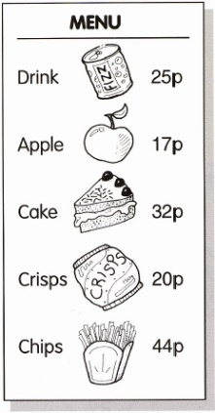  Sally buys crisps and an apple.  Tick the coins she needs.  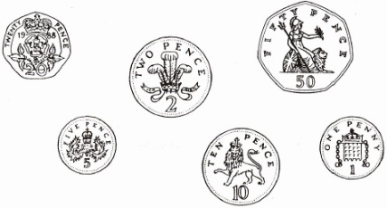

Dan buys a toy that costs 60p.  He pays the 60p with three coins.  Circle three coins that he could use.  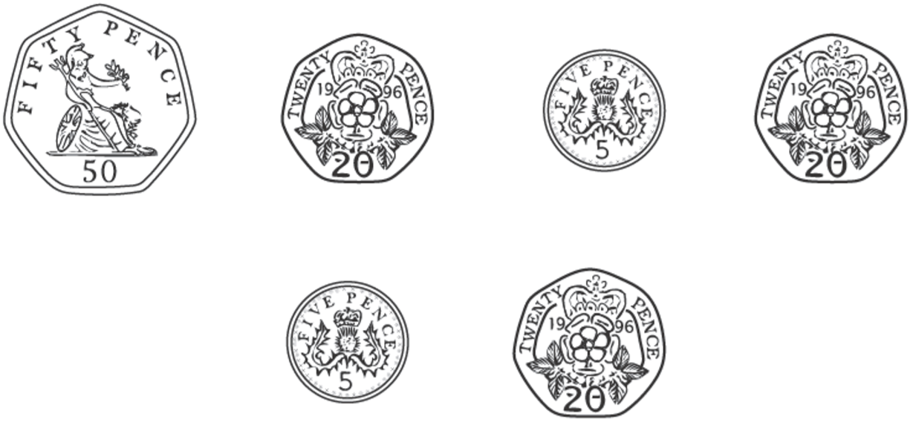 | Reshma has some notes and some coins.  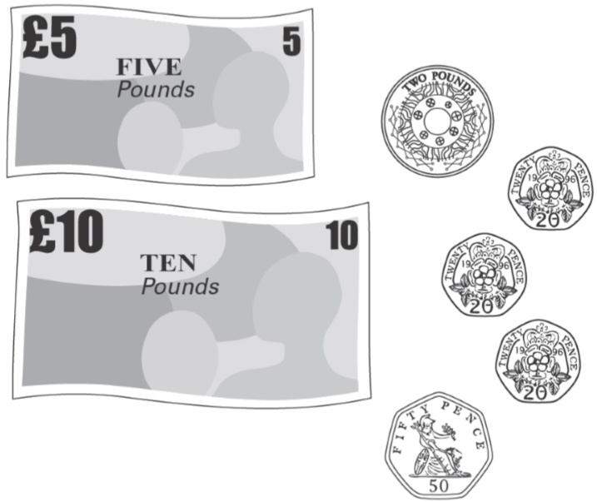  How much money does Reshma have?
Josie has these coins.
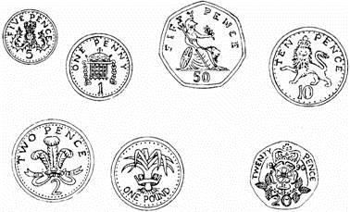
Circle all the amounts she can make using only two coins each time.

61p 52p 20p £1.05 80p

Identify values on simple scales
This scale shows how much Chen weighs.  How much does Chen weigh?  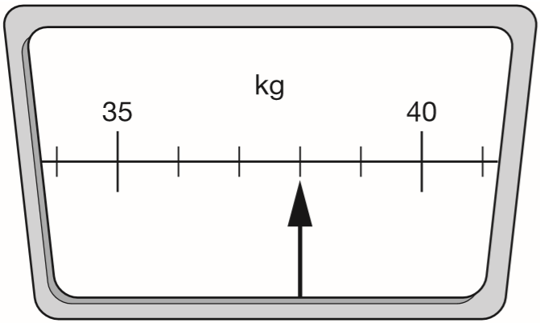 | Vijay weighs 29 kilograms.  Sarah weighs 8 kilograms more than Vijay.  Draw an arrow on the scale to show how much Sarah weighs.  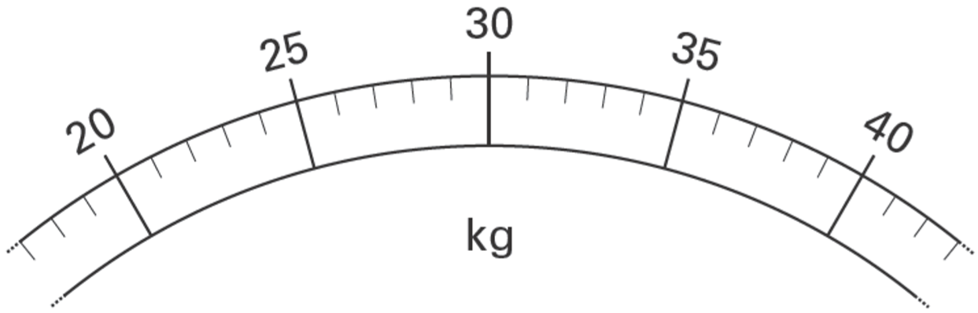
Here is a scale which shows the weight of a letter. How much does the letter weigh?  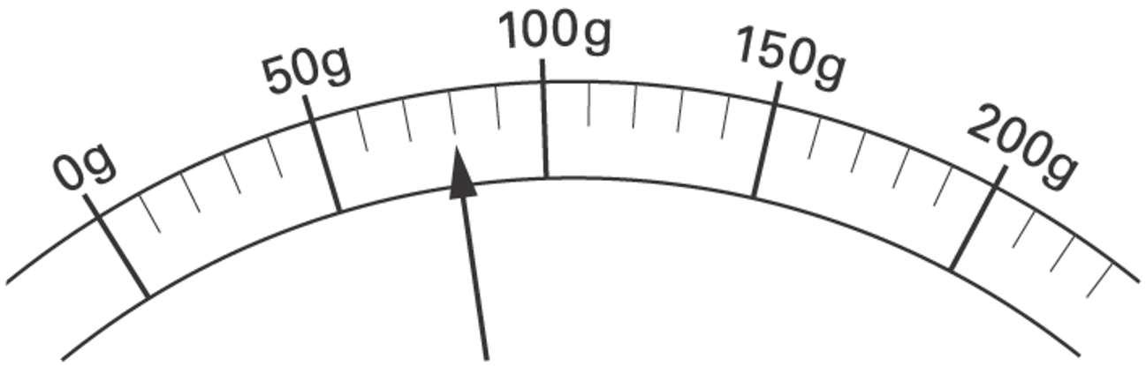 | The scale shows how much Mrs Patel weighs.  How much does Mrs Patel weigh?  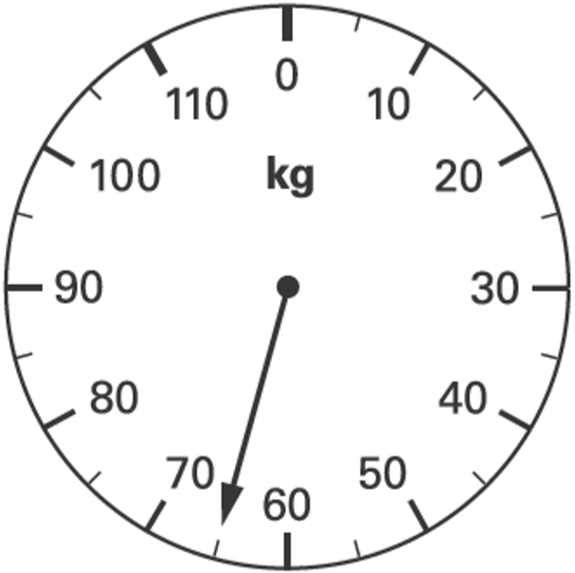

Estimate or identify values on number lines
Write the missing number which is halfway between these two numbers.  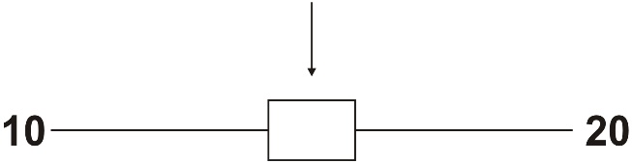 | Work out the number halfway between 26 and 48  Write it in the box.  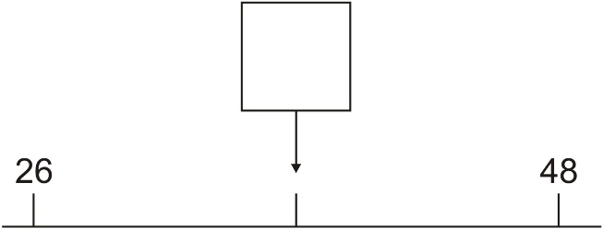
Here is part of a number line.  Write the number shown by the arrow.  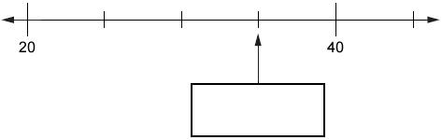 | Here is a number line.  Estimate the number marked by the arrow.  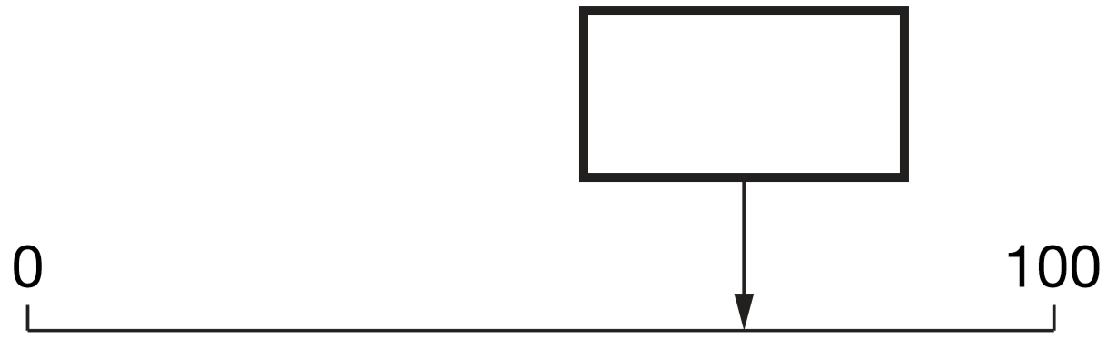

Tell the time to the nearest 5 minutes
The clock shows the same time as one of the watches.  Draw a line to match the clock to a watch.  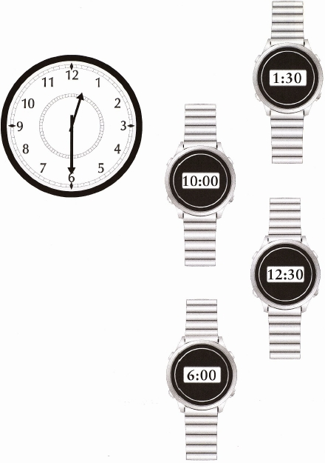 | Two clocks show the same time. Tick them.  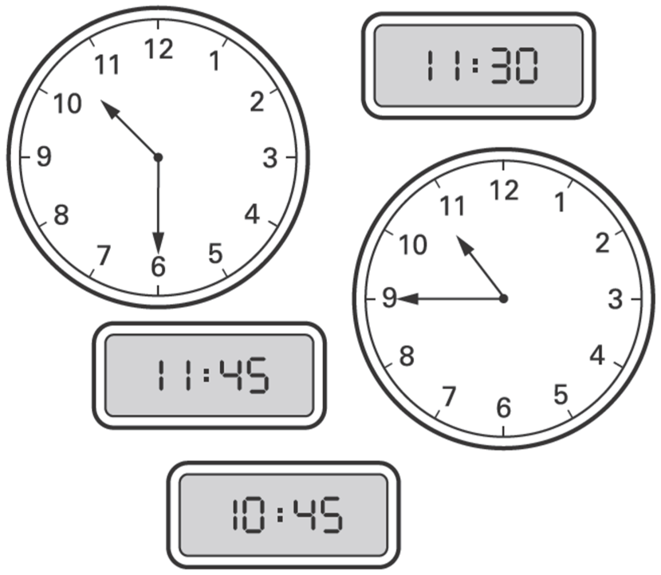

Here are three clock faces.  Match each clock face to the same time on a digital clock.  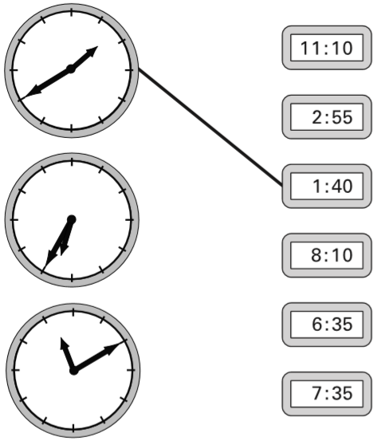 | Here are two clock faces.  Join each clock face to the correct digital time.  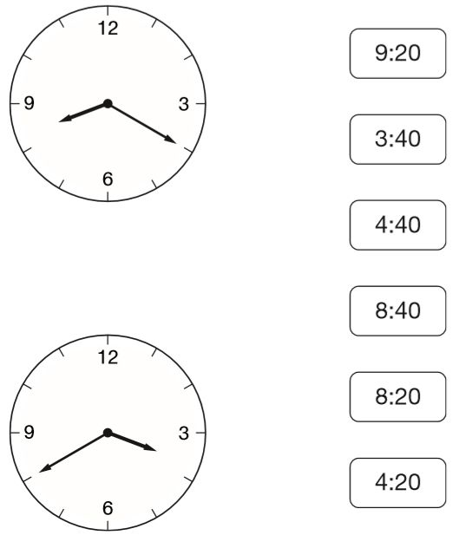
Match each clock to the correct time.  One has been done for you.  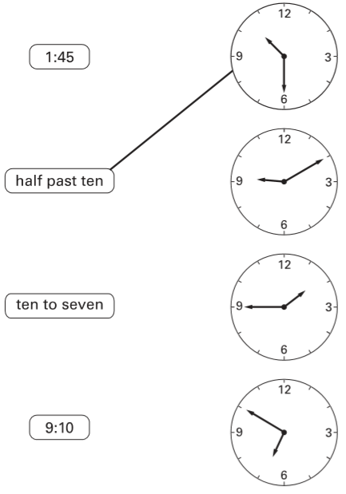 | Grace says, ‘On my clock face, the big hand is on the 4 and the little hand is between the 8 and the 9’  What is the time on Grace’s clock face?

Compare and order times
Jodie has to be at the dentist at half past nine.  How many minutes early is she?  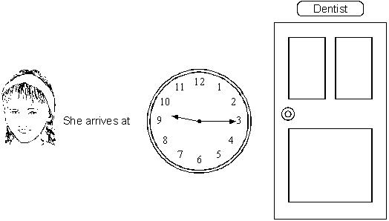 | Circle the time that is 30 minutes before midnight.  12:30am 12:30pm 11:30am  11:30pm 3am
These clocks show the start and finish times of a TV programme.  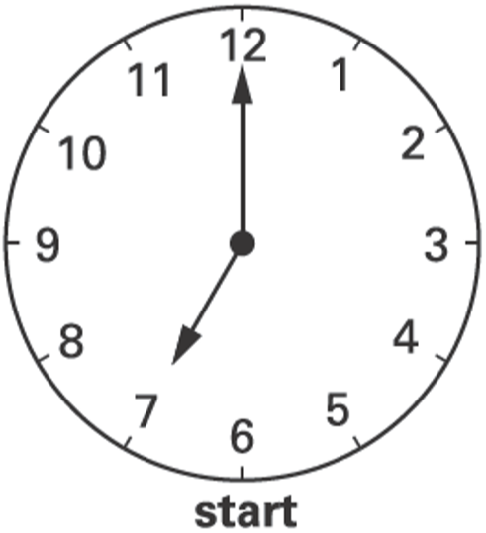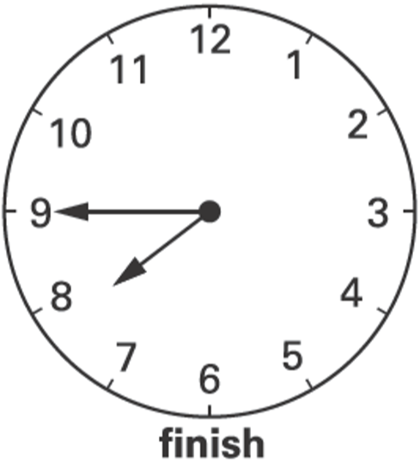  For how many minutes does the programme last? | The time is 10:35am.  Kate says, ‘The time is closer to 11:00am than to 10:00am.’  Explain why Kate is correct.
Liam hires a bike.  He has to return it by 3 pm.  The time is 2:25pm.  How many minutes has he got left? | Raj put the cake in the oven at 4:00pm.  He took the cake out of the oven after 1 ½ hours.  At what time did he take the cake out of the oven?
The time is 8:15  John has to be ready for school in half an hour.  Tick the time when he has to be ready.  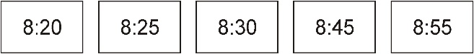 | Put these times in order, starting with the shortest.  5 minutes 20 seconds 1 minute 100 seconds  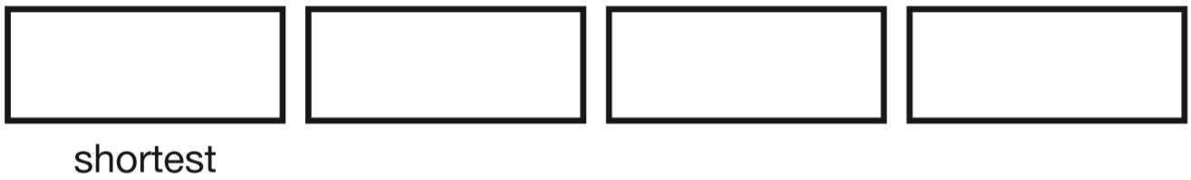
Dan and Ben ran in a race.
Dan took 25 seconds.
Ben was 3 seconds faster.
How many seconds did Ben take?

Tell the time on a 24-hour clock
2016 Paper 3 Question 3  A clock shows this time twice a day.  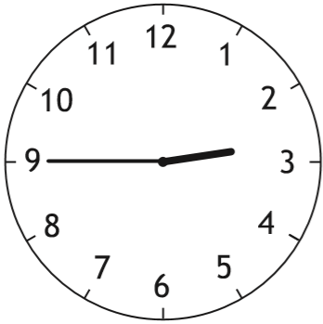  Tick the two digital clocks that show this time.  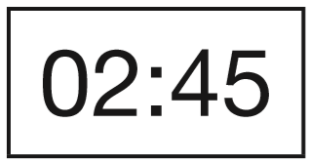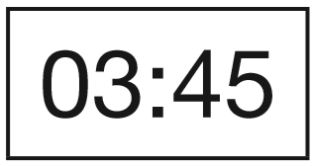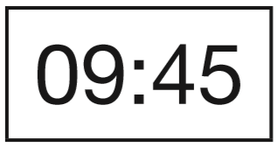  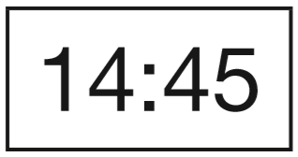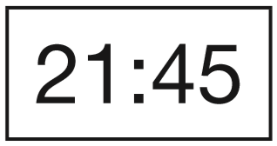 | Match all the times to the correct time of day.  One is done for you.  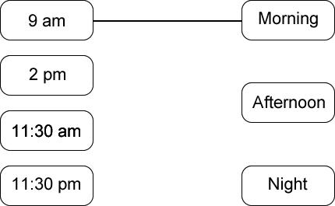
Annie finishes school at ten past 3 in the afternoon.
Circle the 24 hour clock that shows ten past 3 in the afternoon.

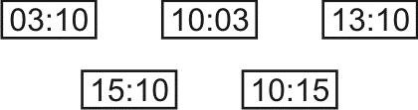
Ben went to cubs at 7pm.  He finished one hour later.  What time did he finish?  Give your answer using digital 24 hour clock time. | Complete the table.  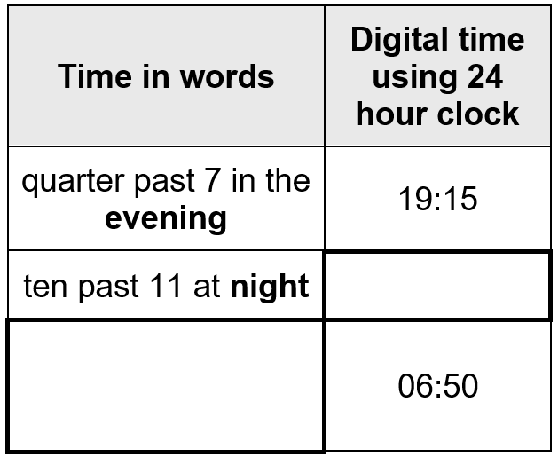
Ben goes to bed at 7:15 pm.
Grace goes to bed an hour later.
What time does Grace go to bed?
Give your answer using 24 hour clock.

Describe position and direction
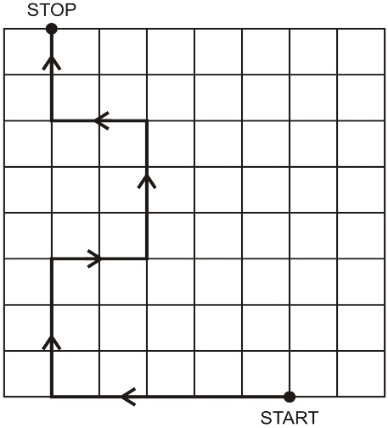
Follow this route with your pencil.
Complete this chart showing the route from START to STOP.
