
Identify information in tables or diagrams
Megan likes honey, but not jam.  Alfie likes honey and jam.  Chen does not like honey or jam.  Donna only likes jam.  Write the children’s names in the correct parts of the sorting diagram.  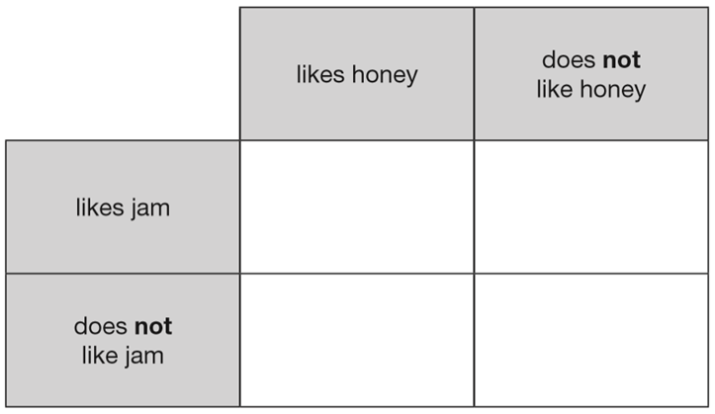 | Jade says, ‘I am 9 years old. My birthday is in July.’  Lauren says, ‘I am 2 years younger than Jade. My birthday is in January.’  Write Jade and Lauren in the correct places on this sorting diagram.  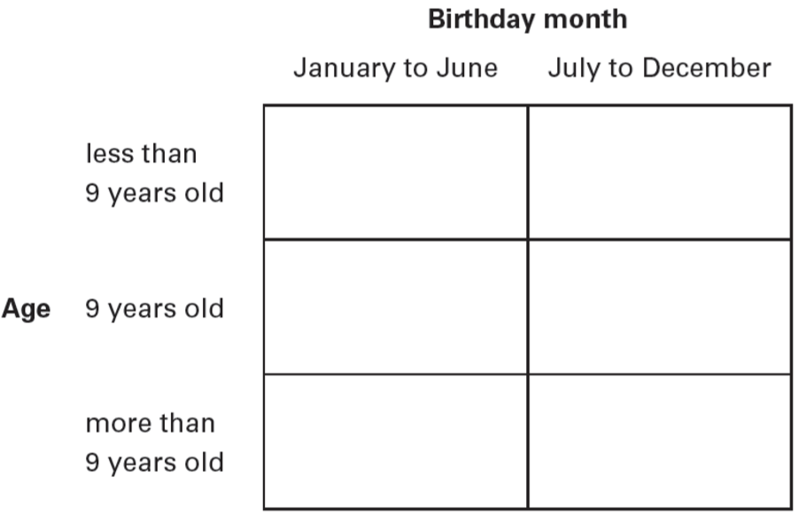
Peter and Stella compare colours they like and do not like. Here is a sorting diagram that shows their results.  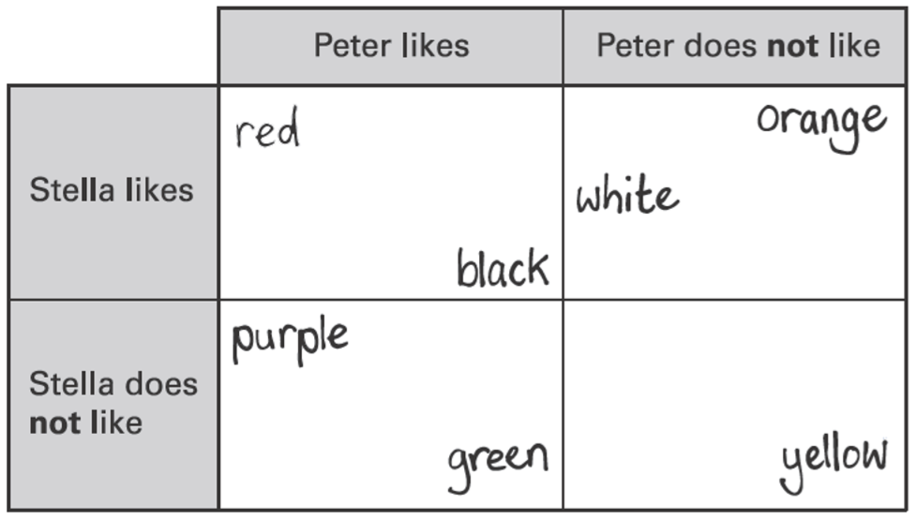  Write the two colours that Stella likes but Peter does not like.  Peter likes the colour blue but Stella does not. Write blue in the correct place on the sorting diagram. | Write each letter in the correct place on the diagram.  One has been done for you.  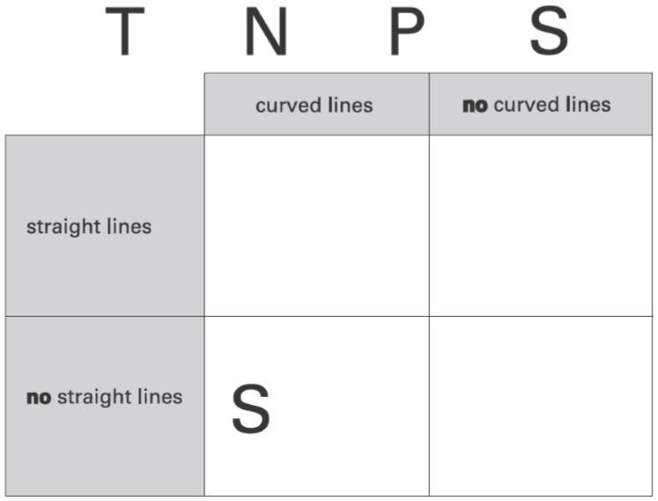
This table shows six different types of cat and where they are found.  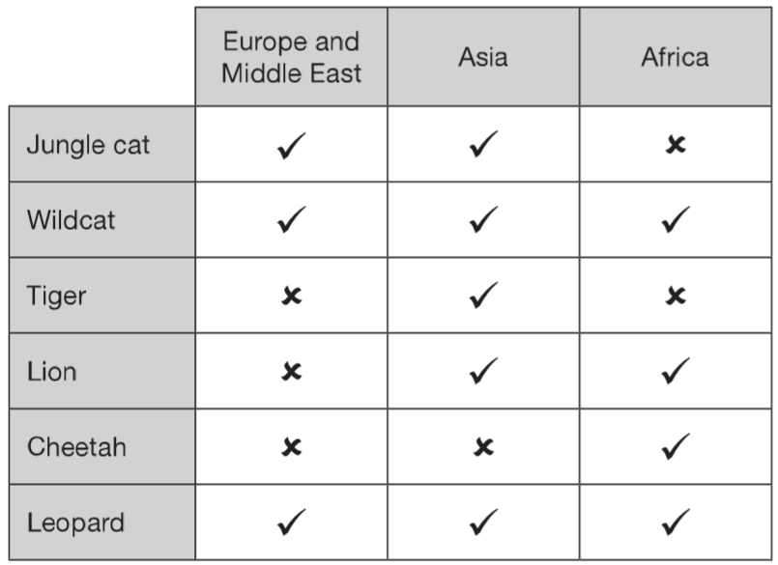  Which type of cat is found only in Africa?  Which types of cat are found in all three parts of the world? | This chart shows the musical instruments some children play.  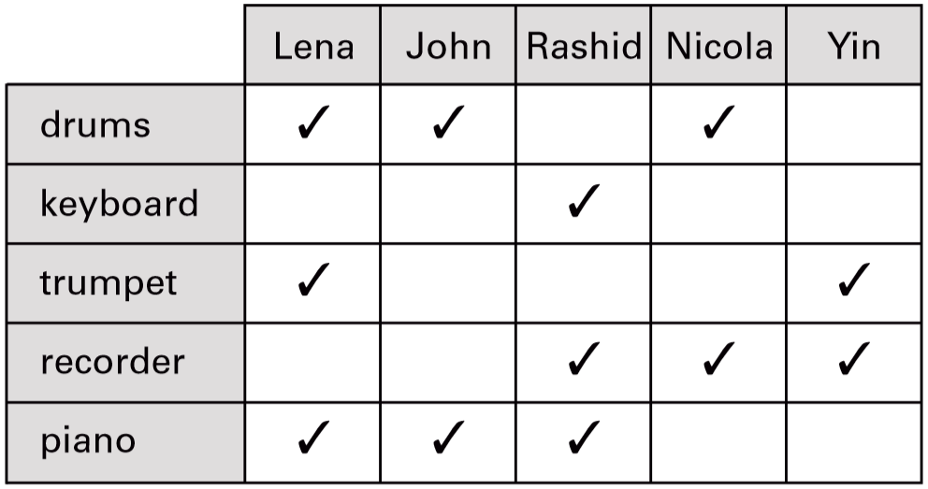  Who plays both recorder and drums?  How many children play more than two musical instruments?



Five children have ticked this table to show on which days they are free to go out.  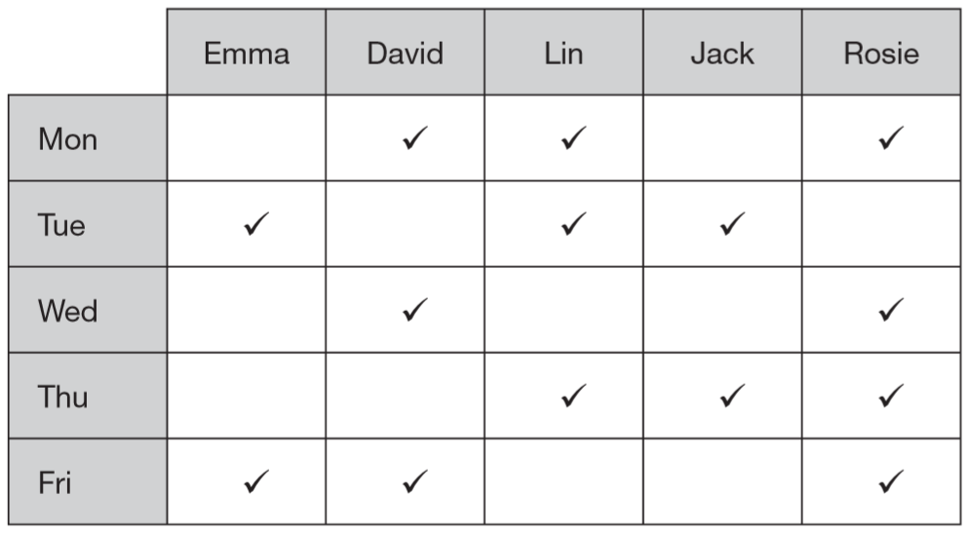  On how many days are more than two children free to go out?  On which days are Lin and Rosie both free to go out together? | Colour of cars we saw  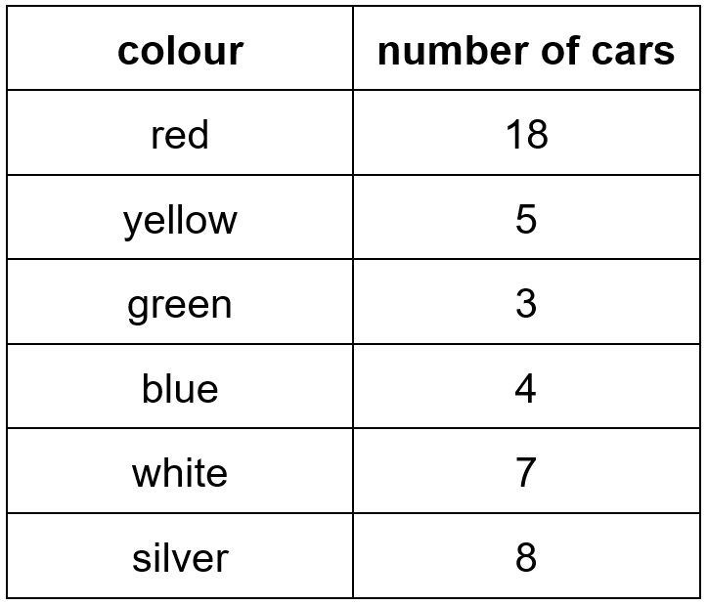  What colour was the second highest number of cars?  Which two colours of cars were seen the least?
The table shows the number of shirts in a shop.  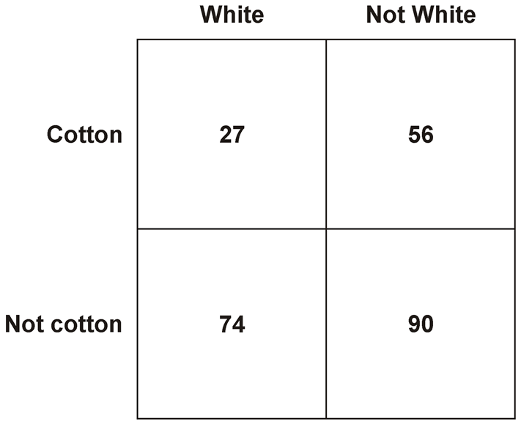  How many shirts are white?  How many shirts are there altogether? | This table shows the increase in bus fares.  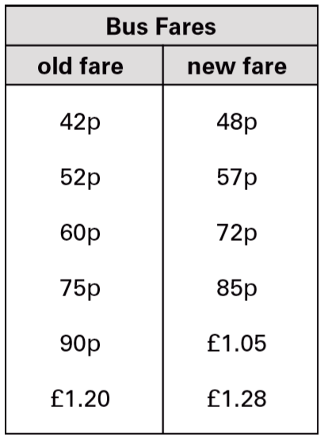  Sohan’s new bus fare is 72p.  How much has his bus fare gone up?  Millie says, ‘My bus fare has gone up by 10p.’  How much is Millie’s new bus fare?
A school has sports day.
The winner of each event scores 10 points.
This chart shows the points scored by each team.
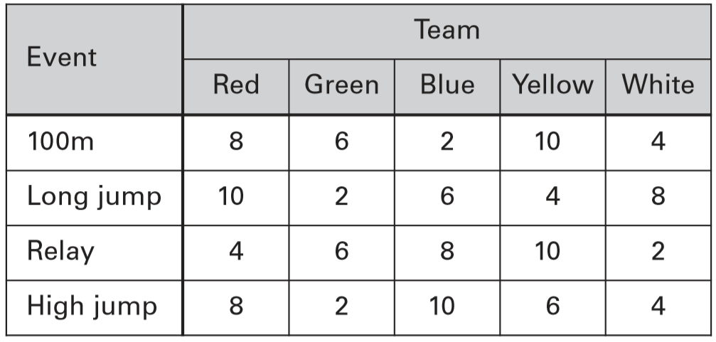
How many events did the Yellow team win?

Which team came second in the relay?

Identify information from pictograms
This pictogram shows the number of ice creams a shop sold in one day.  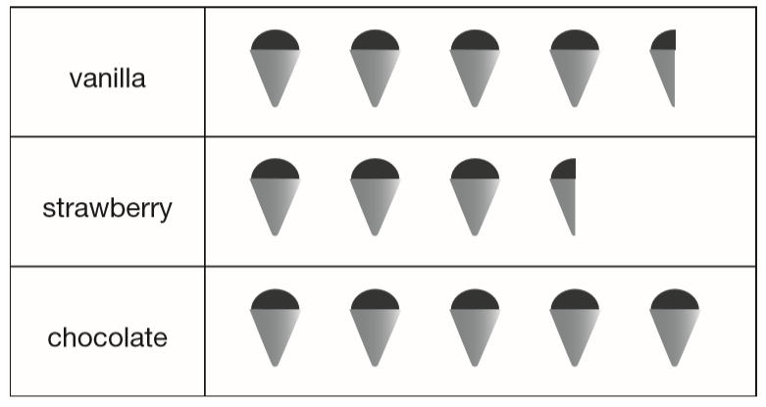  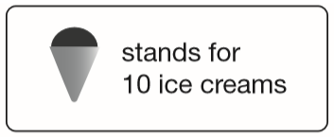  How many more chocolate than strawberry ice creams were sold?  How many ice creams were sold altogether? | A shop sold 10 ice lollies on Wednesday.  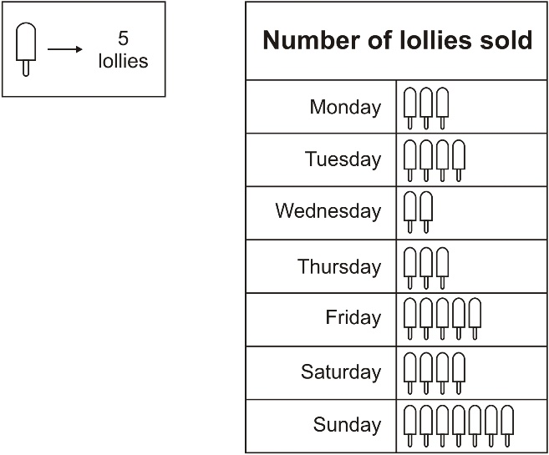  How many lollies were sold on Monday?  How many more lollies were sold on Tuesday than on Wednesday?
Class survey of favourite fruit drinks  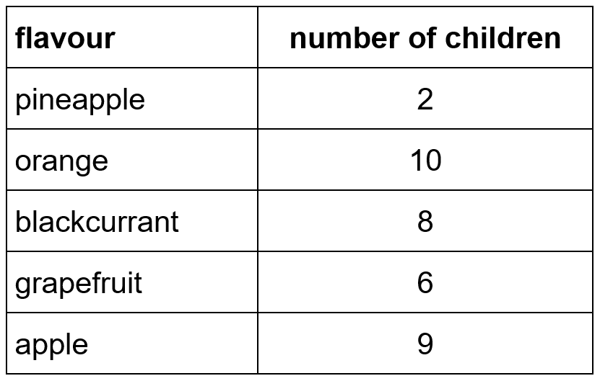  Complete the pictogram for the class.  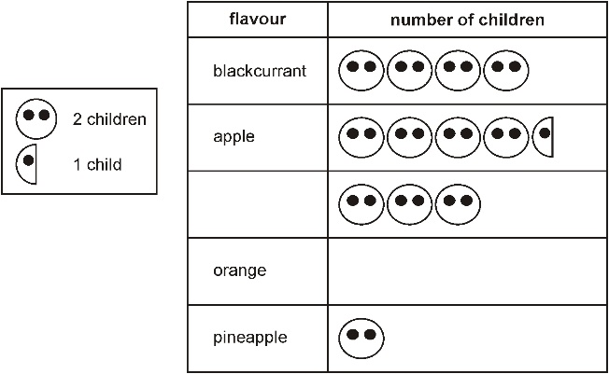  How many children altogether chose the three most popular flavours? | A shop sells different kinds of greeting cards.  This pictogram shows how many they sold in a week.  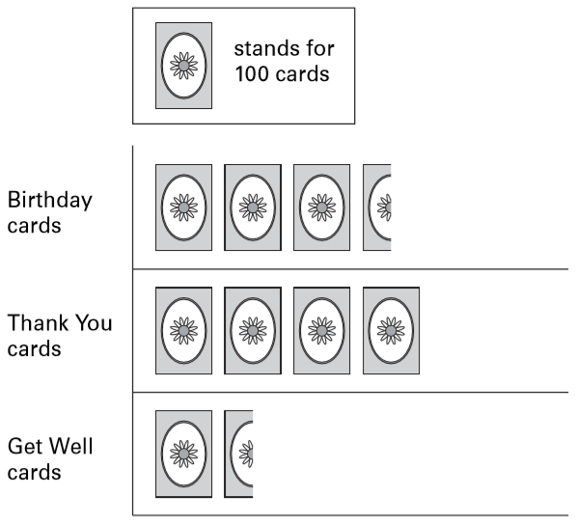  Estimate how many Birthday cards were sold.  Estimate how many more Thank You cards than Get Well cards were sold.

Plot information on bar charts
Alfie collected information about the pets owned by children in his class.  Here are his results.  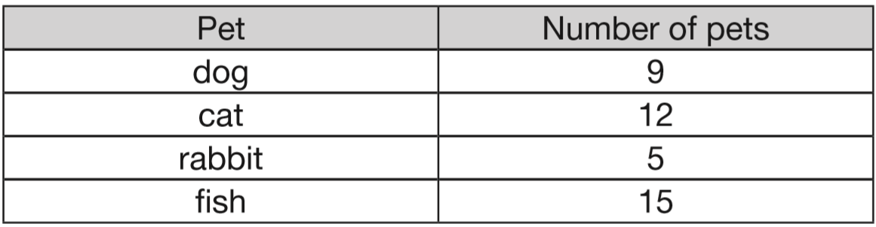  This bar chart shows the information from the table. Fill in all the missing labels.  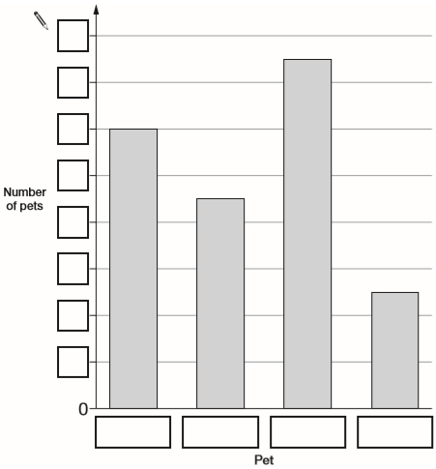 | Robbie collected information about the colours of some bikes. Here are his results.  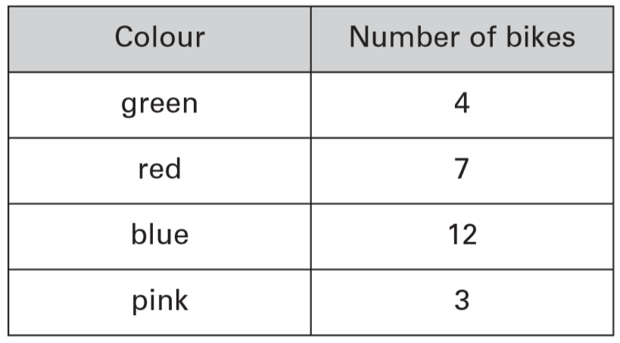  This bar graph shows the information from the table. Fill in all the missing labels.  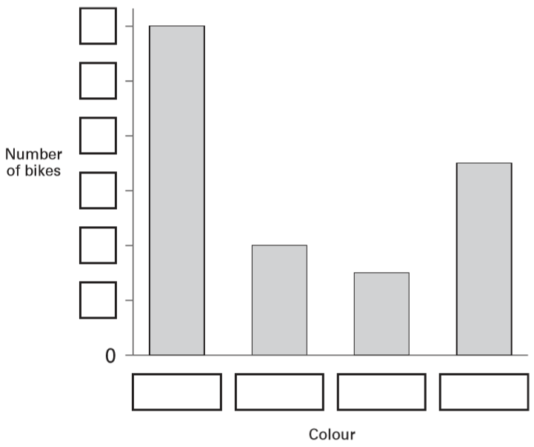
Some children in Class 4 are in a club.  This table shows the club they are in.  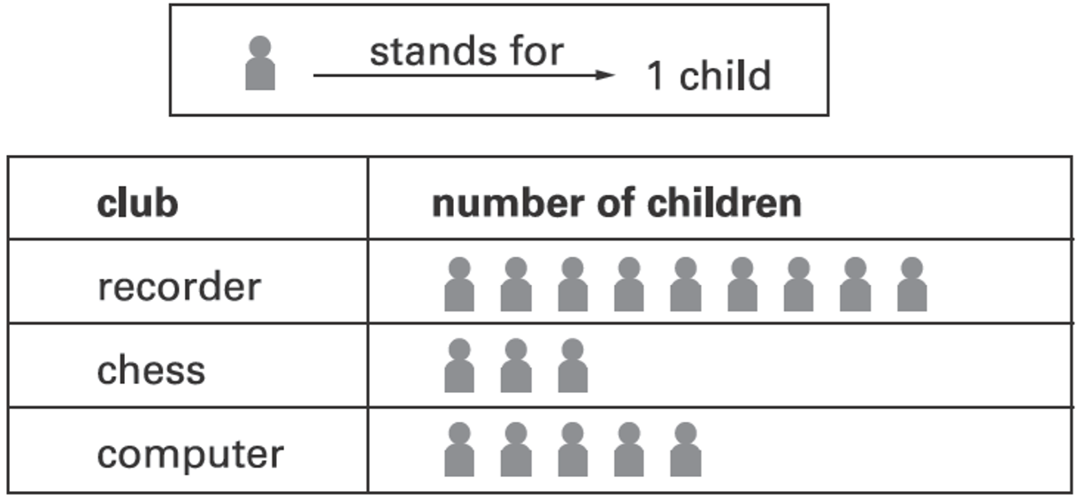  How many more children go to recorder than chess?  This graph should show the same data as the table. Shade in the correct number of blocks for computer club.  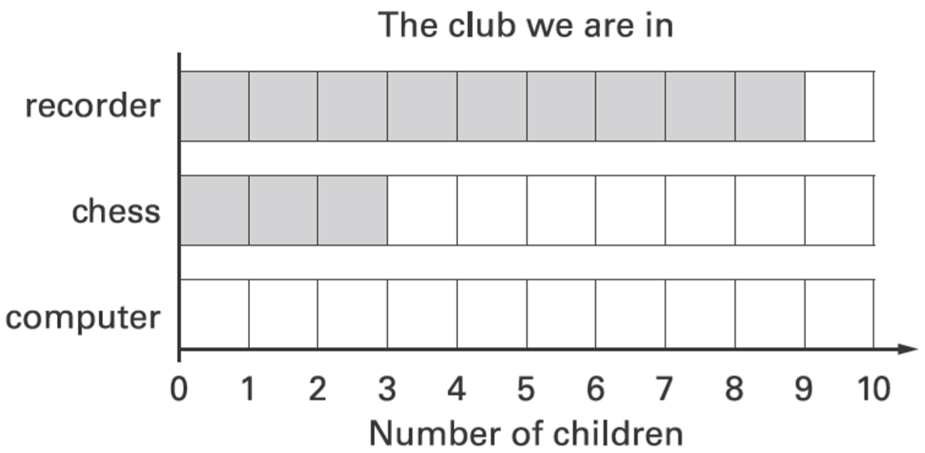 | Rosie collects data about birds visiting a bird table. Here are her results.  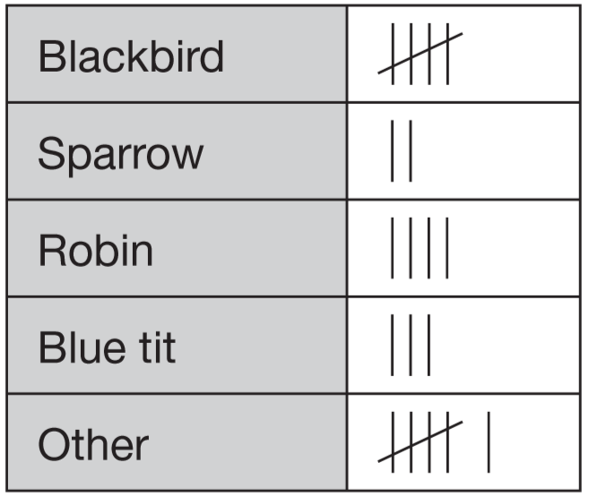  Draw two more lines to complete the graph.  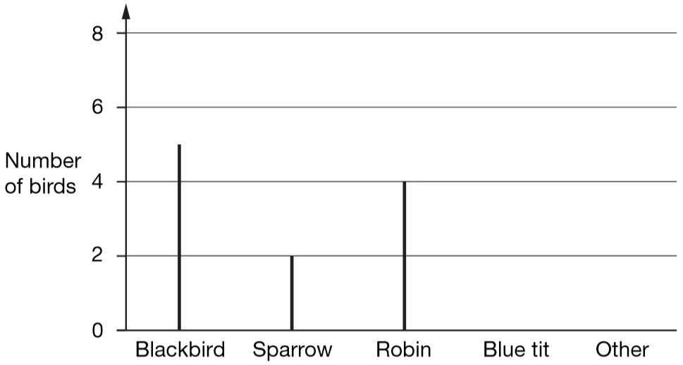

Some children drew this graph.  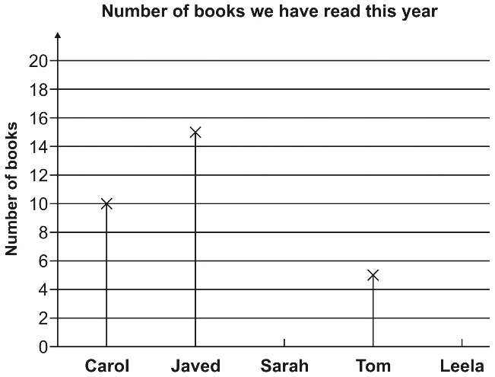  Sarah has read 12 books and Leela 9 books.  Show these on the graph.  Javed has read more books than Tom.  How many more? | This is a list of the highest temperatures each day for one week.  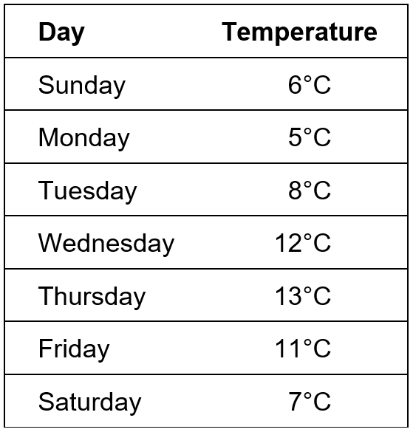  How many degrees warmer was it on the hottest day than on the coldest day?  Here is a chart of the temperatures. Saturday is missing. Draw in the bar for Saturday.  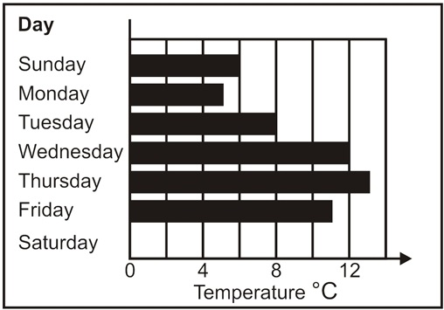
Five children made a graph.
Hazel is 135 cm tall. Show this on the graph.
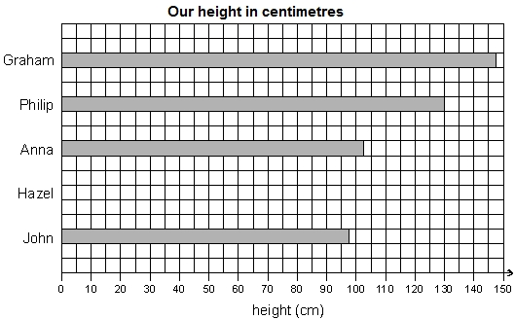

Identify information from simple bar charts
Four children made a graph of their heights.  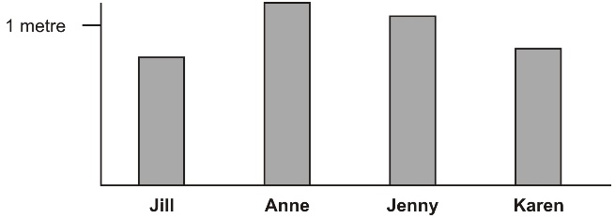  Write their names on the labels.  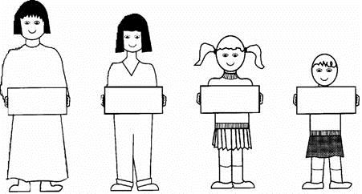 | The children in Vijay’s class vote for their favourite day out. Here are their results.  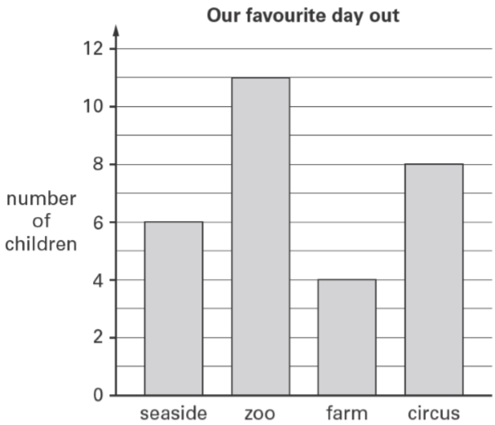  How many children voted for the zoo?
This graph shows the number of books some children read.  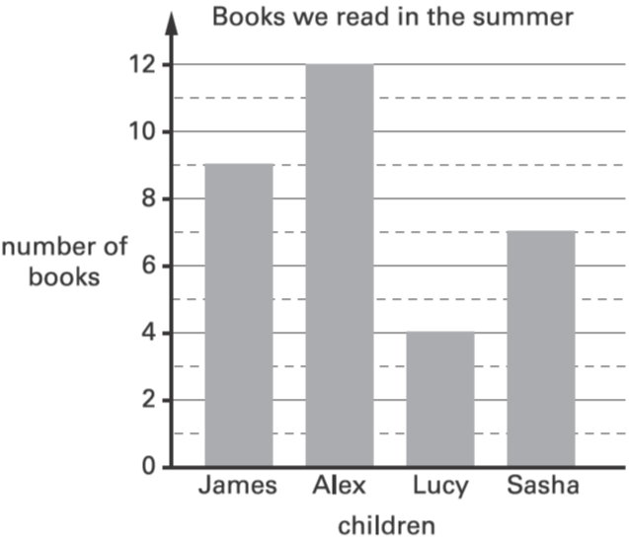  How many more books did James read than Lucy?  Which two children read between 5 and 10 books? | Tom does a survey of children’s favourite breakfast cereals.  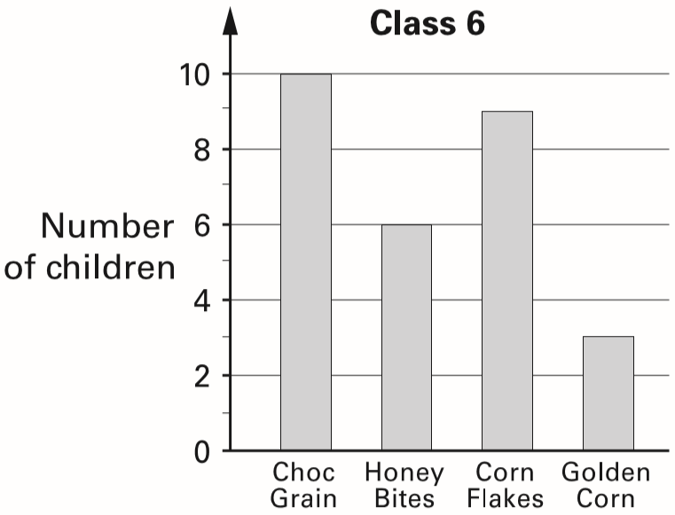  These are the results for Class 6  How many more children in Class 6 prefer Choc Grain than Golden Corn?  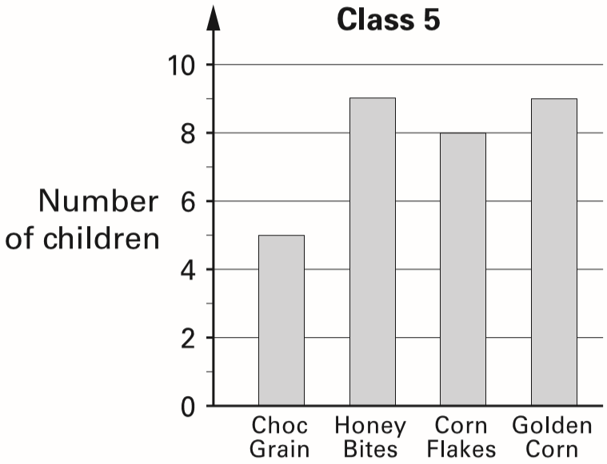  These are the results for Class 5  How many children in both classes like Honey Bites best?
Class 6 did a survey of their favourite types of story book. Here are their results.
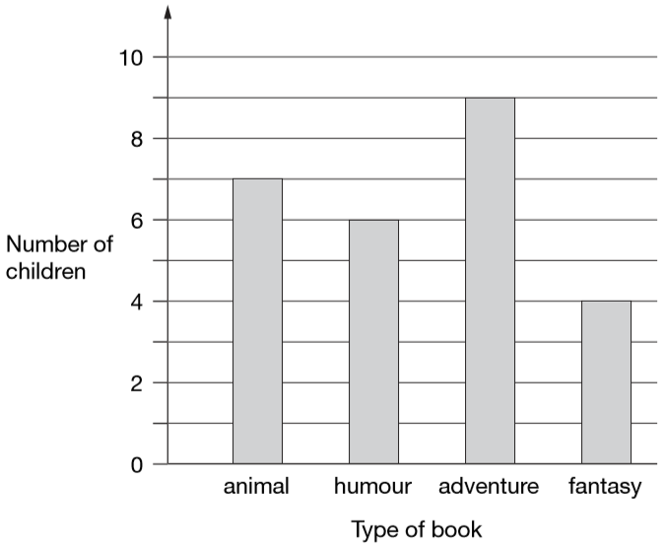
How many more children chose adventure books than fantasy books?

Five girls chose animal books.
How many boys chose animal books?

Identify information from bar charts
Five children collect money to plant trees.  Here is a bar chart of the amounts they have raised so far.  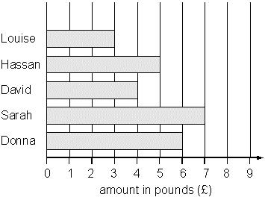  Their target is £40 altogether.  How much more money do they need to reach the target? | 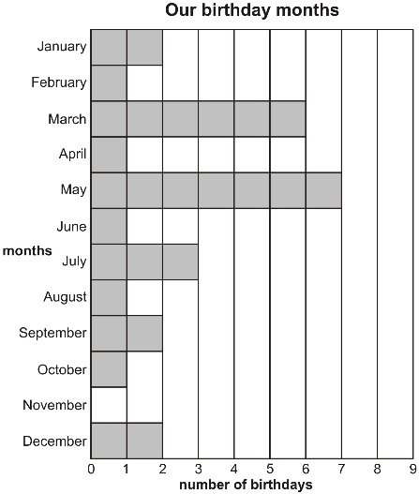  Some children made a graph.  In which months are there more than five birthdays?  How many children were born from July to December?
Here is a table of the number of stamps used each day in school.  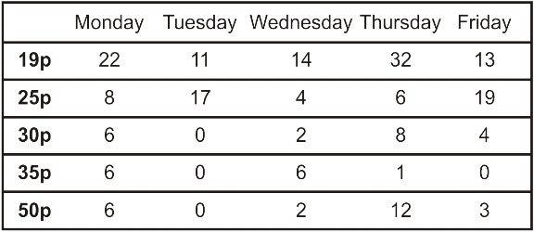  How many 25p stamps did the school use on Wednesday?  This is a graph of one kind of stamp they used. Which stamp is it?  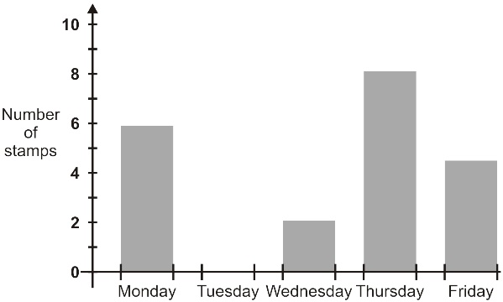 | This graph shows the distance some children walk to school.  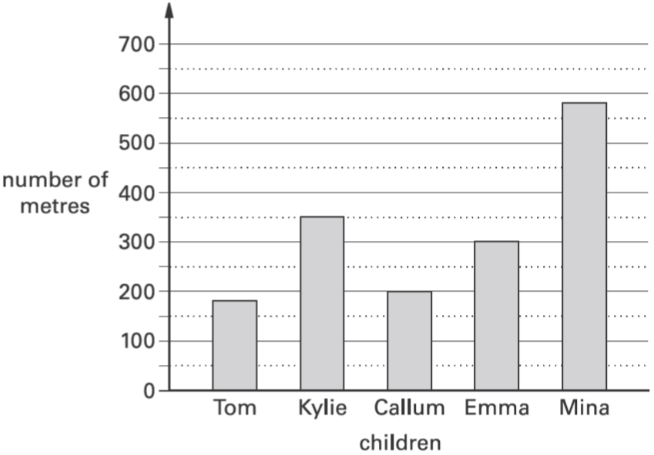  Who walks between 300 and 400 metres to school?
There are five entry gates at an open air concert. This bar chart shows how many people went through each gate.  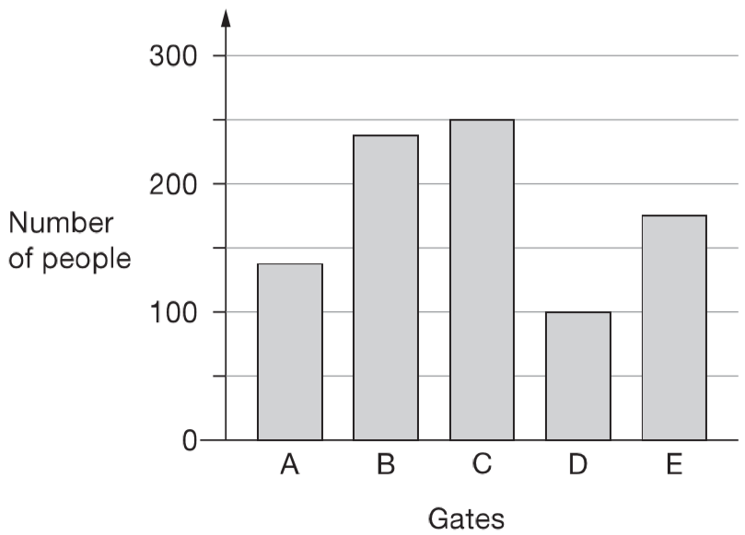  How many more people went through gate C than gate D?  How many gates had fewer than 150 people go through? | 2017 Paper 2 Question 1  William asks the children in Year 2 and Year 6 if they walk to school. This graph shows the results.  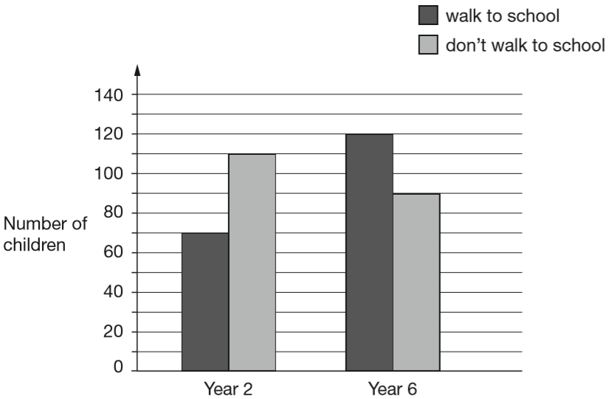  Altogether, how many children don’t walk to school?  How many more Year 6 children than Year 2 children walk to school?

