
Recognise place value in four-digit numbers
Which number below is four thousand and seven? Put a ring round it.  47 407 4,007 40,007 400,007 | In the number 4,378, the ﬁgure 7 represents 7 tens.  What does the ﬁgure 3 represent?  What does the ﬁgure 4 represent?
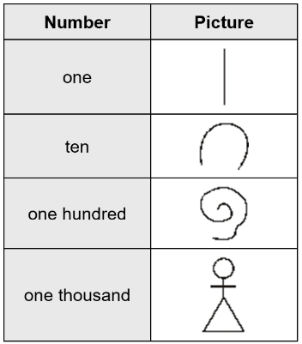  The ancient Egyptians used pictures to show numbers.  The table gives some of these pictures.  Write in figures the number that each picture below is showing.  The first one is done for you.  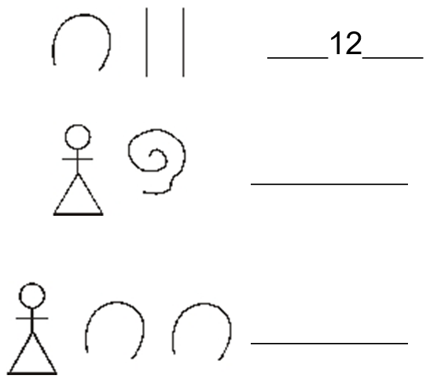 | 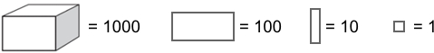  Write the value of each diagram.  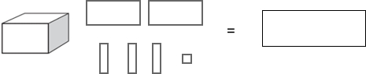  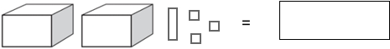
Look at these digits.
5 0 8 2
Make the largest number possible with the digits. Write your number in words.

2018 Paper 3 Question 3  Here are four number cards.  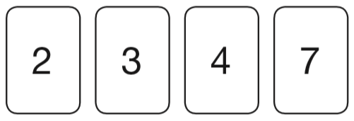  Layla uses each card once to make a four-digit number. She places:  • 4 in the tens column  • 2 so that it has a higher value than any of the other digits  • the remaining two digits so that 7 has the higher value.  Write a digit in each box to show Layla’s number.  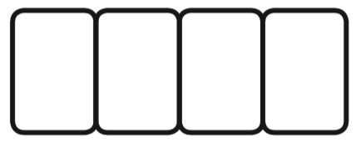 | Here are some number cards:  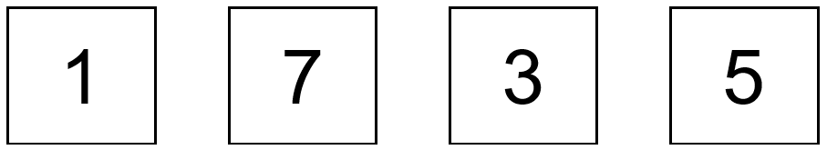  You can use each card once to make the number 1,735, like this:  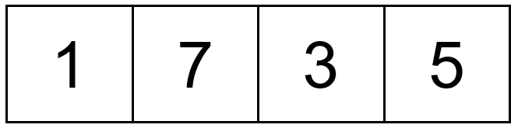  What is the biggest number you can make with the four cards?    Explain why you cannot make an even number with the four cards.
Look at these digits.  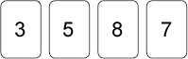  Use the digits to make the largest possible even number. Use each digit once. | Write the number that is nearest to 5000 which uses all the digits 4, 5, 6 and 7  

Here are some number cards:  Use some of the four number cards to make numbers that are as close as possible to the numbers written below.  Examples:  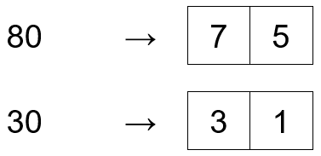  You must not use the same card more than once in each answer.  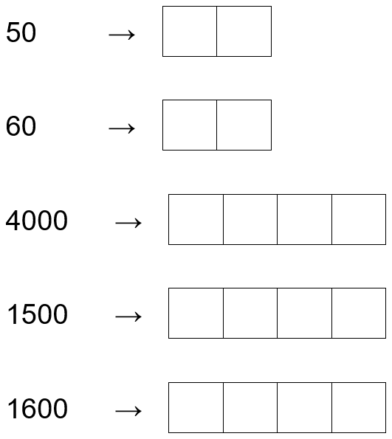 | Here are some number cards:  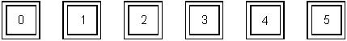  Joan picked these three cards:  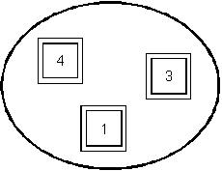  She made the number 314 with her cards.  Make a smaller number with Joan’s three cards.  Make the biggest number you can with Joan’s three cards.    Which extra card should Joan pick to make her number 10 times as big?
Here is a list of numbers.
1140 1400 1440 1040 1410
Complete these sentences.

The smallest number in the list is _______

The largest number in the list is _______

Write these numbers in order of size, starting with the smallest.  901 1091 910 109 190  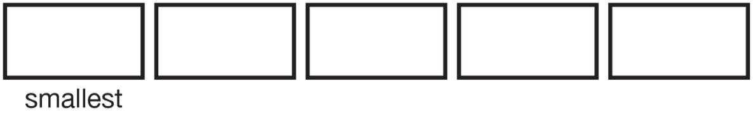 | Write these numbers in order from highest to lowest.  1003 3010 3001 1030  310 130 1300 103  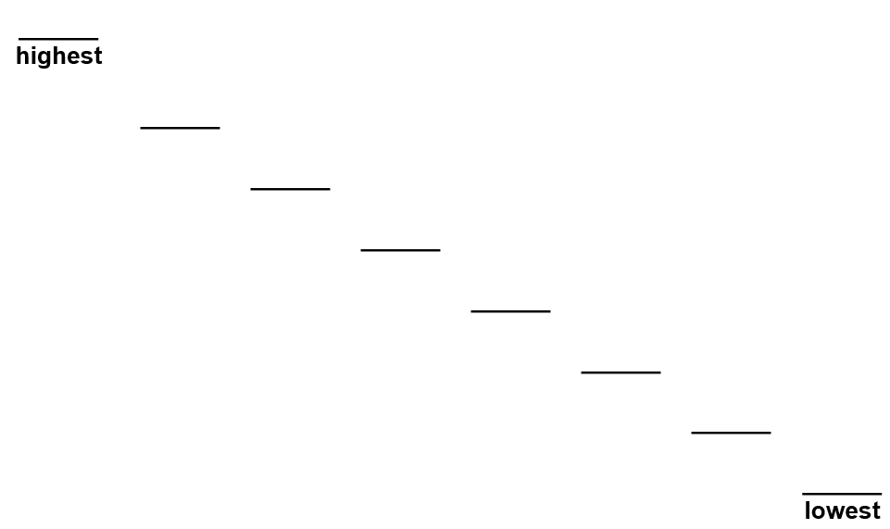
A car costs more than £8600 but less than £9100
Circle the prices that the car could cost.

£8569 £9090 £9130 £8999

Draw two more lines to match 3500 to numbers with the same value.  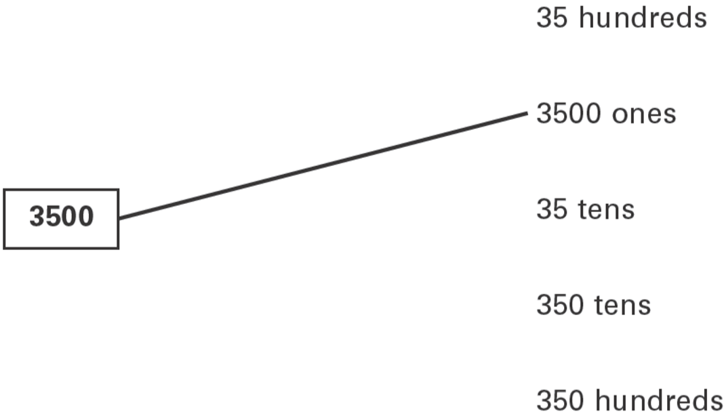 | The difference between two numbers is 2  When each number is rounded to the nearest hundred, the difference between them is 100  Write what the two numbers could be.

v

2015 Paper 2 Question 11  Here is a number written in Roman numerals.  CXV  Write the number in figures. | Here is a number written in Roman numerals.  XXIV  Write the number in figures.
Complete the table.  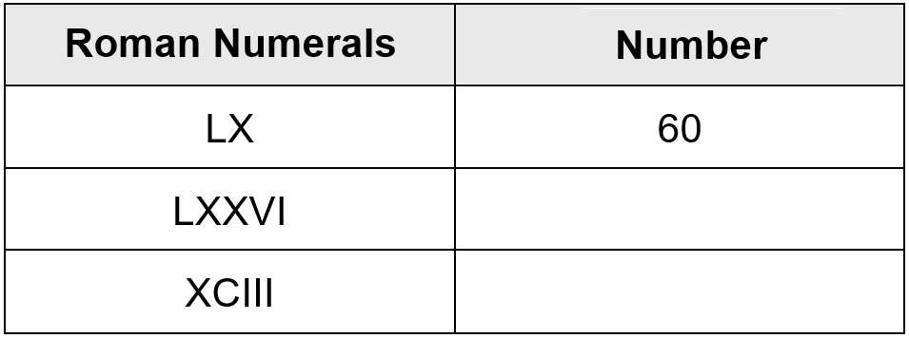 | Write the answers to these calculations in Roman numerals. One has been done for you.  V + VI = XI  IX + XLV =  XC − XXIV =
Find numbers closest to or numbers which make 1000
Circle the number which is closer to 1000  996 1006  Explain how you know. | The three missing numbers are each greater than zero.  Write in what the missing numbers could be.
Circle the number nearest to 1000

1060 1049 1100 960 899

Write two more numbers in this diagram so that the total of all the numbers is 1000.  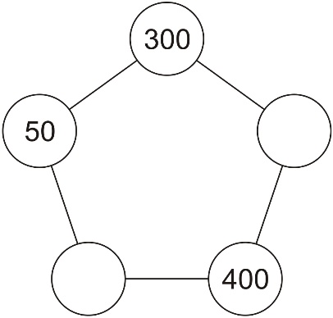 | Circle one number in each box to make a total of 1000  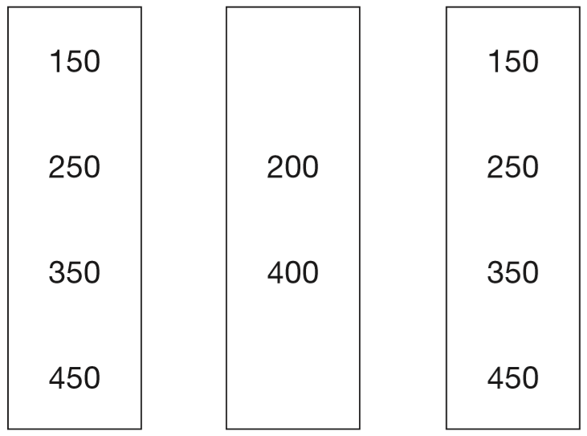
Here are four digit cards.
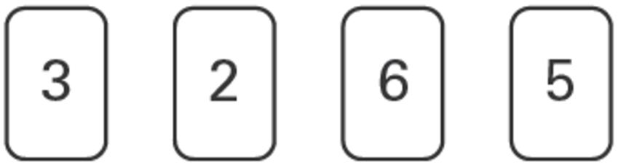
Write in three of the digits to make the total nearest to 1000
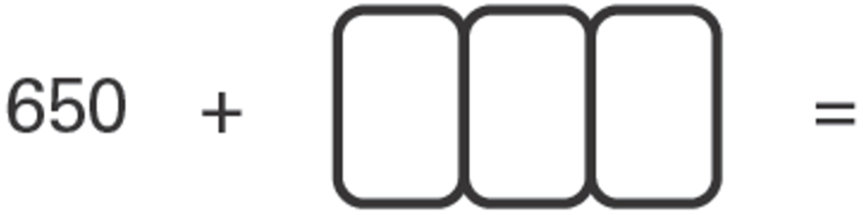

Recognise signs for less than and greater than
Write the largest whole number to make this statement true.  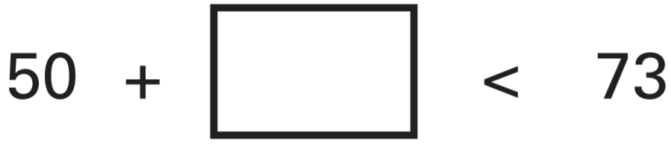 | Here is a number sentence.  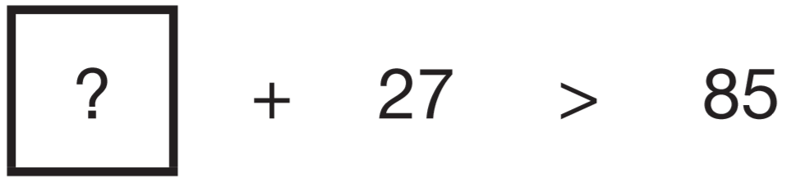  Circle all the numbers below that make the number sentence correct.  30 40 50 60 70

Find three numbers to make a total
Write 3 numbers less than 10 which total 20.  Don’t write the same number more than once. | Circle the numbers that add up to 100  64 32 16 8 4 2 1
Circle three numbers which add to make 190  10 30 50 70 90 | Circle three numbers that add to make 750  450 350 250 150 50

Add and subtract
Write in the missing number.  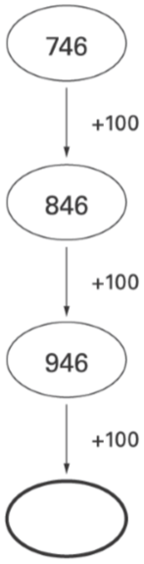 | Write in the missing number.  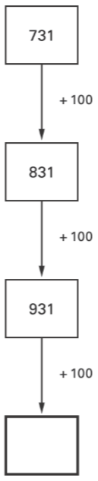 | 2019 Paper 2 Question 2  What number is 1,000 less than 9,072?
Write the missing numbers.

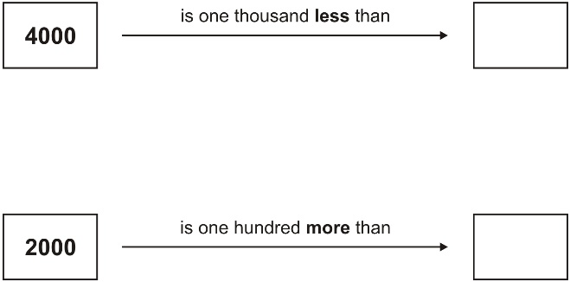

Here is a number sequence.
Write in the missing numbers.
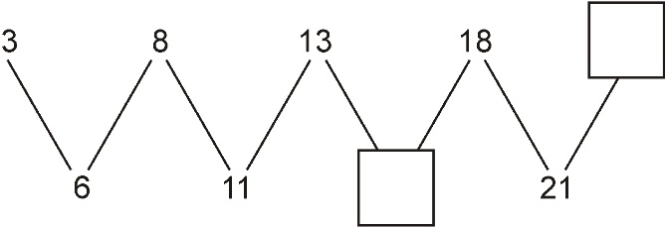
Here is a row of numbers.  1 2 3 4 5 6 7 8 9 10 11 12 13 14 15 16 17 18  Find three numbers next to each other which add up to 39. Draw a ring round them. |  | The numbers in this sequence increase by 101 each time.  Write the next two numbers in the sequence.  
The numbers in this sequence increase by 75 each time. Write in the two missing numbers.   |  | The three numbers on each line add up to 763  Write in the missing numbers.  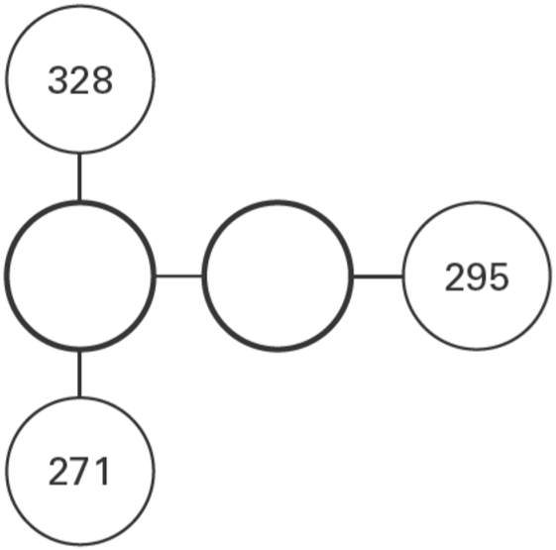
Nadia is working with whole numbers.
She says, ‘If you add a two-digit number to a two-digit number you cannot get a four-digit number.’ Is she correct? Explain why.

Find missing digits in addition and subtraction problems
Each missing digit in this sum is a 9 or a 1  Write in the missing digits.  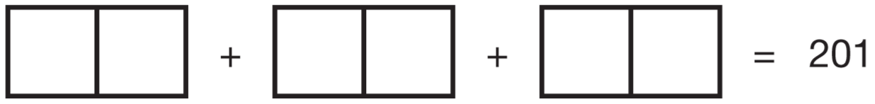 | Write in the four missing digits.  Put one digit in each box.  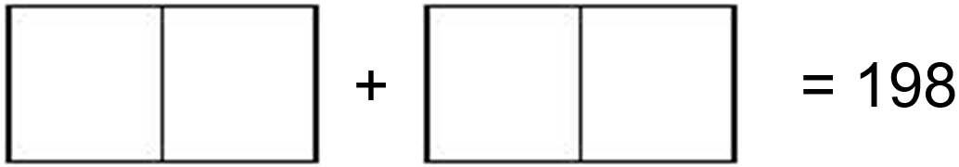
Here are some number cards.  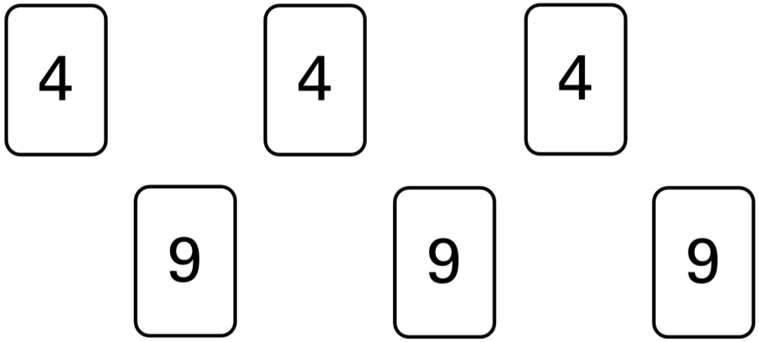  Use five of the number cards to make this correct.  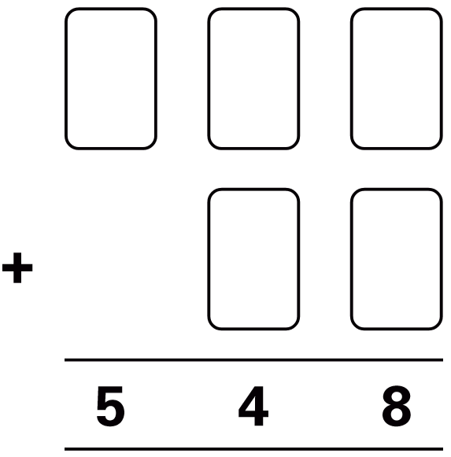 | Write in the missing digits.  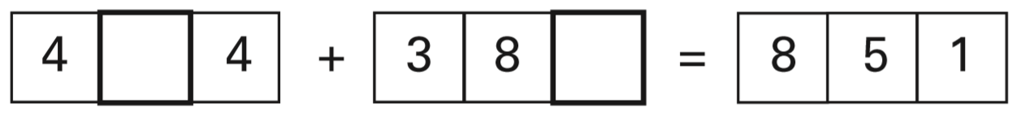
2015 Paper 3 Question 11
Write the four missing digits to make this addition correct.

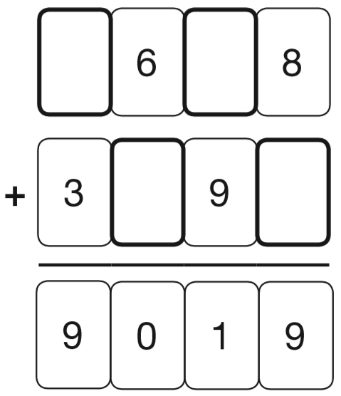
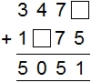

Complete calculations with two unknown numbers
Numbers are missing on four of these calculator buttons.  Write in numbers to make the answer 47  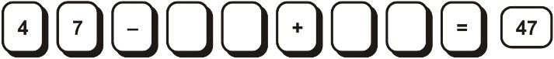 | Write what the three missing numbers could be.  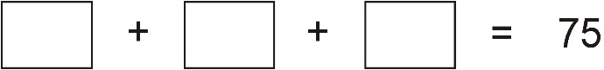  Write what the two missing numbers could be.  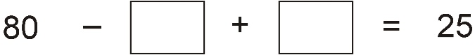
Write numbers in the boxes to make this calculation correct.  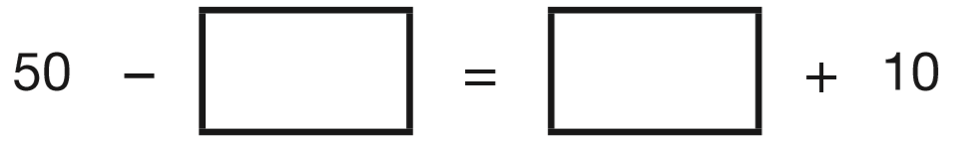 | Write in what the missing numbers could be.  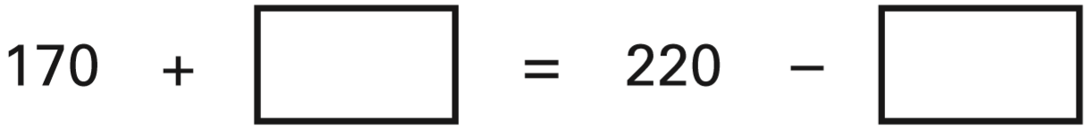
Write what the missing numbers could be.
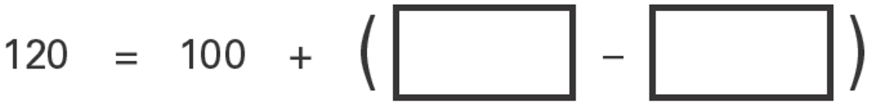

Interpret tables to solve addition and subtraction problems
Seb saved up for a new skateboard that cost £40  The table shows how much money he saved each week.  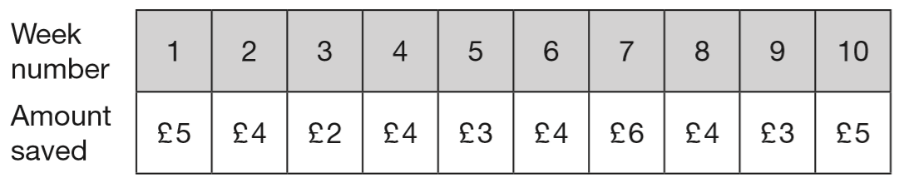  If Seb had saved an extra £1 each week, in which week would he have reached his target of £40? | This table shows the number of visitors to a library during a week.  How many days had a total of more than 150 visitors?  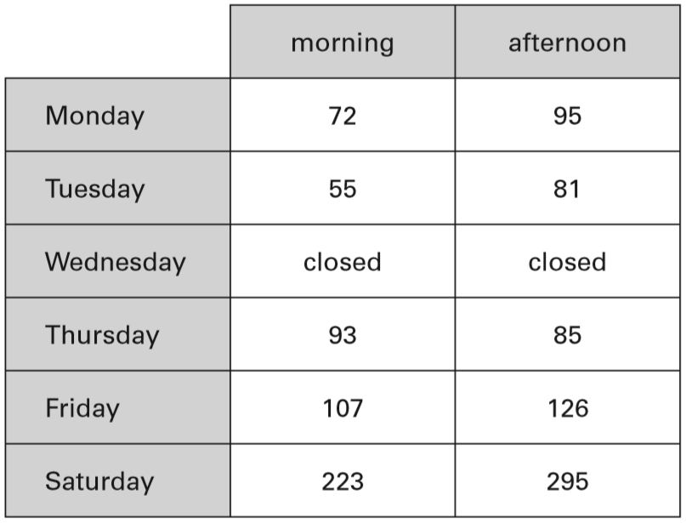
This table shows the numbers of children who went walking, sailing or climbing at an outdoor centre.  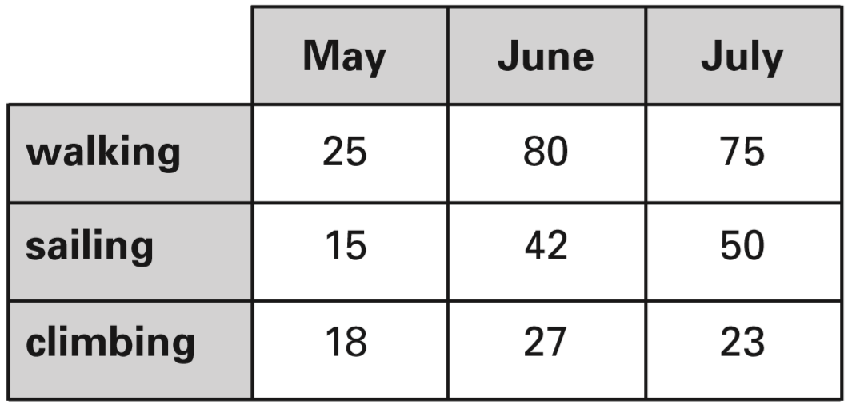  How many children went sailing in May, June and July altogether?  How many more children went walking in June than climbing in June? | Amy did a survey of what time people get up on a Sunday morning. This table shows her results for 150 people.  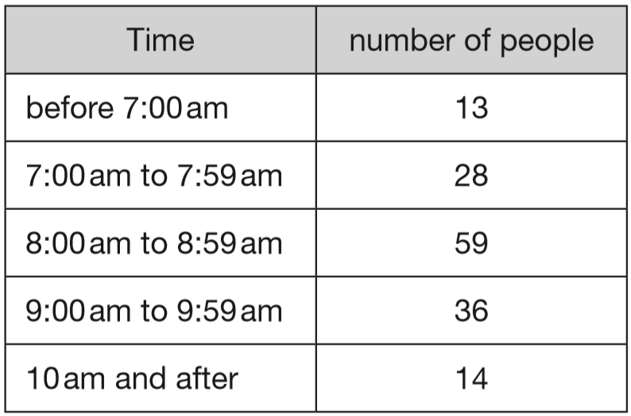  How many people get up at 8am or later?
The children in Farm School Orchestra each play one instrument.  The table show how many children play each instrument.  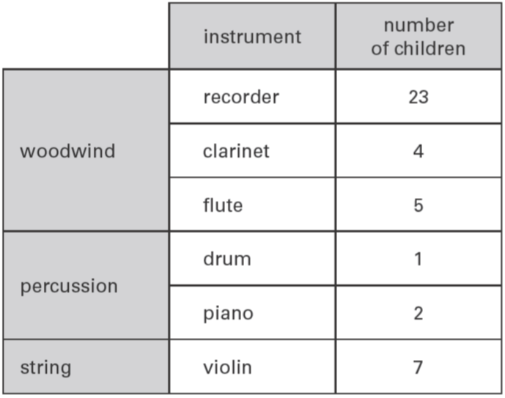  How many more children play a recorder than play a violin?  How many children do not play a percussion instrument? | 2017 Paper 2 Question 4  This table shows the heights of three mountains.  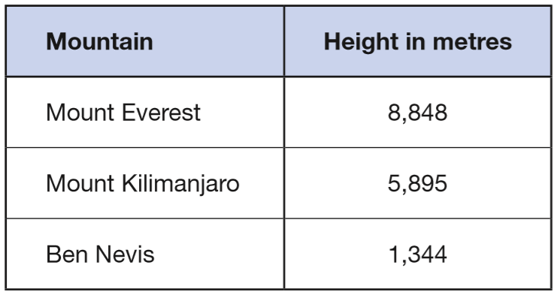  How much higher is Mount Everest than the combined height of the other two mountains?

Solve word problems for addition and subtraction
2019 Paper 3 Question 1  The original price of this car is £8,999  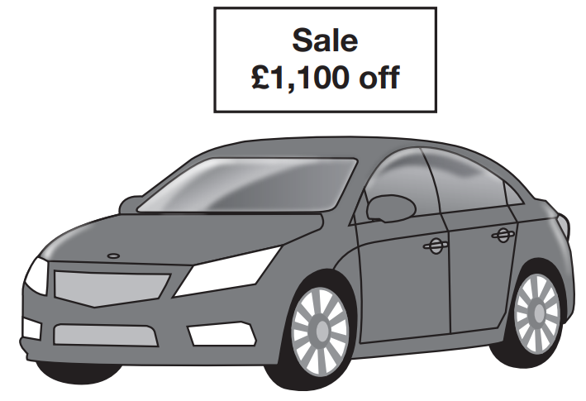  What is the sale price of the car? | 2018 Paper 2 Question 9  The list below shows the years in which the Cricket World Cup was held since 1992:  1992, 1996, 1999, 2003, 2007, 2011, 2015  Adam says, ‘The Cricket World Cup has been held every four years since 1992.’  Adam is not correct. Explain how you know.
Martin has some bricks.  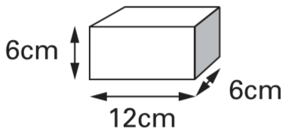  They are 12cm long, 6cm high and 6cm deep.  He builds this tower with five bricks.  How tall is the tower?  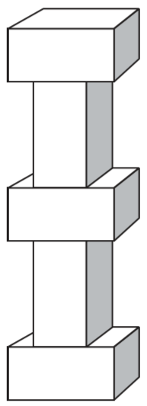 | 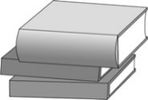  Ellie has a pile of three books.  Two of the books are each 16 mm thick.  The other book is 35 mm thick.  What is the height of the pile of books?
How much heavier is parcel A than parcel B?
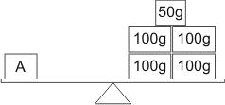
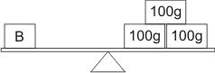
The diagram shows distances on a train journey from Exeter to York.  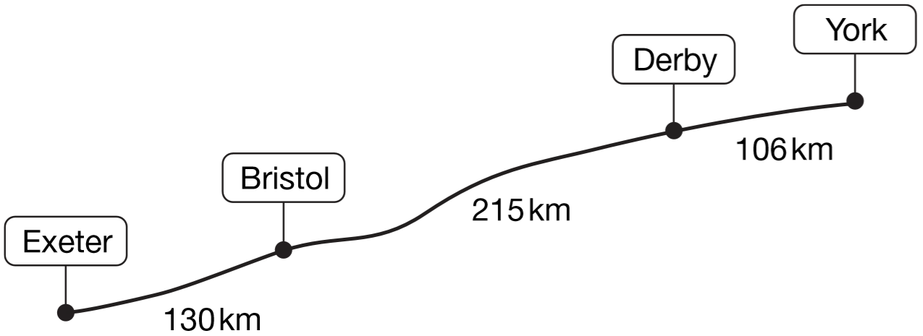  How many kilometres is it altogether from Exeter to York?  What is the distance from Derby to York rounded to the nearest 10km? | 2019 Paper 3 Question 8  Ken is playing a game.  He has 4,289 points.  Then he scores another 355 points.  Ken’s target is 6,000 points.  How many more points does Ken need to reach his target?

Solve number problems involving multiplication and division
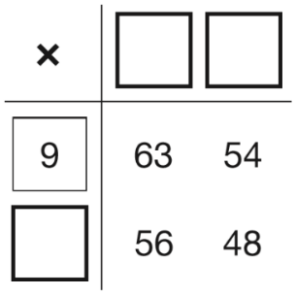  2017 Paper 2 Question 3  Write the missing numbers to make this multiplication grid correct. |  | Write the missing numbers in the sequence.  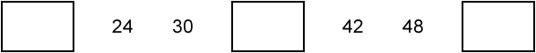
A number multiplied by itself gives the answer 49
Circle the number.

2 3 4 5 6 7 8 9

Ben counts in multiples of 25  Circle the numbers he says.  52 75 125 255 300 |  | 2017 Paper 2 Question 2  Circle the number that is 10 times greater  than nine hundred and seven.  9,700 907 9,007 970 9,070
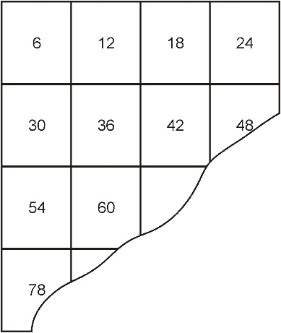  This number square is torn.  What was the largest number on the square before it was torn? |  | Use these signs.  = < >  Write the correct signs in the boxes.  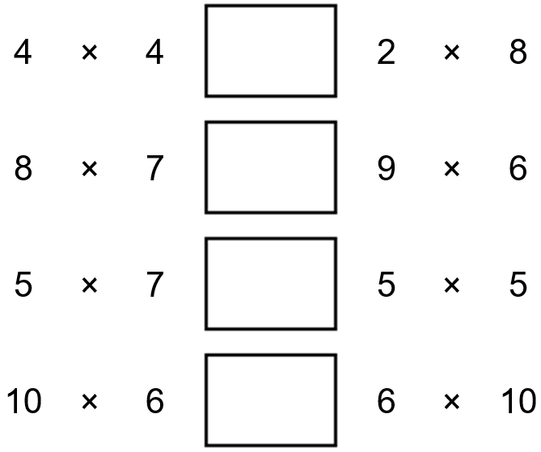
Tick the two divisions that have the same answer.  100 ÷ 10 100 ÷ 5 100 ÷ 2 20 ÷ 2 |  | Write what the missing numbers could be.  
Here are some numbers.  1 2 3 4 5  Write one of the numbers in each box to make these correct.  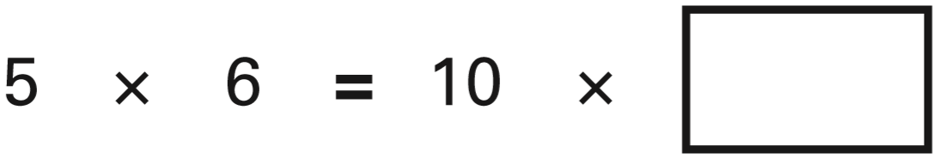  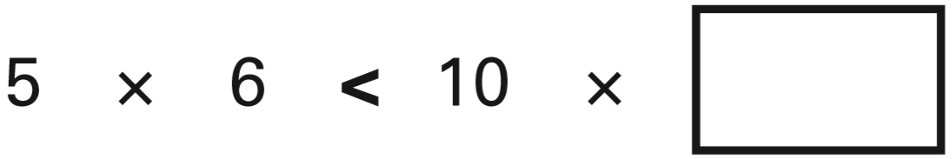 |  | Here are some signs.  ÷ x =  Write two of the signs to make this correct.  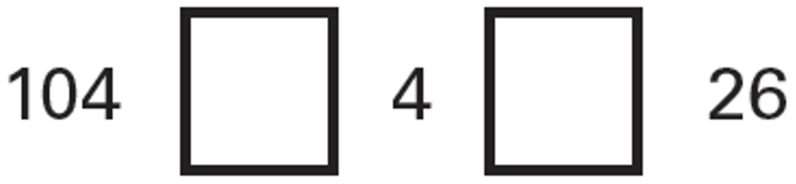
Here is a doubling sequence.
Write the three missing numbers.
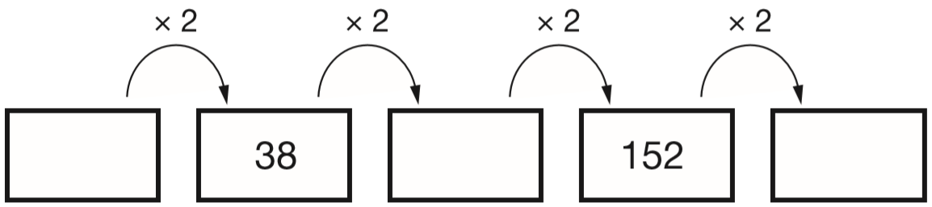
Complete the sequence. 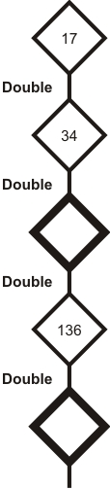 | 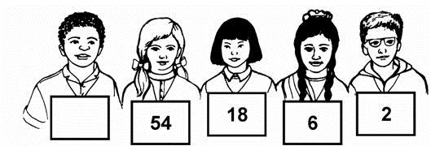  Children in Year 6 make number patterns.  This group uses the rule ‘divide by 3’.  Write in the missing number.
 | Write the missing number.  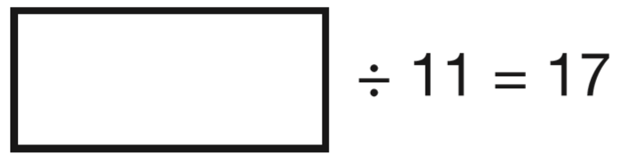 |  | Write the missing number.  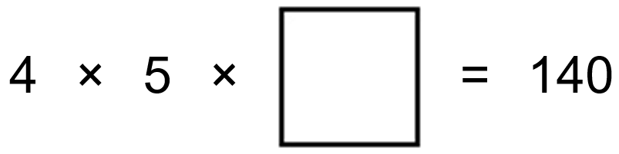
 | Write what the four missing digits could be. |  | Use the digits 2, 3 and 4 once to make the multiplication which has the greatest product.  
 | Write in the missing digit.  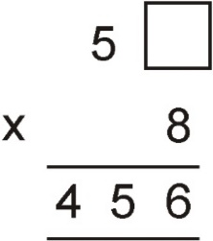 |  | Write in the missing digits to make this correct.  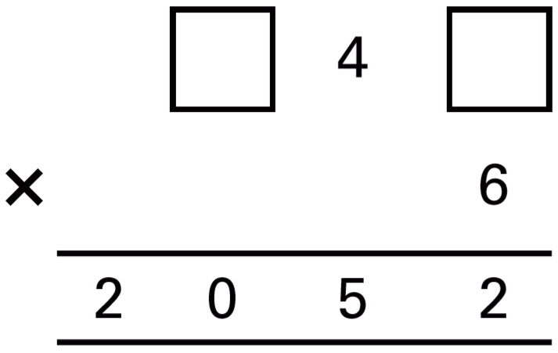
Leila knows that 65 x 3 = 195
Explain how she can use this information to find the answer to this multiplication: 165 x 3

Here are five digit cards.  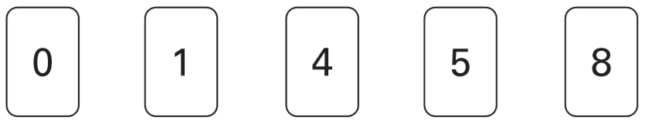  Use all five digit cards to make this correct.  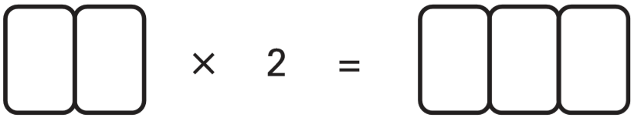 | Write a different digit in each box to make these correct.  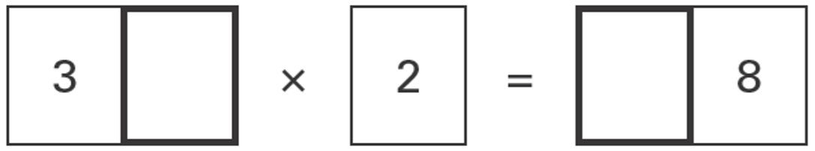  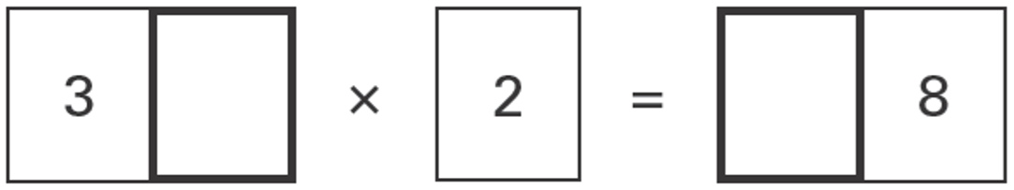
Solve number problems involving division with remainders
Two of these numbers divide by 5 with no remainder. Circle the two numbers.  67 33 25 57 13 60 | Circle two numbers which divide by 5 with no remainder.  7 60 19 45 37 58
Circle the three numbers which divide by 5 with no remainder.  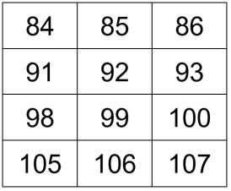 | Write what the missing numbers could be.  ____ is an odd number, and is greater than 15  ____ is a number greater than 100 and can be divided by 4, with no remainder.
 | What is the remainder when you divide 53 by 8?
Circle the two divisions which have an answer of 5 remainder 2  17 ÷ 5 17 ÷ 3 22 ÷ 4 22 ÷ 5 | Circle each number which has a remainder of 2 when divided by 5  15 32 26 24 27 45
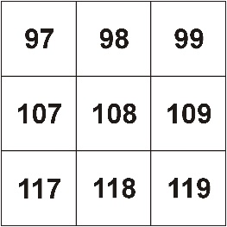  Circle one number on the grid which can be divided by 9 with a remainder of 1 | Write the missing number in each calculation.  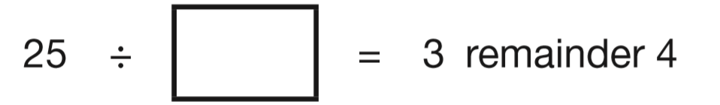  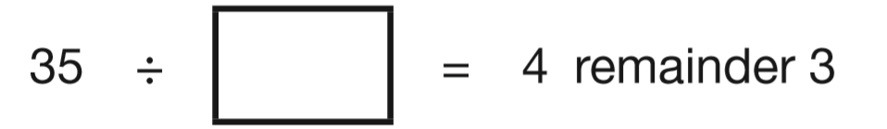
Write in the missing number.   | Complete the number sentences.  340 ÷ 7 = _____ remainder _____  ______ ÷ 3 = 295 remainder 2

Solve word problems involving multiplication and division
Jenny can walk 103 metres in 1 minute.  How far can she walk in 2 minutes? | Each brick is 12cm long.  Martin makes a line of bricks 132cm long.  How many bricks does he use?  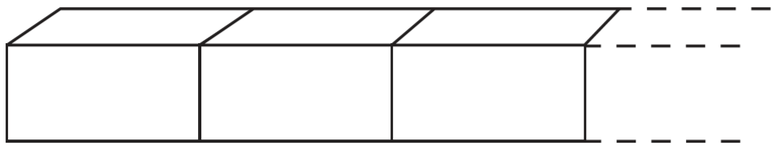
At a tournament there are 7 players in each team. There are 112 players altogether.  How many teams is this? | A spoonful is 5ml.  How many spoonfuls can you get from a 375ml bottle?
There are 12 pencils in a box.  A school buys 24 boxes.  How many pencils does the school buy? | Eggs are put in trays of 12  The trays are packed in boxes.  Each box contains 180 eggs.  How many trays are in each box?
There are 3 chocolates in a tube.  There are 4 tubes in row.  There are 5 rows in a box.  How many chocolates are there in a box? | A rectangular swimming pool is 25 metres long and 10 metres wide.  David swims 5 lengths. Rosie swims 12 widths.  How much further does David swim than Rosie?
Solve word problems involving division with remainders
Zak has more than 10 counters and fewer than 20 counters.  When he groups them in threes no counters are left over.  How many counters could Zak have? | Five children share a bag of cherries.  Each child gets 6 cherries.  There are 3 cherries left over.  How many cherries were in the bag altogether?
Here are some numbers.  6 2 32 5  Write each number in a box to make this number story correct.  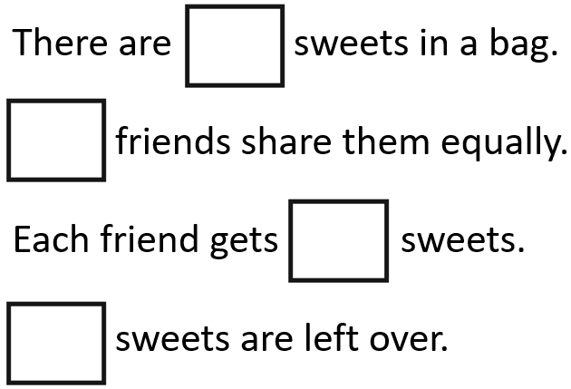 | Alan has 45 beans.  He plants 3 beans in each of his pots.  How many pots does he need?  Leila puts 4 seeds in each of her pots.  She uses 6 pots and has 1 seed left over.  How many seeds did she start with?
2018 Paper 3 Question 7  A farmer is packing eggs.  Each box holds six eggs.  The farmer has 980 eggs to pack.  How many boxes can the farmer fill using 980 eggs?  _____ full boxes  How many eggs will be left over?  _____ left over | A box holds 6 eggs.  How many boxes are needed to hold 52 eggs?
There are 275 children in Fernley School.
They get into groups of eight.
What is the largest number of groups of eight that they can make?

Solve word problems involving division by 20 or 25
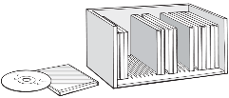  Here is a CD rack.  One rack holds 25 CDs.  David has 83 CDs.  How many racks does he need to hold all his CDs?  Lin has 6 racks full of CDs.  How many CDs does Lin have altogether? | One length of a swimming pool is 25 metres.  How many lengths are there in a 150 metre race?
Plants are sold in trays of 20
Ivana buys 7 trays of plants.
How many plants is this?

David wants 240 plants.
How many trays does he need to buy?

50 children need two pencils each.  There are 20 pencils in a box.  How many boxes of pencils are needed?  50 children need one pen each.  Pens are sold in packs of 4  How many packs of pens need to be bought? |   A farmer has 157 eggs.  He stores them in trays.  Each tray holds 20 eggs.  How many trays does he need to store all the eggs?

Solve number problems using the four operations
Join each of these calculations to the number that is nearest to the correct answer.  One has been done for you.  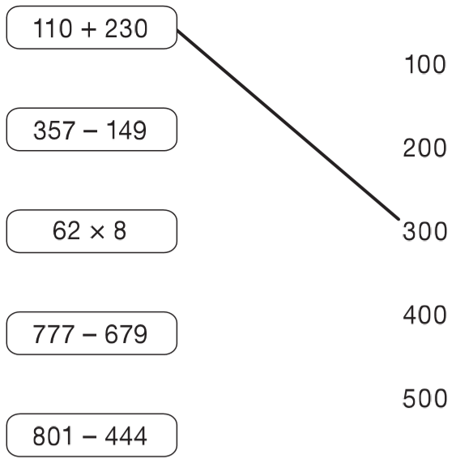 | Here is a number machine.  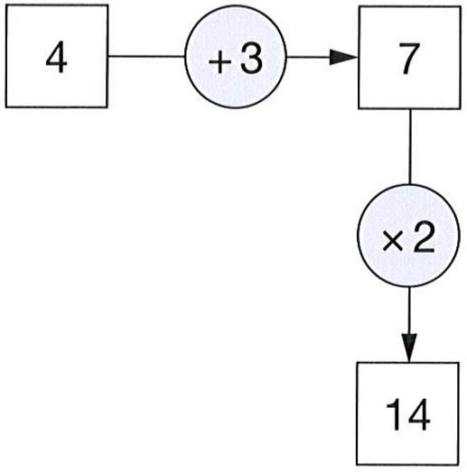  Here is another number machine.  Write the four missing numbers.  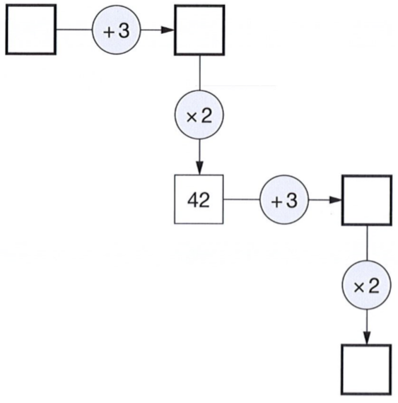
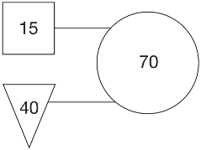  In this diagram the rule is:  ‘double the number in the square and add the number in the triangle to make the number in the circle.’  Use the same rule to write in the missing numbers below.  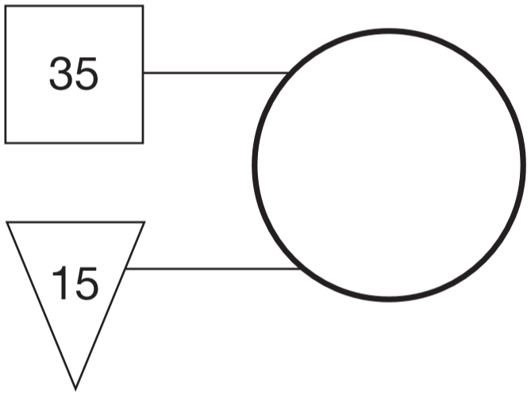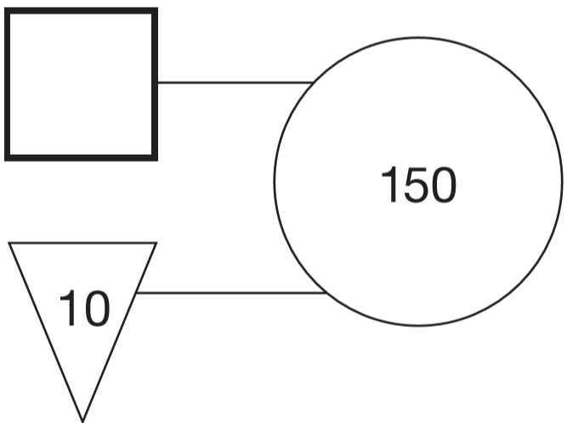 | Write in the missing numbers.  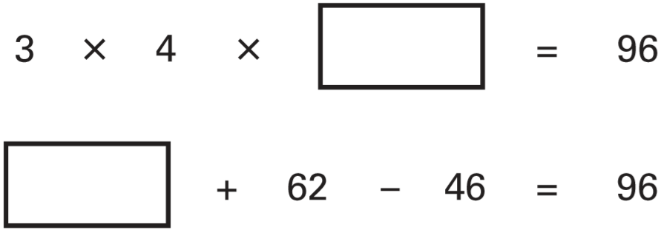
Each missing digit in these calculations is 2, 5 or 7  Write in the missing digits.  You may use each digit more than once.  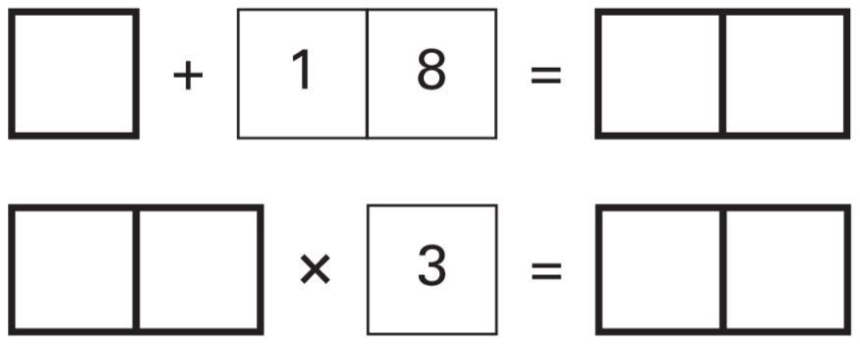 | Write one number from each circle to make this calculation correct.  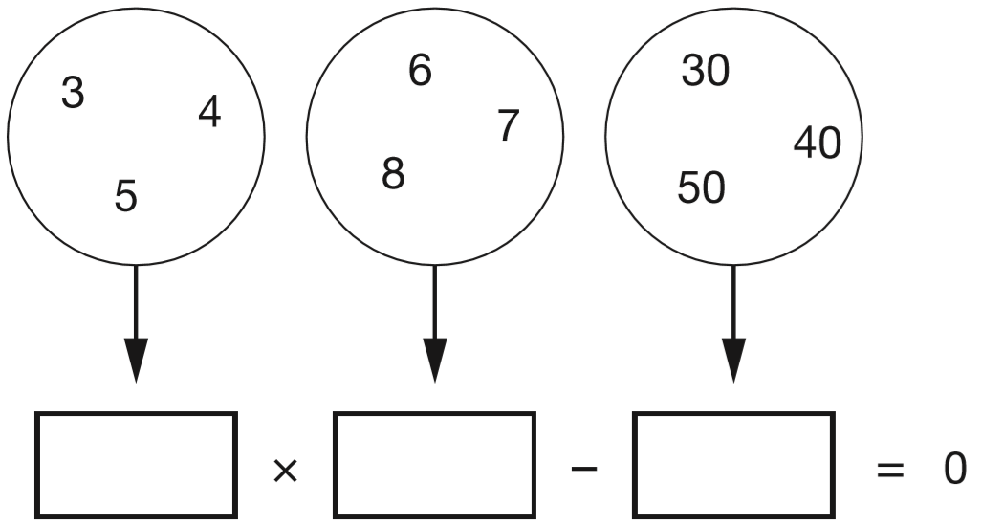
This calculation has the same number missing from each box.  Write the missing number in the boxes.  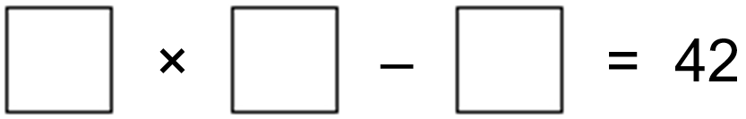 | Write what the numbers in the boxes could be.  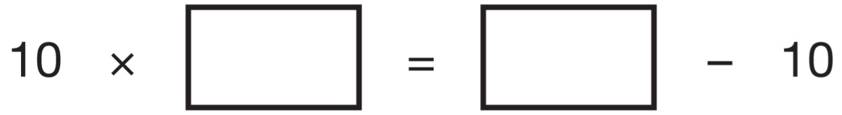
Here are five number cards.
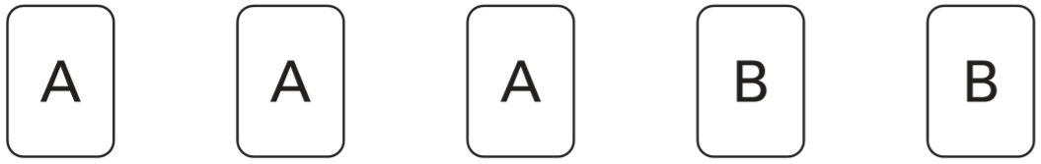
A and B stand for two different whole numbers.
The sum of all the numbers on all five cards is 30
What could be the values of A and B?

Solve word problems using the four operations
On a sheet of stickers there are 5 circles, 2 stars and one rectangle.  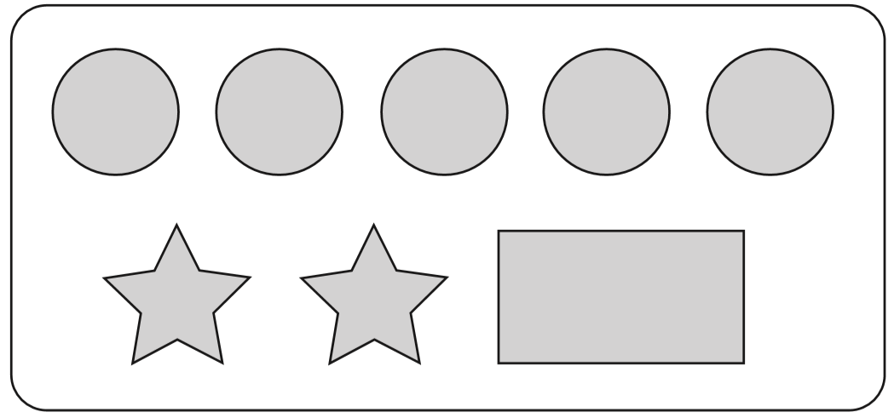  How many stickers are there altogether on 4 sheets?  Nisha needs 55 circles. How many sheets of stickers does she need?  Ben has 10 sheets of stickers.  How many more circles than rectangles does he have? | A letter costs 65p to send.  Carla has 20p stamps and 5p stamps.  How many of each stamp does she need?
Plastic cups are sold in packs of 8
Amir needs 27 cups.
How many packs must he buy?

There are 30 paper plates in a pack.
Amir buys 2 packs.
He uses 37 plates.
How many plates are left?

Kirsty, Seb and Mina made toffee apples to sell at the school fair.  They made 80 toffee apples altogether.  Kirsty sold 12 toffee apples.  Seb sold 25 toffee apples.  Mina sold 17 toffee apples.  How many toffee apples were left?  Kirsty sold her 12 toffee apples for 50p each.  How much money did she collect? | Miss Wood’s class had 120 pencils at the start of the year.  12 children use 5 pencils each.  11 children use 4 pencils each.  How many pencils are left at the end of the year?
Megan and Chen are washing cars.
Megan gets £39 and Chen gets £55
They share what they get equally between them.
How much does each of them get?

There are 64 picture cards in this pile.    Five children each take the same number of cards.  24 cards are left over.  How many cards does each child take? | One battery weighs the same as 60 paperclips.  One pencil sharpener weighs the same as 20 paperclips.  How many pencil sharpeners weigh the same as one battery?  How many paperclips weigh the same as 2 batteries and 4 pencil sharpeners together?
2018 Paper 2 Question 8  Ken buys 3 large boxes and 2 small boxes of chocolates.  - Each large box has 48 chocolates.  - Each small box has 24 chocolates.  How many chocolates did Ken buy altogether? | 2018 Paper 3 Question 20  In March, Ken collects 2, 3 or 4 eggs each day from his hens. In the first 20 days, Ken collects 57 eggs altogether. There are 31 days in March. What is the greatest number of eggs Ken can collect in March?
2019 Paper 2 Question 10
A theme park sells tickets online.
- Each ticket costs £24
- There is a £3 charge for buying tickets.
Which of these shows how to calculate the total cost, in pounds?
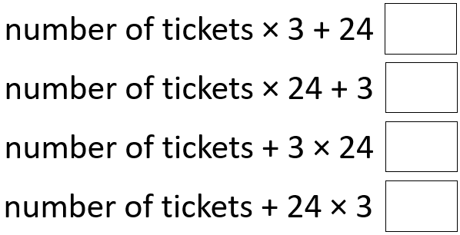
Identify rules for simple sequences
Here is a repeating pattern of shapes.  Each shape is numbered.    The pattern continues in the same way.  Write the numbers of the next two stars in the pattern.  Complete this sentence.  Shape number 35 will be a circle because ... | Here is part of a number sequence.  The numbers increase by the same amount each time.  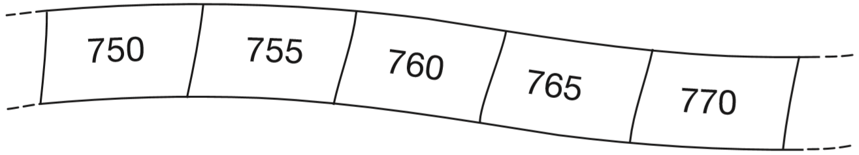  The sequence continues.  Circle all of the numbers below that would appear in the sequence.  840 905 989 1000 2051
Here is part of a number sequence.  The numbers in the sequence increase by 25 each time.  50 75 100 125 …  Circle all of the numbers below that will appear in the sequence.  255 650 735 900 995 | The numbers in this sequence increase by 10 each time.  3 13 23 …  The sequence continues in the same way.  Write two numbers from the sequence that add to make a total of 96  Explain why it is not possible to find three numbers from the sequence that add to make a total of 96
Here is part of a number square.  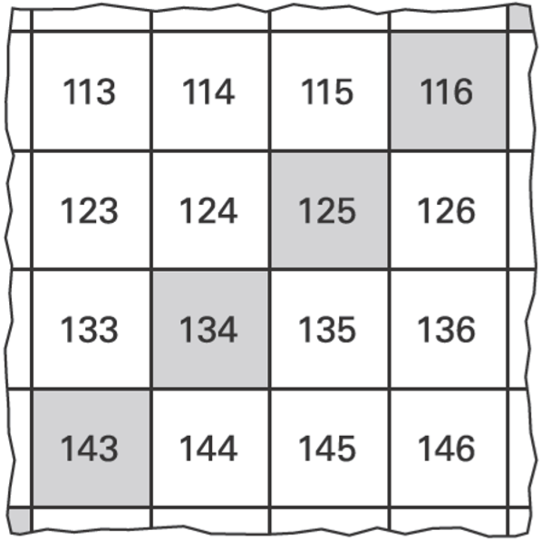  The shaded numbers are part of a sequence.  Explain the rule for the sequence. | Here is part of a number grid.  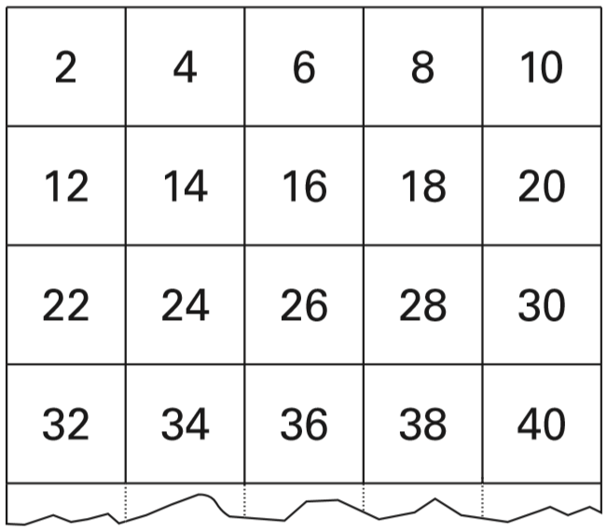  Here is another part of the same grid.  Write in the missing numbers.  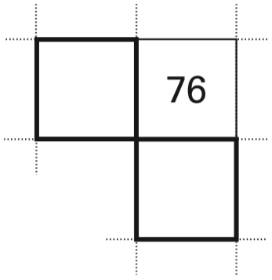

Solve problems by working backwards
Dan says,  ‘I choose a number.  I multiply it by 5  Then I subtract 7  My answer is 38’  What number did Dan choose? | Lauren has some cherries.  She eats 2 of them.  Then she eats half of what is left.  She now has 6 cherries.  How many cherries did she start with?
Jemma thinks of a number. She says,  ‘Add 3 to my number and then multiply the result by 5  The answer is 35’  What is Jemma’s number?  Riaz thinks of a number. He says,  ‘Halve my number and then add 17  The answer is 23’  What is Riaz’s number? | Josh thinks of a number.  He adds 4  He multiplies his result by 3  Then he takes away 9  His final answer is 90  What number did Josh start with?
Leon and Sara each started with different numbers.  Leon says, ‘I added 5 to my number.’  Sara says, ‘I subtracted 8 from my number.’  Leon and Sara both get the same answer.  What numbers could they have started with? | Write the correct number in the IN box.  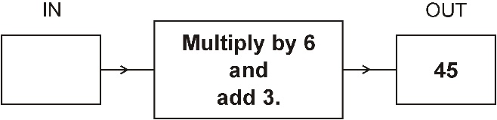
This number machine multiplies all numbers by 2, and then adds 1.  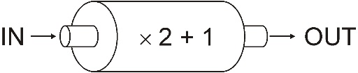  Write the missing numbers in the table.  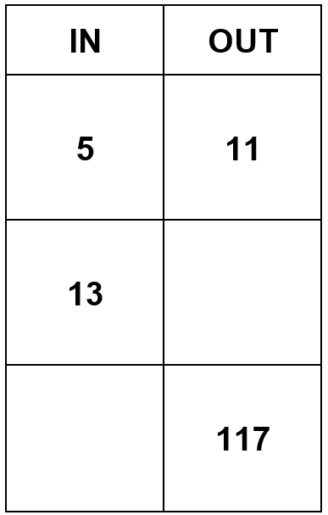 | The rule for this number sequence is "double and subtract 1"  Write in the missing number.  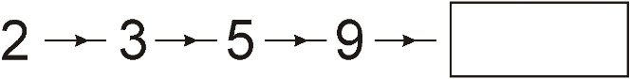  Here is part of another sequence with the same rule. Write in the missing number.  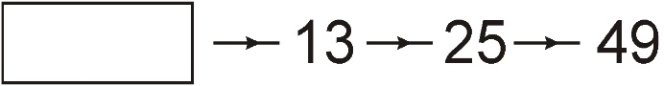
Amy chooses two of these cards.  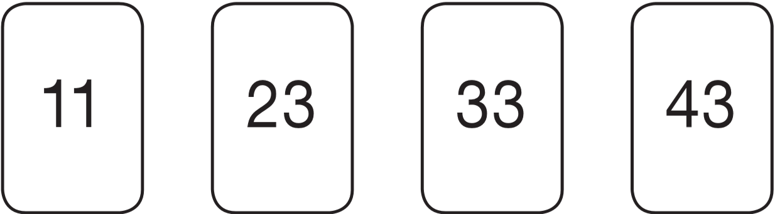  She adds the numbers on her two cards together.  She rounds the result to the nearest 10  Her answer is 60  Which two cards did Amy choose? | 2017 Paper 3 Question 19  Dev thinks of a whole number.  He multiplies it by 4  He rounds his answer to the nearest 10  The result is 50  Write all the possible numbers that Dev could have started with.

