
Identify fractions
Here are three shapes made from regular hexagons.  Write the fraction of each shape that is shaded.  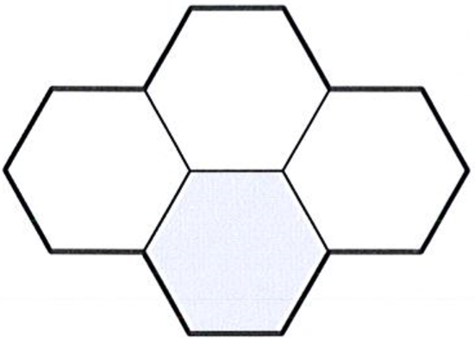  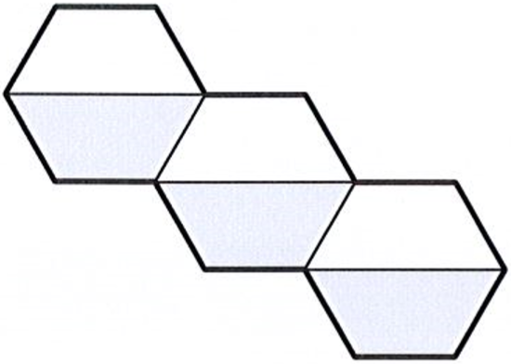  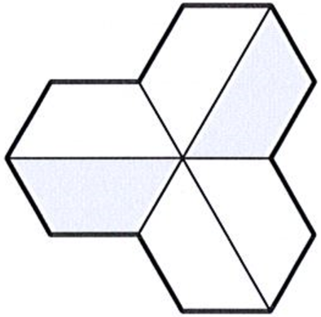 | 2018 Paper 2 Question 4  These diagrams show three equivalent fractions. Write the missing values.  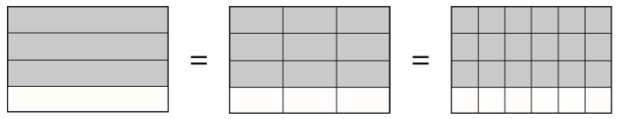  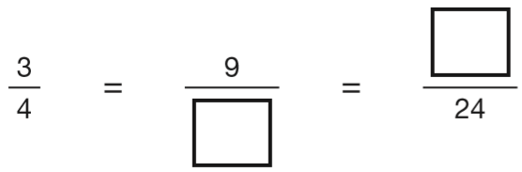
The diagram is made of squares.
What fraction of the diagram is shaded?
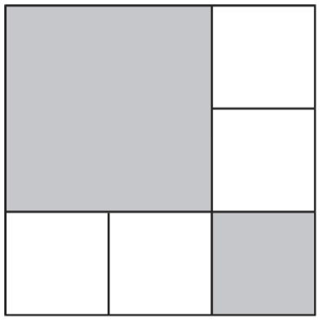
Here is a rectangle with 13 identical shaded squares inside it.  What fraction of the rectangle is shaded?  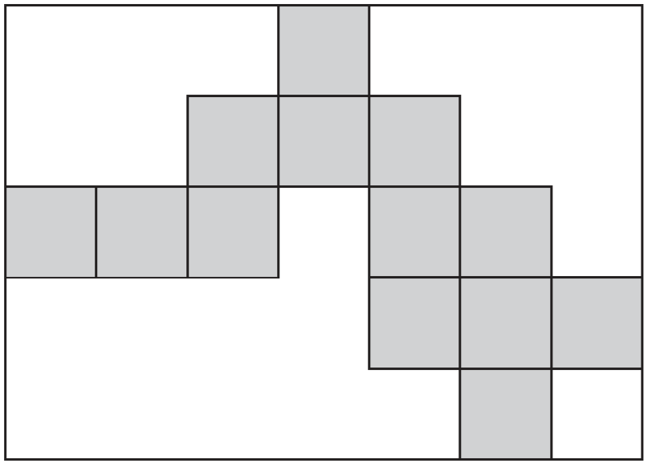 | A line starts at A and goes along the dotted lines to B.  It divides the area of the grid into halves.  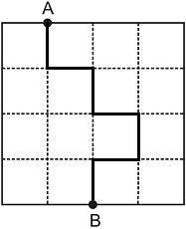  Divide the area of the grid below into halves. Start at A and go along the dotted lines to B.  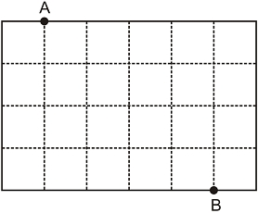
This diagram shows a shaded rectangle surrounded by squares.
What fraction of the diagram is shaded?
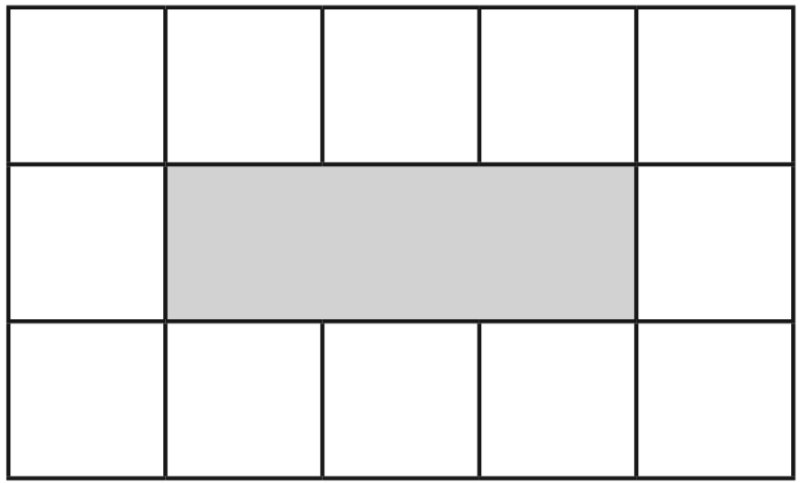



Identify simple fraction sequences
Here is part of a number line.  Write in the missing fraction.  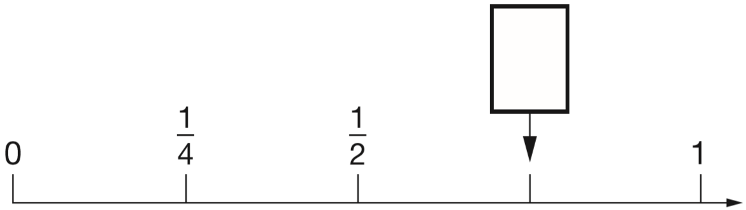 | Draw an arrow on the number line to show 1$\frac{3}{4}$
Write the two missing numbers in this sequence.  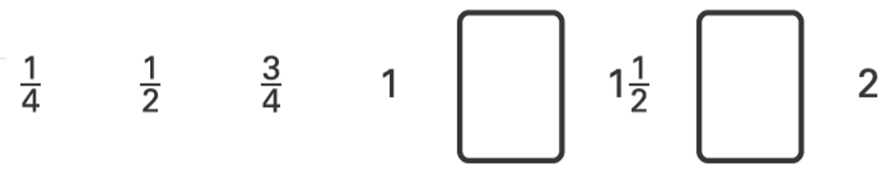 | Here are three fractions.  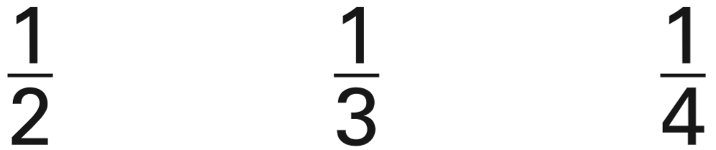  Write the fractions in the correct boxes on the number line.  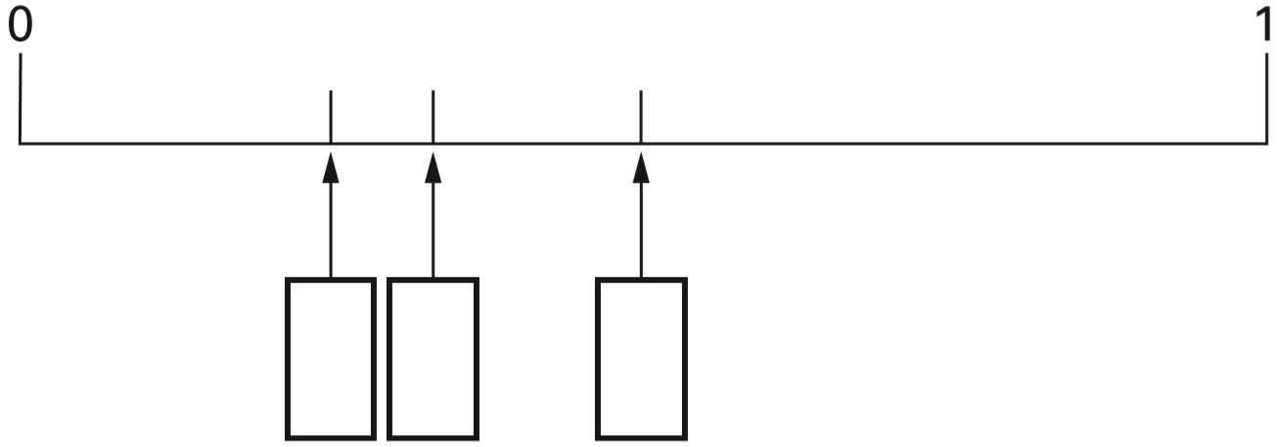

Find equivalent fractions from numbers
Circle the two fractions that have the same value.  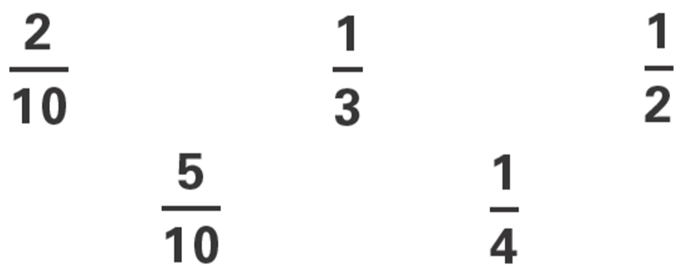 | Two of the fractions below are equivalent. Circle them.  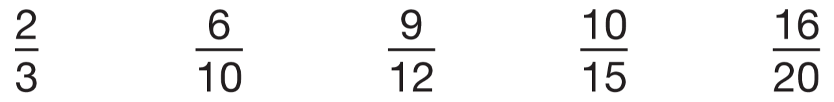
Complete these fractions to make each equivalent to $\frac{3}{5}$  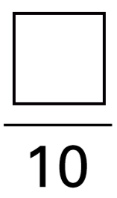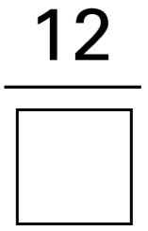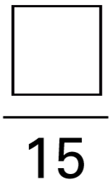 | 2016 Paper 2 Question 7  Write the two missing values to make these equivalent fractions correct.  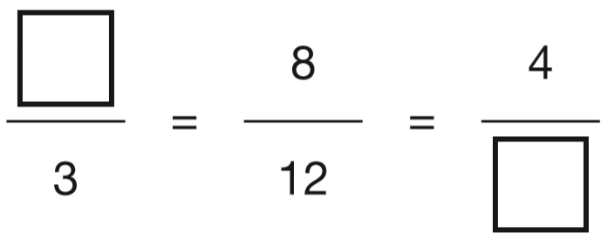
Draw one line to join two fractions which have the same value.  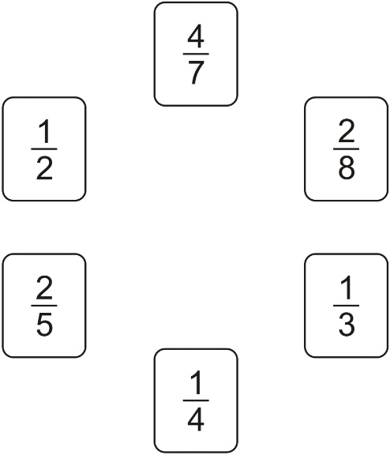 | Karen makes a fraction using two number cards.  She says, ‘My fraction is equivalent to ½  One of the number cards is 6’  What could Karen’s fraction be?  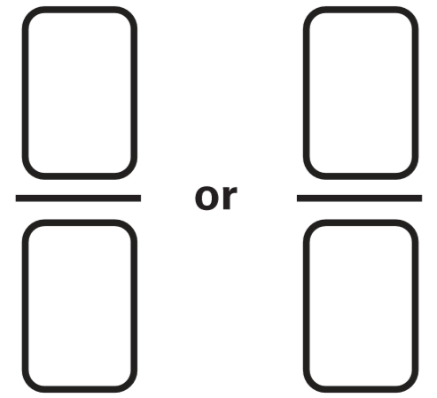
Sarah has a packet of balloons. The contents of the packet are:
5 red balloons, 5 blue balloons, 10 yellow balloons
Sarah says, ‘One-quarter of the balloons are red.’ Is Sarah correct? Explain how you know.

Find equivalent fractions from diagrams
Look at the diagrams. Complete the fractions.  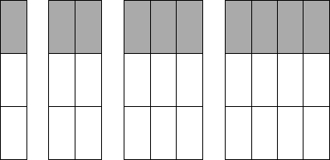  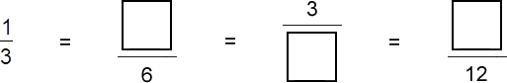 | A fraction of each shape is shaded. Match each fraction to the correct place on the number line. One has been done for you.  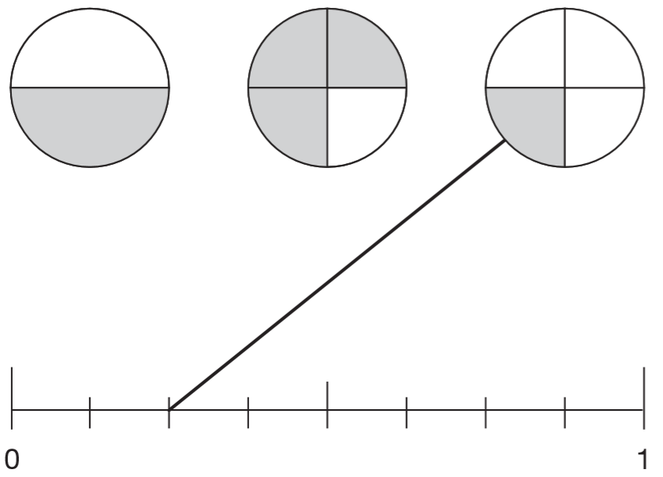
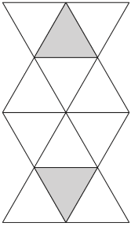  Here is a shape made from matching triangles.  Circle the fraction of the shape that is shaded.  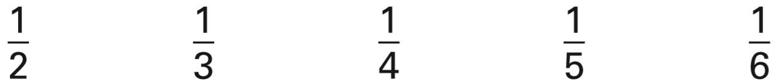 | Tick each shape that is exactly $\frac{1}{4}$shaded.  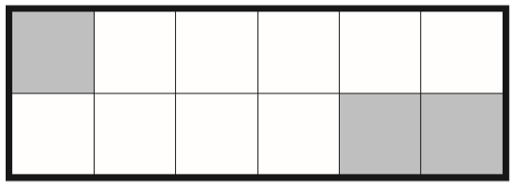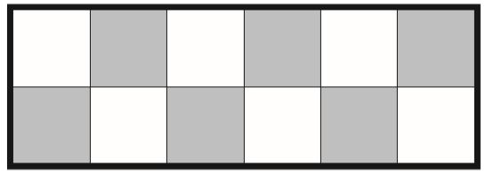  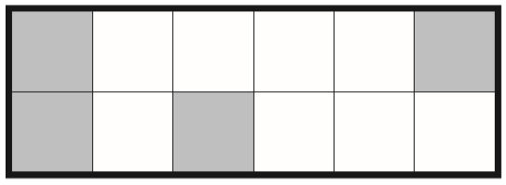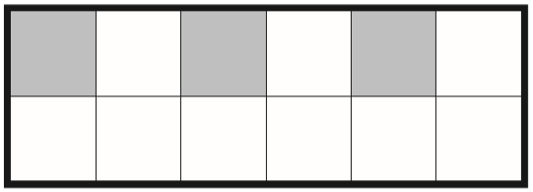
Tick the two shapes that have three-quarters shaded.  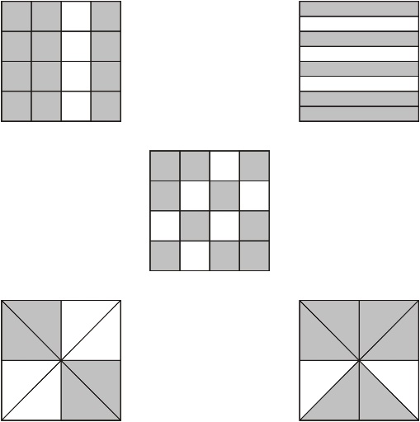 | 2017 Paper 2 Question 9  Tick two shapes that have $\frac{3}{4}$ shaded.  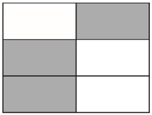  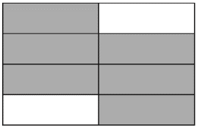  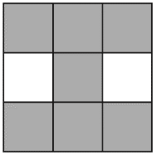  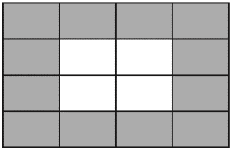
Each of these diagrams is divided into equal parts. Some of the parts are shaded.  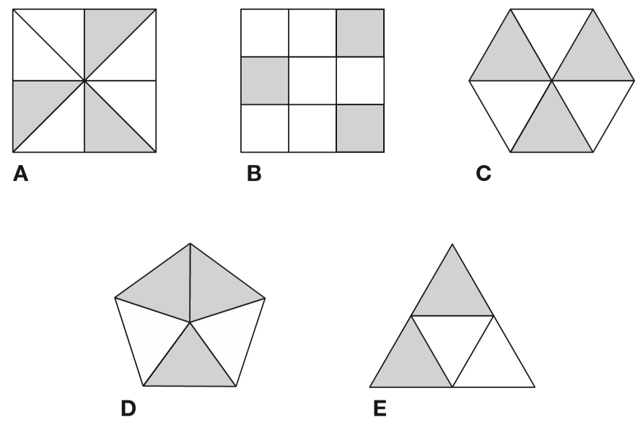  Write the letters of all the diagrams that have exactly $\frac{1}{2}$shaded.  Write the letters of all the diagrams that have exactly $\frac{1}{3}$shaded. | 2015 Paper 2 Question 4  Match each shape to its equivalent fraction.  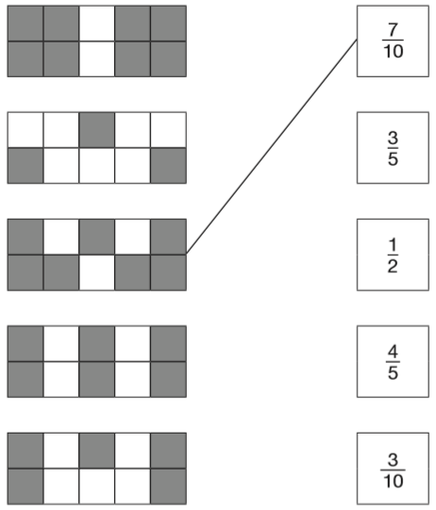

Shade a fraction of a shape
Shade $\frac{1}{4}$of this shape.  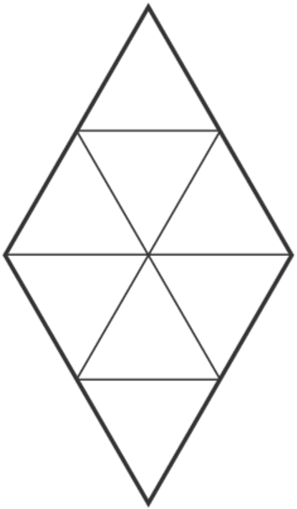 | Shade $\frac{1}{4}$of this shape.  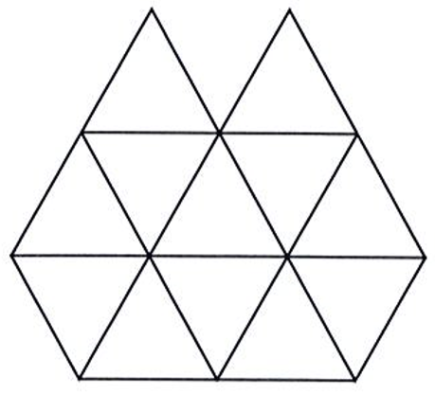
Shade one third of this shape.  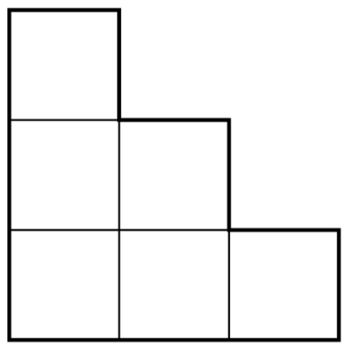  Shade one quarter of this shape.  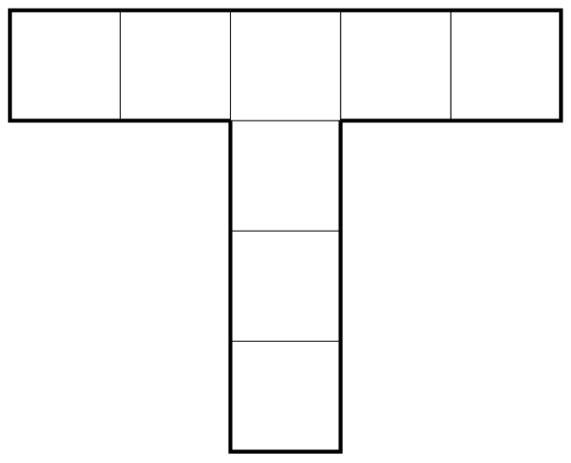 | Shade $\frac{1}{5}$of this shape.  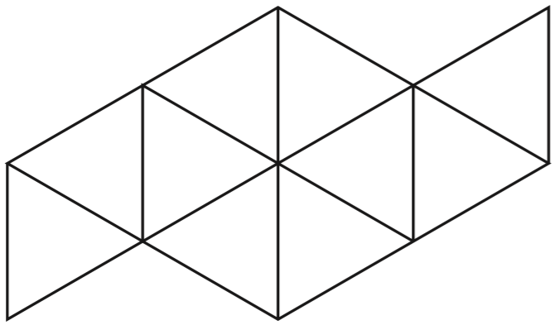
Shade $\frac{1}{5}$of this shape.
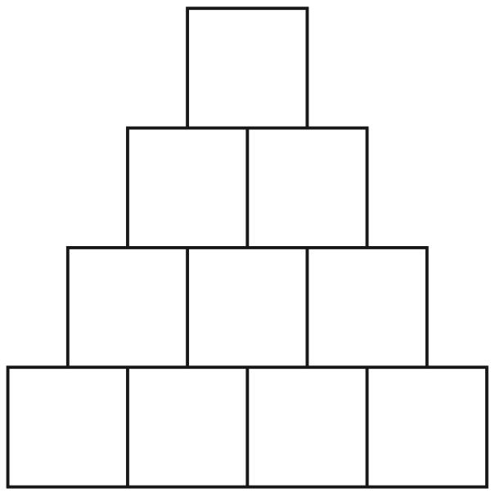
Shade more triangles on this shape so that $\frac{1}{3}$ is shaded.  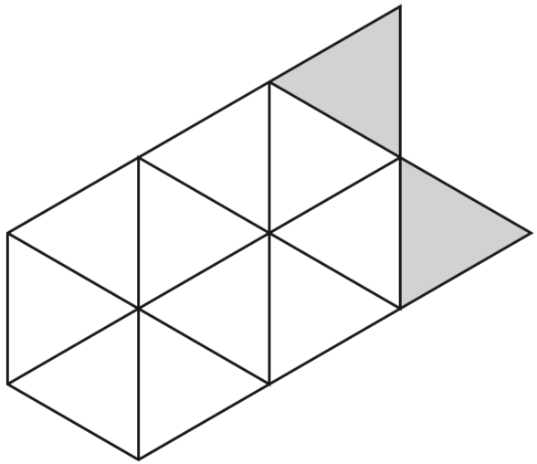 | Shade more squares so that exactly half of the shape is shaded.  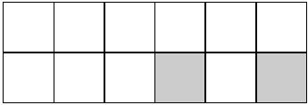
2016 Paper 2 Question 10  Each diagram below is divided into equal sections.  Shade three-quarters of each diagram.  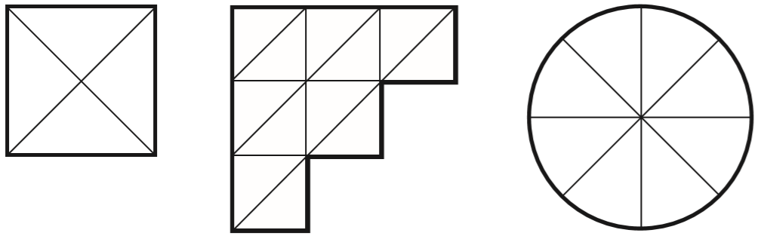 | Sarah wants to shade $\frac{3}{4}$ of this shape.  She has shaded 2 triangles.  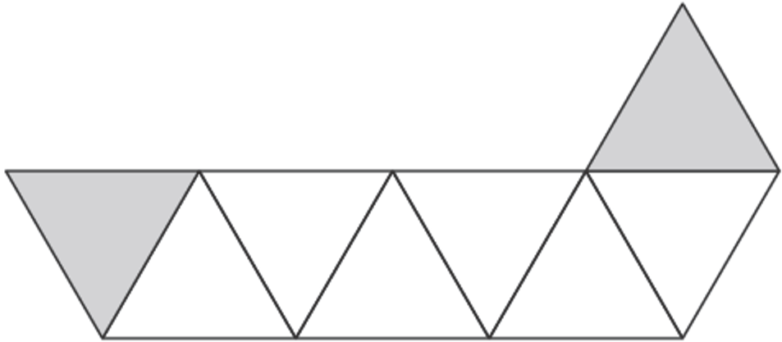  How many more triangles must she shade so that $\frac{3}{4}$is shaded?

Find a fraction of a number
Emma counts how many letters there are in each of 40 words.  The bar chart shows her results.  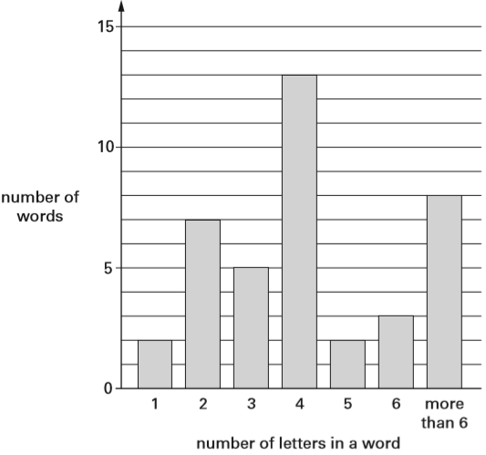  How many words have fewer than 4 letters in them?  What fraction of the 40 words have more than 6 letters in them? | Meg has 20 pet stickers to go on this page.  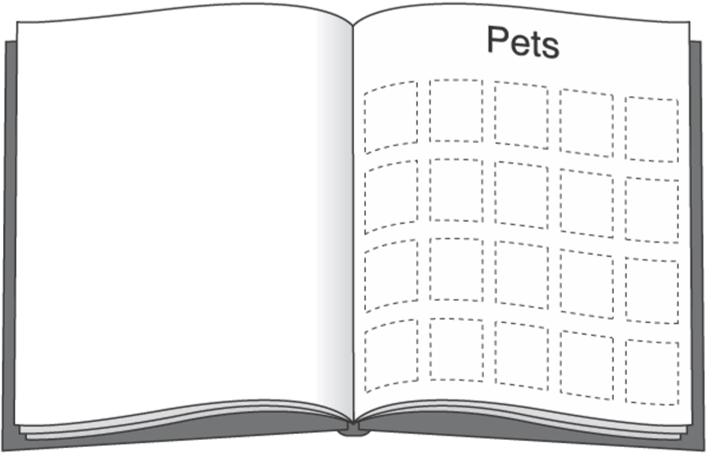  ¼ of them are dog stickers.  ½ of them are cat stickers.  The rest are rabbit stickers.  How many rabbit stickers does she have?
Write the missing number.
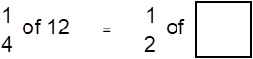
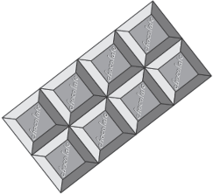
Here is a chocolate bar.
William eats 3 pieces and Amber eats 2 pieces.
What fraction of the chocolate bar remains?

Megan and Chen each have a bag of counters.  Megan’s bag has 5 blue counters and 5 green counters.  Chen’s bag has 10 blue counters, 5 green counters and 5 red counters.  They each take a counter from their bag without looking.  Chen says, ‘I am more likely than Megan to take a blue counter.’  Is Chen correct? Explain how you know. | There are 24 coloured cubes in a box.  Three-quarters of the cubes are red, four of the cubes are blue and the rest are green. How many green cubes are in the box?  One more blue cube is put into the box.  What fraction of the cubes in the box are blue now?
Stefan has a bag that contains 3 blue marbles and 5 red marbles only. What fraction of the marbles in the bag are blue?

Stefan adds one blue marble and one red marble to the bag.
What fraction of the marbles in the bag are blue now?

Annie had 36 sweets. She ate $\frac{2}{3}$of them.  Ben had 40 sweets. He ate $\frac{1}{5}$of them.  How many more sweets did Annie eat than Ben? | Sam has 90 bricks.  He uses $\frac{3}{5}$of them to build a tower.  Grace has 120 bricks.  She uses $\frac{5}{6}$of them to build a tower.  How many bricks are left over altogether?
2018 Paper 3 Question 16  A book has 276 pages.  Amina has read $\frac{1}{3}$of the book.  How many pages are left for Amina to read? | Sam and Ben share a pizza with their Dad.  Sam ate $\frac{1}{3}$of the pizza. Ben ate $\frac{1}{6}$of the pizza.  Dad ate the rest.  What fraction of the pizza did Dad eat?

Solve problems involving finding a fraction of a number
Amy did a survey of what time people get up on a Sunday morning. This table shows her results for 150 people.  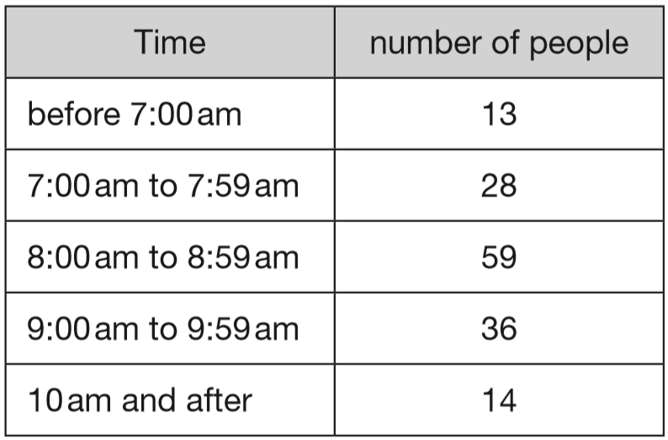  Amy says, ‘Two-thirds of the 150 people in the survey get up before 9am.’ Amy is correct. Explain how you know. | The pie charts show the results of a school’s netball and football matches.  The netball team played 30 games.  The football team played 24 games.  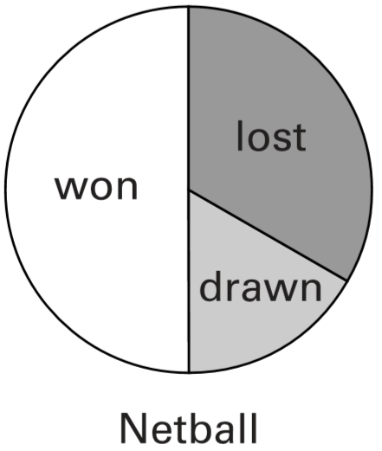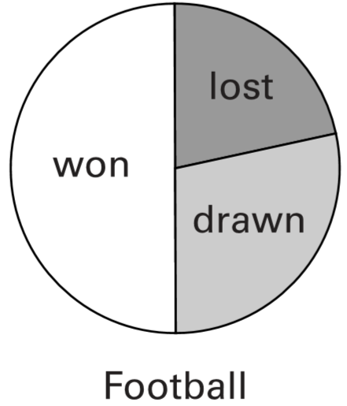  David says, ‘The two teams won the same number of games.’  Is he correct? Explain how you know.
Tony and Gemma looked for snails, worms, slugs and beetles in their gardens. They each made a pie chart of what they found.  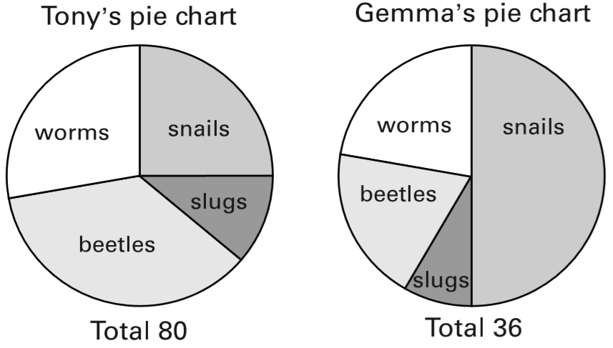  Estimate the number of worms that Tony found.  Who found more snails?  Explain how you know. | 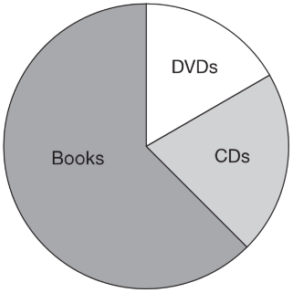  A shop sells books, CDs and DVDs.  This pie chart shows the sales of each in one week.  Estimate the fraction of the total sales that were DVDs.  In this week, 200 CDs were sold.  Estimate how many books were sold.
2018 Paper 3 Question 6
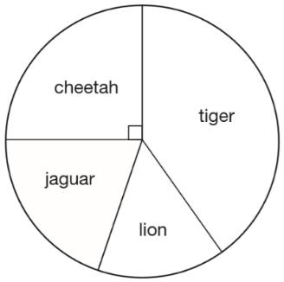
This chart shows the number of different types of big cat in a zoo.
There are 20 big cats in the zoo altogether.
Here are some statements about the chart.
Tick the statements that are true.
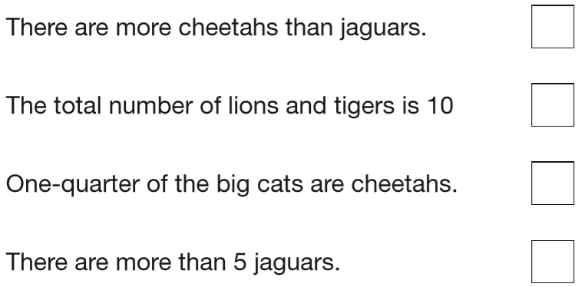

Compare and order numbers with tenths and hundredths
Look at this number.  24.65  Circle the number below that shows the value of the 6.  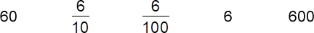 | Look at this number.  46.3  Draw a ring around the value of the 3  $\frac{3}{100}$ 3 $\frac{3}{10}$ 30
Complete the table.  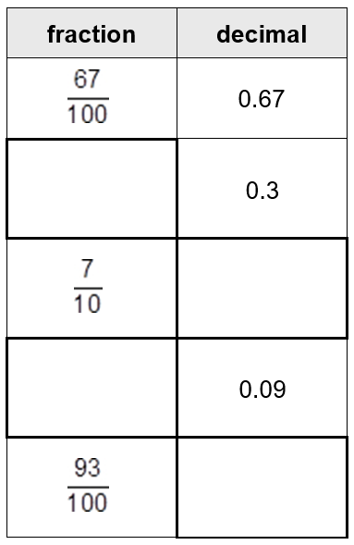 | Here is a number line.  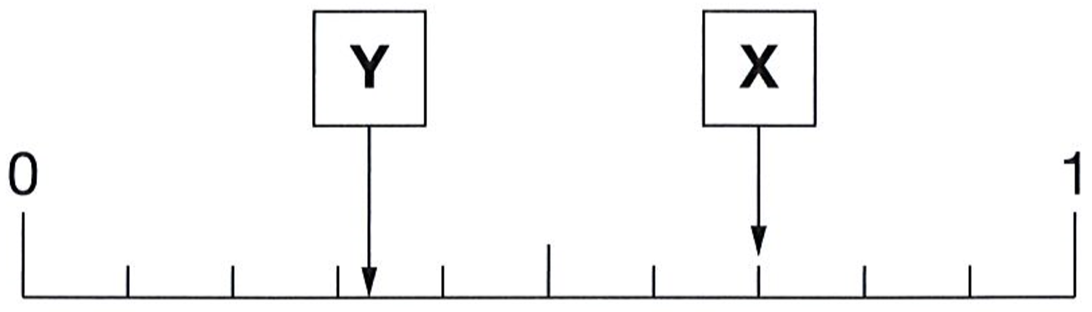  What is the value of X?  Estimate the value of Y.
Here is part of a number line.
Draw an arrow to show the position of 0.32
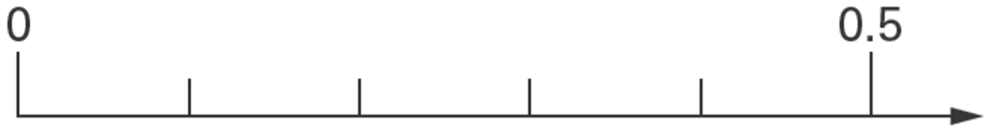
2.1 is marked on the number line.
Mark 0.65 on the number line.
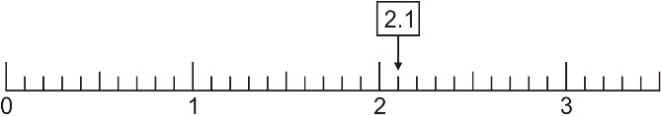
Write these numbers in order.  One has been done for you.  3.03 3 3.3 3.23 3.2  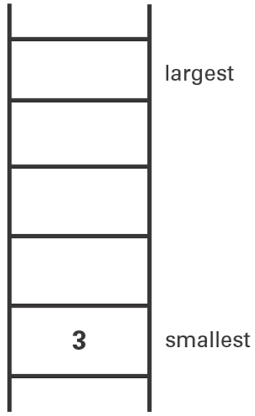 | Write these numbers in order.  One has been done for you.  2.04 24 0.4 0.24 4  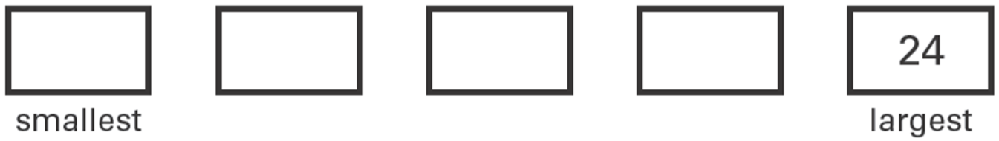
Write these numbers in order of size, starting with the smallest.
3.01 13.0 0.31 1.30 3.1

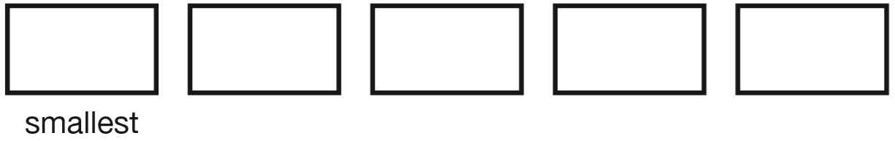
Circle all the numbers that are greater than 0.6  0.5 0.8 0.23 0.09 0.67 | Circle all the numbers that are less than 0.4  0.3 0.8 0.23 0.09 0.63
Write a decimal that is between 3.7 and 3.8 | Here are four digit cards.  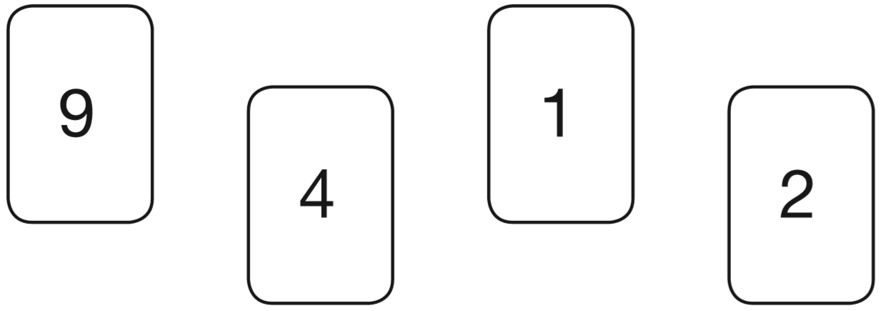  Use each digit card once to make the decimal number nearest to 20  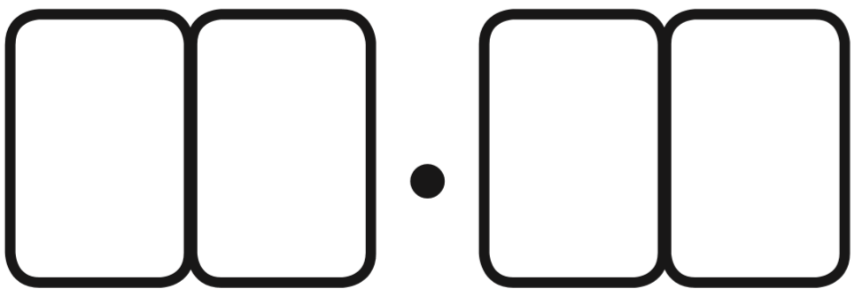
Circle the number closest in value to 0.1

0.01 0.05 0.11 0.2 0.9

Add and subtract decimals
Circle the two numbers which add up to 1  0.1 0.65 0.99 0.45 0.35 | Circle two numbers which add to make 0.12  0.1 0.5 0.05 0.7 0.07 0.2
2016 Paper 2 Question 8  Circle two numbers that add together to equal 0.25  0.05 0.23 0.2 0.5 | Circle two decimals that have a difference of 0.5  0.2 0.25 0.4 0.45 0.6 0.75
Here are some pairs of numbers.  For each pair, circle the number that is nearer to 5  3.5 9.5  2.5 5.5  4.5 6.5 | Tick the two numbers which have a total of 10  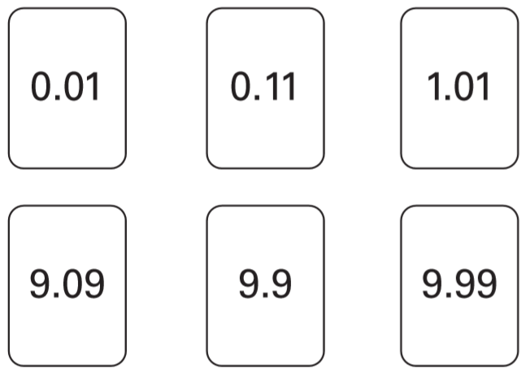
Write in the missing number.  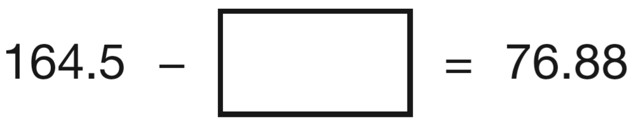 | Write the missing numbers in this sequence.  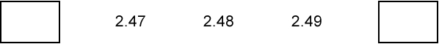
The first two numbers in this sequence are 2.1 and 2.2  The sequence then follows the rule: ‘to get the next number, add the two previous numbers’  Write in the next two numbers in the sequence.  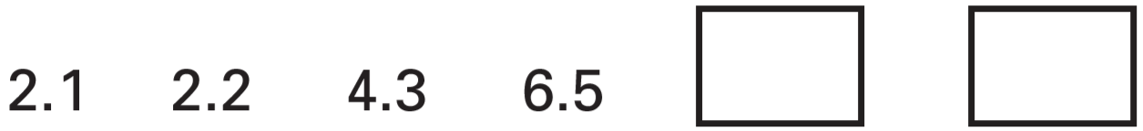 | A boat can safely carry 145 kilograms.  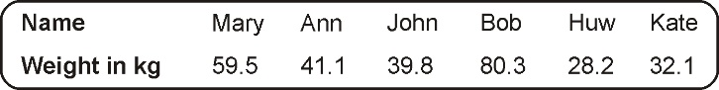  Work out if the boat can safely carry Mary and Bob.
2016 Paper 3 Question 6  Jacob cuts 4 metres of ribbon into three pieces.  The length of the first piece is 1.28 metres.  The length of the second piece is 1.65 metres.  Work out the length of the third piece. | In the chart any three numbers in a line, across or down, have a total of 18.45  Write the missing number.  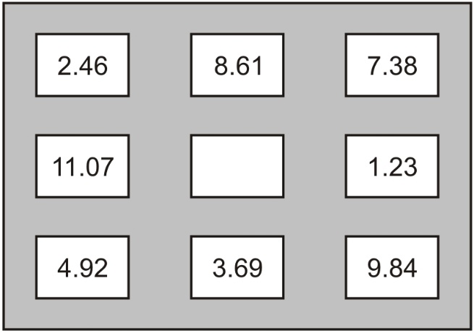
In athletics, Holly did the ‘Hop, step, jump’.
The length of her ‘hop’ was 0.86 m
The length of her ‘step’ was 1.21 m
The length of her ‘jump’ was 3.78 m
What was the total length of Holly’s ‘Hop, step, jump’ to one decimal place?
Circle the correct answer.

5.8 m 5.9 m 6.0 m 6.1 m

Multiply and divide decimals by 10 or 100
2017 Paper 3 Question 1  Write the missing number to make this division correct.  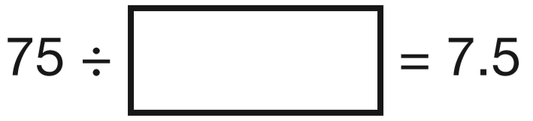 | 2019 Paper 2 Question 6  Write the missing number to make this division correct.  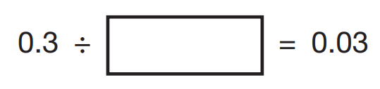
2019 Paper 3 Question 12  Amina’s bed is 190 cm in length and 91 cm in width. She is making a one-tenth scale model of the bed. What are the length and width of Amina’s model?  Length = _____ cm Width = _____ cm | Complete the number sentences using these cards.  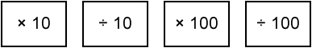  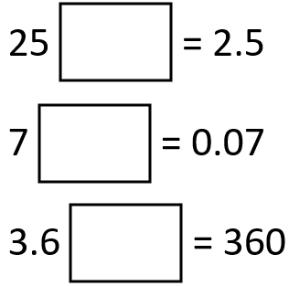
Andy has these cards:
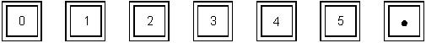
He made the number 42.5 with four of his cards.
Use some of Andy’s cards to show the number 10 times as big as 42.5

Use some of Andy’s cards to show the number 100 times as big as 42.5

Round decimals
Write in the missing numbers.  One has been done for you.  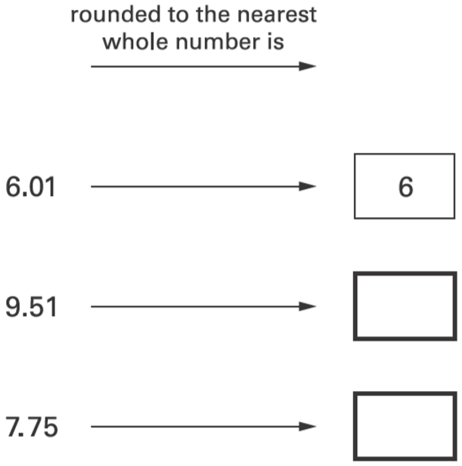 | Write in the missing numbers.  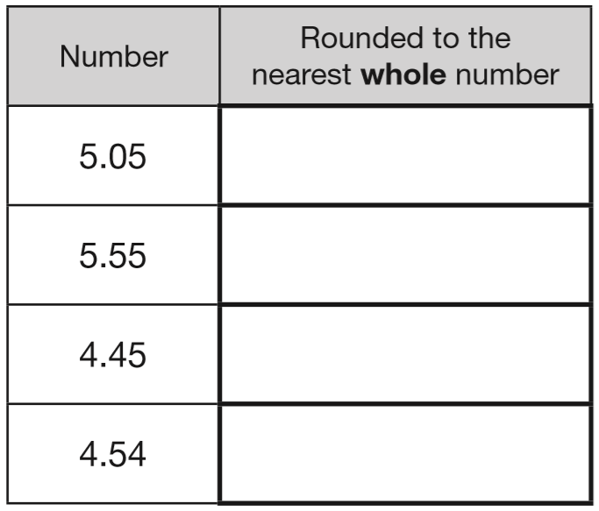
Round the lengths to the nearest whole metre.  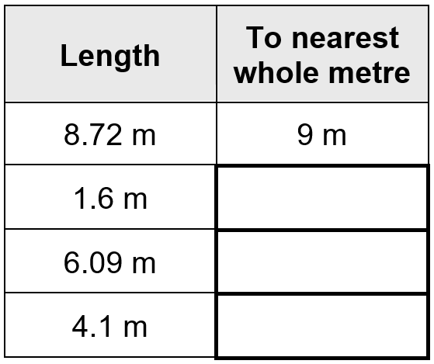 | Round these numbers to one decimal place.  