
Recognise place value in numbers with up to six digits
Write in ﬁgures the number twenty thousand and twenty. | 2015 Paper 3 Question 7  Write the number 53,148 in words.
Circle the value of the digit 9 in the number  6 9 7, 4 3 2  nine thousand  nine hundred  ninety thousand  nine million  nine hundred thousand | Look at this number.  6 9 7, 4 3 2  What is the value of the digit 6 in the number?  Circle the correct answer.  six thousand  six hundred thousand  sixty thousand  six million
Put these houses in order of price starting with the lowest price.
One has been done for you.
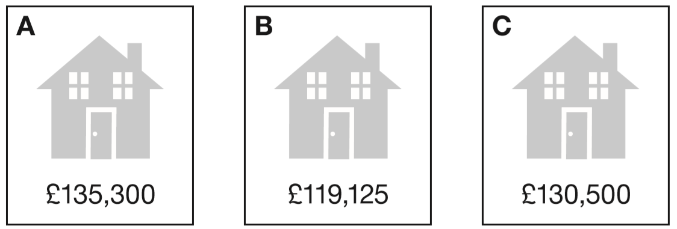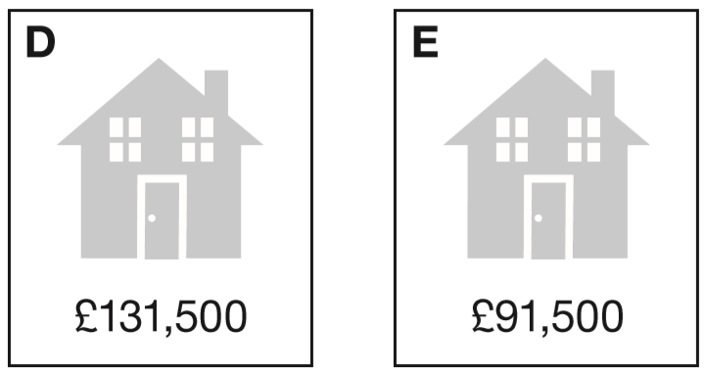




Round numbers with up to 6 digits
2019 Paper 2 Question 14  Complete the table.  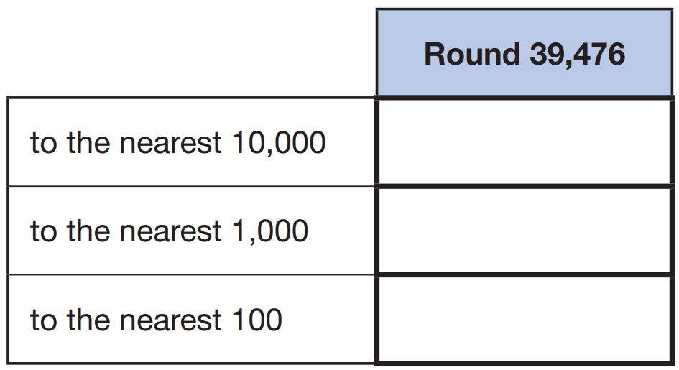 | 2017 Paper 2 Question 10  Round 84,516  to the nearest 10: ________  to the nearest 100: ________  to the nearest 1,000: ________
2015 Paper 2 Question 14  Round 124,531  to the nearest 10,000 __________  to the nearest 1,000 __________  to the nearest 100 __________ | Complete this table to show the numbers rounded to the nearest 100  One has been done for you.  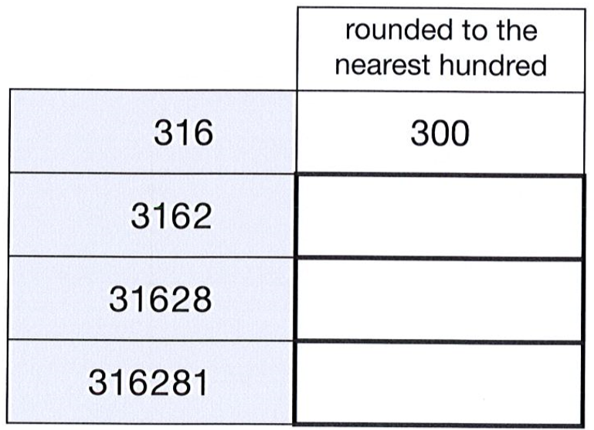
Complete the table.
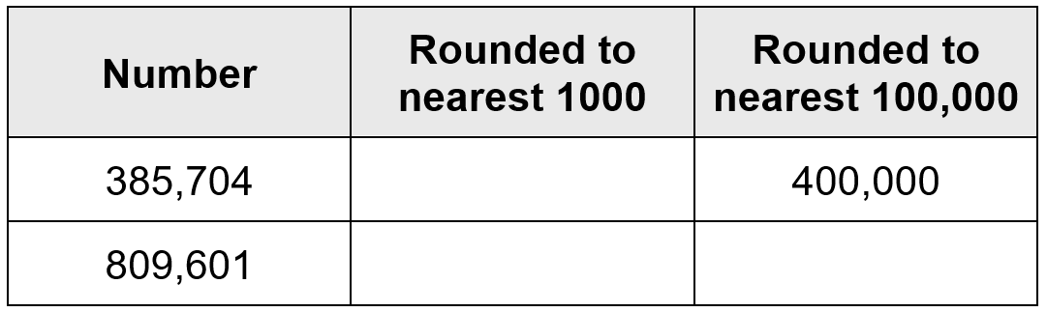
Runa and Jon each start with the same number.
Runa rounds the number to the nearest hundred. Jon rounds the number to the nearest ten.
Runa’s answer is double Jon’s answer. Explain how this can be.

Identify Roman numerals
2017 Paper 2 Question 15    At the end of a film, the year is given in Roman numerals. Write the year MMVI in figures. | Here is a number written in Roman numerals.  DCCIX  Write the number in figures.
Look at these numbers written in Roman numerals.
MCMVII MMCD MDCCXLIII MMDX
Circle the largest number.

What is the value of the smallest number?

Look at these numbers written in Roman numerals.
One is not written correctly. Put a cross on it.

MMCM MCMM MMMC MMCC MCCC

Solve problems involving the addition or subtraction of 10, 100, 1000 or 10 000
2018 Paper 2 Question 6  The numbers in this sequence decrease by the same amount each time.  303,604 302,604 301,604 300,604 …  What is the next number in the sequence? | Write the missing numbers in the sequence.  _______ 467,050 468,050 469,050 _______
Write the missing numbers in the sequence.

_______ 273,001 283,001 293,001 _______
2017 Paper 3 Question 5  Complete this table with the missing numbers.  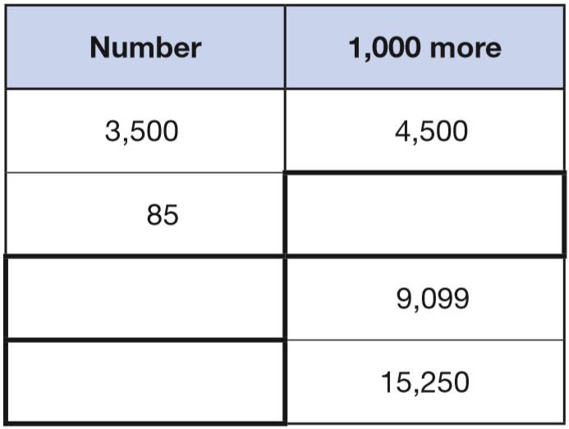 | Write the missing numbers.  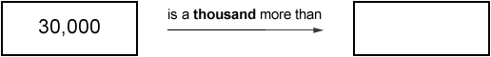  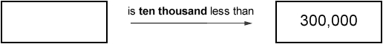
Write the missing numbers.
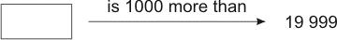

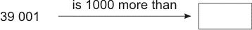
Match pairs of numbers that have a difference of 1000  One has been done for you.  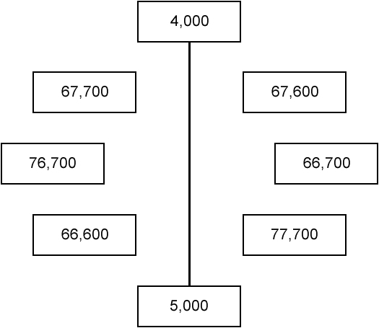 | Write the three missing numbers in the empty boxes.  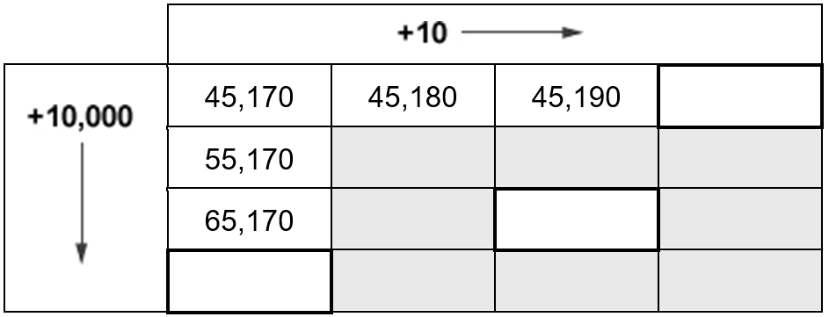
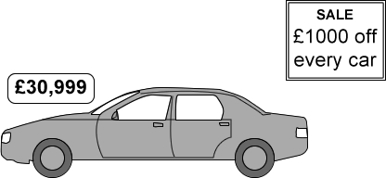
A car usually costs £30,999
How much does it cost in the sale?

Find missing digits in addition and subtraction problems
2018 Paper 3 Question 4  Write the three missing digits to make this addition correct.  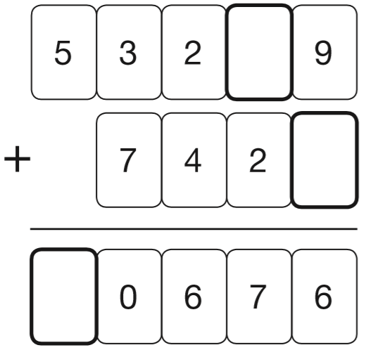 | Write the three missing digits to make this subtraction correct.  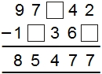

Solve number problems involving addition and subtraction
Here is a number sequence.  Write the missing number.  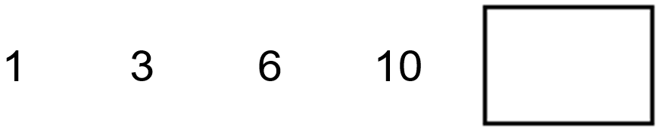 | Estimate the answer to this calculation.  23,901 – 5,097  Circle the correct estimate.  6,000 17,000 18,000 19,000 20,000
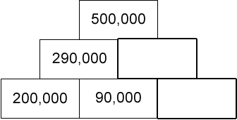
Here is a number pyramid.
The number in a box is the sum of the two numbers below it.
Write the missing numbers.

Solve word problems involving addition and subtraction
2016 Paper 2 Question 4  This table shows the number of people living in various towns in England.  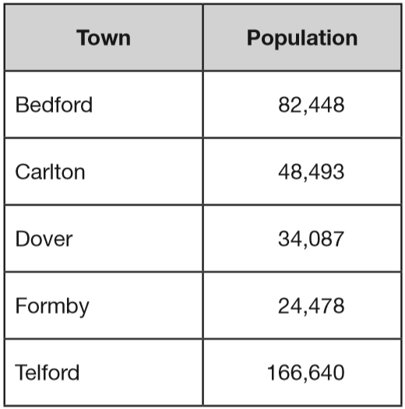  What is the total of the numbers of people living in Formby and in Telford?  What is the difference between the numbers of people living in Bedford and in Dover? | Four children are in a race.  Chen is 2 metres ahead of Alfie.  Nina is 5 metres behind Megan.  Alfie is 3 metres behind Megan.  Write the names of the runners in order, starting with the child who is furthest ahead.
2017 Paper 2 Question 8
At the start of June, there were 1,793 toy cars in the shop. During June,
• 8,728 more toy cars were delivered
• 9,473 toy cars were sold.
How many toy cars were left in the shop at the end of June?

14,890 festival tickets were sold before the event.
Another 6,752 were sold on the day.
546 people did not arrive at the festival.
How many people were at the festival altogether?

Solve number problems involving multiplication and division
Write the missing numbers in this sequence. | Write in the missing numbers in this sequence.  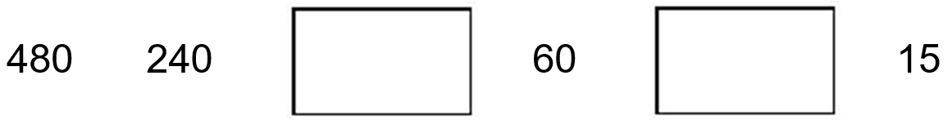
14 × 15 × 16 = 3,360  What is the answer to  15 × 16 × 14 = | Kim knows that  137 × 28 = 3836  Explain how she can use this information to work out this multiplication.  138 × 28
2018 Paper 2 Question 10    Write the correct symbol in each box to make the statements correct.  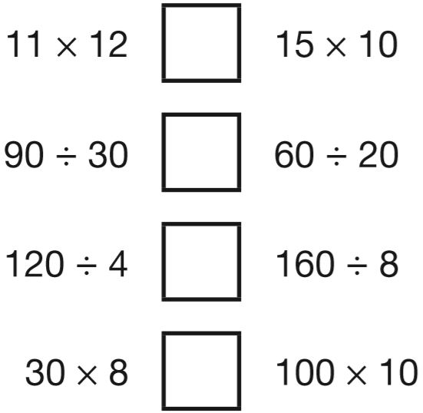 | Circle two different numbers which multiply together to make 1 million.  10 100 1000 10000 100000
2016 Paper 3 Question 19
Circle two numbers that multiply together to equal 1 million.

200 2,000 5,000 50,000

Find missing digits in multiplication or division problems
Write in the two missing digits.  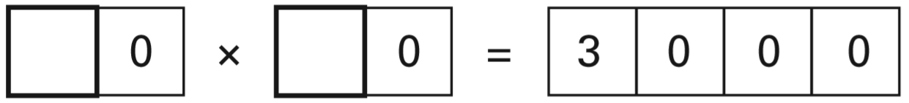 | Write what the three missing digits could be.  
2015 Paper 2 Question 10  Write the two missing digits to make this long multiplication correct.  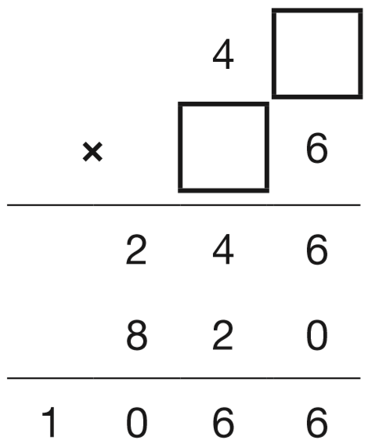 | Write the missing digits.  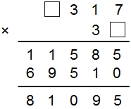
Write in the missing digits.
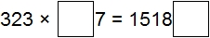

Find missing numbers in multiplication problems
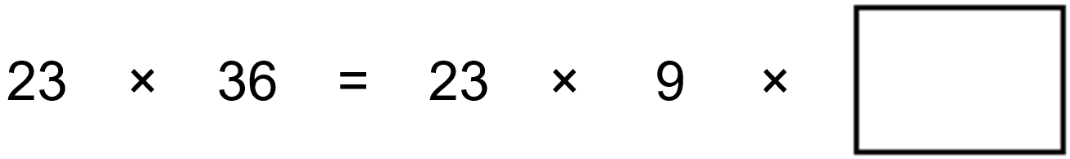 | Write the two other prime numbers that multiply to make 165  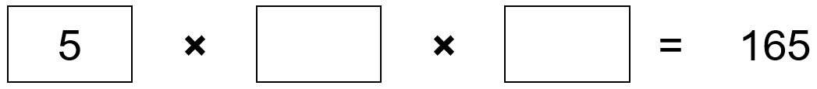
Write what the three missing digits could be in this calculation.  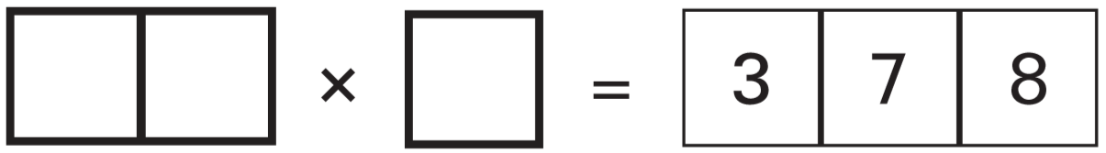 | Fill in the three missing whole numbers in this calculation.  Each number is less than 10  
Write the three prime numbers which multiply to make 231  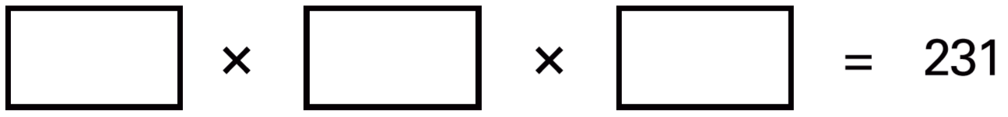 | Three single-digit numbers multiply to make 504  Write the missing numbers  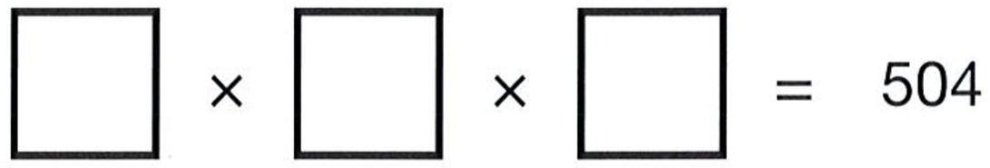
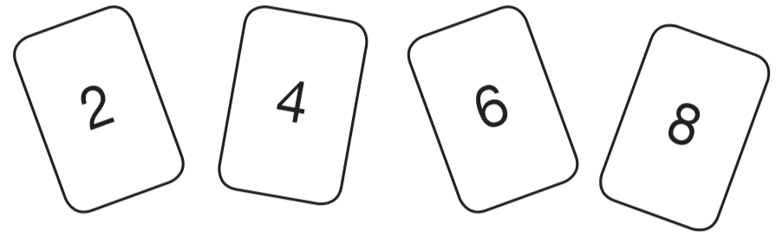  Use all four digit cards to make this number sentence correct.   | Write the two missing digits in this multiplication.  
Two 2-digit numbers multiply to make 176
Write the two missing numbers.
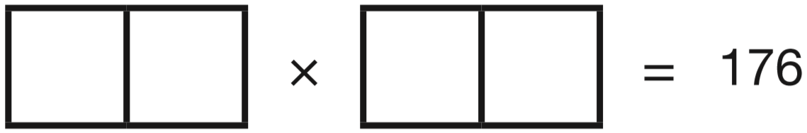

Solve word problems involving multiplication or division
Luke buys 750 grams of apples.  Each apple weighs between 140 grams and 160 grams.  Circle the number of apples that Luke buys.  4 5 6 7 8 | 2018 Paper 3 Question 12  This table shows the areas of the United Kingdom and Jamaica.  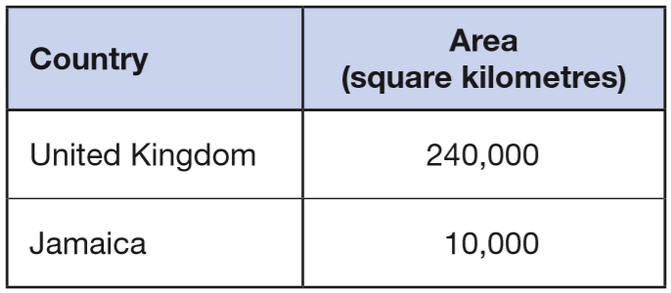  The area of the United Kingdom is larger than the area of Jamaica. How many times larger is the United Kingdom?
This relationship connects the number of pencils and the number of boxes.
number of pencils = number of boxes × 12
How many pencils are in 18 boxes?

Jordan, Anna and Ryan collect picture cards.  Cards are worth either 50 points or 100 points.  This table shows the cards they have.  Complete the table for Anna and Ryan.  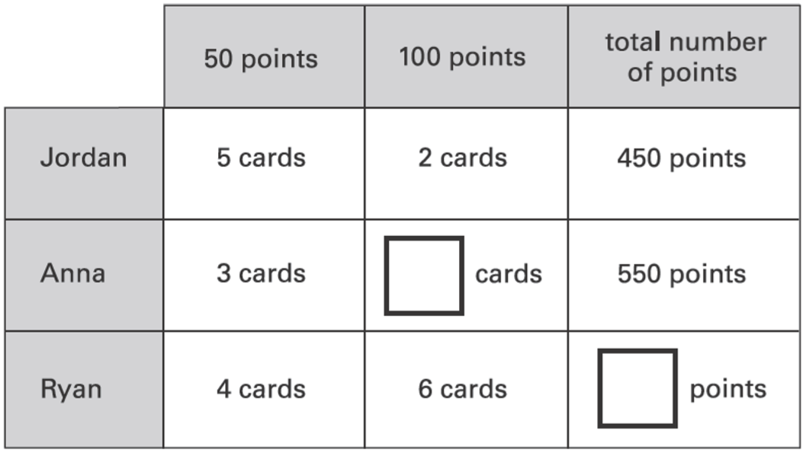 | 2017 Paper 3 Question 2  A group of friends earns £80 by washing cars.  They share the money equally.  They get £16 each.  How many friends are in the group?
In a supermarket storeroom there are:
7 boxes of tomato soup
5 boxes of pea soup
4 boxes of chicken soup
There are 24 tins in every box.
How many tins of soup are there altogether?

2018 Paper 2 Question 15  A box contains trays of melons.  - There are 15 melons in a tray.  - There are 3 trays in a box.  A supermarket sells 40 boxes of melons.  How many melons does the supermarket sell? | 2017 Paper 3 Question 12  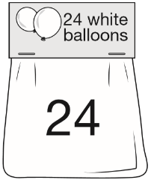  Adam buys 6 bags of white balloons. Chen buys 3 bags of red balloons. Adam says, ‘I have four times as many balloons as Chen.’  Explain why Adam is correct.  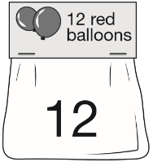
2016 Paper 3 Question 11
A toy shop orders 11 boxes of marbles.
Each box contains 6 bags of marbles.
Each bag contains 45 marbles.
How many marbles does the shop order in total?

Solve number problems using the four operations
Draw one line from each calculation on the left to the correct box on the right. One has been done for you.  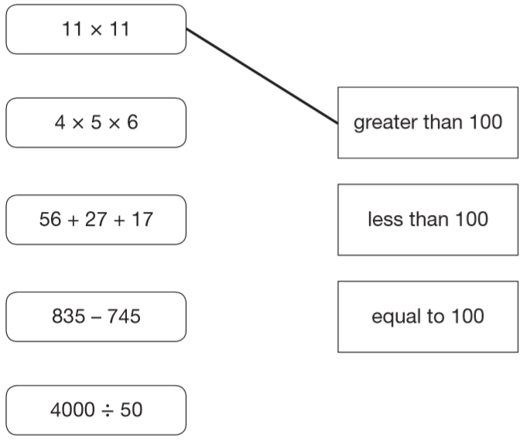 | Hayley makes a sequence of numbers.  Her rule is: ‘find half the last number then add 10’  Write in the next two numbers in her sequence.  
Write the correct sign >, < or = in each of the following.
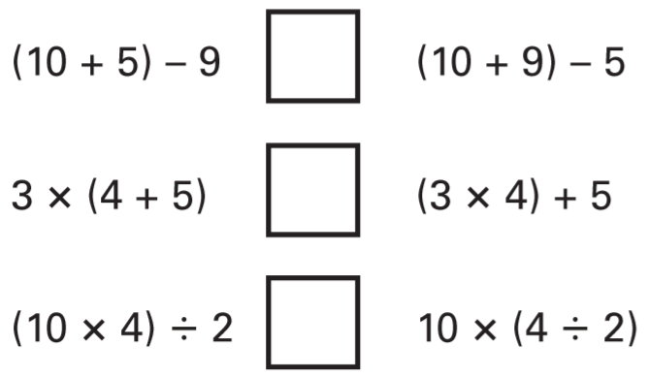
Write in what the missing numbers could be.  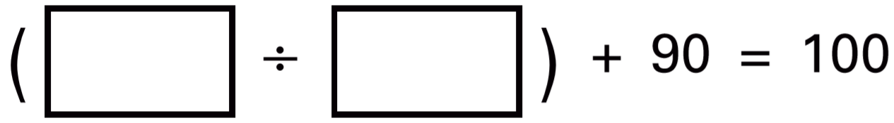 | In the circle write +, –, ×, or ÷ to make the calculation correct.  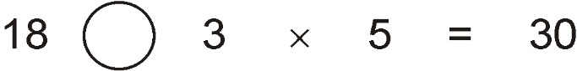
The number in A is twice the number in D.  The number in B is 5 less than the number in C.  The number in D is 10 more than the number in B.  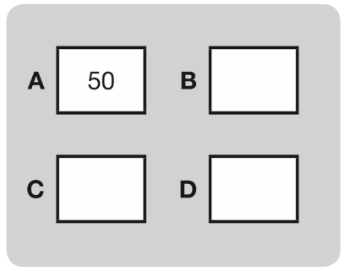  Write the missing numbers in this diagram.  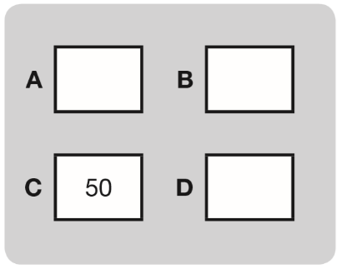  Now use the same rule for this diagram. | The numbers in this sequence increase by the same amount each time. Write in the missing numbers.  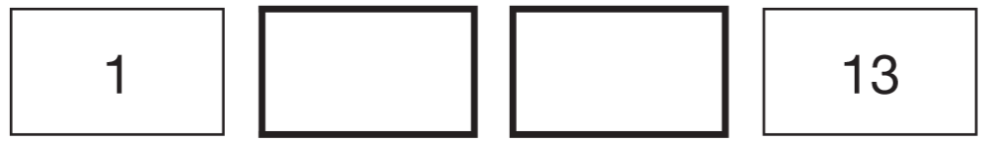
Halid makes a sequence of 5 numbers.
The first number is 2
The last number is 18
His rule is to add the same amount each time.
Write in the missing numbers.
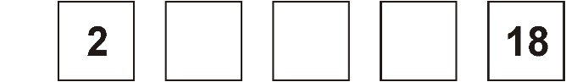

Find unknown values in pictorial equations
and  each stand for a different number.      What is the value of ? | 2016 Paper 3 Question 4  Each shape stands for a number.  Work out the value of each shape.  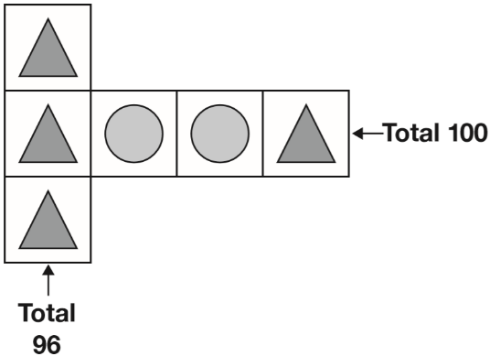  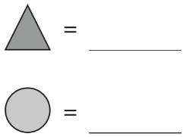
Each shape stands for a number. Work out the value of each shape.  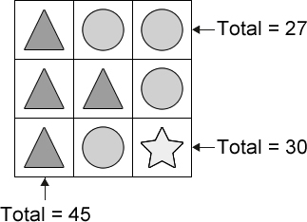  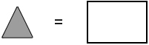     | Amina is making designs with two different shapes.  She gives each shape a value.  Calculate the value of each shape.  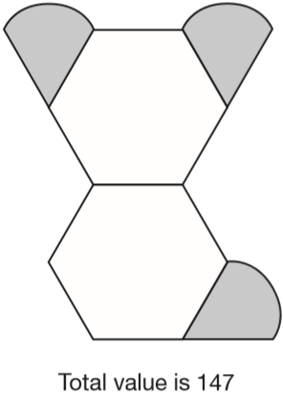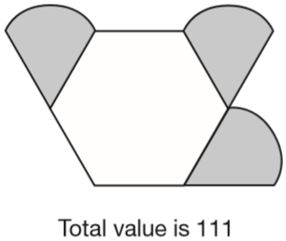  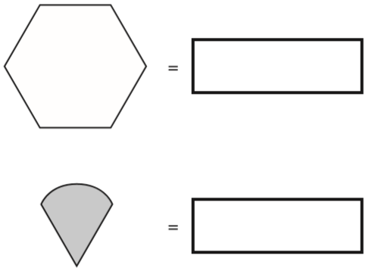
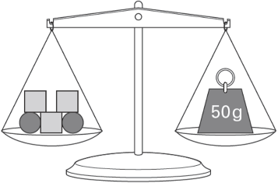  Emma uses 5 shapes to balance a 50 g weight on a scale.  Each square weighs 12 g.  How much does each circle weigh? | 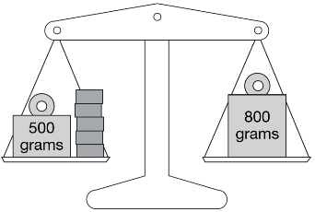  Lin has five blocks which are all the same.  She balances them on the scale with two weights.  Calculate the weight of one block.
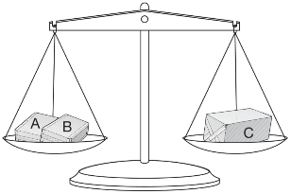
Amir has three parcels.
Parcels A and B together weigh the same as parcel C.
The three parcels weigh 800 grams altogether.
Parcel A weighs 250g.
How much does parcel B weigh?

Solve word problems using the four operations
Alfie has two sticks.  He puts them end to end.  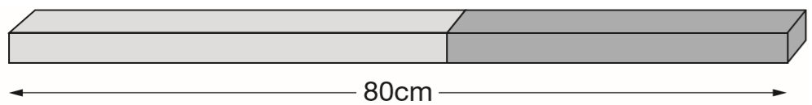  One stick is 10cm longer than the other stick.  How long are the two sticks? | A cake costs 15p more than a biscuit.  Megan bought a cake and two biscuits for 90p.  How much do a cake and a biscuit each cost?
Two letters have a total weight of 120 grams.
One letter weighs twice as much as the other letter.
Write the weight of the heavier letter.

Sarah, Amy and Liam stand on some weighing scales two at a time.  Here are the measurements:  Sarah and Amy – 70 kg  Sarah and Liam – 80 kg  Liam and Amy – 80 kg  How much does Liam weigh? | Mina has 5 more marbles than Kirsty.  Kirsty has 2 more marbles than Seb.  Altogether they have 30 marbles.  How many marbles does each child have?
2017 Paper 3 Question 16  There are 2,400 leaflets in a box.  William and Ally take 450 leaflets each.  Adam and Chen share the rest of the leaflets equally.  How many leaflets does Adam get? | 2019 Paper 3 Question 19  Layla makes jewellery to sell at a school fair. Each bracelet has 53 beads.  She makes 68 bracelets.  Each necklace has 105 beads.  She makes 34 necklaces.  How many beads does Layla use altogether?
Liam thinks of a number.  He multiplies the number by 5 and then subtracts 60 from the result.  His answer equals the number he started with.  What was the number Liam started with? | 30 children are going on a trip.  It costs £5 including lunch.  Some children take their own packed lunch. They pay only £3  The 30 children pay a total of £110  How many children are taking their own packed lunch?

Calculate differences in temperature
Children in Year 6 make number patterns.  This group uses the rule ‘2 less than’.  Write in the missing number.  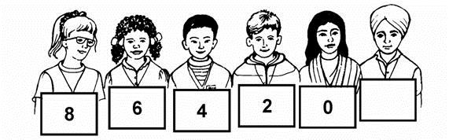 | Write these temperatures in order from hottest to coldest.  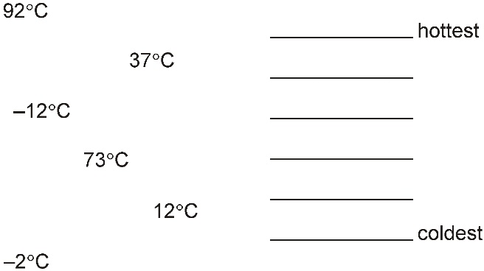
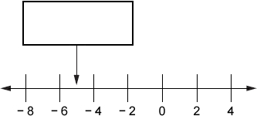
Here is part of a number line.
Write the number shown by the arrow.
Put these temperatures in order, starting with the lowest.  21°C −13°C −24°C 0°C 35°C  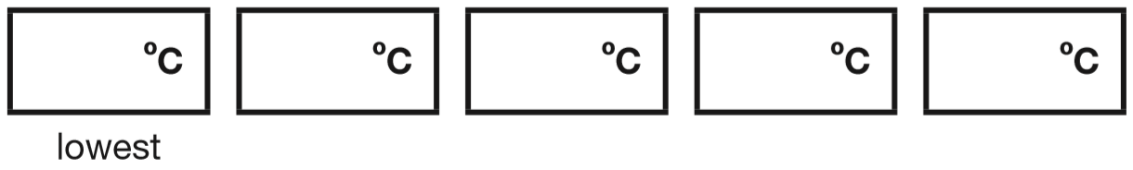 | Circle two numbers which have a difference of 2  –1 – 0.5 0 0.5 1 1.5
Circle two numbers with a difference of 8

–5 –4 –3 –2 –1 0 1 2 3 4 5

Here is part of a temperature scale.  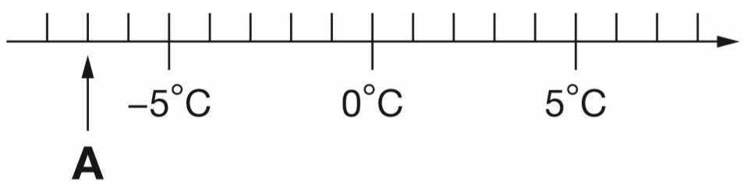  What is the temperature shown at A?  What temperature is 20 degrees higher than A? | The temperature in the fridge is 4°C.  The temperature in the freezer is -18°C.  What is the difference in temperature between the fridge and the freezer?
The temperature inside an aeroplane is 20°C.
The temperature outside the aeroplane is –30°C.
What is the difference between these temperatures?

2016 Paper 3 Question 2  This table shows the temperature at 9am on three days in January.  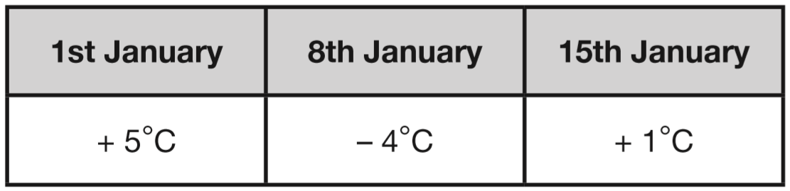  What is the difference between the temperature on 1st January and the temperature on 8th January?  On 22nd January the temperature was 7 degrees lower than on 15th January.  What was the temperature on 22nd January? | 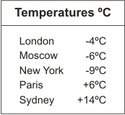  Here is a table of temperatures at dawn on the same day.  What is the difference in temperature between London and Paris?  At noon the temperature in New York has risen by 5°C.  What is the temperature in New York at noon?
Read scales or tables to calculate differences in temperature
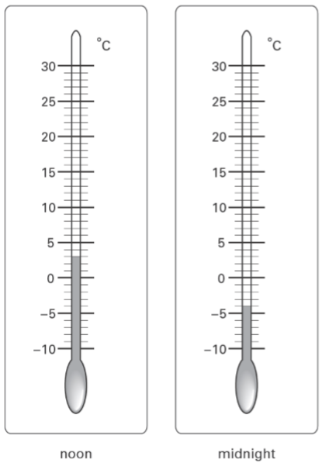  These are the temperatures at noon and midnight on a day in winter.  How many degrees higher is the temperature at noon than at midnight? | Here are two thermometers.  They show two different temperatures.  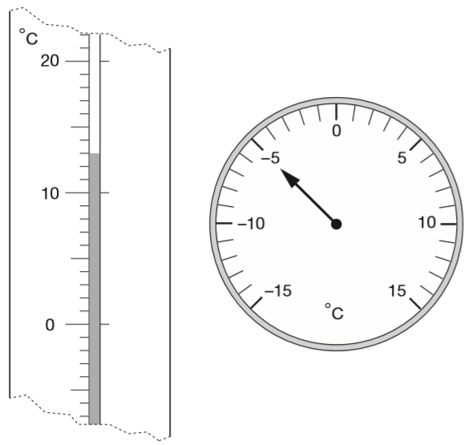  What is the difference between the two temperatures?
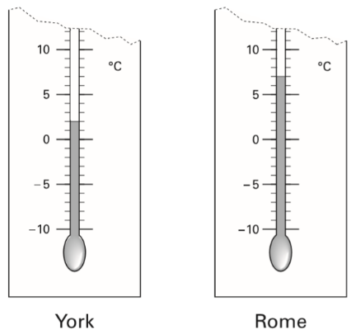  These are the temperatures in York and Rome on a day in winter.  How many degrees colder is it in York than in Rome?  On another day, the temperature in York is 4°C  Rome is 7 degrees colder than York.  What is the temperature in Rome? | 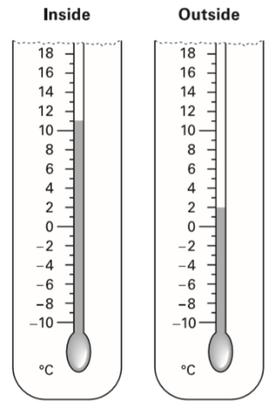  Two thermometers show the temperature inside and outside a greenhouse on a day in January.  How many degrees warmer was it inside the greenhouse than outside?  Later the temperatures were -1°C inside and -8°C outside. What is the difference between these two temperatures?

2018 Paper 2 Question 5  Here are the temperatures in four cities at midnight and at midday.  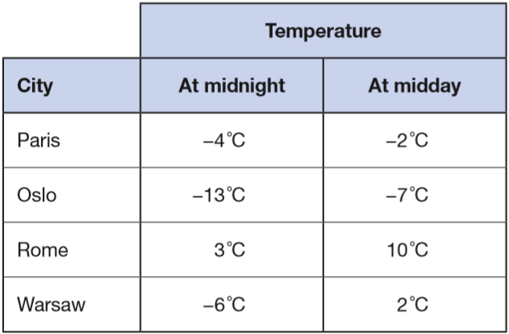  At midnight, how many degrees colder was Paris than Rome?  Which city was 6 degrees colder at midnight than at midday? | This weather chart shows the highest and lowest temperatures in a town on five days in March.  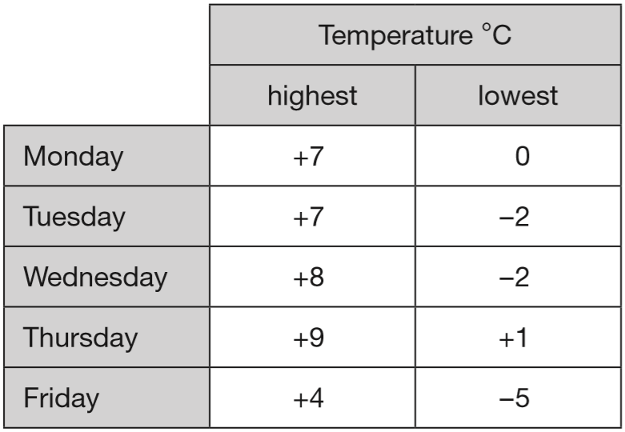  Which day has the greatest difference between the highest and the lowest temperatures?  What is the difference between the lowest temperatures on Thursday and Friday?
2015 Paper 2 Question 3
This graph shows the temperature in six cities on one day in January.
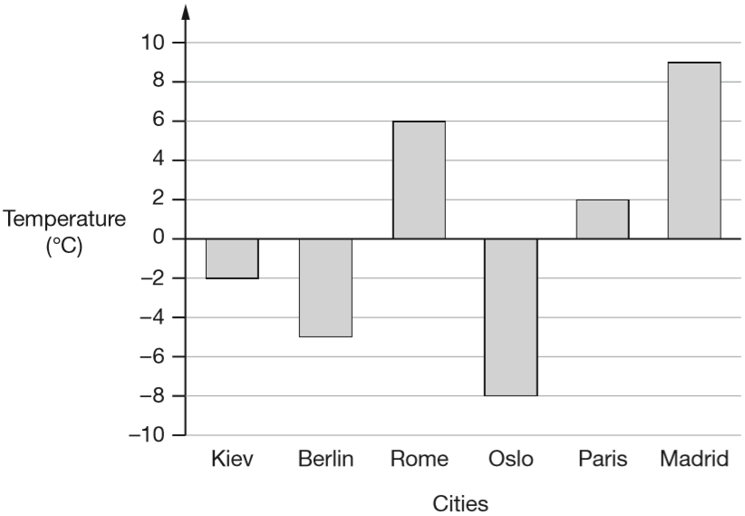
Which city was 4 degrees warmer than Kiev?

What was the difference between the temperature in Oslo and the temperature in Berlin?

Identify multiples
Circle all the multiples of 10.  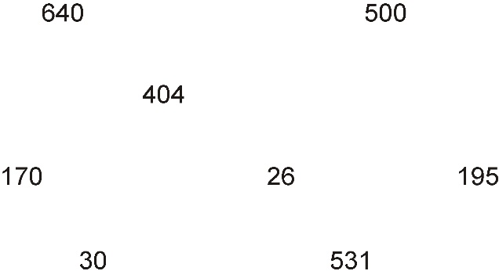 | Write one number in each place in the sorting diagram.  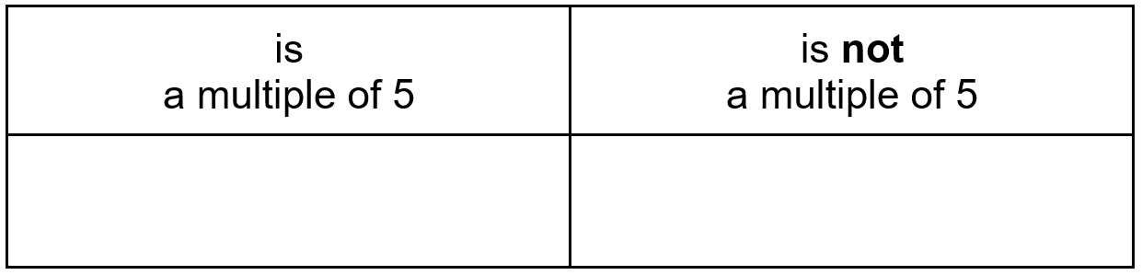
Circle the numbers that are multiples of 4

14 24 34 44 54

Circle all the numbers that are multiples of 4

8 24 5 30 12

Circle all the multiples of 8 in this list of numbers.  18 32 56 68 72 | Circle the numbers that are multiples of 7  27 42 52 63 77

Here is a table. The tick in the box shows that 20 is a multiple of 10  Put four more ticks to complete the table.  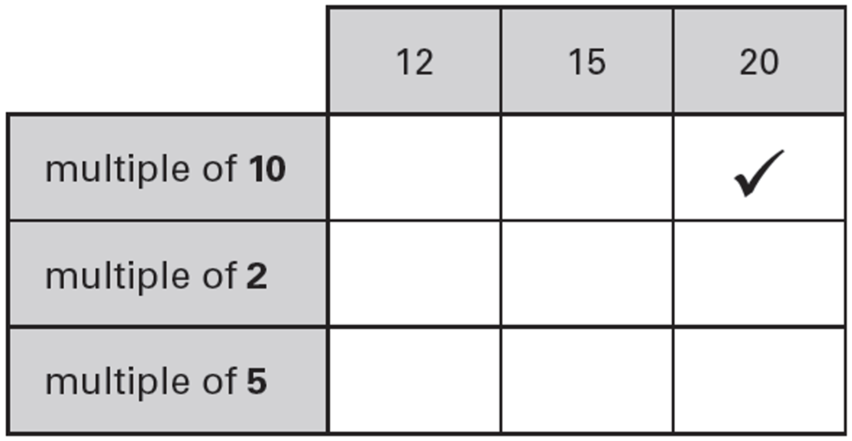 | Circle all the numbers that are one more than a multiple of 4  11 17 25 34 40 49
 | Write all the multiples of 3 that are greater than 10 and smaller than 20
2015 Paper 2 Question 7  In the circles, write a multiple that belongs to each set. One has been done for you.  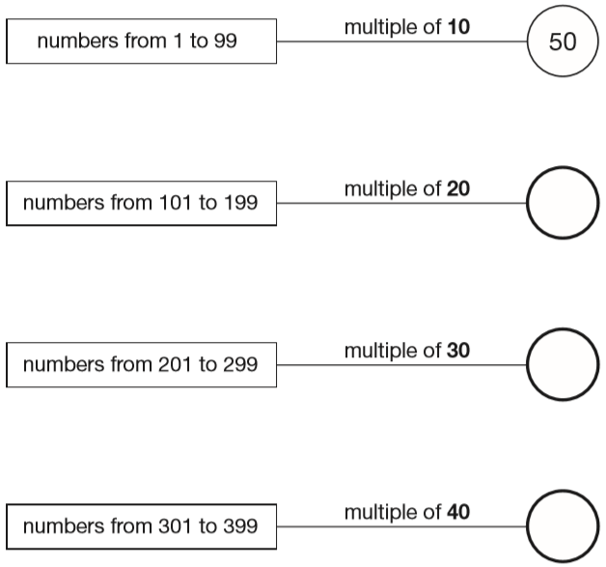 | Here are four labels.  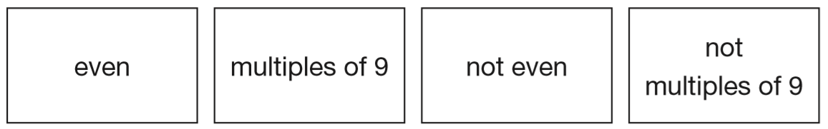  Write each label in the correct position on the sorting diagram below.  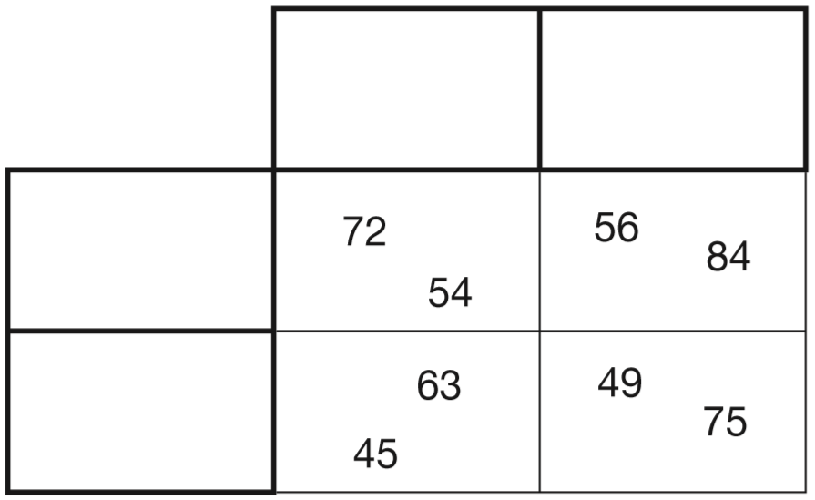
Here is a diagram for sorting numbers.  Write one number in each white section of the diagram.  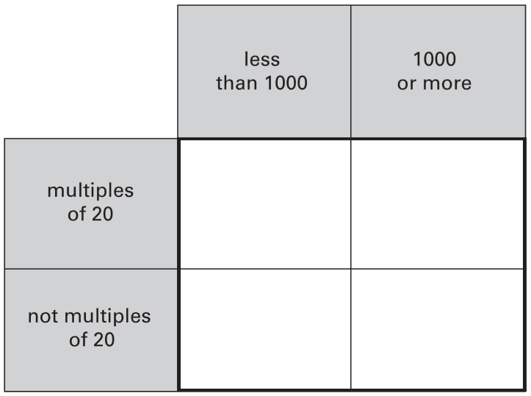 | Here is a diagram for sorting numbers.  Write each number in its correct place on the diagram.  2 20 201 2000  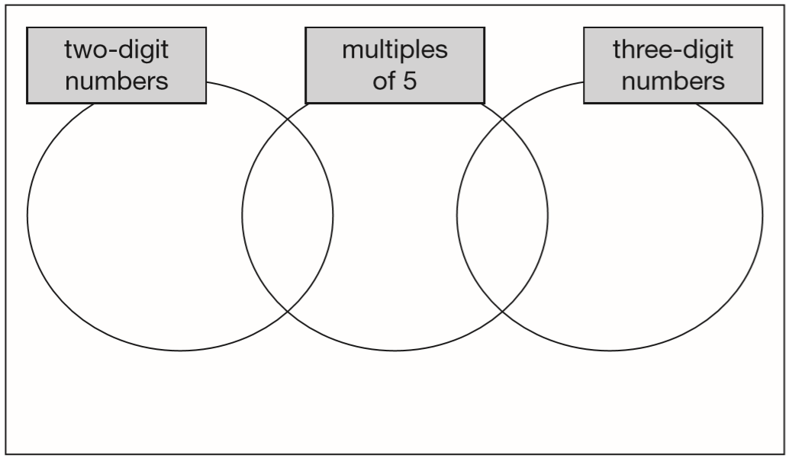
Recognise and use rules for multiples
John says, ‘Every multiple of 5 ends in 5’  Is he correct? Explain how you know. | Amir says, ‘All numbers that end in a 4 are multiples of 4.’ Is he correct? Explain how you know.
This statement is not true.  ‘A multiple of 10 added to a multiple of 10 always makes a multiple of 20’  Give an example to show that this statement is not true. | Circle three numbers that add to make a multiple of 10  11 12 13 14  15 16 17 18 19

2017 Paper 3 Question 3  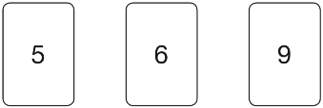  Chen uses these digit cards.  She makes a 2-digit number and a 1-digit number.  She multiplies them together.  Her answer is a multiple of 10  What could Chen’s multiplication be?  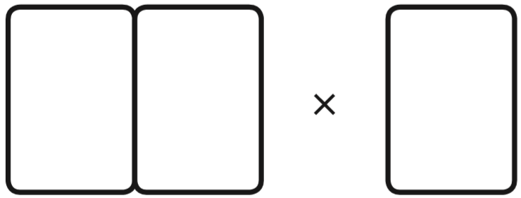 | Here are four digit cards.  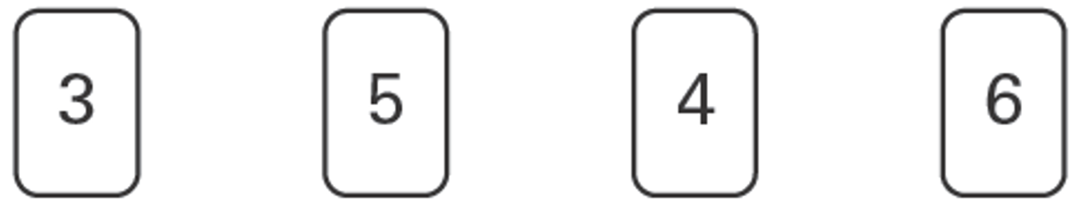  Use each of the digits once to make a total that is a multiple of 5  
Here are six digit cards.  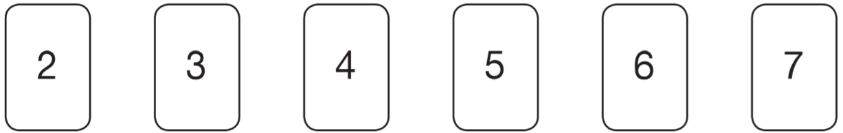  Use all six digit cards to make three multiples of 3.  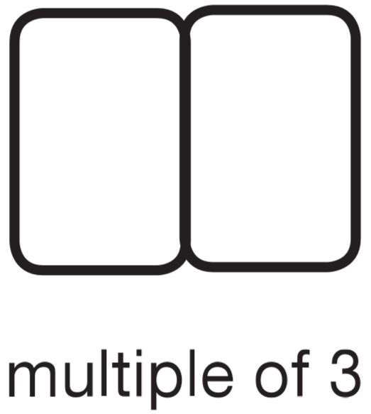 | Here are five number cards.  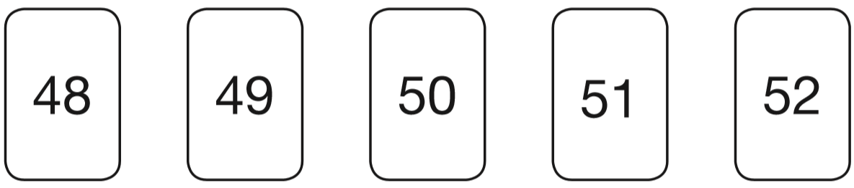  Use each card once to make every statement below correct.  _____ is a multiple of 3  _____ is a multiple of 4  _____ is a multiple of 5  _____ is a multiple of 6  _____ is a multiple of 7
Complete this two digit number so that it is a multiple of 6.  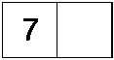 | Complete this three-digit number so that it is a multiple of 9  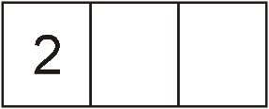
P stands for a multiple of 3  Q stands for a different multiple of 3  Tick each statement according to whether it is always true, sometimes true or never true.  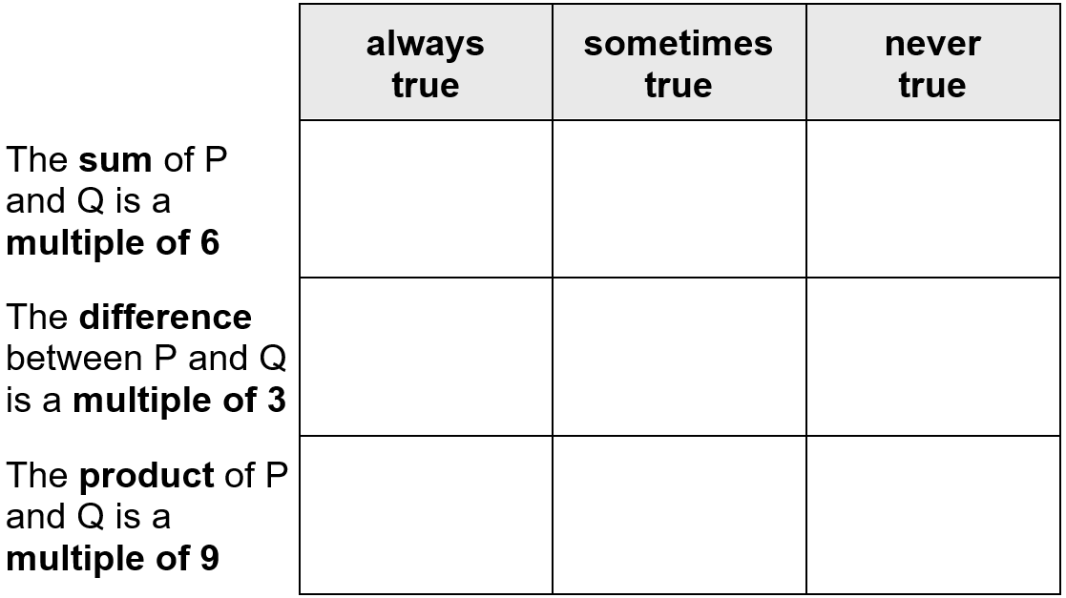 | Here is a sorting diagram with four sections, A, B, C and D.  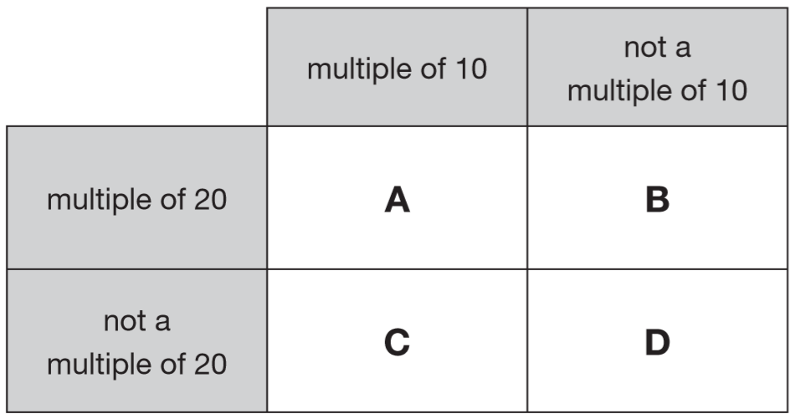  Write a number that could go in section C.  Section B can never have any numbers in it.  Explain why.

Identify common multiples on diagrams
One number is in the wrong place on the sorting diagram. Put a cross on it.  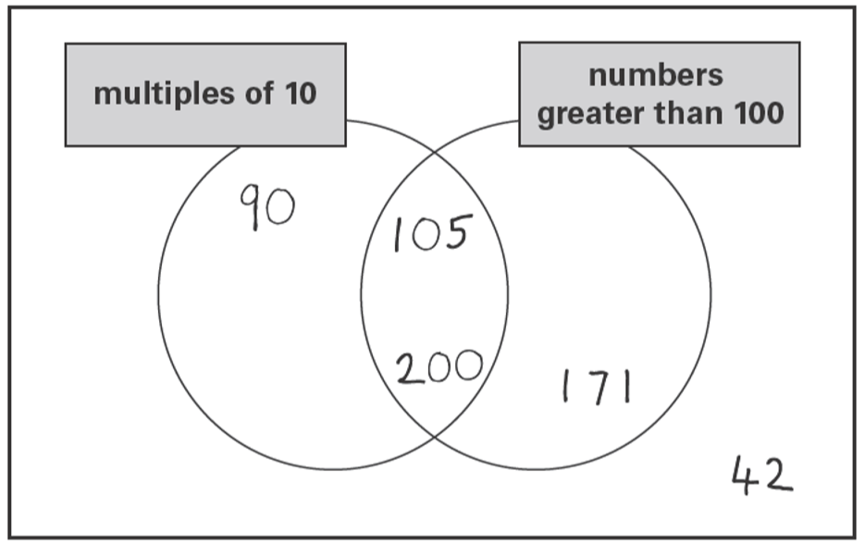 | Here is a sorting diagram.  Write a correct number in each of the two boxes.  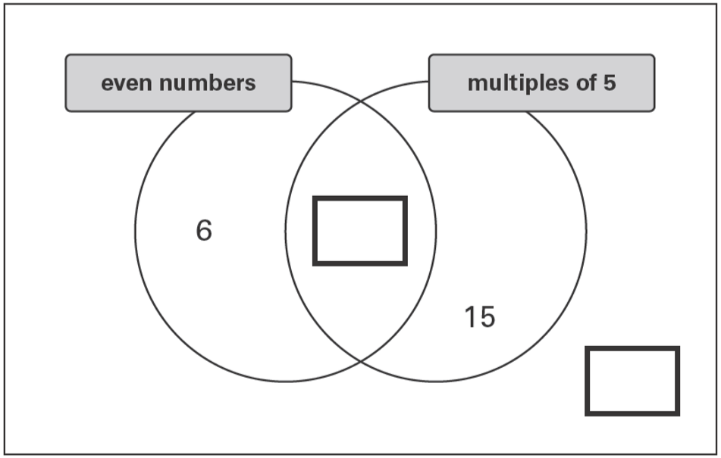
Write each of these numbers in its correct place on the sorting diagram.  40 8 15  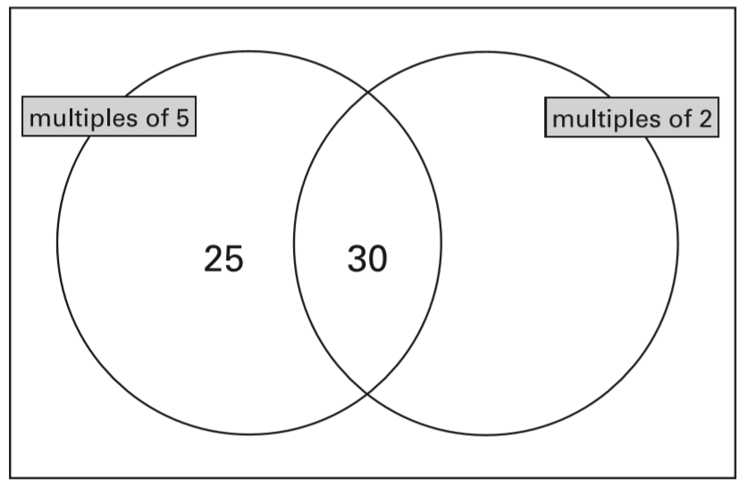 | Write these numbers in the correct places on this sorting diagram.  16 26 36  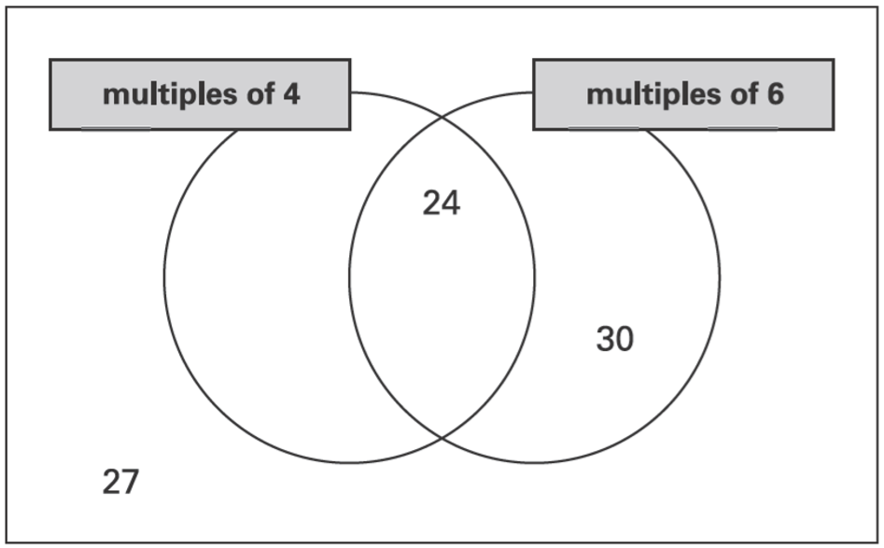
Here is a Venn diagram for sorting numbers.
Write each number in its correct place on the diagram.
10 11 12 13
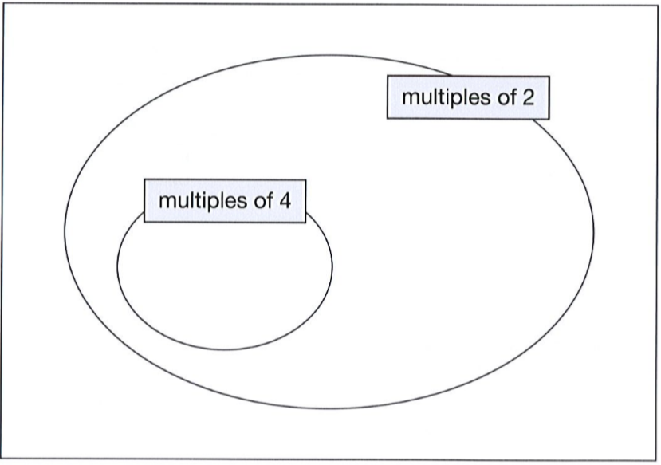

Identify common multiples
2015 Paper 3 Question 1  Here is a diagram for sorting numbers.  Write one number in each box. 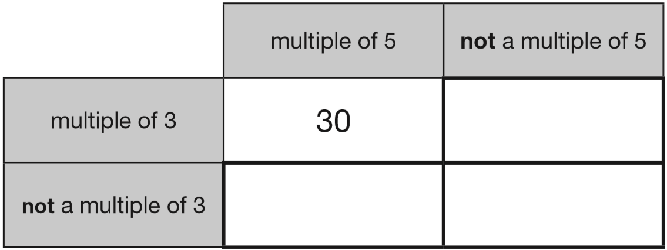 | Write one number which fits all three of these statements:  It is a multiple of 4.  It is a multiple of 6.  It ends in ‘8’  Explain why a number which ends in ‘3’ cannot be a multiple of 4
Here is a number chart. Circle the smallest number on the chart that is a multiple of both 2 and 7  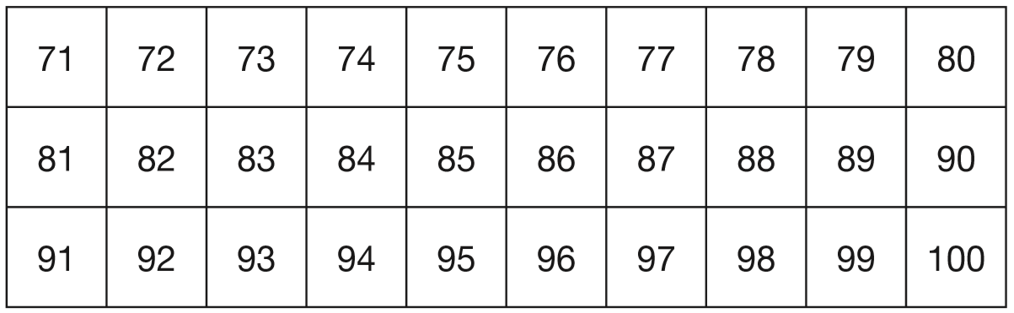  Here is the same number chart. Circle the largest number that is not a multiple of 2 or 3 or 5 | 2016 Paper 2 Question 14  Write all the common multiples of 3 and 8 that are less than 50
364 is a multiple of 7 but not a multiple of 3
384 is a multiple of 3 but not a multiple of 7
Find a number between 364 and 384 that is
both a multiple of 7 and a multiple of 3

n and p stand for two numbers.
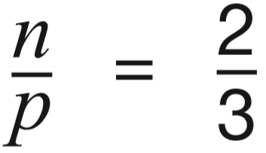
n is a multiple of 5
p is a multiple of 6
Find numbers that n and p stand for.

Work out the missing numbers below.
The first one is done for you.
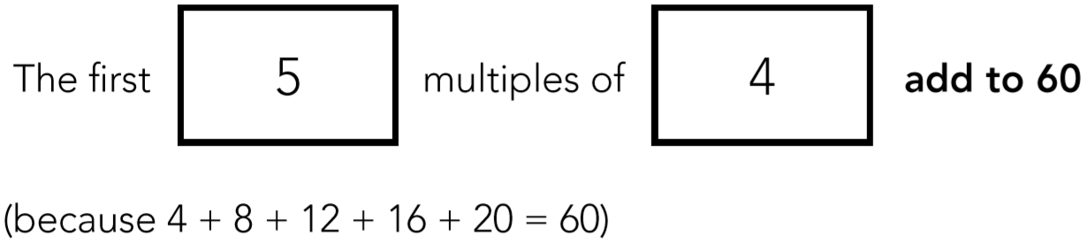


Now use different numbers to complete the sentence below.


Recognise vocabulary of factors
Here are four number cards.  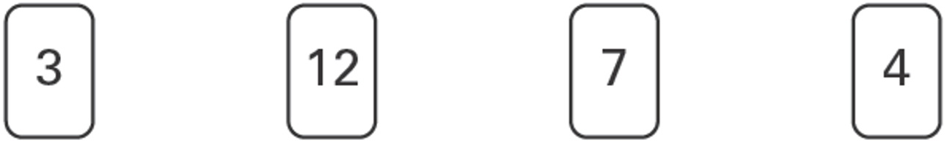  Which two number cards are factors of 42?   | 1 and 35 is a factor pair of 35  What is the other factor pair of 35?  
Write the missing numbers.

Factors of 20 = {1, ___ , ___ , ___ , ___ , 20}

The factor pairs of 8 are  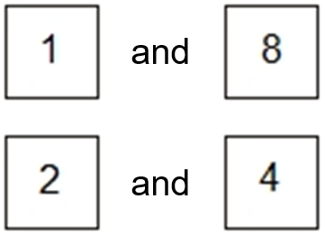  Write all the factor pairs of 42  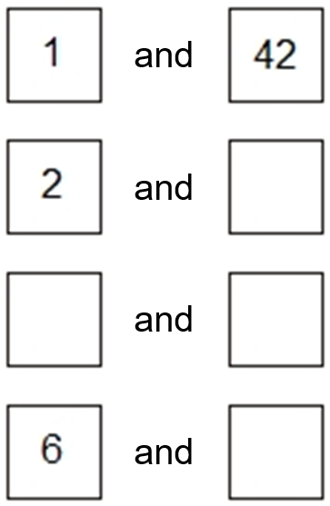 | 1 and 48 is factor pair of 48  Find three other factor pairs of 48  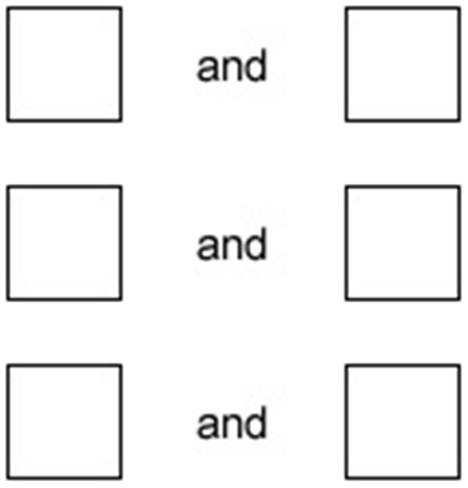
 | Write all the numbers between 50 and 100 that are factors of 180
This three-digit number has 2 and 7 as factors.
2 9 4
Write another three-digit number which has 2 and 7 as factors.
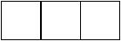
The factors of 11 sum to 12
Write the other number whose factors sum to 12

Identify common factors
Write these numbers in the correct places on the diagram.  5 6 7 8  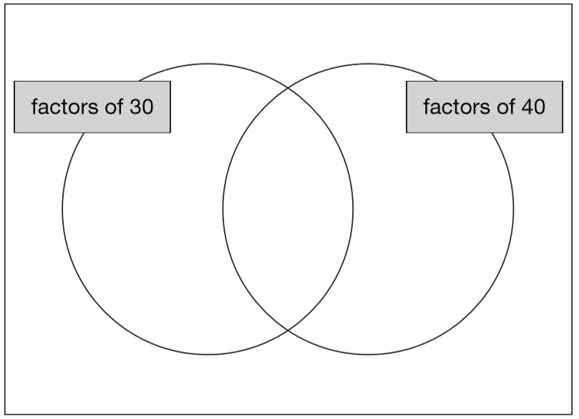 | 2018 Paper 3 Question 5  Tick the numbers that are common factors of both 12 and 18  2 3 6 9 12
 | Write all the factors of 30 which are also factors of 20
2017 Paper 3 Question 8
Write three factors of 30 that are not factors of 15

Identify prime numbers
Circle the two prime numbers.  29 39 49 59 69 | Here is a diagram for sorting numbers.  Write these three numbers in the correct boxes.  You may not need to use all of the boxes.  9 17 20  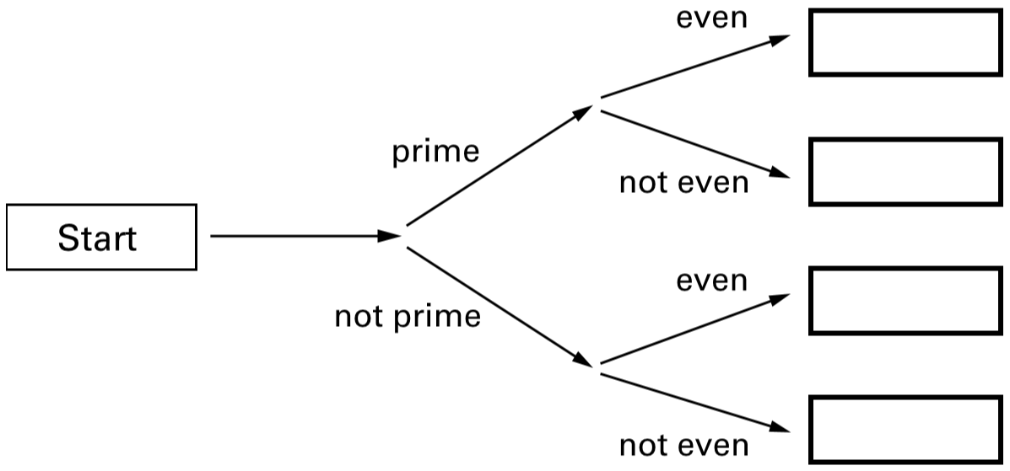
2019 Paper 2 Question 18
Circle the prime number.
95 89 87
Explain how you know the other numbers are not prime.

Tick the correct phrase to complete the sentence.  A number that is not prime is called a _______  prime factor  square number  composite number  common factor | Emma thinks of two prime numbers.  She adds the two numbers together.  Her answer is 36  Write all the possible pairs of prime numbers Emma could be thinking of.

Identify prime factors
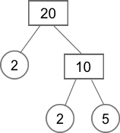  Any number can be written as a product of its prime factors,  for example: 20 = 2 × 2 × 5  Write 90 as a product of its prime factors. | Circle all the prime factors of 30  2 3 5 6 10

Identify square numbers
Put a ring around all the square numbers.  4 7 24 25 36 40 | Explain why 16 is a square number.
Here is a sorting diagram for numbers.  Write a number less than 100 in each space.  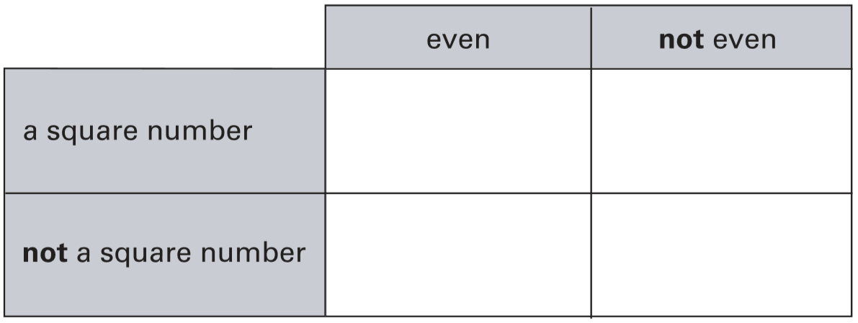 | Find two square numbers that total 45  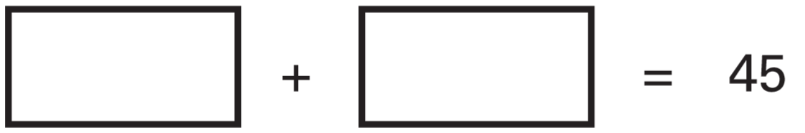
36 and 64 are both square numbers.
They have a sum of 100
Find two square numbers that have a sum of 130

Lara chooses a square number.
She rounds it to the nearest hundred.
Her answer is 200
Write all the possible square numbers Lara could have chosen.

Use vocabulary of multiples, factors, primes, squares and cubes
2016 Paper 2 Question 5  Write each number in its correct place on the diagram.  16 17 18 19  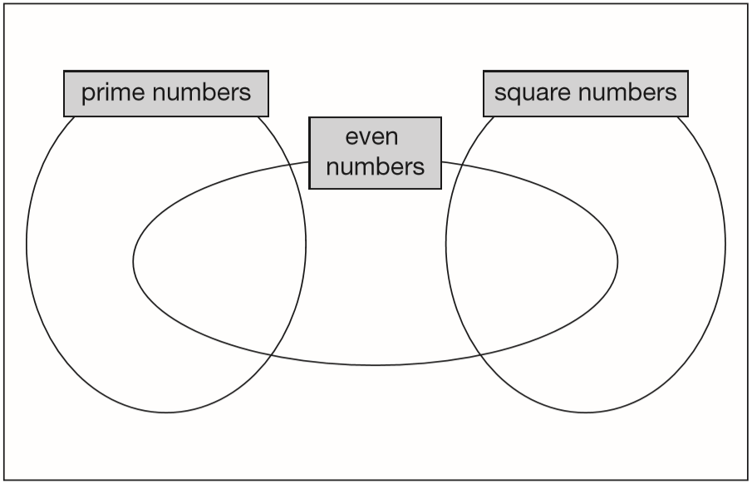 | 2017 Paper 3 Question 18  A square number and a prime number have a total of 22  What are the two numbers?  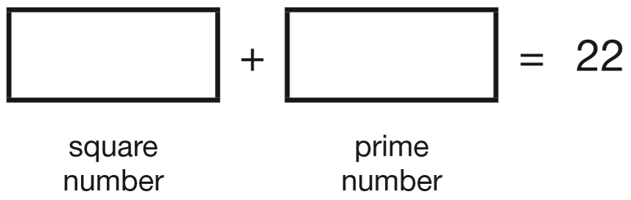
Here are four digit cards.  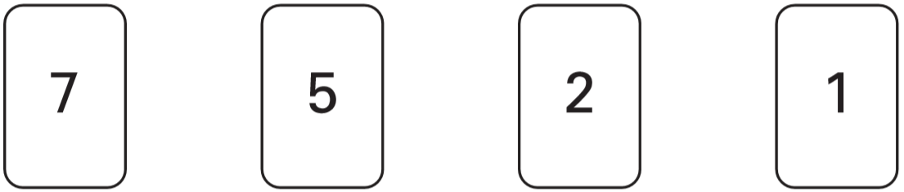  Choose two cards each time to make the following two-digit numbers.  The first one is done for you.  an even number 52  a multiple of 9  a square number  a factor of 96 | Here are three digit cards.  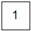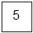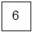  Choose two cards each time to make the following two-digit numbers. The first one is done for you.  an even number 56  an prime number  a common factor of 60 and 90  a common multiple of 5 and 13
2019 Paper 3 Question 11  Here are five numbers.  2 3 4 5 6  Write each number on the correct cards.  The number 2 has been written on the correct cards for you.  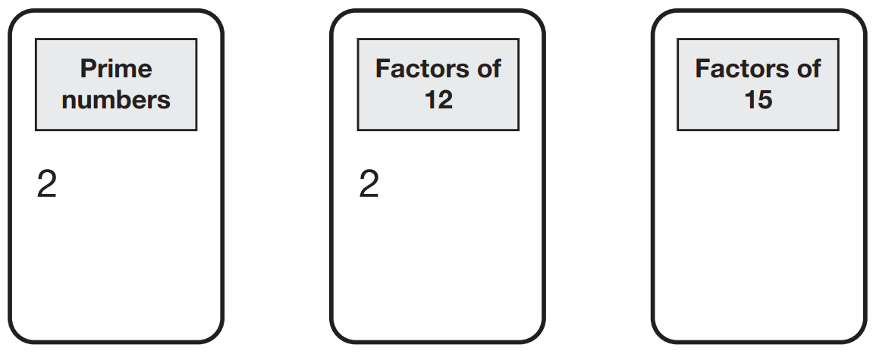 | Millie and Ryan play a number game. What's my number?  Is it under 20? Yes  Is it a multiple of 3? Yes  Is it a multiple of 5? Yes  What is the number?  They play the game again.  Is it under 20? No  Is it under 25? Yes  Is it odd? Yes  Is it a prime number? Yes  What is the number?
Put these values in order with the smallest first.  5² 3² 3³ 2³  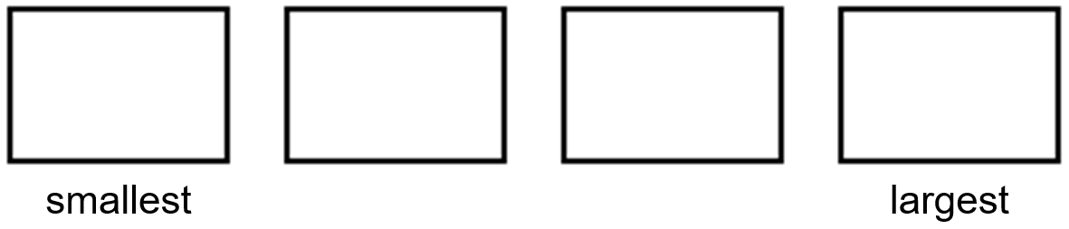 | Here is a sorting diagram for numbers.  Write a number less than 100 in each space.  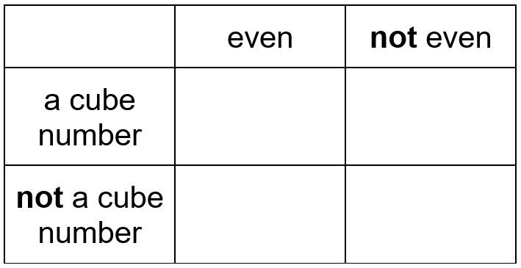
Write a cross on the numbers that are not square numbers.

1³ 2³ 3³ 4³ 5³

Explain why 125 is a cube number.

Here are six digit cards.  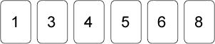  Choose two cards each time to make the following two-digit numbers. Use each digit card once.  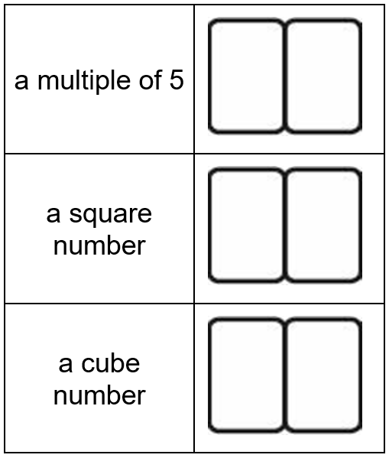 | 1 is both a square number and a cube number.  4 is a square number, but not a cube number.  What is the next number that is both a square number and a cube number?
Find two cube numbers that total 152
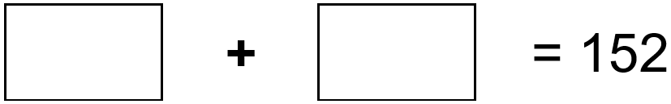

The three numbers missing from these boxes are all prime numbers greater than 3
Write in the missing prime numbers.

Find numbers to fit rules
Here are some number cards.  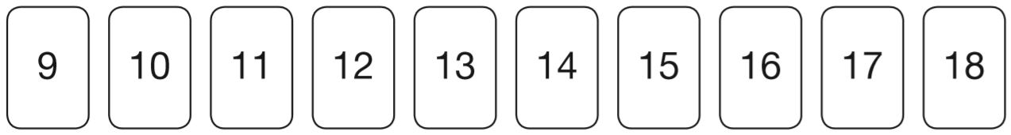  Joe picks two even numbers. Dev picks two odd numbers.  Joe gives one of his cards to Dev. Dev gives one of his cards to Joe.  Joe says, ‘Now my cards are both square numbers.’  Dev says, ‘Now my cards are both multiples of 5.’  What numbers did they each start with?     | Three different numbers add up to 40  The numbers are all even.  Each number is less than 20  Write what the three different numbers could be. 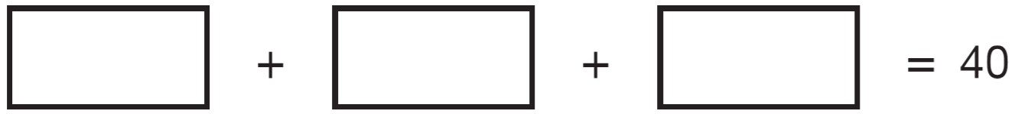
Debbie has a pack of cards numbered from 1 to 20
She picks four different number cards.
Exactly three of the four numbers are multiples of 5
Exactly three of the four numbers are even numbers.
All four of the numbers add up to less than 40
Write what the numbers could be.
Chen chooses a prime number.
He multiplies it by 10
and then rounds it to the nearest hundred.
His answer is 400
Write all the possible prime numbers Chen could have chosen.

Identify rules in sequences
Here is part of a number grid.  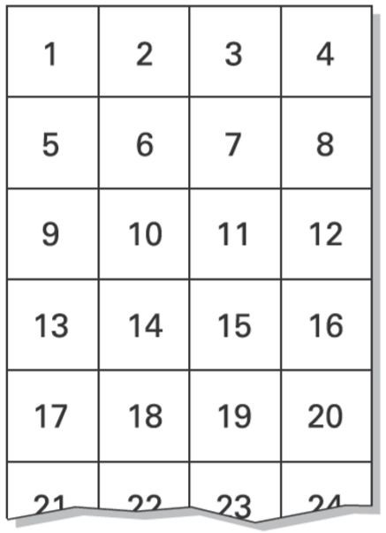  Here is another part of the same grid.  Write in the missing number.  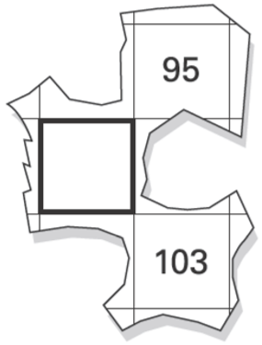 | Here is a number chart that goes up in fives.  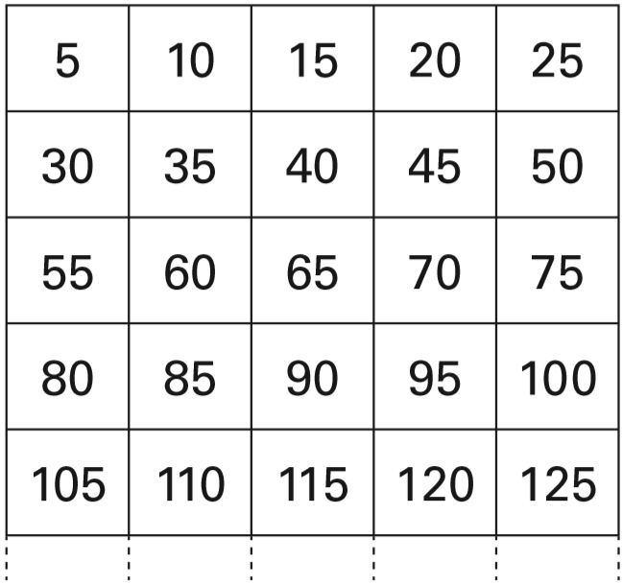  The chart continues in the same way. One of the numbers below will be at the start of a row on the chart. Circle the number.  445 455 465 475 485  One of the numbers below will be at the end of a row on the chart. Circle the number.  345 355 365 375 385
Here is a number chart.  Every third number in the chart has a circle on it.  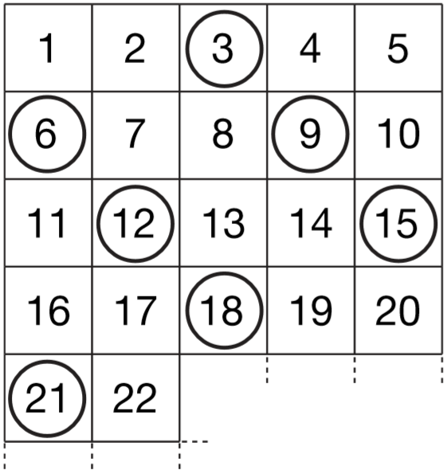  The chart continues in the same way. Here is another row in the chart.  Draw the missing circles.  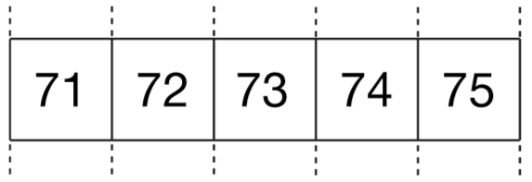  Will the number 1003 have a circle on it?  Explain how you know. | The numbers in this sequence increase by 3 each time.  3 6 9 12 . . .  The numbers in this sequence increase by 5 each time.  5 10 15 20 . . .  Both sequences continue.  Write a number greater than 100 which will be in both sequences.
The numbers in this sequence increase by 30 each time.
20 50 80 110 …
The sequence continues in the same way.
Which number in the sequence will be closest to 300?

Solve problems by working backwards
2019 Paper 2 Question 8  In this sequence, the rule to get the next number is: Multiply by 2, and then add 3  Write the missing numbers.   | Emily chooses two numbers.  She adds the two numbers together and divides the result by 2  Her answer is 44  One of Emily’s numbers is 12  What is Emily’s other number?
Sarah had a bag of cherries.  She ate 5 cherries, then gave  half of what she had left to Liam.  Liam ate 5 of his cherries, then gave half of what he had left to Amy.  Amy got 2 cherries.  How many cherries did Sarah have in her bag at the start? | Liam thinks of a number.  He divides it by 9 and then adds 25 to the result.  His answer is 36  What number did Liam start with?
2019 Paper 2 Question 9
Jack chose a number.
- He multiplied the number by 7
- Then he added 85
- His answer was 953
What number did Jack choose?

