
Identify the shaded fraction of a shape
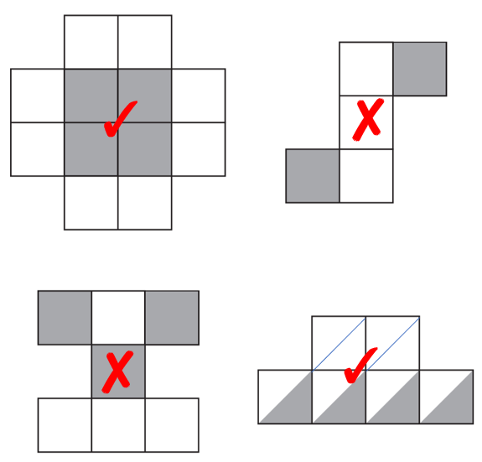 | 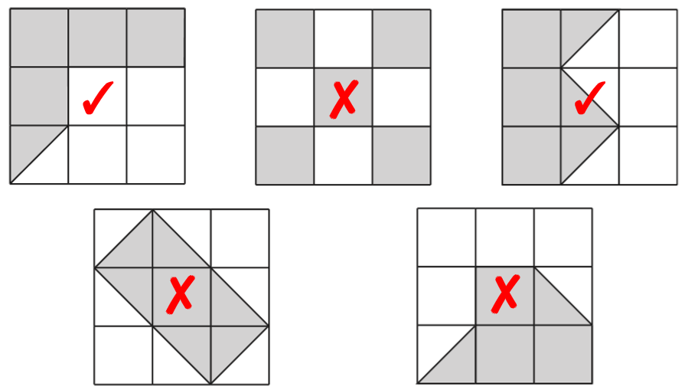
Holly is correct.
The two shaded triangles are the same as one square and that makes one out of three squares (one third) shaded.
Or if you split the square into two triangles you have two parts out of six which is equivalent to one third.

Compare fractions
<  >  = | $\frac{6}{10}$, $\frac{5}{8}$
<  >  = | $\frac{3}{11}$, $\frac{5}{11}$, $\frac{3}{9}$ or $\frac{3}{7}$  $\frac{8}{11}$, $\frac{6}{11}$, $\frac{6}{9}$ or $\frac{4}{7}$
2019 Paper 3 Question 18  Tick  Tick  Cross  Tick  Cross | $\frac{5}{8}$



Order fractions
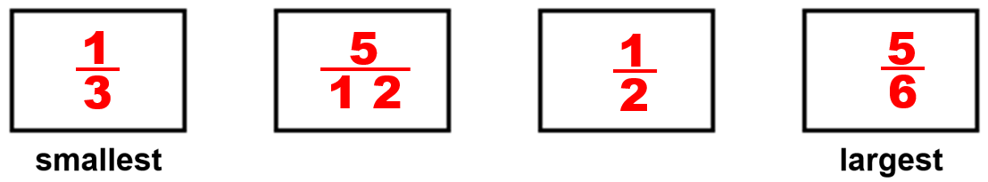 | 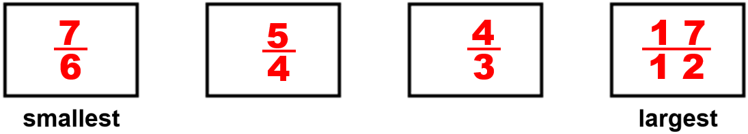
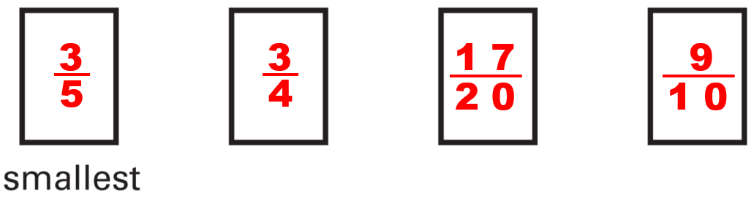 | 2015 Paper 3 Question 13  any 3 in order  $\frac{7}{16}$ < $\frac{6}{12}$ < $\frac{5}{8}$ < $\frac{3}{4}$

Convert between mixed numbers and improper fractions
11  2 | 2018 Paper 2 Question 13  $\frac{55}{8}$
11  2 | 34  2
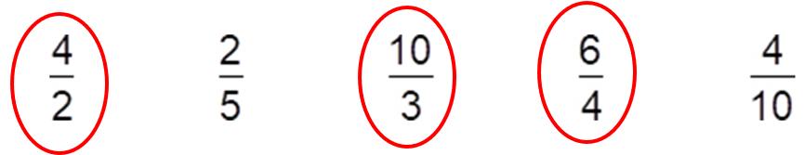  $\frac{6}{4}$  $\frac{2}{5}$ and $\frac{4}{10}$ | 11
 | 30
1$\frac{2}{4}$or 1$\frac{1}{2}$

2$\frac{3}{4}$

Round fractions and decimals to the nearest whole number
500  240  2 | 2018 Paper 2 Question 19  4 – 2 + 2
14  8  3 | 2018 Paper 2 Question 19  4 – 2 + 2

Complete missing number problems for fraction addition and subtraction
$\frac{5}{11}$  $\frac{6}{5}$ | $\frac{5}{10}$ or $\frac{1}{2}$  $\frac{4}{12}$ or $\frac{1}{3}$
303

0.707

Solve problems involving fraction addition and subtraction
6$\frac{1}{4}$  1$\frac{1}{2}$ or 1$\frac{2}{4}$ | 1$\frac{1}{2}$ and 3$\frac{1}{2}$  or 1$\frac{1}{4}$ and 3$\frac{3}{4}$
(3$\frac{1}{2}$ + 1$\frac{1}{2}$) x 2  or (3$\frac{1}{2}$ + $\frac{1}{2}$) x 2$\frac{1}{2}$ | $\frac{1}{4}$ + $\frac{1}{5}$ + $\frac{1}{20}$

2017 Paper 3 Question 21  $\frac{3}{8}$, 2$\frac{7}{8}$ | 2017 Paper 2 Question 23  $\frac{7}{12}$
2018 Paper 3 Question 18
$\frac{1}{12}$
Find a fraction of a number
150  75 | $\frac{4}{5}$
150  75 | 64
150  75 | 24
80 | 2015 Paper 2 Question 20  150
Tick  Cross  Cross  Tick | 14  $\frac{7}{21}$ or $\frac{1}{3}$

Megan is wrong.  One quarter of 240 is more than one half of 80  50 | $\frac{1}{8}$ (accept any answer between $\frac{1}{10}$ and $\frac{3}{20}$)  between 40 and 50
2015 Paper 2 Question 18
Half of 50 = 25 boys
Over a quarter of 100 = over 25 girls

Recognise place value in numbers with up to three decimal places
2015 Paper 3 Question 3  4  6 | 1.28, 1.8, 8.118, 8.12, 8.2
2016 Paper 3 Question 5  0.098, 0.607, 0.78, 4.003, 5.6 | 2017 Paper 2 Question 6  0.328, 0.96, 1.253, 1.9
2019 Paper 3 Question 4  0.009 kg, 0.99 kg, 1.025 kg, 1.25 kg | 0.091, 0.109, 0.19, 0.9
0.11, 1.001, 1.01, 1.101 | 19.95
0.11, 1.001, 1.01, 1.101 | 0.09 and 0.1
Identify decimals on number lines
1000.5 | 2.089, 2.095
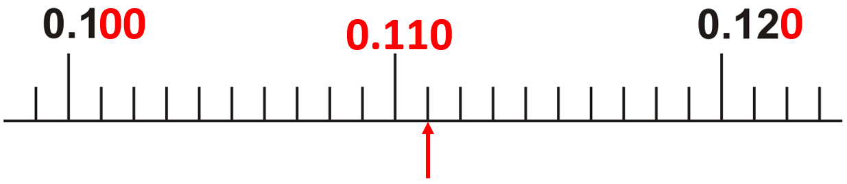

Convert between fractions and decimals
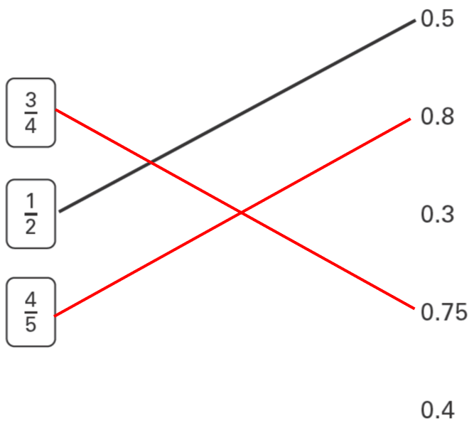 | 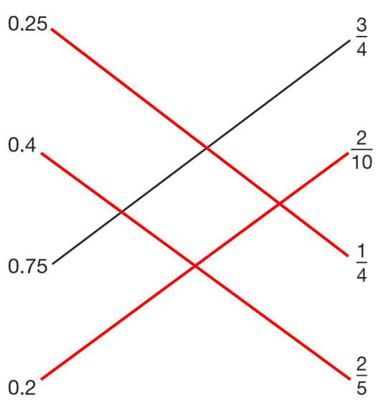
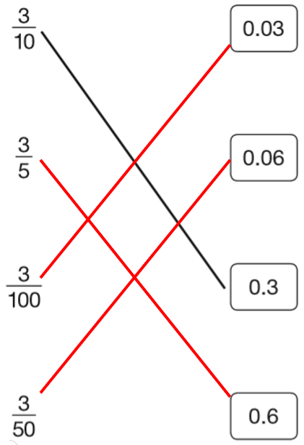 | 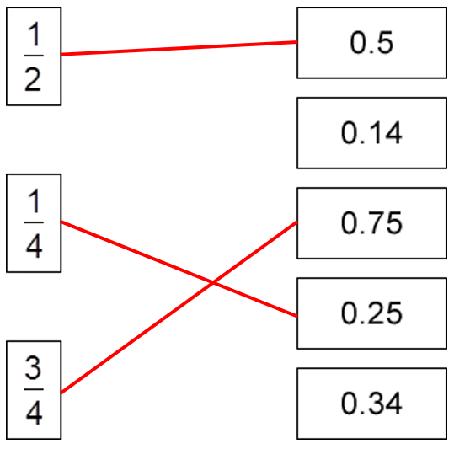
2019 Paper 2 Question 11  0.25  65p | 2019 Paper 2 Question 12  >  <
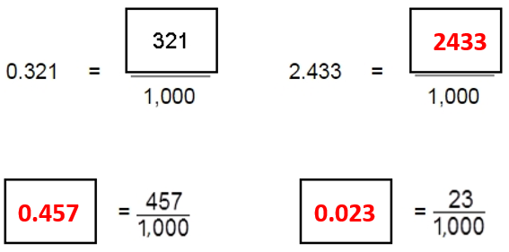 | 0.75
 | 0.5 and 0.50
2018 Paper 2 Question 7  0.25 and $\frac{25}{100}$ | 0.13 and 0.130
2018 Paper 2 Question 7  0.25 and $\frac{25}{100}$ | 0.07
0.099 | $\frac{6}{10}$ and $\frac{60}{100}$
Compare fractions and decimals
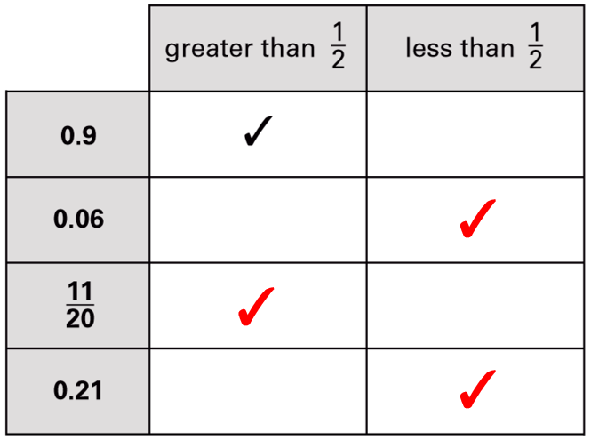 | 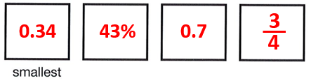
2017 Paper 3 Question 17  1$\frac{1}{2}$  1.3  1.4  1$\frac{3}{5}$ | 1.4, 1$\frac{1}{3}$

Add, subtract, multiply and divide decimals with up to three decimal places
2015 Paper 3 Question 12  0.993 | 2016 Paper 3 Question 16  3 kg
13 | 2016 Paper 3 Question 16  3 kg
x 10  ÷ 100  ÷ 1000  x 100 | 2015 Paper 3 Question 6  ÷ 10  x 1000  ÷ 100
100 and 0.47 (any order)  4.07 and 10 (any order) | 2016 Paper 3 Question 15  20,900  2100  200

Recognise a percentage as a fraction with a denominator of 100
9% | 20%
45% | 20%
between 30% and 36% | between 15% and 25%  between 201 g and 399 g
Jack won.  The pie chart shows ¼ for Jack.  ¼ of 40 = 10  20% | 60%

Connect fractions, decimals and percentages
35% | 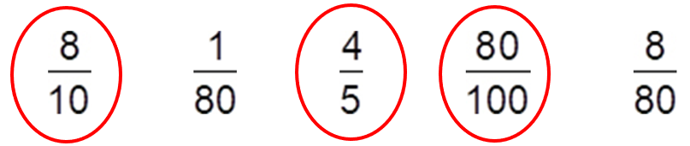
2019 Paper 2 Question 20  $\frac{1}{5}$ and $\frac{3}{15}$ | 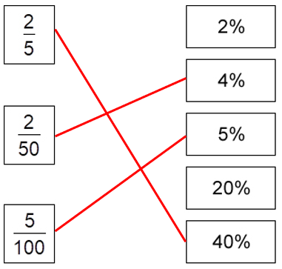
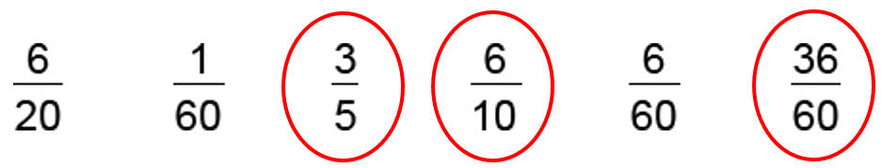
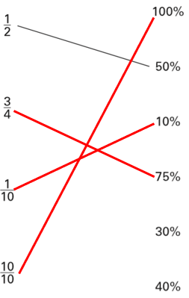 | 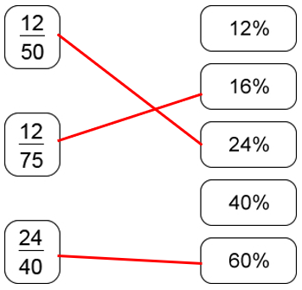
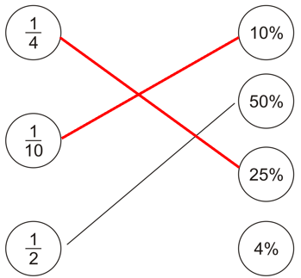 | 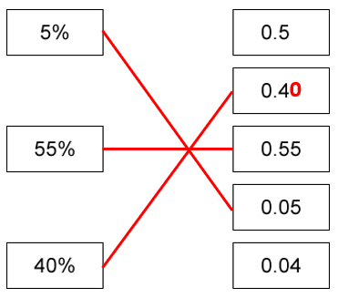
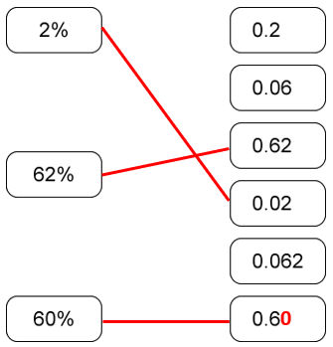 | 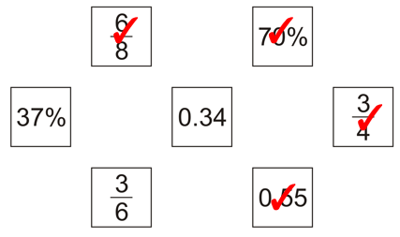

Connect a fraction and a percentage of a shape
40% | 30%
2015 Paper 3 Question 17  35% | 28%
any 3 squares shaded

Solve word problems involving making connections between fractions and percentages
Hassan has the higher score.  40 out of 80 is equivalent to 50%  50% is higher than 40%  or 40% of 80 is 32 so Kate only got 32  32 is less than 40 | 2017 Paper 2 Question 18  75%
2019 Paper 2 Question 15
25%
45% | Cross  Tick  Cross  Tick

