
Identify the shaded fraction of a shape
These diagrams are all made of squares.  Put a tick if exactly $\frac{1}{3}$ is shaded. Put a cross if it is not.  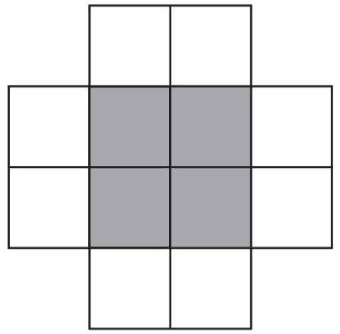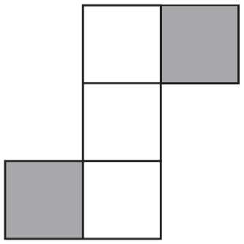  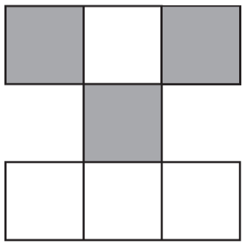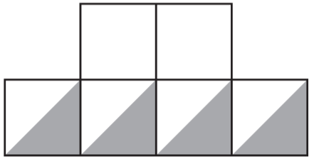 | Put a tick on the diagram if exactly $\frac{1}{2}$of it is shaded.  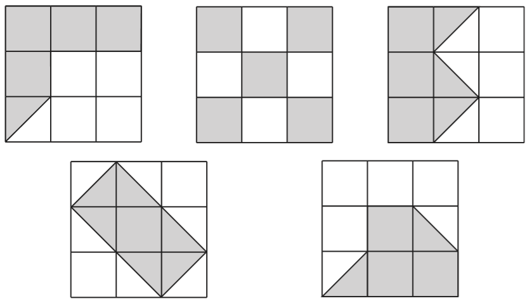
Holly says, ‘One-third of this shape is shaded.’
Is Holly correct? Explain how you know.
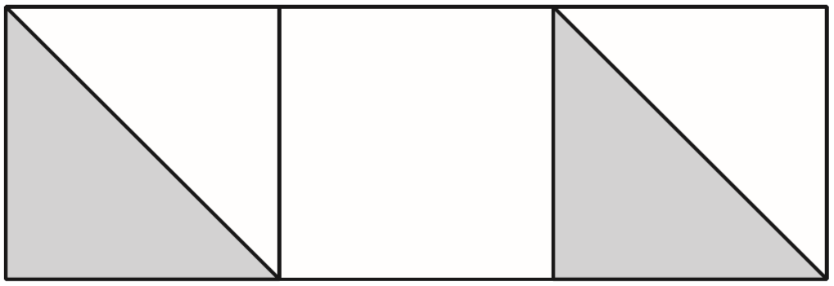

Compare fractions
Write the correct sign < = or > in each box to make these sentences correct.  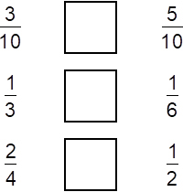 | Circle the two fractions that are greater than $\frac{1}{2}$  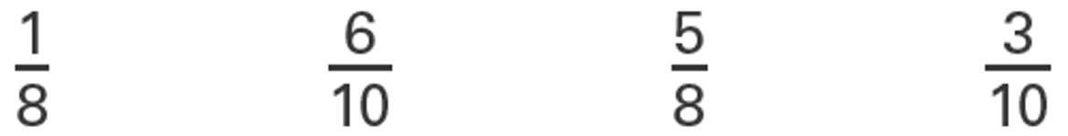
Here are some number cards.
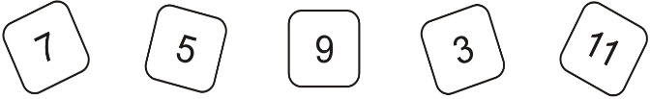
Use two of the cards to make a fraction which is less than $\frac{1}{2}$
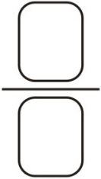
How much less than 1 is your fraction?

2019 Paper 3 Question 18  Tick the fractions less than $\frac{5}{8}$  $\frac{1}{2}$ $\frac{2}{8}$ $\frac{3}{4}$ $\frac{7}{16}$ $\frac{24}{32}$ | Circle the fraction that is greater than $\frac{1}{2}$ but less than $\frac{3}{4}$  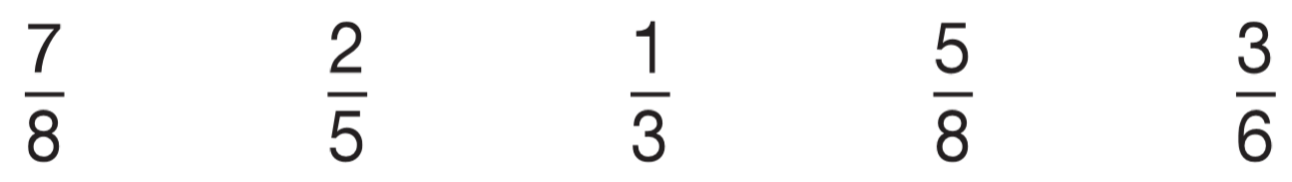



Order fractions
Place these fractions in order of size, starting with the smallest.  $\frac{1}{2}$ $\frac{1}{3}$ $\frac{5}{12}$ $\frac{5}{6}$  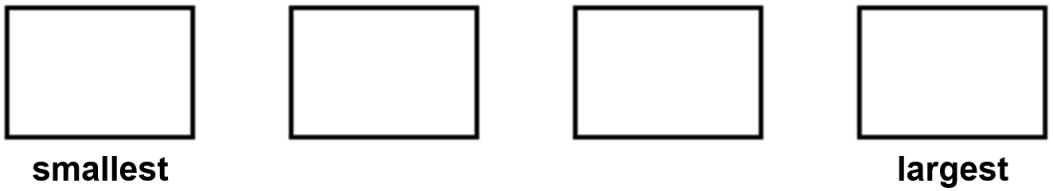 | Write these numbers in order, starting with the smallest.  $\frac{5}{4}$ $\frac{7}{6}$ $\frac{17}{12}$ $\frac{4}{3}$
Write these fractions in order of size starting with the smallest.  $\frac{3}{4}$ $\frac{3}{5}$ $\frac{9}{10}$ $\frac{17}{20}$  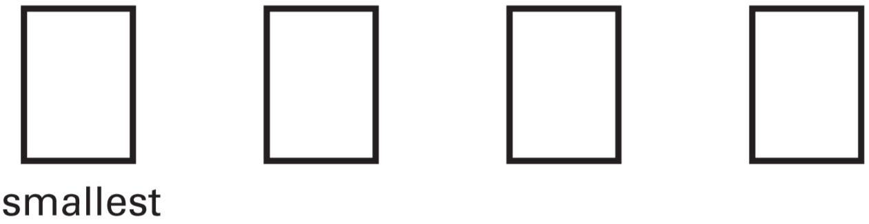 | 2015 Paper 3 Question 13  Here are four fraction cards.  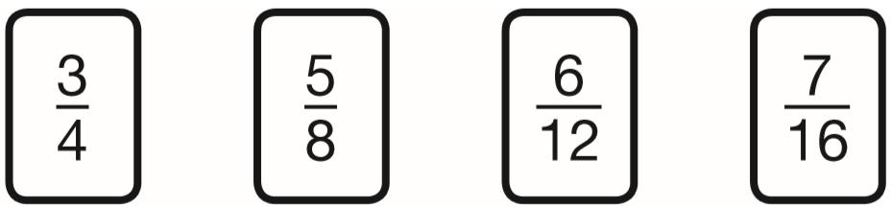  Use any three of the cards to make this correct.  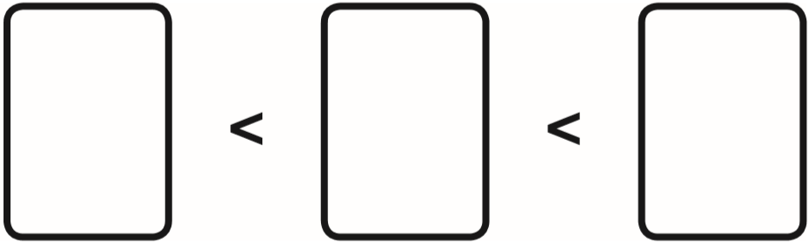

Convert between mixed numbers and improper fractions
Write the missing numbers.  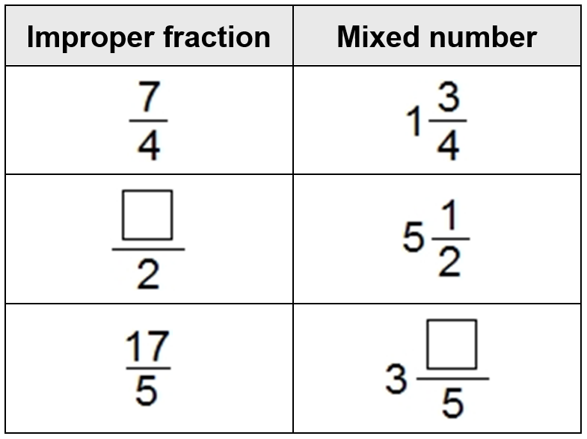 | 2018 Paper 2 Question 13  Circle the improper fraction that is equivalent to 6$\frac{7}{8}$  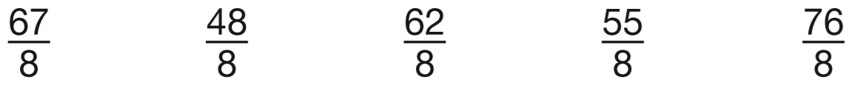
Write the two missing values to make these equivalent fractions correct.
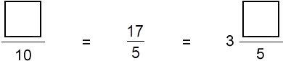
Here are fractions.  Circle the improper fractions.  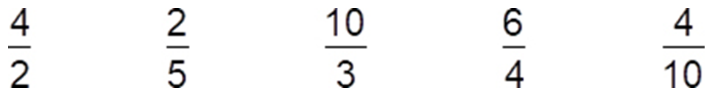  Which fraction is equivalent to 1 $\frac{1}{2}$?  Which two fractions are equivalent? | How many quarters are there in 2 $\frac{3}{4}$ ?
 | How many halves are there in 15?
Here is part of a number line.
Write in the two missing numbers.
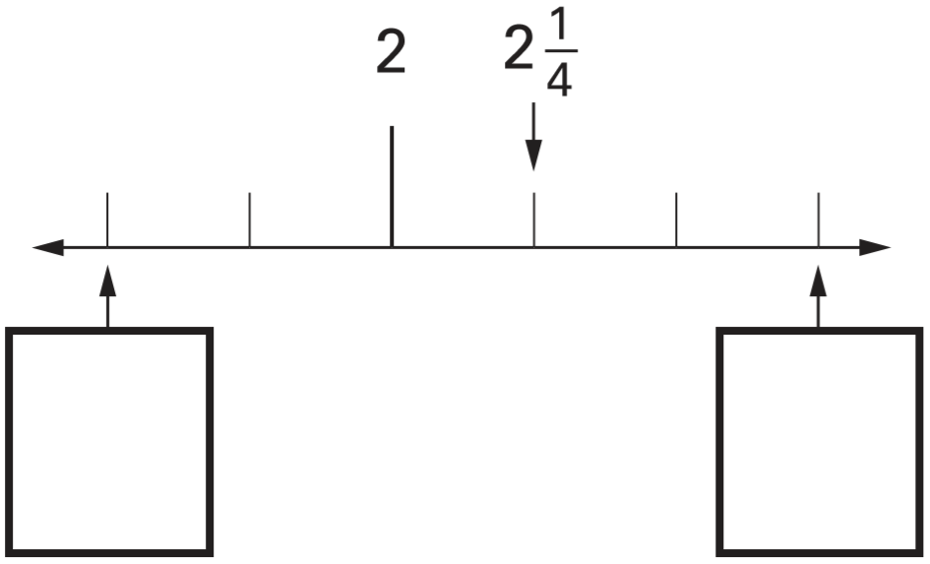

Round fractions and decimals to the nearest whole number
Round the following numbers.  5 4 0 to the nearest 100 _______  2 3 6 to the nearest 10 _______  1 $\frac{3}{4}$ to the nearest whole number _______ | 2018 Paper 2 Question 19  Layla wants to estimate the answer to this calculation.  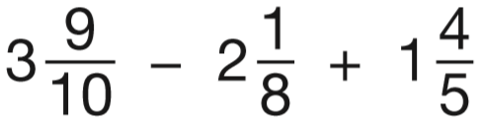  Tick the calculation below that is the best estimate.  3 – 2 + 2 4 – 2 + 1  4 – 2 + 2 3 – 2 + 1
Write each of these shapes to the nearest whole number.

13.7 is nearest to _____

8 $\frac{3}{8}$ is nearest to _____

3.38 is nearest to _____

Complete missing number problems for fraction addition and subtraction
Write the missing fractions.  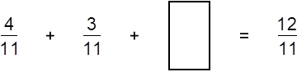  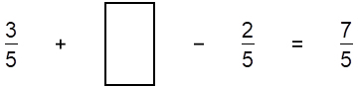 | Write the missing fractions.  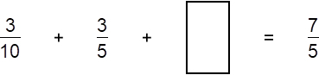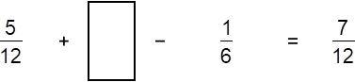
Complete the missing numbers to make the calculations correct.
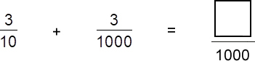

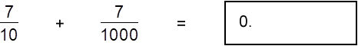

Solve problems involving fraction addition and subtraction
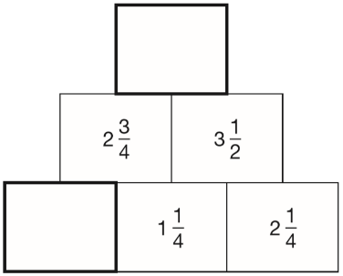  In this diagram, the number in each box is the sum of the two numbers below it.  Write the missing numbers. | Tick two cards that give a total of 5  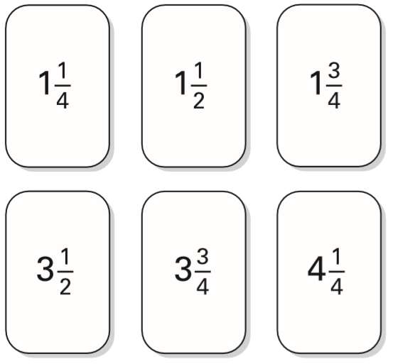
Here are five number cards.  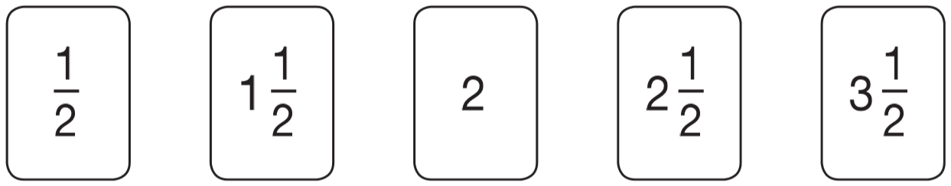  Use three of the number cards to make this calculation correct.  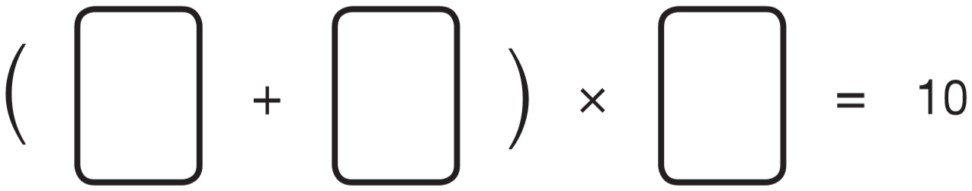 | 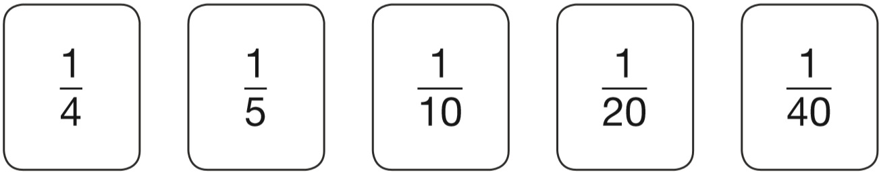  Use three of these fraction cards to complete the sum below.  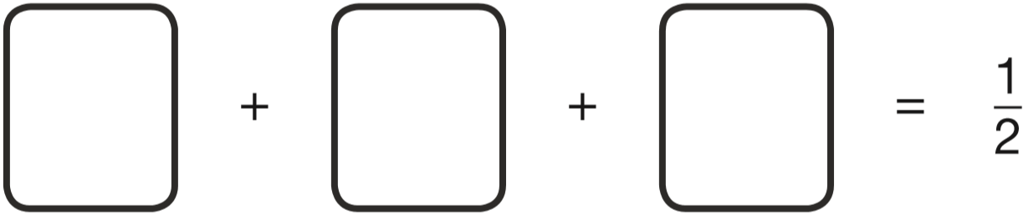

2017 Paper 3 Question 21  The numbers in this sequence increase by the same amount each time.  Write the missing numbers.  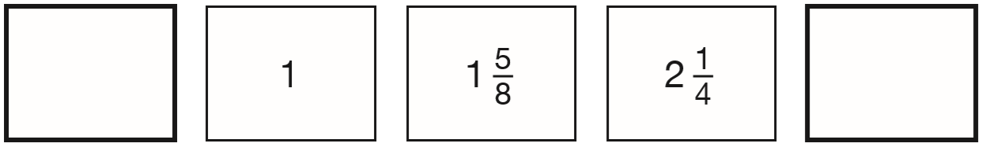 | 2017 Paper 2 Question 23  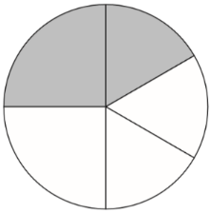  In this circle, $\frac{1}{4}$ and $\frac{1}{6}$ are shaded.  What fraction of the whole circle is not shaded?
2018 Paper 3 Question 18
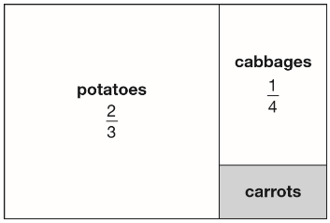
This is a diagram of a vegetable garden.
It shows the fractions of the garden planted with potatoes and cabbages.
The remaining area is planted with carrots.
What fraction of the garden is planted with carrots?

Find a fraction of a number
Write in the missing numbers.  One has been done for you.  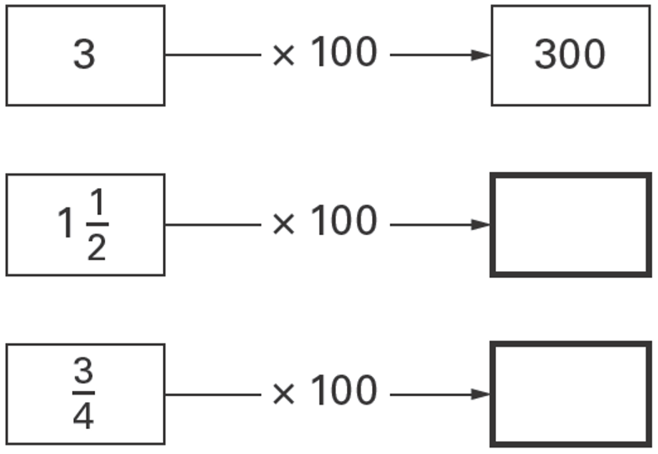 | Five children shared 4 packs of sweets equally.  What fraction of a packet did they each receive?
Three-quarters of a number is 48
What is the number?

In a class, 18 of the children are girls.
A quarter of the children in the class are boys.
Altogether, how many children are there in the class?

Ben thinks of a number.  He adds half of the number to a quarter of the number.  The result is 60  What was the number Ben first thought of? | 2015 Paper 2 Question 20  On Saturday Lara read $\frac{2}{5}$ of her book.  On Sunday she read the other 90 pages to finish the book.  How many pages are there in Lara’s book?
200 girls and 100 boys were asked about their favourite meal.  These pie charts show the results.  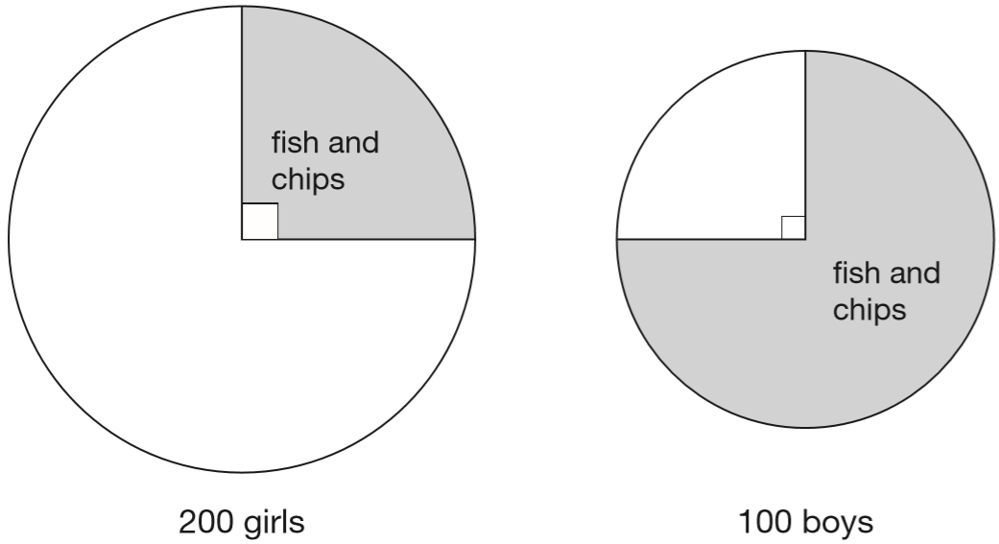  For each statement put a tick if it is true.  Three-quarters of the boys chose fish and chips.  Three times as many boys as girls chose fish and chips.  Altogether, half of the children chose fish and chips.  25 more boys than girls chose fish and chips. | Class 6 did a survey of mushrooms growing in a field. The diagram shows the distances of mushrooms from the centre of the field.  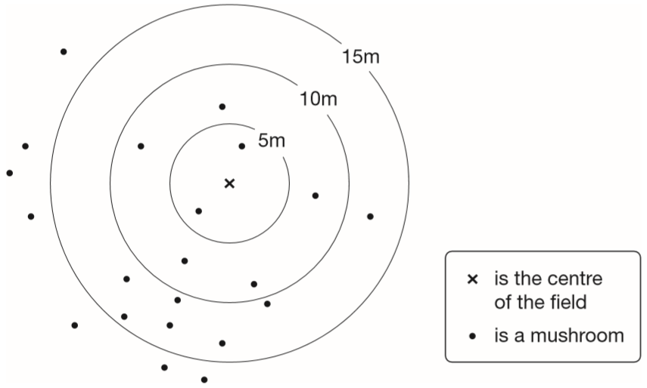  How many mushrooms were more than 10 metres from the centre?  What fraction of the mushrooms were less than 10 metres from the centre?

Megan asked children from two different schools, ‘How do you travel to school?’  Here are her results.  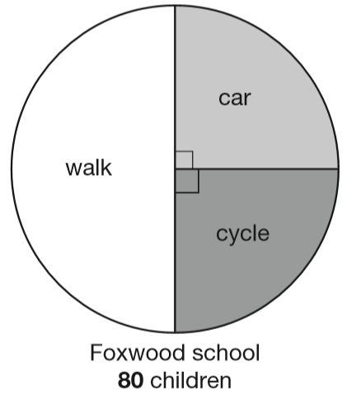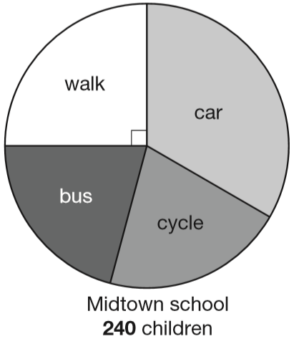  Megan says, ‘The number of children walking to Foxwood school is more than the number walking to Midtown school.’  Is she correct? Explain how you know.  At Midtown school, one third of children travel by car. The number of children who cycle is the same as the number who go on the bus. How many children cycle to Midtown school? | 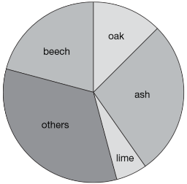  Class 6 did a survey of the number of trees in a country park. This pie chart shows their results.  Estimate the fraction of trees in the survey that are oak trees.  The children counted 60 ash trees.  Use the pie chart to estimate the number of beech trees they counted.
2015 Paper 2 Question 18
100 girls and 50 boys were asked which kind of chocolate they like best. These two pie charts show the results.
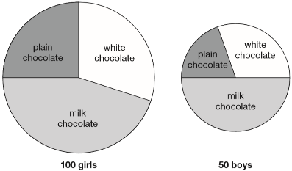
Dev says, “The pie charts show that more girls than boys liked milk chocolate best.”
Dev is correct. Explain how you know.

Recognise place value in numbers with up to three decimal places
2015 Paper 3 Question 3  Look at this number. 23,451.96  Write the digit that is in the hundreds place.  Write the digit that is in the hundredths place. | Write these numbers in order, starting with the smallest.  8.12 1.8 8.118 8.2 1.28  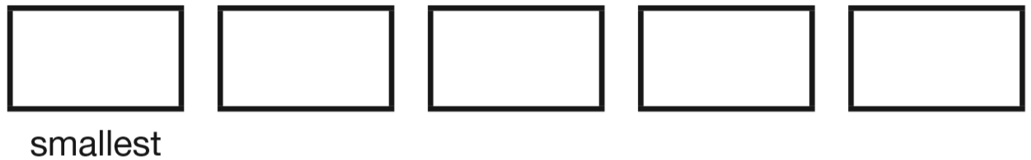
2016 Paper 3 Question 5  Write these numbers in order, starting with the smallest.  0.78 0.607 5.6 0.098 4.003  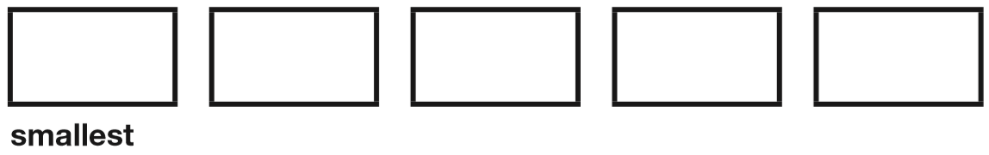 | 2017 Paper 2 Question 6  Write these numbers in order of size, starting with the smallest.  1.9 0.96 1.253 0.328  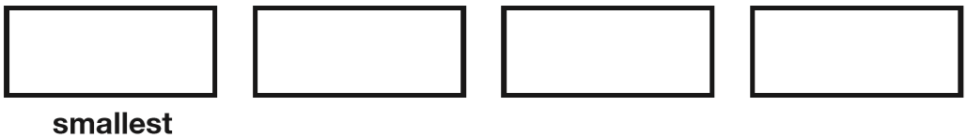
2019 Paper 3 Question 4  Write these masses in order, starting with the lightest.  1.25 kg 0.99 kg 1.025kg 0.009 kg  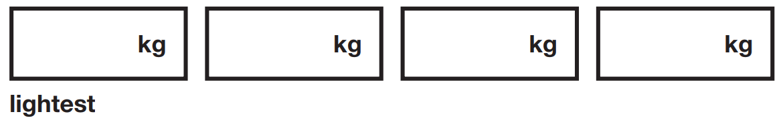 | Place these numbers in order of size, starting with the smallest.  0.19 0.9 0.091 0.109
Write these numbers in order of size, starting with the smallest.  1.01 1.001 1.101 0.11 | Circle the number that is closest to 20  19.95 20.1 19.09 20.09 20.201
Circle the two decimals which are closest in value to each other.

0.9 0.09 0.99 0.1 0.01

Identify decimals on number lines
Here is part of a number line.  Write the number shown by the arrow.  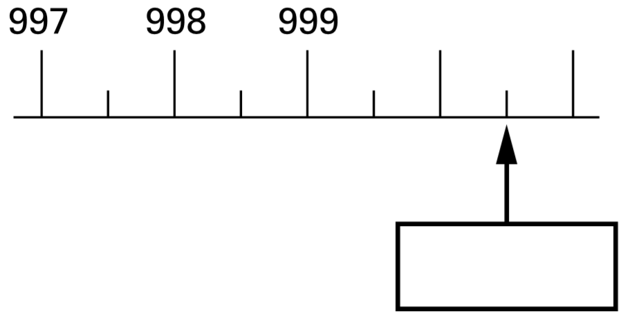 | This is part of a number line.  Write in the missing numbers.  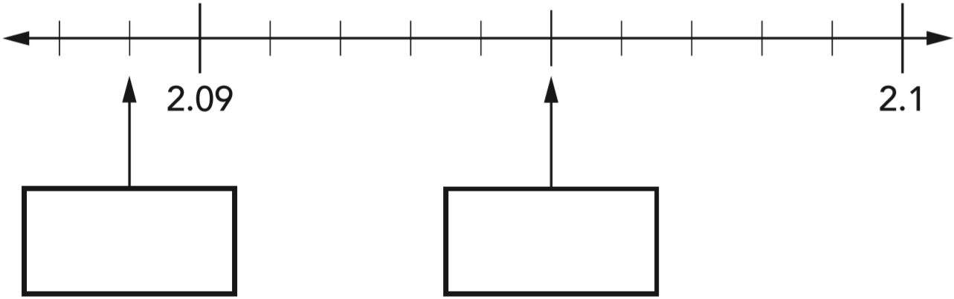
Here is a number line.
Draw an arrow to show the position of 0.111

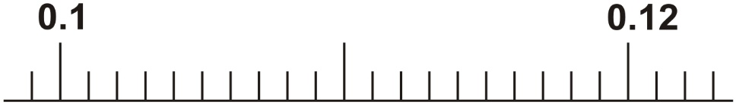

Convert between fractions and decimals
Match each box to the number which has the same value. One has been done for you.  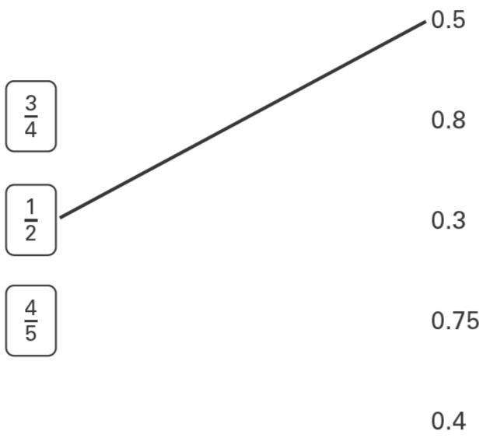 | Match each decimal number to its equivalent fraction. One has been done for you.  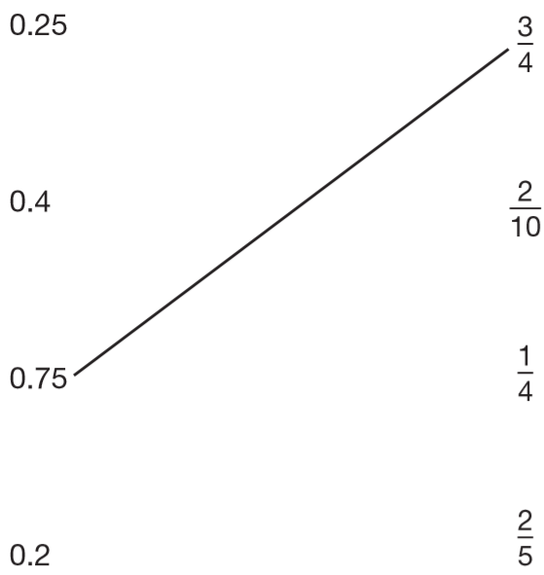
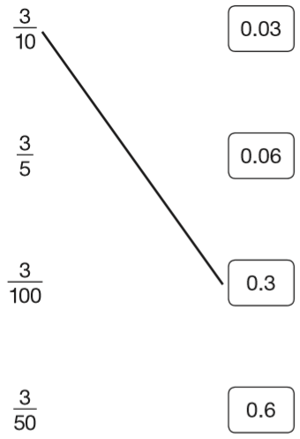  Join each fraction to the correct decimal card.  The first one has been done for you. | Match each fraction to its correct decimal equivalent.  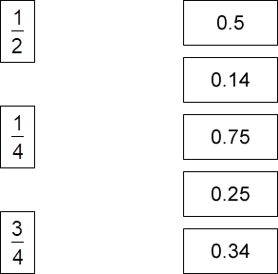
2019 Paper 2 Question 11  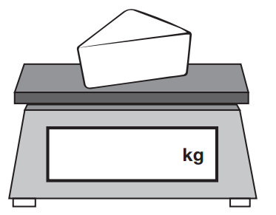  Amina is shopping. She says, ‘I would like to buy one-quarter of a kilogram of cheese.’  Write one-quarter on the scales as a decimal.  The cheese costs £1.35  Amina pays with a £2 coin.  How much change should Amina get? | 2019 Paper 2 Question 12  Here are three symbols.  < > =  Write one symbol in each box to make the statements correct.  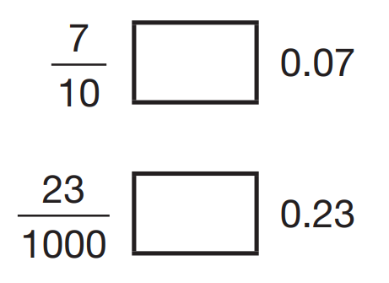
Write in the missing numbers.  One is done for you.  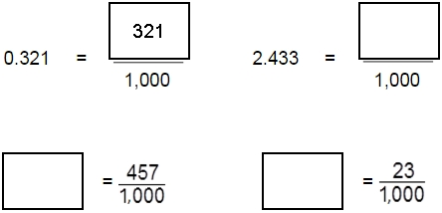 | Circle the number that is equal to $\frac{3}{4}$  0.34 7.5 3.4 0.075 0.75
Circle the numbers that are equal to $\frac{1}{2}$

0.12 0.5 5.0 0.05 0.50
2018 Paper 2 Question 7  Tick the two numbers that are equivalent to $\frac{1}{4}$  0.25 0.75 $\frac{25}{100}$ 0.5 $\frac{2}{5}$ | Tick all the numbers that are equivalent to $\frac{13}{100}$  0.013 1.3 0.13 0.103 0.130
Circle the number that is equal to $\frac{70}{1000}$

0.70 0.007 0.07 0.7

Circle the number that is equal to $\frac{99}{1000}$  0.99 0.099 9.9 0.990 9.990 | Circle two fractions that are equivalent to 0.6  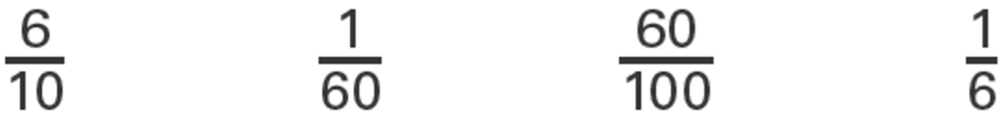
Compare fractions and decimals
Put a tick in each row to complete this table.  One has been done for you.  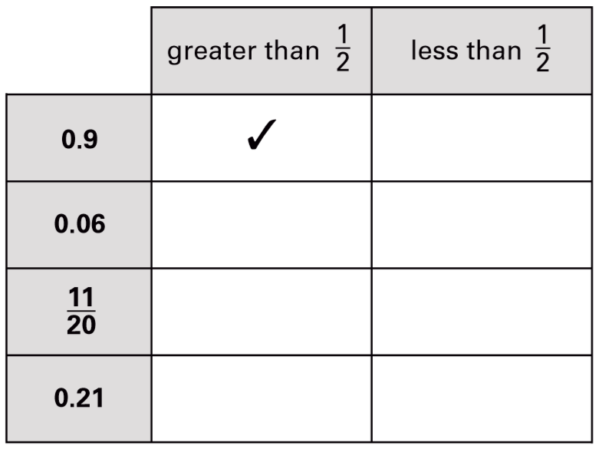 | Write these in order of size, starting with the smallest.  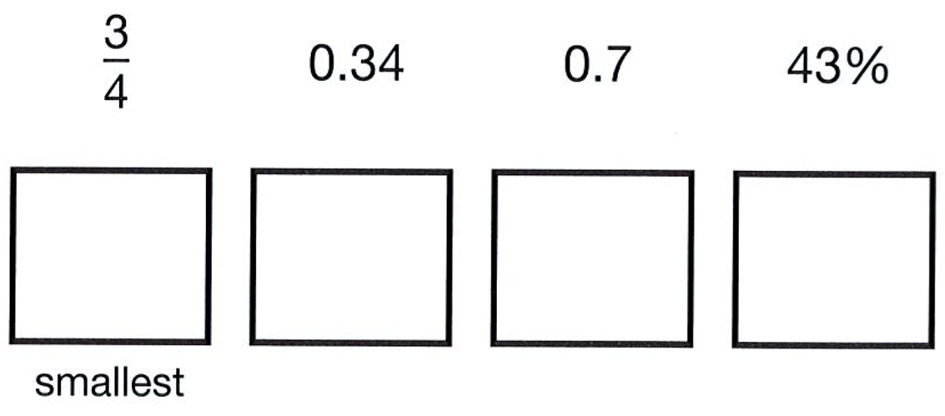
2017 Paper 3 Question 17  In each box, circle the number that is greater.  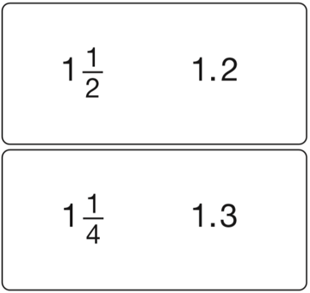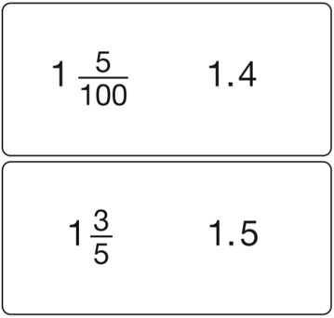 | Part of this number line is shaded.  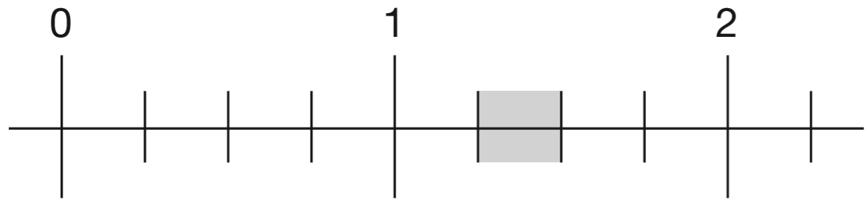  Circle all the numbers below that belong in the shaded part of the number line.  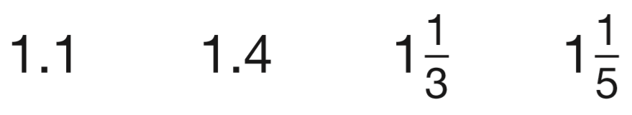

Add, subtract, multiply and divide decimals with up to three decimal places
2015 Paper 3 Question 12  Two decimal numbers add together to equal 1  One of the numbers is 0.007  What is the other number? | 2016 Paper 3 Question 16  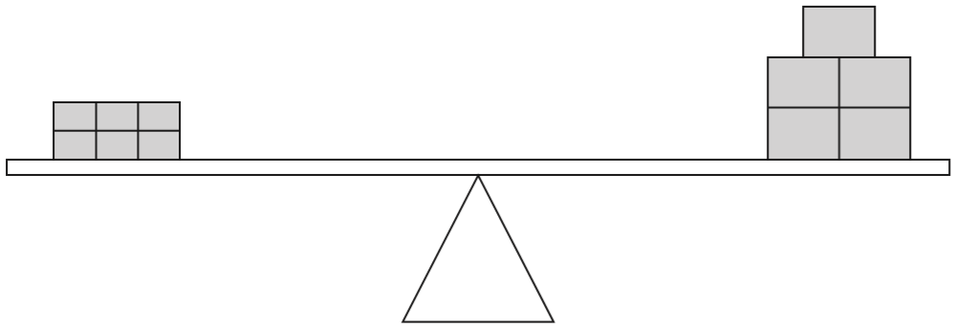  6 small bricks have the same mass as 5 large bricks. The mass of one small brick is 2.5 kg.  What is the mass of one large brick?
Write in the missing number.
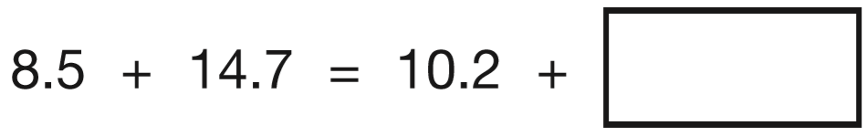
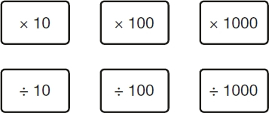  Complete the number sentences using these cards.  36.55 _____ = 365.5  0.2 _____ = 0.002  7800 _____ = 7.8  47.3 _____ = 4730 | 2015 Paper 3 Question 6  Here are six cards.  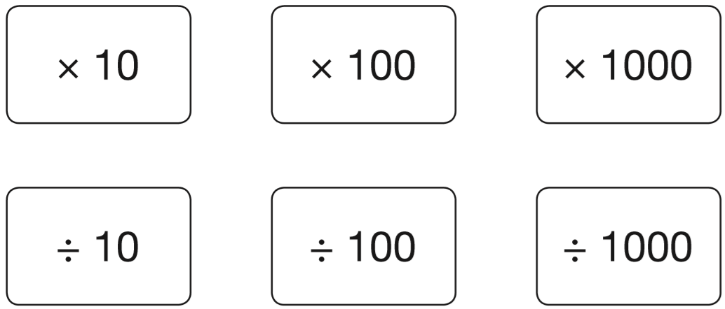  Use a card to complete each calculation.  5.3 _____ = 0.53  5.3 _____ = 5300  5.3 _____ = 0.053
Here are five number cards.  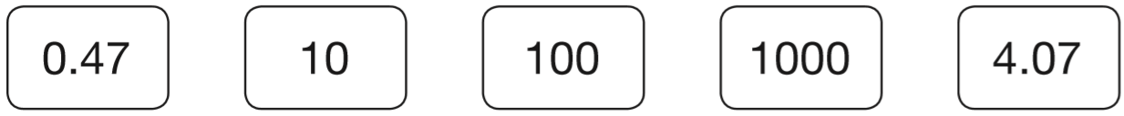  Use four of the cards to complete these calculations.  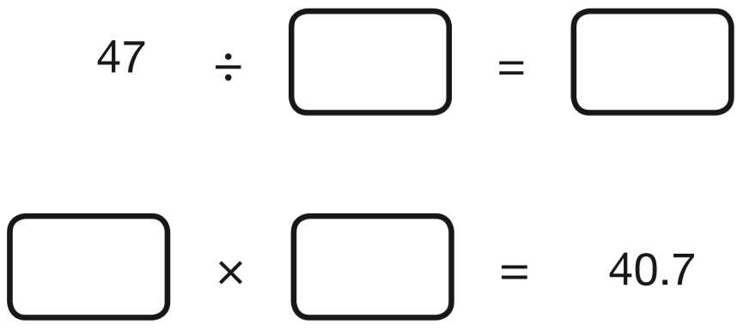 | 2016 Paper 3 Question 15  Complete this table by rounding the numbers to the nearest hundred.  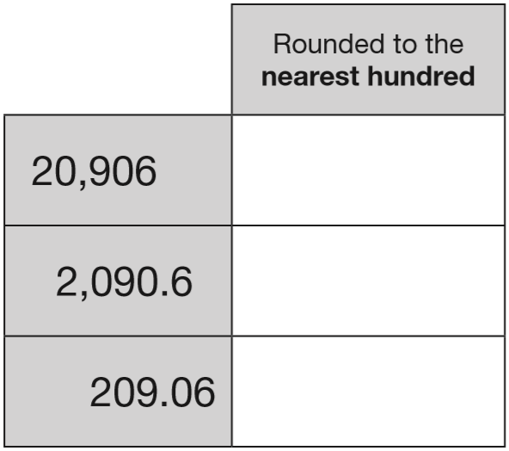

Recognise a percentage as a fraction with a denominator of 100
Circle the percentage that is equal to $\frac{9}{100}$  90% 90.9% 99% 9.9% 9% | Grace made purple paint by mixing three colours.  50% was red  30% was blue  and the rest was white.  What percentage of the purple paint was white?
15% of the people walk 5 km or less.
40% of the people walk 8 km or more.
What percentage of the people walk between 5 km and 8 km?

The pie charts show the results of a school’s netball and football matches.  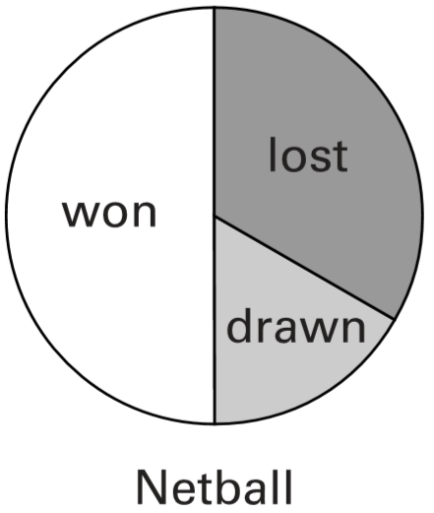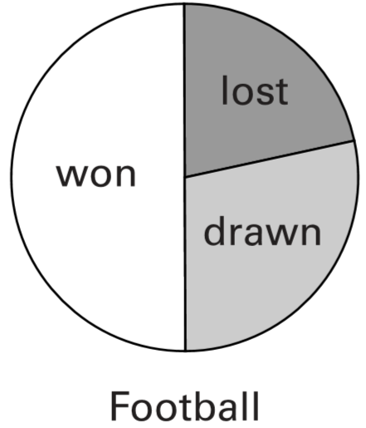  The netball team played 30 games.  The football team played 24 games.  Estimate the percentage of games that the netball team lost. | 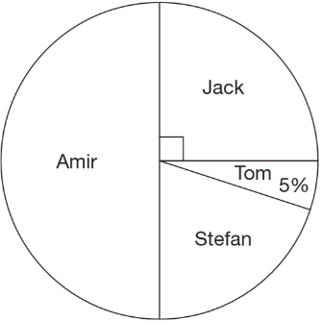  40 children predicted who would win the boys’ race at sports day.  This pie chart shows their predictions.  What percentage of the children predicted that Stefan would win?  10 children predicted the winner of the race correctly. Who won the race?  Explain how you know.
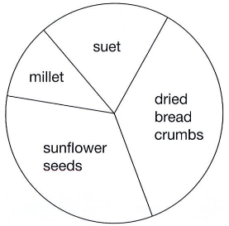  This pie chart shows the ingredients to make a food mixture for wild birds. Estimate the percentage of the mixture that is suet.  Mina uses 100 grams of millet in the mixture.  Estimate how many grams of sunflower seeds she should use. | All the children in Class 6 vote to pick a class captain.  The choice is Holly or Dev or Joe.  Dev gets 10% of the votes.  Joe gets twice as many votes as Holly.  What percentage of the votes does the winner get?

Connect fractions, decimals and percentages
Circle the percentage that is equal to $\frac{7}{20}$  7% 35% 70% 20% 140% | Circle the fractions that are equal to 80%  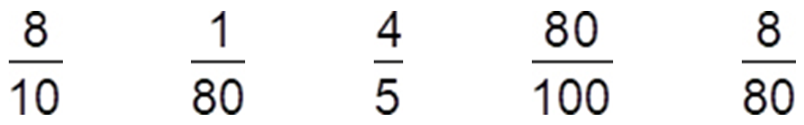
2019 Paper 2 Question 20  Tick the fractions that are equal to 20%.  $\frac{1}{20}$ $\frac{20}{40}$ $\frac{1}{5}$ $\frac{3}{15}$ $\frac{2}{100}$ | 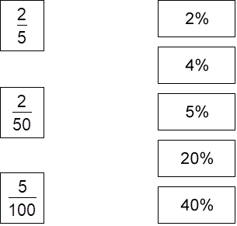  Match each fraction to its correct percentage equivalent.
Circle the fractions that are equal to 60%

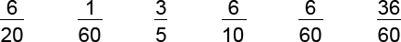

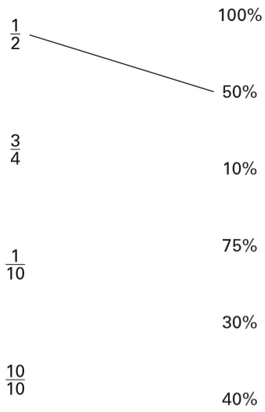  Match each fraction to the percentage which has the same value.  One has been done for you. | Match each fraction to its correct percentage equivalent.  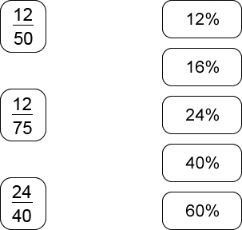
Draw a line to join each fraction to a percentage of the same value.  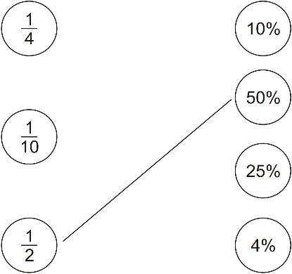 | Match each percentage to its correct decimal equivalent.  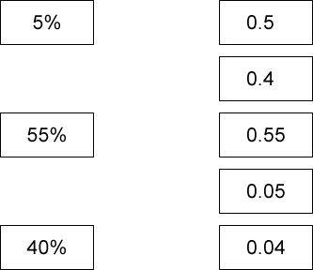
Match each percentage to its correct decimal equivalent.  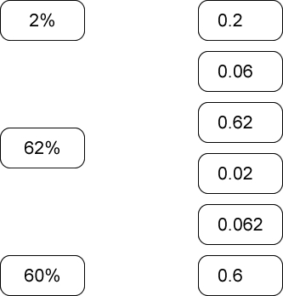 | Tick each of the cards that shows more than a half.  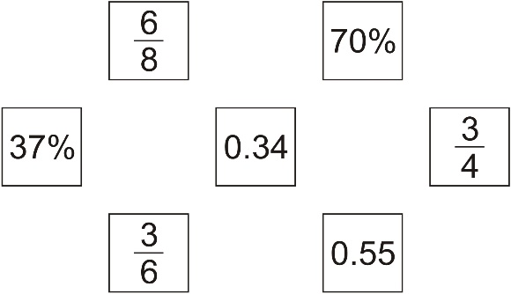

Connect a fraction and a percentage of a shape
Here is a pattern on a grid.  What percentage of the grid is shaded?  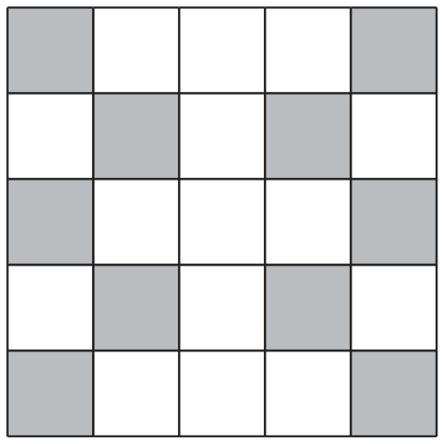 | Here is a grid of 20 squares.  What percentage of the grid is shaded?  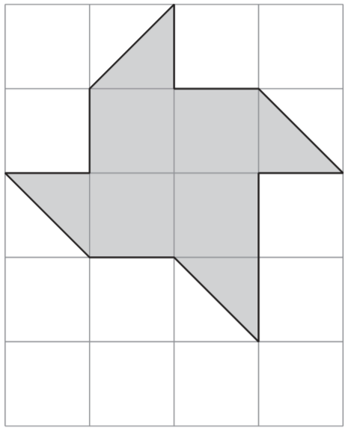
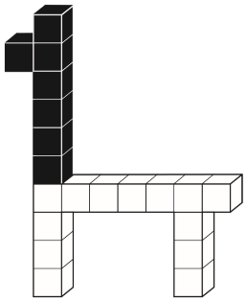  2015 Paper 3 Question 17  This model is made with 20 cubes.  What percentage of the cubes in the model is black? | Look at this pattern.  What percentage of the pattern in black?  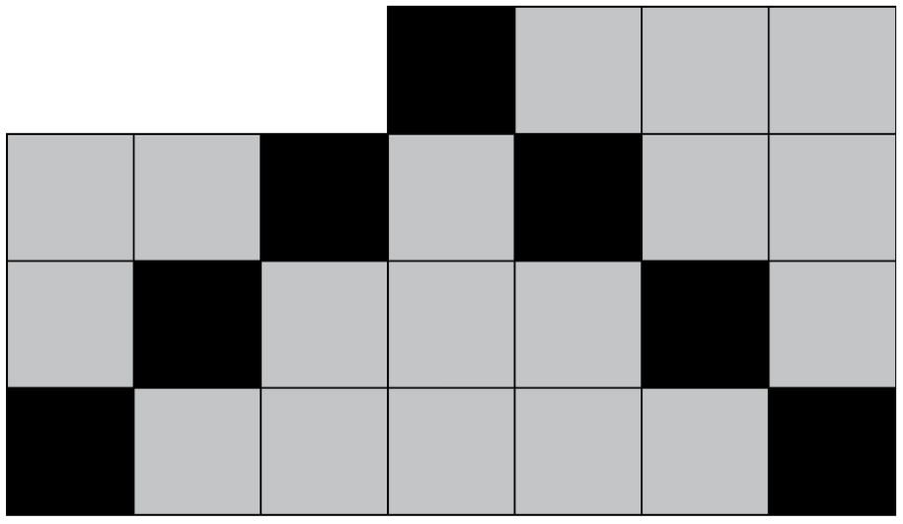
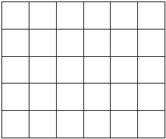
Here is a grid made of squares.
Shade 10% of this grid.

Solve word problems involving making connections between fractions and percentages
Hassan scores 40 out of 80 in a test.  Kate scores 40% in the same test.  Who has the higher score?  Explain how you know. | 2017 Paper 2 Question 18  A cat sleeps for 12 hours each day.  50% of its life is spent asleep.  A koala sleeps for 18 hours each day.  _____ % of its life is spent asleep.
2019 Paper 2 Question 15
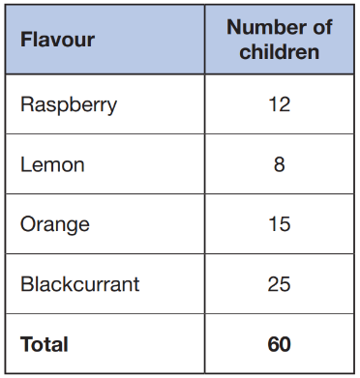
Amina asked 60 children to choose their favourite flavour of jelly.
These were her results.
What percentage of the 60 children chose orange?

A box of crisps contains three different flavours.  prawn cocktail  cheese and onion  salt and vinegar  A quarter of the packets are prawn cocktail flavour.  30% are cheese and onion flavour.  What percentage are salt and vinegar flavour? | 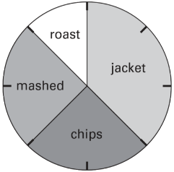  This pie chart shows how the children in Class 6 best like their potatoes cooked.  32 children took part in the survey.  For each statement put a tick if it is correct.  10 children like chips best.  25% of the children like mashed potatoes best.  $\frac{1}{5}$of the children like roast potatoes best.  12 children like jacket potatoes best.

