

Solve money problems involving multiplication, addition and subtraction
2017 Paper 3 Question 5  The children at Farmfield School are collecting money for charity. Their target is to collect £360  So far they have collected £57.73  How much more money do they need to reach their target? | Books are 25p each at a car boot sale.  Alfie wants to buy 12 books.  He only has £2.35  How much more money does Alfie need?
A pack of 20 postcards costs £3.60  A single postcard costs 20p.  Zak buys 1 pack of postcards. Jade buys 20 single postcards. Zak says to Jade, ‘My postcards cost 40p less than yours.’  Is he correct? Explain how you know. | Car Boot Sale Entrance Fee:  Adults 50p Children 30p  100 adults and 80 children pay to go in.  How much money do they pay altogether?
Emma saves £3.50 each week.
How much has she saved after 16 weeks?

This is what it costs to visit a castle.
Adults £2.45
Children (11 and over) £1.30
Children (under 11) 95p
How much will it cost for 18 children (under 11) to visit the castle?

Here are three supermarket bills.  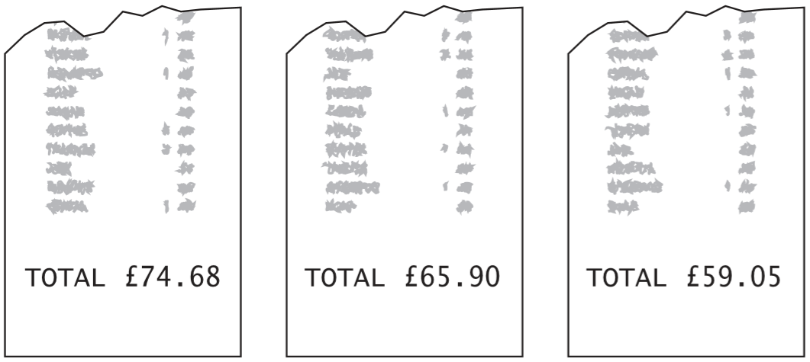  Tom rounds each bill to the nearest £10 and then adds them up. What is the total amount that Tom gets?  Mary adds up the three bills exactly.  What is the difference between her total and Tom’s total? | The table shows the cost of coach tickets to different cities.  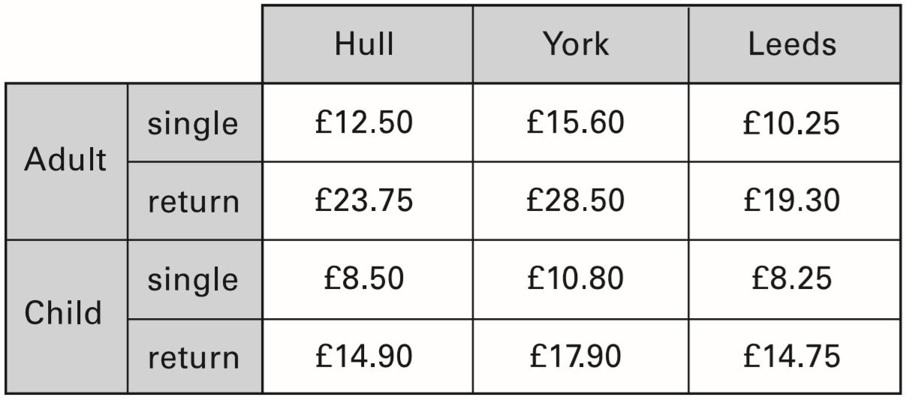  What is the total cost for a return journey to York for one adult and two children?  How much more does it cost for two adults to make a single journey to Hull than to Leeds?
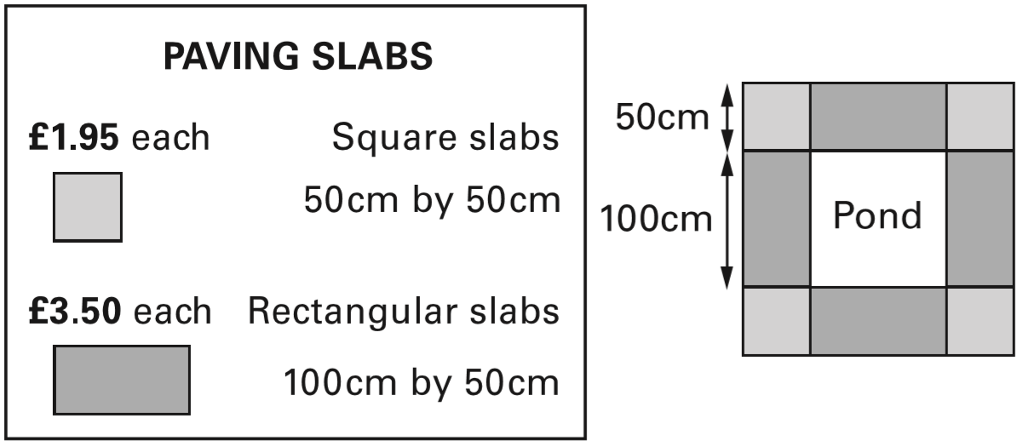  Mr Singh buys paving slabs to go around his pond. He buys 4 rectangular slabs and 4 square slabs. What is the total cost of the slabs he buys?  Mr Singh says, ‘It would cost more to use square slabs all the way round.’ Explain why he is correct. | Emily, Ben and Nisha take part in a sponsored swim to collect money for charity.  Emily collects £2.75 more than Nisha.  Ben collects £15  Nisha collects £7 less than Ben.  Altogether how much money do the three children collect?
2016 Paper 2 Question 19
Miss Mills is making jam to sell at the school fair.
- Strawberries cost £7.50 per kg.
- Sugar costs 79p per kg.
- 10 glass jars cost £6.90
She uses 12 kg of strawberries and 10 kg of sugar to make 20 jars full of jam.
Calculate the total cost to make 20 jars full of jam.

Solve money problems involving the four operations
Kate and Jamie each have some money.  Altogether they have £1.50  Kate gives Jamie 10p so that they both have the same amount.  How much money did each have at the start?  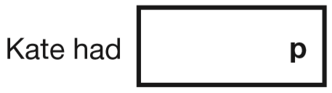  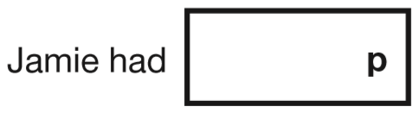 | A shop sells flowers.  daffodils: 99p for a bunch  roses: 40p each  John buys 3 bunches of daffodils.  How much does he pay altogether?  Karpal has £4.00 to spend on roses.  How many roses can she buy for £4.00?
Forest School sells badges for charity.  For each badge sold, £1.20 is given to a charity.  How much does the charity get when 12 badges are sold?  If the charity got £24, how many badges were sold? | 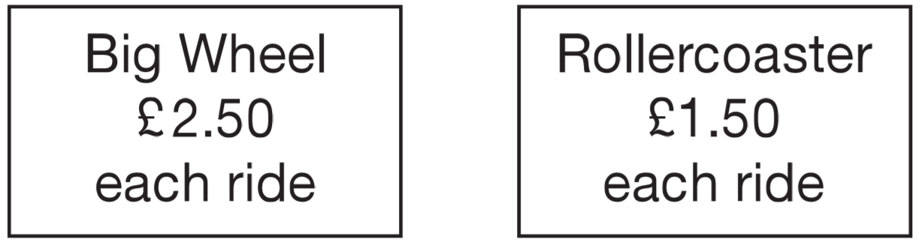  Liam spends £14 altogether on the Big Wheel and the Rollercoaster.  He goes on the Big Wheel twice.  How many times does he go on the Rollercoaster?
A shop sells pairs of socks.  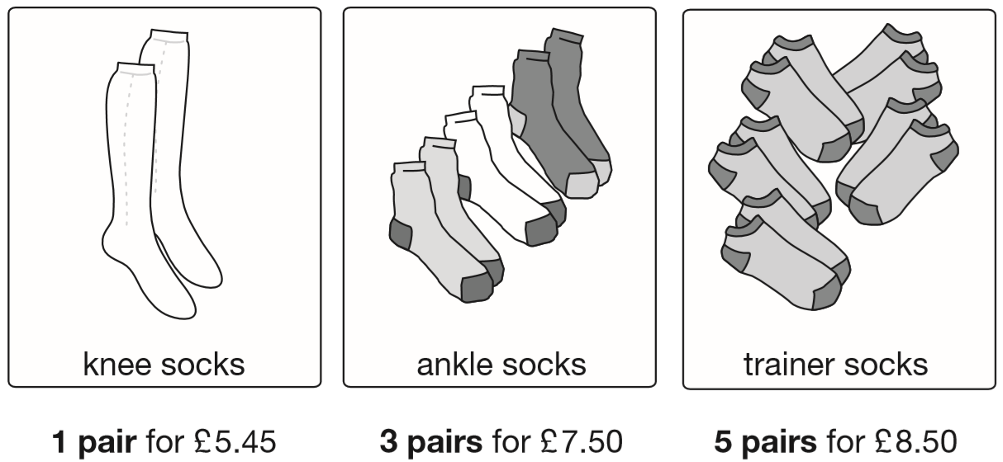  Kirsty buys 1 pair of knee socks and 3 pairs of ankle socks.  She pays with a £20 note.  How much change does she get?  Amy spends £25.50 on trainer socks.  How many pairs of trainer socks does she get? | Amir and Lara buy some fruit.  grapes - £2.50 for 1 kilogram  peaches - £1.99 for a box  pineapples - £1.40 each  Amir buys 2 pineapples and a box of peaches.  How much does he pay?  Lara buys half a kilogram of grapes and one pineapple.  How much change does she get from £5?
2015 Paper 3 Question 10
A bag of 5 lemons costs £1
A bag of 4 oranges costs £1.80
How much more does one orange cost than one lemon?

2019 Paper 3 Question 16  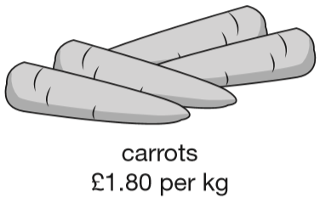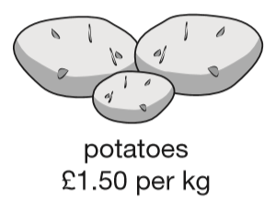  Jack buys 1 ½ kg of potatoes and ½ kg of carrots. How much change does he get from £5? | 2015 Paper 2 Question 16  Large pizzas cost £8.50 each.  Small pizzas cost £6.75 each.  Five children together buy one large pizza and three small pizzas.  They share the cost equally.  How much does each child pay?
102 people came to a car boot sale and paid 15p each to go in.  How much money was collected?  Each car had to pay £7 to be at the sale.  The school collected £399 from the cars.  How many cars were there? | Calculate ¾ of £15
8 friends share £434 equally between them.
How much does each person receive?

Calculate the cost of a single item given the cost of items in groups
Parveen buys 3 small bags of peanuts.  She gives the shopkeeper £2 and gets 80p change.  What is the cost in pence of one bag of peanuts? | A torch costs £7.65  Kate buys a torch and two batteries.  She pays £8.75 altogether.  How much does one battery cost?
A shop sells fruit.  - Chen buys 2 apples and 3 bananas. He pays £2.35  - Megan buys 2 apples and 1 banana. She pays £1.25  How much does one banana cost? | Alfie buys two books, each at the same price.  He pays with a £10 note and gets £2.30 change.  What is the cost of one book?
2017 Paper 2 Question 19  Amina posts three large letters.  The postage costs the same for each letter.  She pays with a £20 note.  Her change is £14.96  What is the cost of posting one letter? | A shop sells notebooks and pens.  Hassan bought a notebook and a pen. He paid £1.10  Kate bought a notebook and 2 pens. She paid £1.45  Calculate the cost of a notebook.
A drink and a box of popcorn together cost 90p.  2 drinks and a box of popcorn together costs £1.45  What does a box of popcorn cost? | Seb bought 2 apples and 3 pears.  He spent £1.59 altogether.  Apples cost 24p each.  How much does one pear cost?
A shop sells jars of honey and honey dippers.  Chen bought three jars of honey and a dipper.  The total cost was £5.40  The dipper cost 75p.  How much did each jar of honey cost? | 2016 Paper 2 Question 9  6 pencils cost £1.68  3 pencils and 1 rubber cost £1.09  What is the cost of 1 rubber?
2017 Paper 3 Question 14  3 pineapples cost the same as 2 mangoes.  One mango costs £1.35  How much does one pineapple cost? | An iced cake costs 10p more than a plain cake.  Sarah bought two of each cake.  They cost £1 altogether.  What is the cost of an iced cake?

Solve money problems by scaling up
Annie has collected 10p coins.  They are worth £10.  How many 10p coins does Annie have? | Lake School collected 10p coins for charity.  They raised £31.50  How many 10p coins did they collect?
Chris saves 50p coins.  He has saved 45 of them.  How much money has Chris saved? | Michelle has saved £8.40 in 20p coins.  How many 20p coins does Michelle have?
A machine only takes 20p coins.  The coins inside total £9.80  How many 20p coins are there? | Guide books cost £1.50 each. The waxworks sells £24 worth of guide books. How many guide books is this?
Dev has a bag of 50p coins and Holly has a bag of 20p coins.  Both bags have the same amount of money in.  There are thirty 50p coins in Dev’s bag.  How many 20p coins are there in Holly’s bag? | You save £1.50 per week.  How many weeks before you can buy a book which costs £18.49?
Seb goes on a sponsored walk to collect money for charity.  His aunt promises to pay 75p for each kilometre he walks.  She pays him £6.75 at the end of the walk.  How many kilometres does Seb walk? | Programmes cost 15p each.  Selling programmes raises £12.30  How many programmes are sold?
A shop sells food for birds.  Bird seed - £3.79 for a bag  Peanuts - £1.35 for a bag  Bird feeder - £8.95 each  Lara has £10 to spend on peanuts.  How many bags of peanuts can she get for £10? | A school buys some yo-yos as prizes.  The yo-yos cost £4.25 each.  The school has £40 to spend on prizes.  They buy as many yo-yos as they can.  How much money is left?
Tickets for a school play cost £2.75 each.
Dev sold 23 tickets.
How much ticket money did Dev collect?

Holly collected £77 altogether from selling tickets.
How many tickets did she sell?

Compare or find equivalent units of measurement
Match each length to the correct box on the right. One has been done for you.  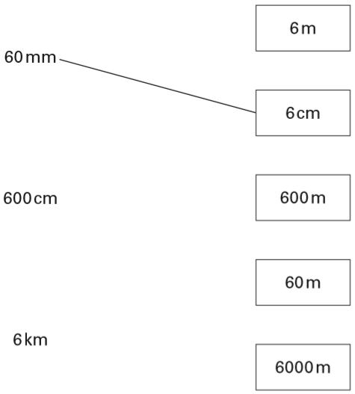 | Here are four lengths.  Write the lengths in order, starting with the shortest.  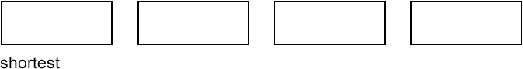
Katie’s glass holds a quarter of a litre when it is full.
She nearly fills it to the top with juice.
Tick the approximate amount of juice she puts in the glass.

4 millilitres 20 millilitres 120 millilitres

220 millilitres 420 millilitres

Put these volumes in order, starting with the smallest.  900 ml ½ litre 1 litre 80 ml  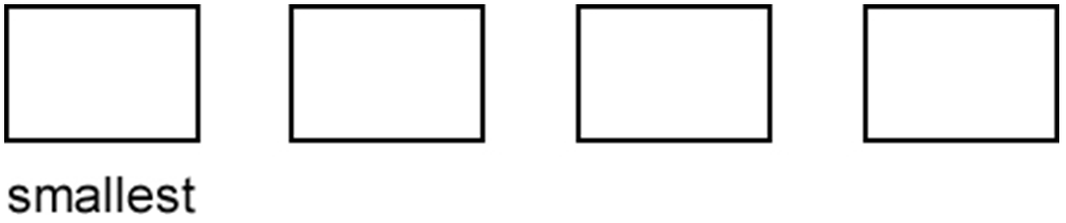 | Put these masses in order, starting with the heaviest.  800 g ½ kg 1 kg 60 g  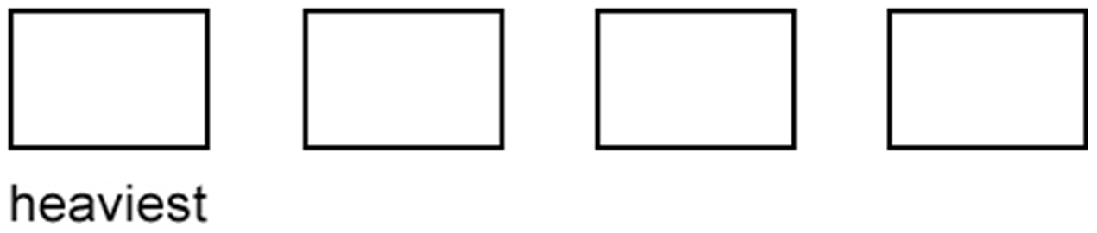
Here are four masses.  2 kilograms  1 tonne  800 grams  ½ kilogram  Write the masses in order, starting with the lightest.  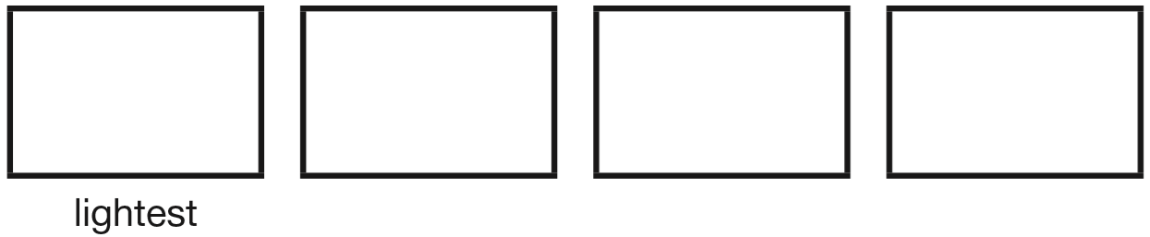 | Tick the two weights which are the same.  1.5 kilograms  1 kilogram 50 grams  15 kilograms  150 grams  1500 grams
Here are five letters on a scale.  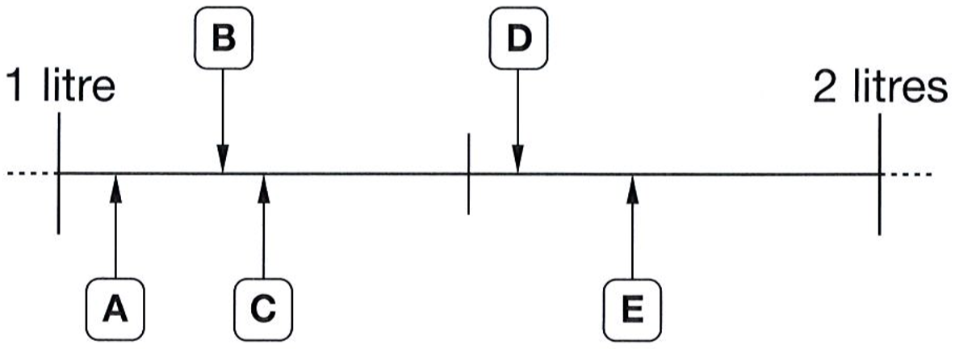  Match each letter to one of the capacities in the list below.  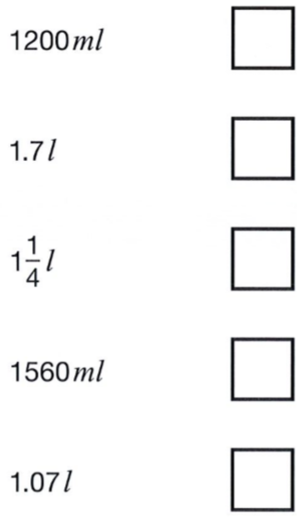 | This table shows the weight of some fruits and vegetables. Complete the table.  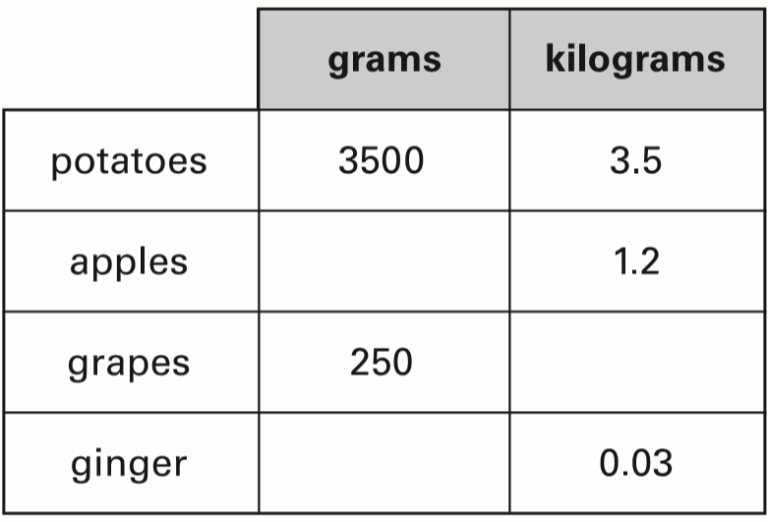
Chen and Megan each have a parcel.
Chen’s parcel weighs 1½ kg.
Megan’s parcel weighs 1.2kg.
How many more grams does Chen’s parcel weigh than Megan’s parcel?

Write the correct whole number in the box.

5 miles is approximately _____ kilometres.

Solve problems involving measurement
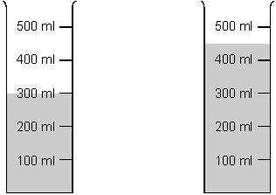  All the water in these two containers is to be poured into the empty container below.  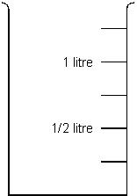  Draw where the water level will be in the container. | This is the scale on the side of a measuring jar.  There is some coloured water in the jar.  How much more water is needed to make 2 litres?  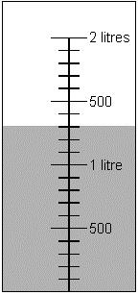
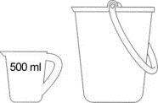  Steve needs to put 1 litre of water in a bucket.  He has a 500 ml jug.  Explain how he can measure 1 litre of water. | This jug holds ½ litre.  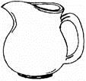  This bucket holds 5 litres.  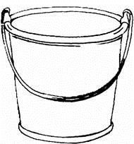  How many full jugs of water are needed to fill the bucket?
Megan wants to fill a bucket with water.  A bucket holds 6 litres. A jug holds 500 millilitres. How many jugs of water does Megan need to fill an empty bucket? | 2017 Paper 3 Question 10  A bottle contains 568 millilitres of milk.  Jack pours out half a litre.  How much milk is left?
A bottle holds 1 litre of lemonade.  Rachel fills 5 glasses with lemonade.  She puts 150 millilitres in each glass.  How much lemonade is left in the bottle? | 2018 Paper 2 Question 17  There are 28 pupils in a class.  The teacher has 8 litres of orange juice.  She pours 225 millilitres of orange juice for every pupil.  How much orange juice is left over?
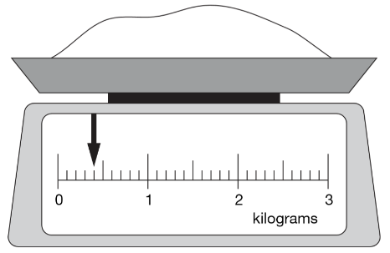  Here is some flour on a weighing scale.  How many grams of flour are on the scale?  How much more flour must be added to the scale to make 1.6kg? | Chen is cooking some pasta.  The recipe says he needs 350 grams of pasta for 4 people.  How many kilograms of pasta does he need for 12 people?
Jamie takes three parcels to be posted.
One parcel has a mass of 750 g
Another weighs 2.8 kg
The total mass of the three parcels is 5.13 kg
What is the mass of the third parcel?

Identify values on fractional scales
What is the total mass of these apples?  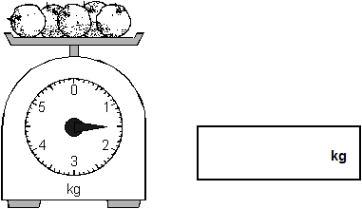 | 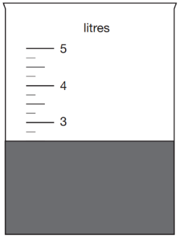  2019 Paper 2 Question 7  Jack pours some dark paint into a container.  In litres, how much paint is in the container?
Raj is making a cake.  He pours 275ml of milk into a jug.  Draw a line on the jug to show the level of milk.  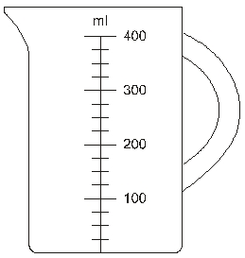  The scales below show how much flour he uses. How much flour does Raj use?  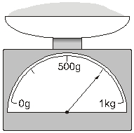 | A piece of cheese has a mass of 350 grams.  Mark an arrow on the scale to show the reading for 350 g.  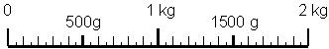
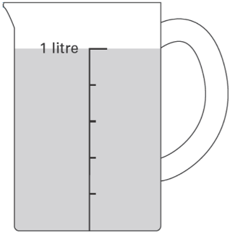
This jug has 1 litre of water in it.
Lauren pours out 400 millilitres of water.
Draw an arrow to show the new level of water in the jug.

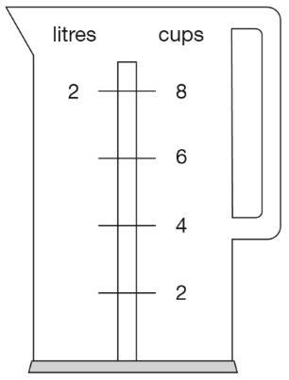
Nisha’s kettle holds 2 litres of water.
How many millilitres are equal to 1 cup?

On this scale, the arrow shows the weight of a pineapple.  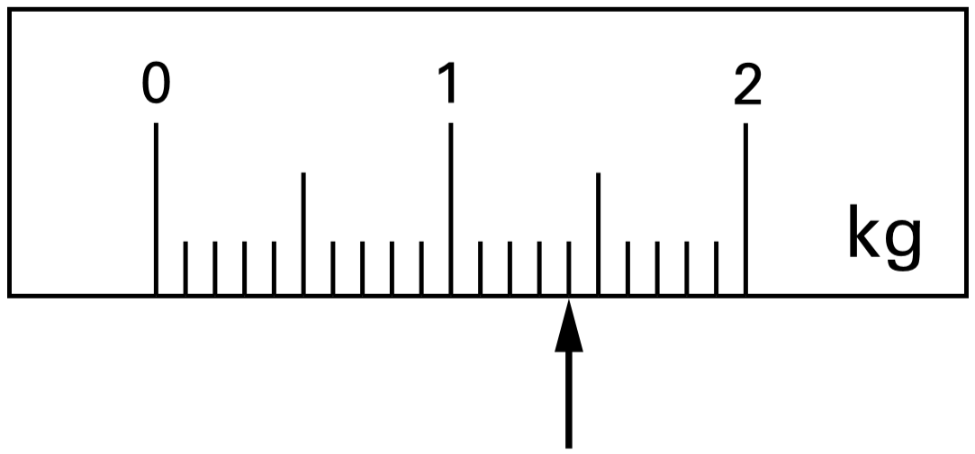  Here is a different scale. Mark with an arrow the weight of the same pineapple.  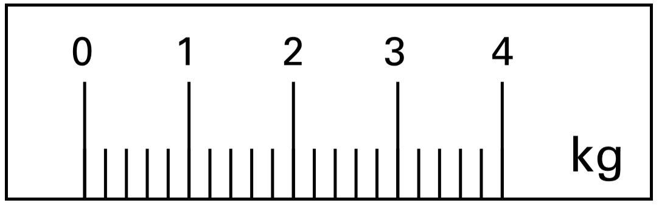 | This scale shows the dates of floods and the height of the water in the floods.  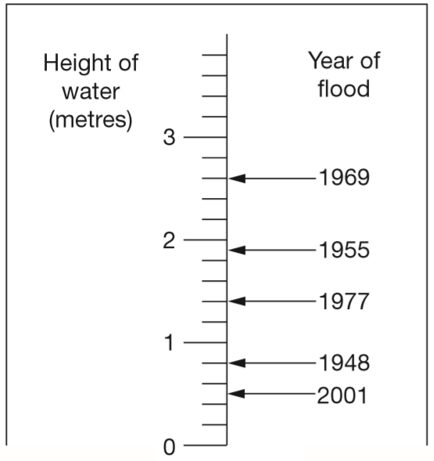  How high was the water in the 1955 flood?  How much higher was the water in the 1969 ﬂood than in the 1948 ﬂood?
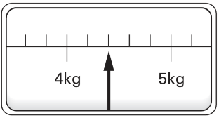
This scale shows the weight of Fred’s cat.
What is the weight of Fred’s cat?

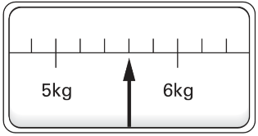
This scale shows the weight of Fred’s dog.
How much more does Fred’s dog weigh than his cat?

Estimate or identify values on number lines
Here are four digit cards.  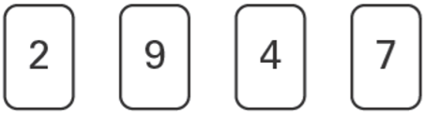  Use two of the four cards to make the number on the number line.  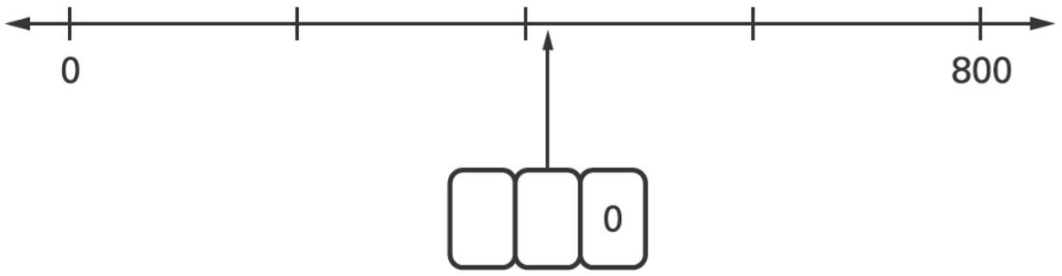 | Write the correct number shown by the arrow.  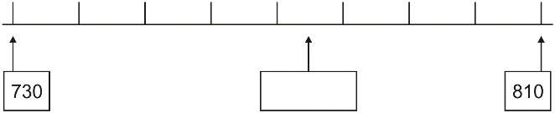
Here is part of a number line.
Write the two missing numbers in the boxes.
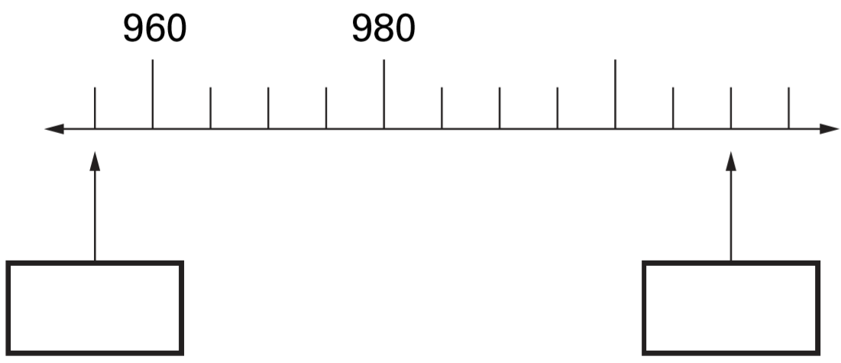
Here is part of a number line.  Write in the number indicated by the arrow.  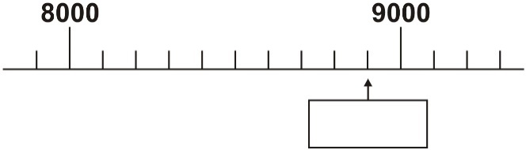 | Here is part of a time line. Draw a line from each invention to the correct point on the time line. One has been done for you.  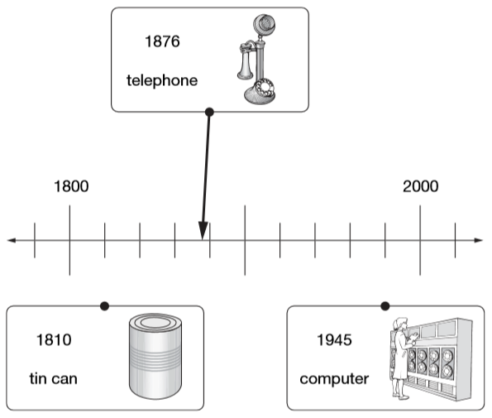
Here is part of a number line.
Write the number shown by the arrow.
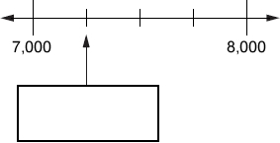
Draw an arrow to show the position for 7,500
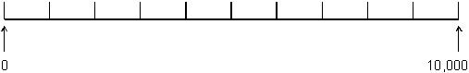

Estimate values on scales
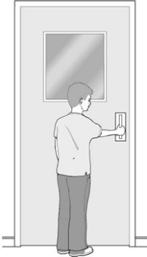  Tom’s bedroom door is about 190 cm tall.  Estimate Tom’s height.  Draw a circle around the best estimate.  60 cm 90 cm  130 cm 160 cm | 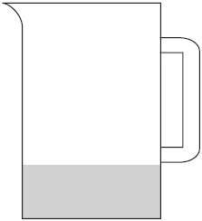  The jug holds 800 ml of water when it is full.  Estimate the amount of water that is in the jug.
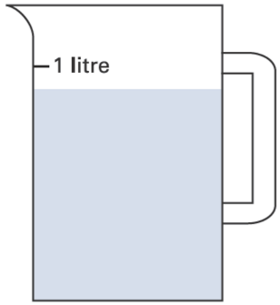  Sophie poured some water out of a litre jug.  Look how much is left in the jug.  Estimate how many millilitres of water are left. | 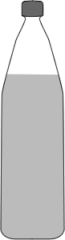  When full, Sam’s bottle holds a litre of water. Sam drinks some.  Estimate the amount of water left.  Circle the best estimate.  800 ml 600 ml 80 ml  70 ml 7 ml
2015 Paper 3 Question 5  Chen pours 165 millilitres of milk into a measuring jug. Draw an arrow on the jug to show the level of the milk.  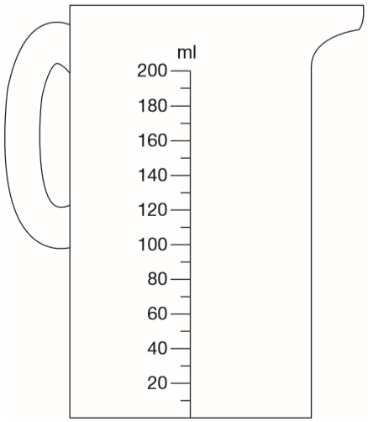 | Mina has two cartons of juice.  Each carton contains 220ml.  She empties them both into this jug.  Draw an arrow to show the level of the mixture in the jug.  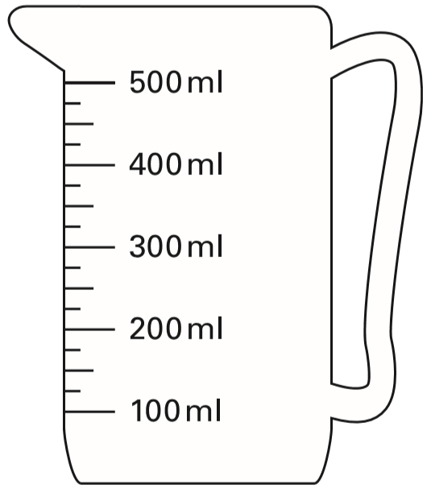
This scale shows length measurements in centimetres and feet.  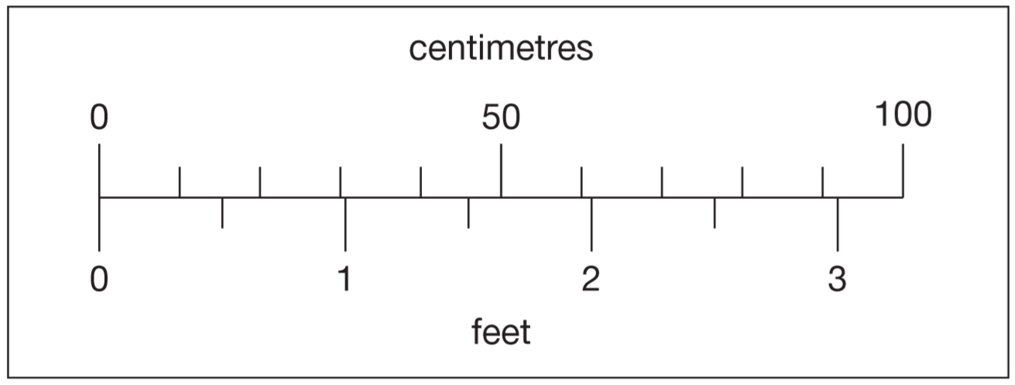  Estimate the number of centimetres that are equal to 2½ feet.  Estimate the difference in centimetres between 50cm and 1½ feet. | 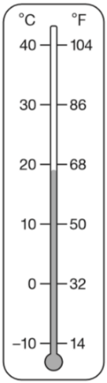  2016 Paper 2 Question 15  This thermometer shows temperatures in both °C and °F.  Work out what 25 °C is in °F.

Solve simple scaling problems
Purple paint is made by mixing blue and red paint.  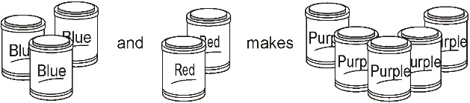  Use the picture to work out the missing numbers.  For 25 tins of purple paint you need _____ tins  of blue pain and _____ tins of red paint. | A shop sells packs of sweets.  Each pack has one red sweet and two green sweets.  Sam buys some packs so he has 4 red sweets.  How many green sweets does he have?
Jade makes fruit salad.
For every three apples, she uses one banana.
She uses 27 apples.
How many bananas does she use?

Sapna makes a fruit salad using bananas, oranges and apples.  For every one banana, she uses 2 oranges and 3 apples.  Sapna uses 24 fruits.  How many oranges does she use? | Mari is the presenter of a weekly radio show.  She always plays five new songs for every two old songs.  Last week she played 15 new songs.  How many songs did she play altogether?
2017 Paper 2 Question 14  Amina planted some seeds.  For every 3 seeds Amina planted, only 2 seeds grew. Altogether, 12 seeds grew.  How many seeds did Amina plant? | Seb had some cherries.  Every day he ate 10 cherries and gave 5 away.  After he gave the last 5 cherries away, he had eaten 40 cherries altogether.  How many cherries did Seb have at the start?
Joe has some triangular tiles and some quarter-circle tiles.  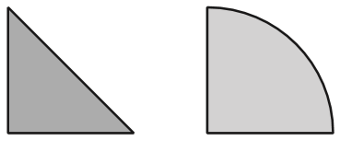  He uses 2 triangles and 7 quarter-circles to make this ‘flying bird’ design.  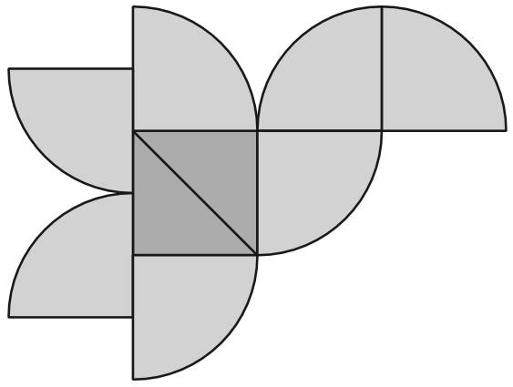  Joe makes some more of these ‘flying bird’ designs. He uses 56 quarter-circles.  How many triangles does he use? | Here is a recipe for pasta sauce  300g tomatoes 120g onions 75g mushrooms  Josh makes the pasta sauce using 900g of tomatoes.  What weight of onions should he use?
A gardener plants tulip bulbs in a flower bed.
She plants 3 red bulbs for every 4 white bulbs.
She plants 60 red bulbs.
How many white bulbs does she plant?

David and his friends prepare a picnic.
Each person at the picnic will get:
3 sandwiches, 2 bananas, 1 packet of crisps
The children pack 45 sandwiches.
How many bananas do they pack?

On a school trip, every child is given 2 apples and 5 cherries.  Mrs Smith gives her group 12 apples.  How many cherries does she give her group? | A and B are two chain wheels on a bike.  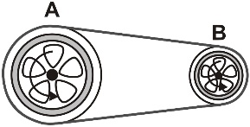  For every 2 complete turns that wheel A makes, wheel B makes 5 complete turns.  If wheel A makes 150 turns, how many turns will wheel B make?  If wheel B makes 90 turns, how many turns will wheel A make?
In a country dance there are 3 boys and 2 girls in every line.
42 boys take part in the dance.
How many girls take part?

Calculate length
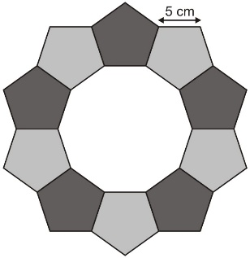  This ring is made of regular pentagons, with sides of 5 centimetres.  What is the length of the outer edge of the ring? | Three identical blocks are placed in a line 80 centimetres long.  The gaps between the blocks are each 7cm.  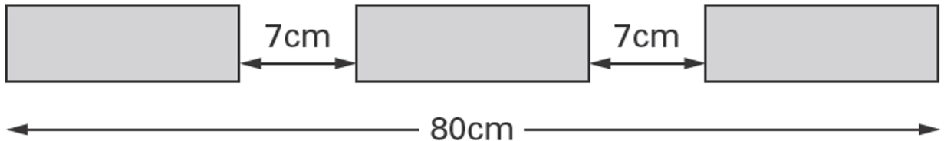  Work out the length of each block.
Liam has two different sizes of rectangle.  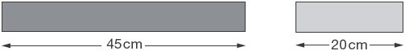  He makes this pattern with them.  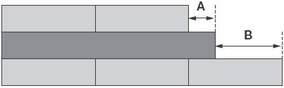  Calculate the lengths of A and B. | Ben has a rectangle (A) and a square (B).  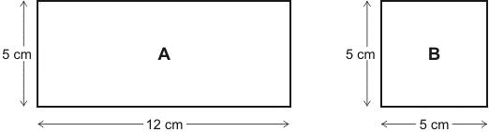  Ben puts B directly on top of A.  What is the length of x?  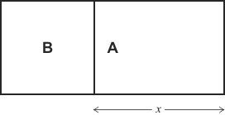
2016 Paper 2 Question 13  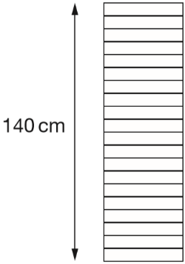  A stack of 20 identical boxes is 140 cm tall.  Stefan takes three boxes off the top.  How tall is the stack now? | This fence has three posts, equally spaced. Each post is 15 centimetres wide. The length of the fence is 153 centimetres.  Calculate the length of one gap between two posts.  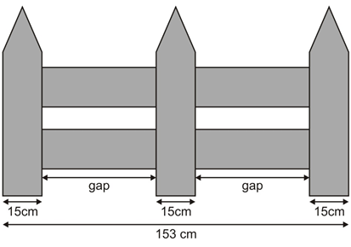
Strips of paper are each 30 centimetres long.  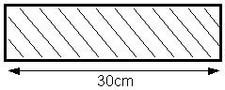  Steve joins strips of paper together to make a streamer.  The strips overlap each other by 5 cm.  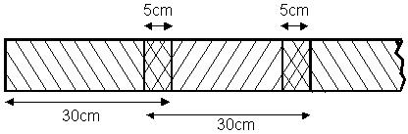  How long is a streamer made from only 2 strips?  Sunita makes a streamer that is 280 cm long.  How many strips does she use? | The distance from A to B is three times as far as from B to C.  The distance from A to C is 60 centimetres.  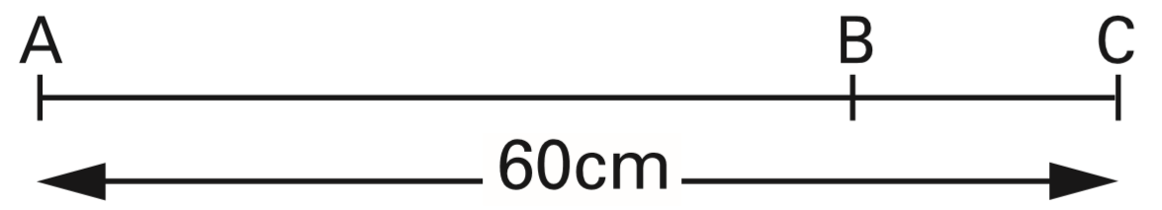  Calculate the distance from A to B.
2019 Paper 3 Question 23
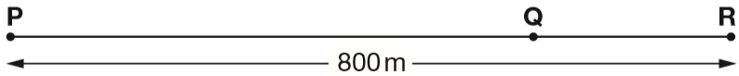
The distance from point P to point R is 800 metres. The distance from point P to point Q is 4 times the distance from point Q to point R.
Olivia says, ‘It is 600 metres from point P to point Q.’ Explain why Olivia is not correct.

Find the perimeter of a shape
Lara has some identical rectangles. They are 7 centimetres long and 2 centimetres wide.  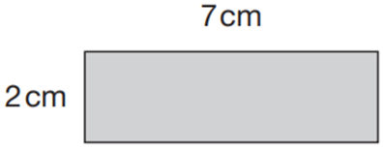  She uses five of her rectangles to make the large rectangle below.  What is the perimeter of the large rectangle?  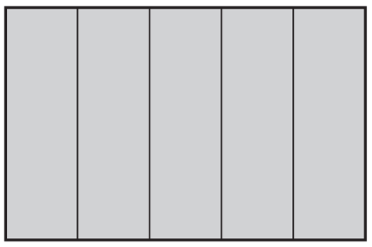 | Millie has some star-shaped tiles.  Each edge of a tile is 5 centimetres long.  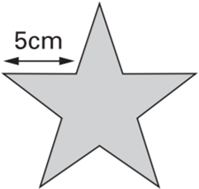  She puts two tiles together to make this shape.  Work out the perimeter of Millie’s shape.  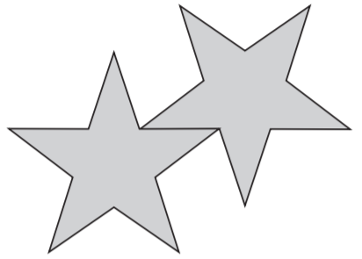
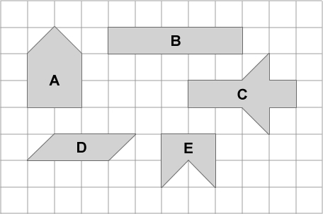
The diagram shows some shapes on a centimetre square grid.
Which two shapes have the same perimeter as shape A?

Draw shapes of a given perimeter
Note: Questions have been scaled down, so measurements given in cm are not to scale.
Draw a rectangle whose perimeter is 18 centimetres (cm).  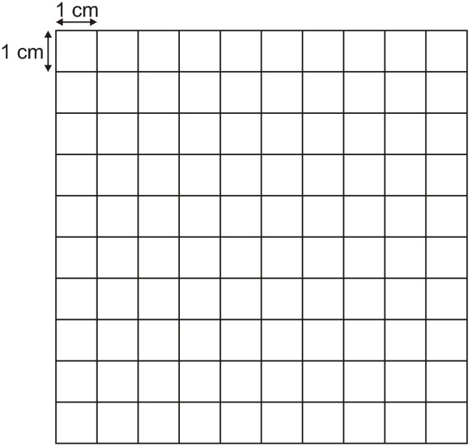 | Here is a centimetre square grid.  On the grid draw a rectangle which has a perimeter of 10 square centimetres.  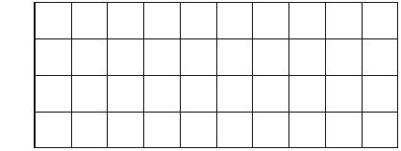
Grace has a rectangle with sides of 4 cm and 5 cm. Draw a different rectangle that has the same perimeter.

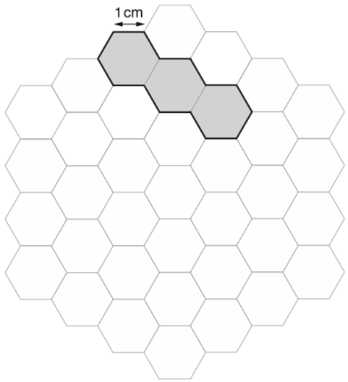
Here is a grid of regular hexagons.
The shaded shape has an area of 3 hexagons
and a perimeter of 14cm.
Draw another shape on the grid which has an area of 4 hexagons and a perimeter of 14cm.

Find missing lengths to calculate perimeter
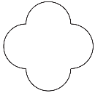  This shape is made out of four identical curves. The perimeter of the shape is 28 centimetres.  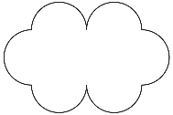  A new shape is made out of curves of the same size.  What is the perimeter of the new shape? | 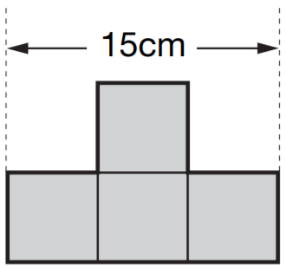  This shape is made from 4 shaded squares. Calculate the perimeter of the shape.
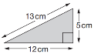  Chen has some right-angled triangular tiles.  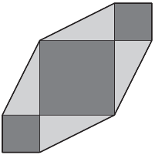  He makes this shape with four of his triangular tiles and three square tiles. What is the perimeter of Chen’s shape? | 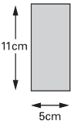  Liam has two rectangular tiles like this.  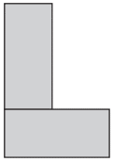  He makes this L shape.  What is the perimeter of Liam’s  L shape?
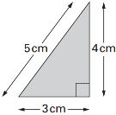  Jody has some triangular tiles.  He uses two of these tiles to make different shapes.  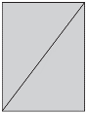  The perimeter of the rectangle is:  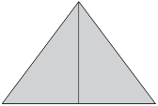  The perimeter of the isosceles triangle is:  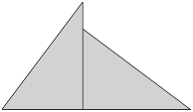  The perimeter of the quadrilateral is: | Alfie has some rectangles.  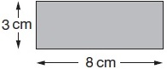  He makes this shape using three of the rectangles.  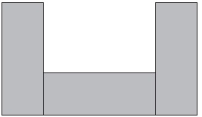  What is the perimeter of Alfie’s shape?
Lindy has 4 triangles, all the same size.
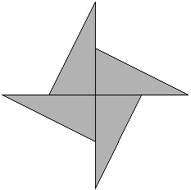
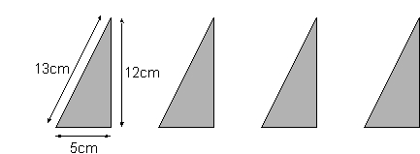
She uses them to make a star.
Calculate the
perimeter of the star.

Find the perimeter of squares and rectangles or use the perimeter to calculate length
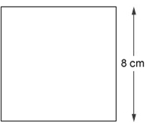  Calculate the perimeter of this square. | Grace has a square.  It has a perimeter of 28 cm.  What is the side length of her square?  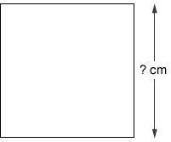
A field measures 89.5 m by 60 m.  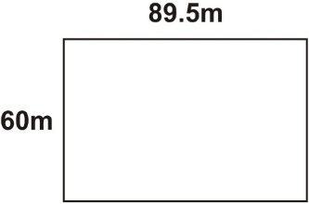  What is the perimeter of the field? | The perimeter of this rectangle is 20 cm.  The length is 6 cm.  How long is the width of the rectangle?  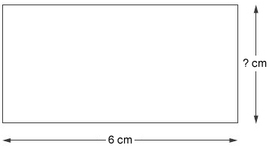
Ben’s rectangle is 10 cm long.  It has a perimeter of 28 cm.  How wide is his rectangle?  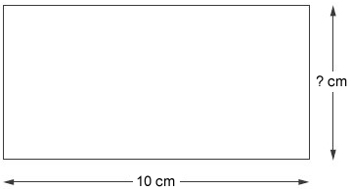 | The perimeter of this rectangle is 50 centimetres.  Calculate the length of the rectangle.  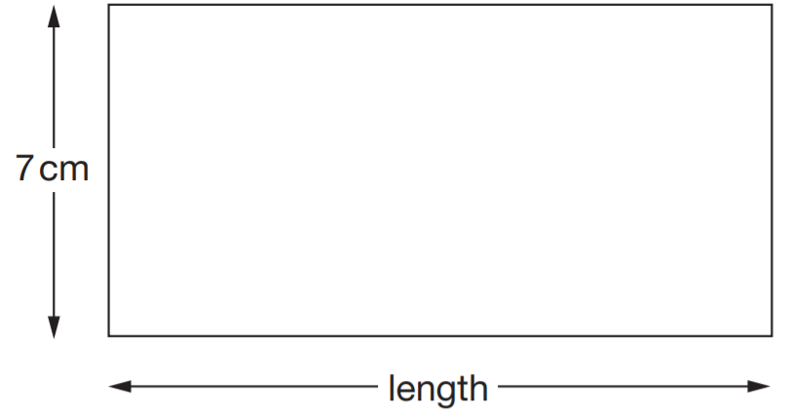
The perimeter of a rectangle is one metre.  Each longer side is 36 centimetres.  What is the length of each shorter side? | Here is a rectangle with a width of 15.7 centimetres.  The perimeter of this rectangle is 85 centimetres.  Calculate the length of the rectangle.  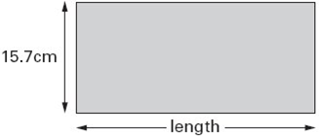

Find area by counting squares
Note: Questions have been scaled down, so measurements given in cm are not to scale.
Here is a shaded shape on a 1 cm square grid.  What is the area of the shaded shape?  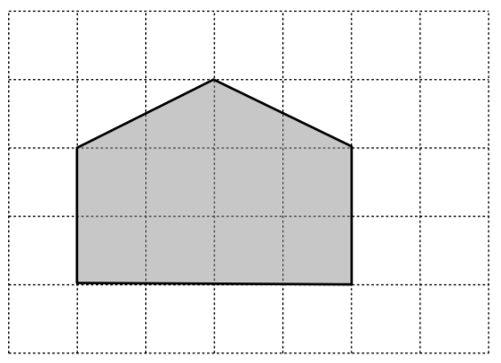 | Here is a 1cm square grid.  Some of the grid is shaded.  What is the area of the shaded shape?  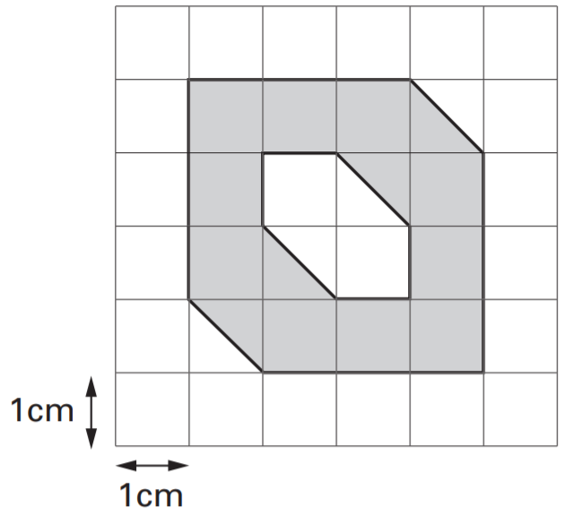
Here are some shapes on a 1cm square grid.  Write the letter of the shape that has the smallest area.  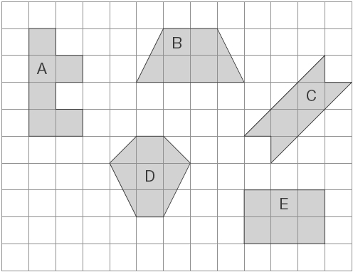 | Draw one line from each shape to the rectangle which has the same area.  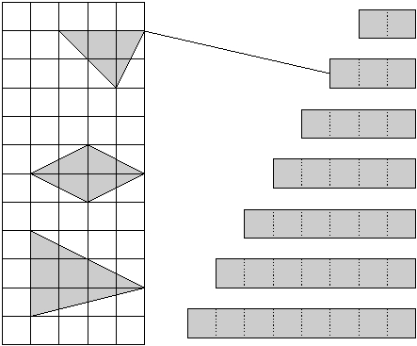
Match each shape on the left to one with equal area on the right.  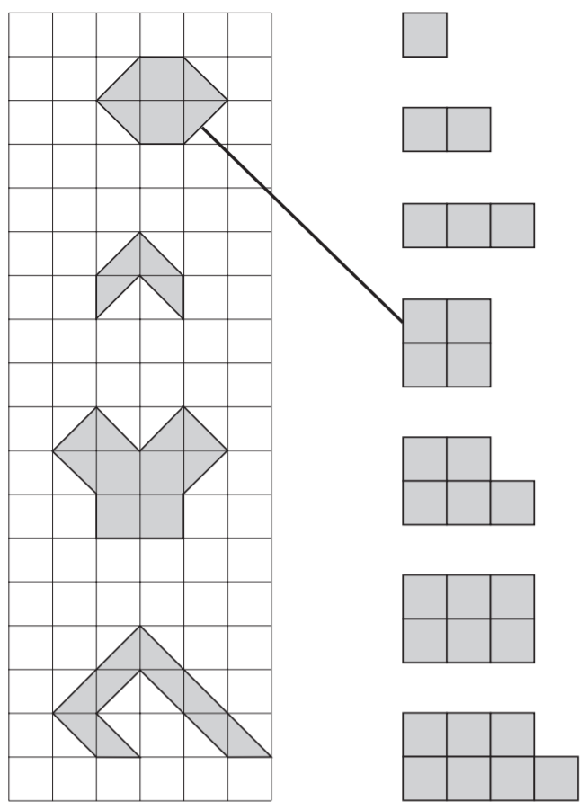 | The diagram shows some shapes on a centimetre square grid.  Which two shapes have the same area as shape A?
Here are some shapes drawn on a grid.
Write the letters of the two shapes that are equal in area.
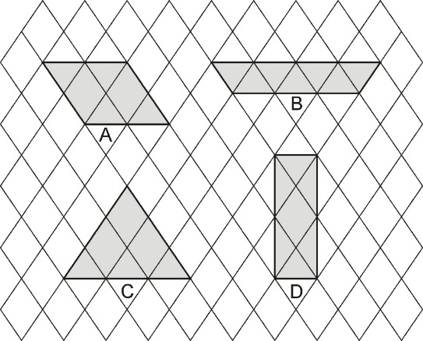

Draw shapes of a given area or perimeter
Note: Questions have been scaled down, so measurements given in cm are not to scale.
On this grid draw a different shape which has the same area as shape A.  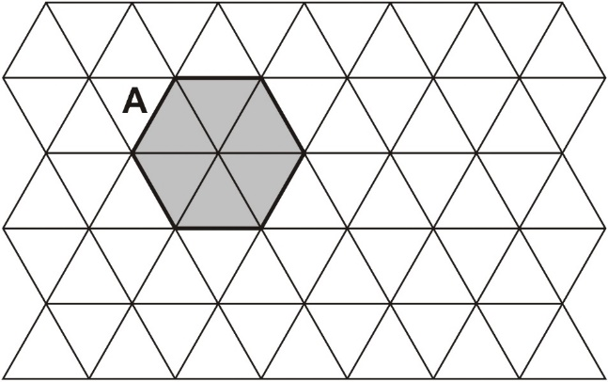 | Grace has a rectangle that has sides of 4 cm and 5 cm.  Draw a different rectangle that has the same area.  
Here is a quadrilateral drawn on a square grid. On the same grid, draw a different quadrilateral that has the same area.  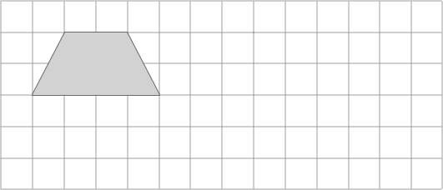 | Here is a centimetre square grid.  On the grid draw a shape which has a perimeter of 10 square centimetres.
On the grid, draw a rectangle which has the same area as this shaded pentagon.  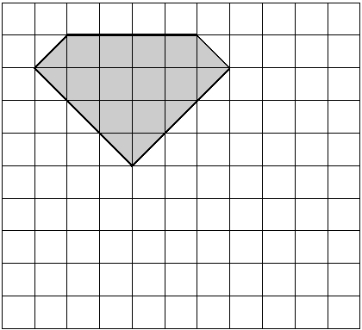 | Join the dots to draw a rectangle that has  an area of 20 cm² and a perimeter of 18 cm.  

Calculate area and calculate lengths from area
A rectangle has an area of 36 cm².  How long could the sides of the rectangle be?  Give three different examples, using whole numbers. | A rectangle has an area of 100 cm².  How long could the sides of the rectangle be?  Give three different examples, using whole numbers.
2015 Paper 3 Question 19  The area of a rugby pitch is 6,108 square metres. A football pitch measures 112 metres long and 82 metres wide.  How much larger is the area of the football pitch than the area of the rugby pitch? | 2017 Paper 3 Question 20  A square tile measures 20 cm by 20 cm.  A rectangular tile is 3 cm longer and 2 cm narrower than the square tile.  What is the difference in area between the two tiles?

Calculate the area of compound shapes
Lara has some identical rectangles. They are 7 centimetres long and 2 centimetres wide.  She uses five of her rectangles to make the large rectangle below.  What is the area of the large rectangle? | Rebecca has rectangular tiles like this.  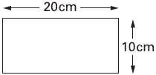  She makes a larger rectangle using 4 of the tiles. What is the area of the larger rectangle?  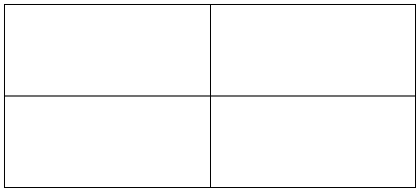
This plan of a garden is made of rectangles and triangles. The area of each rectangle is 12 square metres. What is the area of the whole garden?  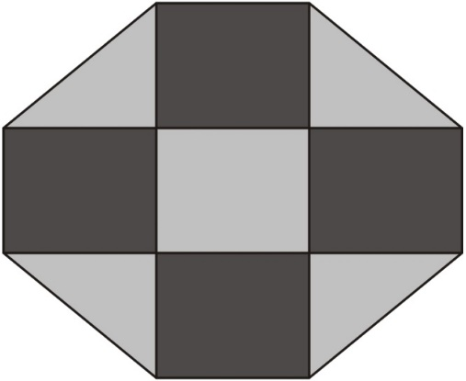 | A white square is painted in one corner of a grey square.  Each side of the white square is half the length of a side of the grey square. What is the area of the grey section?  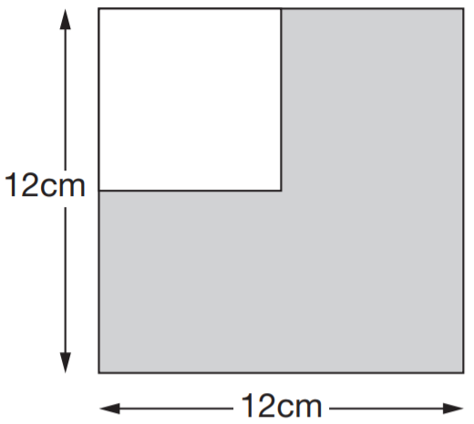
What is the area of this shape?
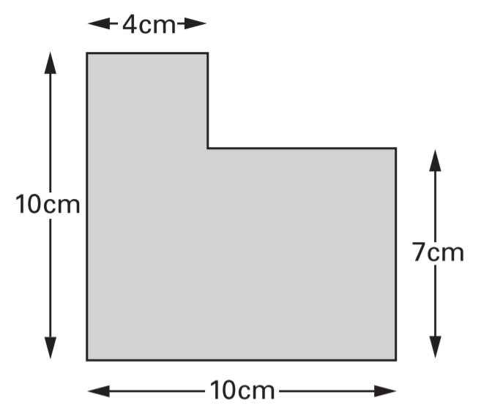

Explore area and perimeter
Note: Questions have been scaled down, so measurements given in cm are not to scale.
Here are two shapes made with centimetre squares.  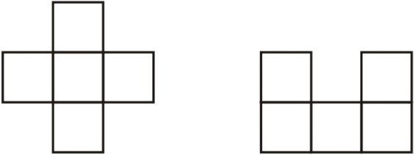  Each shape has 5 squares. Write one other thing which is the same about the two shapes. | Megan says, ‘If two rectangles have the same perimeter, they must have the same area.’  Is she correct? Explain how you know.
Look at the shaded rectangles drawn on a centimetre square grid.  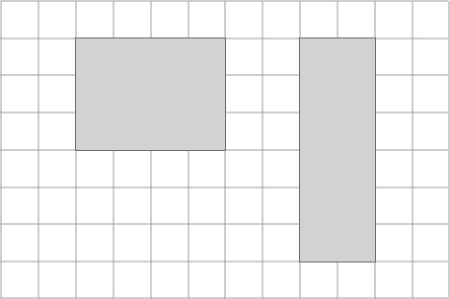  Sam says, “The two rectangles have the same area as each other and the same perimeter as each other.”  Is Sam correct? Explain how you know. | The area of a rectangle is 16 cm².  One of the sides is 2 cm long.  What is the perimeter of the rectangle?
A rectangle has an area of 36 cm².
How long could the sides of the rectangle be?
Give three different examples, using whole numbers.

What is the perimeter of a square with an area of 64 cm²?

Now give an example of a rectangle with an area of 64 cm² but a different perimeter.

2019 Paper 2 Question 17
These two shapes have the same perimeter.
The length of each side of the hexagon is 8 centimetres.
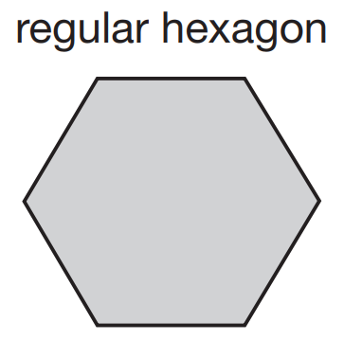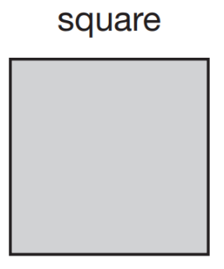
Calculate the area of the square.

Read calendars
Here is part of a calendar.  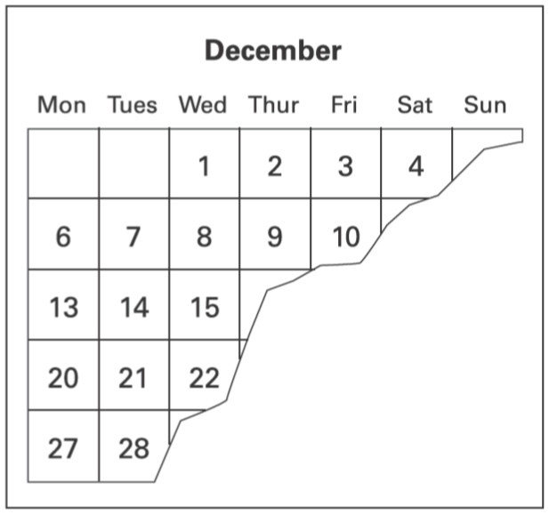  Tyrone’s birthday is on December 18th.  On what day of the week is Tyrone’s birthday? | Here is the calendar for the August when Luke was on holiday.  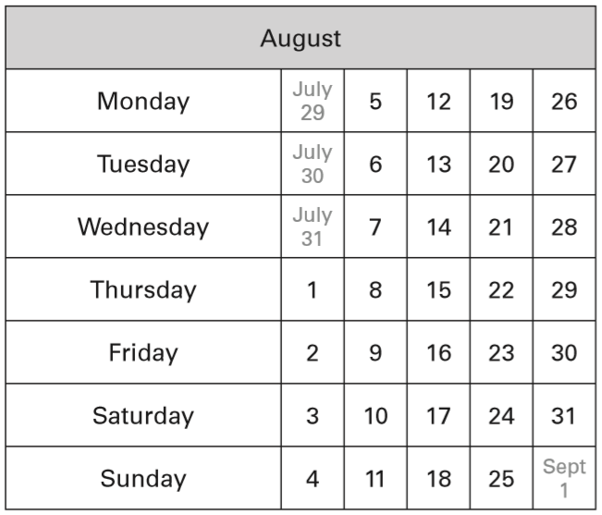  Luke came back from holiday on August 4th.  He went on holiday two weeks before that date. On what date did Luke go on holiday?
Here is the calendar for August 1998.  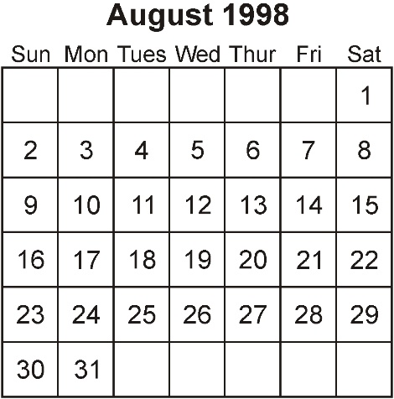  Simon's birthday is on August 20th.  In 1998 he had a party on the Sunday after his birthday.  What was the date of his party?  Tina's birthday is on September 9th.  On what day of the week was her birthday in 1998? | Joe goes skating every Saturday.  He went skating on Saturday January 1st.  Altogether, how many times did Joe go skating in January?
 | October has 31 days. On October 24th, Zak says, ‘My birthday is exactly two weeks from now.’ Write the date of Zak’s birthday.
Tick the months that have 31 days.
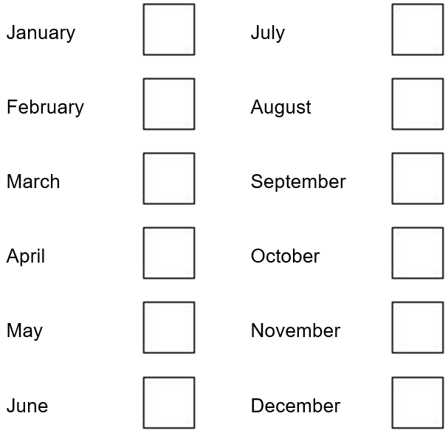
2019 Paper 3 Question 14  How many days are there in September, October and November altogether? | Write the missing numbers.  There are _____ days in a year and _____ days in a leap year.
Ryan collects 2 comics each week for a whole year.
How many comics does he collect in a year?

Compare lengths of time
2015 Paper 2 Question 5  What is 444 minutes in hours and minutes?  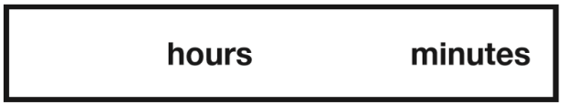 | 2016 Paper 3 Question 14  Complete each sentence using a number from the list below.  120 240 600 1,440 3,600 6,000  There are _____ seconds in an hour.  There are _____ minutes in a day.
2017 Paper 2 Question 7
Write the missing numbers.

60 months = _____ years

72 hours = _____ days

84 days = _____ weeks

Read information from timetables
2017 Paper 3 Question 6  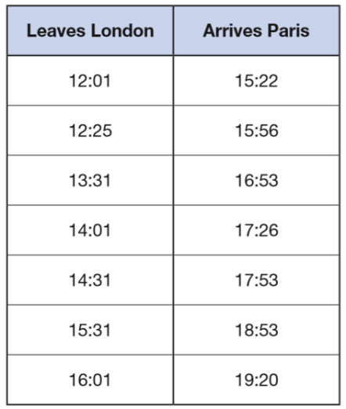  William wants to travel to Paris by train.  He needs to arrive in Paris by 5:30 pm.  Circle the latest time that William can leave London. | 2016 Paper 3 Question 9  Here is part of the bus timetable from Riverdale to Mott Haven.  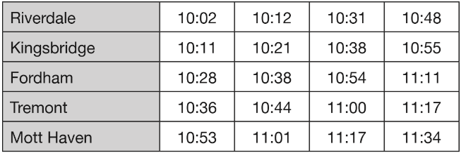  How many minutes does it take the 10:31 bus from Riverdale to reach Mott Haven?  Mr Evans is at Fordham at 10:30  What is the earliest time he can reach Tremont on the bus?
Here is part of the morning bus timetable from Winton to Yansley.  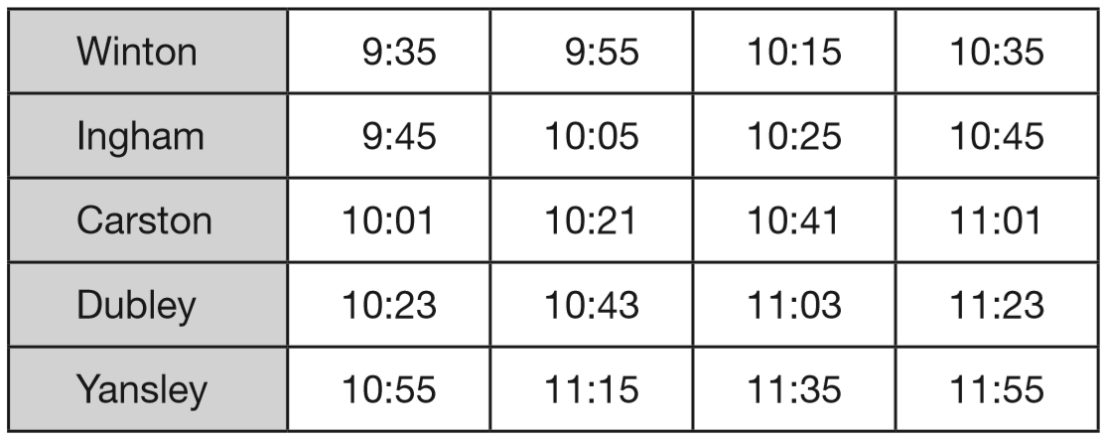  How many minutes does the bus take to get from Ingham to Dubley?  Megan is in Carston.  She wants to be in Yansley before 11:30  What is the time of the latest bus she can take from Carston?  One morning, the 10:35 bus from Winton gets to Carston 3 minutes early. What time does it get to Carston? | Here is part of the morning train timetable from Perth to Midland in Australia.  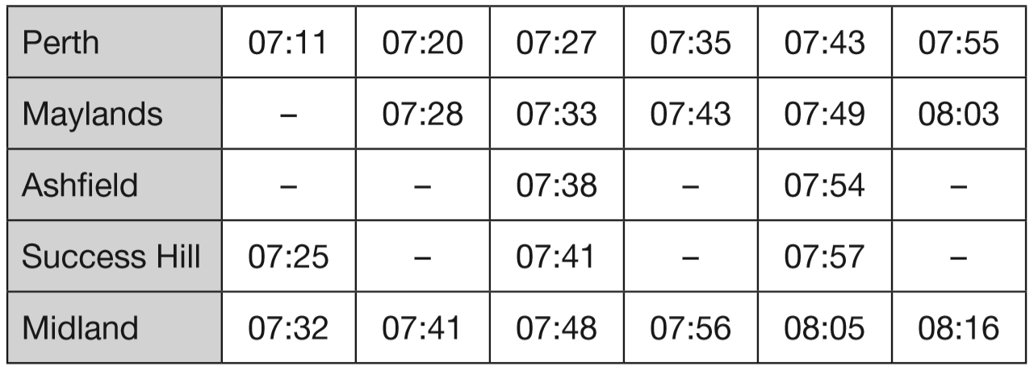  What time is the first train from Maylands that stops at Success Hill?  Mr Evans is in Perth and wants to be in Midland by 08:00  What is the time of the latest train he can take from Perth?

Here is a part of a train timetable.
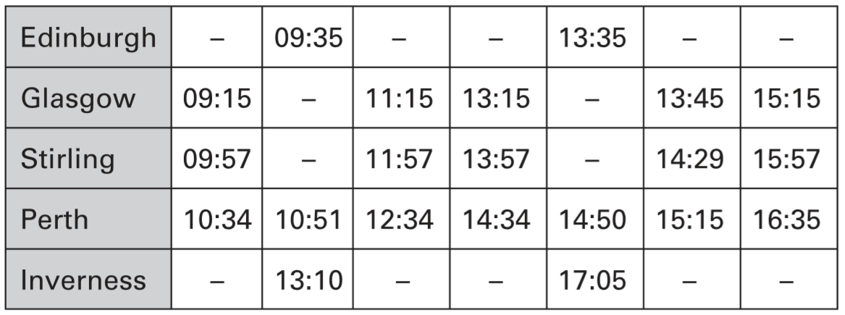
How long does the first train from Edinburgh take to travel to Inverness?

Ellen is at Glasgow station at 1:30pm.
She wants to travel to Perth.
She catches the next train.
At what time will she arrive in Perth?

