
Recognise that angles are measured in degrees and estimate their size
2019 Paper 3 Question 13  many possible explanations  e.g.  An acute angle is less than 90°  1° is an acute angle  Double 1° is 2° which is still less than 90° | 190°

Find missing angles on a straight line
117° | 25°
107° | a = 135°  b = 45°



Find missing angles on a point
170° | 78°
141°

Recognise angles in turns
270° | 2017 Paper 2 Question 16  540°
5  270° | 9  30°

Apply knowledge that angles in a triangle always total 180 degrees
Angles in a triangle add up to 180°.  35° + 75° + 45° = 155° | Angles in a triangle add up to 180°.  Obtuse angles are larger than 90°.  If you have two angles which are larger than 90°, you will have more than 180°.
107° | x = 55°  y = 145°
35° | 118°

Recognise isosceles triangles
C, D  A, D | B, C
A, B, D  A, C | 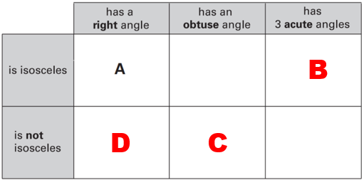
5 cm and 2 cm  3.5 cm and 3.5 cm  (any order) | 2 lines of the triangle must be the same length  e.g.  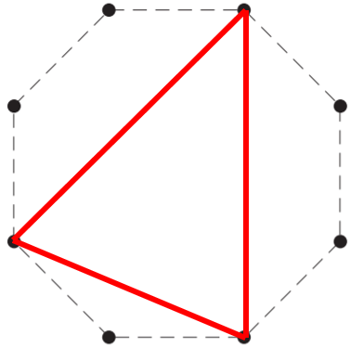

Recognise equilateral triangles
sides of the same length  or angles of the same size (60°) | 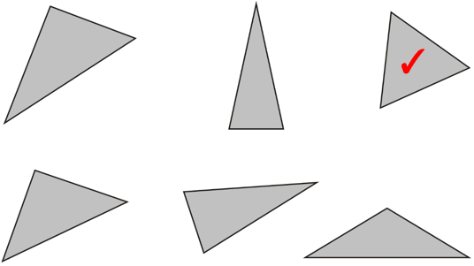
2018 Paper 3 Question 14
The angles in an equilateral triangle are always the same (60°)

all 3 lines of the triangle must be the same length  e.g.  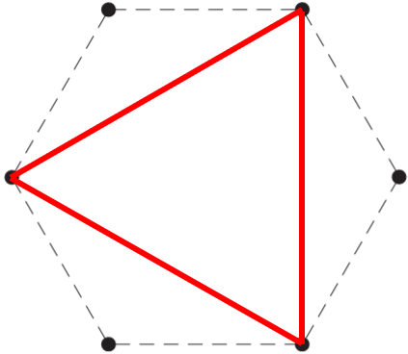 | isosceles  scalene

Recognise parallel and perpendicular lines
DA, BC  AB, CD | 2017 Paper 3 Question 15  E
DA, BC  AB, CD | A, C
Tick  Cross  Cross  Tick | 2015 Paper 2 Question 13  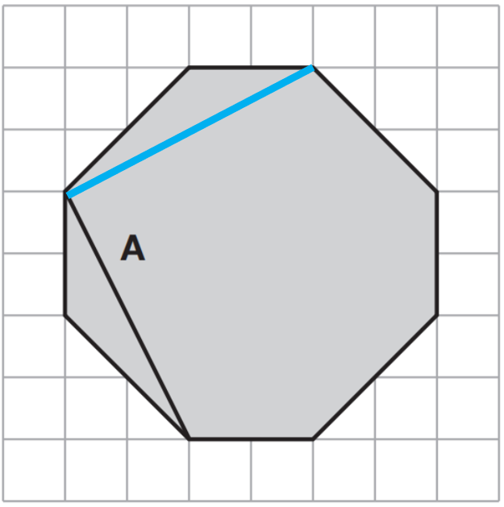 or 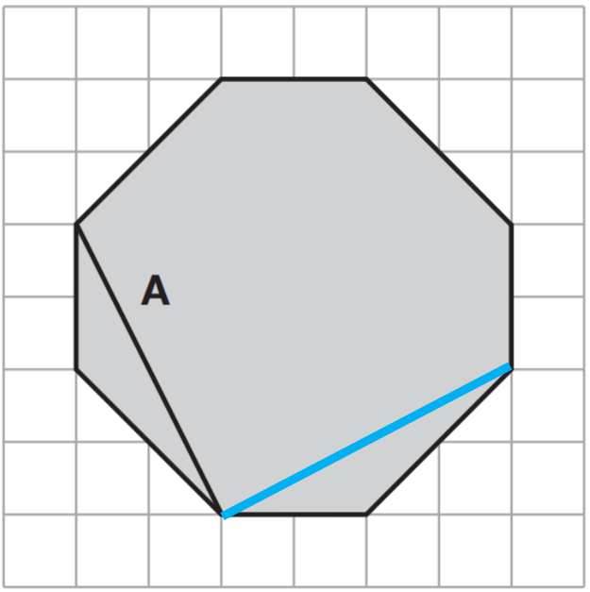  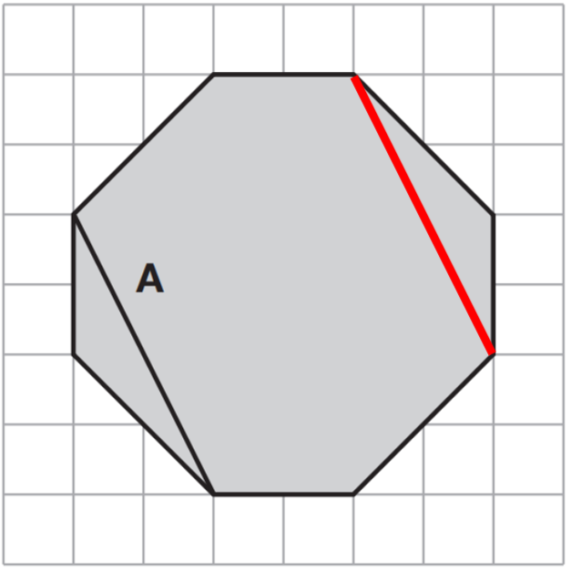
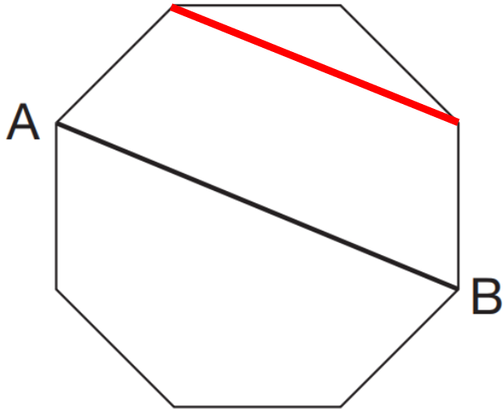 or 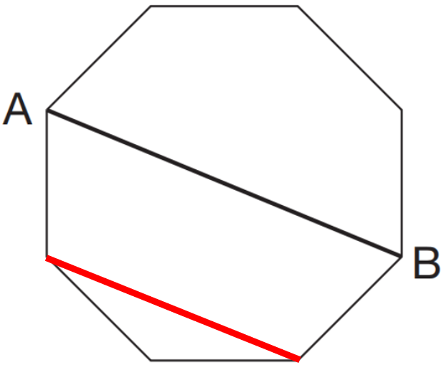 | 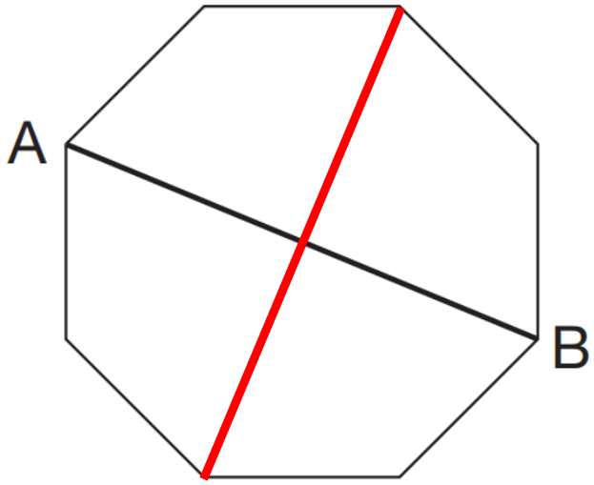 or 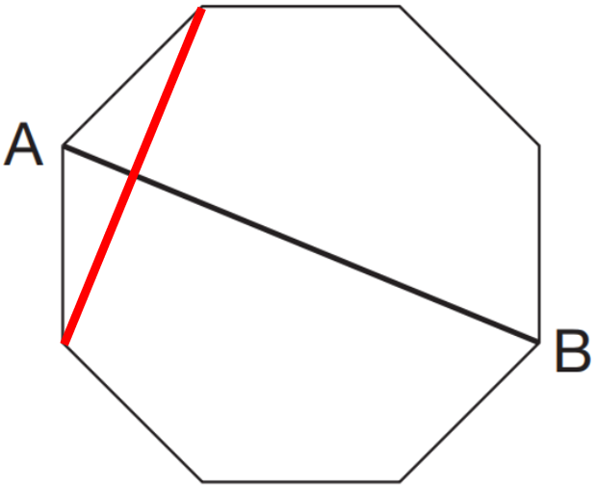  or 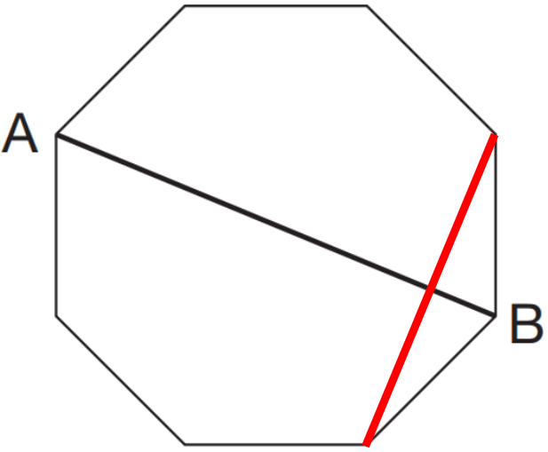
Measure angles and lines
95°

75°

101, 102 or 103 millimetres

21°, 22° or 23°

126, 127 or 128 millimetres
21°, 22° or 23°

65, 66, 67, 68 or 69 millilitres

123°, 124°, 125°, 126° or 127°
Identify different types of quadrilateral from descriptions
No. A rectangle had 4 sides but it’s not a square.  A square is a four-sided shape where all sides are the same length and all angles are 90°. | parallelogram
rectangle | parallelogram
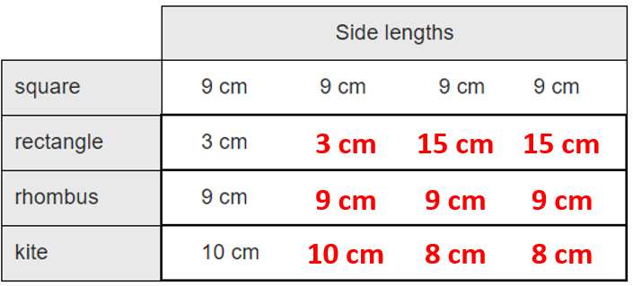 | rectangle  kite  square

Rotate shapes mentally
D and E | B and D
B, C and G

Make 2D shapes
many possible answers  any 4-sided shape with 1 pair of parallel lines  e.g.  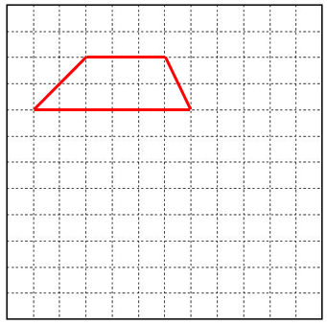 | many possible answers  e.g.  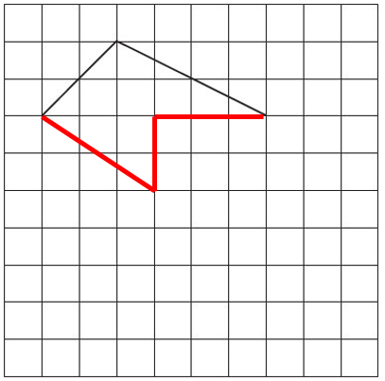
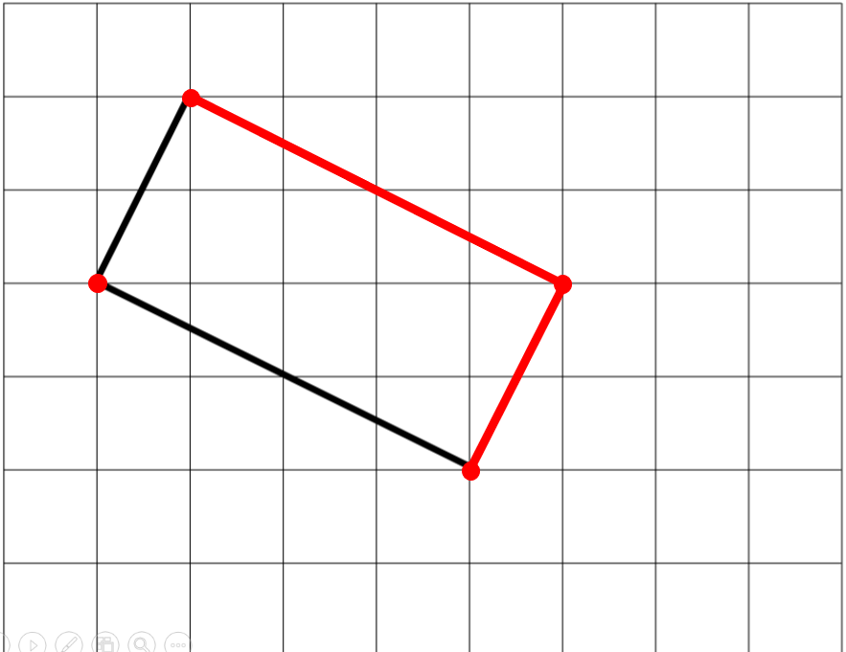 | 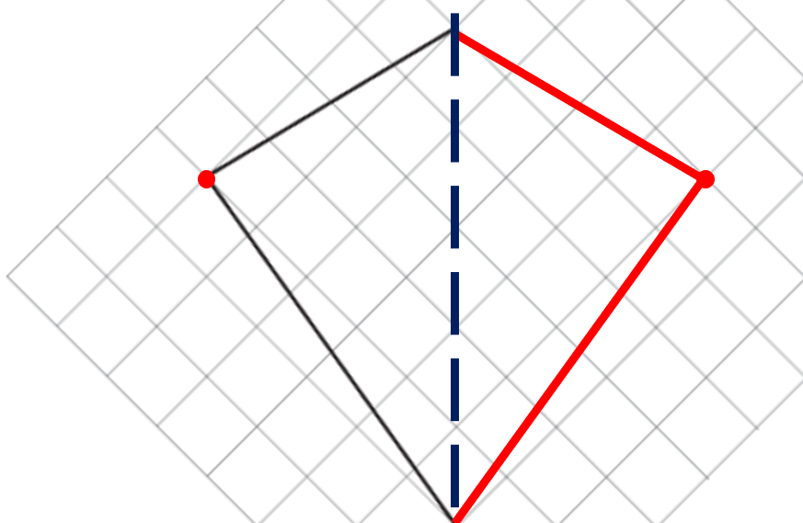
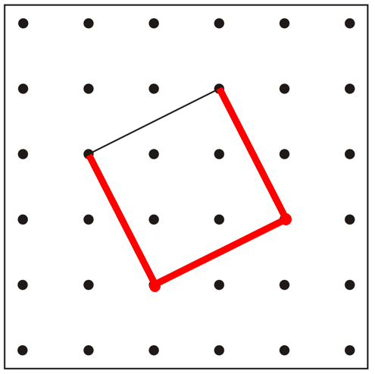 | 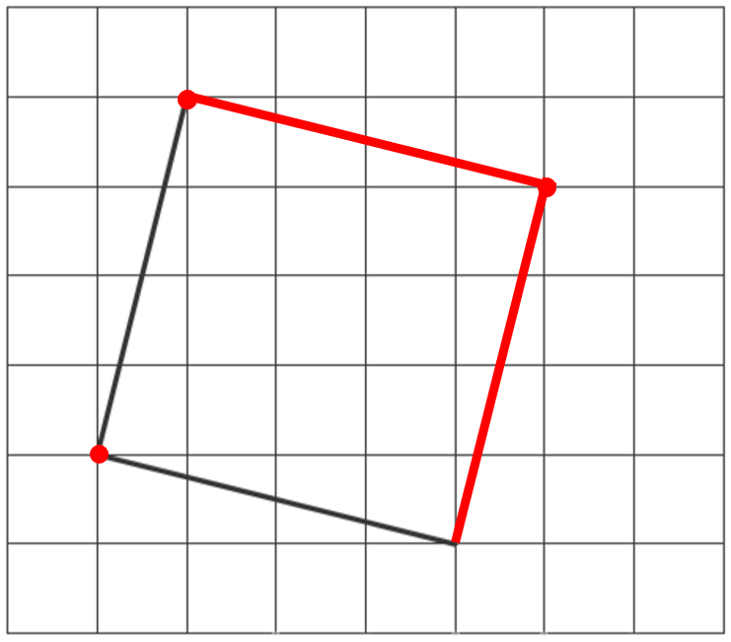

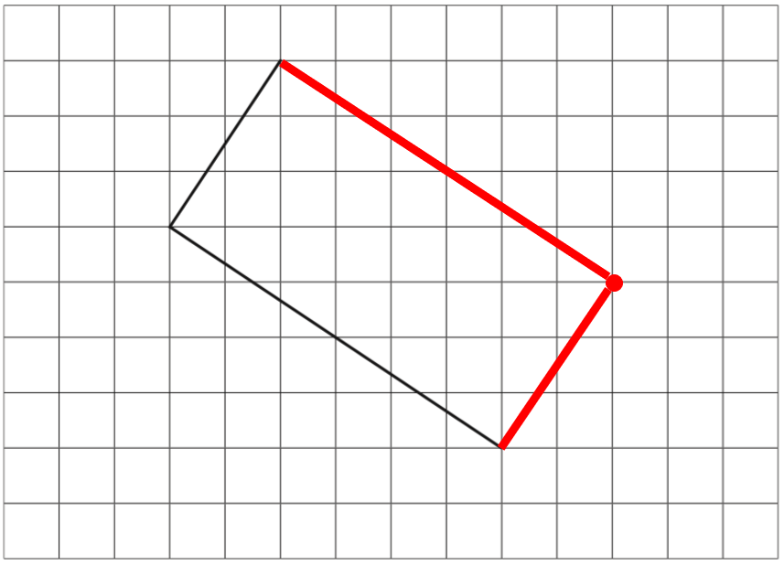 | 2015 Paper 3 Question 15  many possible answers  e.g.  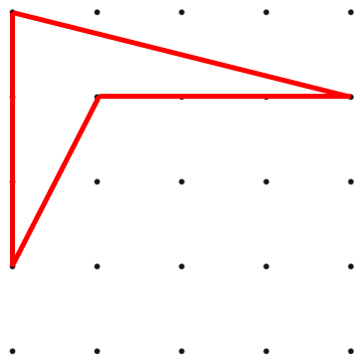
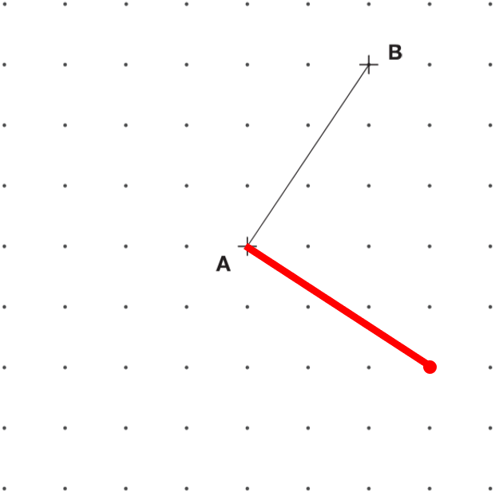  or  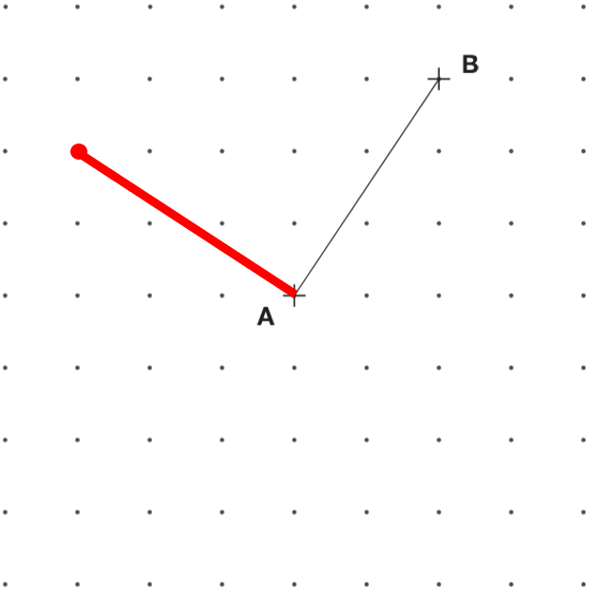 | many possible answers  e.g.  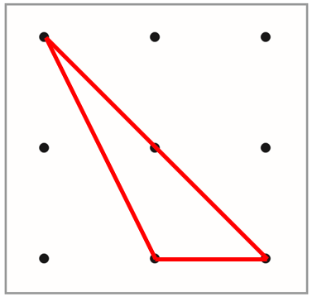
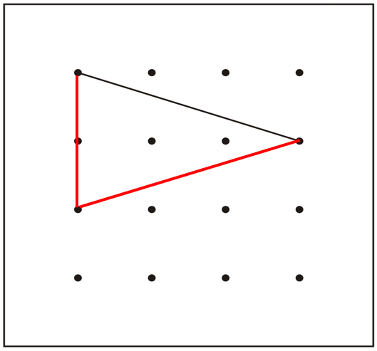 or 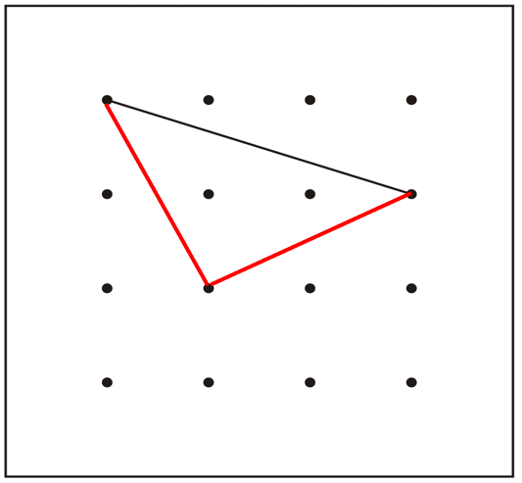

or 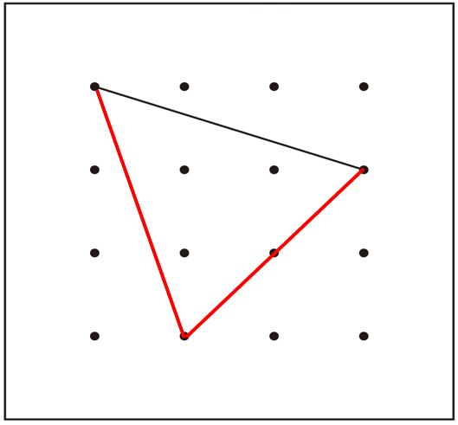
many possible answers  e.g.  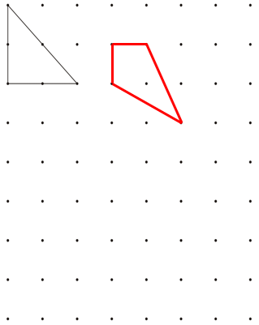 | many possible answers  e.g.  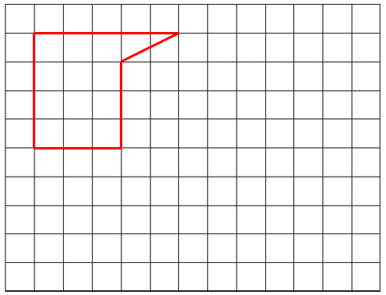

many possible answers  e.g.  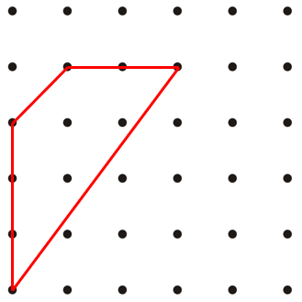 | many possible answers  e.g.  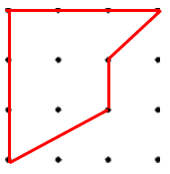  many possible answers  e.g.  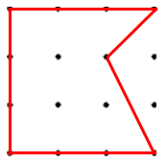
many possible answers
e.g.
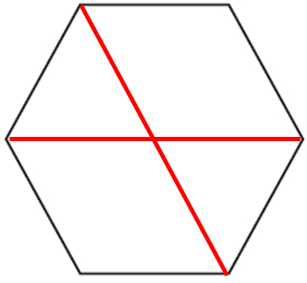
2019 Paper 2 Question 21  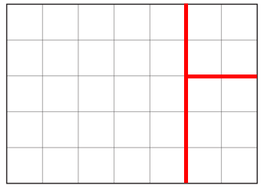 or 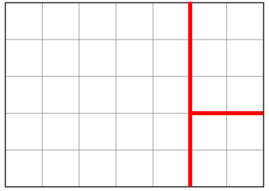  or 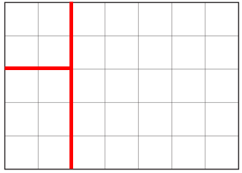 or 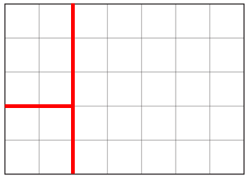 | there must be 1 point between each vertex of the hexagon (or 2 points from one vertex to the next)
two sides must be the same length | there must be 2 points between each vertex of the square (or 3 points from one vertex to the next)
many possible answers  e.g.  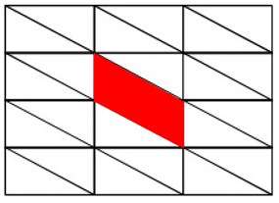  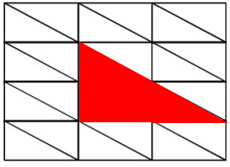  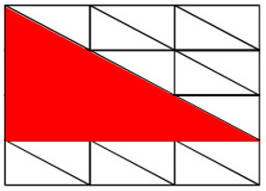 | many possible answers  e.g.  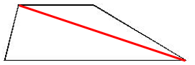  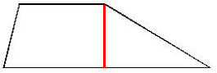  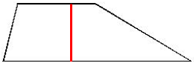
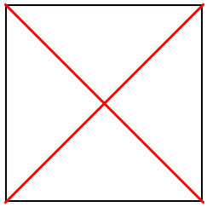

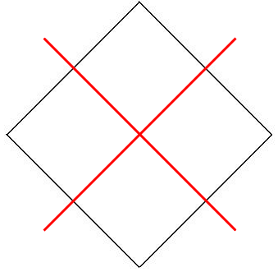
many possible answers
e.g.
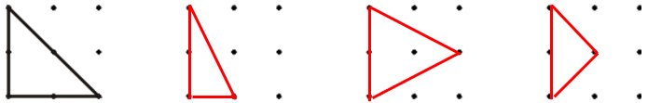

many possible answers  e.g.  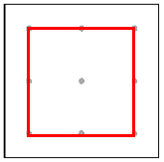  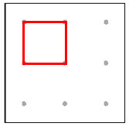  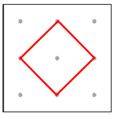 | square drawn  rectangle drawn  parallelogram drawn
Recognise angles in 2D shapes
B, D  C, E | A  F  E  B
2017 Paper 3 Question 13
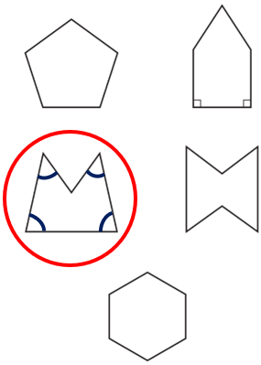

Recognise angles and parallel lines in 2D shapes
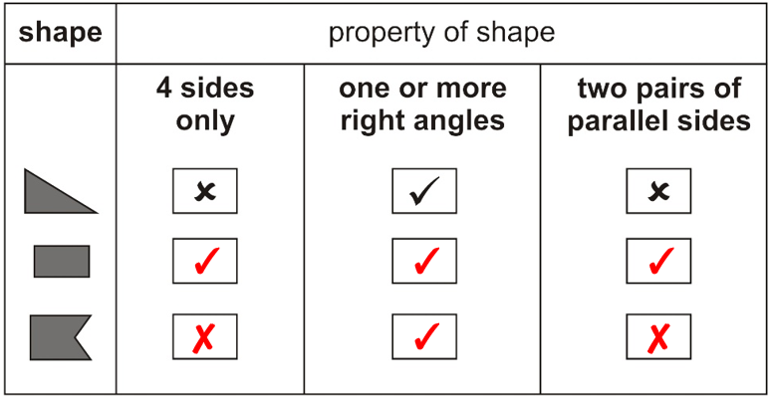 | 2016 Paper 3 Question 18  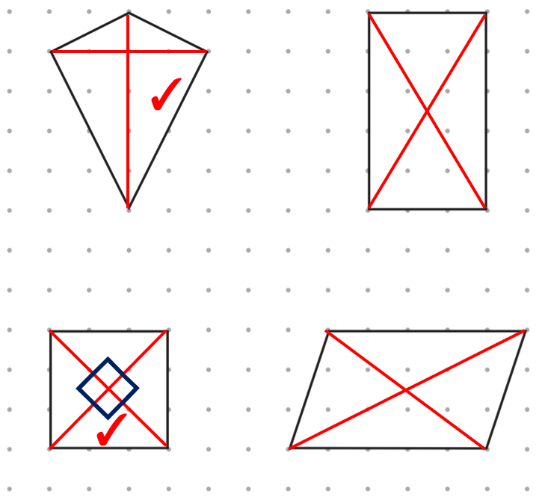
4
4
2
4
Tick  Cross  Cross  Tick | E  D
rhombus  kite |  | Tick  Cross  Cross  Tick
Recognise angles, parallel lines and symmetry in 2D shapes
Tick  Cross  Cross  Tick | 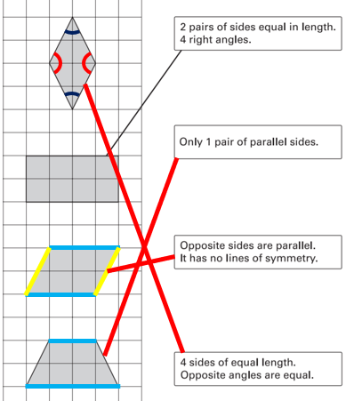
Tick  Cross  Cross  Tick | C  A  E

Identify faces, edges and vertices in different 3D shapes
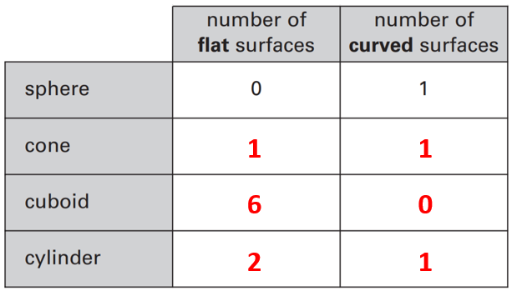 | 6 faces  8 vertices  12 edges
8  5, 6  5, 5 | 8  9, 6  6, 4
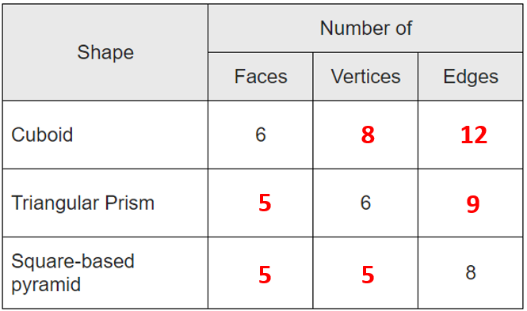 | Faces: 8  Edges: 12

Identify 3D shapes from their description
square-based pyramid | triangular prism
cube | Jack is not correct.  many possible explanations  e.g. A square based pyramid has 5 faces and 5 vertices. A triangular prism  has 5 faces and 6 vertices.

Identify nets of 3D shapes
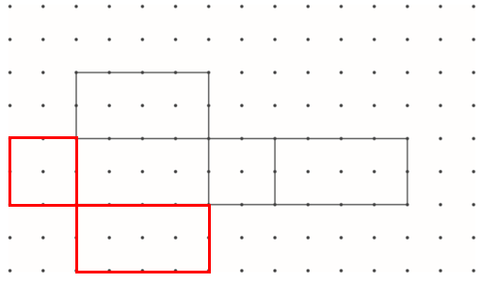 | one of the faces shown below  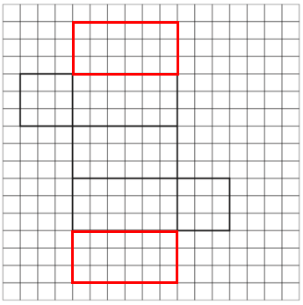
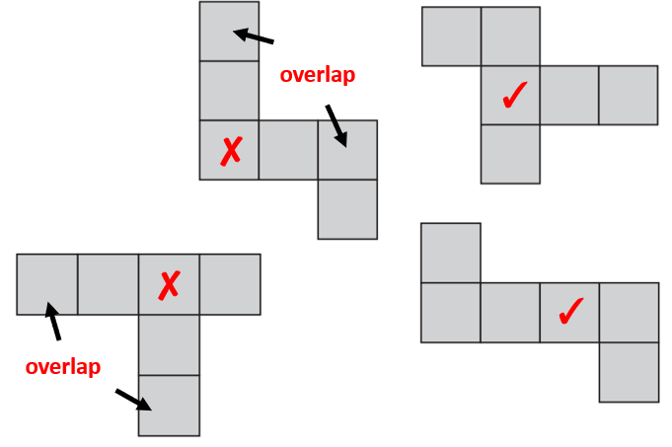 | 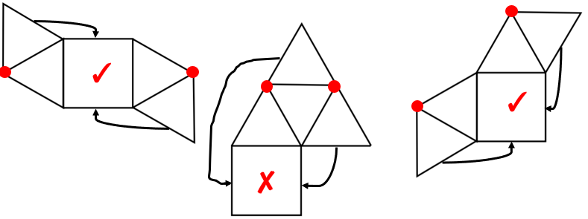
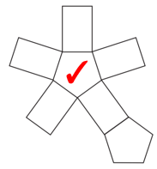 | 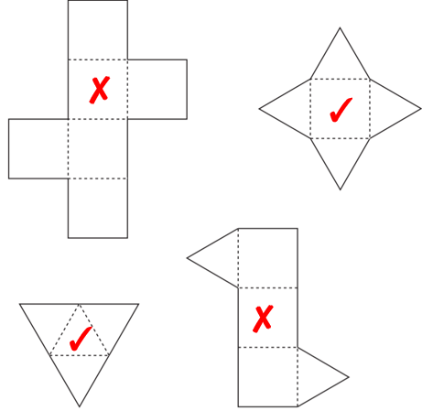

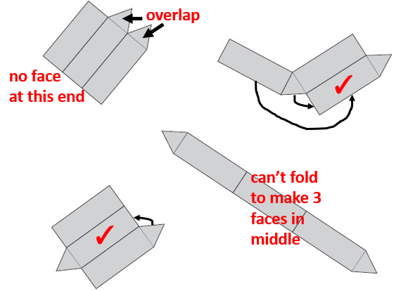 | 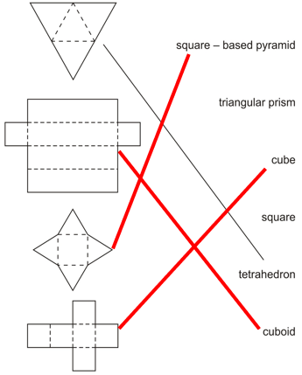
Identify the base or lid of a cube or cuboid
one of the squares shown below  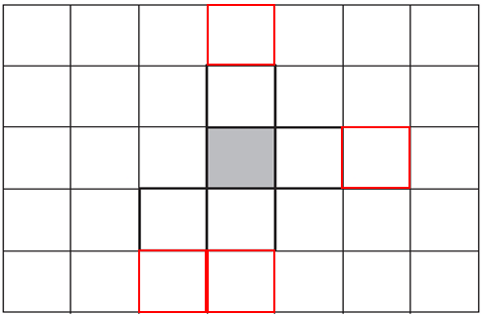 | 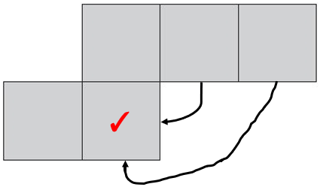
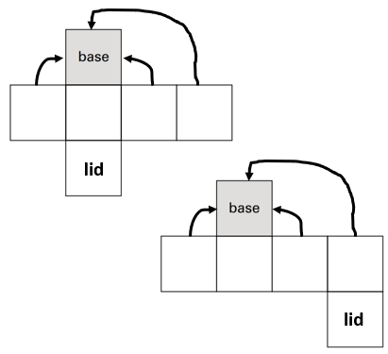 | A tick  B cross  C tick  D tick

Find volume by counting cubes
2016 Paper 3 Question 10  C | 10  16  30
24 | 38

Draw the reflection of a shape in a vertical mirror line on a squared grid
Draw the reflection of each shape in the mirror line.
2019 Paper 2 Question 4  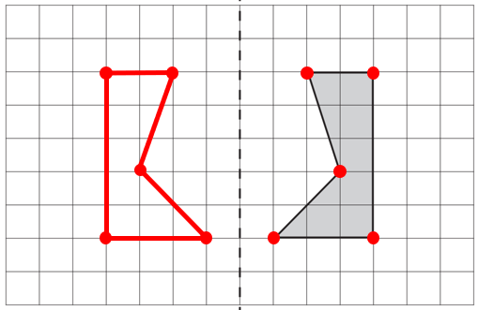 | 2018 Paper 2 Question 1  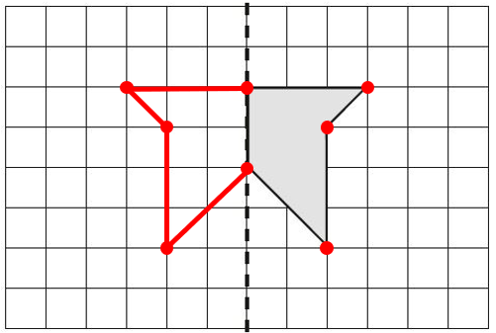
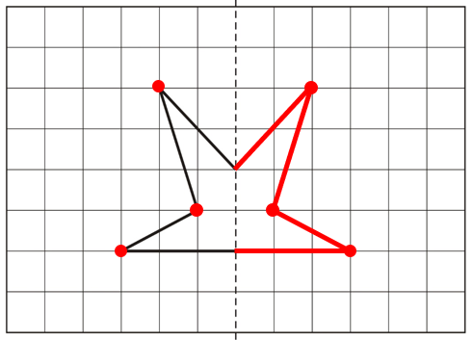 | 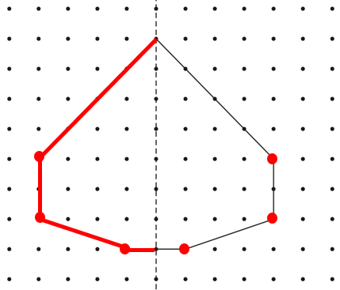
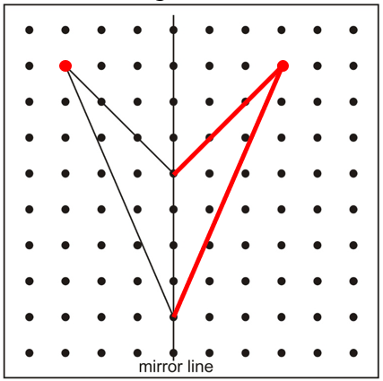 | 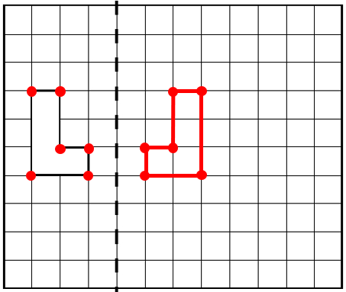
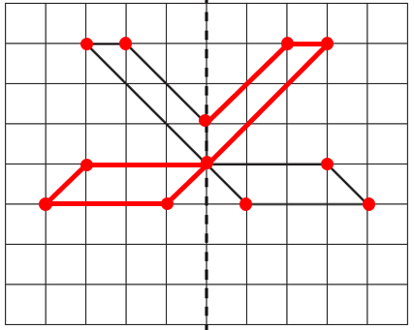

Draw the reflection of a shape in a vertical mirror line on different grids
Draw the reflection of each shape in the mirror line.
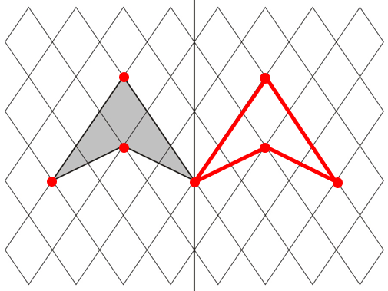 | 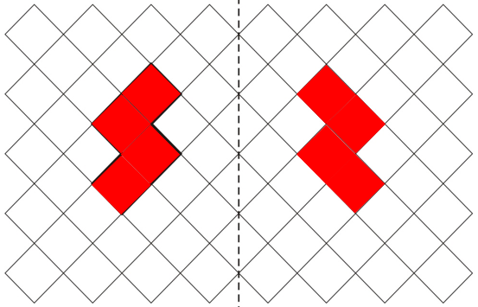
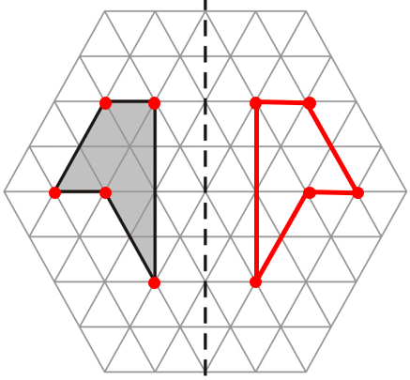 | 2016 Paper 2 Question 6  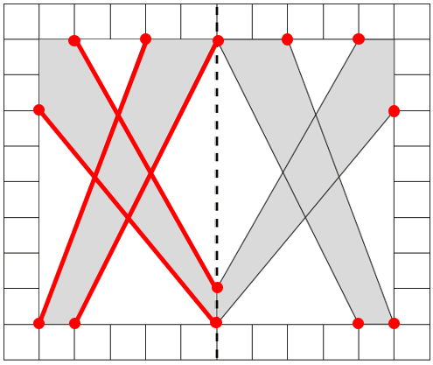
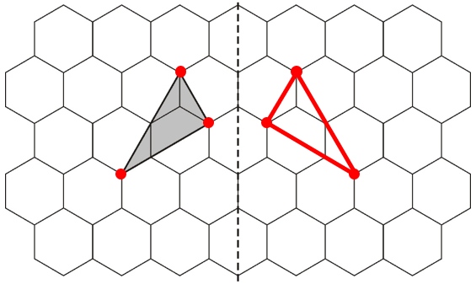 | 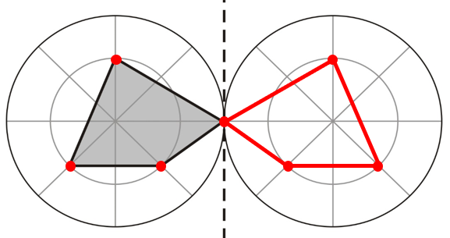

Draw the reflection of a shape in a horizontal mirror line
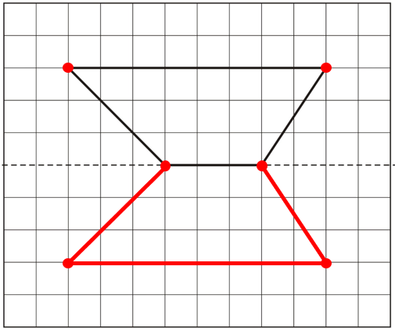 | 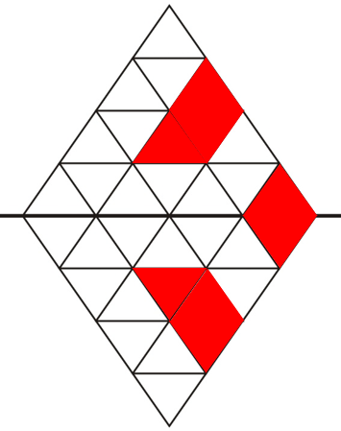
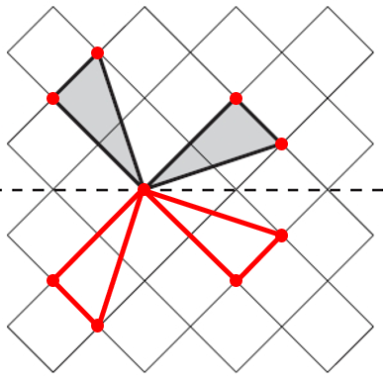 | 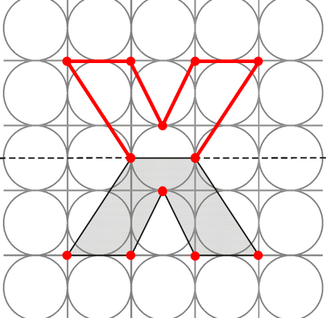

Shade squares to make a design symmetrical
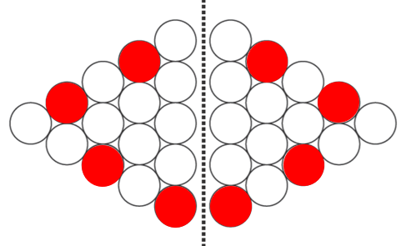 | 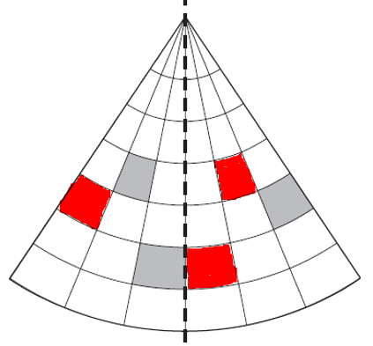

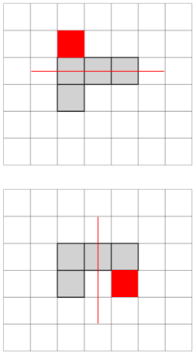(any order) | 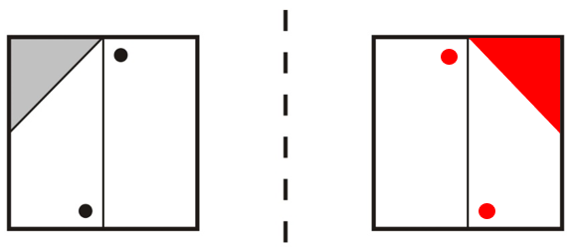
 | 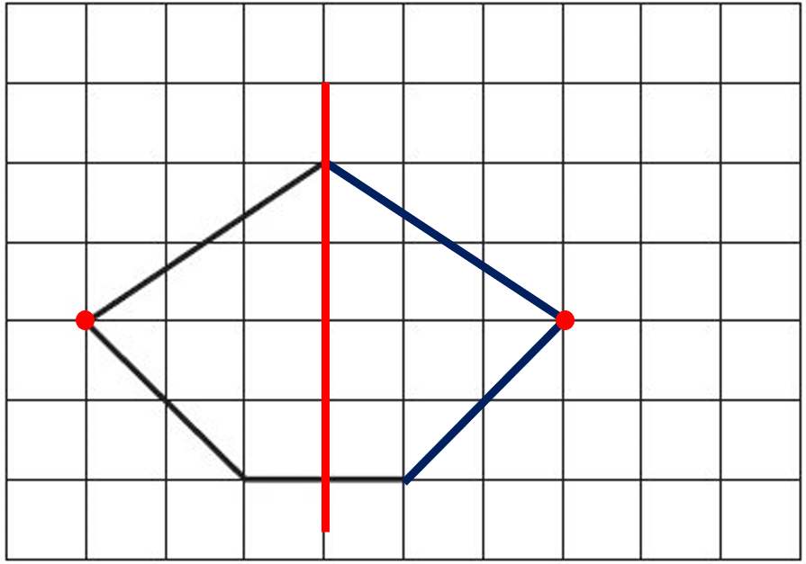
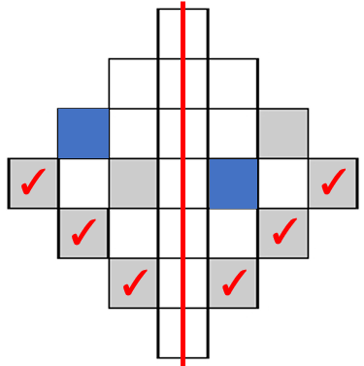 | 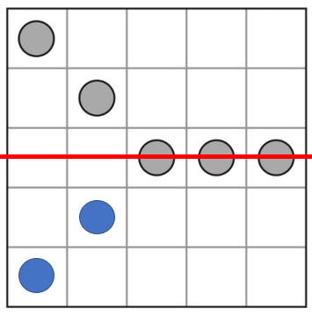 or 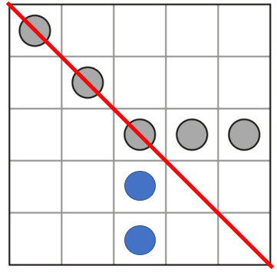
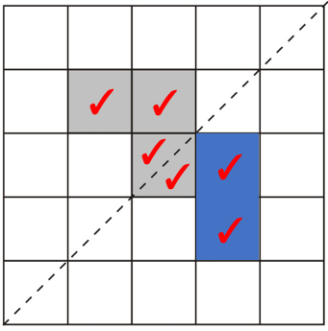 | 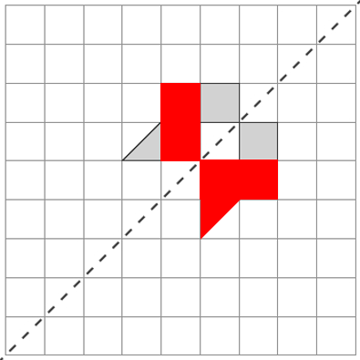
Draw the reflection of a shape in a diagonal mirror line
Draw the reflection of each shape in the mirror line.
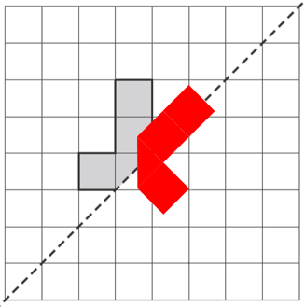 | 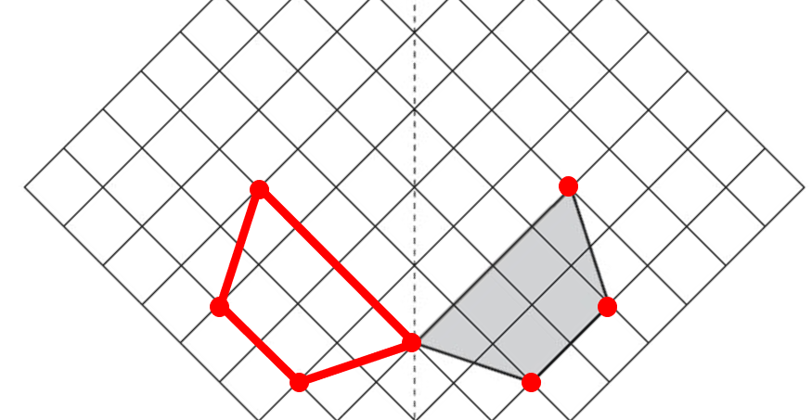
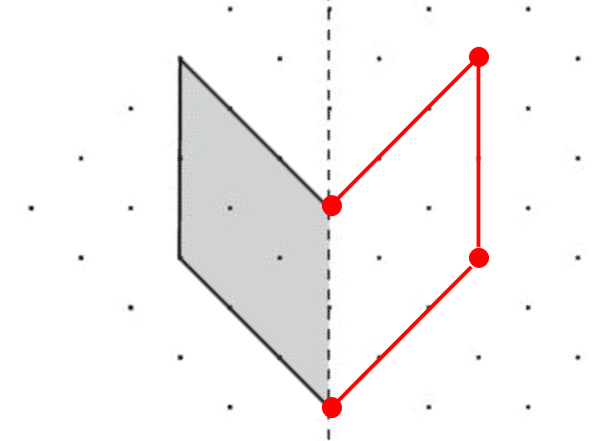 | 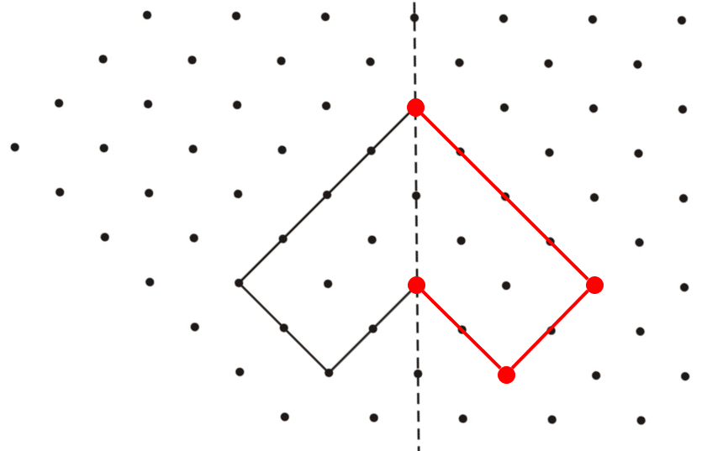
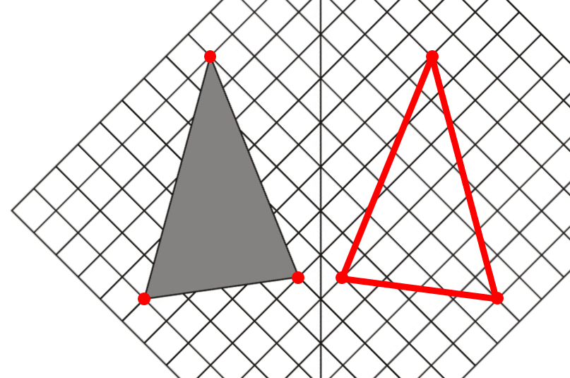 | 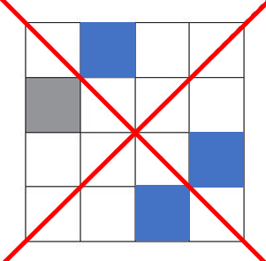

Translate a shape
2016 Paper 3 Question 12  6  5 | 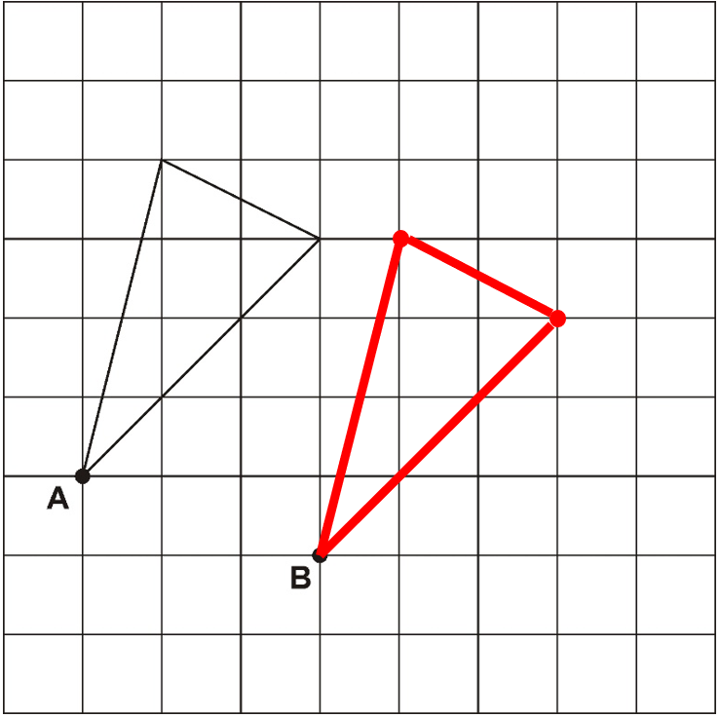
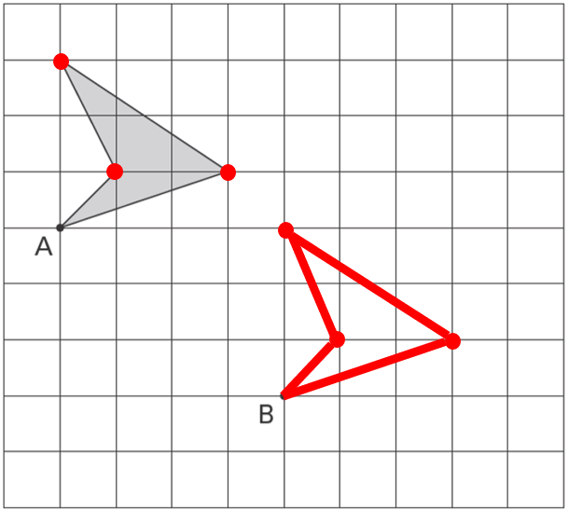 | 2015 Paper 3 Question 8  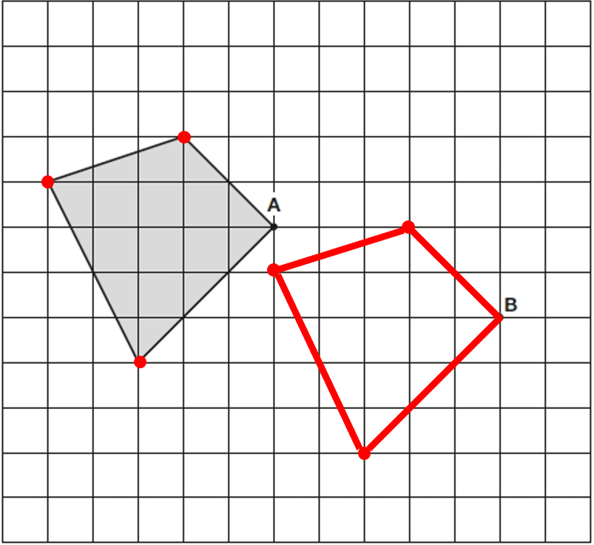
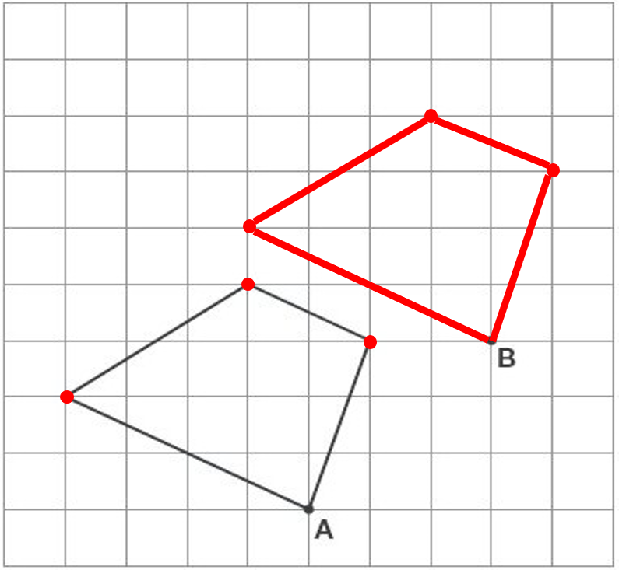
Translate a shape on a simple co-ordinate grid
(4, 3) | (6, 3)
2018 Paper 2 Question 12  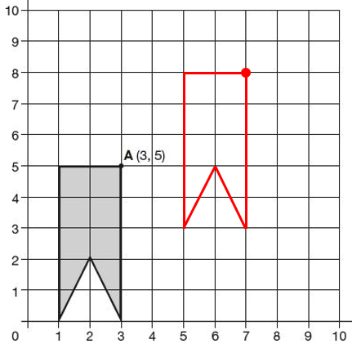 | (10, 7)  (10, 10)  (12, 7)

Calculate co-ordinates on a simple co-ordinate grid using knowledge of the properties of squares and rectangles
A is (7, 13)  B is (17, 13) | (3, 11)
(8, 7)  (5, 3) | (6, 7)
B is (0, 10)  C is (10, 20) | 2019 Paper 3 Question 21  B is (55, 30)  D is (55, 14)
A is (12, 6)  B is (19, 3) | (5, 7)  (3, 4)
Calculate co-ordinates on a simple co-ordinate grid using knowledge of the properties of shapes
(5, 2) | (10, 9)
28 | (40, 27)

Calculate and plot the co-ordinates of tilted squares or rectangles on a simple co-ordinate grid
(5, 2) | (4, 3)
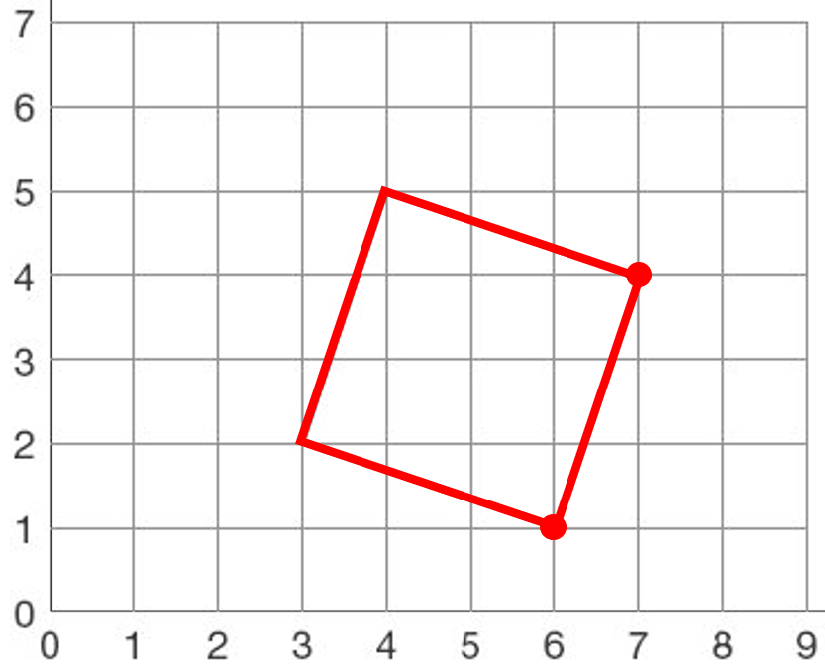 | (4, 6)

