
Recognise that angles are measured in degrees and estimate their size
2019 Paper 3 Question 13  Kirsty says, ‘When you double the size of an acute angle, you always get an obtuse angle.’  Explain why Kirsty is not correct. | Estimate the size of angle x.  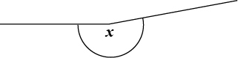  Circle the closest estimate.  170° 310° 190° 260° 180°

Find missing angles on a straight line
Calculate the size of angle x in the diagram.  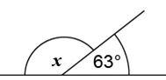 | Calculate the size of angle y in this diagram.  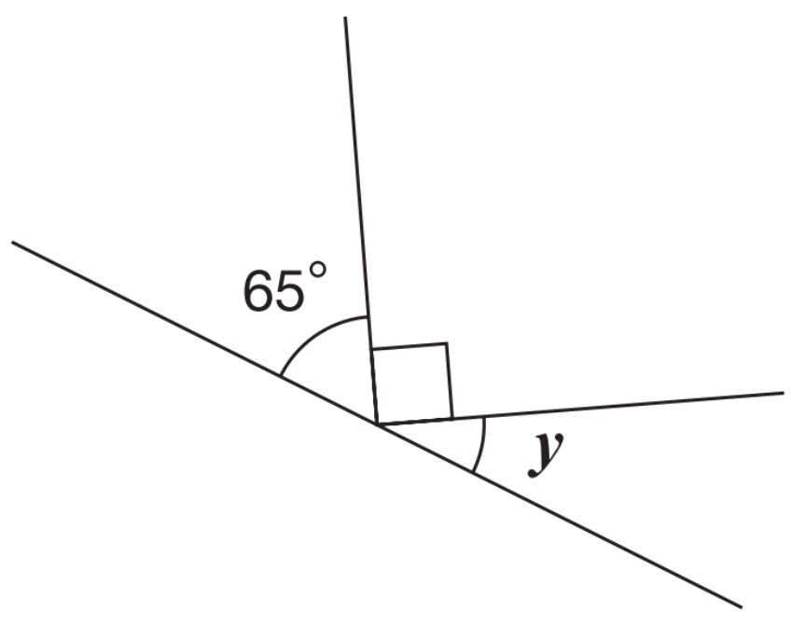
PQ is a s traight line. Calculate the size of angle x.  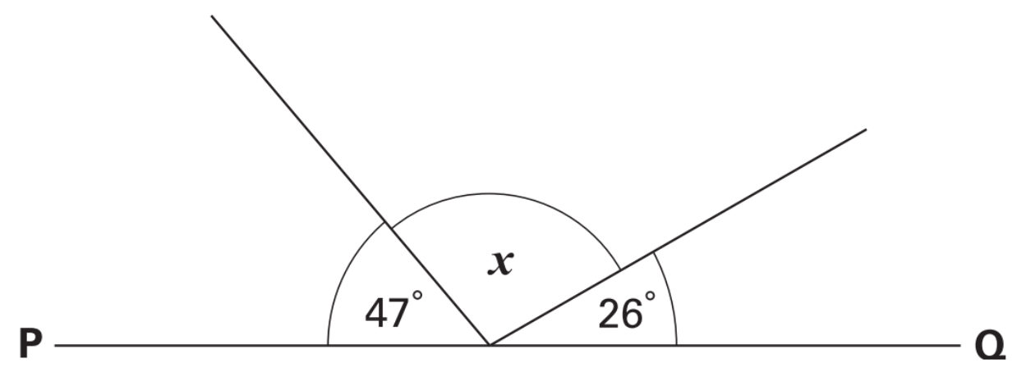 | Here is a regular octagon.  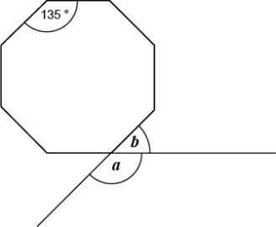  Calculate the sizes of angles a and b.



Find missing angles on a point
Calculate the size of angle p in the diagram.  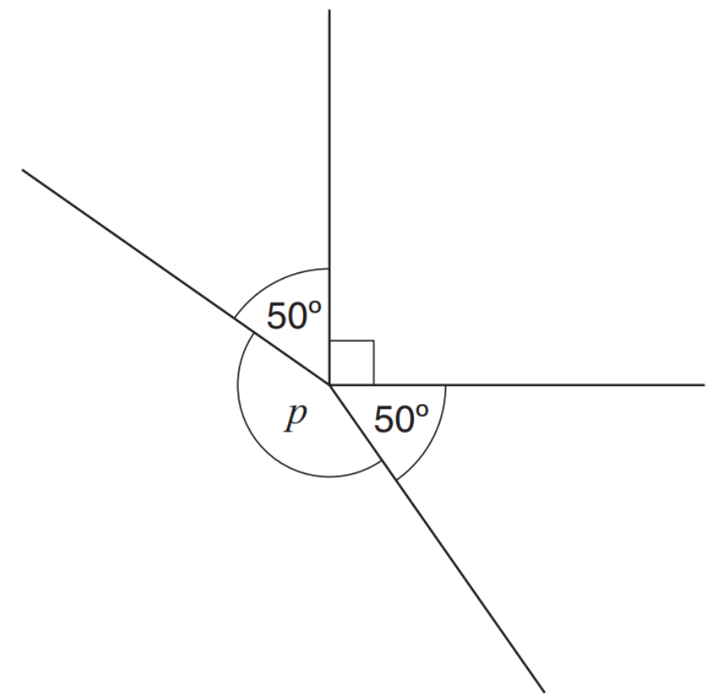 | Calculate the size of angle p in the diagram.  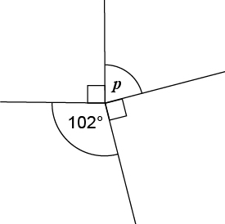
Calculate the size of angle y.
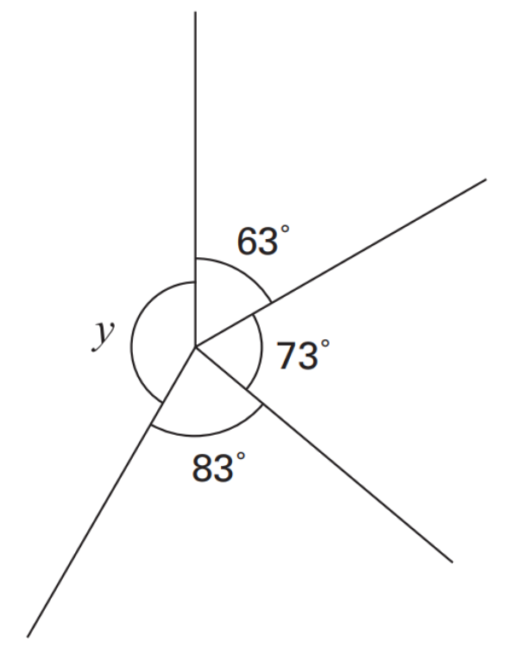

Recognise angles in turns
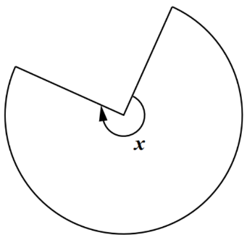  This shape is three-quarters of a circle. How many degrees is angle x? | 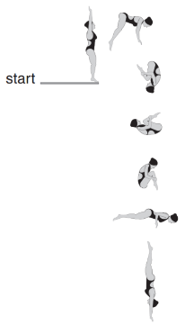  2017 Paper 2 Question 16  Layla completes one-and-a-half somersaults in a dive.  How many degrees does Layla turn through in her dive?
This regular 12-sided shape has a number at each vertex.  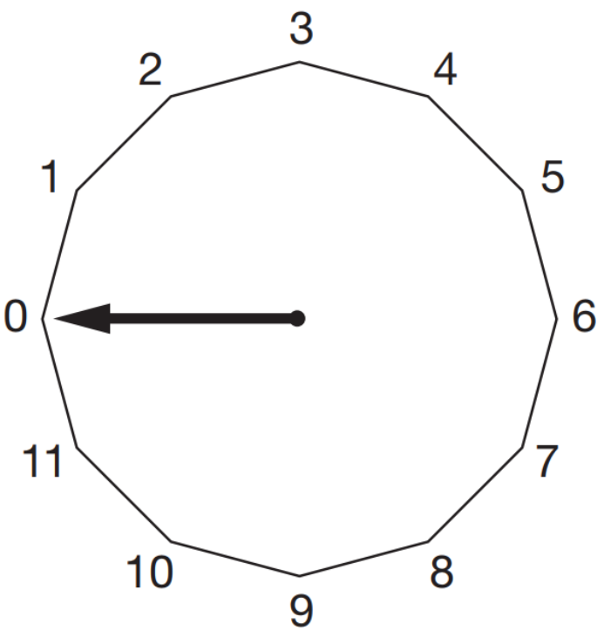  Ben turns the pointer from zero, clockwise through 150°. Which number will the pointer now be at?  Nisha turns the pointer clockwise from number 2 to number 11. Through how many degrees does the pointer turn? | 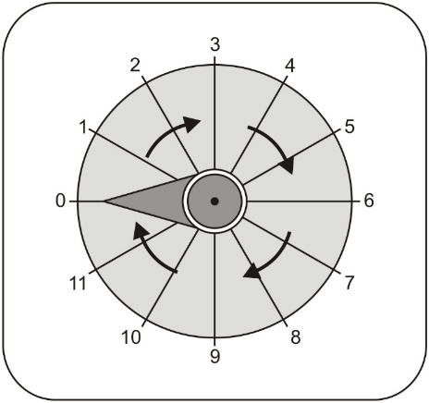  The pointer on this dial turns in a clockwise direction. The pointer is at 0. Which number does it point to after a turn of 270°?  The pointer moves from 10 to 11.  How many degrees does it turn through?

Apply knowledge that angles in a triangle always total 180 degrees
Tina measures the angles in a triangle.  The sketch shows her results.  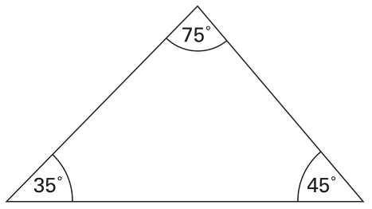  How can you tell that Tina has made a mistake? | Jamie draws a triangle. He says, ‘Two of the three angles in my triangle are obtuse.’ Explain why Jamie cannot be correct.
Here is a trian gle. Calculate the size of angle x.  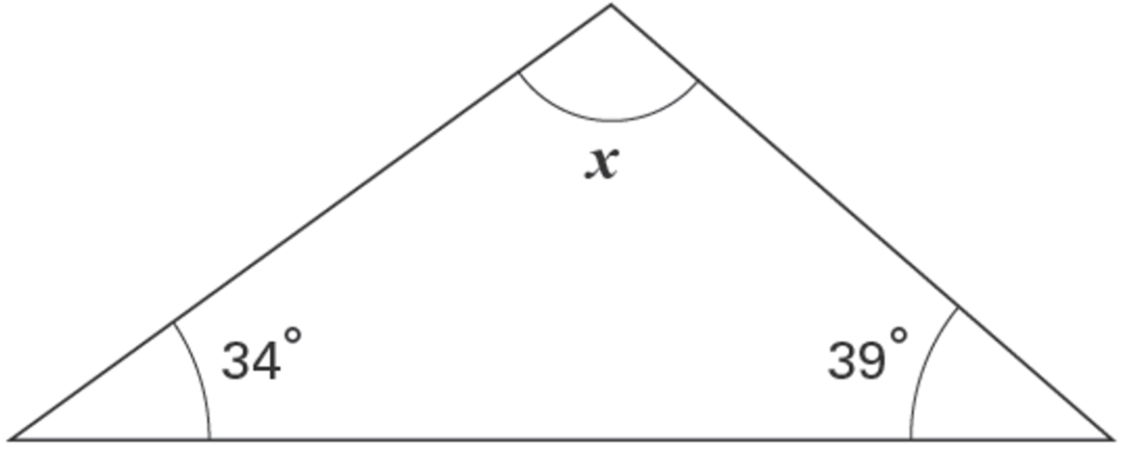 | Look at this diagram.  Calculate the size of angle x and angle y.  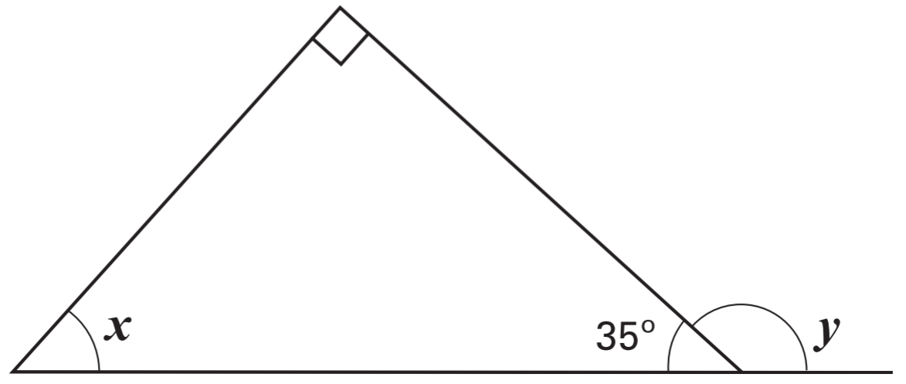
Look at the diagram. AB is a straight line.  Work out the size of angle k.  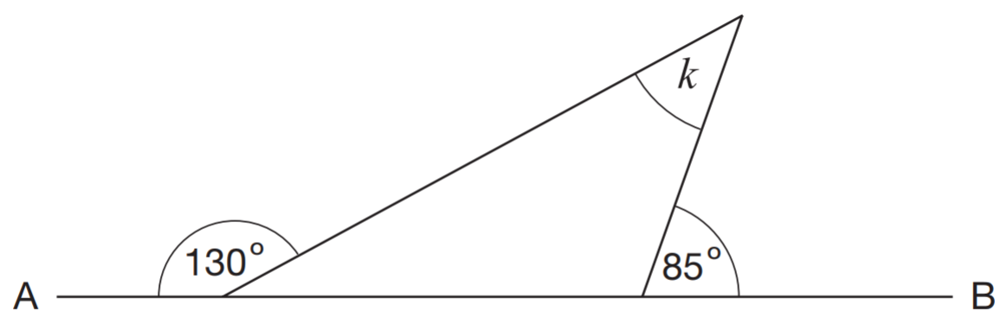 | Calculate the size of angle x.  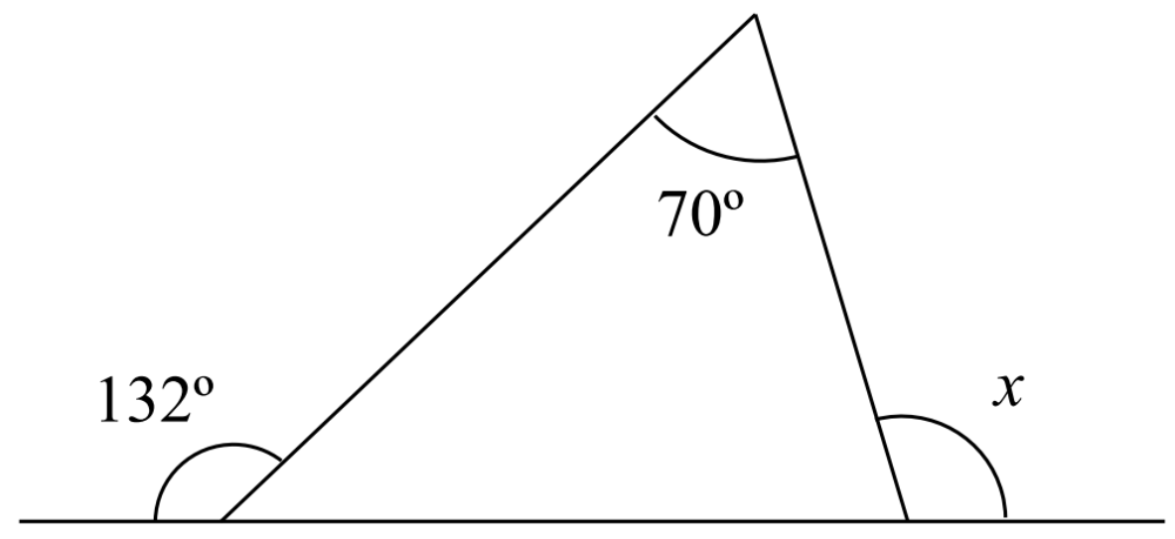

Recognise isosceles triangles
Here are five shaded triangles on a square grid.  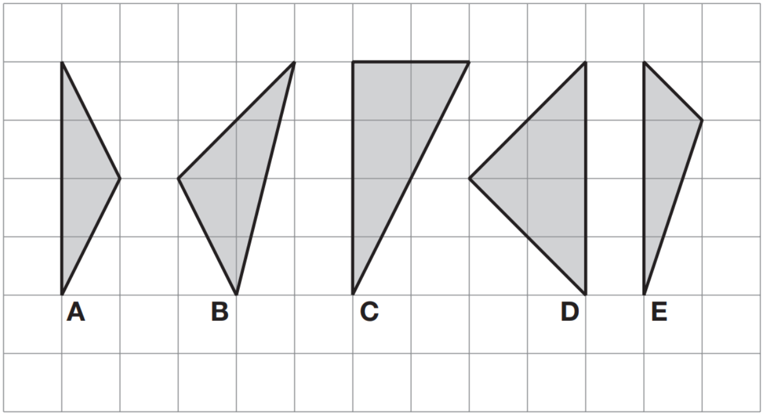  Write the letter of each triangle that has a right angle.  Write the letter of each triangle that has two equal sides. | Here are four triangles on a square grid.  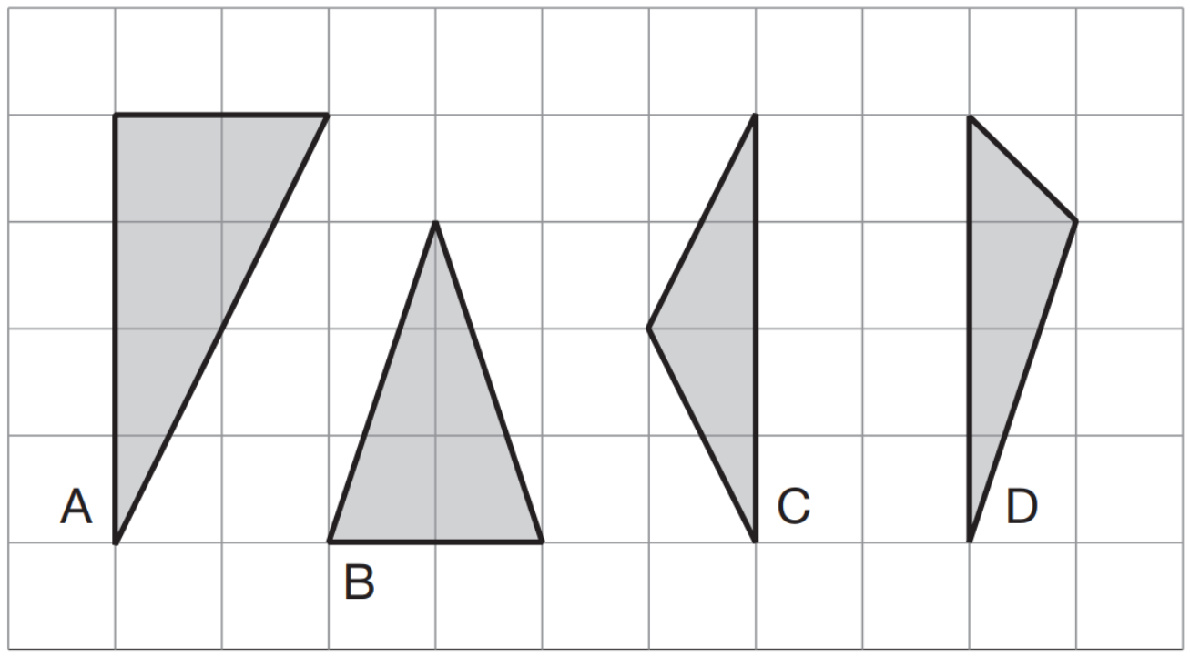  Write the letters of the two isosceles triangles.
This diagram shows a square with dots at the vertices and at the middle of each side. The square is divided into four triangles, A, B, C and D.  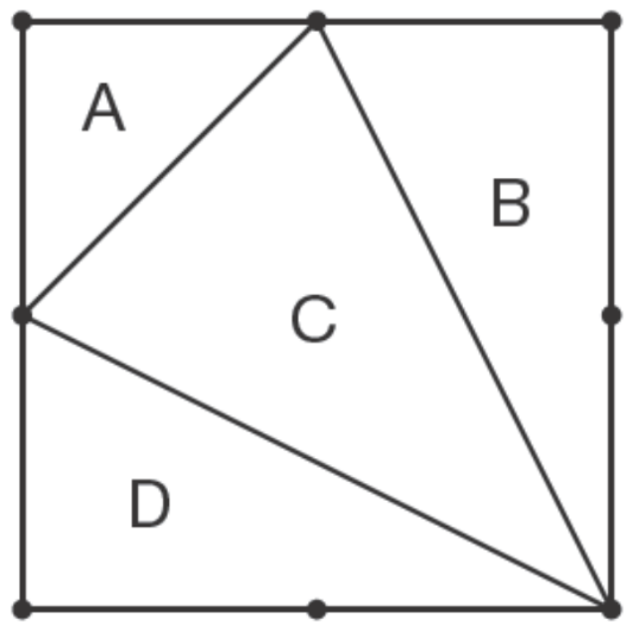  Write the letters of all the triangles that have a right angle.  Write the letters of all the isosceles triangles. | Here are four triangles drawn on a square grid.  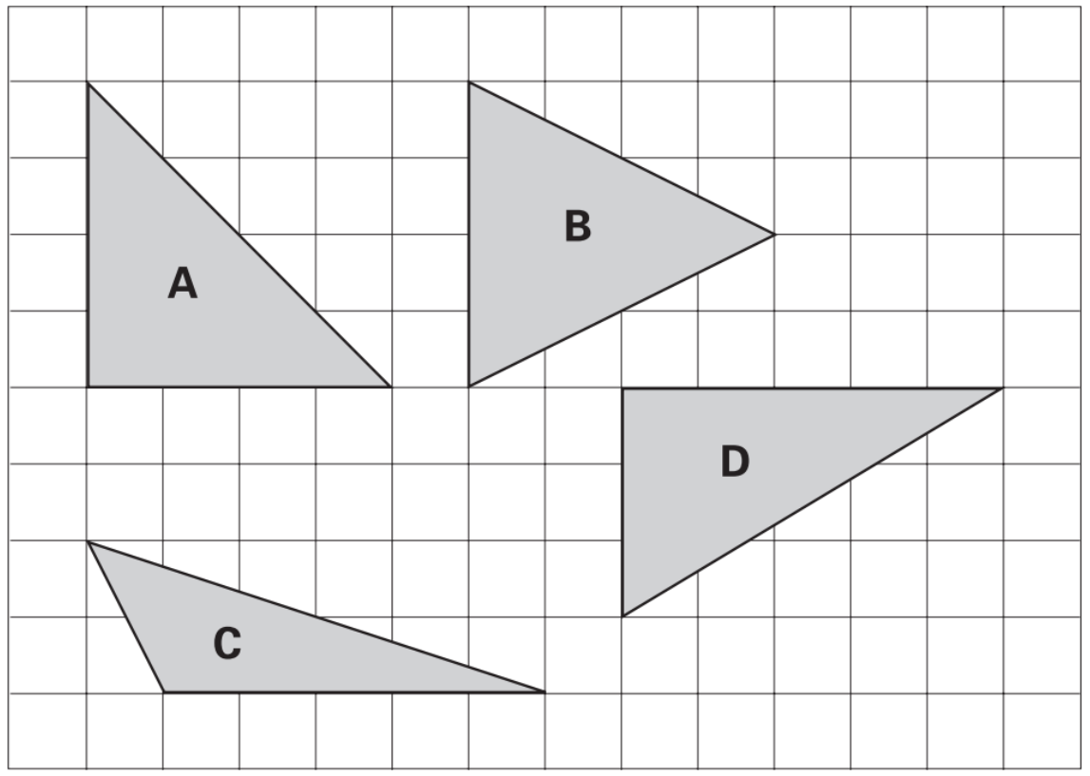  Write the letter for each triangle in the correct region of the sorting diagram. One has been done for you.  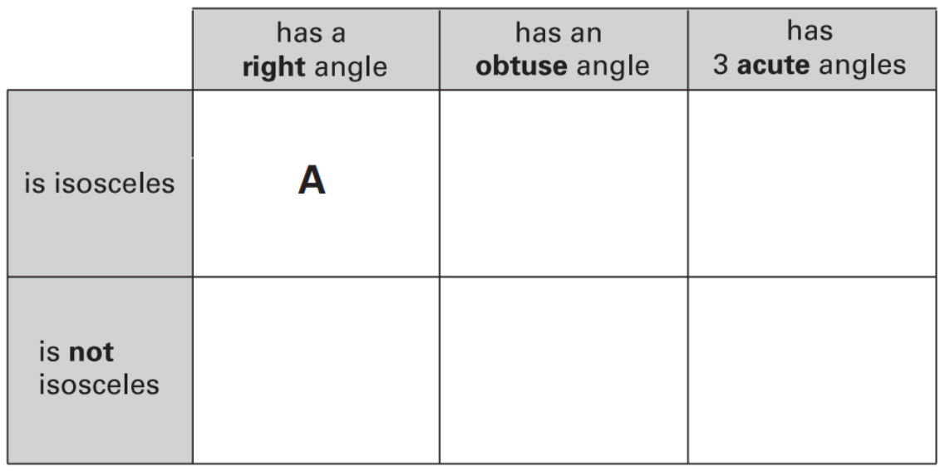
An isosceles triangle has a perimeter of 12cm.  One of its sides is 5cm.  What could the length of each of the other two sides be?  Two different answers are possible.  Give both answers. | Here is a regular octagon. Join three of the dots to make an isosceles triangle.  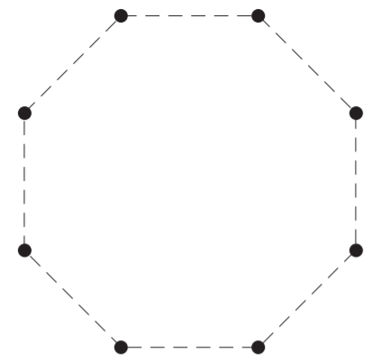

Recognise equilateral triangles
Complete this sentence.  All equilateral triangles have | Here are six triangles.  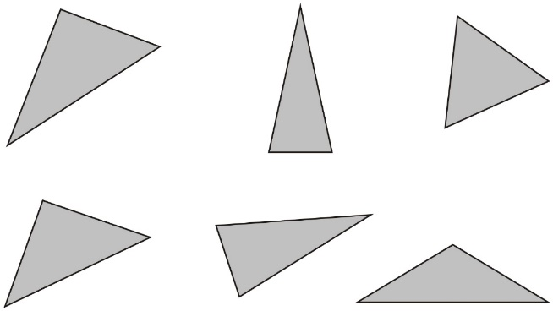  One of them is an equilateral triangle.  Put a tick in the equilateral triangle.
2018 Paper 3 Question 14
Two of the angles in a triangle are 70° and 40°.
Jack says, ‘The triangle is equilateral.’
Explain why Jack is not correct.

Here is a regular hexagon.  Join three of the dots to make an equilateral triangle.  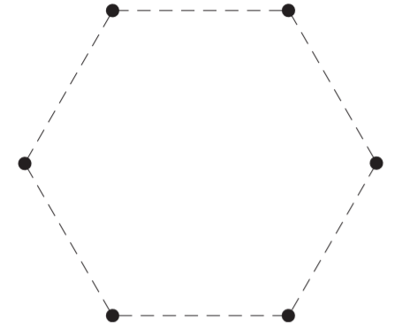 | These two shaded triangles are each inside a regular hexagon.  Under each hexagon, tick the correct name of the shaded triangle.  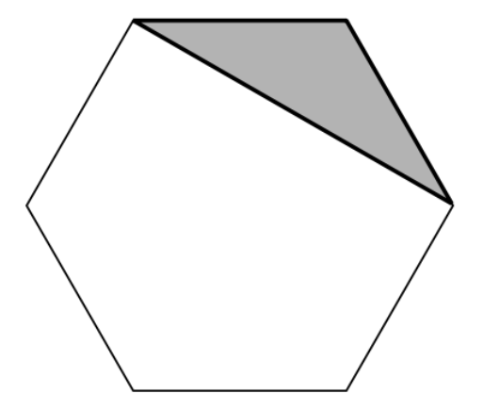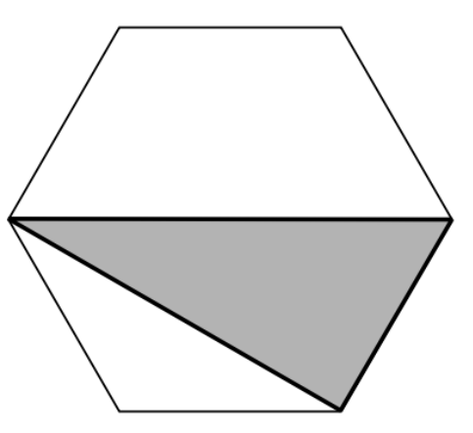  equilateral equilateral  isosceles isosceles  scalene scalene

Recognise parallel and perpendicular lines
The diagram shows four lines drawn on a square grid. The lines are AB, BC, CD and DA.  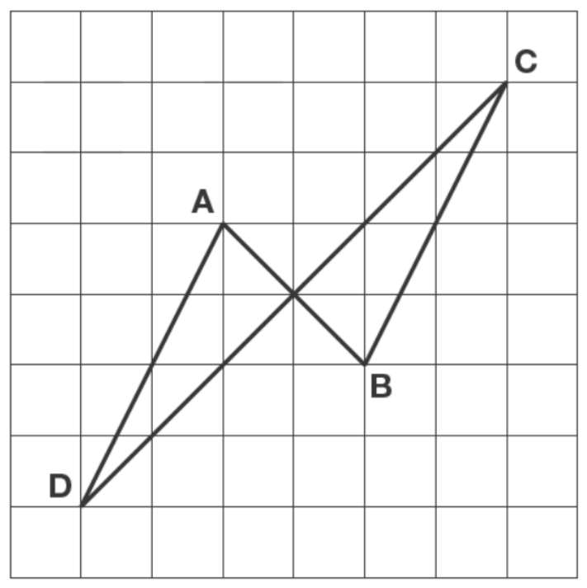  Which two of the lines are parallel?  Which two of the lines are perpendicular? | 2017 Paper 3 Question 15  Circle the letter below that has both parallel and perpendicular lines.  
Here are some shapes on a grid.
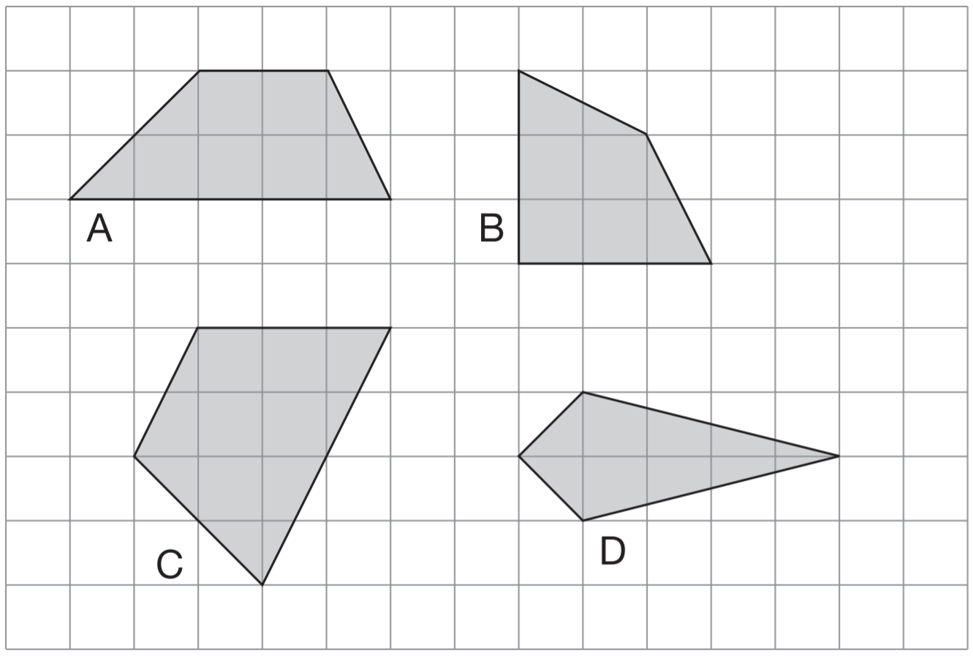
Write the letter of each shape that has one pair of parallel sides.

Here is a shape on a square grid.  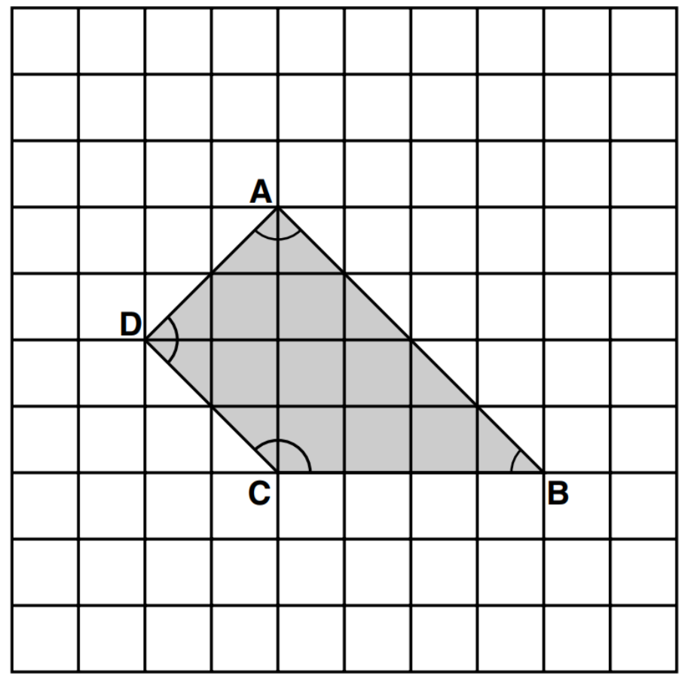  For each of the four sentences below, put a tick if it is true. Put a cross if it is not true.  1) Angle C is an obtuse angle.  2) Angle D is an acute angle.  3) Line AD is parallel to line BC.  4) Line AB is perpendicular to line AD. | 2015 Paper 2 Question 13  The diagram shows a shaded octagon on a square grid.  Line A joins two vertices of the octagon.  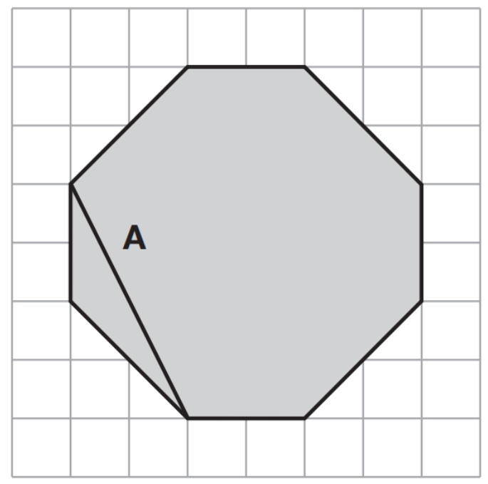  Join two vertices to draw a line perpendicular to line A.  Join two other vertices to draw a line parallel to line A.
Here is a regular octagon with two vertices joined to make the line AB.  Join two other vertices to draw one line that is parallel to the line AB.  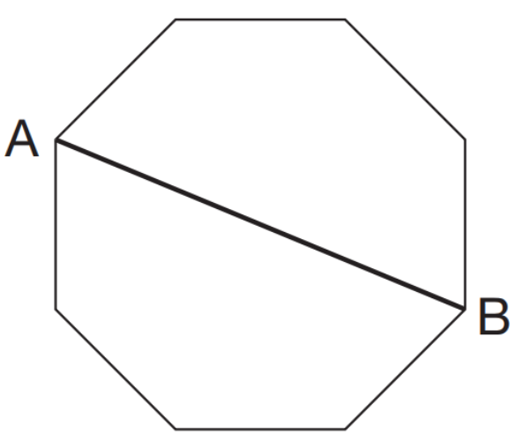 | Here is a regular octagon with two vertices joined to make the line AB.  Join two other vertices to draw one line that is perpendicular to the line AB.
Measure angles and lines
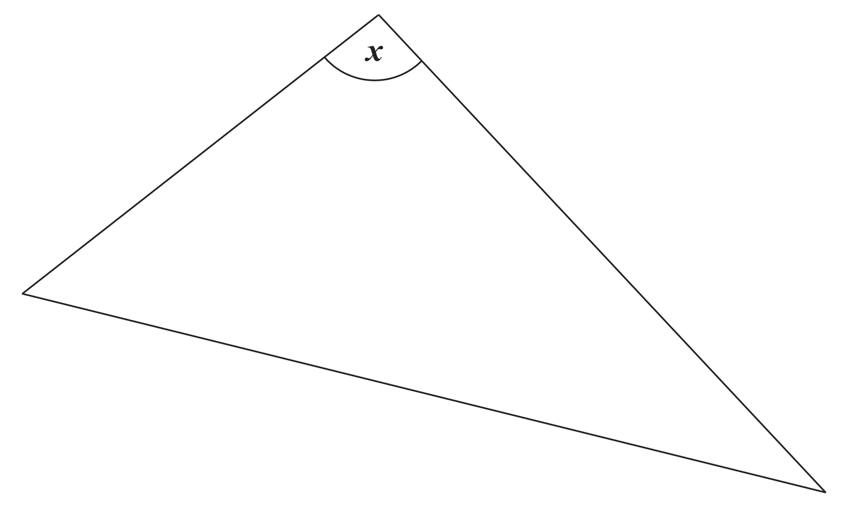
Measure angle x accurately.
Use a protractor (angle measurer).
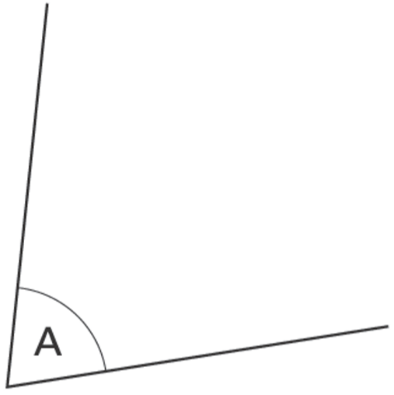
Measure angle A accurately.
Use a protractor (angle measurer).

Measure accurately the longest side of this shape. Give your answer in millimetres.

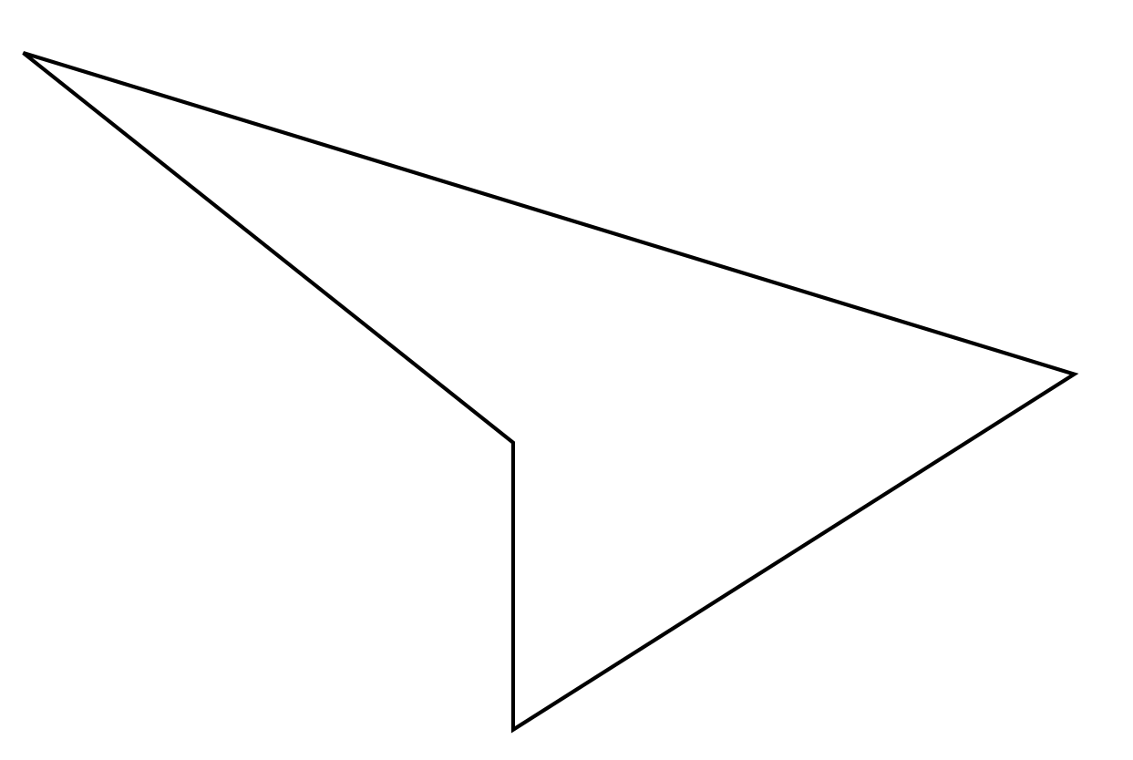
Measure accurately the smallest angle in the shape. Use a protractor (angle measurer)
Use a ruler to measure accurately the width of the star, from P to Q.
Give your answer in millimetres.

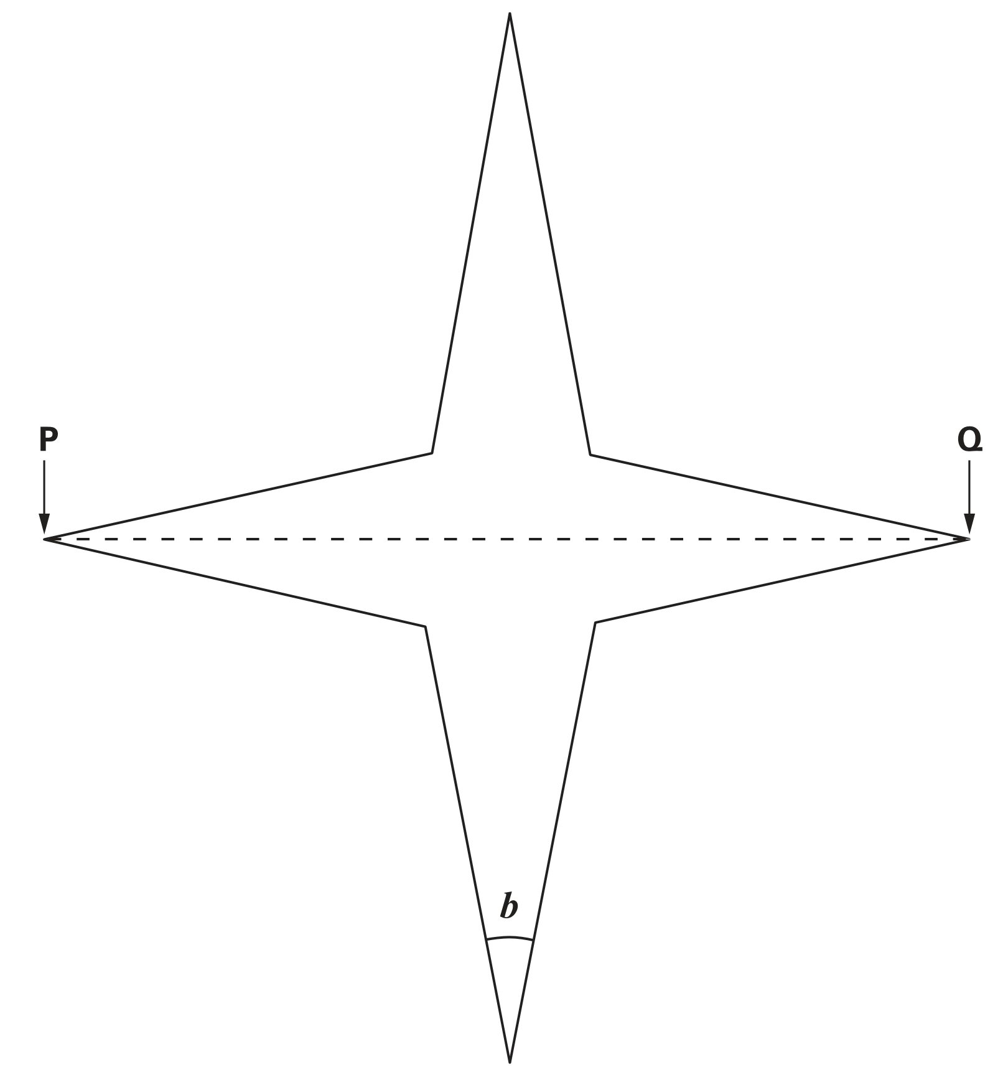
Use a protractor (angle measurer) to measure angle b.
Measure the length of the shortest side of this triangle in millimetres.

Measure the size of the largest angle in this triangle.

Identify different types of quadrilateral from descriptions
A square always has four sides.  Is it true that a four-sided shape is always a square? Explain how you know. | Sarah draws a quadrilateral. It has these properties:  • it has 2 long sides the same length;  • it has 2 short sides the same length;  • it does NOT have any right angles;  • it does NOT have reflective symmetry.  Write the mathematical name for Sarah’s quadrilateral.
A shape has 4 right angles.
It has 4 sides which are not all the same length. Write the name of this shape.

The following quadrilaterals all have a perimeter of 36 cm. Here is a table to show the length of each side.  Complete the table. One quadrilateral is done for you.  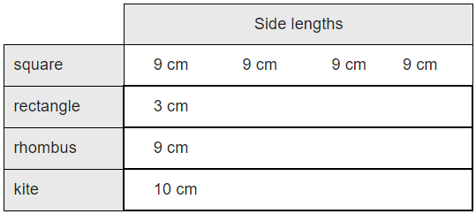 | These diagrams show the diagonals  of three quadrilaterals.  Write the names of the quadrilaterals in the boxes.  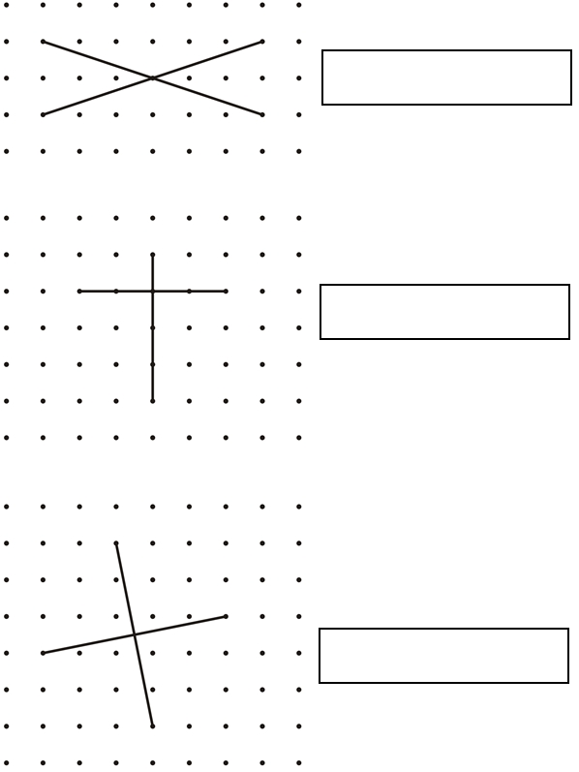

Rotate shapes mentally
Here are six rectangles on a grid. Which two rectangles fit together, without overlapping, to make a square?  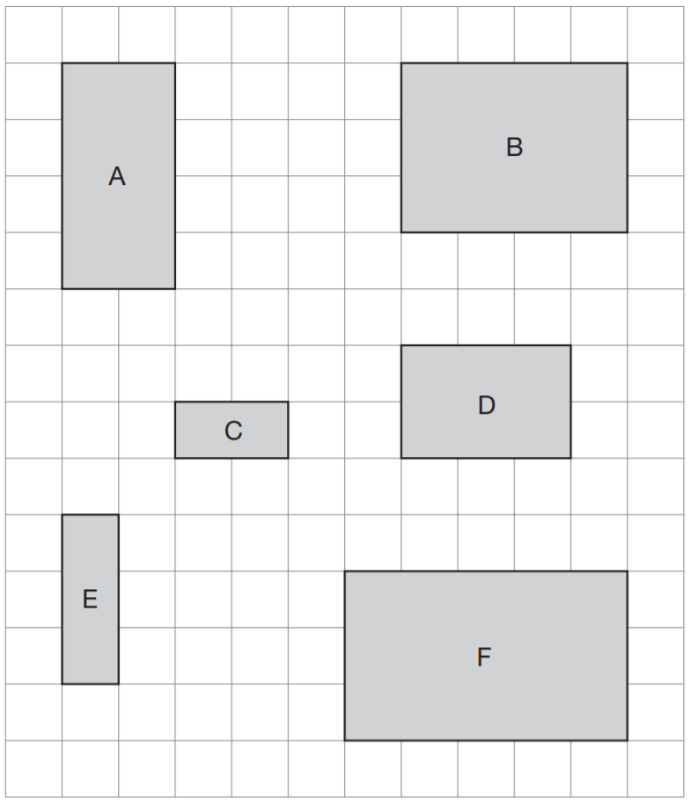 | Here are five shapes on a square grid.  Which two shapes fit together to make a square?  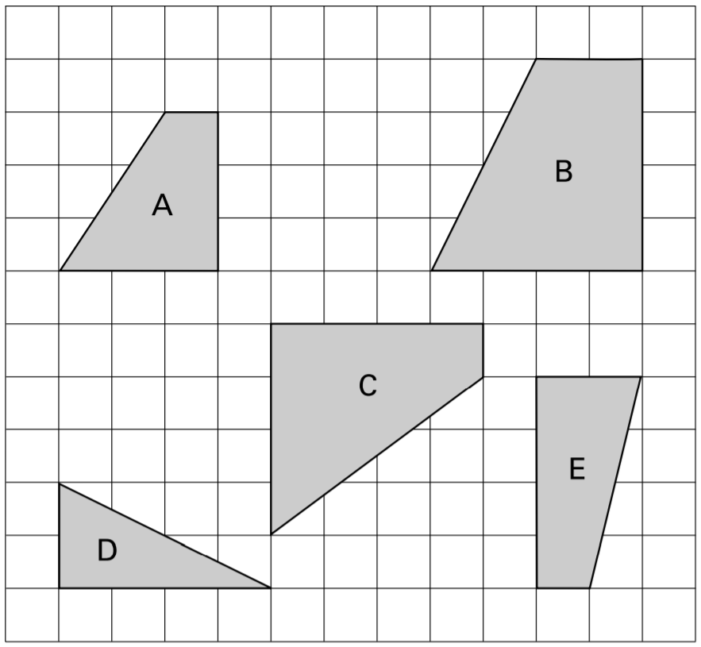
Here are some tiles on a square grid. Three different tiles can be fitted together without overlapping to make a shape identical to tile A. Write the letters of the three tiles.
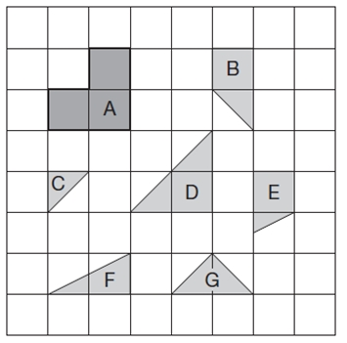

Make 2D shapes
Here is a grid of centimetre squares.  On the grid draw a quadrilateral.  It must have only one pair of parallel sides.  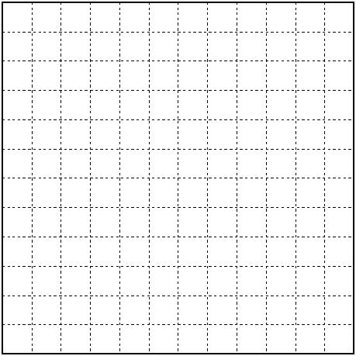 | The lines drawn on the grid are two sides of a pentagon. Complete the pentagon.  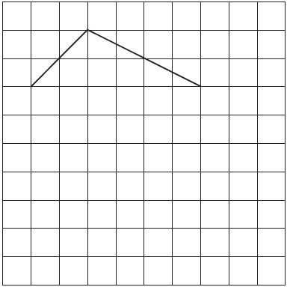
Draw two more straight lines to make a rectangle.  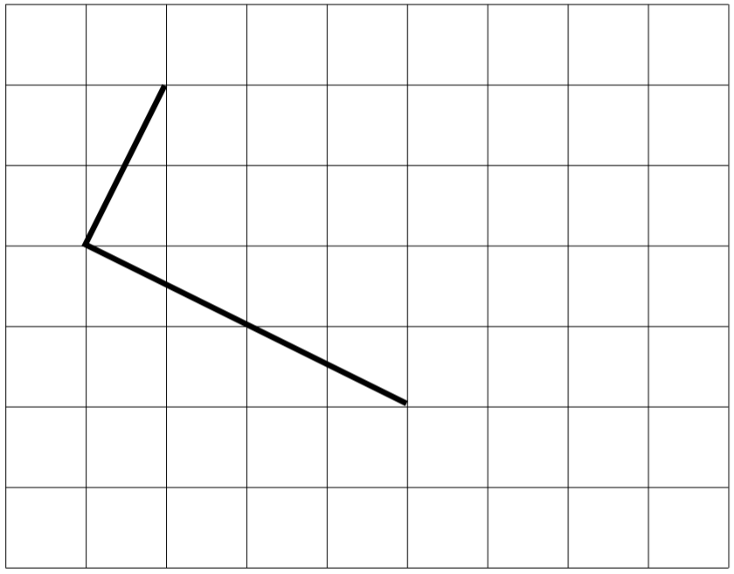 | Here is a square grid. Two sides of a kite are drawn on the grid. Complete the kite by drawing the two missing sides.  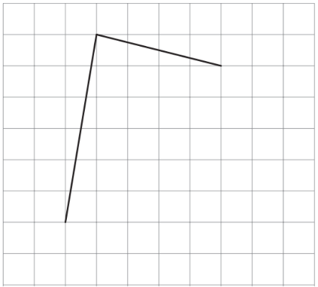
The line on the grid is one side of a square.  On the grid, draw the other three sides of the square.  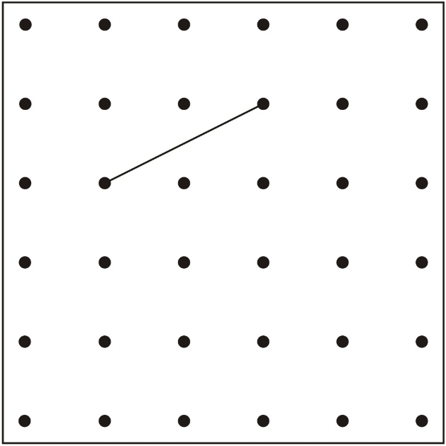 | Draw two more lines on this grid to make a square.  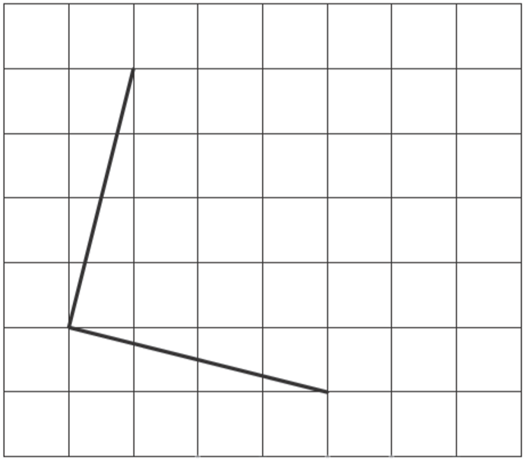

Draw two more line on this grid to complete the rectangle.  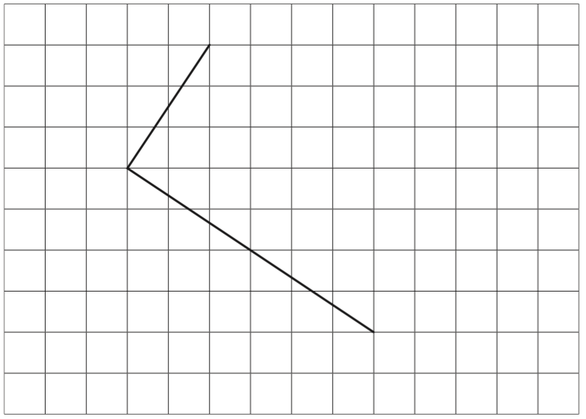 | 2015 Paper 3 Question 15  Join dots on the grid to make a quadrilateral that has 3 acute angles.  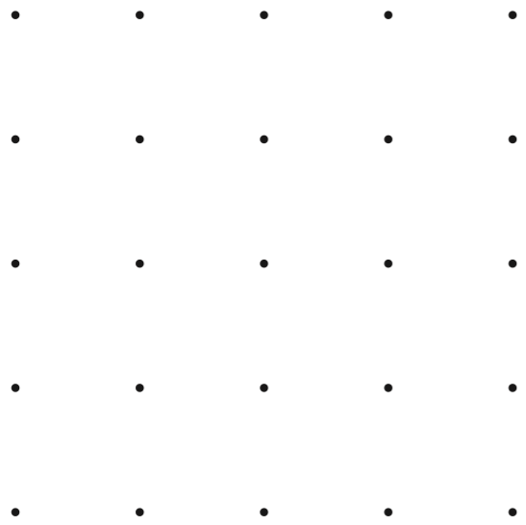
Here is a grid of dots. Point A and point B are joined by a straight line. Draw a line to join point A to another dot on the grid so that the two lines make a right angle.  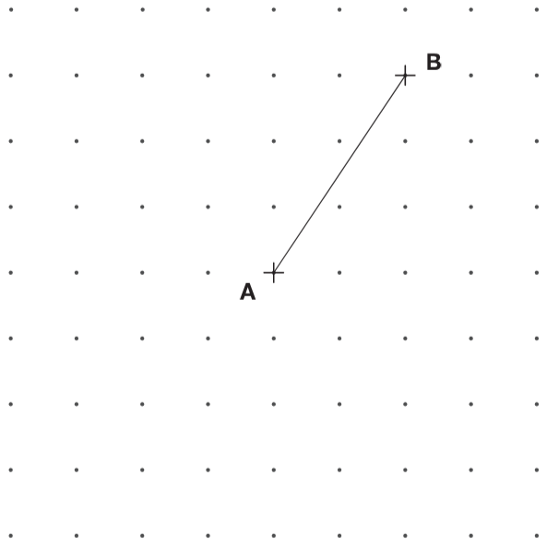 | 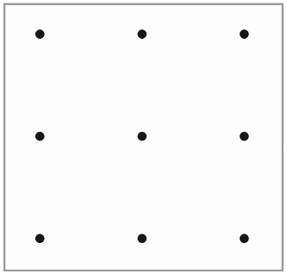  On the grid join dots to make a triangle which does not have a right angle.
Use a ruler to draw 2 more lines to make an isosceles triangle.
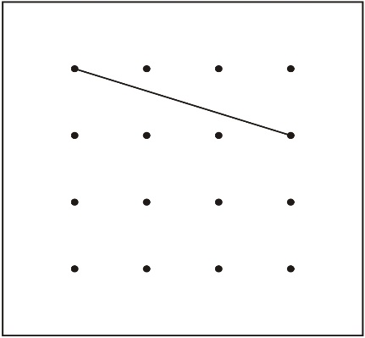

Use the dots to draw one different shape which has a right angle.  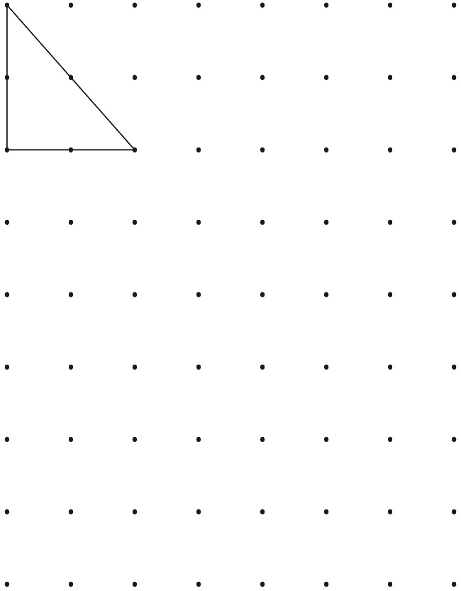 | On the grid below, use a ruler to draw a pentagon that has three right angles.  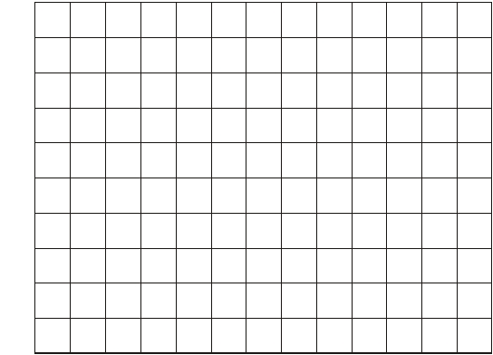

Use the dots to draw a shape that has 4 straight sides and no right angles.   | Join the dots to make a pentagon with only one right angle.  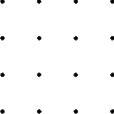  Now join the dots to make a pentagon with exactly two right angles.
Here is a hexagon. Draw two straight lines across the hexagon to make two triangles and two quadrilaterals.
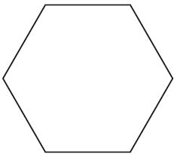
2019 Paper 2 Question 21  Adam has this rectangular piece of card. It is marked with grid lines.  Adam makes two straight cuts along the grid lines.  The two cuts divide the rectangle into 3 shapes:  • 2 squares of different size, and  • 1 rectangle.  Using the grid lines, draw two lines that show where Adam could have made his cuts. Use a ruler.  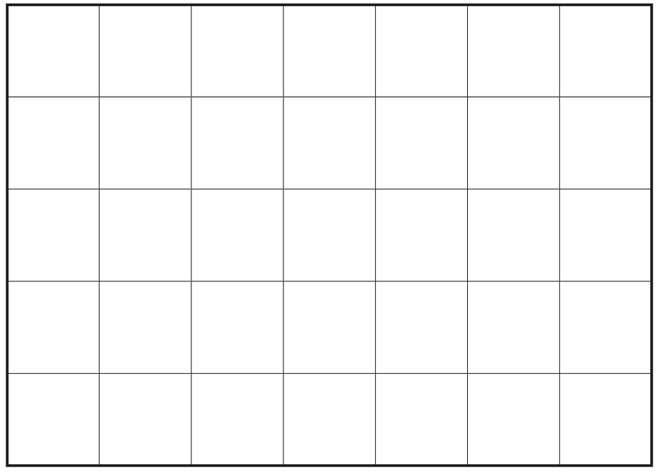 | 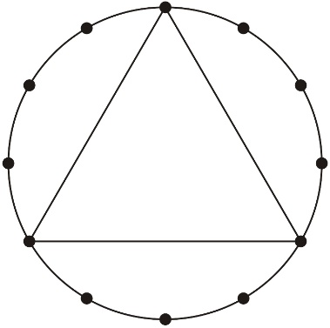  Here is an equilateral triangle drawn on a circle.  Use a ruler to draw a regular hexagon on this circle.  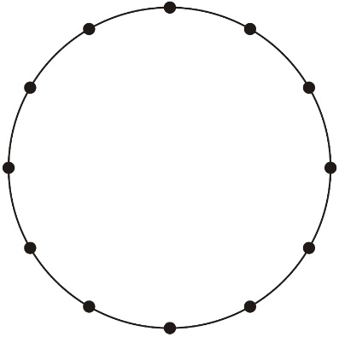
Join 3 points to make an isosceles triangle. | Join 4 points to make a square.
Mike has a triangle grid.  He shades in 2 triangles to make a shape with 4 sides.  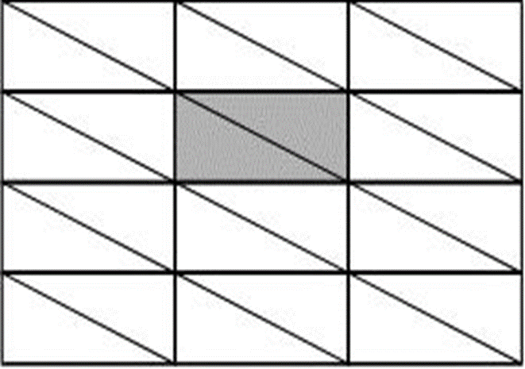  Shade in 2 triangles on this grid to make a different shape with 4 sides.  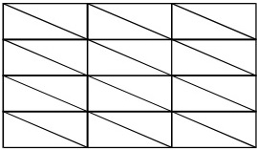  Shade in 4 small triangles on this grid to make a bigger triangle.  Shade in more than 4 small triangles on this grid to make a bigger triangle. | Look at this quadrilateral.  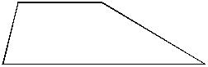  You can draw one line on the quadrilateral to make two triangles.  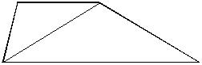  Use a ruler to draw a line in a different place on the quadrilateral to make two triangles.  Now draw one line on the quadrilateral to make a quadrilateral and a triangle.  Now draw one line on the quadrilateral to make two quadrilaterals.
Draw two lines on the square below to make four triangles that are all the same size.

Now draw two lines on the square below to make four squares that are all the same size.
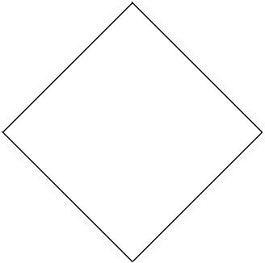
Join the dots to make 4 different triangles.
One has been done for you.

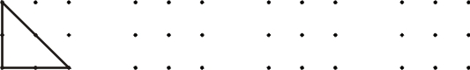

Here is a triangle made using the pins on a pin board.  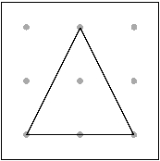  Show how to make a square. Use the pins below.  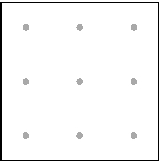  Now show how to make a different sized square. Use the pins below.  Now show how to make another square which is a different size to the ones you have drawn.  Use the pins below. | A shape has 4 right angles.  It has 4 straight sides.  All 4 sides are the same length.  Draw what the shape could be.  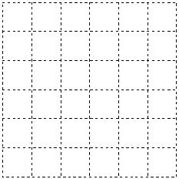  A different shape has 4 right angles.  It has 4 straight sides.  It has 2 pairs of parallel lines.  Draw what the shape could be.  A shape has no right angles.  It has 4 straight sides.  It has 2 pairs of parallel lines.  Draw what the shape could be.
Recognise angles in 2D shapes
Here are some shaded shapes on a square grid.  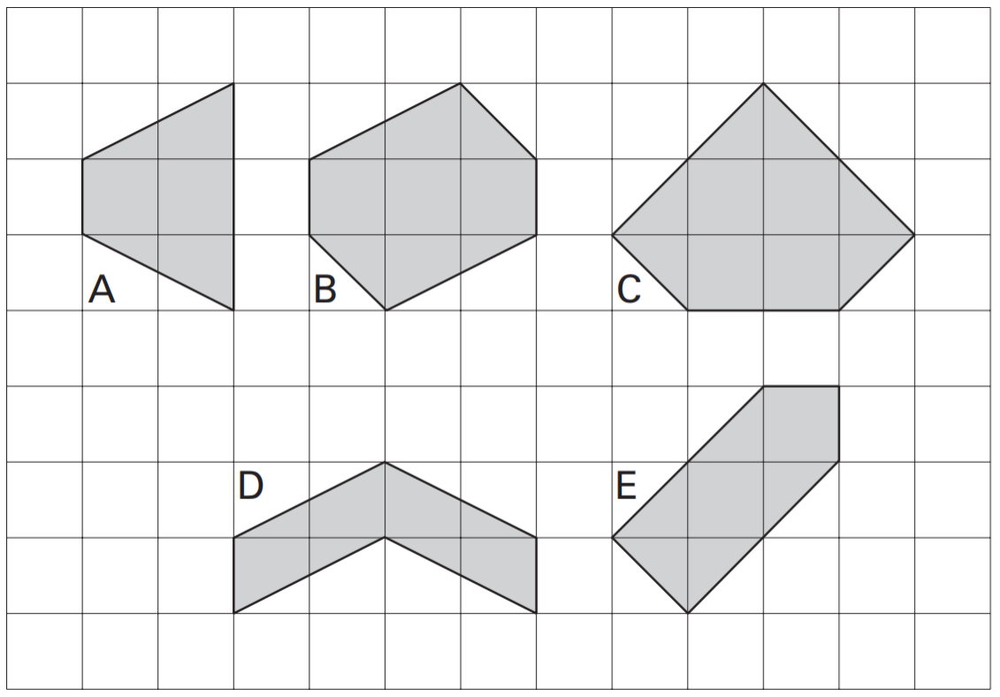  Write the letters of the two shapes which are hexagons.  Write the letters of the two shapes which have right angles. | Look at these shapes.  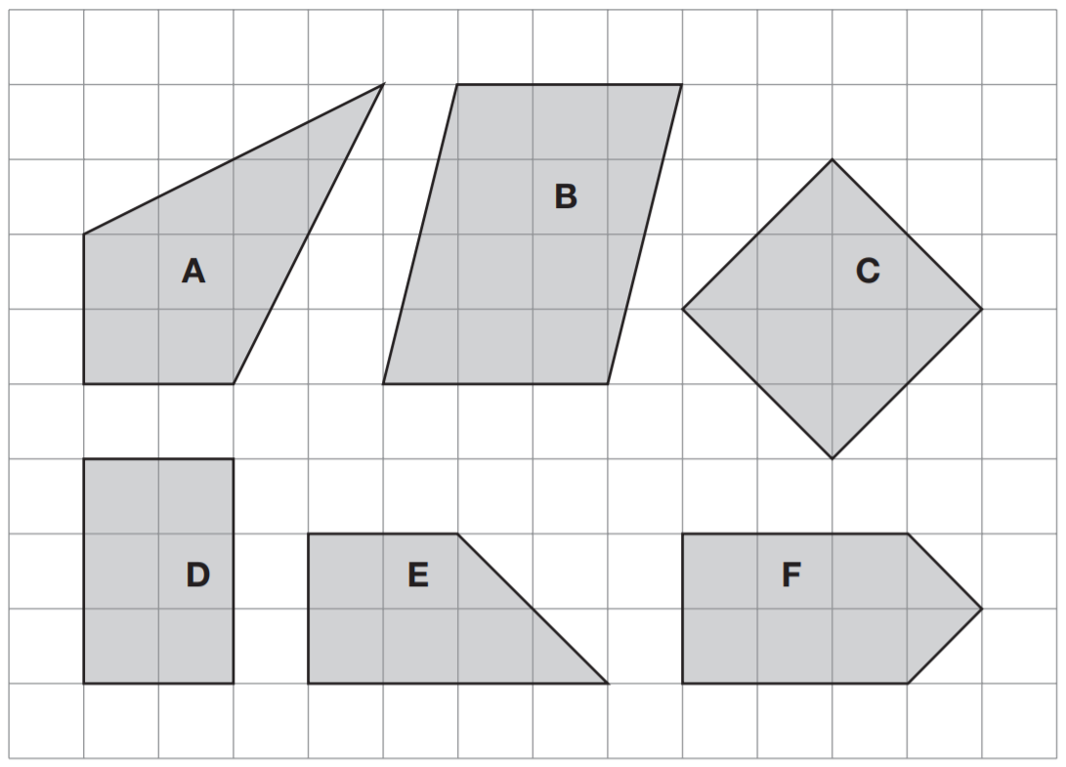  Complete the sentences below.  __is a kite  __is not a quadrilateral  __has only 2 right angles  __has 2 acute angles
2017 Paper 3 Question 13
Circle the pentagon with exactly four acute angles.
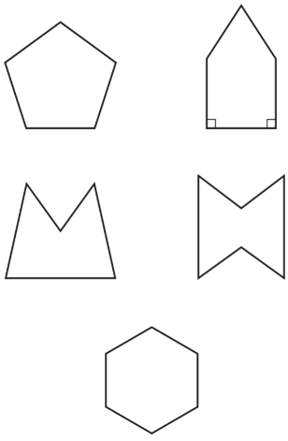

Recognise angles and parallel lines in 2D shapes
Complete the table.  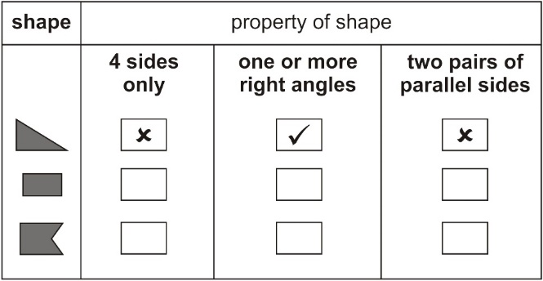 | 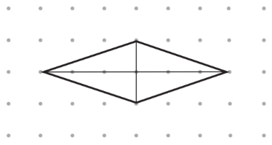  2016 Paper 3 Question 18  The diagonals of this quadrilateral cross at right angles.  Tick all the quadrilaterals that have diagonals which cross at right angles.  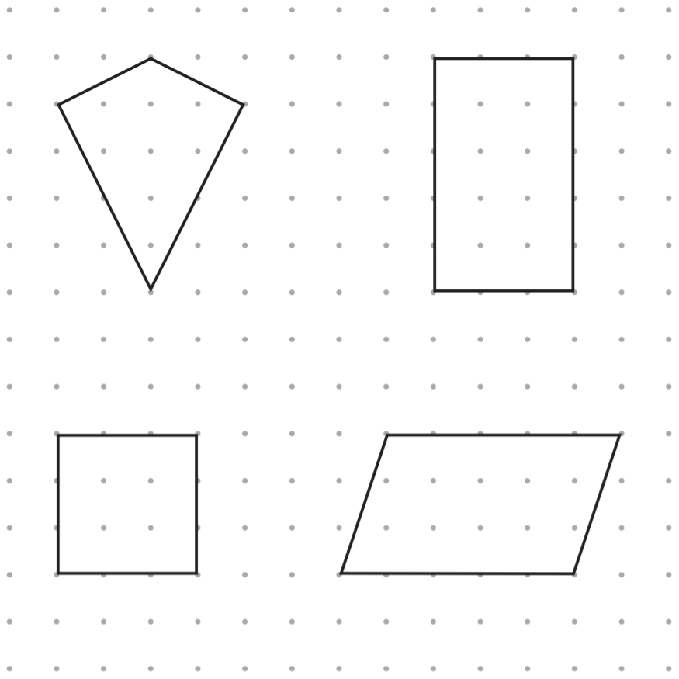
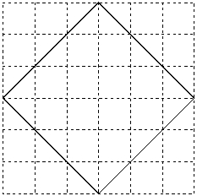
Fill in the gaps in the sentences below.

The shape has ____ right angles.

It has ____ straight sides.

It has ____ pairs of parallel lines.

____ sides are the same length.

Look at the shaded shape on the square grid.  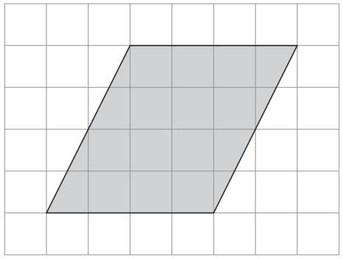  For each statement below, tick or cross to show if it is True or False.  1)The shaded shape is a quadrilateral.  2)The shaded shape has four equal sides.  3)The shaded shape has four equal angles.  4)The shaded shape has two pairs of parallel sides. | Here are five shapes made from equilateral triangles.  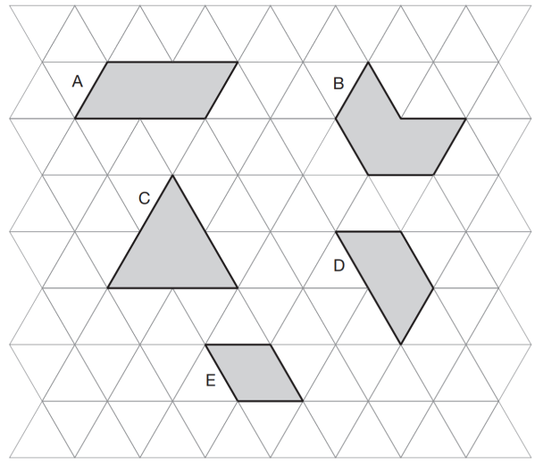  Write the letter of the shape that is a rhombus.  Write the letter of the shape that has only one pair of parallel sides.
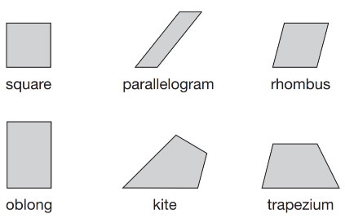  Here are six quadrilaterals.  Lara chooses one of the quadrilaterals. She says, ‘It has two acute angles. All four sides are the same length.’ Which quadrilateral did Lara choose?  Stefan chooses one of the quadrilaterals. He says, ‘It has more than one obtuse angle. It has no parallel sides.’ Which quadrilateral did Stefan choose? |  | For each of the four sentences below, put a tick if it is true. Put a cross if it is not true.  1) A triangle can have 2 acute angles.  2) A triangle can have 2 obtuse angles.  3) A triangle can have 2 parallel sides.  4) A triangle can have 2 perpendicular sides.
Recognise angles, parallel lines and symmetry in 2D shapes
Look at the shape drawn on the square grid.  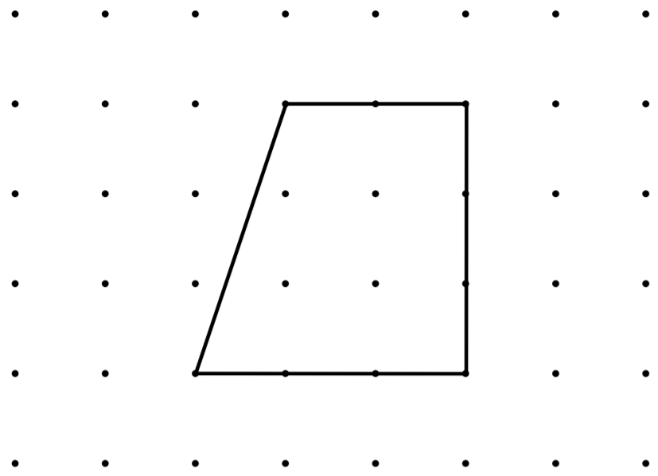  For each of the four sentences below, put a tick if it is true. Put a cross if it is not true.  1) The shape has exactly 2 right angles.  2) The shape has 2 pairs of parallel lines.  3) The shape has one line of symmetry.  4) The shape is a quadrilateral. | Match each quadrilateral to the correct description. One has been done for you.  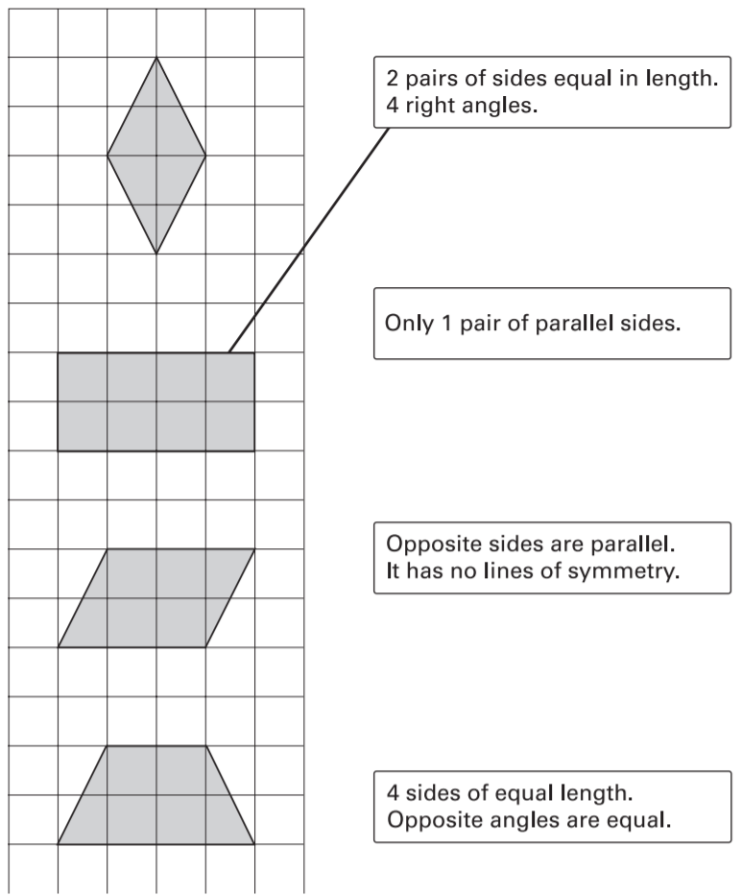
Here is a shape on a grid.  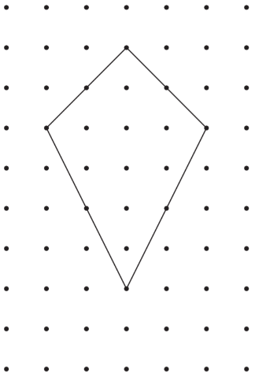  For each of the four sentences below, put a tick if it is true. Put a cross if it is not true.  1) The shape is a quadrilateral.  2) The shape has 2 lines of symmetry.  3) The shape is a parallelogram.  4) The shape has one right angle. | Here are five shapes on a square grid.  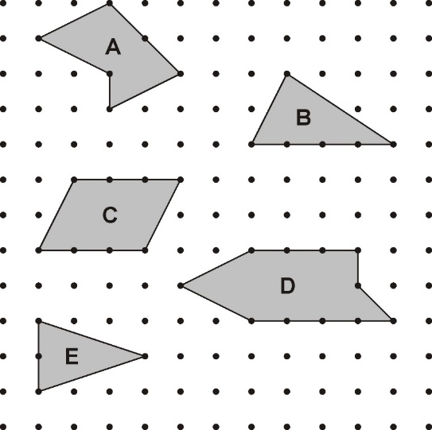  Write in the missing letters.  Shape ____ has two pairs of parallel sides.  Shape ____ is a pentagon.  Shape ____ has reflective symmetry.

Identify faces, edges and vertices in different 3D shapes
This table shows information about four solid shapes. One has been done for you.  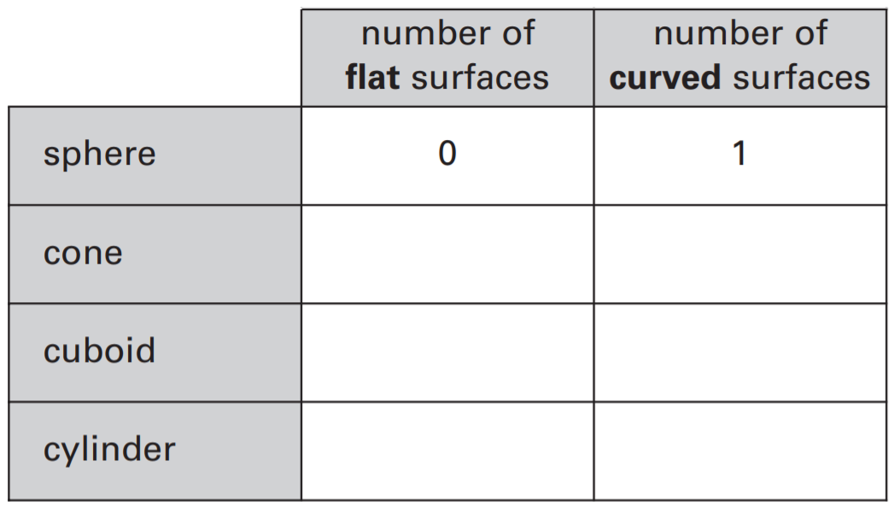 | Write each word in the correct box.    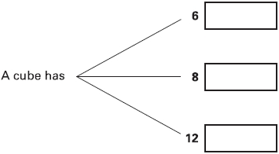
The table shows information about three solid shapes. Complete the table.  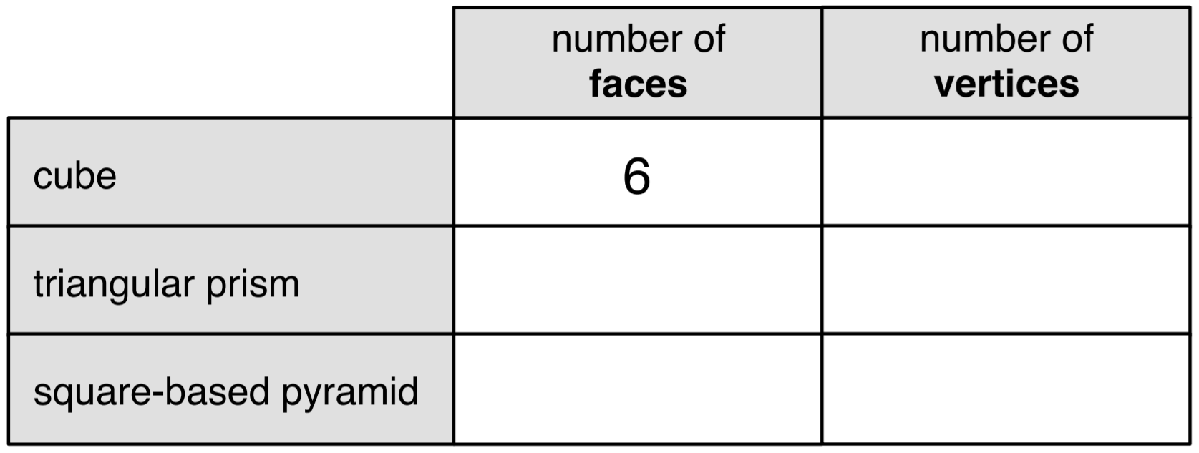 | The table shows information about three solid shapes. Complete the table.  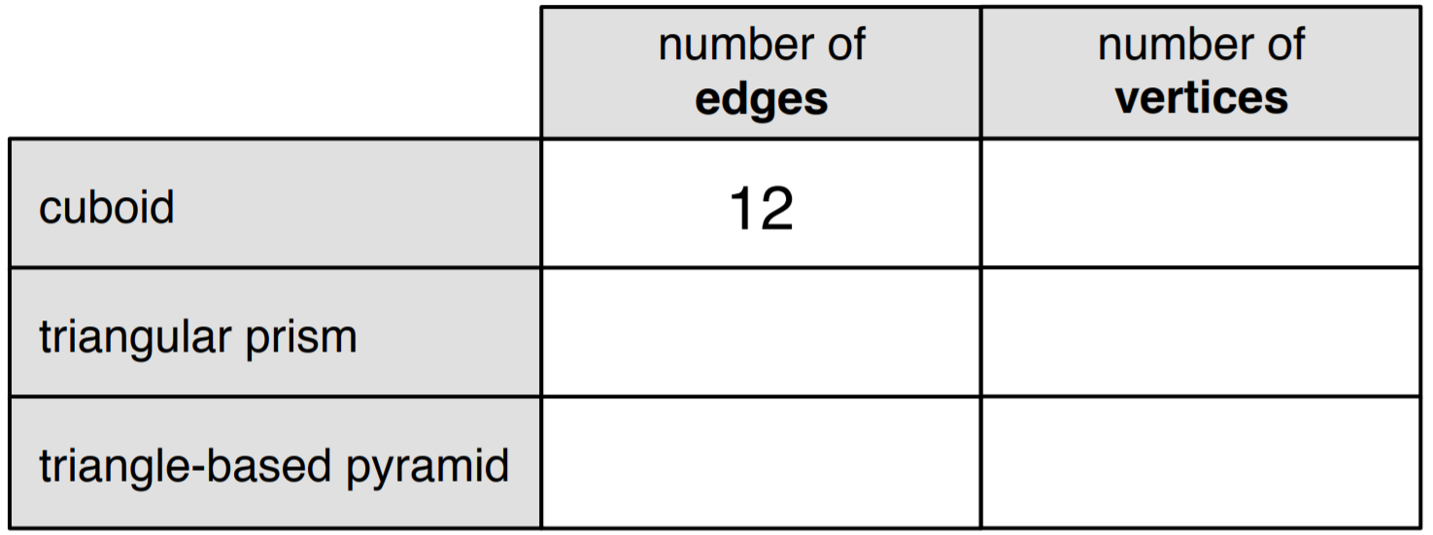
Complete the table.  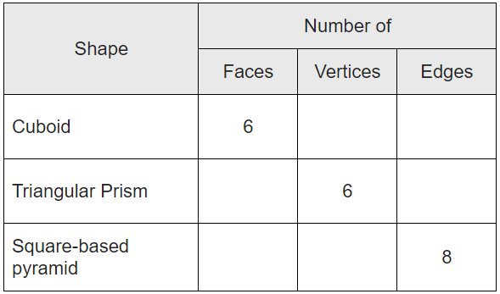 | Jack has two square-based pyramids that are the same size. He sticks the square faces together to make a new 3-D shape. How many faces and how many edges does his new 3-D shape have?  Faces:  Edges:

Identify 3D shapes from their description
I’m thinking of a 3-D shape.  It has a square base.  It has 4 other faces, which are triangles.  What is the name of the 3-D shape? | Mina thinks of a 3-D shape.  She says, ‘It has 5 faces. Two opposite faces are triangles. The other faces are rectangles.’  What is the name of the 3-D shape?
A 3-D shape has 8 vertices.  It has 6 faces.  Each face is the same.  What is the correct name for this shape? | Jack says, "Two 3D shapes with the same number of faces as each other also have the same number of vertices as each other."  Is Jack correct? Explain how you know.

Identify nets of 3D shapes
Look at the cuboid below.  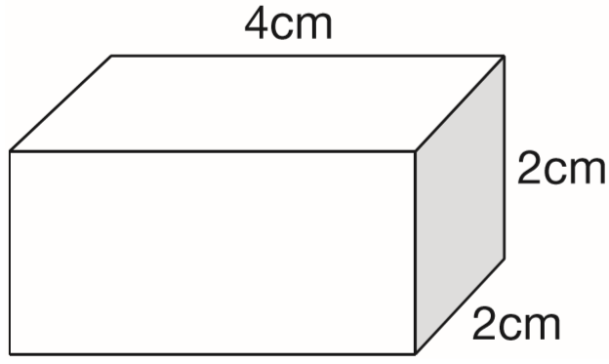  Draw two more faces to complete the net of the cuboid.  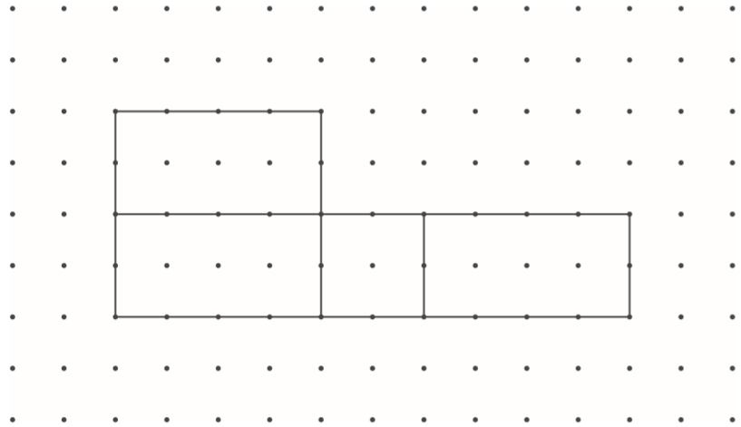 | Here is part of a net for a cuboid.  Draw in the missing face to complete the net.  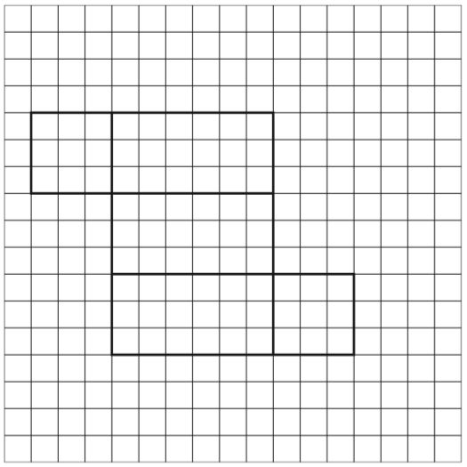
Here are four diagrams.  On each one, put a tick if it is a net of a cube.  Put a cross if it is not.  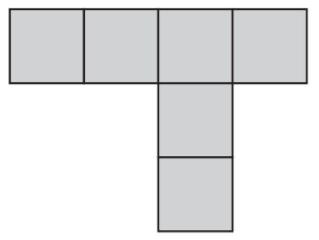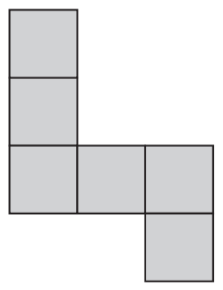  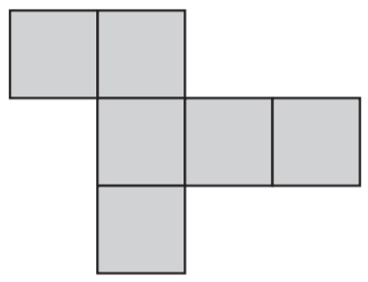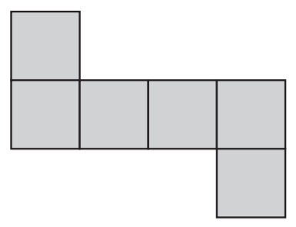 | Look at each of these diagrams.  On each one, put a tick if it is the net of a square based pyramid. Put a cross if it is not.  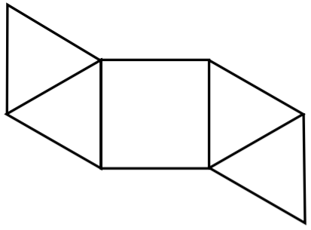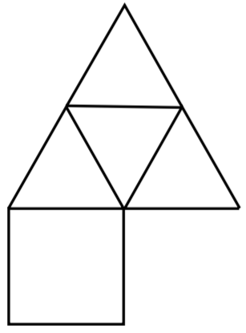  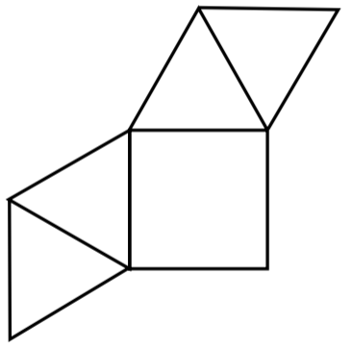
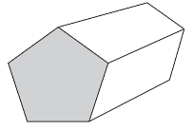  This is a drawing of a pentagonal prism. Tick the one shape that is a net for the pentagonal prism.  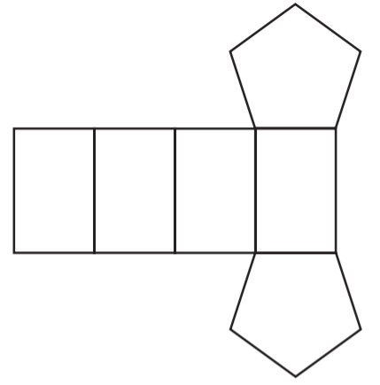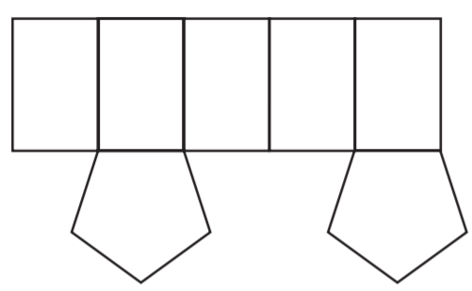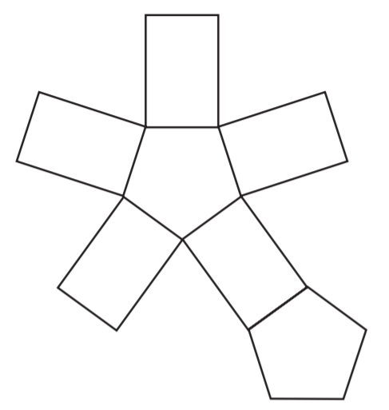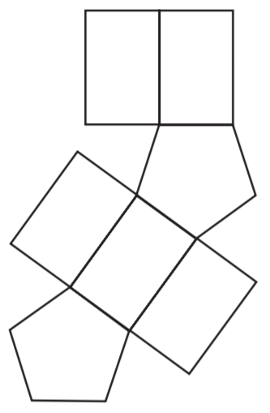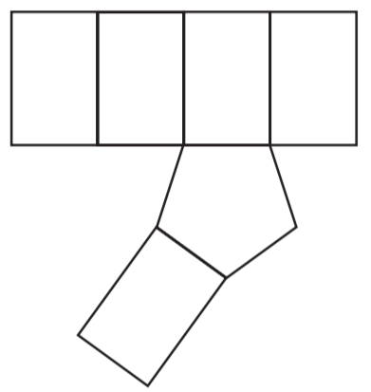 | Here are some nets of shapes. For each net, put a tick if it folds to make a pyramid. Put a cross if it does not.  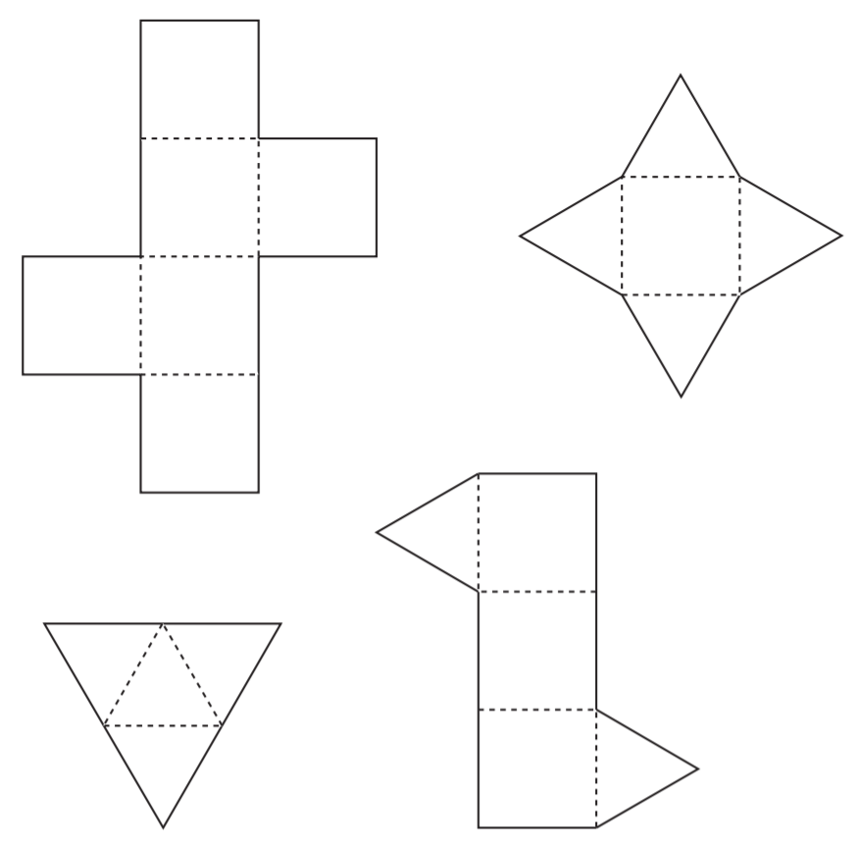

Two of these diagrams are nets for a triangular prism. Put a tick in them.  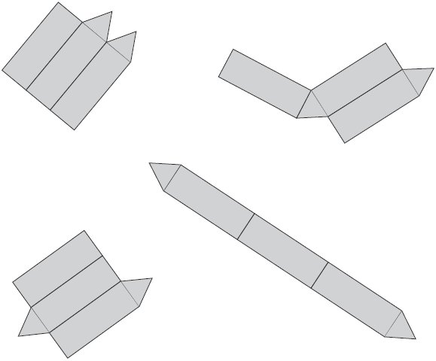 | These nets will fold to make 3-D shapes. Match each net to the name of its shape.  One has been done for you.  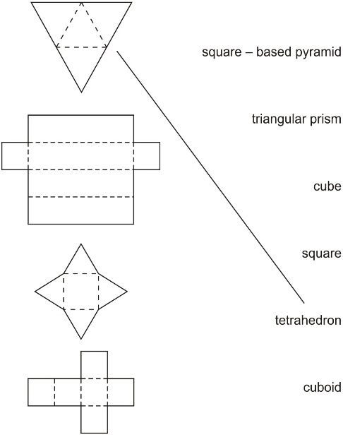
Identify the base or lid of a cube or cuboid
Here is the net of a cube with no top. The shaded square shows the bottom of the cube. Draw an extra square to make the net of a cube which does have a top.  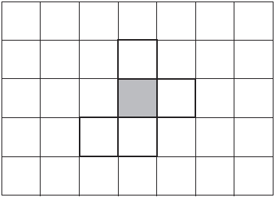 | Here is an open top cube.  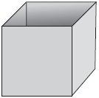  Here is the net from which it is made.  Put a tick on the square which is its base.  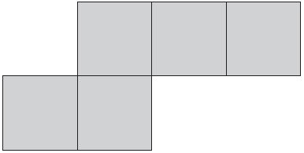
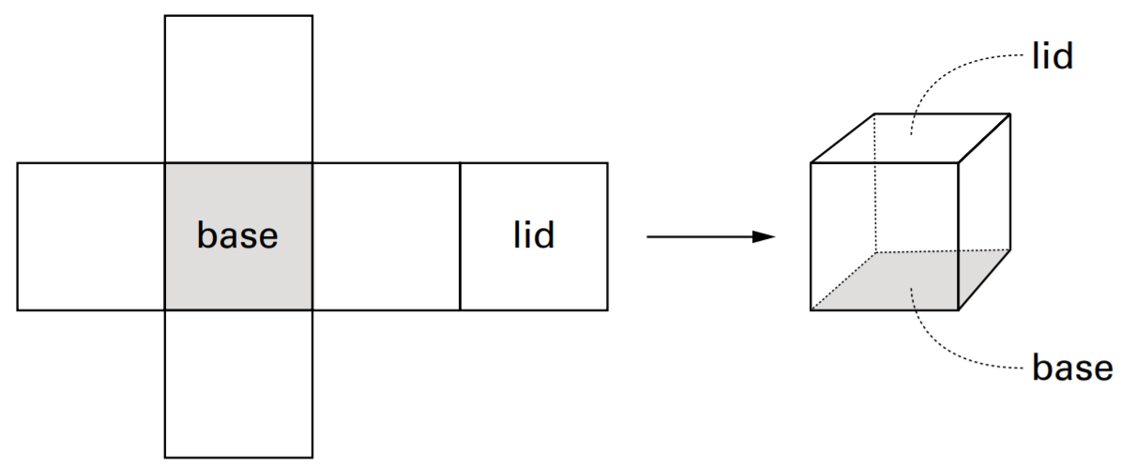  The diagram above shows a net that folds to make a box. There are two different nets shown below. Each net folds to make a box. The base of each box is labelled. For each box, label the face that will be the lid.  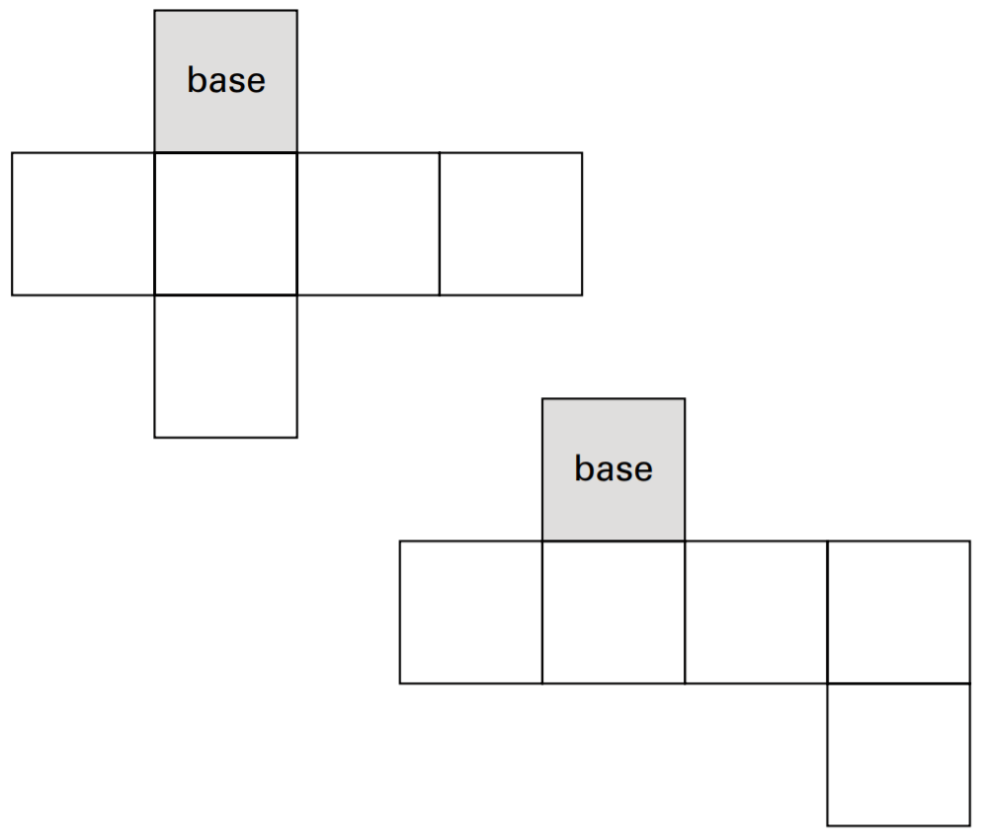 | This is an open top box.  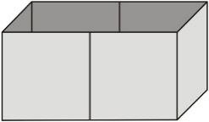  Put a tick for each diagram if it is a net for the box. Put a cross if it is not. The base is shaded in each one.  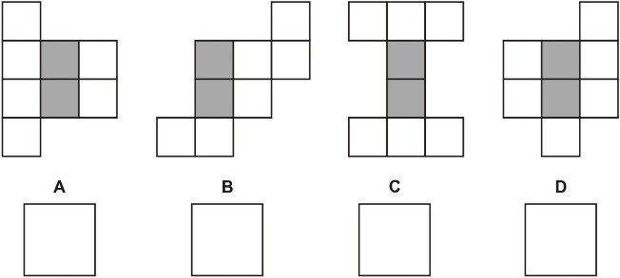

Find volume by counting cubes
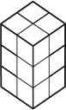  2016 Paper 3 Question 10  Emma makes a cuboid using 12 cubes.  Write the letter of the cuboid that has a different volume from Emma’s cuboid.  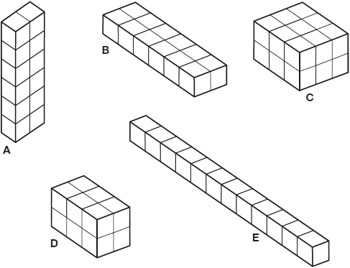 | These cuboids are made from small cubes. Write how many small cubes there are in each cuboid. The first is done for you.  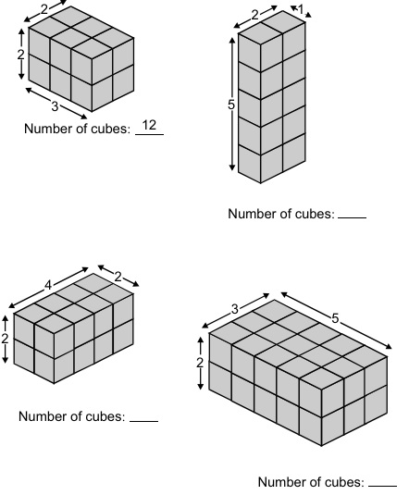
This shape is made with two cuboids. Write how many small cubes there are in this shape.  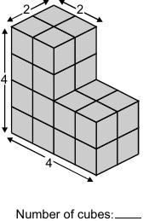 | This shape is made of wooden centimetre cubes.  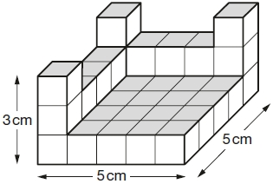  How many more centimetre cubes are needed to make it into a solid cuboid 3 cm tall, 5 cm long and 5 cm wide?

Draw the reflection of a shape in a vertical mirror line on a squared grid
Draw the reflection of each shape in the mirror line.
2019 Paper 2 Question 4  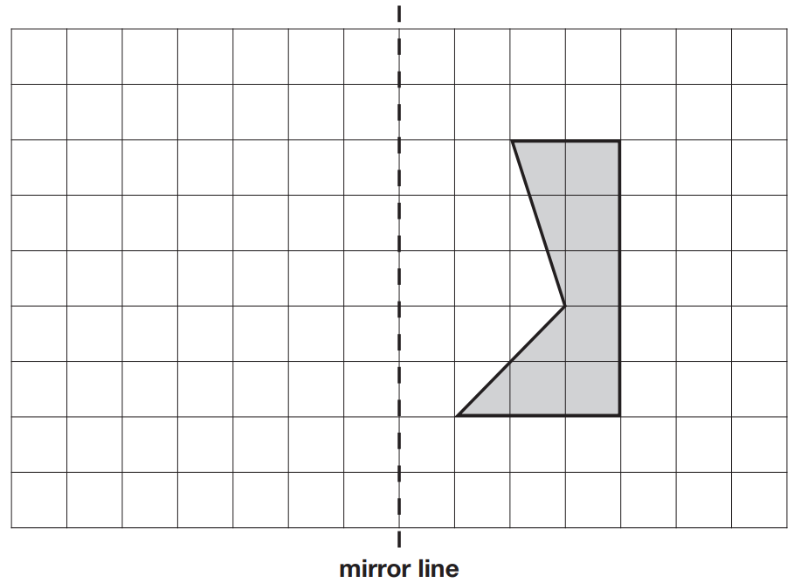 | 2018 Paper 2 Question 1  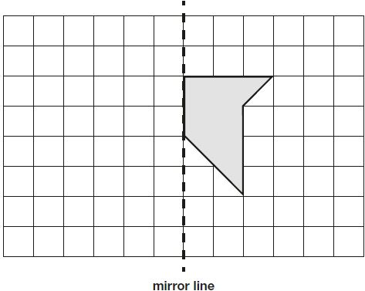
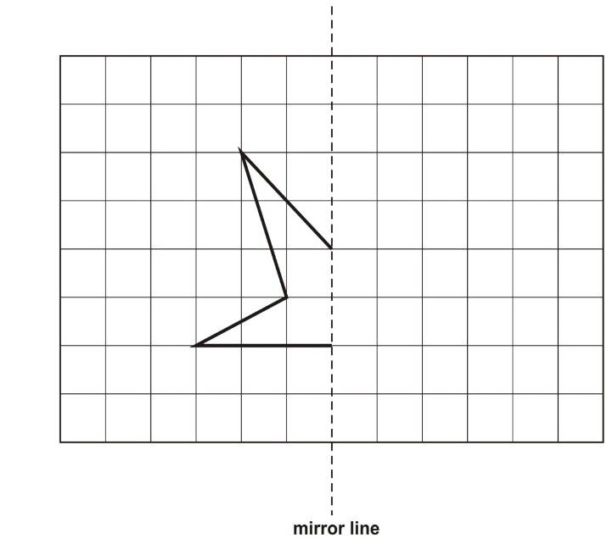 | 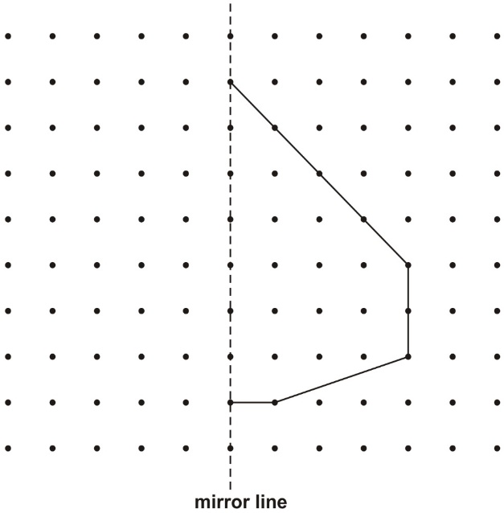
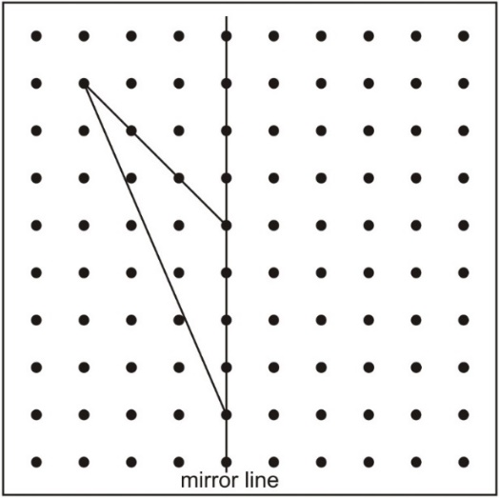 | 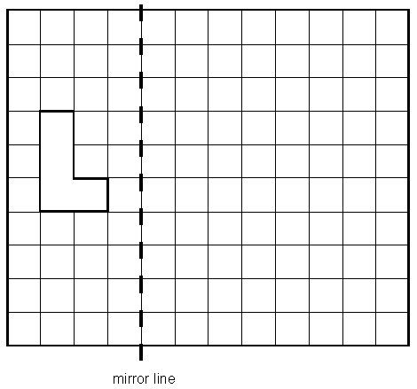
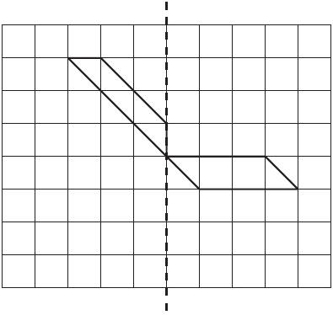

Draw the reflection of a shape in a vertical mirror line on different grids
Draw the reflection of each shape in the mirror line.
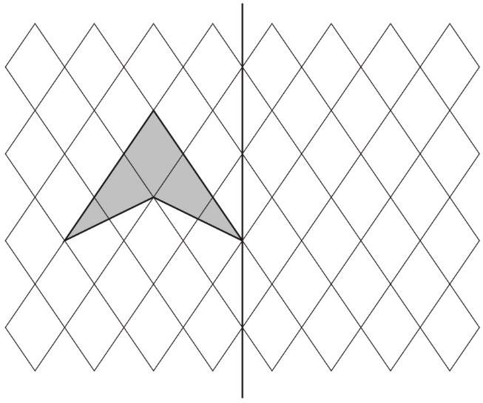 | 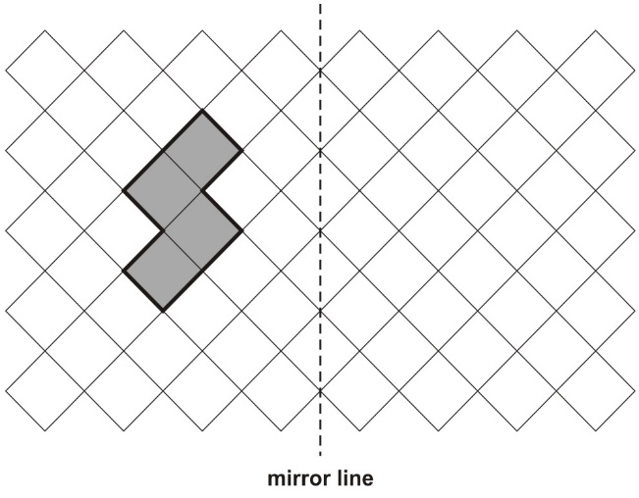
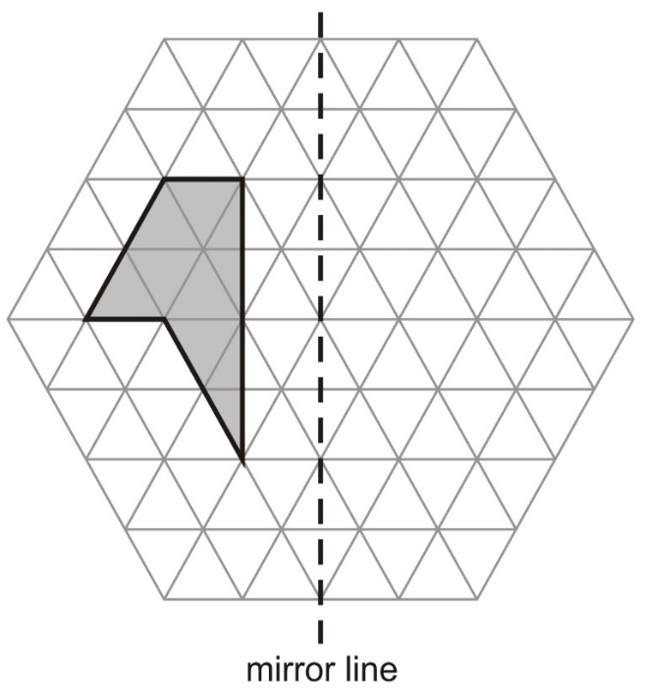 | 2016 Paper 2 Question 6  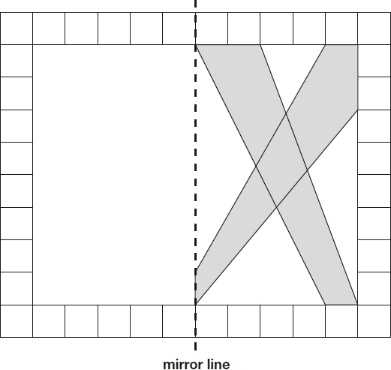
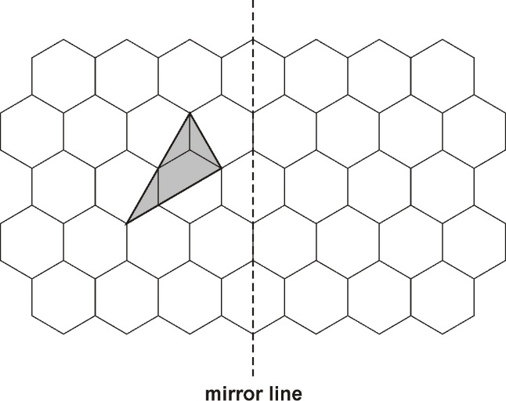 | 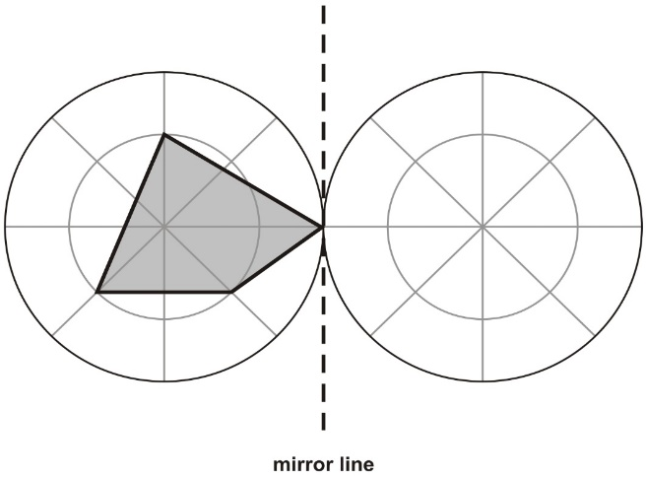

Draw the reflection of a shape in a horizontal mirror line
Complete the diagram below to make a shape that is symmetrical about the mirror line.  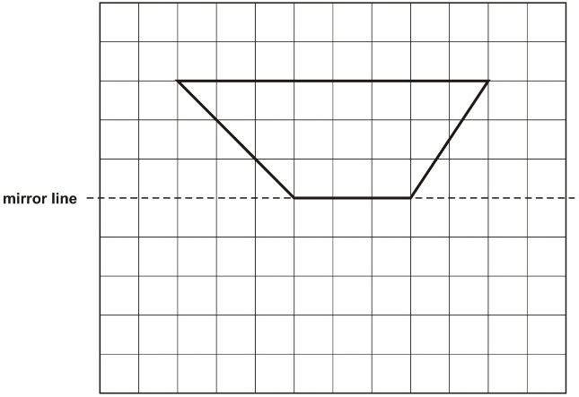 | Shade in the reflection of this shape.  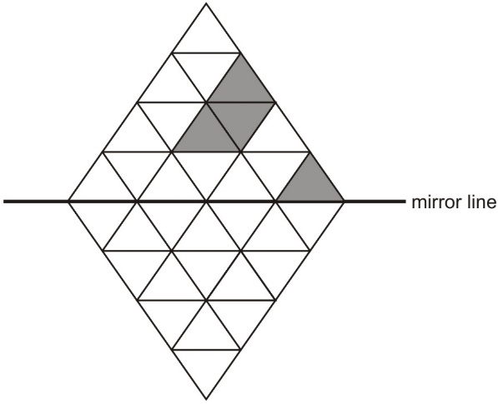
Complete this shape so that it is symmetrical about the mirror line.  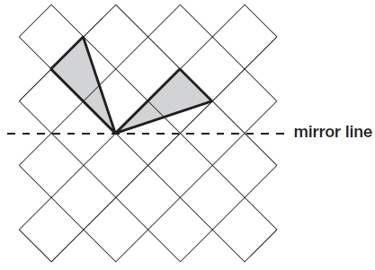 | Draw the reflection of the shaded shape in the mirror line.  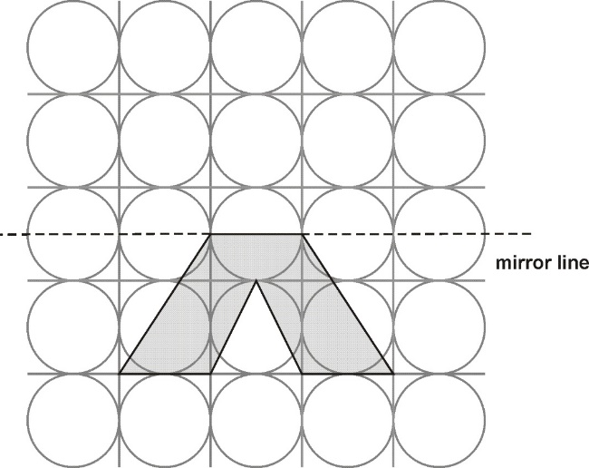

Shade squares to make a design symmetrical
Complete the reflection of this pattern in the mirror line.  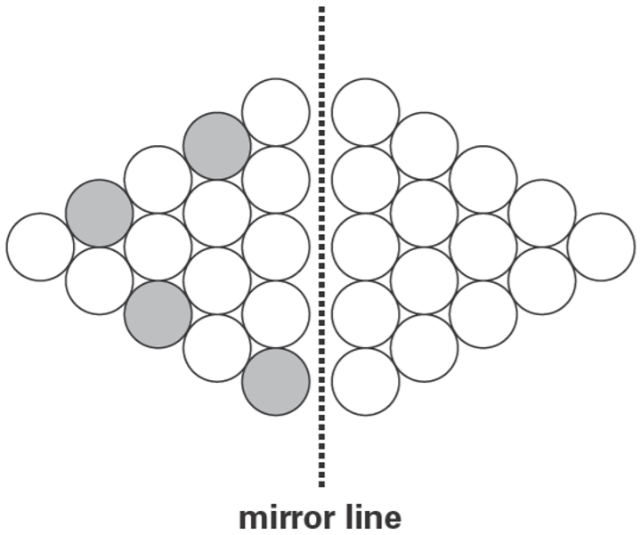 | Draw the reflection of all the shaded shapes in the mirror line.  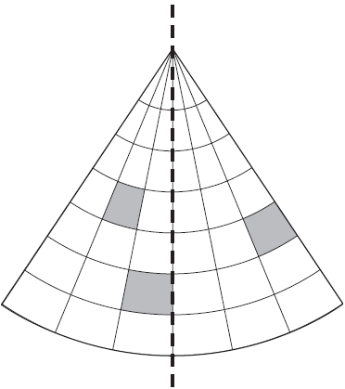

Here is a grid with four squares shaded in.  Shade in one more square to make a shape with a line of symmetry.  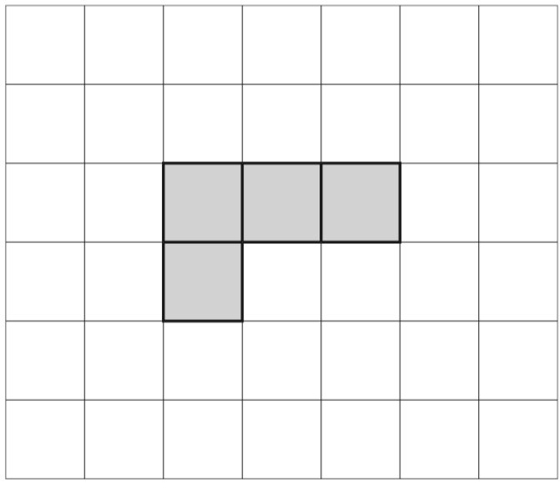  Shade in a different square to make a shape with a line of symmetry. | Here is a square with a design on it. The square is reflected in the mirror line. Draw the missing triangle and dots on the reflected square.  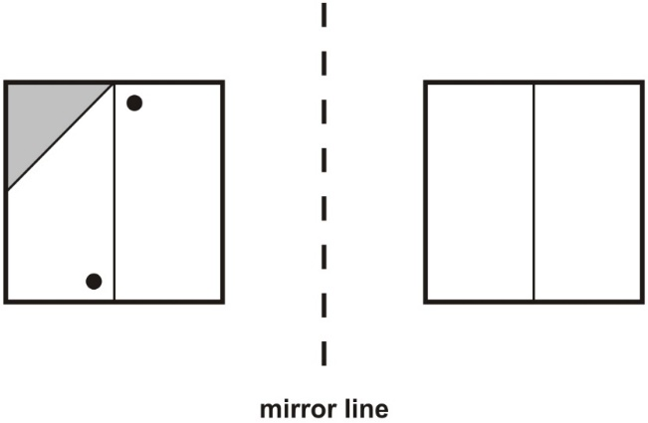
Draw two more lines to make a shape which has a line of symmetry.
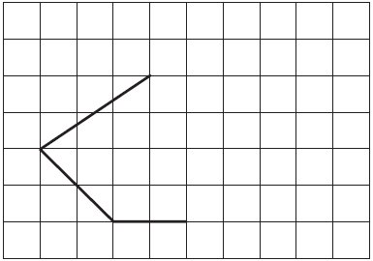
Shade in two more squares to make a symmetrical pattern.  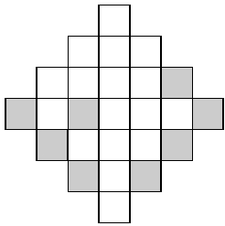 | Draw two more circles on this grid to make a design that has a line of symmetry.  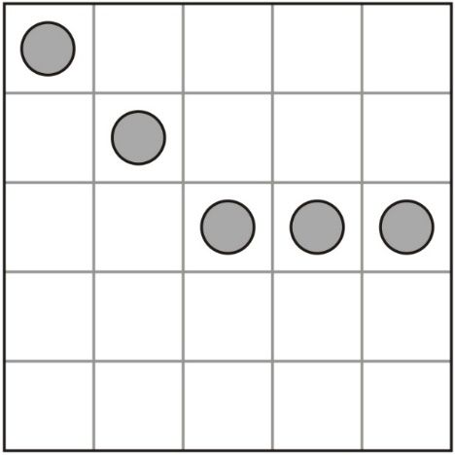
Shade in two more squares to make this design symmetrical about the mirror line.  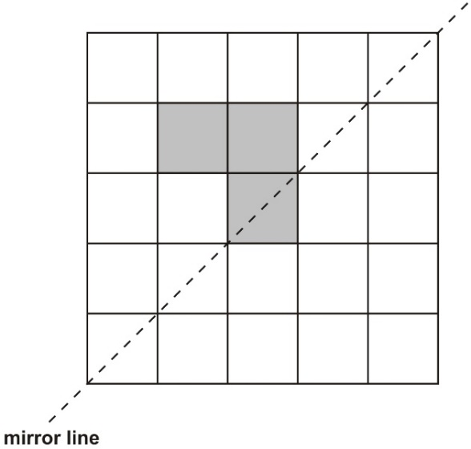 | Shade two squares and one triangle to make this design symmetrical about the mirror line.  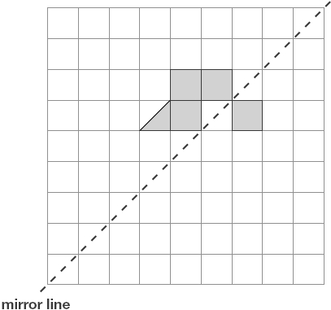
Draw the reflection of a shape in a diagonal mirror line
Draw the reflection of each shape in the mirror line.
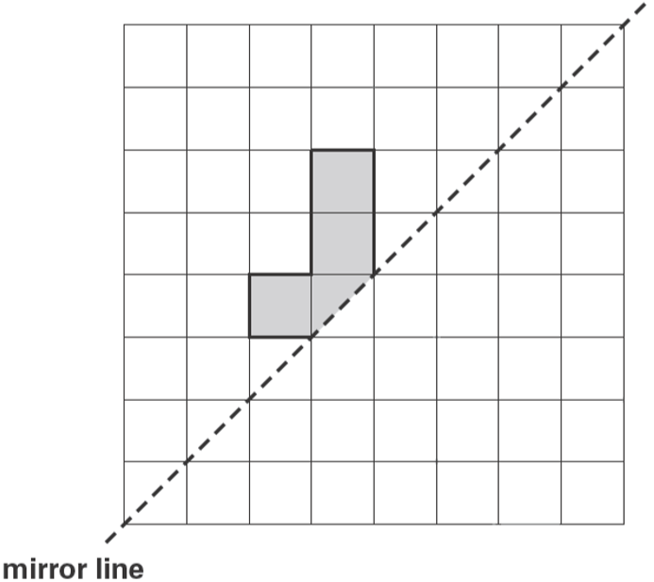 | 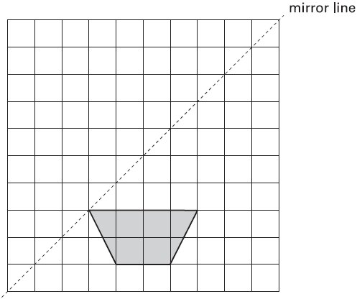
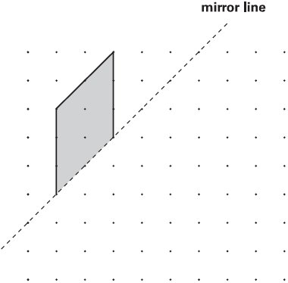 | 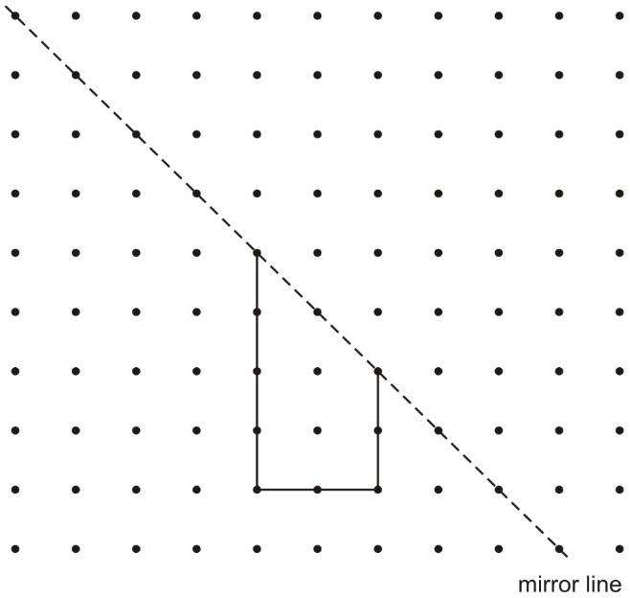
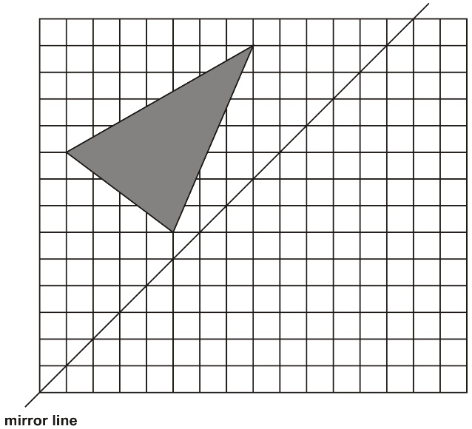 | 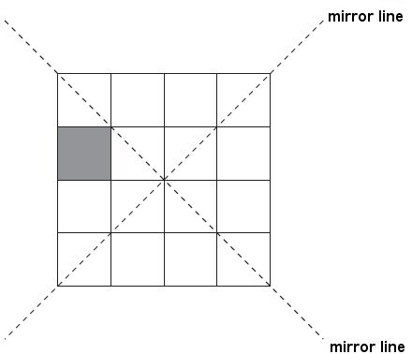

Translate a shape
2016 Paper 3 Question 12  A triangle is translated from position A to position B.  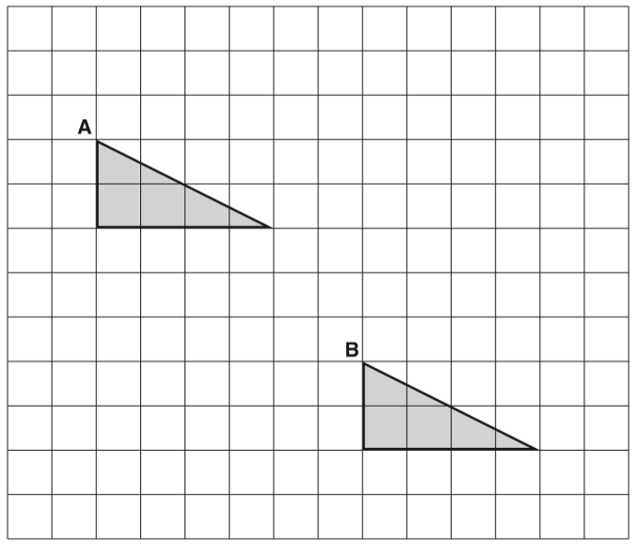  Complete the sentence.  The triangle has moved __ squares to the right  and __ squares down. | Here is a triangle on a square grid. The triangle is translated so that point A moves to point B. Draw the triangle in its new position.  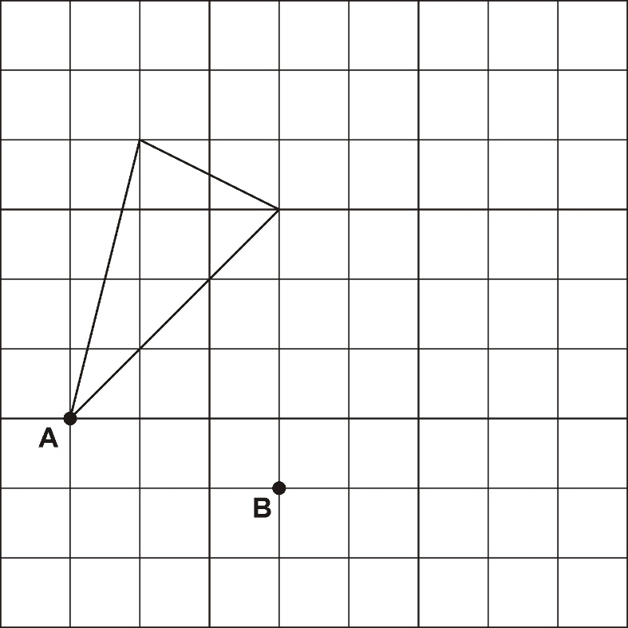
Here is a shaded shape on a square grid.  Rehsma translates the shape from point A to point B. Draw the new position of the shape after the translation.  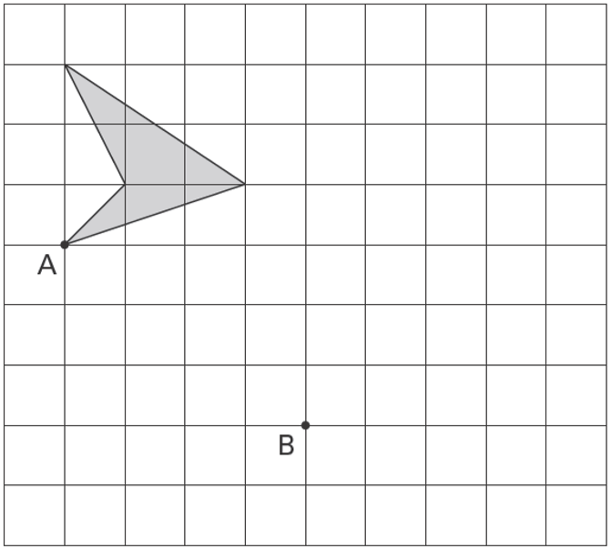 | 2015 Paper 3 Question 8  Here is a shaded shape on a grid. The shape is translated so that point A moves to point B. Draw the shape in its new position.  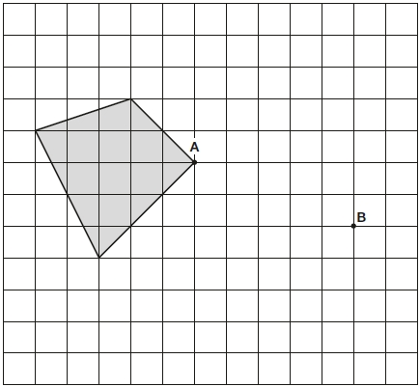
Here is a quadrilateral on a square grid.
The quadrilateral is translated so that point A moves to point B. Draw the quadrilateral in its new position.
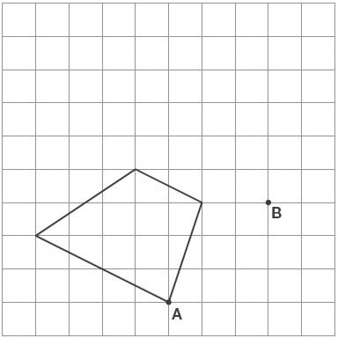
Translate a shape on a simple co-ordinate grid
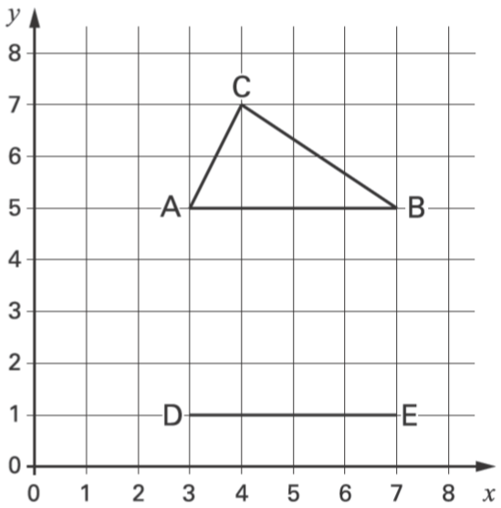  Kyle has drawn triangle ABC on this grid.  Holly has started to draw an identical triangle DEF. What will be the coordinates of point F? | Zak draws this shape on a grid.  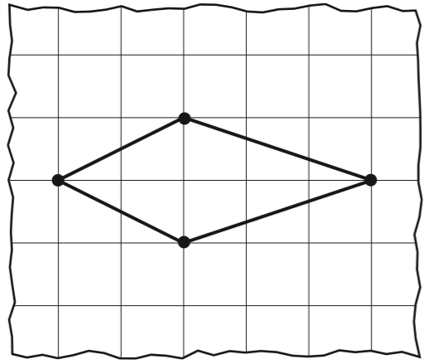  Lauren starts to draw an identical shape on the grid below.  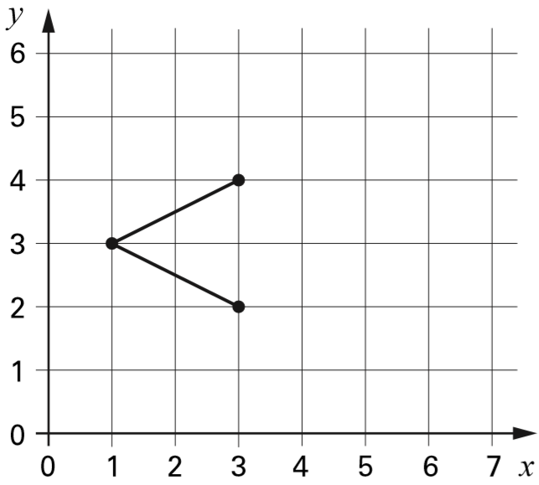  Write the coordinates of the missing point.
2018 Paper 2 Question 12  Here is a shape on a grid. The shape is translated so that point A moves to (7, 8). Draw the shape in its new position.  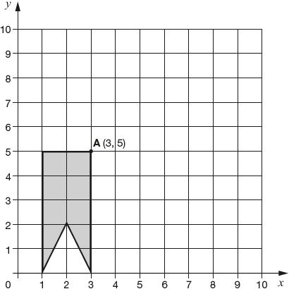 | 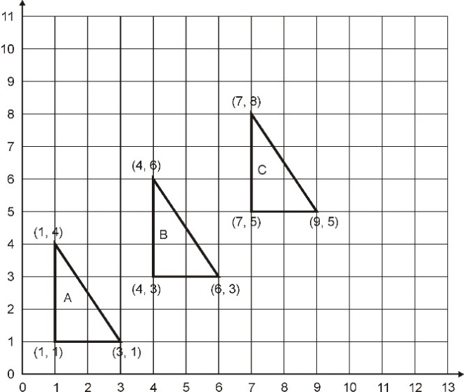  Write the co-ordinates of the next triangle in the sequence.

Calculate co-ordinates on a simple co-ordinate grid using knowledge of the properties of squares and rectangles
The shaded shape is a square.  What are the coordinates of A and B?  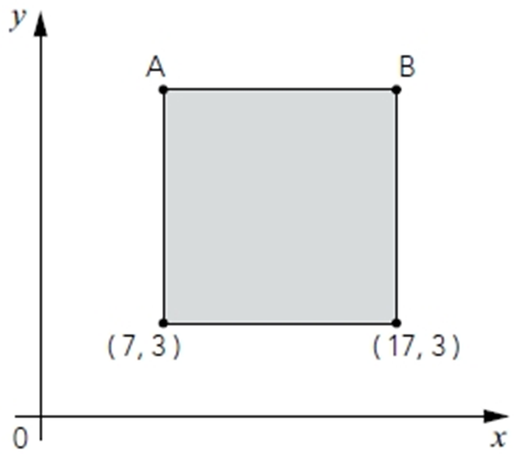 | Here is a shaded square.  Write the coordinates for point A.  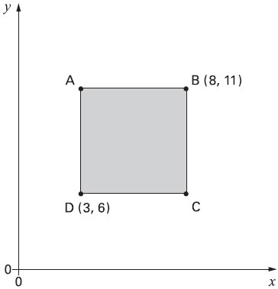
Here is a shaded rectangle.  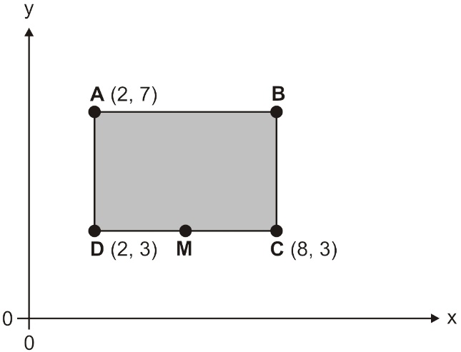  What are the co-ordinates of B?  M is half way between D and C.  What are the co-ordinates of M? | Here is a square drawn on a coordinate grid.  What are the coordinates of the point at the centre of the square?  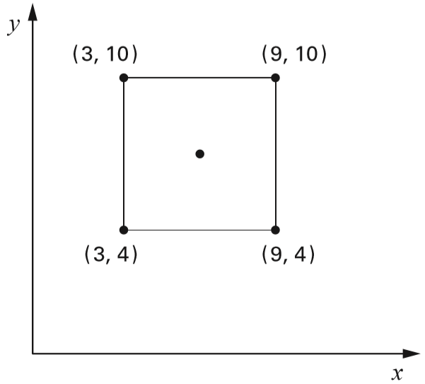
The diagram shows two identical squares.  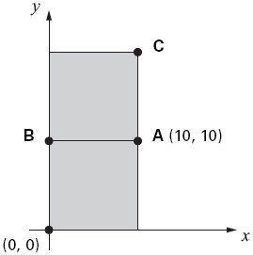  A is the point (10, 10).  What are the coordinates of B and C? | 2019 Paper 3 Question 21  ABDE is a rectangle on coordinate axes.  The sides of the rectangle are parallel to the axes.  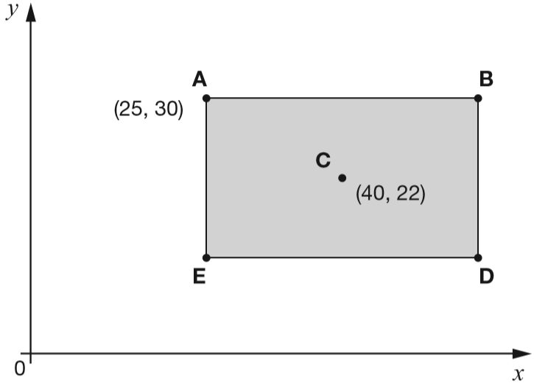  Point C is the centre of the rectangle.  What are the coordinates of B and D?
This diagram shows two identical rectangles on coordinate axes. Write the coordinates of point A and point B.  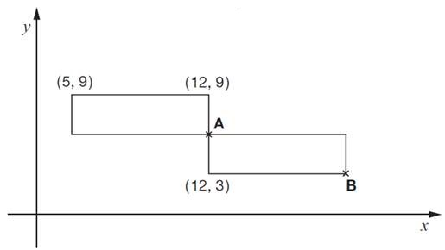 | A, B, C and D are the vertices of a rectangle.  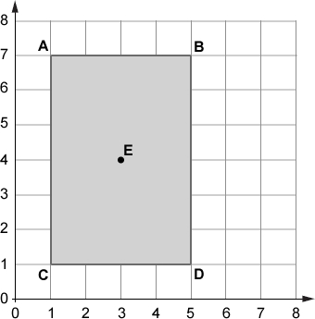  Write the coordinates of point B.  Point E is the centre of the rectangle.  Write the coordinates of point E.
Calculate co-ordinates on a simple co-ordinate grid using knowledge of the properties of shapes
Here is a kite.  Write the coordinates of point D.  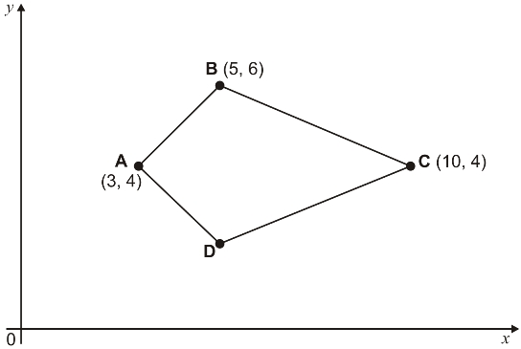 | Here is a pentagon drawn on a coordinate grid. The pentagon is symmetrical.  What are the coordinates of point C?  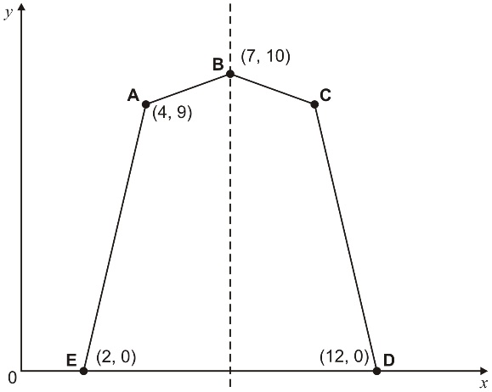
The shaded shape is an isosceles triangle.  Write in the missing co-ordinate.  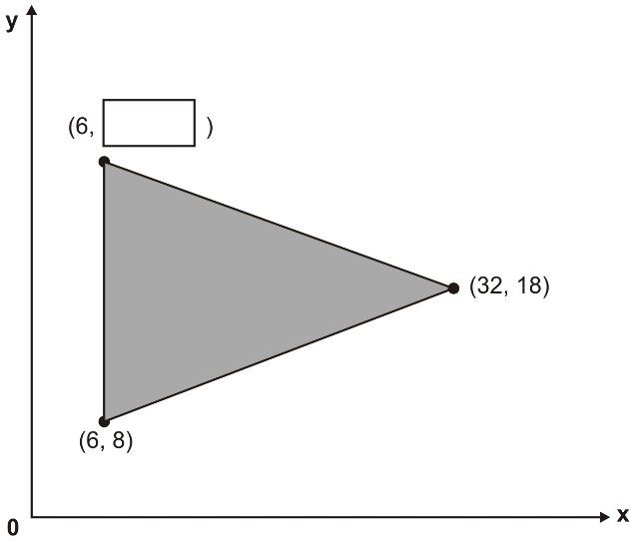 | The shaded shape is a parallelogram.  Write in the coordinates of point A.  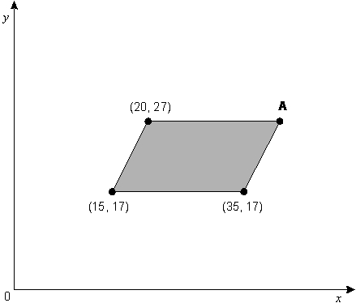

Calculate and plot the co-ordinates of tilted squares or rectangles on a simple co-ordinate grid
A, B, C and D are the vertices of a rectangle.  A and B are shown on the grid.  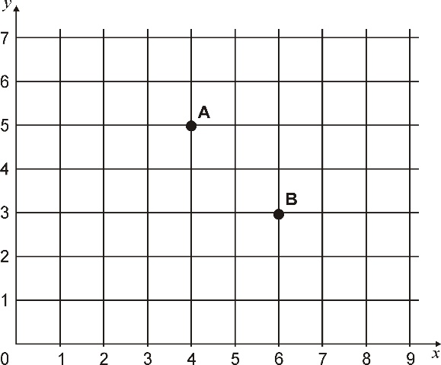  D is the point (3, 4).  Write the coordinates of point C. | A, B and C are three corners of a square.  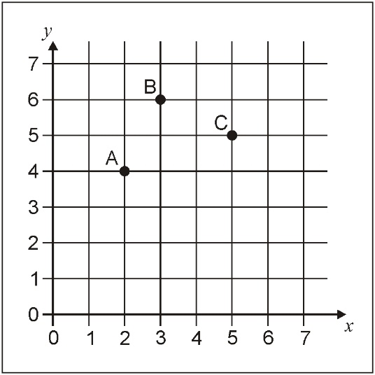  What are the co-ordinates of the other corner?
Here is one side of a square drawn on a coordinate grid.  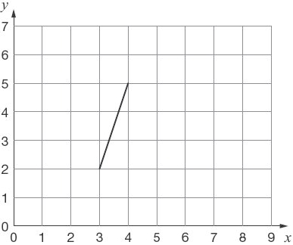  The square has a vertex at (6, 1). Draw the other three sides of the square on the grid. | A, B and C are three corners of a rectangle.  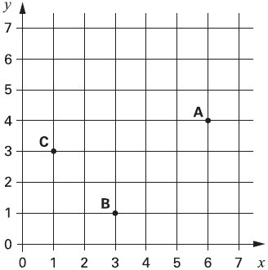  What are the coordinates of the fourth corner?

