
Identify information from atypical bar charts
This chart shows the times when 5 children were at a swimming pool one afternoon.  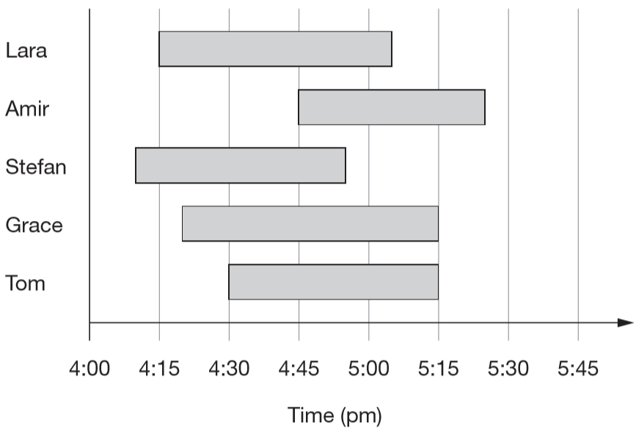  Who was the next person to arrive after Stefan?  Who spent the longest time at the swimming pool? | This chart shows when some children were asleep one night.  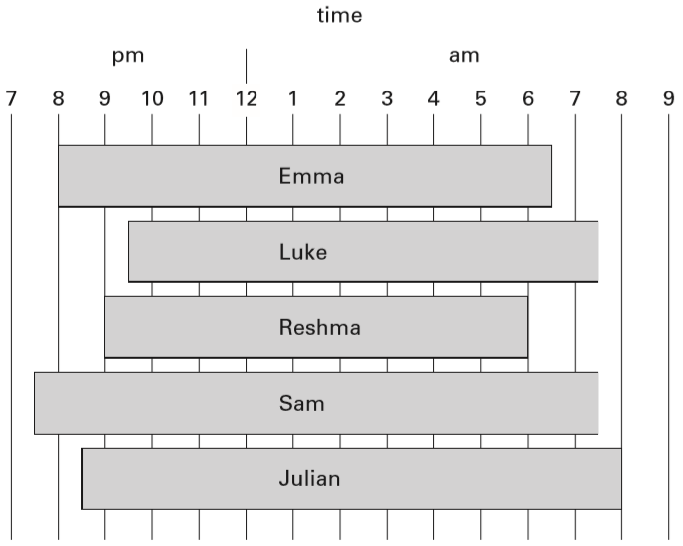  For how many hours was Luke asleep?  How many children woke up after 7am?
Some children each chose their favourite sport. This chart shows the results.  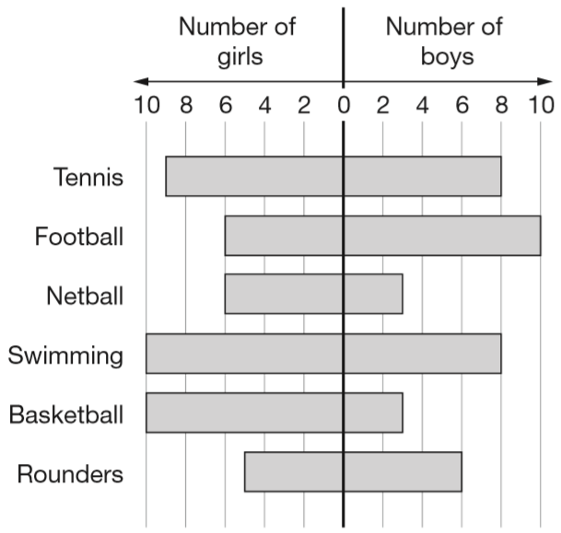  Which sport was chosen by the most children?  How many more girls than boys chose basketball?  Write all the sports that were chosen by more boys than girls. | 40 children each chose their favourite flavour of yogurt. This chart shows the results.  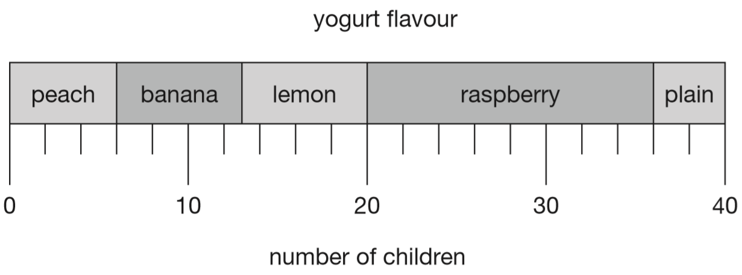  How many children chose lemon yogurt?  How many more children chose raspberry than plain yogurt?
2015 Paper 3 Question 4
A school plans to collect £200 between January and May. This chart shows how much they collected by the end of April.
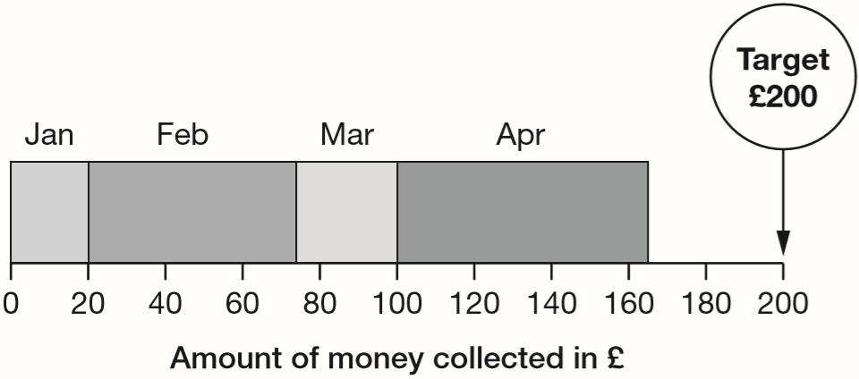
Write the name of each month where they collected more than £50

How much money did they collect in February and March altogether?



This chart shows the favourite snacks of some boys and girls.  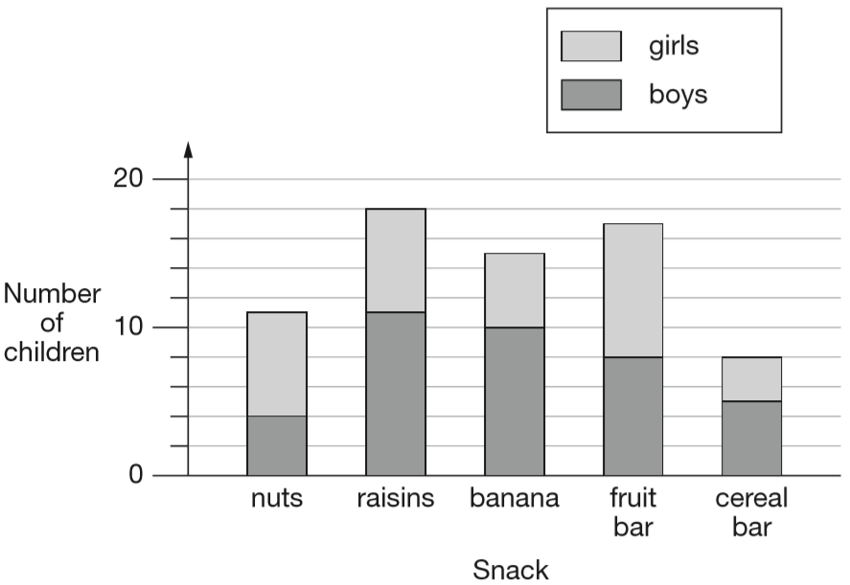  How many snacks were chosen by more girls than boys?  How many more boys than girls chose raisins?  Which snack was chosen by twice as many boys as girls? | 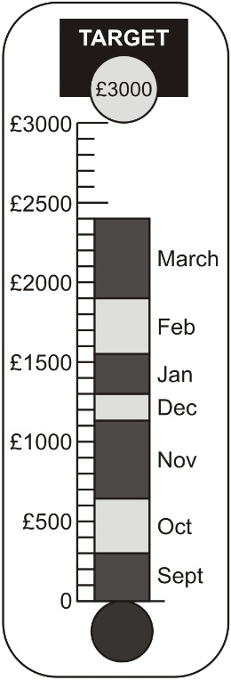  A school collects money for charity.  This chart shows how much has been collected.  The target is £3000  Estimate how much more money the school needs to reach the target.  Anil says, ‘The chart shows that we will reach the target in two months.’  Use the chart to explain why Anil may be wrong.
Identify information from bar charts
Five children grow pumpkins.  This bar chart shows how heavy their pumpkins are.  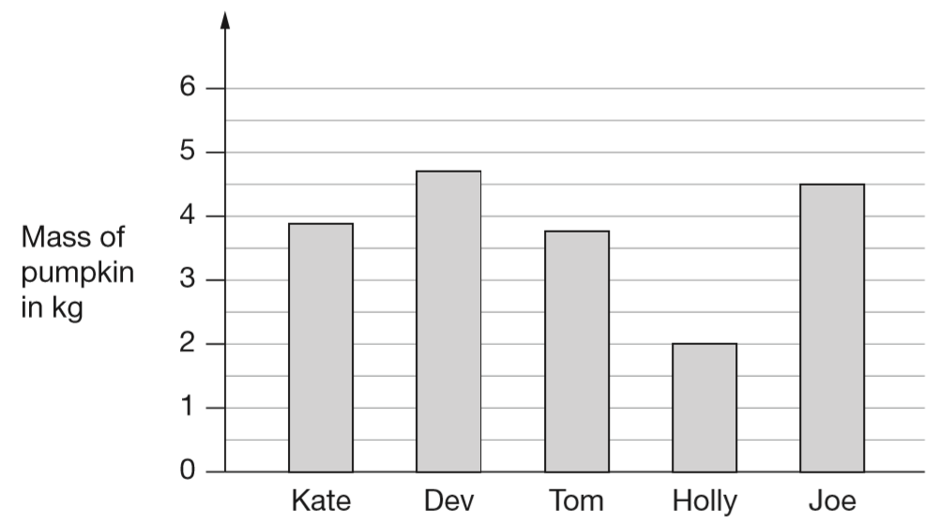  How much heavier is Joe’s pumpkin than Holly’s?  What is the mass of Dev’s pumpkin to the nearest kilogram? | Some children do a sponsored walk.  The graph shows their results.  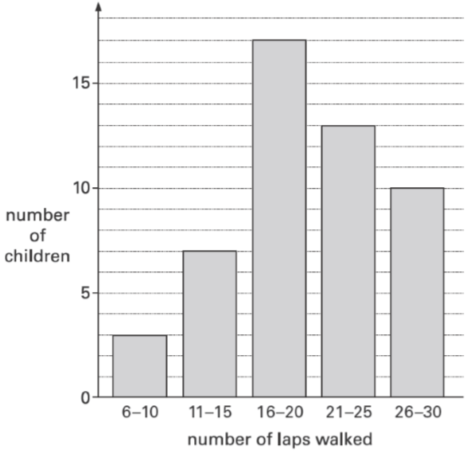  How many children walked 21 laps or more?

Some children take part in the long jump.  The graph shows the distances the children jumped.  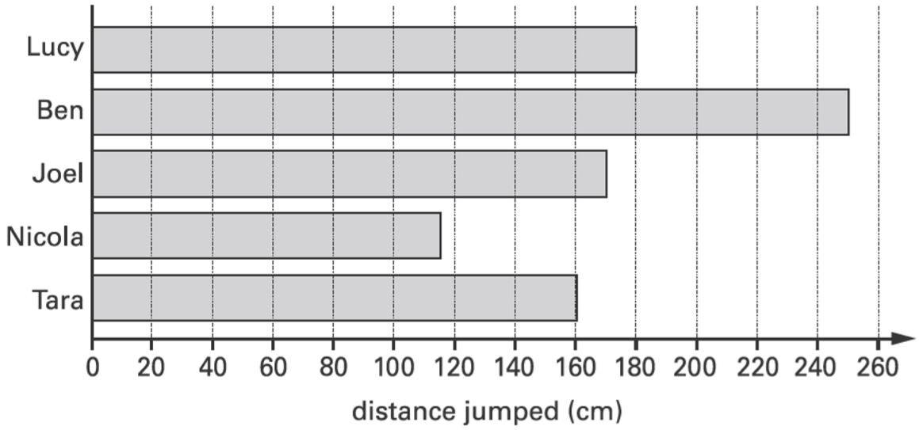  Estimate how much further Lucy jumped than Nicola. | The graph shows the heights of 28 children in Alfie’s class, to the nearest centimetre.  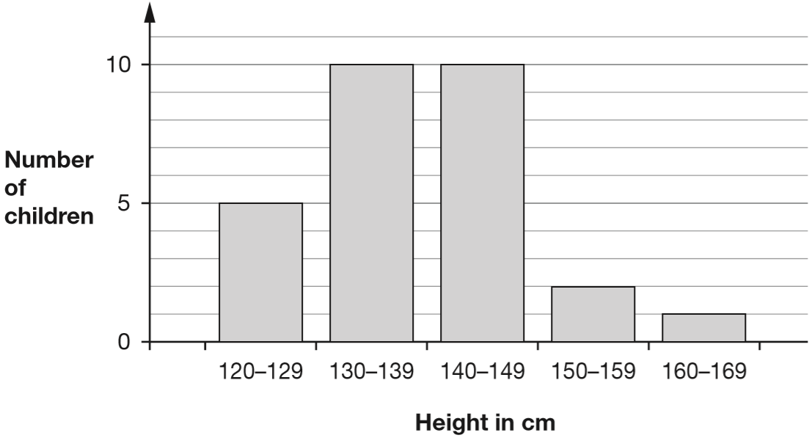  Alfie is 153 cm tall. He says, ‘Only one person in my class is taller than I am.’  Emma says, ‘You can’t tell this from the graph.’ Explain why Emma is correct.
This chart shows the number of books some children read last month.  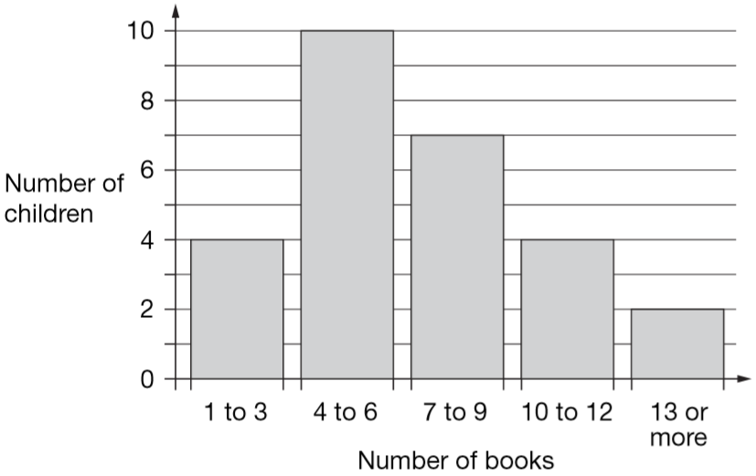  How many children altogether read more than 9 books?  7 children read 4 books. 1 child read 5 books.  Lin says, ‘That means 2 children read 6 books’.  Explain how she can work this out from the chart. | All the children at Park School chose their favourite soup.  The graph shows the results.  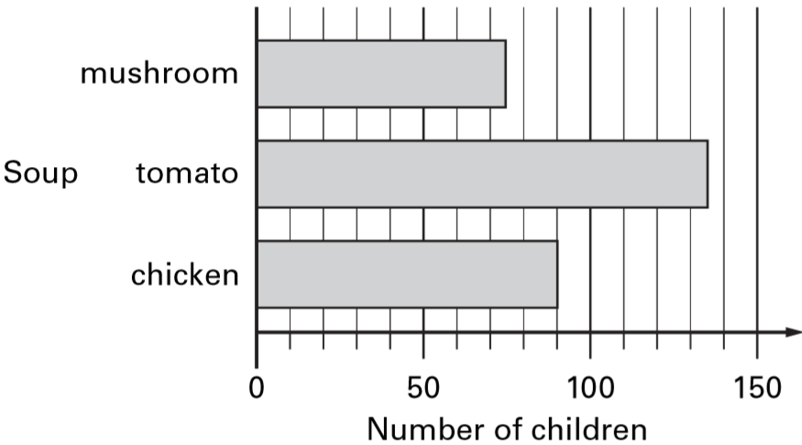  How many more children chose chicken soup than mushroom soup?  Robbie says, ‘More than half of the children chose tomato soup.’ Is he correct?  Explain how you can tell from the graph.
This bar chart shows how many people went to a school play.  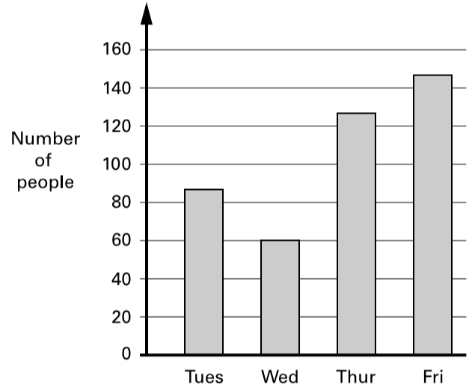  Estimate the number of people who went there on Thursday and Friday altogether.  Each person paid £2.25 for a ticket to get in. How much ticket money was collected on Wednesday? | This chart shows the amount of money spent in a toy shop in three months.  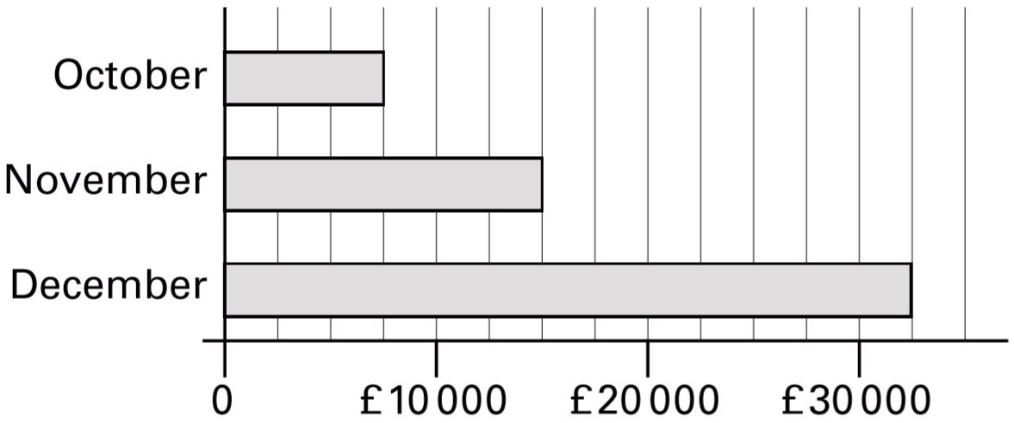  How much more money was spent in the shop in December than in November?
This table shows the number of things to eat in five children’s lunch boxes.
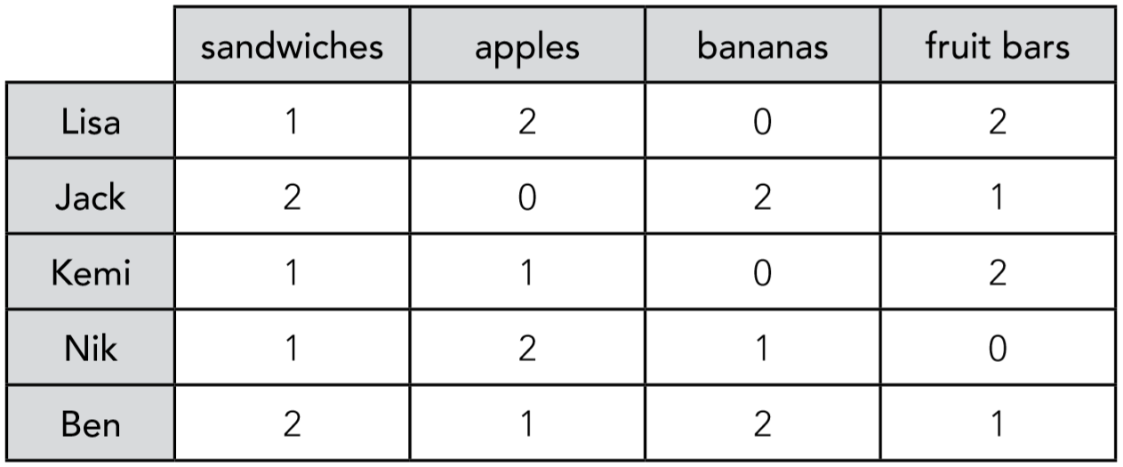
Here is a graph of the information for four of the children. Which child’s information is missing from the graph?
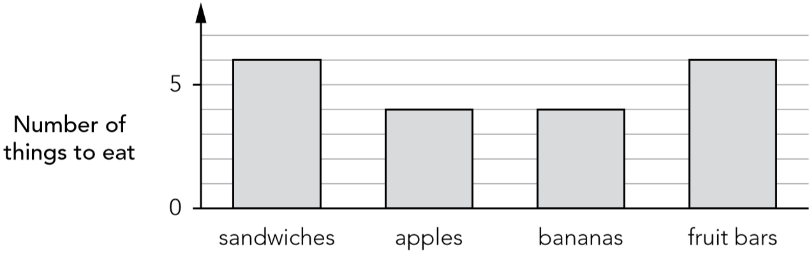

Identify values on a line graph to use in calculations
This graph shows the cost of phone calls in the daytime and in the evening.  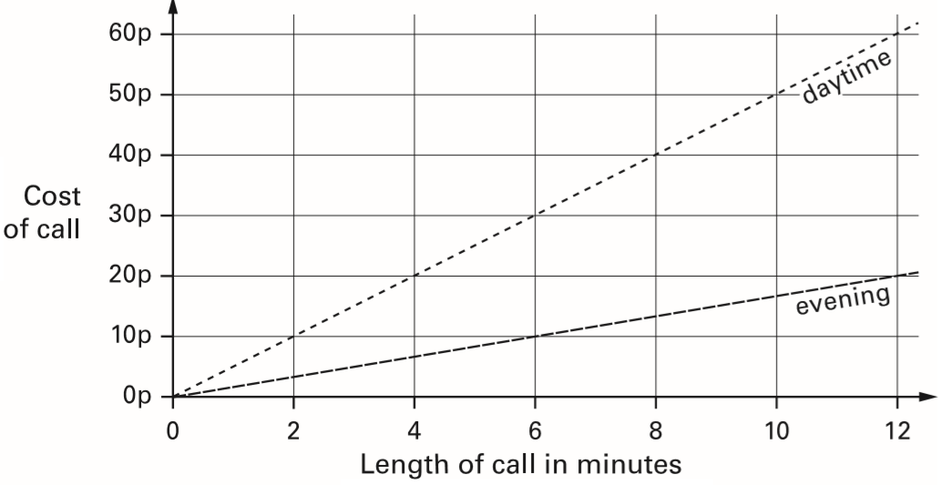  How much does it cost to make a 9 minute call in the daytime?  How much more does it cost to make a 6 minute call in the daytime than in the evening? | Abbie takes the temperature outside at midday on the first day of each month.  The graph shows her results from January to December.  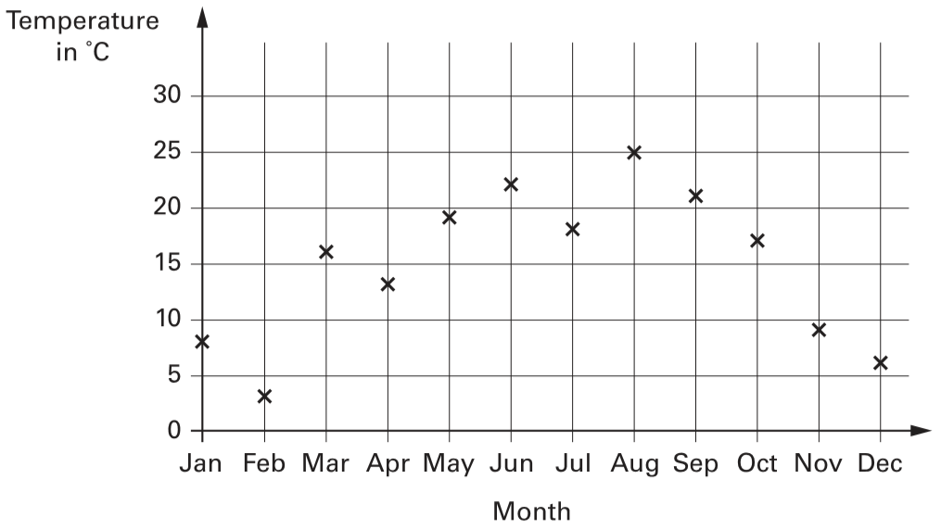  How many months on the graph show a temperature between 10°C and 20°C?  Find the difference in temperature shown on the graph between July and August.

Class 6 count how many seeds they find under two trees. They show the data in a graph.  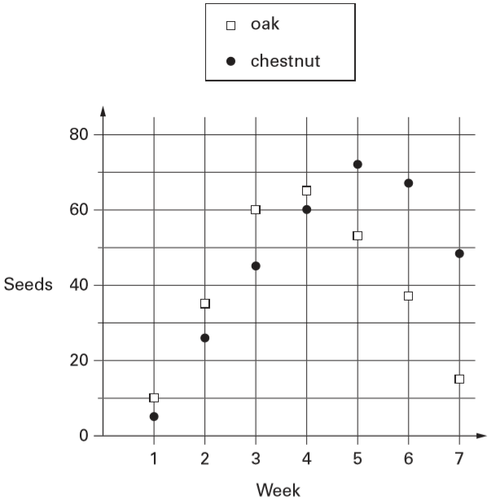  How many seeds did they find in week 3 altogether?  In how many weeks did they find more than 40 chestnut seeds? | This graph shows the distance Alfie and Chen walked in an afternoon. They started at 1:45pm and had two breaks.  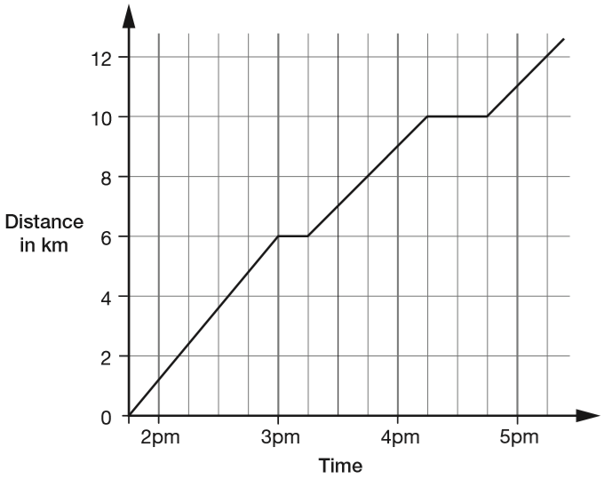  How many kilometres did they walk between the first and second breaks?  At what time did Alfie and Chen start their second break?
The graph shows the journey of a hot-air balloon.  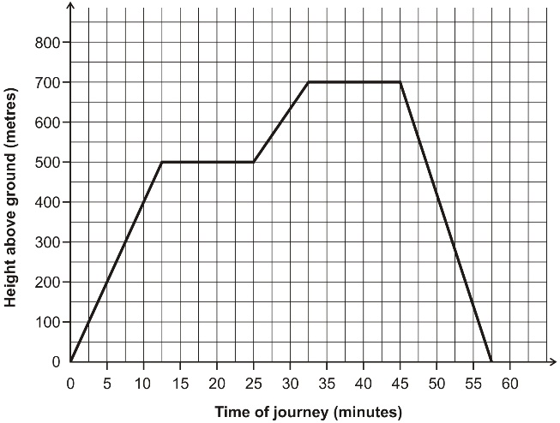  At what height above the ground was the balloon after 10 minutes?  After how many minutes of the journey did the balloon begin to go down? | 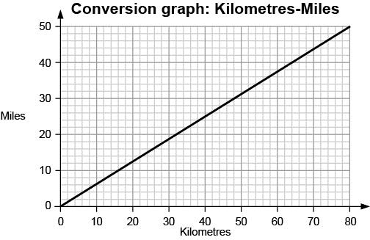Use the graph to work out how many miles are equal to 20 km.  Use the graph to work out how many kilometres are equal to 40 miles.

Estimate values on a line graph to use in calculations
This graph shows the temperature on a day in July.  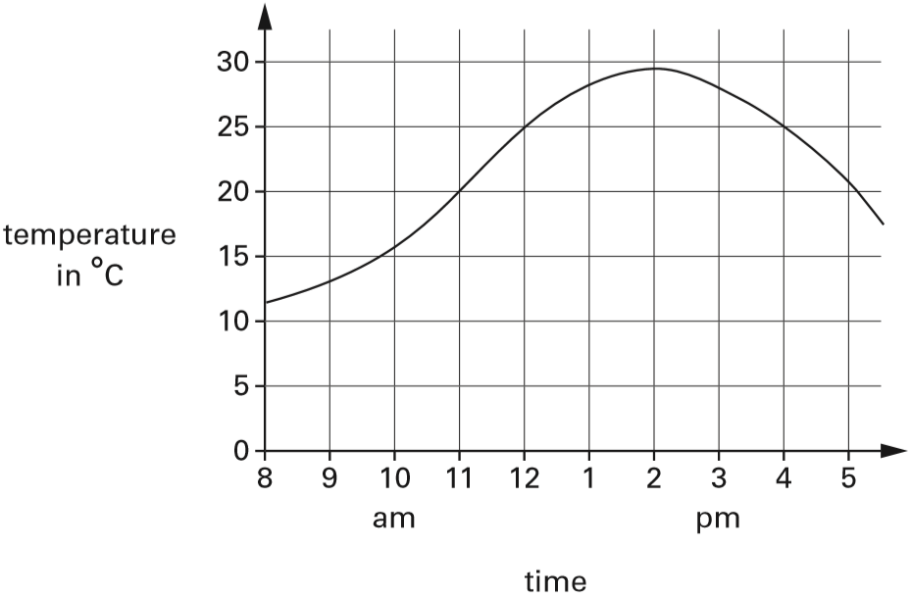  What is the temperature at 2pm?  For how many hours is the temperature above 25°C? | This graph shows the height of a balloon at different times.  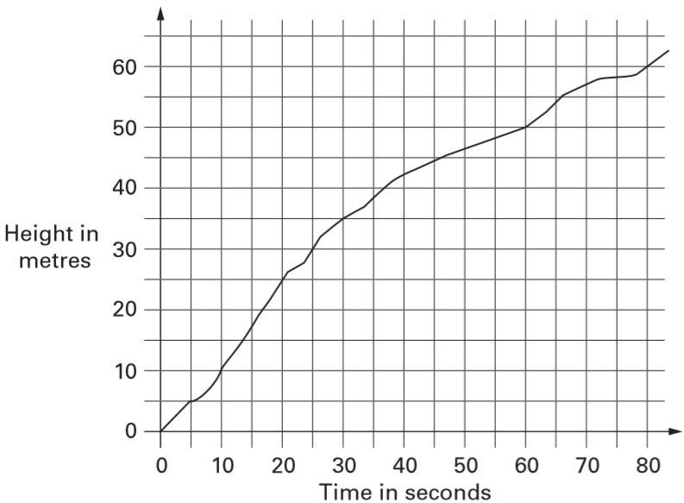  From the graph, find the height of the balloon at 50 seconds.  Use the graph to find how long it took the balloon to rise from 30 metres to 60 metres.
The London Eye is a big wheel with pods to carry passengers. It takes 30 minutes for the wheel to make a complete turn.  This graph shows the height of a pod above the ground as the wheel turns.  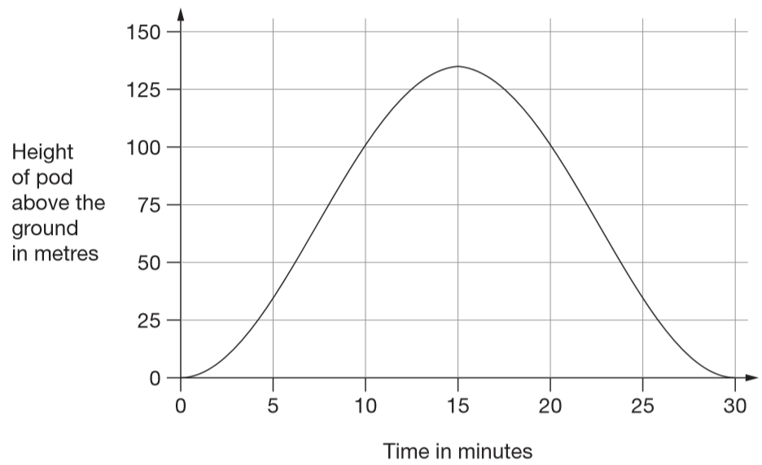  How long from the start does it take the pod to reach a height of 75 metres?  How many metres above the ground is the pod at its highest point? | This chart shows the population of Cornwall from 1950 to 2010.  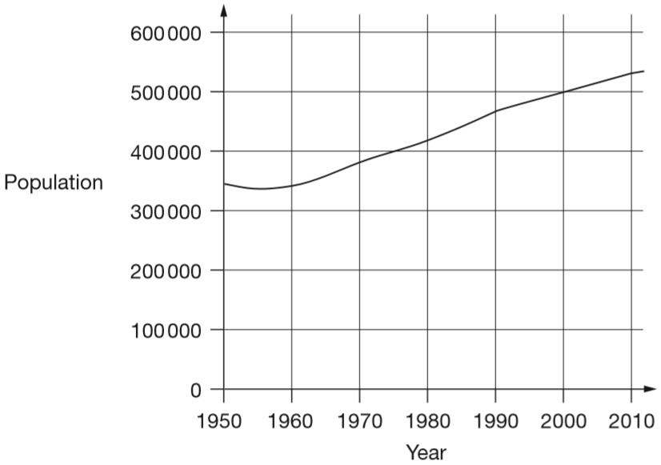  In which year did the population first reach 400 000?  How much did the population increase from 1950 to 2000?  What was the population of Cornwall in 2010?

Kirsty measured the length of her shadow every hour on one sunny day. She plotted her results on this graph.  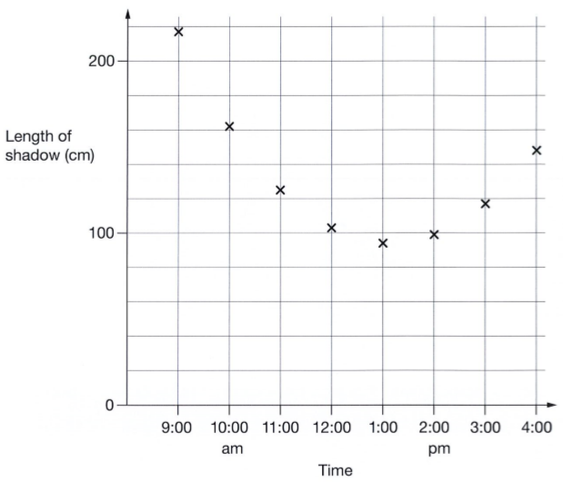  Look at the graph.  Estimate the length of Kirsty’s shadow at 3:30pm.  Estimate a time when her shadow was 180 centimetres long. | Mandy bounces a ball. She plots the results on this graph.  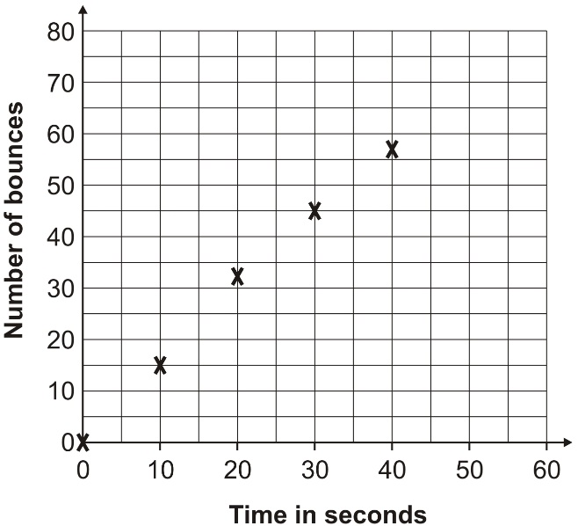  After 50 seconds Mandy has done 65 bounces. Plot this on the graph.  Use the graph to estimate the number of bounces Mandy has done after 35 seconds.

