
Recognise place value in numbers with up to seven digits
3,000,000 | 4,044,044
sixty thousand | 4,994,449
5,555,055 | 2,109,000  80,000
2019 Paper 2 Question 3  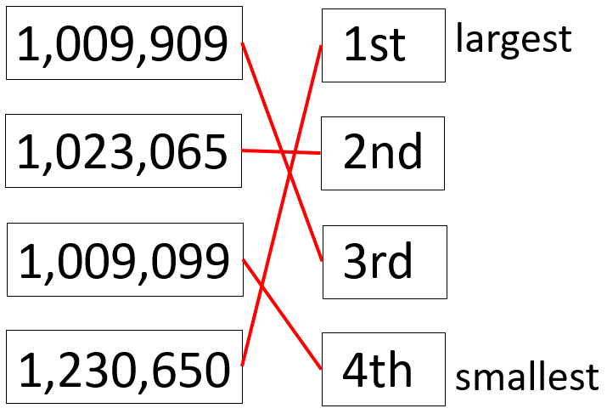 | B, D, E
2019 Paper 3 Question 2  7  4,000,000 | 3,350,000  3,449,999
5,500,000 | 3,000,000  80,000



2016 Paper 2 Question 16  9,999,995  5,900,000 | B
6,750,000 | 5,925,000
Solve problems involving addition and subtraction
6,642,000 7,042,000 | 7,999,000  7,990,000
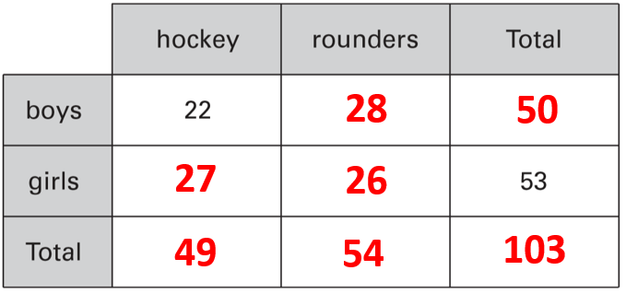 | 10
103

Solve problems involving multiplication or division
2016 Paper 3 Question 21  This shows that 17 x 326 = 5542  so you can work out 326 + 5542  because 1 x 326 = 326  and if you add 1 times a number to 17 times a number, you get 18 times that number. | 16
19 | 16  46p
2019 Paper 2 Question 16  4 | 7  8
 | 6.3
7 | 29
8 | 29
7  4 | 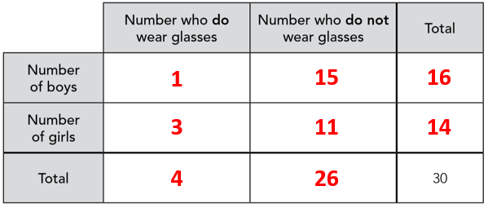
2019 Paper 3 Question 20  29 | 67
29,160 | 67
Identify negative numbers on number lines
2015 Paper 3 Question 2  -12, 2 | -100, 150
-10, 45 | X is 125  Y is -75
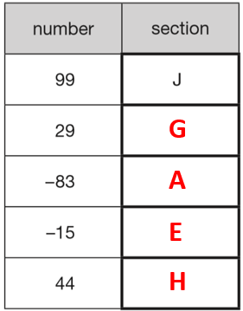 | A is -80  B is 60

Complete sequences involving negative numbers
-75, -200 | -60, -140
4, 9, 14 | -35, -80
67 | 2, -1, 1

Use knowledge of multiples to identify rules in sequences
Mary is correct.  The numbers in the sequence are always 1 more than a multiple of 3. | It will not be in the sequence.  All numbers in the sequence are multiples of 40.  2140 is not in the 40 times table.
It will not be in the sequence.  The numbers in this sequence are always 1 more than a multiple of 7.  777 ÷ 7 = 111 so 777 is a multiple of 7 | 12
 | 2051

