
Find a fraction of a shape
$\frac{4}{24}$ or $\frac{1}{6}$ | $\frac{2}{6}$ or $\frac{1}{3}$  $\frac{1}{9}$
if hexagons are split down the middle to make equal parts (triangles), 8 triangles should be shaded, e.g.  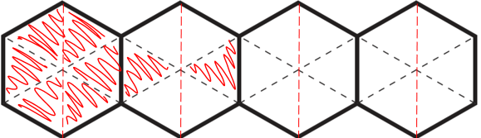 | $\frac{2}{6}$ or $\frac{1}{3}$  $\frac{1}{9}$


Complete fraction arithmetic problems
$\frac{2}{5}$is larger because it is equivalent to $\frac{6}{15}$  $\frac{1}{3}$ is only equivalent to $\frac{5}{15}$ | $\frac{4}{7}$is larger because it is equivalent to $\frac{36}{63}$  $\frac{5}{9}$ is only equivalent to $\frac{35}{63}$
2018 Paper 2 Question 14  $\frac{3}{5}$, $\frac{3}{4}$, $\frac{6}{5}$ | Yes  $\frac{1}{3}$ is only equivalent to $\frac{3}{9}$so $\frac{4}{9}$ is larger  No  $\frac{4}{9}$ is equivalent to $\frac{8}{18}$so they are the same size
8, 19, 30 | 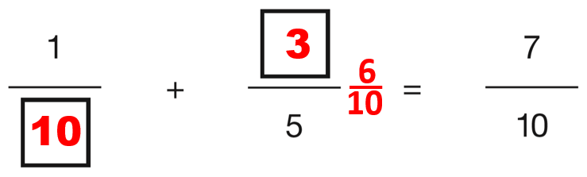  and  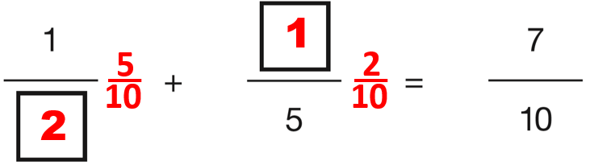  (any order)
3, 17
$\frac{11}{6}$ | $\frac{11}{5}$
25  36 | 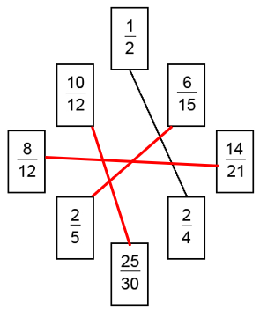
<
>
=
12  40  5 | $\frac{3}{5}$  $\frac{1}{3}$
3

$\frac{10}{13}$

1$\frac{5}{6}$ | 3$\frac{1}{8}$
1$\frac{5}{6}$ | $\frac{3}{10}$  $\frac{9}{20}$
Solve word problems involving fractions
$\frac{12}{20}$or $\frac{3}{5}$ | $\frac{3}{10}$
$\frac{3}{8}$ shaded  e.g.  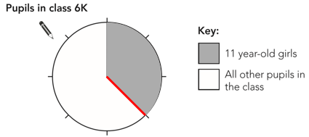 | $\frac{3}{16}$
2018 Paper 2 Question 23
1408 hours
1.6 or 1$\frac{3}{5}$

0.625 or $\frac{5}{8}$
 | $\frac{3}{8}$m

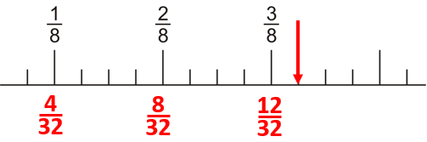 | many possible answers  e.g. $\frac{7}{8}$ and $\frac{1}{8}$
220 | $\frac{23}{35}$
117 cm² | $\frac{4}{15}$
between £80 and £100  £50 | 150 degrees
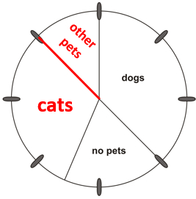

Solve problems involving decimals
36 litres | 3.5 + 3.5 + 3.5
2017 Paper 2 Question 20  many possible explanations  e.g. 0.25 is twenty-five hundredths.  Two fifths is equivalent to forty hundredths.  or  Two fifths is equivalent to four tenths, which is 0.4  0.25 is smaller than 0.4 because it has fewer tenths. | 2.5, 4, 5.5
 | 20
2016 Paper 2 Question 18
20
2015 Paper 3 Question 14  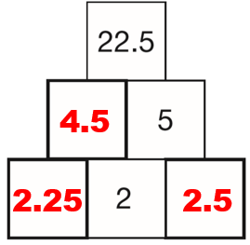 | 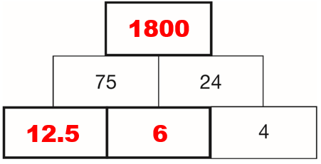
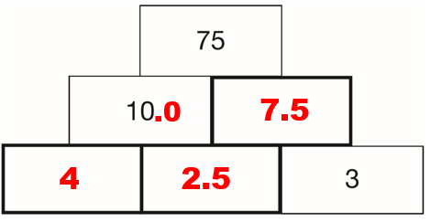 | 0.75, 1.5, 96
 | 20, 33.125
2015 Paper 2 Question 12
1.75

4.9  -0.5 | 3.5 km
2018 Paper 2 Question 20
30 cm
2015 Paper 3 Question 9  29.25 g | Alfie is wrong.  many possible explanations  e.g.  If one of the numbers is 1, the answer will be the same as (not greater than) the other number. e.g. 3 x 1 = 3  If one of the numbers is 0, the answer will always be 0 no matter how large the other number is. e.g. 5 x 0 = 0  If one of the numbers is less than 1, the answer will always be smaller than the other number. e.g. ½ x 4 = 2 or 5 x 0.1 = 0.5
2018 Paper 3 Question 19  3363  336,300  35.4 | 16  800
2.5 | 0.5, 0.65
54.75 | 37.75
0.625 | 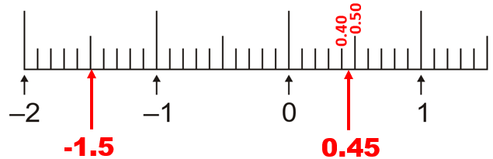
many possible answers
e.g. 0.001 + 0.002 + 0.007
many possible answers  e.g. $\frac{701}{1000}$ | 2.25 and 2.75
Complete sequences involving decimals
15 | 2015 Paper 3 Question 16  96
2016 Paper 3 Question 13  15 | 7.5

Solve problems involving percentages
2018 Paper 3 Question 8  £140 | 30
36%  46% | 10% of 55 is 5.5  You can’t have 5.5 people.
36%  46% | 112,500
150 g | £1.25
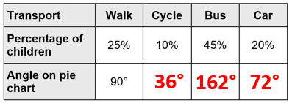 | Reasoning  Spelling  Arithmetic and Reading

Calculate a whole quantity given a percentage
Divide by 40 to get 1%, then multiply by 100 to get 100%  or  Divide by 4 to get 10%, then multiply by 10 to get 100% | 18  200
160 | 400
32 | 160

60% | 5%  95%
20 | 137.5 g
£22.50 | £7.00

