
Find a fraction of a shape
The diagram shows three regular octagons joined together.  There is a dot at the centre of each octagon.  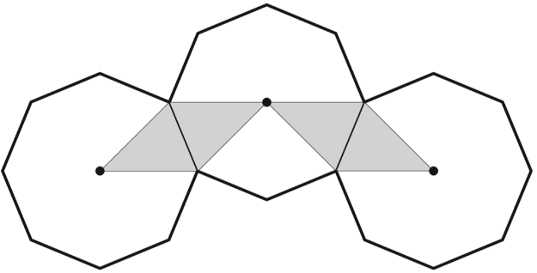  What fraction of the diagram is shaded? | $\frac{1}{3}$of this square is shaded.  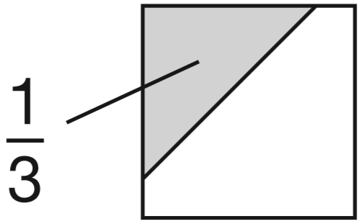  The same square is used in the diagrams below.  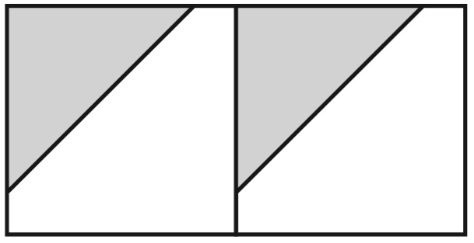  What fraction of this diagram is shaded?  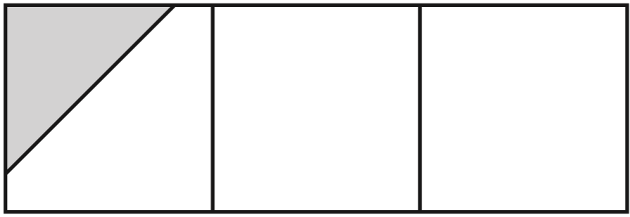  What fraction of this diagram is shaded?
This diagram shows four regular hexagons.
Shade in one third of the diagram.
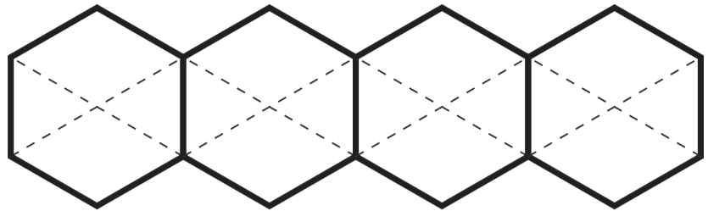


Complete fraction arithmetic problems
Which is larger, $\frac{1}{3}$ or $\frac{2}{5}$ ?  Explain how you know. | Anna says $\frac{4}{7}$ is greater than $\frac{5}{9}$  Explain why Anna is correct.
2018 Paper 2 Question 14  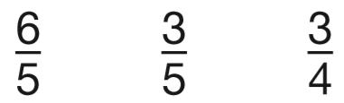  Write these fractions in order, starting with the smallest.  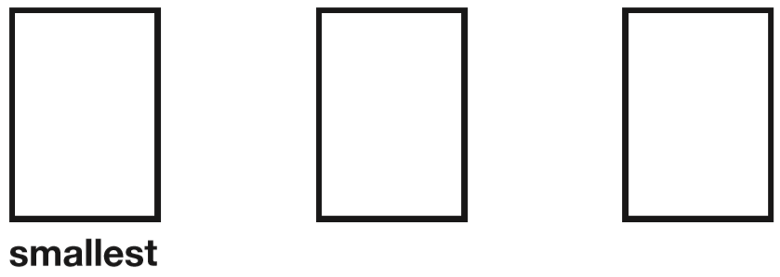 | Is $\frac{4}{9}$ greater than $\frac{1}{3}$? Show how you know.  Is $\frac{4}{9}$ half of $\frac{8}{18}$ ? Show how you know.
The numbers in this sequence increase by equal amounts each time.  Write in the missing numbers.  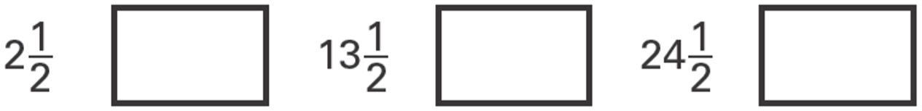 | Write numbers in the boxes to make this fraction calculation correct.  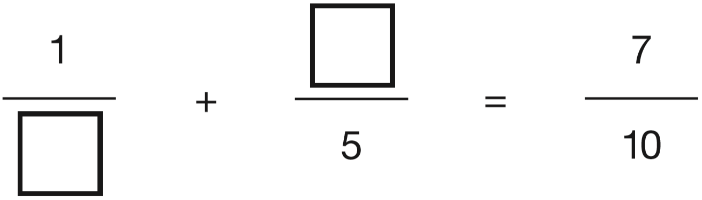  Now write two different numbers to make the calculation correct.
The diagram shows part of a number line.
Two of the fractions are not complete.
Write the missing numerator in each box.
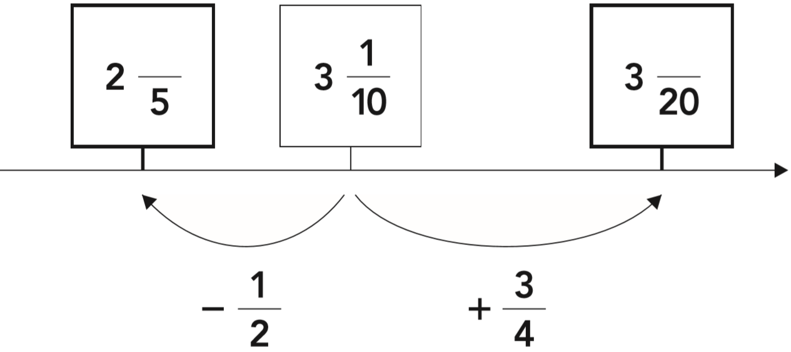
Circle the fraction that is bigger than $\frac{7}{5}$  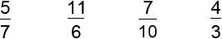 | Circle the biggest fraction.  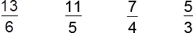
Write the two missing values to make these equivalent fractions correct.  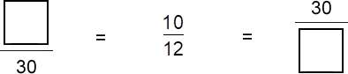 | Join pairs of equivalent fractions.  One is done for you.  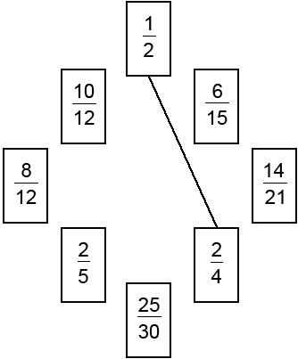
Write the correct sign < = or > in each box to make these sentences correct.
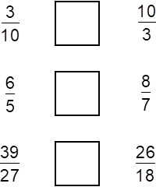
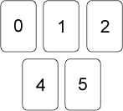  Here are five digit cards.  Use each card once to make these calculations correct.  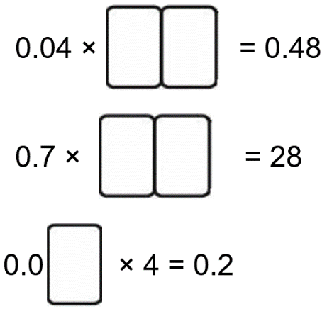 | Write the missing fractions.  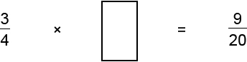  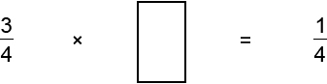
Complete the number sentences.
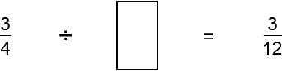

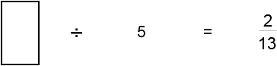

Grace, Ellie and Alfie bought 5 pizzas to share.  Grace ate 1$\frac{1}{2}$pizzas.  Ellie ate 1$\frac{2}{3}$pizzas.  And Alfie ate the rest.  How many pizzas did Alfie eat? | What number is exactly halfway between 2$\frac{3}{4}$ and 3$\frac{1}{2}$?
Write the missing fractions.
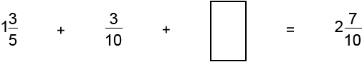

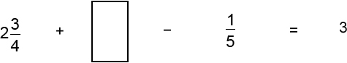

Solve word problems involving fractions
Alfie did a survey to find which soup was most popular.  The choices were:  • tomato  • chicken  • mushroom  A quarter of the children chose chicken soup.  Four times as many children chose tomato soup as mushroom soup.  What fraction of the children chose tomato soup? | 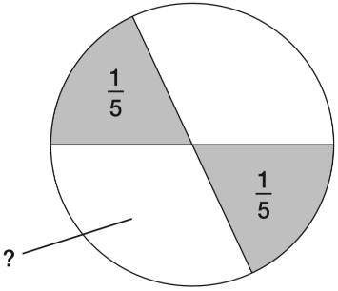  In this circle, each shaded part is $\frac{1}{5}$of the area of the circle.  The two white parts have equal areas.  What fraction of the circle is one of the white areas?
Look at the information in these two pie charts.  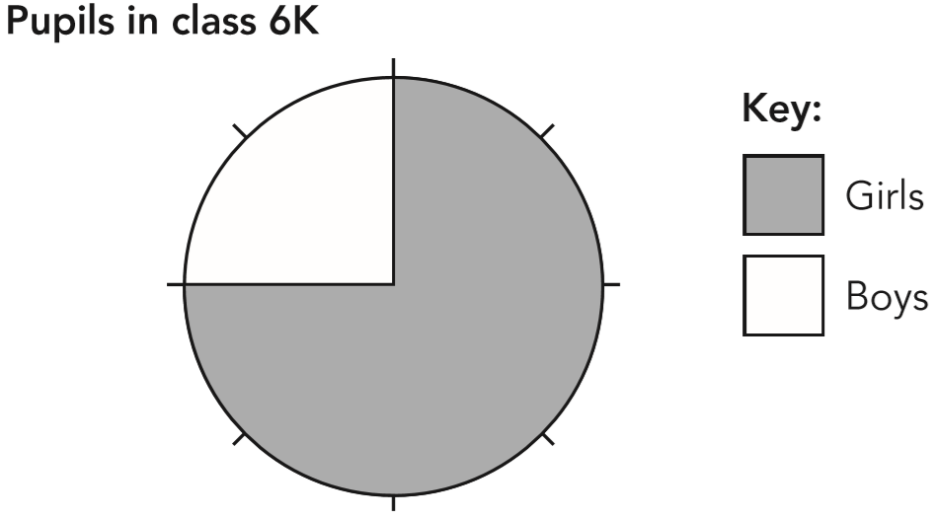  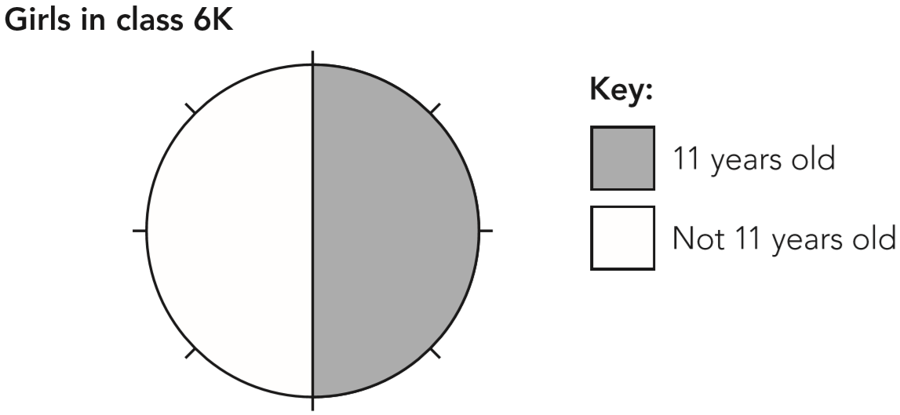  Use the information in the two pie charts to complete the pie chart below.  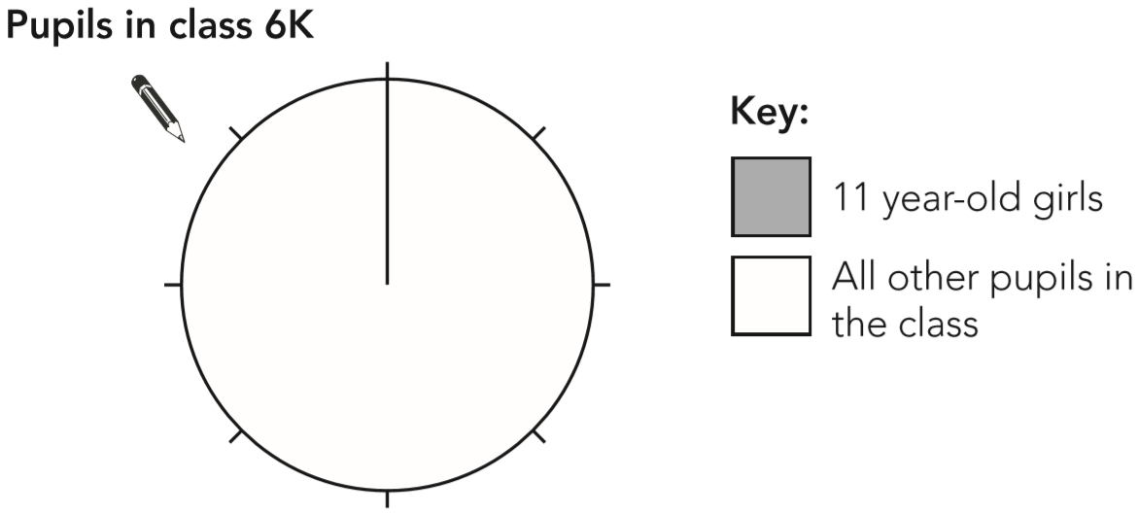 | Annie ate ¼ of a cake.  Four other children shared the remainder equally.  What fraction of the cake did each of the other children get?
2018 Paper 2 Question 23
The length of a day on Earth is 24 hours.
The length of a day on Mercury is 58$\frac{2}{3}$ times the length of a day on Earth.
What is the length of a day on Mercury, in hours?

5 miles is approximately equal to 8 km.
Complete the sentences below:

1 mile is approximately equal to _____km

1 km is approximately equal to _____miles

Ellie had a piece of ribbon that was ¾m long.
She cut it and gave half to Grace.
What fraction of a metre did she give to Grace?

Here is a number line.  Draw an arrow to show the position of $\frac{13}{32}$  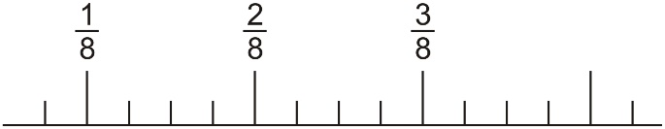 | Write two fractions, each greater than 0 and less than 1, which have a difference of ¾
Lili and Julian each start with the same number.  Lili works out half of the number.  Julian works out three-quarters of the number.  The sum of their answers is 275  What was the number they started with? | What fraction is exactly half-way between $\frac{3}{5}$ and $\frac{5}{7}$ ?
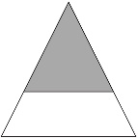  The diagram shows a shaded triangle inside a larger triangle.  The area of the shaded triangle is 52 cm².  The area of the shaded triangle is $\frac{4}{9}$ of the area of the larger triangle.  Calculate the area of the larger triangle. | This square is divided into three parts.  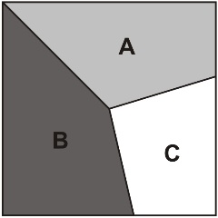  Part A is $\frac{1}{3}$of the area of the square.  Part B is $\frac{2}{5}$of the area of the square.  What fraction of the area of the square is part C?
Some children work out how much money two shopkeepers get from selling fruit. They use pie charts to show this.  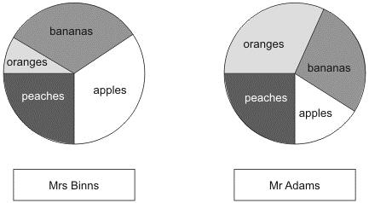  Mrs Binns gets £350 selling bananas. Estimate how much she gets selling oranges.  Mrs Binns gets a total of £1000 and  Mr Adams gets a total of £800  Estimate how much more Mrs Binns gets than Mr Adams for selling peaches. | Sarah makes a pie chart to show the proportion of boys and girls in her class.  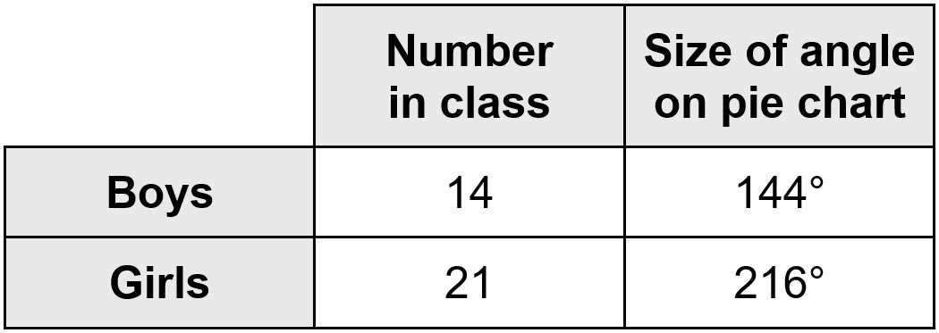  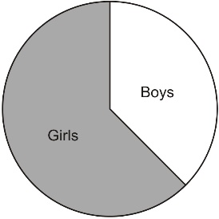  The next day another boy joins Sarah's class.  She makes a new pie chart.  Calculate the angle for boys on the new pie chart.
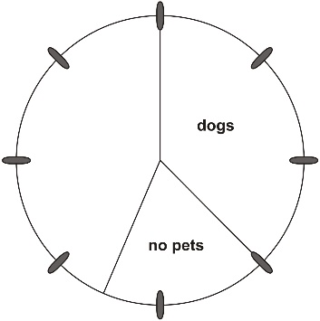
80 people were asked if they owned a pet.
30 had dogs
25 had cats
10 had other pets
15 had no pets
Complete the pie chart to show this information.

Solve problems involving decimals
1 gallon is approximately 4.5 litres.  Mrs Smith buys 8 gallons of petrol.  How many litres of petrol does she buy? | Write the same number in each box to make this correct.  
2017 Paper 2 Question 20  Adam says, 0.25 is smaller than $\frac{2}{5}$  Explain why he is correct. | The numbers in this sequence increase by equal amounts each time.  Write in the three missing numbers.  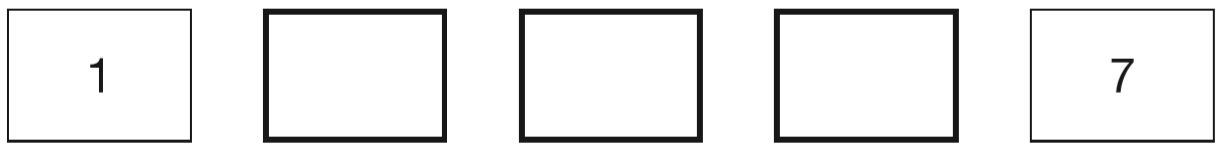
Write in the missing number.
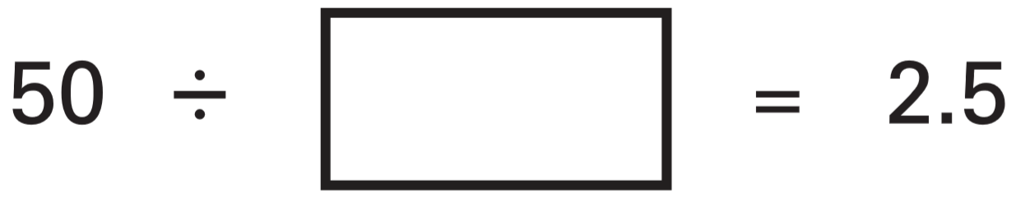

2016 Paper 2 Question 18
Write the missing number.
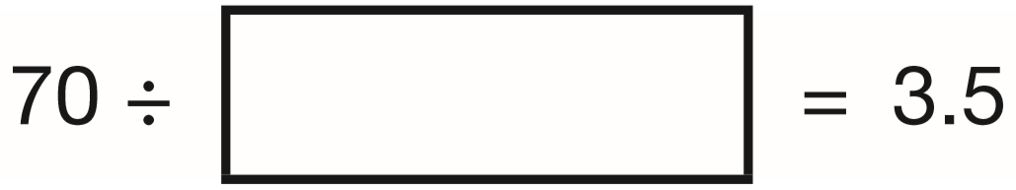

2015 Paper 3 Question 14  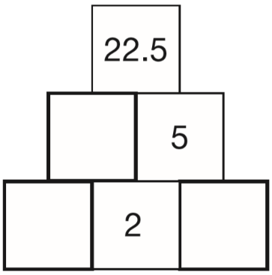  Here is a number pyramid.  The number in a box is the product of the two numbers below it. Write the missing numbers. | 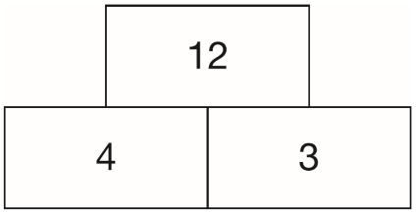  In this tower, two numbers are multiplied to give the number above.  Write the missing numbers in the tower below to make it correct.  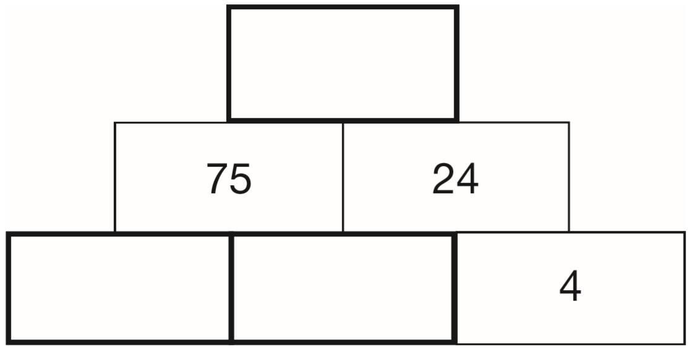
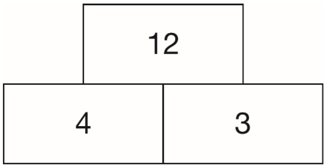  In this tower, two numbers are multiplied to give the number above.  Write the missing numbers in the tower below to make it correct.  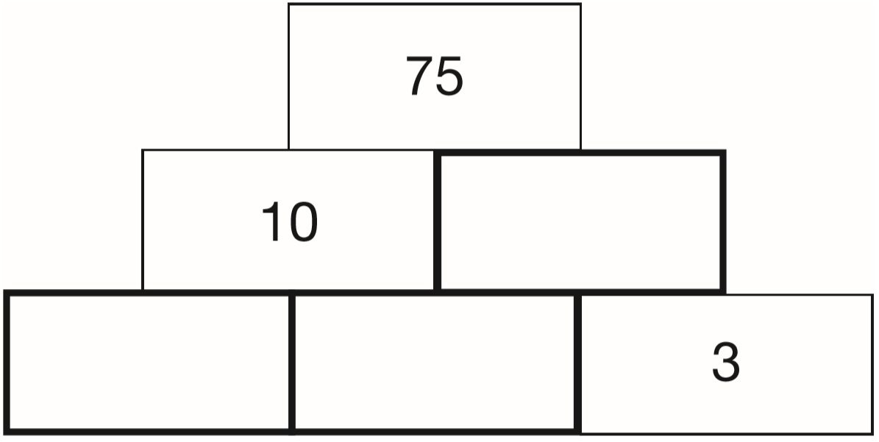 | In this sequence each number is double the previous number.  Write in the missing numbers.  
The rule to get each number in a sequence is
subtract the previous number from 100,
then divide the answer by 2
Here is part of the sequence. Write the two missing numbers.


2015 Paper 2 Question 12
What number is halfway between 1.4 and 2.1?

The number 7.5 is halfway between 5 and 10  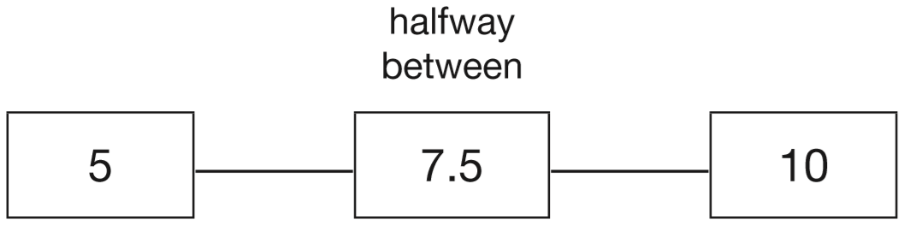  Write in the missing numbers.  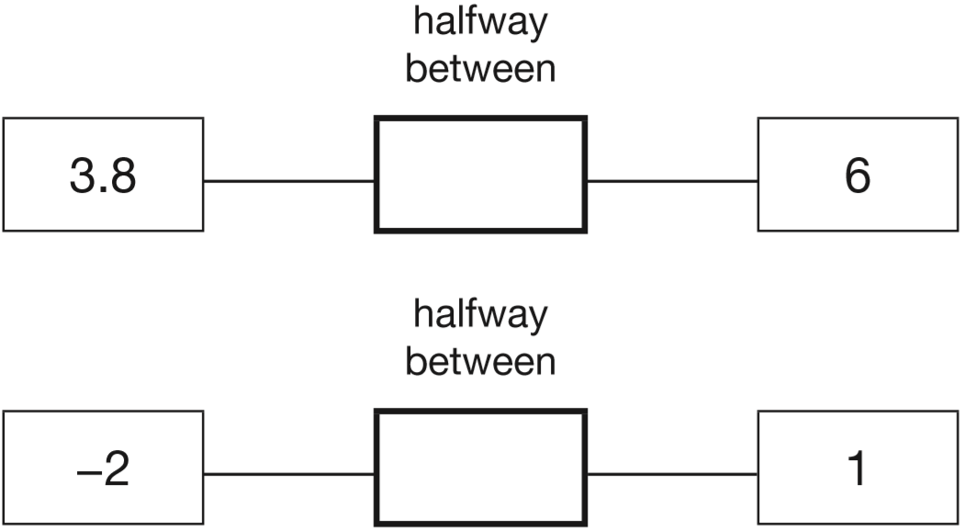 | Annie swims on average 0.87 km in 30 minutes.  If she continues at the same speed, how far will she swim in 2 hours, rounded to one decimal place?  Circle your answer.  3.2 km 3.3 km 3.4 km 3.5 km 3.6 km
2018 Paper 2 Question 20
The length of an alligator can be estimated by:
• measuring the distance from its eyes to its nose
• then multiplying that distance by 12
What is the difference in the estimated lengths of these two alligators?
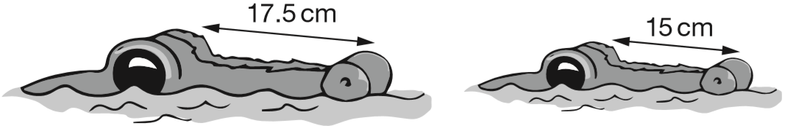
2015 Paper 3 Question 9  The mass of a 10p coin is 6.5g. The mass of a 5p coin is half the mass of a 10p coin.  What is the mass of these six coins altogether?  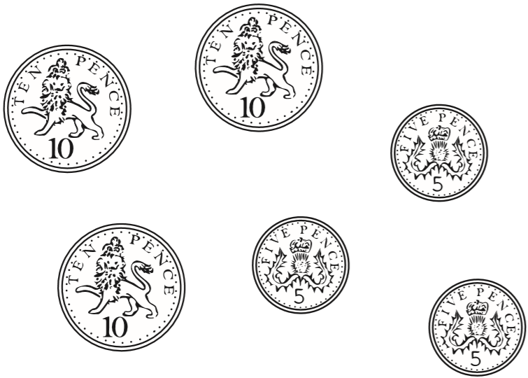 | Alfie says, ‘When you multiply two numbers together, the answer is always greater than either of the numbers you started with.’  Is Alfie correct? Explain how you know.
2018 Paper 3 Question 19  33,630 = 354 × 95  Use this multiplication to complete the calculations below.  354 × 9.5 =  3,540 × 95 =  3,363 ÷ 95 = | Write the missing numbers.  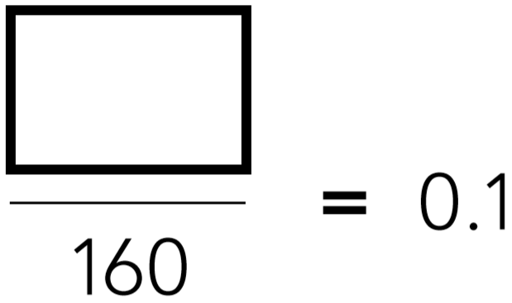  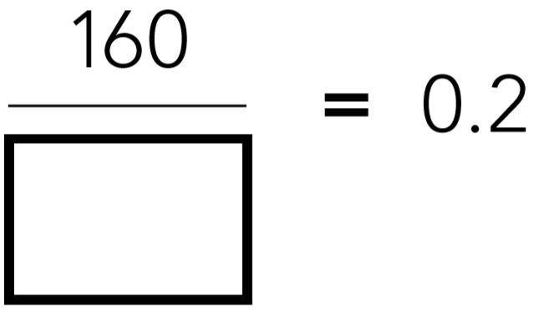
Write the missing number.  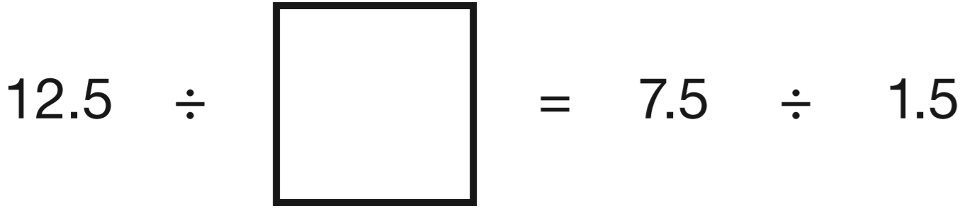 | Here is part of a number line.  Write the numbers shown by the arrows.  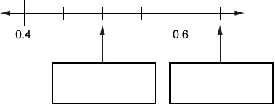
Write in the missing numbers.  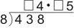 | Write the missing digits to make the calculation correct.  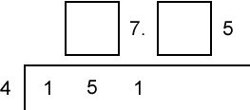
What is $\frac{5}{8}$as a decimal? | Mark with arrows the points –1.5 and 0.45 on the number line.  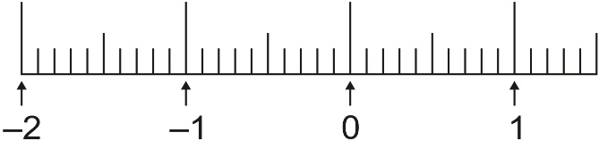
Write three decimals, each greater than zero, which add together to make a total of 0.01
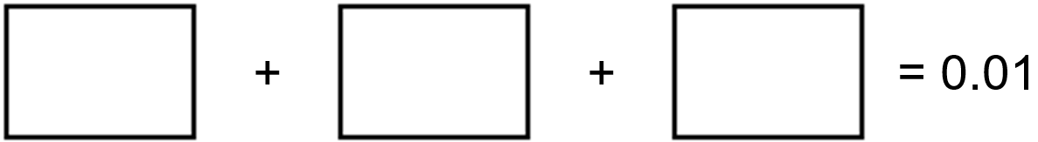
Write a fraction which is greater than 0.7 and less than 0.71 | The sum of two numbers is 5  The difference between the numbers is 0.5  What are the numbers?
Complete sequences involving decimals
Amy thought of a number.  She added 0.5 to her number and then doubled the result.  Then she subtracted 0.5 and doubled the new result.  Her final answer was 61  What number did Amy start with? | 2015 Paper 3 Question 16  Lara chooses a number less than 100  She divides it by 3 and then subtracts 11  She then divides this result by 2  Her answer is 10.5  What was the number she started with?
2016 Paper 3 Question 13  Lara chooses a number less than 20  She divides it by 2 and then adds 6  She then divides this result by 3  Her answer is 4.5  What was the number she started with? | I’m thinking of a number.  I multiply it by 10 and add 25.  My answer is 100.  What is the number?

Solve problems involving percentages
2018 Paper 3 Question 8  Jack has £400  He spends 35% of his money on a new bike.  How much does Jack spend on his new bike? | 200 children went on holiday.  10% of the children went to Wales.  25% of the children went to Scotland.  How many more children went to Scotland than went to Wales?
In a survey people were asked if they like tea and coffee.  The results are in this Venn diagram.  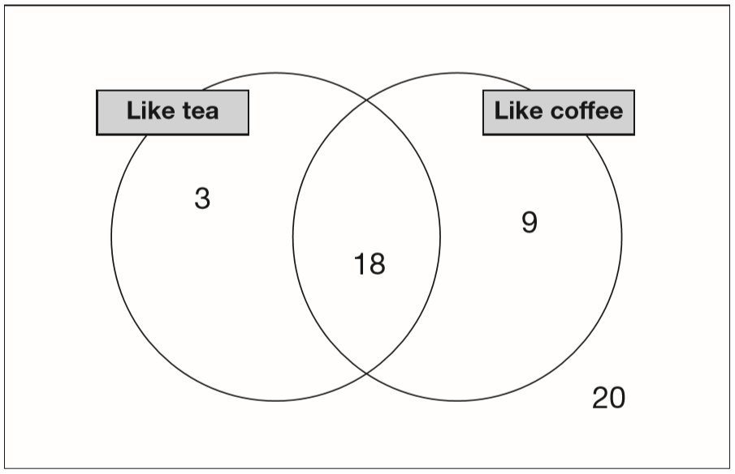  What percentage of people in the survey like both tea and coffee?  What percentage of people in the survey do not like coffee? | Liam did a survey of 55 people to see how many were left-handed.  Liam says, ‘The results show that exactly 10% of the people in the survey are left-handed.’  Explain why Liam cannot be correct.
John had £5
He gave 25% of it to charity.
How much did he give?

250 000 people visited a theme park in one year.  15% of the people visited in April and 40% of the people visited in August. How many people visited the park in the rest of the year? | Emily makes 250 grams of a snack mixture. 15% of the weight is raisins, 25% is banana chips and the rest is peanuts.  How many grams of peanuts does she use?
In a survey of how children travel to school, these were the results.  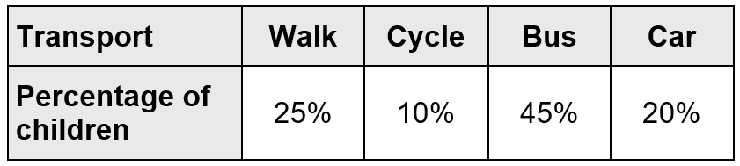  Abby wants to make a pie chart to show the results.  Complete the table to show the angles of each section of the pie chart.  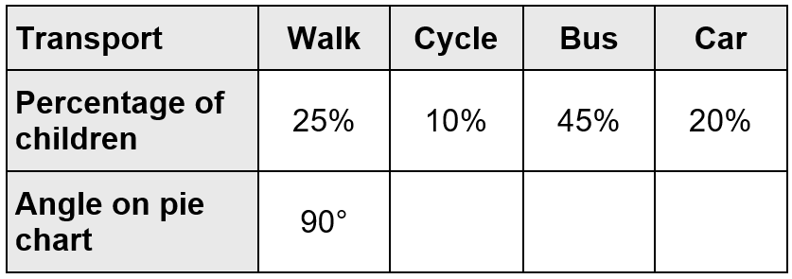 | The table shows Tom’s test results for different subjects.  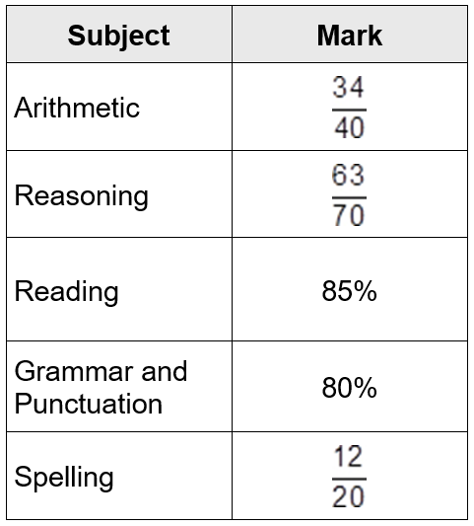  In what subject did Tom get the highest mark?  In what subject did Tom get the lowest mark?  In which two subjects did he get the same marks?

Calculate a whole quantity given a percentage
If you know 40% of a number, explain how you could work out the original number. | Write in the missing numbers.  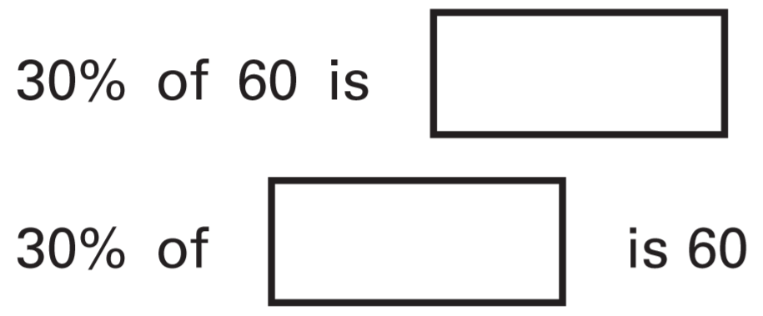
20% of Megan’s number is 64  What is 50% of Megan’s number? | In a survey of children’s favourite fruit juices, these were the results.  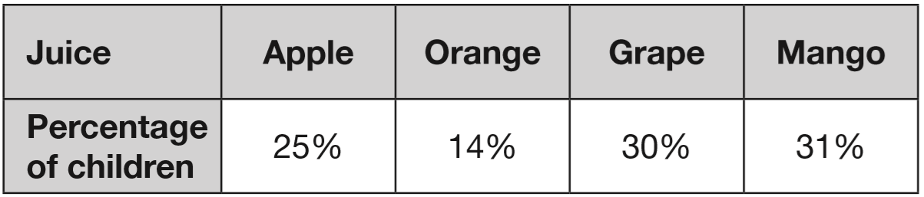  20 more children chose grape than chose apple.  How many children took part in the survey?
The pie chart shows the Year groups of children at Woodland Infant School.  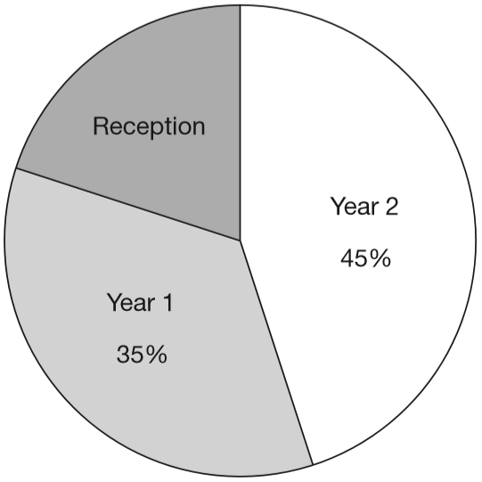  There are 56 children in Year 1  How many children are there in Reception? | 20% of the children in a sports club play tennis.  25% of the children who play tennis also play rounders.  There are 8 children in the club who play both tennis and rounders.  How many children are there in the sports club altogether?

In Class 6, 80% of the children like crisps.  75% of the children who like crisps also like chocolate.  In Class 6, what percentage of the children like both crisps and chocolate? | What is 10% of a half?  What percentage of 20 is 19?
This pie chart shows the lunch choices of year 6 children at a school.  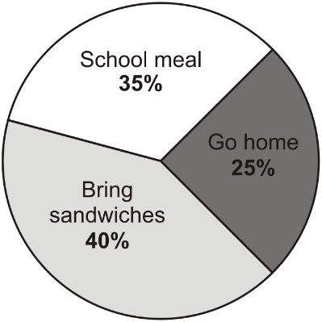  28 children in year 6 have a school meal.  How many go home for lunch? | Two of the ingredients of chocolate are cocoa and sugar.  In milk chocolate,  20% of the mass is cocoa, 55% is sugar.  A bar of milk chocolate contains 50 grams of cocoa.  How many grams of sugar does it contain?
Linda buys a pair of trainers.  She says, ‘I bought this pair of trainers when there was 20% off the normal price. I paid £18 for them.’  What was the normal price of the trainers? | Chloe and Denise each bought identical T-shirts from the same shop.  Chloe bought hers on Monday when there was 15% off the original price.  Denise bought hers on Friday when there was 20% off the original price.  Chloe paid 35p more then Denise.  What was the original price of the T-shirt?

