
Solve problems involving money
bag of 6 green apples for 75p  bag of 10 red apples for 90p  Jason bought some bags of green apples and some bags of red apples. He spent £4.20  How many bags of each type of apple did he buy?  Nika and Hassan bought some bags of apples.  Nika says, ‘I bought more apples than Hassan, but I spent less money.’  Explain how this is possible. | 2016 Paper 3 Question 20  Lara had some money.  She spent £1.25 on a drink.  She spent £1.60 on a sandwich.  She has three-quarters of her money left.  How much money did Lara have to start with?
Cost to hire a boat: £4.50 per boat and then £3.50 per hour
Four friends hire a boat for five hours.
They share the cost equally.
How much does each person pay?

Chen’s family hires a boat and pays a total of £15
How many hours did they have the boat for?

Cheddar cheese costs £7.50 for 1kg.
Marie buys 200 grams of cheddar cheese.
How much does she pay?

Cream cheese costs £3.60 for 1kg.
Robbie buys a pot of cream cheese for 90p.
How many grams of cream cheese does he buy?

1 kilogram of grapes costs £5.80  Megan buys 700 grams of grapes.  How much does she pay?  1 kilogram of cheese costs £13.50  Megan buys a piece of cheese costing £2.49  What is the mass of the cheese to the nearest 100 grams? | Small peaches – 15p each  Large peaches – 25p each  Emily has £5 to spend on peaches.  She decides to buy only small peaches or only large peaches. How many more small peaches than large peaches can she buy for £5?
2015 Paper 2 Question 19
One gram of gold costs £32.94
What is the cost of half a kilogram of gold?

This is the cost to visit the waxworks.  Adults £8.50 Children £4.50  On Friday morning 12 adults and 20 children visit the waxworks.  How much do they pay altogether? | Two families go to the cinema.  The Smith family buy tickets for one adult and four children and pay £19  The Jones family buy tickets for two adults and two children and pay £17  What is the cost of one child's ticket?
Shenaz buys a pack of 24 cans of cola for £6.00
What is the cost of each can?



Solve scaling problems
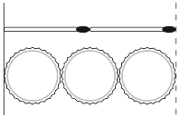  Two matchsticks have the same length as three bottle tops. How many bottle tops will have the same length as 50 matchsticks? | Every 100g of brown bread contains 6g of fibre.  A loaf of bread weighs 800g and has 20 equal slices.  How much fibre is there in one slice?
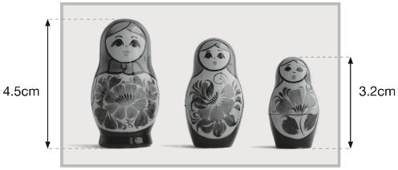  This photograph shows three Russian dolls.  The real-life height of the largest Russian doll is 13.5cm  What is the real-life height of the smallest Russian doll? | In a zoo, the adult polar bear weighs three times more than the baby elephant. Together they weigh 700 kilograms.  How much does the polar bear weigh?

Solve scaling problems involving measurement
A packet contains 1.5 kilograms of guinea pig food.  Remi feeds her guinea pig 30 grams of food each day.  How many days does the packet of food last? | There are 60g of rice in one portion. How many portions are there in a 3 kg bag of rice?
2016 Paper 2 Question 11
A packet contains 1.5 kg of oats.
Every day Maria uses 50 g of oats to make porridge.
How many days does the packet of oats last?

2018 Paper 3 Question 13  A box contains 2. 6 kg of washing powder.  Jack uses 65 grams of powder for each wash.  He uses all the powder.  How many washes did Jack do? | 2019 Paper 2 Question 19  A machine pours 250 millilitres of juice every 4 seconds. How many litres of juice does the machine pour every minute?
2018 Paper 3 Question 9  The Angel of the North is a large statue in England.  It is 20 metres tall and 54 metres wide.  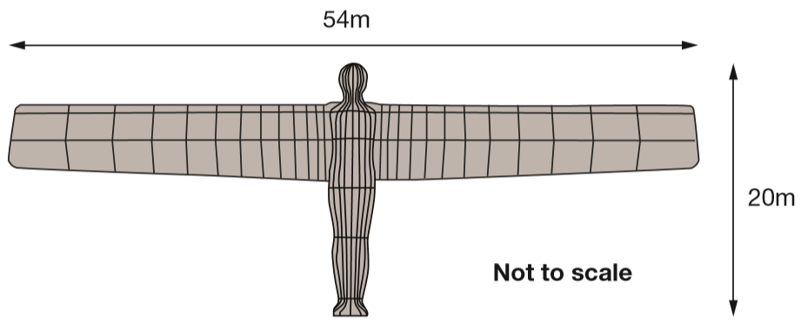  Ally makes a scale model of the Angel of the North.  Her model is 40 centimetres tall.  How wide is her model?  _____ cm | The distance from Calais to Paris is 320 kilometres.  5 miles is approximately 8 kilometres.  Calculate the approximate distance in miles from Calais to Paris.
2019 Paper 3 Question 15
The International Space Station orbits the Earth at a height of 250 miles.
What is the height of the International Space Station in kilometres?
Use 8 kilometres equals 5 miles.

A shop sells rolls of wire.  Two rolls, A and B, each have 45 metres of wire on them.  The wire on roll A is cut into 1.25 m lengths.  The wire on roll B is cut into 2.25 m lengths.  How many more lengths of wire are cut from roll A than roll B | A 5p coin has a diameter of 1.8 centimetres.  Holly makes a straight line of 5p coins worth £10  How long is Holly’s line? Give your answer in metres.

Use the notation of ratio
2017 Paper 2 Question 22  Here are two similar right-angled triangles.  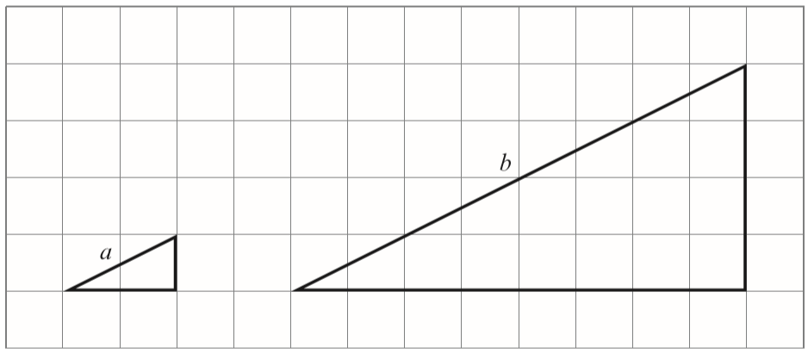  Write the ratio of side a to side b.  a : b = _____: _____ | These patterns are drawn on square grids.  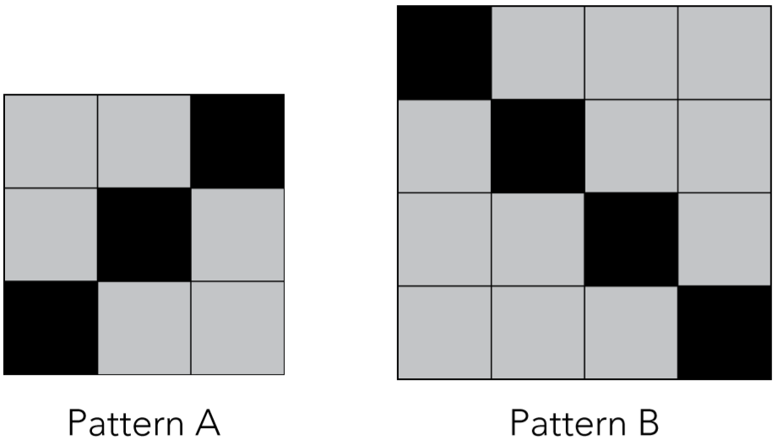  In pattern A, the ratio of black squares to grey squares is 1 : 2  What is the ratio of black squares to grey squares in pattern B?
Children were asked to choose between a safari park and a zoo for the school trip.  They had a vote.  The result was a ratio of 10:3 in favour of going to a safari park.  130 children voted in favour of going to a safari park.  How many children voted in favour of going to the zoo? | Shortcrust pastry is made using flour, margarine and lard.  The flour, margarine and lard are mixed in the ratio  8 : 3 : 2 by weight.  How many grams of margarine and lard are needed to mix with 200 grams of flour?
Two numbers are in the ratio 4 : 5
One of the numbers is 60
There are two possible values for the other number. What are the two possible values?

There are 90 children in Year 6 at Woodland Junior School. They are split into three classes.  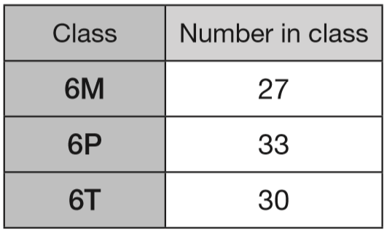  Each child chose football or netball or hockey.  - In 6M, 13 children chose hockey. The rest of the class were split equally between football and netball.  - In 6P, 9 children chose netball. Twice as many children chose football as chose hockey.  - In 6T, the ratio of children who chose football to netball to hockey was 1:2:3  Complete this table.  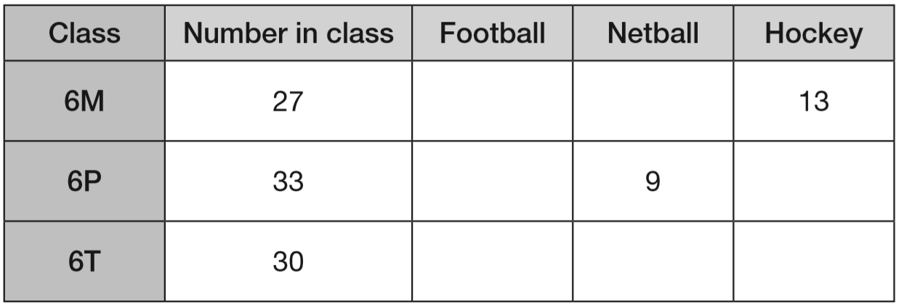 | Alfie asks some boys and girls about their favourite hobby.  He shows the results on a graph.  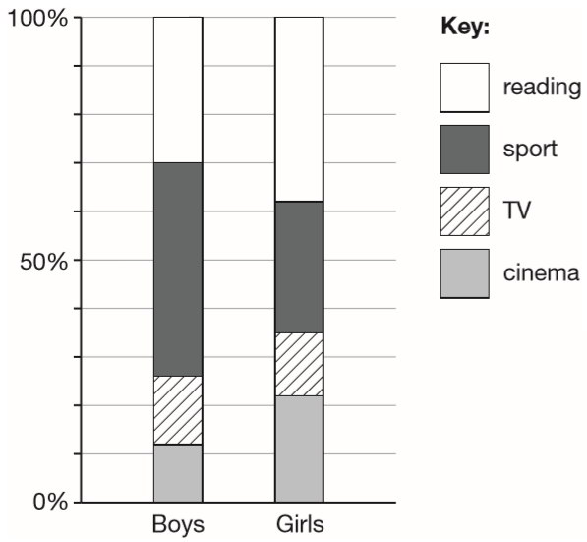  The graph shows that 44% of boys chose sport.  Estimate the percentage of girls who chose sport.  120 boys chose reading.  Estimate the number of boys who chose cinema.

Tom was born in 1988  Ben was born in 2000  Tom and Ben have the same birthday. The ratio of Tom’s age to Ben’s age on their birthday in 2001 was 13 : 1  What was the ratio of Tom’s age to Ben’s age on their birthday in 2003? Write the ratio in its simplest form.  In what year was the ratio of Tom’s age to Ben’s age 3 : 1? | In a class the ratio of boys to girls is 7:4  There are 9 more boys than girls.  How many children are in the class?
In a survey, the ratio of the number of people who preferred milk chocolate to those who preferred plain chocolate was 5 : 3
46 more people preferred milk chocolate, to plain chocolate.
How many people were in the survey?

Solve money problems involving ratios with a decimal scaling factor
These are the prices of fruit in a shop.  Oranges 5 for 90p  Cherries 80p for 100 grams  Emma buys 15 oranges. How much does she pay?  Reshma buys some cherries. They cost £1.20  How many grams of cherries does she buy? | Cheddar cheese: 82p for 100 grams  Edam cheese: 66p for 100 grams  Cottage cheese: 45p for 100 grams  Mina buys 200g of Cheddar cheese and 150g of Edam cheese.  How much does she pay altogether?  Seb buys some Cottage cheese for £1.35  How many grams of cottage cheese does he get?
Peanuts cost 60p for 100 grams.
What is the cost of 350 grams of peanuts?

Raisins cost 80p for 100 grams.
Jack pays £2 for a bag of raisins.
How many grams of raisins does he get?

Solve measurement problems with a decimal scaling factor
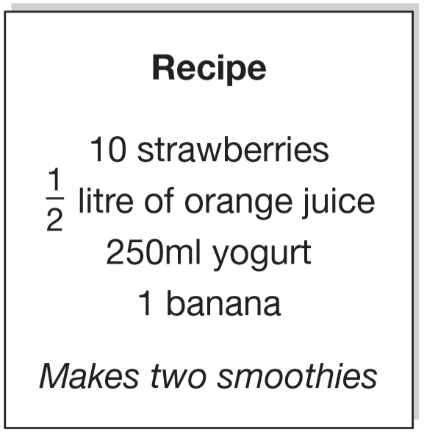  Here is a recipe for fruit smoothies.  Stefan uses the recipe to make smoothies. He uses 1 litre of yogurt.  How many strawberries does he use?  Amir wants to make 5 smoothies.  He has 1 litre of orange juice.  How many more millilitres of orange juice does he need? | This is Kirsty’s recipe for breakfast cereal.  50 grams of oats  30 grams of raisins  40 grams of nuts  If she uses 125 grams of oats, how many grams of raisins does she need?
Here is a recipe for raspberry ice cream.
Raspberry ice cream for 8 people:
½ litre of cream
1kg raspberries
250g sugar
This recipe is for 8 people. Josie makes enough raspberry ice cream for 12 people. How much cream does she use?

Fred makes raspberry ice cream in the same way. He uses 2½ kg of raspberries.
How much sugar does he use?

2015 Paper 3 Question 18  Here are the ingredients for chocolate ice cream.  cream: 400 ml milk: 500 ml egg yolks: 4  chocolate: 120 g sugar: 100 g  Stefan has only 300ml of cream to make chocolate ice cream.  How much chocolate should he use? | 2017 Paper 2 Question 21  On a map, 1cm represents 20 km.  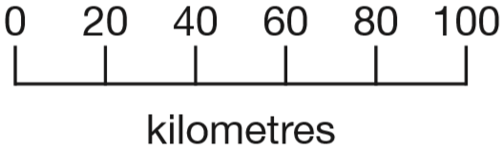  The distance between two cities is 250 km.  On the map, what is the distance between the two cities?
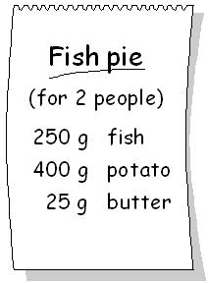  Here are the ingredients for fish pie for two people.  Omar makes fish pie for 3 people.  How many grams of fish should he use? | 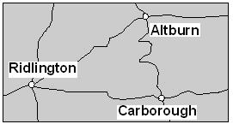  This map has a scale of 1 centimetre to 6 kilometres.  The road from Ridlington to Carborough measured on the map is 6.6 cm long.  What is the length of the road in kilometres?
Use a formula
2017 Paper 2 Question 11  Here is a rule for the time it takes to cook a chicken.  Cooking time = 20 minutes plus an extra 40 minutes for each kilogram  How many minutes will it take to cook a 3 kg chicken?  What is the mass of a chicken that takes 100 minutes to cook? | 2015 Paper 2 Question 8  Maria bakes cakes and sells them in bags. She uses this formula to work out how much to charge for one bag of cakes.  Cost = number of cakes × 20p + 15p for the bag  How much will a bag of 12 cakes cost?  Olivia buys a bag of cakes for £5.15  Use the formula to calculate how many cakes are in the bag.
2018 Paper 3 Question 15
A shop prints designs on T-shirts.
They use this formula to work out the price for printing a design.
price = 60p × number of colours + £1.25
What is the price for printing a design that has 3 colours in it?

Amina has £5 to spend on printing a design.
What is the greatest number of colours she can have in the design?

Find numbers that meet conditions
n stands for a number between 50 and 60  Complete these statements.  One has been done for you.  n + 10 stands for a number between 60 and 70 .  10 × n stands for a number between ___ and ___  n – 5 stands for a number between ___ and ___ | m stands for a whole number greater than 10 and less than 20  n stands for a whole number greater than 2 and less than 10  What is the smallest number that m × n could be?  What is the largest number that m – n could be?
p and q each stand for whole numbers.  p + q = 1000  p is 150 greater than q.  Calculate the numbers p and q. | k, m and n each stand for a whole number.  They add together to make 1500  k + m + n = 1500  m is three times as big as n.  k is twice as big as n.  Calculate the numbers k, m and n.
k stands for a whole number.  k + 7 is greater than 100  k – 7 is less than 90  Find all the numbers that k could be. | j and k stand for two numbers.  Double j equals half of k.  Write numbers to complete the sentence below.  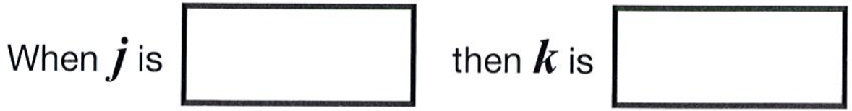
2017 Paper 3 Question 23  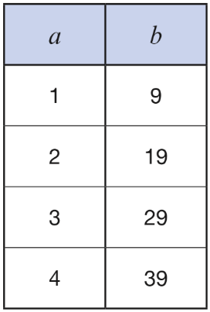  Here is a pattern of number pairs.  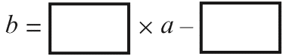  Complete the rule for the number pattern. | Here are three equations.  a + b + c = 30  a + b = 24  b + c = 14  What are the values of a, b and c?

Write rules using algebraic notation
2019 Paper 3 Question 3  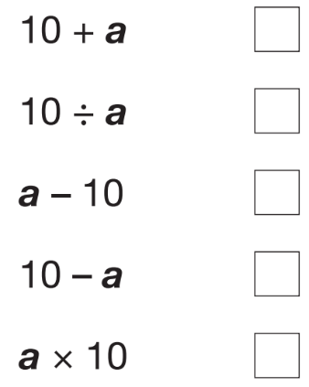  Dev says, ‘I had £10. I gave some money away.’  Which expression shows how much money Dev has left?  a is the amount of money, in pounds, that Dev gave away. | k stands for a number.  Complete the number sentences below.  One has been done for you.  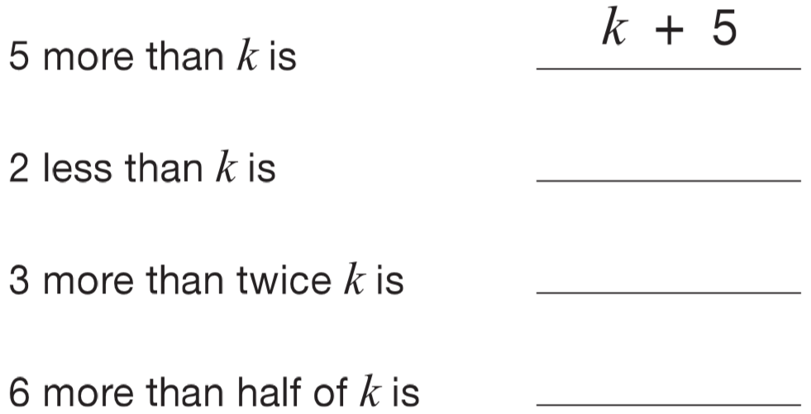

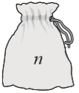  There are n counters in Alfie’s bag.  Alfie puts 3 more counters in the bag.  Write an expression for the number of counters that are in the bag now.  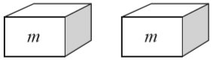  Megan has two boxes. There are m counters in each box.  She puts all her counters together in a pile, then removes 5 of them.  Write an expression for the number of counters  that are in the pile now. | n stands for number.  Match the equivalent expressions.  One has been done for you.  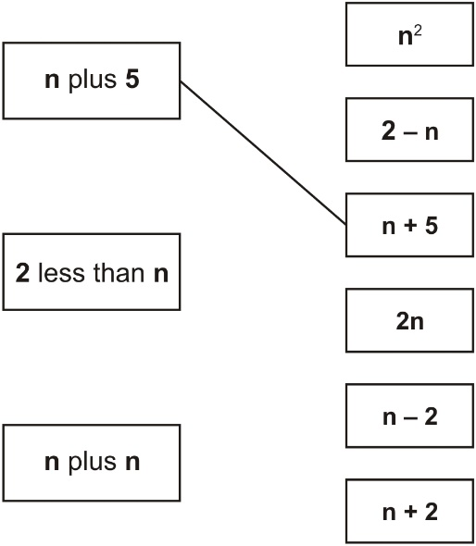
Look at these equations.
a = 2b
b = 3c
Which equation below is also true?
Put a ring round the correct one.

b = 2a a = 2b + 3c a = 5c

a = 6c a + b = 5

Find values given rules expressed with algebraic notation
n stands for a number.  n + 7 = 13  What is the value of n + 10? | What is the value of 4x + 7 when x = 5?
g stands for a number on a grey card.  w stands for a number on a white card.  Join all pairs of numbers that match this rule:  2g + w = 10  One is done for you.  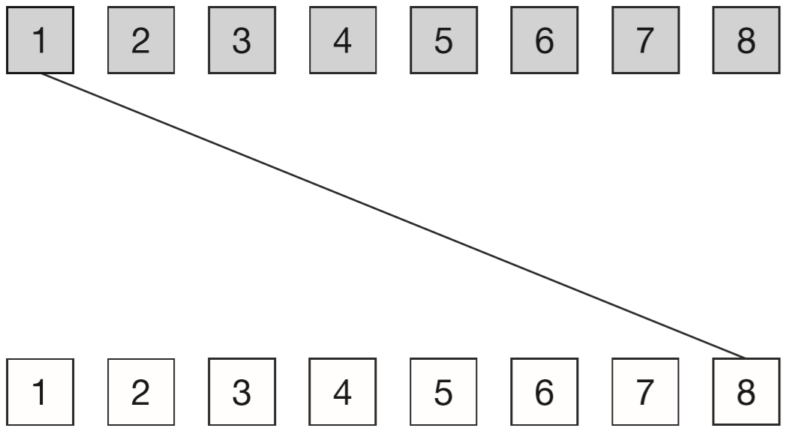 | 2019 Paper 3 Question 17  x + 2y = 20  x and y are whole numbers less than 10  What could x and y be?  x = _____ y = _____
Write the missing numbers so that 2a + 5b = 30
One is done for you.
2a + 5b = 30 when a = 0 and b = _6_

2a + 5b = 30 when a = 5 and b = ___

2a + 5b = 30 when a = 15 and b = ___

Here is an equation.  m – 2n = 10  When n = 20 what is the value of m?  When m = 20 what is the value of n? | n stands for a whole number.  2n is greater than 30  5n is less than 100  Write all the numbers that n stands for.

n stands for a number.  Complete this table of values.  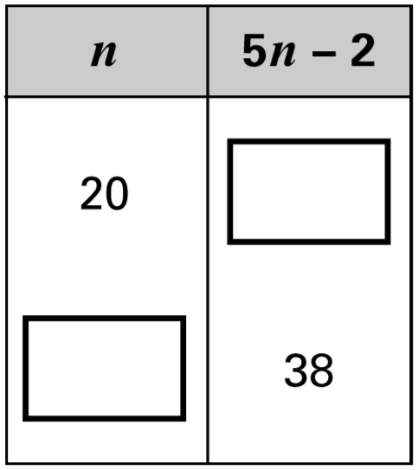 | 2016 Paper 2 Question 12  n = 22  What is 2n + 9?  2q + 4 = 100  Work out the value of q.
2x + y = 20

when x = 6, y = _____

when y = 2, x = _____

x is a whole number.  40 < x < 45  x could be 41, 42, 43 or 44  k is a whole number.  29 < 2k < 35  k could be ____________  w is a whole number.  18 < 3w + 1 < 24  w could be ___________ | Here is a sequence of shapes.  Each time a square is added to a shape, two more circles are added.  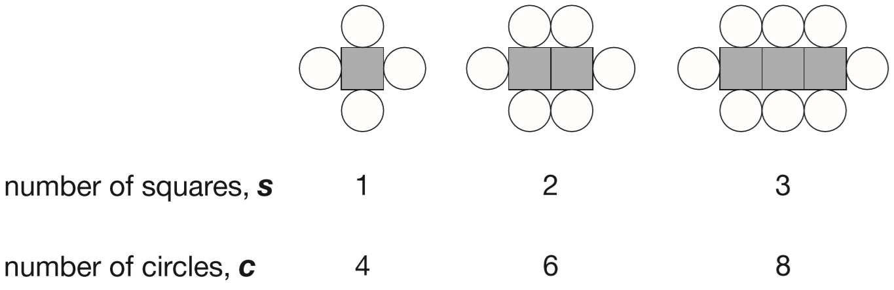  The sequence of shapes continues.  The formula for the sequence is c = 2s + 2  Calculate the number of circles when the number of squares in a shape is 150  How many squares are there in a shape that has 100 circles?
a and b each represent a whole number between 1 and 10  2a + b = 8  Write the three possible combinations of a and b  One is done for you.  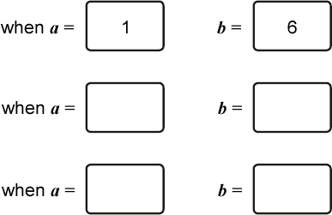 | Here is an equation.  k = 100 − 4n  Find the value of k when n = 60  Find the value of n when k = 99
Look at this expression.
10y + 2
When y = 0.4, the value of 10y + 2 is an even number because 10 × 0.4 + 2 = 6
Write a value for y so that 10y + 2 is a prime number.

Now write a value for y so that 10y + 2 is a square number.

Use an algebraic formula
Here is a sequence of shapes made from squares.  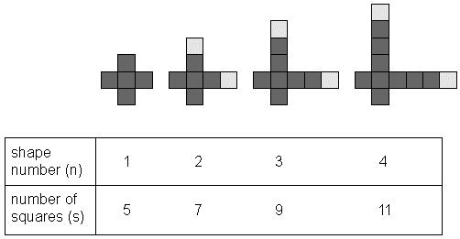  There is a formula which connects the number of squares (s) used in a shape, with the shape number (n). Tick the correct formula.  s = 3n + 2 s = 3n + 1 s = 2n + 3  s = 5n – 3 s = 2n + 5 | Alfie has some photographs printed.  The cost is £2.50 for postage and 12 pence for each print.  Alfie uses this formula for the total cost (C) in pence.  C = 250 + 12n  n stands for the number of photographs.  The total cost for Alfie is £6.70  How many photographs does he have printed?
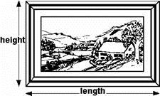  Here are some picture frame sizes.  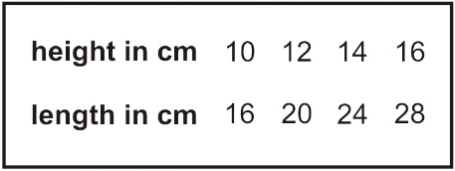  For each frame, the length is twice the height, subtract 4  What is the length of a frame which has a height of 36 cm?  For each frame, the length (L) is twice the height (H), subtract 4  Write this in symbols. | Print charges:  3p per page  75p for the cover  Jon pays £4.35 for his book, including the cover.  How many pages are in his book?  Write a formula for the total cost of printing a book with cover.  t stands for the total cost in pence.  Use n for the number of pages.  t = ________
Ann makes a pattern of L shapes with sticks.  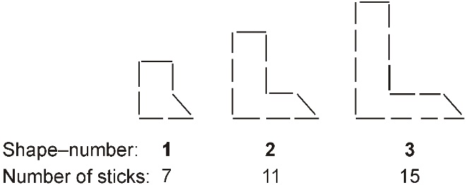  Ann says, ‘I find the number of sticks for a shape by first multiplying the shape–number by 4, then adding 3.’  Work out the number of sticks for the shape that has shape-number 10  Ann uses 59 sticks to make another L shape in this pattern. What is its shape-number?  Write a formula to work out the number of sticks for any L shape. Use S for the number of sticks and N for the shape-number. | Javed makes rectangular frames with grey centimetre squares.  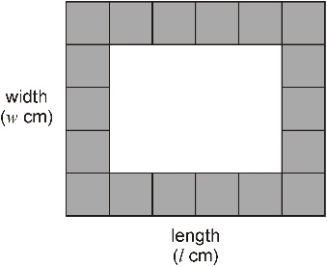  n stands for the number of grey centimetre squares in a frame.  Javed has a formula for working out n.  n = 2 (l + w) – 4  Javed makes a frame with l = 28 and w = 15  Use the formula to work out how many grey squares he uses.  Javed makes a square frame with 84 grey squares.  Use the formula to find how many grey squares are in each side of the square frame.

Here is a sequence of shapes made from squares and circles.  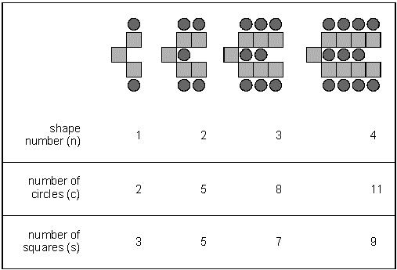  The sequence continues in the same way. The formula for the number of circles (c)  n shape number (n) is  c = 3n − 1  Use the formula to work out the shape number which has 104 circles.  Write the formula for the number of squares (s) in shape number (n).  S = _______ | Here is a sequence of patterns made from octagons and squares.  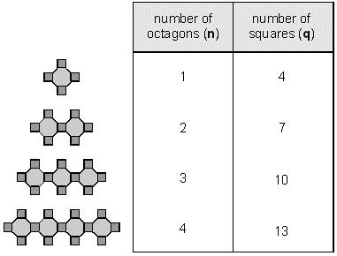  The sequence continues.  How many squares will there be in the pattern that has 40 octagons?  q represents the number of squares.  n represents the number of octagons.  What is the rule connecting q and n?
In this pattern white hexagons surround shaded hexagons.
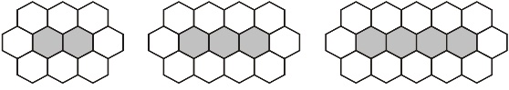
How many white hexagons are needed to surround a line of 100 shaded hexagons?

W represents the number of white hexagons.
S represents the number of shaded hexagons.
What is the rule connecting W and S?

Find missing values to calculate length
Josh has some tiles.  Each tile is 10 cm long.  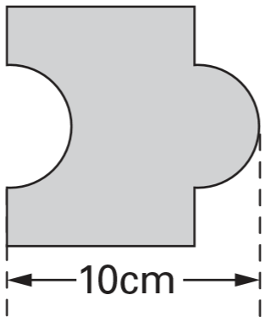  Two tiles fitted together are 18 cm long.  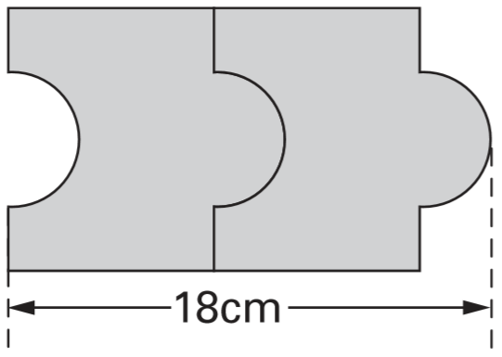  Calculate the length of five tiles fitted together.  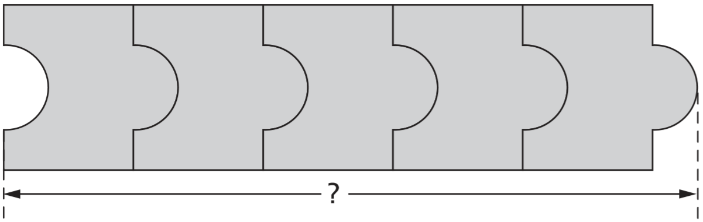 | 2017 Paper 3 Question 22  In this diagram, the shaded rectangles are all of equal width (w).  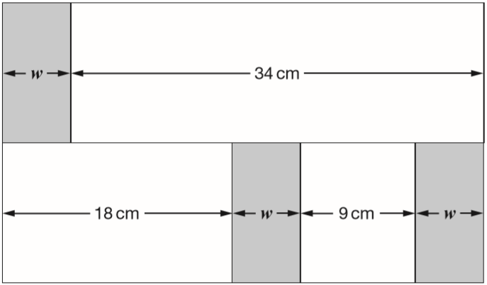  Calculate the width (w) of one shaded rectangle.
Kate has some rectangles.  Each one is 4 centimetres by 9 centimetres.  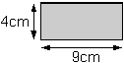  She makes a design with them.  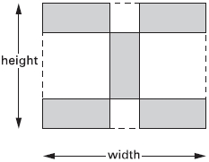  Calculate the width and height of her design. | Joe has two strips of card. Each strip is 36 centimetres long. One strip is divided into three equal parts. The other strip is divided into four equal parts.  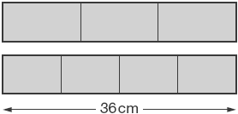  Joe uses the two strips to make this shape.  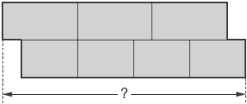  What is the total length of Joe’s shape?
This design has one large square and two identical small squares.  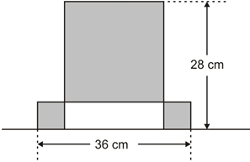  The design measures 36 centimetres by 28 centimetres. Calculate the length of a side of the large square. | 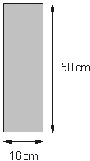  Kate has some rectangles.  They each measure 16 centimetres by 50 centimetres.  She makes this design with four of the rectangles.  Work out the lengths x and y.  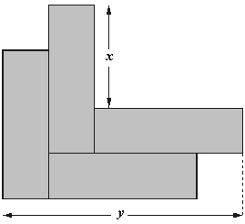
Solve ratio problems involving length
Four large circles and five small circles fit exactly inside this rectangle.  The diameter of a large circle is 17.5 centimetres.  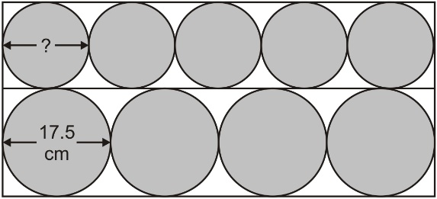  Calculate the diameter of a small circle. | 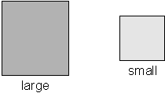  Mr Jones has two sizes of square paving stones.  He uses them to make a path. The path measures 1.55 metres by 3.72 metres.  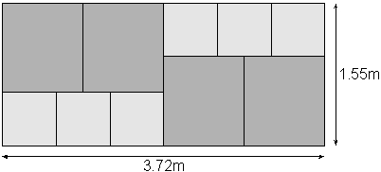  Calculate the width of a small paving stone.

2019 Paper 3 Question 22  Six identical right-angled triangles are arranged to make a rectangle.  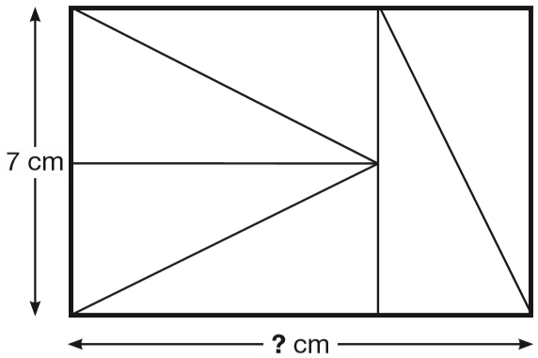  Calculate the length of the rectangle. | Here is a rectangle with six identical shaded squares inside it.  The width of the rectangle is 7.2 centimetres.  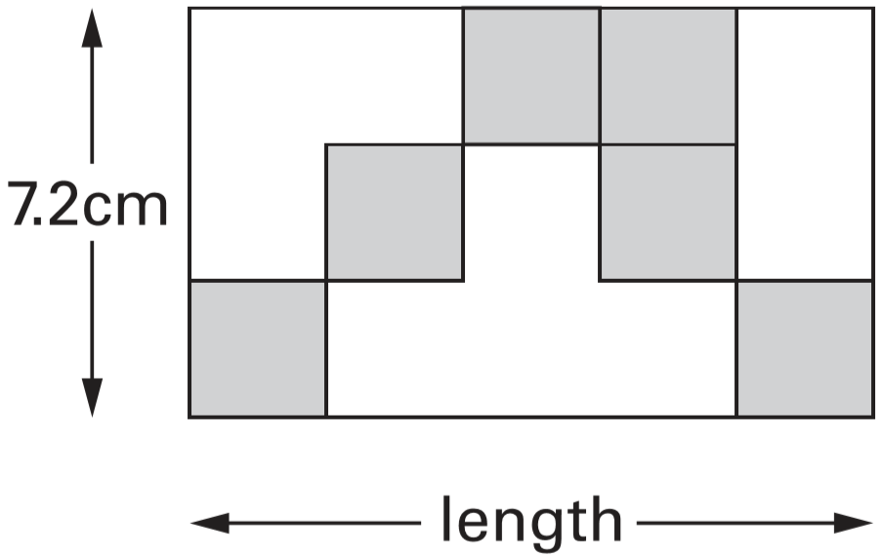  Calculate the length of the rectangle.
Solve problems involving perimeter
The perimeter of a square is 72 centimetres.  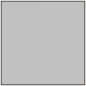  The square is cut in half to make two identical rectangles.  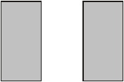  What is the perimeter of one rectangle? | This plan of a garden is made of rectangles and triangles. The perimeter of the garden is 34 metres.  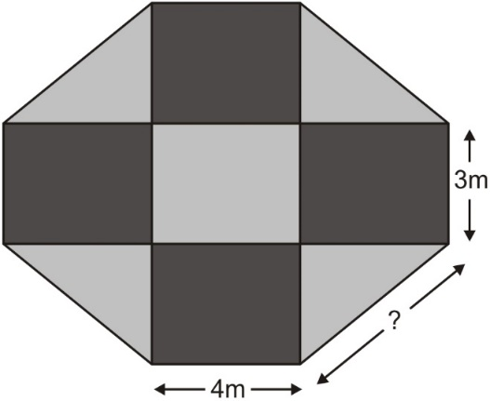  What is the length of the longest side of each triangle?
Here are an equilateral triangle and a regular pentagon.  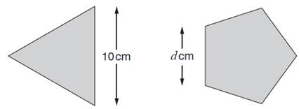  Each side of the triangle is 10 cm.  Each side of the pentagon is d cm.  The perimeter of the pentagon is 4 centimetres more than the perimeter of the triangle.  What number does d represent? | The area of this square is 36 cm².  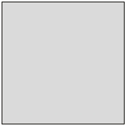  The square is cut into quarters to create 4 identical rectangles.  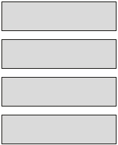  What is the perimeter of one of the small rectangles?

Solve ratio problems involving perimeter
Triangle ABC is isosceles and has a perimeter of 20 centimetres.  Sides AB and AC are each twice as long as BC.  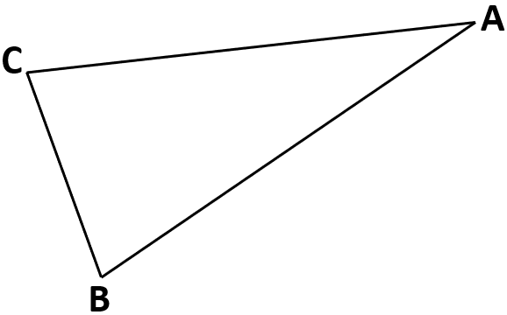Calculate the length of the side BC. | Rectangle ABCD has a perimeter of 24 centimetres.  Sides AB and DC are twice as long as sides AD and BC.  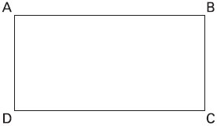  Calculate the length of side AD.

Calculate area and recognise that area can be divided
Here is a T-shape made from 3 identical rectangles. The area of the T-shape is 90 cm².  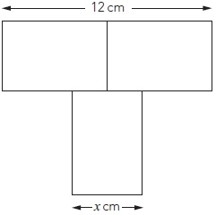  Work out the value of x. | The diagram shows a square of side length 12 cm.  Inside the square are 8 congruent trapeziums and a shaded square.  The side length of the shaded square is 6 cm.  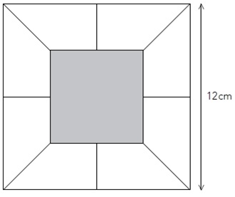  What is the area of one of the trapeziums?
Twelve rectangles, all the same size, are arranged to make a square, as shown in the diagram.  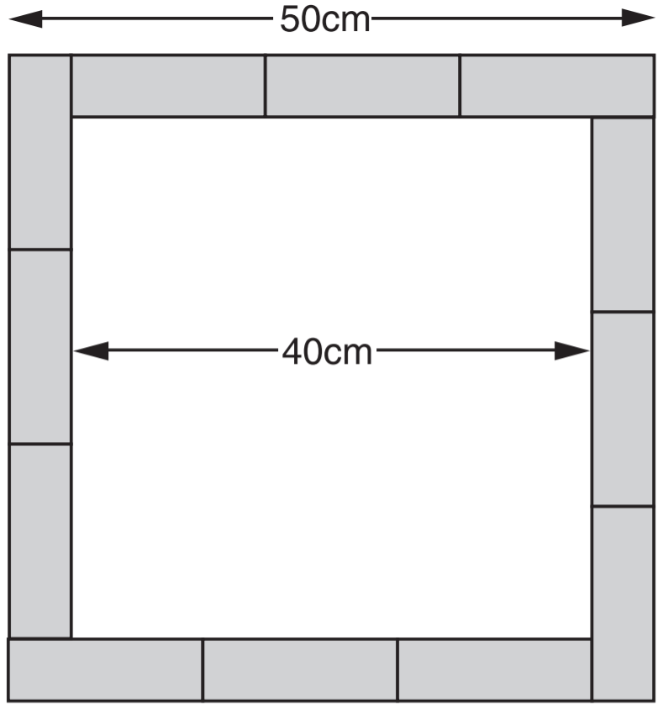  Calculate the area of one of the rectangles. | Here is a flag.  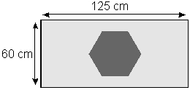  What is the area of this flag?  20% of the flag is a hexagon. What area of the flag is a hexagon?

Calculate the area of a triangle
Note: Questions have been scaled down, so measurements given in cm are not to scale.
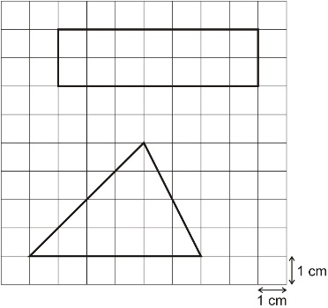  Work out the area of each shape.  Rectangle:  Triangle: | Here is a triangle on a 1 cm square grid.  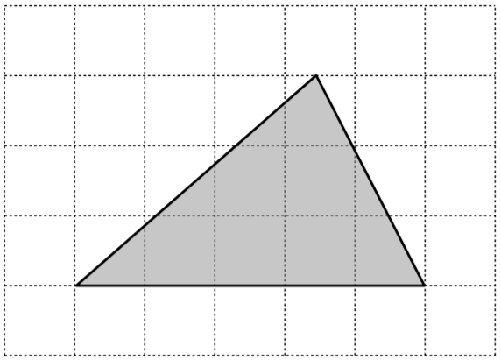  What is the area of the triangle?
Calculate the area of this triangle.  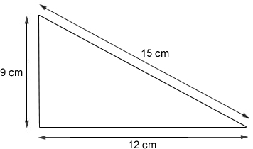 | Calculate the area of the triangle.  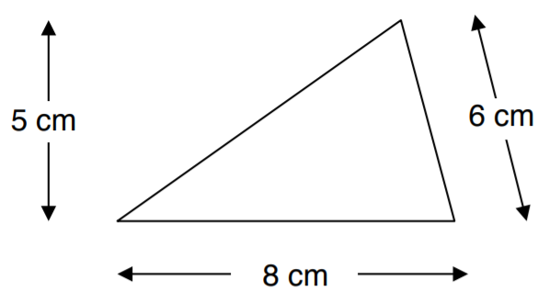
2016 Paper 3 Question 17  Here are five triangles on a square grid.  Four of the triangles have the same area.  Which triangle has a different area?  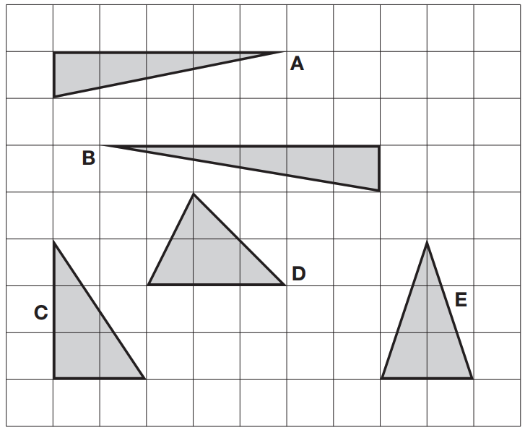 | The diagram shows a shaded triangle inside a rectangle.  What is the area of the shaded triangle?  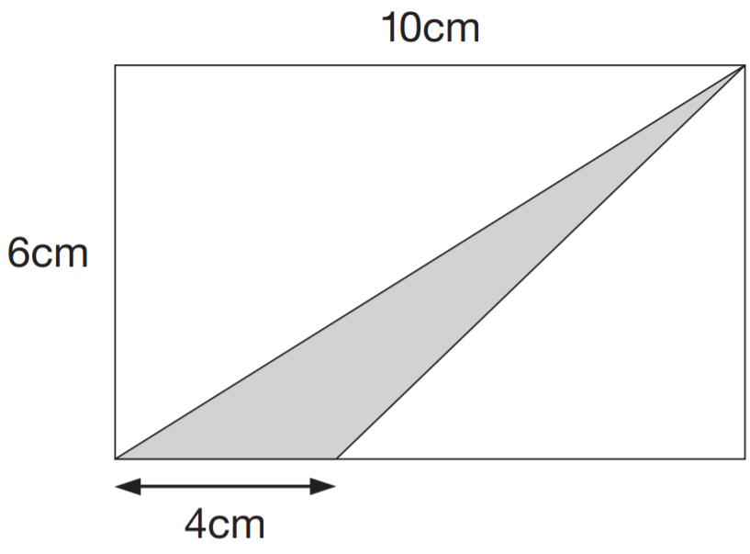
Here is a trapezium with a height of 10 centimetres.  The parallel sides are 5.5cm long and 10.5cm long.  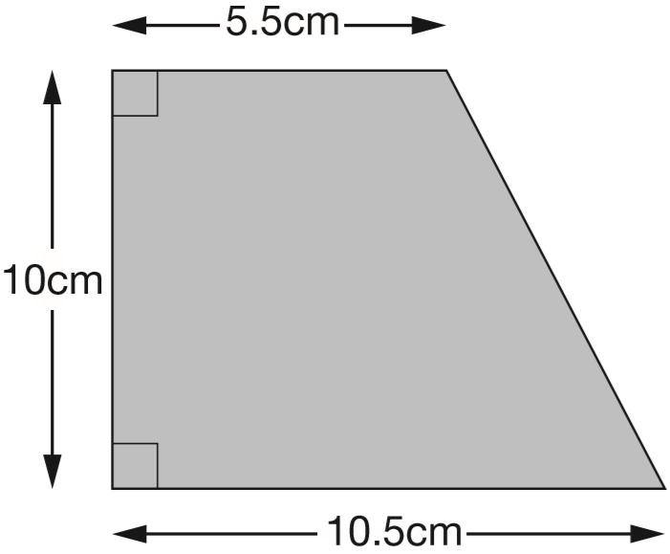  Find the area of the trapezium. | The diagram shows 4 identical shaded triangles in a rectangle.  The rectangle measures 36 centimetres by 24 centimetres.  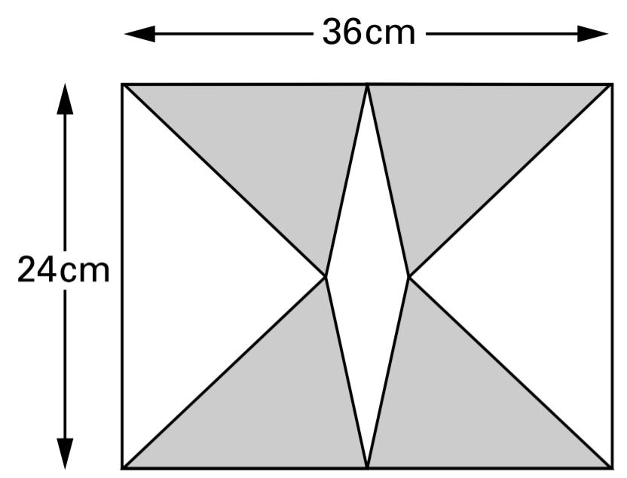  Calculate the area of one shaded triangle.

Relate the area of triangles and rectangles
Note: Questions have been scaled down, so measurements given in cm are not to scale.
The triangle and rectangle below have the same area.  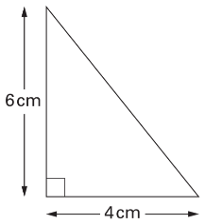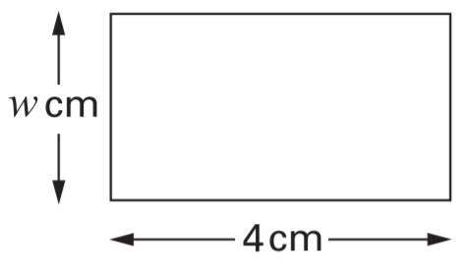  Work out the value of w. | Here is a triangle drawn on a square grid.  Draw a rectangle on the grid with the same area as the triangle.  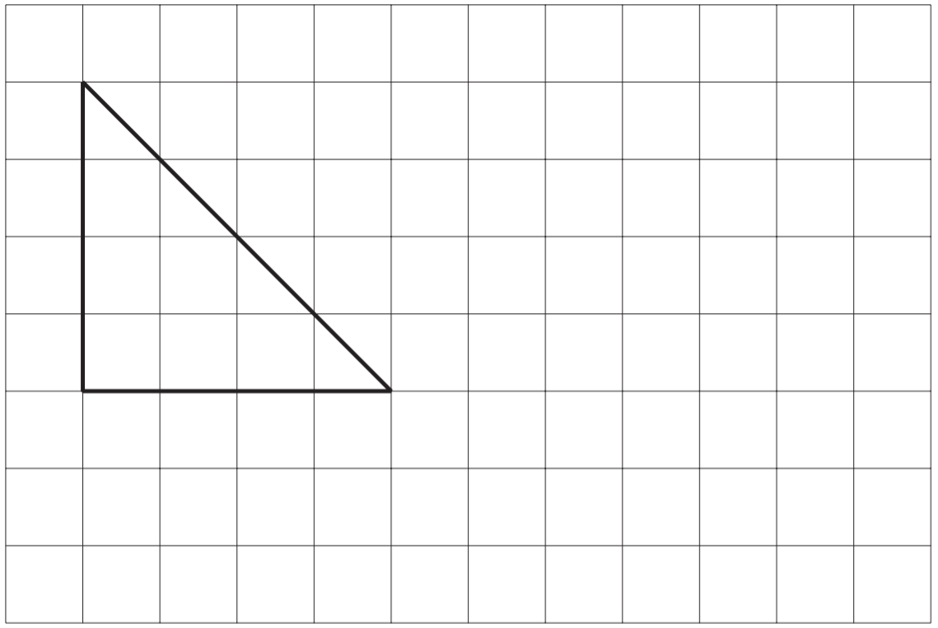

Draw a triangle of a given area
Note: Questions have been scaled down, so measurements given in cm are not to scale.
On the centimetre square grid, draw a triangle that has an area of 5 cm².  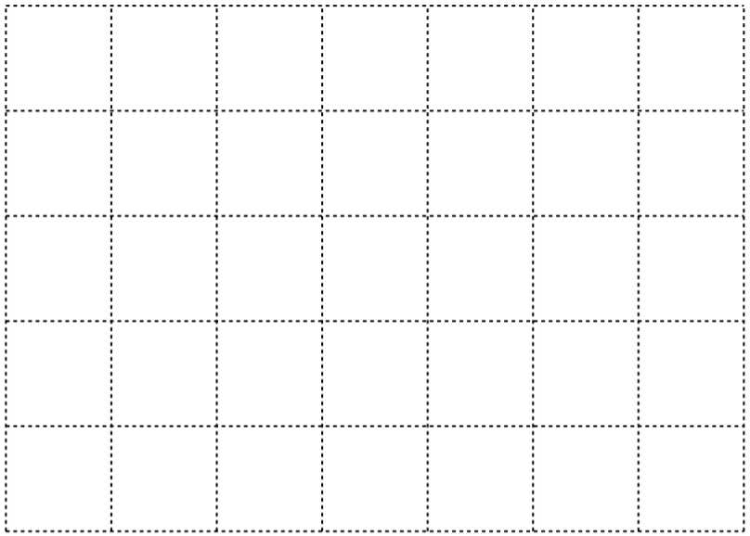 | Draw two more lines to complete the triangle with an area of 10 cm².  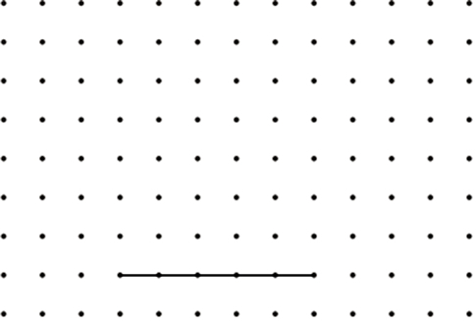
On the grid draw a triangle with the same area as the shaded rectangle.  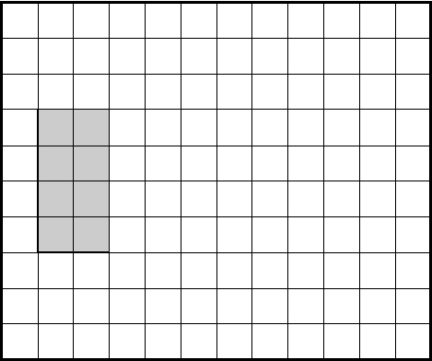 | This is a centimetre grid. On the grid draw a triangle which has an area of 7.5 cm² and which has an obtuse angle.  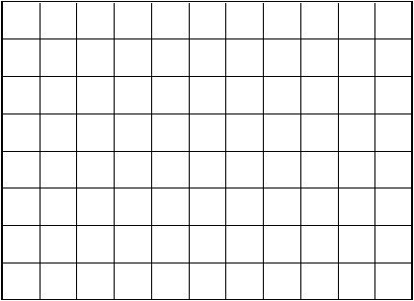
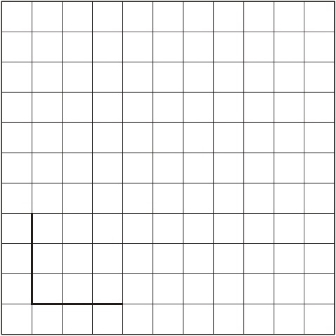
Here is a centimetre grid.
Draw two more lines to make a quadrilateral with an area of 18 cm².

Calculate the area of a parallelogram
Note: Questions have been scaled down, so measurements given in cm are not to scale.
Here is a parallelogram on a 1 cm square grid.  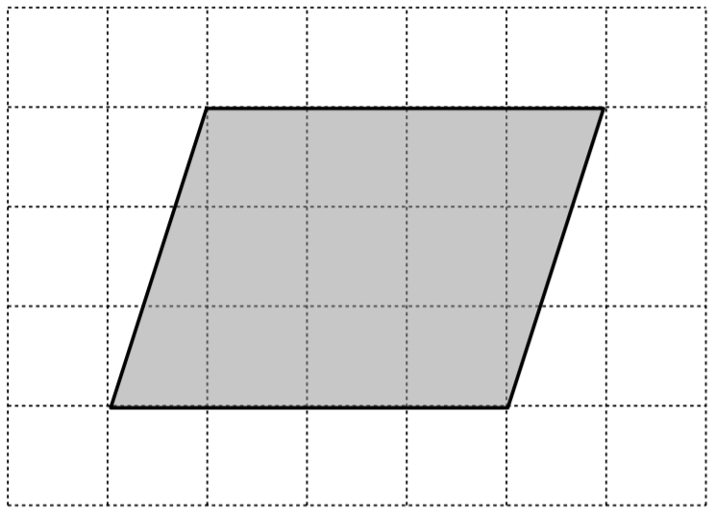  What is the area of the parallelogram? | Calculate the area of the parallelogram.  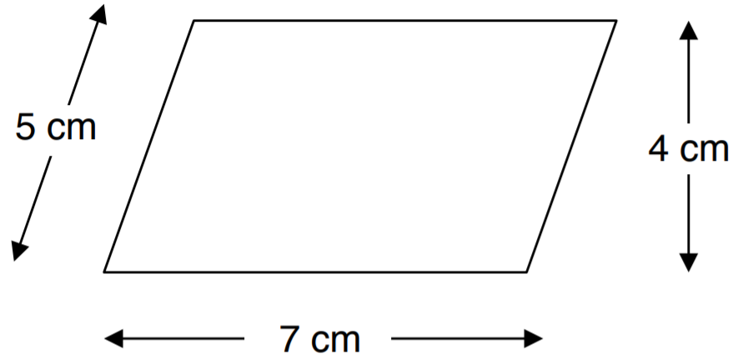
Calculate the area of this parallelogram.
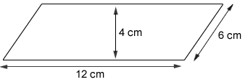

Draw a parallelogram of a given area
Note: Questions have been scaled down, so measurements given in cm are not to scale.
On the centimetre square grid, draw a parallelogram that has an area of 8 cm² .  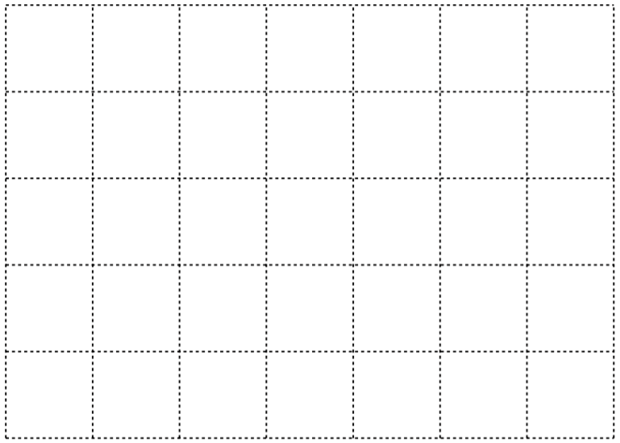 | This is a centimetre grid. Draw 3 more lines to make a parallelogram with an area of 10cm².  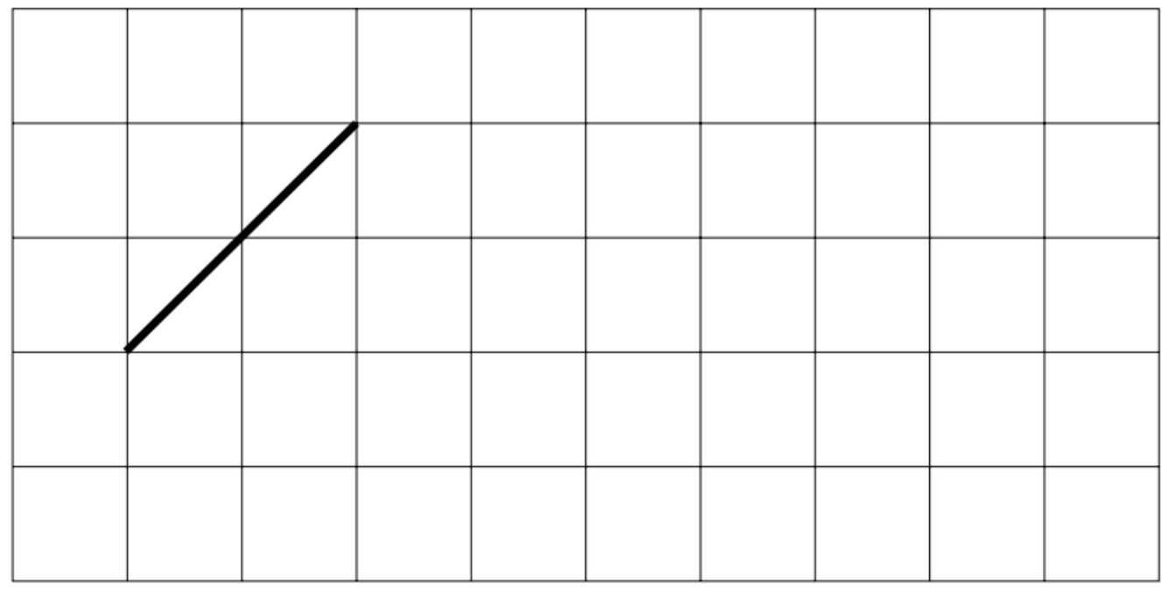
Draw three more lines to complete the parallelogram with an area of 24 cm².
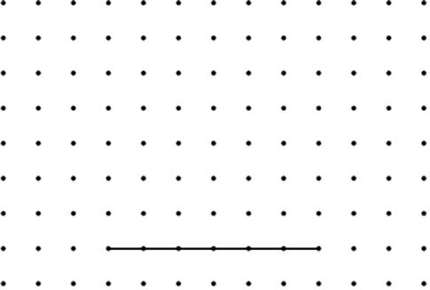

Solve problems involving area
The diagram shows a shaded square inside a larger square.  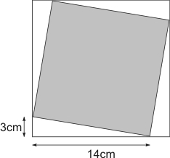  Calculate the area of:  - the larger square  - the shaded square | Here is a flag.  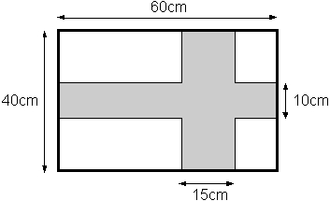  Calculate the area of the shaded cross.

