

Apply knowledge of angles with isosceles triangles
35° | 2015 Paper 2 Question 15  104°
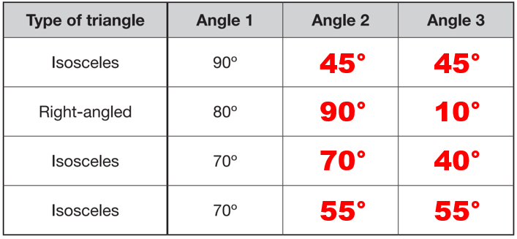 | 17°
140° | r = 150°  t = 110°
108°

Apply knowledge of angles and lengths in equilateral triangles
18° | x = 155°  y = 85°
64 cm | 49 cm

Apply knowledge of angles in quadrilaterals (360) and pentagons (540)
132° | 50°  20°
132° | No, because regular shapes have angles of the same size, not just sides of the same length.  60°
Recognise vertically opposite angles and Z angles
a = 56°  b = 34° | x = 108°  y = 54°
b and d | x = 40°  y = 25°

Solve problems involving angles
2016 Paper 2 Question 17  a = 160°  b = 20° | x = 55°  y = 25°
x = 55°  y = 20° | x = 125°  y = 145°

a = 36°
b = 72°
c = 144°

Draw shapes by measuring angles
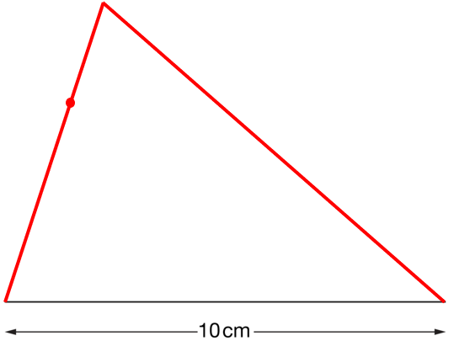

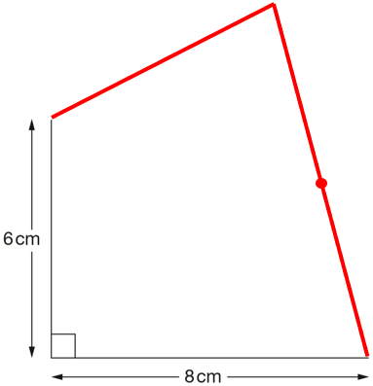

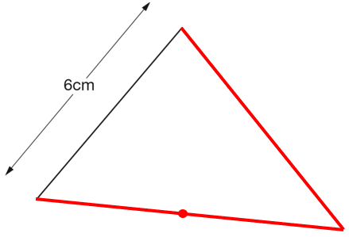

2019 Paper 2 Question 13
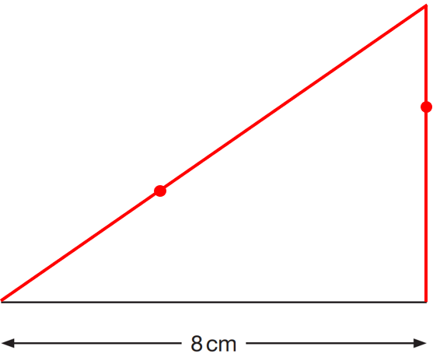

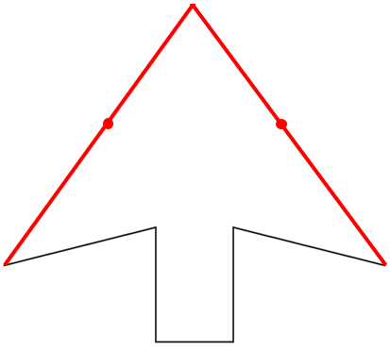

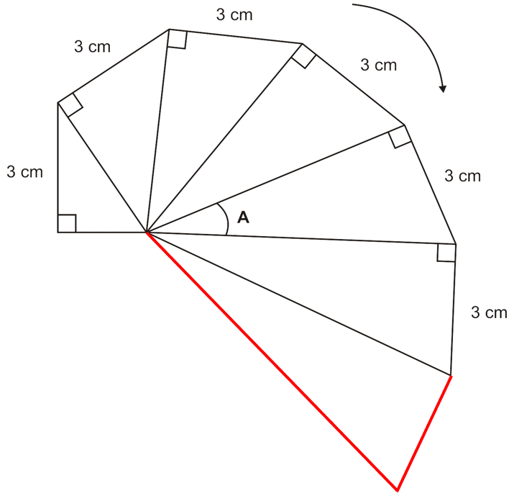

25°
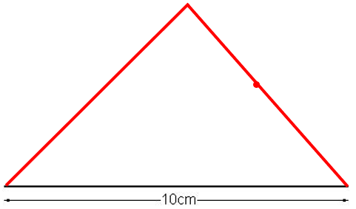

Recognise parts of a circle
2017 Paper 3 Question 11  32 cm | 11 cm
4  8  25 | 12.5 cm²

Solve problems involving nets of 3D shapes
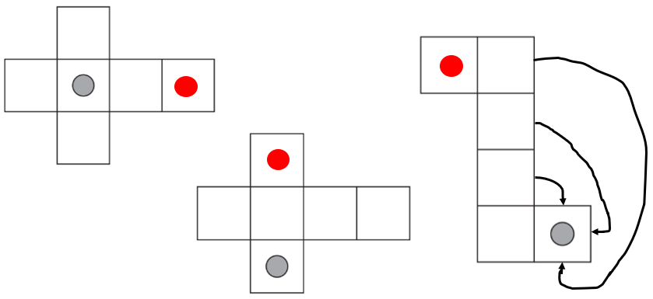 | 2018 Paper 3 Question 17  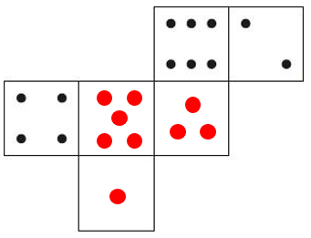
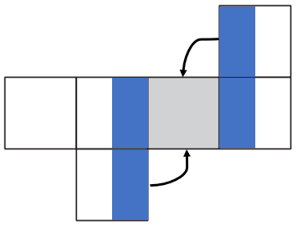 | 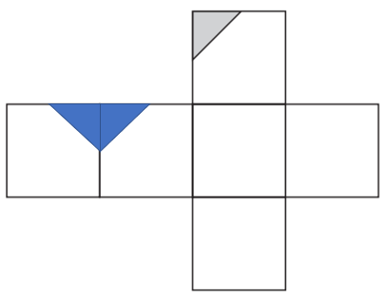

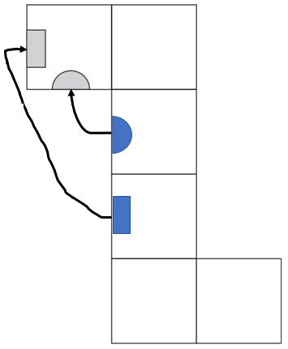 | 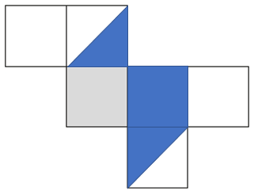
Calculate volume
24 cm³ | 600 cm³  many possible answers  e.g. 10 cm x 10 cm x 3 cm  or 10 cm x 6 cm x 5 cm
7 | 18 cm²

Write the possible dimensions of a cuboid given volume
4 cm, 3 cm and 2 cm  or 12 cm, 2 cm and 1 cm  or 24 cm, 1 cm and 1 cm  or 8 cm, 3 cm and 1 cm  or 6 cm, 4 cm and 1 cm | All the same  They all have a volume of 16 cubes.  Volume is how much space a 3D shape takes up.  4
30 cm, 1 cm and 1 cm
15 cm, 2 cm and 1 cm
5 cm, 3 cm and 2 cm
6 cm, 5 cm and 1 cm
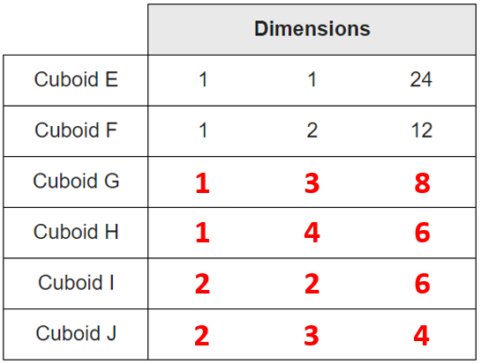
(any order)

Calculate missing lengths given volume
2017 Paper 3 Question 24  9 cm | 5 cm
5 cm | 5 cm

Calculate volume from nets
2018 Paper 2 Question 22  125cm³ | The cuboids have the same volume.  4 cm x 3 cm x 1 cm = 12cm³  3 cm x 2 cm x 2 cm = 12cm³

Solve problems involving volume of cubes and cuboids
2019 Paper 2 Question 23  720 | 64
2019 Paper 2 Question 23  720 | 600cm³  many possible answers  e.g. 10 cm, 10 cm and 3 cm
300cm³

360cm³

12

Solve ratio problems involving co-ordinates on a simple co-ordinate grid
(2, 1)  The co-ordinates of point B are (12, 6).  x co-ordinates are increasing by 2 each time from an even number and 11 is an odd number.  y co-ordinates are increasing by 1 each time and point B is the 6th, not the 5th, point. | (50, 15)
B is (5, 4)  D is (10, 0) | (75, 36)
M is (15, 40)  C is (20, 0) | (13, 15)
Identify and plot points on a full co-ordinate grid
Cross  Tick  Tick  Cross | 2017 Paper 2 Question 17  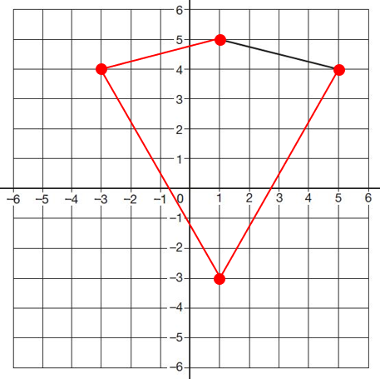

D is (-10, -4)  E is (0, 8) | 2018 Paper 3 Question 10  (-3, 1)
(-3, -12) | P is (-12, -30)  Q is (38, -30)
A is (19, 25)  B is (-6, 19) | M is (-10, 0)  L is (30, -20)
Translate a shape on a full co-ordinate grid
2017 Paper 3 Question 7  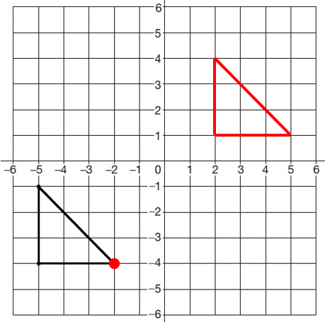 | 2019 Paper 3 Question 10  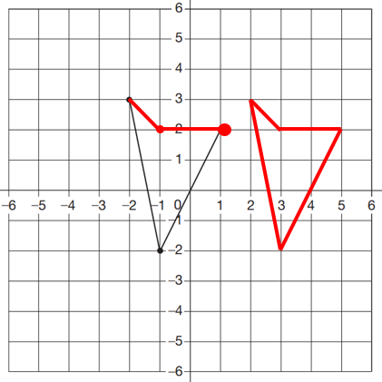
2015 Paper 3 Question 20
A is (12, 0)

B is (9, -8)

Reflect a shape on a full co-ordinate grid
A is (11, 9)  B is (15, 3) | 2016 Paper 2 Question 20  (-10, -40)

Identify co-ordinates from equations on a line graph
A is (4, 9)  B is (-8, -3)  (-5, 0) | No. y is always 3 more than x.  -103 is 3 less than -100  y = x + 3  or x = y – 3
(1, -6)
or (2, -5)
or (3, -4)
or (4, -3)
or (5, -2)
or (6, -1)

