

Estimate values on a line graph to use in calculations
40  12 km or 13 km  It shows 22 km travelled in the first 60 minutes.  This means that 40 – 22 = 18 km was travelled in the second hour.  22 km is further than 18 km. | 16 km  between 180 and 190
25,000  1997  1964 | 18 minutes or 19 minutes  between 6 minutes and 7.5 minutes
3:15pm  13 degrees or 14 degrees | 10 years old  3 cm
between 140 and 160 metres  27 seconds  It reaches 200 m at 3 seconds and falls below 200 m at 26 seconds  26 – 3 = 23 | 6 seconds  17.5 metres
between 255 seconds and 265 seconds  470 seconds | £550  15 seconds
between 12:40pm and 12:50pm

Estimate decimals or negative numbers on a line graph to use in calculations
between 8.6 kg and 8.8 kg  between 3.2 kg and 3.4 kg | between 22.2°C and 22.8°C  between 2:48pm and 2:52pm  5 degrees
between 7.3 cm and 7.7 cm  3 hours 45 minutes | 8:45pm  3 degrees

2017 Paper 3 Question 4  7 degrees  -2 degrees | 9  8th March  39.1 degrees
Solve problems involving information presented in line graphs
700 and 1000  Elementary  1 minute = 30 words  so 10 minutes = 300 words  Lines drawn vertically on 10 minutes and horizontally on 300 words cross in Elementary. | the delivery cost is the same (£5) whatever the cost of the toy

it’s a straight line

08:10

Calculate the mean
2015 Paper 2 Question 17  145 cm | 2018 Paper 2 Question 18  £5.40
2015 Paper 2 Question 17  145 cm | 3
2015 Paper 2 Question 17  145 cm | 160 g
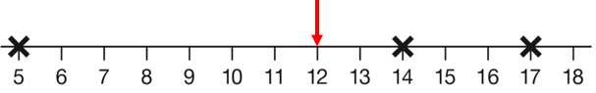  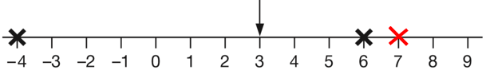 | 14 + 23 + 13 + 13 = 63  63 ÷ 4 = more than 15 (15.75)  22 km
2019 Paper 2 Question 22  $\frac{2}{5}$  10.7 °C | 2.8 cm
2019 Paper 2 Question 22  $\frac{2}{5}$  10.7 °C | 52

