1 Recognise representations for numbers to 20
Let’s Learn
Write the numbers represented by the blocks below.
  3 |   9
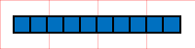  10 | 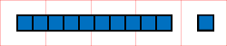  11
  15 | 18

2 Represent numbers to 20
Let’s Learn
Represent the numbers below by drawing a line for a ten and a dot for a one.
2   | 6  
11 | 15
Four   | Ten
Sixteen   | Twenty  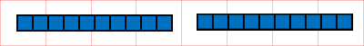

3 Count on or back from any number to 20
Let’s Learn
For the questions below, write the next two numbers, counting on or back in ones.
10  11  7, 8, 9, , | 16  17  20, 19, 18, ,
17  18  14, 15, 16, , | 5  4  8, 7, 6, ,

4 Order numbers to 20
Let’s Learn
Order each set of numbers from smallest to largest.
11, 2, 20, 17, 12
17
20
11
12
2

10, 1, 8, 16, 7
7
1
16
10
8

5 Recognise representations for numbers to 100
Let’s Learn
Write the numbers represented by the blocks below.
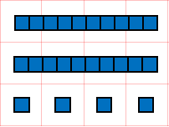24 | 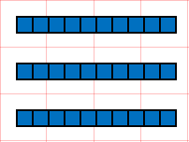30
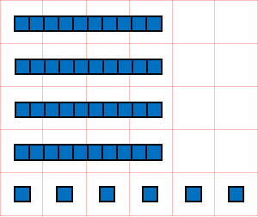46 | 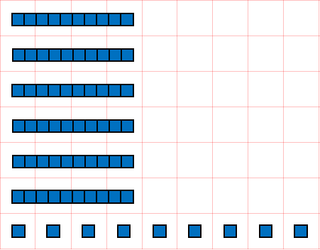69
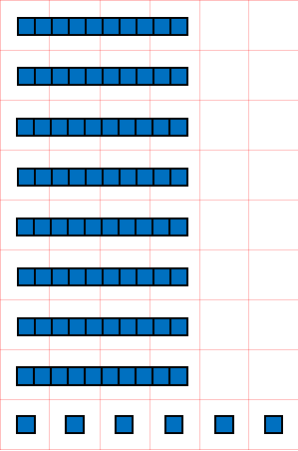86 | 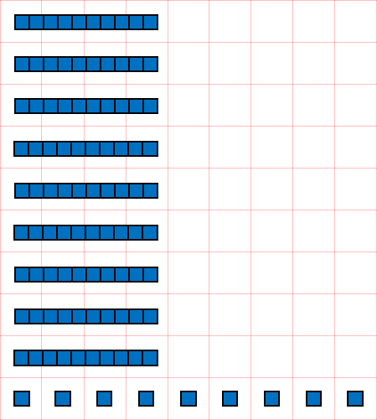99

6 Represent numbers to 100
Let’s Learn
Represent the numbers below using a line for a ten and a dot for a one.
33  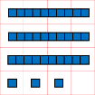 | 50  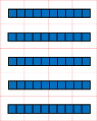
74  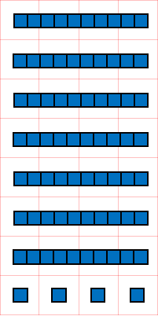 | 85  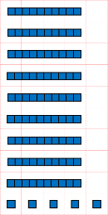
Forty-five  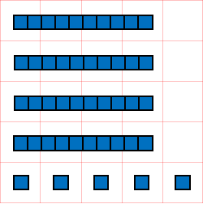 | Sixty-six  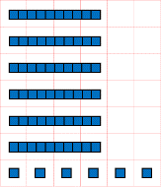
Eighty-one  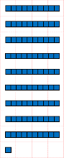 | Ninety  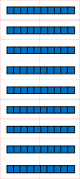

7 Partition two-digit numbers
Let’s Learn
Partition the numbers below into tens and ones.
1  40  41 = + | 5  70  75 = + | 8  80  88 = +

8 Compare two-digit numbers
Let’s Learn
Write > or < in each box.
<  19 31 | <  38 60 | <  74 76

9 Order two-digit numbers
Let’s Learn
Order each set of numbers from smallest to largest.
40, 43, 34, 44, 30
43
44
34
40
30

85, 56, 9, 65, 58
56
9
85
65
58

